ADULTS: Bible study will resume in the Fall.

Thursdays from 10:00 AM to 12:00 PM the Church is open for quiet reflection with Jesus. Mass: Sunday and Wednesday at 11:00 AM; Monday at 9:00 AM

SUNDAY: (8/3) Ecclesiastes 1:2, 2:21-23; Psalm 90; Colossians 3:1-11; Luke 12:13-21
MONDAY: (8/4) Numbers 11:4-15; Psalm 81; Matt. 14:13-21
TUESDAY: (8/5) Numbers 12:1-13; Psalm 51; Matt. 14:22-36
WEDNESDAY: (8/6) Daniel 7:9-14; Psalm 97; II Peter 1:16-19; Luke 9:28-36
THURSDAY: (8/7) Numbers 20:1-13; Psalm 95; Matt. 16:13-23
FRIDAY: (8/8) Deuteronomy 4:32-40; Psalm 77; Matt. 16:24-28
SATURDAY: (8/9) Deuteronomy 6:4-13; Psalm 18; Matt. 17:14-20
SUNDAY: (8/10) Wisdom 18:6-9; Psalm 33; Hebrews 11:1-12; Luke 12:32-48

August: Month of the Immaculate Heart
The month of August is dedicated to the Immaculate Heart. Since the 16th century Catholic piety has assigned entire months to special devotions. The month of August is traditionally dedicated to the Immaculate Heart of Mary. The physical heart of Mary is venerated (and not adored as the Sacred Heart of Jesus is) because it is united to her person and is the seat of her love (especially for her divine Son), virtue, and inner life. Such devotion is an incentive to a similar love and virtue. This devotion has received new emphasis in this century from the visions given to Lucy Dos Santos, oldest of the visionaries of Fatima, in her convent in Tuy, in Spain, in 1925 and 1926. In the visions Our Lady asked for the practice of the Five First Saturdays to help make amends for the offenses committed against her heart by the blasphemies and ingratitude of men. The practice parallels the devotion of the Nine First Fridays in honor of the Sacred Heart.


Please pray for the protection of ALL human life
from the moment of conception
to natural death!!

Immaculate Conception Parish
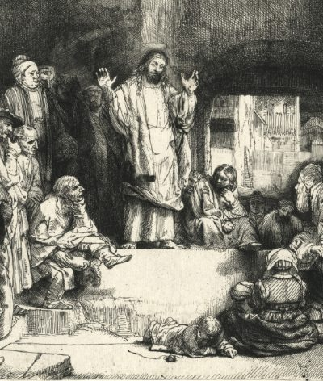
Pastor
Father George Panthananickal, CMI e-mail: gmariadoss@yahoo.com
(931) 433-6525
1900 Huntsville Hwy.
Fayetteville, TN 37334 Deacon Mike Hume: (931) 638-9700

Ecclesiastes 1:2, 2:21-23; Psalm 90; Colossians 3:1-11; Luke 12:13-21
Trust in God—as the Rock of our salvation, as the Lord who made us His chosen people, as our shepherd and guide. This should be the mark of our following of Jesus. Like the Israelites we recall in this week’s Psalm Response, we have made an exodus, passing through the waters of Baptism, freeing us from our bondage to sin. We too are on a pilgrimage to a promised homeland, the Lord in our midst, feeding us heavenly bread, giving us living waters to drink (see 1 Corinthians 10:1-4). We must take care to guard against the folly that befell the Israelites, that led them to quarrel and test God’s goodness at Meribah and Massah. We can harden our hearts in ways more subtle but no less ruinous. We can put our trust in possessions, squabble over earthly inheritances, kid ourselves that what we have we deserve, store up treasures and think they’ll afford us security and rest. All this is “vanity of vanities,” a false and deadly way of living, as this week’s First Reading tells us.This is the greed that Jesus warns against in this week’s Gospel. The rich man’s anxiety and toil expose his lack of faith in God’s care and provision. That’s why Paul calls greed “idolatry” in the Epistle this week. Mistaking having for being, possession for existence, we forget that God is the giver of all that we have, we exalt the things we can make or buy over our Maker (see Romans 1:25). Jesus calls the rich man a “fool”—a word used in the Old Testament for someone who rebels against God or has forgotten Him (see Psalm 14:1). We should treasure most the new life we have been given in Christ and seek what is above, the promised inheritance of heaven. We have to see all things in the light of eternity, mindful that He who gives us the breath of life could at any moment—this night even—demand it back from us. --Dr. Scott Hahn, PhD

