ADULTS: Bible study will resume in the Fall.

Thursdays from 10:00 AM to 12:00 PM the Church is open for quiet reflection with Jesus. Mass: Sunday and Wednesday at 11:00 AM; Monday at 9:00 AM

SUNDAY: (6/29) Acts 12:1-11; Psalm 34; II Timothy 4:6-18; Matt. 16:13-19
MONDAY: (6/30) Gen. 18:16-33; Psalm 103; Matt. 8:18-22
TUESDAY: (7/1) Gen. 19:15-29; Psalm 26; Matt. 8:23-27
WEDNESDAY: (7/2) Genesis 21:5-20; Psalm 34; Matt. 8:28-34
THURSDAY: (7/3) Eph. 2:19-22; Psalm 117; John 20:24-29
FRIDAY: (7/4) Gen. 23:1-4, 19; Psalm 106; Matt. 9:9-13
SATURDAY: (7/5) Gen. 27:1-5, 15-29; Psalm 135; Matt. 9:14-17
SUNDAY: (7/6) Isaiah 66:10-14; Psalm 66; Galatians 6:14-18; Luke 10:1-9

June: Month of the Sacred Heart of Jesus
June is known as the month of the Sacred Heart of Jesus most simply because the solemnity of the Sacred Heart is celebrated during this month. This year, the solemnity falls on June 27. The date changes each year because it is celebrated on the Friday after the Corpus Christi octave, or the Friday after the second Sunday after Pentecost. However, other reasons exist as to why June is dedicated to the Sacred Heart. The feast dates back to 1673, when a French nun who belonged to the Order of the Visitation of Holy Mary (Visitandines) in eastern France began to receive visions about the Sacred Heart. Jesus appeared to Sister Margaret Mary Alacoque and revealed ways to venerate his Sacred Heart and explained the immense love he has for humanity, appearing with his heart visible outside his chest, on fire, and surrounded by a crown of thorns.

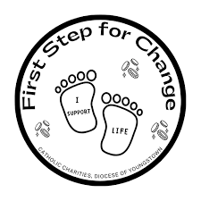
Please pray for the protection of ALL human life
from the moment of conception
to natural death!!
Immaculate Conception Parish
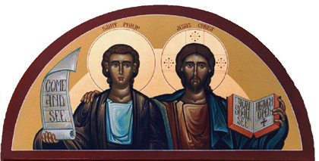
Pastor
Father George Panthananickal, CMI e-mail: gmariadoss@yahoo.com
(931) 433-6525
1900 Huntsville Hwy.
Fayetteville, TN 37334 Deacon Mike Hume: (931) 638-9700

Acts 12:1-11; Psalm 34; II Timothy 4:6-18; Matt. 16:13-19

This Sunday’s celebration of the great apostles Peter and Paul is a celebration of the Church. Peter’s deliverance from jail is compared to the deliverance of Israel from Egypt. Like Israel, he is rescued at Passover from “the hand” of his enemy by an “angel of the Lord” after girding himself with belt, sandals, and cloak. As Peter affirms in his great confession of faith in Sunday’s Gospel, Jesus is “the Christ,” the Messiah for whom the prophets had taught Israel to hope. But He is more than what the Jewish people had been hoping for. He is the Christ, but He is also, as Peter confesses, “the Son of the living God.” Born of the flesh of the Jewish people, He is a son of Abraham and David. Through Him and the Church founded on the rock of Peter’s faith, God fulfills the promise He made to Abraham; to bless all nations in his seed. What Christ calls “my Church” is the new Israel, the kingdom of God, the family made up of all peoples – Jews and Gentiles – who believe that Jesus is the Christ, the Son of the living God. And we must make this confession our own. Jesus’ question, “Who do you say that I am?” is addressed to each of us personally. We must confess our faith in Christ, not only with our tongues, but with our lives. As Paul describes his discipleship in this week’s Epistle, we must make our lives an oblation, an offering of love for the sake of Jesus and His Kingdom. We know, as we sing in this week’s Psalm, that the Lord has rescued us in Christ Jesus. We know that He will stand by us, giving us strength to face every evil – and that He will bring us to the Heavenly Kingdom we anticipate in this Eucharist.
--Dr. Scott Hahn, PhD

