Upcoming Events:
**Parish picnic Saturday, September 13 with a vigil Mass at 5 PM, followed by a meal and games. Sign up for sides in foyer.

RCIA classes will begin September 25. If you are interested in coming into the Catholic Church OR learning more about our Catholic faith, please contact Jay/JoAnne Beam at: (931) 565-3535.

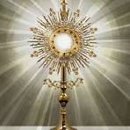

Adoration from 7-8 PM this Friday (First Friday of September).

***CRFD is selling smoked Boston butts for $40/butt. These can be ordered today and the next couple of Sundays. Pick up of butts is on Sept. 26 or 27. See Kathy Grindrod for details and purchasing.

CRFD NEEDS DONATIONS
There is a jar in the foyer labeled CRFD. We packed over 500 boxes in June and gave them to those in need in our area. PLEASE be generous to this cause. Just drop your donation into the jar, so we can help purchase more food for those in need!!



St. Michael Prayer

St. Michael, the Archangel, defend us in battle. Be our protection against the wickedness and snares of the devil. May God rebuke him, we humbly pray, and do thou, Oh Prince of the Heavenly Host, by the power of God, thrust into Hell, Satan and all evil spirits who prowl around the world seeking the ruin of souls. Amen.

Our Prayer After Communion
O Sacrament most holy, O sacrament divine
all praise and all thanksgiving
be every moment thine.
We believe that Jesus Christ is really, truly,
and substantially present in
Holy Communion,
Body, Blood Soul and Divinity!!
O Sacrament most holy, O Sacrament divine
all praise and all thanksgiving
be every moment thine.
Mary, Blessed Mother, help us, your children,
to experience and develop in the Eucharist,
a deeper and more intimate relationship
with your son, Jesus Christ, our Lord. Amen

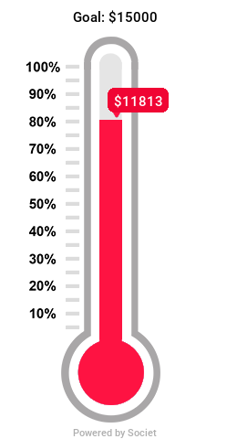

Only $3187 to go to meet our goal of $15,000!!

*Matthew 25 has a “bag” day every 4th Thursday where you can fill a bag of anything for $6. They also provide food on Mondays and Wednesdays from 9-11.

Sign up sheet for children’s Religious Education is in the foyer. Sign up so we make sure to have enough materials.

Adult Bible study on the Creed to begin after Mass on Sunday, September 21. Meal provided!!

Where can you help??
Call the Parish secretary for more information:

Parish Secretary – (931) 363-5776 iccpulaski@energize.net
Charities: Life Choice Pregnancy Resource Center, Inc. – JoAnne Beam (M, Th – 9-5, Tue & F – 9-1)
Matthew 25 – Linda Vanzant (Tue, W, & Th – 9-3:30, M&W – 9-12)
Community Rural Food Distribution –Kathy Grindrod (3rd Th pack 5:30 at the Old Sharp Motor building, distribute 3rd Sat. – 9:00 at the Agri-Park. Volunteers are needed!!
Help Center – Lucian Czejak (M-F 10-2)

**Bishop’s Annual Appeal’s envelopes are in the foyer. You can also donate online:
https://pushpay.com/g/immaculateconceptionpulaski

NOTE: Online donations to our church can be made at: https://pushpay.com/g/immaculateconceptionpulaski

August – Month of the Immaculate Heart of Mary

When one is truly advancing towards perfection, he feels within himself a constant urge to progress and improve. Because the more grace or enlightenment he receives, the more he realizes how much he is still lacking in virtue and good works. On the other hand, if he does realize that he is doing a little good, he feels it is very imperfect and does not give it much credit. Hence he continuously works for perfection without slacking in pace.
(St. Lawrence Justinian)

