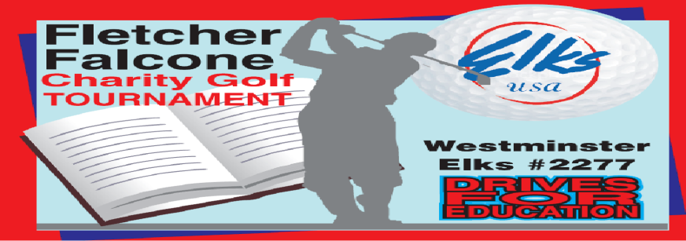

538 Gorsuch Ave
Westminster, Md. 21157
Sponsorship Form

Complete this section for Hole Sponsorship
Company

Address

Phone /email

The 2023 Fletcher Falcone Golf Outing will be dedicated to funding Elks Youth activities. These activities include the Annual Hoop Shoot, Camp Barrett, Elks Scholarship Fund and others.

Thank you for your support

Checks made out to Westminster Elks #2277 or can go to Carroll Community Foundation, under Westminster Elks Charities to donate online. Website below.

wearecarroll.org click tab “donate now” type in “Westminster Elks Charities” to donate

