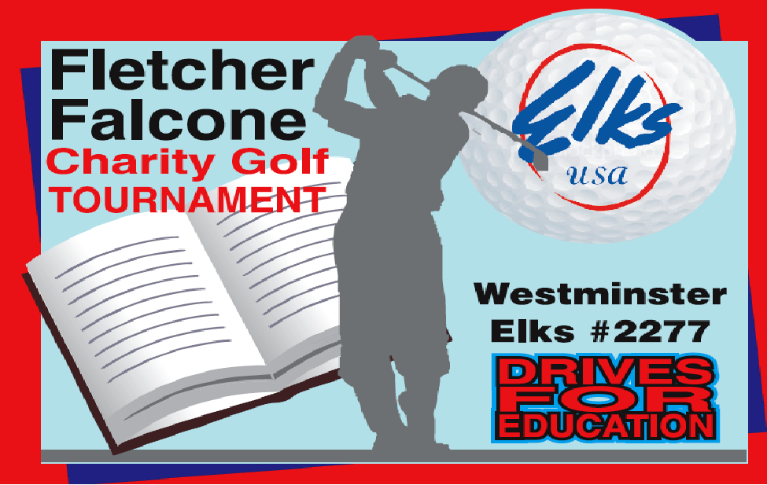

OCTOBER 2, 2020 SHOTGUN START 8:30 AM
QUAIL VALLEY GOLF COURSE
$110.00 Per Player
(Includes; Green Fees, Cart, Food, Drinks,
Entry to a Par 3 Closest to the Pins contest)
To reserve your foursome, payment needed by September 1st, 2020)
Make Check Payable to: Westminster Elks 2277 538 Gorsuch Ave
Westminster, Md. 21157

GOLF PARTICIPANT ENTRY FORM

NAME ___________________________________________________

STREET _________________________________________________

CITY _____________________ MD _______ ZIP _____________ Email Address __________________________________

PHONE _______________________________ AGE _____________ HANDICAP___________

NAME ___________________________________________________

STREET _________________________________________________

CITY _____________________ MD _______ ZIP _____________ Email Address __________________________________

PHONE _______________________________ AGE _____________ HANDICAP____________

NAME ___________________________________________________

STREET _________________________________________________

CITY _____________________ MD _______ ZIP _____________ Email Address __________________________________

PHONE _______________________________ AGE _____________ HANDICAP____________

NAME ___________________________________________________

STREET _________________________________________________

CITY _____________________ MD _______ ZIP _____________ Email Address __________________________________

PHONE _______________________________ AGE _____________ HANDICAP_____________

IF YOUR TEAM IS INTERESTED IN SPONSORING A
HOLE FOR $100 or MORE INCLUDE THIS IN YOUR APPLICATION.

WE HAVE SET OUR CHARITABLE GOAL
THIS YEAR TO $40,000
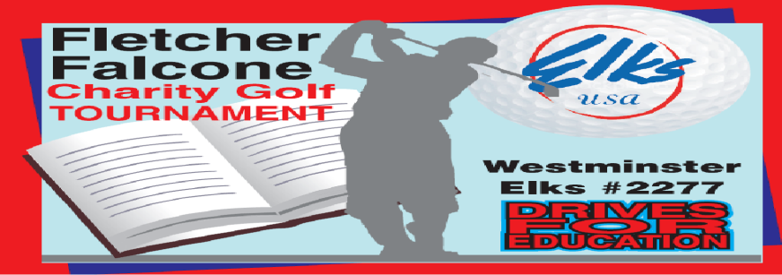

538 Gorsuch Ave
Westminster, Md. 21157
Sponsorship / Silent Auction Form
(Check appropriate box) Hole Sponsorship Silent Auction item 
Complete this section for Hole Sponsorship
Company

Address

Phone /email
Note: Signs are printed in Arial font type. Font size will be determined by the print vendor based on number of characters and available sign spacing.
Complete this section for Silent Auction
Auction Item |  | Value

The 2020 Fletcher Falcone Golf Outing will be dedicated to funding Elks Youth activities. These activities include the Annual Hoop Shoot, Camp Barrett, Elks Scholarship Fund and others.

Thank you for your support

Checks made out to Westminster Elks #2277 or can go to Carroll Community Foundation, under Westminster Elks Charities to donate on line.

http://www.carrollcommunityfoundation.org/funds.asp?fund_id=310

