INTRODUCTION OF DERIVATIVES
The emergence of the market for derivative products, most notably forwards, futures and options, can be traced back to the willingness of risk-averse economic agents to guard themselves against uncertainties arising out of fluctuations in asset prices. By their very nature, the financial markets are marked by a very high degree of volatility. Through the use of derivative products, it is possible to partially or fully transfer price risks by locking-in asset Prices. As instruments of risk management, these generally do not influence the Fluctuations in the underlying asset prices. However, by locking-in asset prices, Derivative products minimize the impact of fluctuations in asset prices on the Profitability and cash flow situation of risk-averse investors.
Derivatives are risk management instruments, which derive their value from an underlying asset. The underlying asset can be bullion, index, share, bonds, Currency, interest, etc., Banks, Securities firms, companies and investors to hedge risks, to gain access to cheaper money and to make profit, use derivatives. Derivatives are likely to grow even at a faster rate in future.

DEFINITION OF DERIVATIVES
“Derivative is a product whose value is derived from the value of an underlying asset in a contractual manner. The underlying asset can be equity, Forex, commodity or any other asset.”

- Securities Contract ( regulation) Act, 1956 (SC(R) A)defines “debt instrument, share, loan whether secured or unsecured, risk instrument or contract for differences or any other form of security”
- A contract which derives its value from the prices, or index of prices, of underlying securities.
HISTORY OF DERIVATIVES MARKETS

Early forward contracts in the US addressed merchants concerns about ensuring that there were buyers and sellers for commodities. However “credit risk” remained a serious problem. To deal with this problem, a group of Chicago; businessmen formed the Chicago Board of Trade (CBOT) in 1848. The primary intention of the CBOT was to provide a centralized location known In advance for buyers and sellers to negotiate forward contracts. In 1865, the CBOT went one step further and listed the first “exchange traded” derivatives Contract in the US; these contracts were called “futures contracts”. In 1919, Chicago Butter and Egg Board, a spin-off CBOT was reorganized to allow futures trading. Its name was changed to Chicago Mercantile Exchange (CME). The CBOT and the CME remain the two largest organized futures exchanges, indeed the two largest “financial” exchanges of any kind in the world today.

The first stock index futures contract was traded at Kansas City Board of Trade. Currently the most popular stock index futures contract in the world is based on S&P 500 index, traded on Chicago Mercantile Exchange. During the Mid eighties, financial futures became the most active derivative instruments Generating volumes many times more than the commodity futures. Index futures, futures on T-bills and Euro-Dollar futures are the three most popular Futures contracts traded today. Other popular international exchanges that trade derivatives are LIFFE in England, DTB in Germany, SGX in Singapore, TIFFE in Japan, MATIF in France, Eurex etc.,

THE GROWTH OF DERIVATIVES MARKET
Over the last three decades, the derivatives markets have seen a phenomenal growth. A large variety of derivative contracts have been launched at exchanges across the world. Some of the factors driving the growth of financial derivatives are:
- Increased volatility in asset prices in financial markets,
- Increased integration of national financial markets with the international markets,
- Marked improvement in communication facilities and sharp decline in their costs,
- Development of more sophisticated risk management tools, providing economic agents a wider choice of risk management strategies, and
- Innovations in the derivatives markets, which optimally combine the risks and returns over a large number of financial assets leading to higher returns, reduced risk as well as transactions costs as compared to individual financial assets.

DERIVATIVE PRODUCTS (TYPES)
The following are the various types of derivatives. They are:
Forwards:
A forward contract is a customized contract between two entities, where settlement takes place on a specific date in the future at today’s pre-agreed price.

Futures:
A futures contract is an agreement between two parties to buy or sell an asset at a certain time in the future at a certain price. Futures contracts are special types of forward contracts in the sense that the former are standardized exchange-traded contracts.
Options:
Options are of two types-calls and puts. Calls give the buyer the right but not the obligation to buy a given quantity of the underlying asset, at a given price on or before a given future date. Puts give the buyer the right, but not the obligation to sell a given quantity of the underlying asset at a given price on or before a given date.
Warrants:
Options generally have lives of upto one year; the majority of options traded on options exchanges having a maximum maturity of nine months. Longer-dated options are called warrants and are generally traded Over-the-counter.
Leaps:
The acronym LEAPS means Long-Term Equity Anticipation Securities. These are options having a maturity of upto three years.

Baskets:
Basket options are options on portfolio of underlying assets. The underlying asset is usually a moving average of a basket of assets. Equity index options are a form of basket options.

Swaps:
Swaps are private agreement between two parties to exchange cash flows in the future according to a prearranged formula. They can be regarded as portfolios of forward contracts. The two commonly used swaps are:
- Interest rate swaps:
The entail swapping only the interest related cash flows between the parties in the same currency.
- Currency swaps:
These entail swapping both principal and interest between the parties, with the cashflows in one direction being in a different currency than those in the opposite direction.
Swaptions:
Swaptions are options to buy or sell a swap that will become operative at the expiry of the options. Thus a swaption is an option on a forward swap. Rather than have calls and puts, the swaptions market has receiver swaptions and payer swaptions. A receiver swaption is an option to receive fixed and pay floating. A payer swaption is an option to pay fixed and received floating.

PARTICIPANTS IN THE DERRIVATIVES MARKETS
The following three broad categories of participants:
HEDGERS:
Hedgers face risk associated with the price of an asset. They use futures or options markets to reduce or eliminate this risk.
SPECULATORS:
Speculators wish to bet on future movements in the price of an asset. Futures and options contracts can give them an extra leverage; that is, they can increase both the potential gains and potential losses in a speculative venture.
ARBITRAGEURS:
Arbitrageurs are in business to take advantage of a discrepancy between prices in two different markets. If, for example they see the futures prices of an asset getting out of line with the cash price, they will take offsetting positions in the two markets to lock in a profit.

FUNCTIONS OF THE DERIVATIVES MARKET
In spite of the fear and criticism with which the derivative markets are commonly looked at, these markets perform a number of economic functions.
- Price in an organized derivative markets reflect the perception of market participants about the future and lead the prices of underlying to the perceived future level. The prices of derivatives converge with the prices of the underlying at the
Expiration of the derivative contract. Thus derivatives help in discovery of future as well as current prices.
- The derivative markets helps to transfer risks from those who have them but may not like them to those who have an appetite for them.
- Derivative due to their inherent nature, are linked to the underlying cash markets. With the introduction of derivatives, the underlying market witness higher trading volumes because of participation by more players who would not otherwise participate for lack of an arrangement to transfer risk.
- Speculative trades shift to a more controlled environment of derivatives market. In the absence of an organized derivatives market, speculators trade in the underlying cash markets. Margining, monitoring and surveillance of the activities of various participants become extremely difficult in these kinds of mixed markets.
- An important incidental benefit that flows from derivatives trading is that it acts as a catalyst for new entrepreneurial activity. The derivatives have a history of attracting many bright, creative, Well-educated people with an entrepreneurial attitude. They often energize others to create new businesses, new products and new employment opportunities, the benefit of which are immense.

SCOPE OF THE STUDY
The Study is limited to “Derivatives” with special reference to futures and Option in the Indian context and the Inter-Connected Stock Exchange have been Taken as a representative sample for the study. The study can’t be said as totally perfect. Any alteration may come. The study has only made a humble Attempt at evaluation derivatives market only in India context. The study is not Based on the international perspective of derivatives markets, which exists in NASDAQ, CBOT etc.,

OBJECTIVES OF THE STUDY
- To analyze the derivatives market in India.
- To analyze the operations of futures and options.
- To find the profit/loss position of futures buyer and also
The option writer and option holder.
- To study about risk management with the help of derivatives.

LIMITATIONS OF THE STUDY
The following are the limitation of this study.
- The scrip chosen for analysis is OIL & NATURAL GAS CORPORATION LTD and the contract taken is March 2007 ending one-month contract.
- The data collected is completely restricted to the OIL & NATURAL GAS CORPORATION LTD of March 2007; hence this analysis cannot be taken universal.

NATURE OF THE PROBLEM

The turnover of the stock exchange has been tremendously increasing form Last 10 years. The number of trades and the number of investors, who are participating, have increased. The investors are willing to reduce their risk, so they are seeking for the risk management tools.
Prior to SEBI abolishing the BADLA system, the investors had this system as a source of reducing the risk, as it has many problems like no strong margining System, unclear expiration date and generating counter party risk. In view of this problem SEBI abolished the BADLA system.
After the abolition of the BADLA system, the investors are seeking for a Hedging system, which could reduce their portfolio risk. SEBI thought the Introduction of the derivatives trading, as a first step it has set up a 24 member Committee under the chairmanship of Dr.L.C.Gupta to develop the appropriate Framework for derivatives trading in India, SEBI accepted the recommendation of the committee on May 11, 1998 and approved the phase introduction of the Derivatives trading beginning with stock index futures.
There are many investors who are willing to trade in the derivatives segment, Because of its advantages like limited loss unlimited profit by paying the small Premiums.

THE DEVELOPMENT OF DERIVATIVES MARKET
Holding portfolios of Securities is associated with the risk of the possibility that the investor may realize his returns, which would be much lesser than what he expected to get. There are various factors, which affect the returns:
- Price or dividend (interest)
- Some are internal to the firm like
  - Industrial policy
  - Management capabilities
  - Consumer’s preference
  - Labor strike, etc.,
These forces are to a large extent controllable and are termed as non systematic risks. An investor can easily manage such non-systematic by having a Well-diversified portfolio spread across the companies, industries and groups so that a loss in one may easily be compensated with a gain in other.

There are yet other of influence which are external to the firm, cannot be controlled and affect large number of securities. They are termed as systematic Risk. They are:
- Economic
- political
- Sociological changes are sources of systematic risk
For instance, inflation, interest rate, etc. Their effect is to cause prices if nearly All-individual stocks to move together in the same manner. We therefore quite often find stock prices falling from time to time in spite of company’s earning rising and vice versa.
Rational Behind the development of derivatives market is to manage this systematic risk, liquidity in the sense of being able to buy and sell relatively large amounts quickly without substantial price concession.
In debt market, a large position of the total risk of securities is systematic. Debt instruments are also finite life securities with limited marketability due to their small size relative to many common sticks. Those factors favour for the purpose of both portfolio hedging and speculation, the introduction of a derivatives securities that is on some broader market rather than an individual security.
GLOBAL DERIVATIVES MARKET
The global financial centers such as Chicago, New York, Tokyo and London dominate the trading in derivatives. Some of the world’s leading exchanges for the exchange-traded derivatives are:
- Chicago Mercantile exchange (CME) and London International Financial Futures Exchange (LIFFE) ( for currency & Interest rate futures)
- Philadelphia Stock Exchange(PSE), London Stock Exchange (LSE) & Chicago Board Options Exchange (CBOE) ( for currency options)
- New York Stock Exchange (NYSE) and London Stock Exchange (LSE) (for equity derivatives)
- Chicago Mercantile Exchange(CME) and London Metal Exchange (LME) ( for Commodities)
These exchanges account for a large portion of the trading volume in the respective derivatives segment.
NSE’s DERIVATIVES MARKET
The derivatives trading on the NSE commenced with S&P CNX Nifty index Futures on June 12, 2000. The trading in index options commenced on June 4, 2001 and trading in options on individual securities commenced on July 2, 2001 Single stock futures were launched on November 9, 2001. Today, both in terms of volume and turnover, NSE is the largest derivatives exchange in India. Currently, the derivatives contracts have a maximum of 3-month expiration cycles. Three contracts are available for trading, with 1 month, 2 month and 3 month expiry. A new contract is introduced on the next trading day following of the near month contract.

REGULATORY FRAMEWORK
The trading of derivatives is governed by the provisions contained in the SC(R) A, the SEBI Act, the rules and regulations framed there under and the rules and bye-laws of stock exchanges.
In this chapter we look at the broad regulatory framework for derivatives trading and the requirement to become a member and an authorized dealer of the F&O segment and the position limits as they apply to various participants.
Regulation for derivatives trading:
SEBI set up a 24-members committee under the Chairmanship of Dr.L.C.GUPTA to develop the appropriate regulatory framework for derivatives trading in India. On May 11, 1998 SEBI accepted the recommendations of the committee and approved the phased introduction of derivatives trading in India beginning with stock index futures.
The provision in the SC(R) A and the regulatory framework developed there under govern trading in securities. The amendment of the SC(R) A to include derivatives within the ambit of “securities” in the SC(R) A made trading in derivatives possible within the framework of that Act.
- Any Exchange fulfilling the eligibility criteria as prescribed in the L.C.Gupta committee report can apply to SEBI for grant of recognition under Section 4 of the SC(R) A, 1956 to start trading derivatives. The derivatives exchange/segment should have a separate governing council and representation of trading/clearing members shall be limited to maximum of 40% of the total members of the governing council. The exchange would have to regulate the sales practices of its members and would have to obtain prior approval of SEBI before start of trading in any derivative contract.

- The Exchange should have minimum 50 members.
- The members of an existing segment of the exchange would not automatically become the members of derivative segment. The members of the derivative segment would need to fulfill the eligibility conditions as laid down by the L.C.Gupta committee.
- The clearing and settlement of derivatives trades would be through a SEBI approved clearing corporation/house. Clearing corporations/houses complying with the eligibility as laid down by the committee have to apply to SEBI for grant of approval.
- Derivatives brokers/dealers and clearing members are required to seek registration from SEBI. This is in addition to their registration as brokers of existing stock exchanges. The minimum net worth for clearing members of the derivatives clearing corporation/house shall be Rs.300 Lakh. The net worth of the member shall be computed as follows :
  - Capital + Free reserves
  - Less non-allowable assets viz.,
    - Fixed assets
    - Pledged securities
    - Member’s card
    - Non-allowable securities ( unlisted securities)
    - Bad deliveries
    - Doubtful debts and advances
    - Prepaid expenses
    - Intangible assets
    - 30 % marketable securities
      - The minimum contact value shall not be less than Rs.2 Lakh. Exchanges have to submit details of the futures contract they propose to introduce.
      - The initial margin requirement, exposure limits linked to capital adequacy and margin demands related to the risk of loss on the position will be prescribed by SEBI / Exchanged from time to time.
      - The L.C.Gupta committee report requires strict enforcement of “Know your customer “rule and requires that every client shall be registered with the derivatives broker. The members of the derivatives segment are also required to make their clients aware of the risks involved in derivatives trading by issuing to the clients the Risk Disclosure and obtain a copy of the same duly signed by the clients.
- The trading members are required to have qualified approved user and sales person who have passed a certification programmed approved by SEBI.
ELIGIBILITY OF ANY STOCK TO ENTER IN DERIVATIVES MARKET

- Non Promoter holding ( free float capitalization ) not less than Rs. 750 Crores from last 6 months

- Daily Average Trading value not less than 5 Crores in last 6 Months

- At least 90% of Trading days in last 6 months

- Non Promoter Holding at least 30%

- BETA not more than 4 ( previous last 6 months )

DESCRIPTION OF THE METHOD
The following are the steps involved in the study.
Selection of the scrip:-
The scrip selection is done on a random and the scrip selected is
OIL & NATURAL GAS CORPORATION LTD. The lot is 225. Profitability position of the futures buyers and seller and also the option holder and option writers is studied.
Data Collection:-
The data of the ONGC Ltd has been collected from the “the Economic
Times” and the internet. The data consist of the March Contract and period of Data collection is from 23rd FEBRUARY 2007 - 29th MARCH 2007.
Analysis:-
The analysis consist of the tabulation of the data assessing the profitability Positions of the futures buyers and sellers and also option holder and the option Writer, representing the data with graphs and making the interpretation using Data.

INTRODUCTION OF FUTURES
Futures markets were designed to solve the problems that exist in forward markets. A futures contract is an agreement between two parties to buy or sell an asset at a certain time in the future at a certain price. But unlike forward contract, the futures contracts are standardized and exchange traded. To facilitate liquidity in the futures contract, the exchange specifies certain standard features of the contract. It is standardized contract with standard underlying instrument, a standard quantity and quality of the underlying instrument that can be delivered,
(Or which can be used for reference purpose in settlement) and a standard timing of such settlement. A futures contract may be offset prior to maturity by entering into an equal and opposite transaction. More than 90% of futures transactions are offset this way.
The standardized items in a futures contract are:
- Quantity of the underlying
- Quality of the underlying
- The date and the month of delivery
- The units of price quotation and minimum price change
- Location of settlement
DIFINITION
A Futures contract is an agreement between two parties to buy or sell an asset at a certain time in the future at a certain price. Futures contracts are special types of forward contracts in the sense that the former are standardized exchange-traded contracts.

HISTORY OF FUTURES

Merton Miller, the 1990 Nobel Laureate had said that “financial futures represent the most significant financial innovation of the last twenty years.” The first exchange that traded financial derivatives was launched in Chicago in the year 1972. A division of the Chicago Mercantile Exchange, it was called the international monetary market (IMM) and traded currency futures. The brain behind this was a man called Leo Melamed, acknowledged as the “father of financial futures” who was then the Chairman of the Chicago Mercantile Exchange. Before IMM opened in 1972, the Chicago Mercantile Exchange sold contracts whose value was counted in millions. By 1990, the underlying value of all contracts traded at the Chicago Mercantile Exchange totaled 50 trillion dollars.

These currency futures paved the way for the successful marketing of a dizzying array of similar products at the Chicago Mercantile Exchange, the Chicago Board of Trade and the Chicago Board Options Exchange. By the 1990s, these exchanges were trading futures and options on everything from Asian and American stock indexes to interest-rate swaps, and their success transformed Chicago almost overnight into the risk-transfer capital of the world.

DISTINCTION BETWEEN FUTURES AND FORWARDS CONTRACTS

Forward contracts are often confused with futures contracts. The confusion is primarily because both serve essentially the same economic functions of allocating risk in the presence of futures price uncertainty. However futures are a significant improvement over the forward contracts as they eliminate counterparty risk and offer more liquidity. Comparison between two as follows:

FUTURES | FORWARDS
1.Trade on an Organized Exchange  2.Standardized contract terms  3. hence more liquid  4. Requires margin  payment  5. Follows daily  Settlement | 1. OTC in nature  2.Customized contract  terms  3. hence less liquid  4. No margin payment  5. Settlement happens at end of period

Table 2.1

FEATURES OF FUTURES

- Futures are highly standardized.
- The contracting parties need not pay any down payment.
- Hedging of price risks.
- They have secondary markets too.

TYPES OF FUTURES

On the basis of the underlying asset they derive, the futures are divided into two types:
- Stock Futures
- Index Futures

PARTIES IN THE FUTURES CONTRACT

There are two parties in a futures contract, the buyers and the seller. The buyer of the futures contract is one who is LONG on the futures contract and the seller of the futures contract is who is SHORT on the futures contract.
The pay-off for the buyers and the seller of the futures of the contracts are as follows:

PAY-OFF FOR A BUYER OF FUTURES

LOSS
PROFIT
F
L
P
E₁

E₂

Figure 2.1

CASE 1:- The buyers bought the futures contract at (F); if the futures
Price Goes to E₁ then the buyer gets the profit of (FP).

CASE 2:- The buyers gets loss when the futures price less then (F); if
The Futures price goes to E₂ then the buyer the loss of (FL).

PAY-OFF FOR A SELLER OF FUTURES

F
LOSS
PROFIT
E₁
P
E₂
L
Figure 2.2

F = FUTURES PRICE
E₁, E2 = SETLEMENT PRICE

CASE 1:- The seller sold the future contract at (F); if the future goes to
E₁ Then the seller gets the profit of (FP).

CASE 2:- The seller gets loss when the future price goes greater than (F);
If the future price goes to E₂ then the seller get the loss of (FL).

MARGINS
Margins are the deposits which reduce counter party risk, arise in a futures contract. These margins are collect in order to eliminate the counter party risk. There are three types of margins:
Initial Margins:-
Whenever a future contract is signed, both buyer and seller are required to post initial margins. Both buyers and seller are required to make security deposits that are intended to guarantee that they will infect be able to fulfill their obligation. These deposits are initial margins and they are often referred as purchase price of futures contract.
Mark to market margins:-
The process of adjusting the equity in an investor’s account in order to reflect the change in the settlement price of futures contract is known as MTM margin.
Maintenance margin:-
The investor must keep the futures account equity equal to or greater than certain percentage of the amount deposited as initial margin. If the equity goes less than that percentage of initial margin, then the investor receives a call for an additional deposit of cash known as maintenance margin to bring the equity up to the initial margin.
ROLE OF MARGINS
The role of margins in the futures contract is explained in the following example: Siva Rama Krishna sold an ONGC July futures contract to Nagesh at Rs.600; the following table shows the effect of margins on the Contract. The contract size of ONGC is 1800. The initial margin amount is say Rs. 30,000 the maintenance margin is 65% of initial margin.

PRICING FUTURES
Pricing of futures contract is very simple. Using the cost-of-carry logic, we calculate the fair value of a future contract. Every time the observed price deviates from the fair value, arbitragers would enter into trades to captures the arbitrage profit. This in turn would push the futures price back to its fair value. The cost of carry model used for pricing futures is given below.
F = Se^{rT}
Where:
F = Futures price
S = Spot Price of the Underlying
r = Cost of financing (using continuously compounded
Interest rate)
T = Time till expiration in years
e = 2.71828
(OR)

F = S (1+r- q) t
Where:
F = Futures price
S = Spot price of the underlying
r = Cost of financing (or) interest Rate
q = Expected dividend yield
t = Holding Period

FUTURES TERMINOLOGY
Spot price:
The price at which an asset trades in the spot market.
Futures Price:
The price at which the futures contract trades in the futures market.
Contract cycle:
The period over which a contract trades. The index futures contracts on the NSE have one-month and three-month expiry cycles which expire on the last Thursday of the month. Thus a January expiration contract expires on the last Thursday of January and a February expiration contract ceases trading on the last Thursday of February. On the Friday following the last Thursday, a new contract having a three-month expiry is introduced for trading.
Expiry date:
It is the date specified in the futures contract. This is the last day on which the contract will be traded, at the end of which it will cease to exist.
Contract size:
The amount of asset that has to be delivered under one contract. For instance, the contract size on NSE’s futures markets is 200 Nifties.
Basis:
In the context of financial futures, basis can be defined as the futures price minus the spot price. These will be a different basis for each delivery month for each contract. In a normal market, basis will be positive. This reflects that futures prices normally exceed spot prices.

Cost of carry:
The relationship between futures prices and spot prices can be summarized in terms of what is known as the cost of carry. This measures the storage cost plus the interest that is paid to finance the asset less the income earned on the asset.
Initial margin:
The amount that must be deposited in the margin account at the time a futures contract is first entered into is known as initial margin.
Marking-to-market:
In the futures market, at the end of each trading day, the margin account is adjusted to reflect the investor’s gain or loss depending upon the futures closing price. This is called marking-to-market.
Maintenance margin:
This is some what lower than the initial margin. This is set to ensure that the balance in the margin account never becomes negative. If the balance in the margin account falls below the maintenance margin, the investor receives a margin call and is expected to top up the margin account to the initial margin level before trading commences on the next day.

INTRODUCTION TO OPTIONS
In this section, we look at the next derivative product to be traded on the NSE, namely options. Options are fundamentally different from forward and futures contracts. An option gives the holder of the option the right to do something. The holder does not have to exercise this right. In contrast, in a forward or futures contract, the two parties have committed themselves to doing something. Whereas it costs nothing (except margin requirement) to enter into a futures contracts, the purchase of an option requires as up-front payment.
DEFINITION
Options are of two types- calls and puts. Calls give the buyer the right but not the obligation to buy a given quantity of the underlying asset, at a given price on or before a given future date. Puts give the buyers the right, but not the obligation to sell a given quantity of the underlying asset at a given price on or before a given date.
HISTORY OF OPTIONS
Although options have existed for a long time, they we traded OTC, without much knowledge of valuation. The first trading in options began in Europe and the US as early as the seventeenth century. It was only in the early 1900s that a group of firms set up what was known as the put and call Brokers and Dealers Association with the aim of providing a mechanism for bringing buyers and sellers together. If someone wanted to buy an option, he or she would contact one of the member firms. The firms would then attempt to find a seller or writer of the option either from its own clients of those of other member firms. If no seller could be found, the firm would undertake to write the option itself in return for a price.
This market however suffered form two deficiencies. First, there was no secondary market and second, there was no mechanism to guarantee that the writer of the option would honour the contract. In 1973, Black, Merton and scholes invented the famed Black-Scholes formula. In April 1973, CBOE was set up specifically for the purpose of trading options. The market for option developed so rapidly that by early’ 80s, the number of shares underlying the option contract sold each day exceeded the daily volume of shares traded on the NYSE. Since then, there has been no looking back.
Option made their first major mark in financial history during the tulip-bulb mania in seventeenth-century Holland. It was one of the most spectacular get rich quick brings in history. The first tulip was brought Into Holland by a botany professor from Vienna. Over a decade, the tulip became the most popular and expensive item in Dutch gardens. The more popular they became, the more Tulip bulb prices began rising. That was when options came into the picture. They were initially used for hedging. By purchasing a call option on tulip bulbs, a dealer who was committed to a sales contract could be assured of obtaining a fixed number of bulbs for a set price. Similarly, tulip-bulb growers could assure themselves of selling their bulbs at a set price by purchasing put options. Later, however, options were increasingly used by speculators who found that call options were an effective vehicle for obtaining maximum possible gains on investment. As long as tulip prices continued to skyrocket, a call buyer would realize returns far in excess of those that could be obtained by purchasing tulip bulbs themselves. The writers of the put options also prospered as bulb prices spiraled since writers were able to keep the premiums and the options were never exercised. The tulip-bulb market collapsed in 1636 and a lot of speculators lost huge sums of money. Hardest hit were put writers who were unable to meet their commitments to purchase Tulip bulbs.

PROPERTIES OF OPTION
Options have several unique properties that set them apart from other securities. The following are the properties of option:
- Limited Loss
- High leverages potential
- Limited Life
PARTIES IN AN OPTION CONTRACT
There are two participants in Option Contract.
Buyer/Holder/Owner of an Option:
The Buyer of an Option is the one who by paying the option premium buys the right but not the obligation to exercise his option on the seller/writer.
Seller/writer of an Option:
The writer of a call/put option is the one who receives the option premium and is thereby obliged to sell/buy the asset if the buyer exercises on him.

TYPES OF OPTIONS
The Options are classified into various types on the basis of various variables. The following are the various types of options.
- On the basis of the underlying asset:
On the basis of the underlying asset the option are divided in to two types:
Index options:
These options have the index as the underlying. Some options are European while others are American. Like index futures contracts, index options contracts are also cash settled.

Stock options:
Stock Options are options on individual stocks. Options currently trade on over 500 stocks in the United States. A contract gives the holder the right to buy or sell shares at the specified price.
- On the basis of the market movements :
On the basis of the market movements the option are divided into two types. They are:
Call Option:
A call Option gives the holder the right but not the obligation to buy an asset by a certain date for a certain price. It is brought by an investor when he seems that the stock price moves upwards.
Put Option:
A put option gives the holder the right but not the obligation to sell an asset by a certain date for a certain price. It is bought by an investor when he seems that the stock price moves downwards.

3. On the basis of exercise of option:
On the basis of the exercise of the Option, the options are classified into two Categories.
American Option:
American options are options that can be exercised at any time up to the expiration date. Most exchange –traded options are American.
European Option:
European options are options that can be exercised only on the expiration date itself. European options are easier to analyze than American options, and properties of an American option are frequently deduced from those of its European counterpart.

PAY-OFF PROFILE FOR BUYER OF A CALL OPTION
The Pay-off of a buyer options depends on a spot price of an underlying asset. The following graph shows the pay-off of buyers of a call option.
OTM
LOSS
S
P
E₂
R
PROFIT
ITM
ATM
E₁
Figure 2.3

S = Strike price ITM = In the Money
Sp = premium/loss ATM = At the Money
E₁ = Spot price 1 OTM = Out of the Money
E₂ = Spot price 2
SR = Profit at spot price E₁

CASE 1: (Spot Price > Strike price)
As the Spot price (E₁) of the underlying asset is more than strike price (S).
The buyer gets profit of (SR), if price increases more than E₁ then profit also increase more than (SR)

CASE 2: (Spot Price < Strike Price)
As a spot price (E₂) of the underlying asset is less than strike price (S)
The buyer gets loss of (SP); if price goes down less than E₂ then also his loss is limited to his premium (SP)

PAY-OFF PROFILE FOR SELLER OF A CALL OPTION

The pay-off of seller of the call option depends on the spot price of the underlying asset. The following graph shows the pay-off of seller of a call option:
ITM

PROFIT
E₁
P
S
ATM
E₂
OTM
R
LOSS
Figure 2.4
S = Strike price ITM = In the Money
SP = Premium / profit ATM = At The money
E₁ ₌ Spot Price 1 OTM = Out of the Money
E₂ = Spot Price 2
SR = loss at spot price E₂

CASE 1: (Spot price < Strike price)
As the spot price (E₁) of the underlying is less than strike price (S). The seller gets the profit of (SP), if the price decreases less than E₁ then also profit of the seller does not exceed (SP).

CASE 2: (Spot price > Strike price)
As the spot price (E₂) of the underlying asset is more than strike price (S) the Seller gets loss of (SR), if price goes more than E₂ then the loss of the seller also increase more than (SR).

PAY-OFF PROFILE FOR BUYER OF A PUT OPTION

The Pay-off of the buyer of the option depends on the spot price of the underlying asset. The following graph shows the pay-off of the buyer of a call option.
PROFIT
ITM
R
E₁
ATM
P
LOSS
OTM
E₂
S
Figure 2.5
S = Strike price ITM = In the Money
SP = Premium / loss ATM = At the Money
E₁ = Spot price 1 OTM = Out of the Money
E₂ = Spot price 2
SR = Profit at spot price E₁

CASE 1: (Spot price < Strike price)
As the spot price (E₁) of the underlying asset is less than strike price (S). The buyer gets the profit (SR), if price decreases less than E₁ then profit also increases more than (SR).

CASE 2: (Spot price > Strike price)
As the spot price (E₂) of the underlying asset is more than strike price (S),
The buyer gets loss of (SP), if price goes more than E₂ than the loss of the buyer is limited to his premium (SP).

PAY-OFF PROFILE FOR SELLER OF A PUT OPTION

The pay-off of a seller of the option depends on the spot price of the underlying asset. The following graph shows the pay-off of seller of a put option.
LOSS
OTM
R
S

E₁
P
PROFIT
ITM
ATM
E₂
Figure 2.6
S = Strike price ITM = In The Money
SP = Premium/profit ATM = At The Money
E₁ ₌ Spot price 1 OTM = Out of the Money
E₂ ₌ Spot price 2
SR = Loss at spot price E₁

CASE 1: (Spot price < Strike price)
As the spot price (E₁) of the underlying asset is less than strike price (S), the seller gets the loss of (SR), if price decreases less than E₁ than the loss also increases more than (SR).

CASE 2: (Spot price > Strike price)
As the spot price (E₂) of the underlying asset is more than strike price (S), the seller gets profit of (SP), of price goes more than E₂ than the profit of seller is limited to his premium (SP).

FACTORS AFFECTING THE PRICE OF AN OPTION
The following are the various factors that affect the price of an option they are:
Stock Price:
The pay-off from a call option is an amount by which the stock price exceeds the strike price. Call options therefore become more valuable as the stock price increases and vice versa. The pay-off from a put option is the amount; by which the strike price exceeds the stock price. Put options therefore become more valuable as the stock price increases and vice versa.
Strike price:
In case of a call, as a strike price increases, the stock price has to make a larger upward move for the option to go in-the –money. Therefore, for a call, as the strike price increases option becomes less valuable and as strike price decreases, option become more valuable.
Time to expiration:
Both put and call American options become more valuable as a time to expiration increases.
Volatility:
The volatility of a stock price is measured of uncertain about future stock price movements. As volatility increases, the chance that the stock will do very well or very poor increases. The value of both calls and puts therefore increases as volatility increase.
Risk- free interest rate:
The put option prices decline as the risk-free rate increases where as the price of call always increases as the risk-free interest rate increases.

Dividends:
Dividends have the effect of reducing the stock price on the X- dividend rate. This has a negative effect on the value of call options and a positive effect on the value of put options.

PRICING OPTIONS

An option buyer has the right but not the obligation to exercise on the seller. The worst that can happen to a buyer is the loss of the premium paid by him. His downside is limited to this premium, but his upside is potentially unlimited. This optionality is precious and has a value, which is expressed in terms of the option price. Just like in other free markets, it is the supply and demand in the secondary market that drives the price of an option.
There are various models which help us get close to the true price of an option. Most of these are variants of the celebrated Black- Scholes model for pricing European options. Today most calculators and spread-sheets come with a built-in Black- Scholes options pricing formula so to price options we don’t really need to memorize the formula. All we need to know is the variables that go into the model.

The Black-Scholes formulas for the price of European calls and puts on a non-dividend paying stock are:

Call option
CA = SN (d₁) – Xe^{- rT} N (d₂)

Put Option
PA = Xe^{- rT} N (- d₂) – SN (- d₁)

Where d₁ = ln (S/X) + (r + v²/2) T
v√T
And d₂ = d₁ - v√T

Where
CA = VALUE OF CALL OPTION
PA = VALUE OF PUT OPTION
S = SPOT PRICE OF STOCK
N = NORMAL DISTRIBUTION
VARIANCE (V) = VOLATILITY
X = STRIKE PRICE
r = ANNUAL RISK FREE RETURN
T = CONTRACT CYCLE
e = 2.71828
r = ln (1 + r)

Table 2.2

OPTIONS TERMINOLOGY
Option price/premium:
Option price is the price which the option buyer pays to the option seller. It is also referred to as the option premium.
Expiration date:
The date specified in the options contract is known as the expiration date, the exercise date, the strike date or the maturity.
Strike price:
The price specified in the option contract is known as the strike price or the exercise price.
In-the-money option:
An in-the-Money (ITM) option is an option that would lead to a positive cash flow to the holder if it were exercised immediately. A call option on the index is said to be in-the-money when the current index stands at a level higher than the strike price (i.e. spot price > strike price). If the index is much higher than the strike price, the call is said to be deep ITM. In the case of a put, the put is ITM if the index is below the strike price.
At-the-money option:
An at-the-money (ATM) option is an option that would lead to zero cash flow if it were exercised immediately. An option on the index is at-the-money when the current index equals the strike price (i.e. spot price = strike price).
Out- of–the money option:
An out-of-the-money (OTM) option is an option that would lead to a negative cash flow it was exercised immediately. A call option on the index is out-of-the-the money when the current index stands at a level which is less than the strike price (i.e. spot price < strike price). If the index is much lower than the strike price, the call is said to be deep OTM. In the case of a put, the put is OTM if the index is above the strike price.
Intrinsic value of an option:
The option premium can be broken down into two components- intrinsic value and time value. The intrinsic value of a call is the amount the option is ITM, if it is ITM. If the call is OTM, its intrinsic value is zero.
Time value of an option:
The time value of an option is the difference between its premium and its intrinsic value. Both calls and puts have time value. An option that is OTM or ATM has only time value. Usually, the maximum time value exists when the option is ATM. The longer the time to expiration, the greater is an option’s time value, all else equal. At expiration, an option should have no time value.

DISTINCTION BETWEEN FUTURES AND OPTIONS
FUTURES | OPTIONS
- Exchange traded, with Novation  2. Exchange defines the  product  3. Price is zero, strike  price moves  4. Price is Zero  5. Linear payoff  6. Both long and short  at risk | - Same as futures  - Same as futures  - Strike price is fixed, price moves  - Price is always positive  - Nonlinear payoff  - Only short at risk

Table 2.3

CALL OPTION

STRIKE PRICE | PREMIUM |  |  | CONTRACT
STRIKE PRICE | INTRINSIC  VALUE | TIME  VALUE | TOTAL  VALUE | CONTRACT
560  540  520 | 0  0  0 | 2  5  10 | 2  5  10 | OUT OF THE  MONEY
500 | 0 | 15 | 15 | AT THE  MONEY
480  460  440 | 20  40  60 | 10  5  2 | 30  45  62 | IN THE  MONEY
Table 2.4

PUT OPTION

STRIKE PRICE | PREMIUM |  |  | CONTRACT
STRIKE PRICE | INTRINSIC  VALUE | TIME  VALUE | TOTAL  VALUE | CONTRACT
560  540  520 | 60  40  20 | 2  5  10 | 62  45  30 | IN THE MONEY
500 | 0 | 15 | 15 | AT THE  MONEY
480  460  440 | 0  0  0 | 10  5  2 | 10  5  2 | OUT OF THE  MONEY
Table 2.5
PREMIUM = INTRINSIC VALUE + TIME VALUE
The difference between strike values is called interval

TRADING INTRODUCTION
The futures & Options trading system of NSE, called NEAT-F&O trading system, provides a fully automated screen-based trading for Nifty futures & options and stock futures & Options on a nationwide basis as well as an online monitoring and surveillance mechanism. It supports an order driven market and provides complete transparency of trading operations. It is similar to that of trading of equities in the cash market segment.
The software for the F&O market has been developed to facilitate efficient and transparent trading in futures and options instruments. Keeping in view the familiarity of trading members with the current capital market trading system, modifications have been performed in the existing capital market trading system so as to make it suitable for trading futures and options.
On starting NEAT (National Exchange for Automatic Trading) Application, the log on (Pass Word) Screen Appears with the Following Details.
    - User ID
    - Trading Member ID
    - Password – NEAT CM (default Pass word)
    - New Pass Word
Note: - 1) User ID is a Unique
2) Trading Member ID is Unique & Function; it is Common for all user of the Trading Member
3) New password – Minimum 6 Characteristic, Maximum 8 characteristics only 3 attempts are accepted by the user to enter the password’ to open the Screen
4) If password is forgotten the User required to inform the Exchange in writing to reset the Password.

TRADING SYSTEM
Nation wide-online-fully Automated Screen Based Trading System (SBTS)
- Price priority
- Time Priority
Note:- 1) NEAT system provides open electronic consolidated limit orders book (OECLOB)
2) Limit order means: Stated Quantity and stated price
Before Opening the market
User allowed to set Up 1) Market Watch Screen
2) Inquiry Screens Only
Open phase (Open Period)
User allowed to 1) Enquiry
2) Order Entry
3) Order Modification
4) Order Cancellation
5) Order Matching
Market closing period
User Allowed only for inquiries
Surcon period
(Surveillance & Control period)
The System process the Date, for making the system, for the Next Trading day.
Log of the Screen (Before Surcon Period)
The screen shows :- 1) Permanent sign off Not allowed inquiry
2) Temporary sign off and
3) Exit Order Placing
Permanent sign off: - market not updates.
Temporary sign off: - market up date (temporary sign off, after 5 minutes Automatically Activate)
Exit: - the user comes out sign off Screen.
Local Database
Local Database is used for all inquiries made by the user for Own Order/Trades Information. It is used for corporate manager/ Branch Manager Makes inquiries for orders/ trades of any branch manager /dealer of the trading firm, and then the inquiry is Serviced By the host. The local database also includes message of security information.
Ticker Window
The ticker window displays information of All Trades in the system.
The user has the option of Selecting the Security, which should be appearing in the ticker window.
Securities in ticker can be selected for each market types
The ticker window displays both derivative and capital market segment
Market watch Window
Title Bar: Title Bar Shows: NEAT, Date & Time.
Market watch window felicitate to set only 500 Scrip’s, But the User set up a Maximum of 30 Securities in one Page.
Previous Trade Screen
Previous trade screen shows & allows security wise information to user for his own trade in chronological order.
- request for trade modification allowed with the following conditions
  - During the day only
  - Must be lower then the traded Quantity
  - Both Parties acceptance (Buyer and Seller)
  - Final Decision is taken by NSE (to accept or reject)
- Request for Trade Cancellation Allowed with same as Above Conditions (A).
Out Standing Order Screen
Out standing Order Screen show, Status out Standing Order enter by User for a particular security (R.L. Order & SL Order) it Allows :- Order Modification & Orders Cancellation.
Activity Log Screen
Activity logon screen show, all Activities performed on any order by the User, in Reversal chronological Order
B Buying
S Selling Orders
OC Cancellation of Order
OM Modifying Order
TC BUY Order & Sell Order, Involving in
Trade are Cancelled
TM By Order & Sell Orders, involving Trade is
Modified
It is very useful to a corporate manager to view all the activities that have been performed on any order (or) all ordered under his Branches & Dealers
Order status Screen
Order Status Screen Shows, Current status of “dealers” own Specified Orders
SNAP Quote Shows
Instantaneous Information About a particular Security can be shown on Market watch window (which is not set up in market Watch window)
Market Movement Option
Over all Movement of the Security, in Current Day, on time Basis.

Market Inquiry
Market Inquiry Screen Shows Market Statistics for Particular Market, for a particular Security.
It shows information about:-
RL Market (Regular lot Market)
RD Market (Retail Debt Market)
OL Market (Odd lot Market)
It shows Following Statistics: - Open Price, High Price, Low Price, Last Traded Price, Traded Quantity, 52 Weeks high/Low Price.
MBP (Market by Price)
MBP (F6) Screen shows Total Out standing Orders of a particular security, in the Market, Aggregate at each price in order of Best 5 prices.
It Shows: - RL Order (Regular Lot Order)
SL Order (Stop Loss Order)
ST Order (Special Term Orders)
Buy Back Order with ‘*’ Symbol
P = indicate Pre Open Position
S = Indicate Security Suspend
Security/ Portfolio List
- It Facilitate the user to set up market watch screen
- And Facilitate to set up his own portfolios
ON-LINE Bach Up
It facilitates the user to take back up of all Orders & Trade Related information, for current day only.
ON-LINE/TABULAR SLIPS
It Select the Format for conformation slips

About Window
This window displays Software related version numbers details and copy right information.
Most Activity Securities Screen
It shows most active securities, based on the total traded value during the day

Report Selection Window
It facilitates to print each copy of report at any time. These Reports are
- Open order report :- For details of out standing orders
- Order log report:-For details of orders placed, modified&cancelled
- Trade Done-today report :- For details of orders traded
4) Market Statistics report: - For details of all securities traded
Information in a Day

Internet Broking
- NSE introduced internet trading system from February 2000
- Client place the order through brokers on order routing system
WAP (Wireless Application Protocol)
- NSE.IT Launches the from November 2000
- 1st Step-getting the permission from exchange for WAP
- 2nd step-Approved by the SEBI(SEBI Approved only for SEBI registered Members)
X.25 Address check
X.25 Address check, is performed in the NEAT system, when the user log on into the NEAT, system & during report down load request.

FTP (File Transfer protocol)
- NSE Provide for each member a separate directory (File) to know their trading DATA, clear DATA, bill trade Report.
- NSE Provide in Addition a “Common” directory also, to know circulars, NCFM & Bhava Copy information.
- FTP is connected to each member through VSAT, leased line and internet.
- VSAT (FROM 4:15PM to 9:30AM), Internet (24 Hours).
Bhava Copy Data Base
Bhava copy data provides summary information about each security, for each day (only last 7 days bhava Copy file are stored in report directory.)
Note: - Details in Bhava copy-open price, high and low prices, closing prices traded value, traded volume and No. of transactions.
Snap Shot Data Base

Snap shot data base provides Snap shot of the limit order book at many time points in a day.
Index Data Base
Index Data Base provides information about stock market indexes.
Trade Data Base
Trade Data Base provides a data base of every single traded order, take place in exchange.

BASKET TRADING SYSTEM
1) Taking advantage for easy arbitration between future market and & cash market difference, NSE introduce basket trading system by off setting positions through off line-order-entry facility.
2) Orders are created for a selected portfolio to the ratio of their market
Capitalization from 1 lake to 30 crores.
- Offline-order-entry facility: - generate order file in as specified format out side the system & up load the order file in to the system by invoking this facility in Basket trading system.

TRADING NETWORK


NSE MAIN FRAME
HUB ANTENNA
SATELLITE
BROKER’S PREMISES

Figure 2.7

Participants in Security Market

- Stock Exchange (registered in SEBI)-23 Stock Exchanges
- Depositaries (NSDL,CDSL)-2 Depositaries
- Listed Securities-9,413
- Registered Brokers-9,519
- FIIs-502

Highest Investor Population

State | Total No. Investors | % of Investors in India
Maharastra | 9.11 Lakhs | 28.50
Gujarat | 5.36 Lakhs | 16.75
Delhi | 3.25 Lakhs | 10.10%
Tamilnadu | 2.30 Lakhs | 7.205
West Bangal | 2.14 Lakhs | 6.75%
Andhra Pradesh | 1.94 Lakhs | 6.05%

Table 2.6
Investor Education & protection Fund

This fund used to educate & develop the awareness of the Investors.
The following funds credited to IE & PF
- Unpaid dividends
- Due for refund (application money received for allotment)
- Matured deposits & debentures with company.
- Government donations.

company

SHAREKHAN

SSKI, a veteran equities solutions company with over 8 decades of experience in the Indian stock markets. The SSKI Group comparies of institutional Broking and Corporate Finance. The institutional broking division caters to domestic and foreign institutional investors, while the Corporate Finance Division focuses on ninche areas such as infrastructure, telecom and media, SSKI has been voted as the Top Domestic Brokerage House in the research category, by the Euro Money survey and Asia Money survey.

Share khan is also about focus. Sharekhan does not claim expertise in too many things. Sharekhan’s exoertise lies in stocks and that’s what he talks about with authority.So when he says that investing in stocks shouldnot be confused with trading in stocks or a portfolio-based strategy is better than betting on a single horse, it is some thing that is spoken with years of focused learning and experience in the stock markets. And these beliefs are reflected in everything Sharekhan does for you!

Share khan India’s leading stockbroker is the retail arm of SSKI, An organization with over eighty years experience in the stock market. With over 240share shops in 110.

Cities, and India’s premier online trading destinations-www.sharekhan.com, ours customer enjoy multi-channel access at the stock markets, share khan offer u trade execution facilities for cash as well as derivaties on the BSE &NSE and most importunity we bring you investment advice tempered by eighty years of broking experience.

Through our portal Sharekhan.com, we’ve been providing investors a powerful online trading platform, the latest news, research and other knowledge-based tools for over 5years now. We have dedicated terms for fundamental and technical research so that you get all the information your need to take the right investment decisions. With branches and outlets across the country , our ground network is one of the biggest in India. We have a talent pool of experienced professionals specially designated to guide you when you need assistance, which is why investing with us is bound to be a hassle-free experience for you!

Reason why you should choose Share Khan

1. Experience:
SSKI has more than eight decades of trust and credibility in the Indian stock market. In the Asia Money Broker’s poll held recently, SSKI won the ‘India’s best broking division in February 2000, it has been providing institutional-level research and broking services to individual investors.
2.Technology:
With our online trading account you can buy and sell shares in an instant from any PC with an Internet connection. You will get acces to our powerful inline trading tools that will help you take complete control over your investment in shares.

3.Accessibility:
In addition to our online and phone trading services, we also have a ground network of 240 share shops across 110 cities in India where you can get personalized services.

4.Knowledge:
In a business where the right information at the right time can translate into direct profit, you get access to wide range of information on our content- rich portal, Sharekhan.com. You will also get a useful set of knowledge-based tools that will empower you to take informed decisions.
5.Convenience:
You can all our Dial-n-Trade number to get investment and execute your transaction. We have a dedicated call-center to provide this service via a toll-free number from anywhere in India.
6.Customer service:
Our customer service team will assist you for any help that you need relating to transactions, billing, demat and other queries, our customer service can be contacted via a toll-free number, email or live chat on sharekhan.com
7.Investment Advice:
Sharekhan has dedicated research teams for fundamental and technical research.Our analysts constantly track the pulse of the market and provide timely investment advice to you in the form of daily research emails, online chat, printed reports on SMS on your phone.Cutomers of Share Khan Experience language, presentation style, content or for that matter the online trading facility find a common thread; one that helps the customers make informed decisions and simplifies investing in stocks. The common thread of empowerment is what Sharekhan’s all about! Sharekhan is also about focus. Share khan does not claim expertise in too many things. Sharekhan’s expertise lies in stocks and that’s what he talks about with authority. So when he says that investing in stocks should not be confused with trading in stocks or a portfolio-based strategy is better than betting on a single horse, it is something that is spoken with years of focused learning and experience in the stock markets. And these beliefs are reflected in everything Sharekhan does for customers.
To sum up, Sharekhan brings to customers a user-friendly online trading facility, coupled with a wealth of content that will help customers stalk the right shares.
Those of customers who feel comfortable dealing with a human being and would rather visit a brick-and-mortar outlet than talk to a PC; Sharekhan offers customers the facility to visit (or talk to) any of sharekhan’s share shops across the country. In fact Sharekhan runs India’s largest chain of share shops with over hundred outlets in 80 cities!

Sharekhan services:
Sharekhan, one of India’s leading brokerage houses, is the retail arm of SSKI. With over 510 share shops in 170 cities, and India’s premier online trading portal www.sharekhan.com, sharekhan’s customers enjoy multi-channel access to the stock markets.
Online Services to Suit customers Needs:
With a Sharekhan online trading account, customers can buy and sell shares in an instant! Anytime customers like trading account that suits customer’s trading habits and preferences – the Classic Account for most investors and Speed trade for active day traders. Customer’s Classic Account also comes with Dial-n-Trade completely free, which is an exclusive service for trading shares by using customer’s telephone.
When beginning customer’s foray in investing in shares, customers need a lot of things – from the right information at customer’s disposal, to assistance when customers need it and advice on investing.Sharekhan have been in this business for over 80 years now, and with sharekhan customers get a host of serices and tools that are difficult to fing in one place anywhere else. The Sharekhan First Step program, built specifically for new investors. All customers have to do is walk into any of sharekhan’s 510 share shops across 170 cities in India to get a host of trading related services – sharekhan’s friendly customer service staff will also help customers with any accounts related queries customers may have.

A Sharekhan outlet offers the following services:

Online BSE and NSE execution (through BOLT & NEAT terminals)Free access to investment advice from Sharekhan value line (a monthly publication with reviews of recommendations, stocks to watch out for etc)

Daily research reports and market review(High Noon & Eagle Eye)
Pre-market Report (Morning Cuppa)
Daily trading calls based on Technical Analysis
Cool trading products(Darling Derivatives and Market Strategy)
Personalised Advice
Live Market Information
Depository Services: Demat & Remat Transactions
Derivatives Trading (Futures and Options)
Commodities Trading
IPOs & Mutual Funds Distribution
Interner-based Online Trading: Speed Trade

Investing in Mutual Funds though customers will now be able to invest in Mutual Funds through Sharekhan; it has started this service for few mutual funds, and in the near future will be expanding sharekhan’s scope to include a whole lot more. Applying for a mutual fund through sharekhan is open to everybody, regardless of whether customers are a Sharekhan customer.

ANALYSIS
The Objective of this analysis is to evaluate the profit/loss position futures and options. This analysis is based on sample data taken of NTPC Scrip. This analysis considered the JANUARY contract of NTPC. The lot Size of NTPC is 1625, the time period in which this analysis done is from 01-1-2009 to 18-2-2009.

Date | Open | High | Low | Close | Qty
1-Jan-09 | 179.4 | 181.4 | 178.1 | 180.9 | 43441780
2-Jan-09 | 181.2 | 184.2 | 178.55 | 182.85 | 43378320
5-Jan-09 | 182.5 | 182.5 | 177.5 | 179.4 | 50263850
6-Jan-09 | 178.9 | 179 | 172.7 | 174.75 | 64962540
7-Jan-09 | 175.05 | 175.05 | 165.55 | 168.85 | 49464510
9-Jan-09 | 168.9 | 174.8 | 165.8 | 173.9 | 54847000
12-Jan-09 | 177.5 | 177.5 | 165 | 166.55 | 60508820
13-Jan-09 | 166.1 | 167 | 162 | 163.15 | 1.26E+08
14-Jan-09 | 164.15 | 166.3 | 161.85 | 164.7 | 4.37E+08
15-Jan-09 | 162.25 | 164.45 | 160 | 160.8 | 2.05E+08
16-Jan-09 | 162 | 175.8 | 162 | 174.45 | 3.12E+08
19-Jan-09 | 174.25 | 175.5 | 172.4 | 174.1 | 1.46E+08
20-Jan-09 | 172.05 | 182.15 | 169.3 | 180.4 | 5.67E+08
21-Jan-09 | 178 | 181.1 | 173.4 | 174.95 | 1.07E+09
22-Jan-09 | 174.95 | 176.5 | 171.65 | 173.05 | 7.17E+08
23-Jan-09 | 172.1 | 173.45 | 167.45 | 170.55 | 1.13E+09
27-Jan-09 | 173.85 | 186.3 | 171.6 | 185.25 | 2.33E+09
28-Jan-09 | 185.9 | 188.8 | 183 | 187.35 | 2.06E+09
29-Jan-09 | 189.8 | 189.8 | 181.1 | 184.55 | 2.83E+09
30-Jan-09 | 183 | 188.9 | 182.2 | 188.05 | 2.58E+09
2-Feb-09 | 187 | 187 | 177.5 | 178.05 | 2.38E+09
3-Feb-09 | 179.8 | 181.4 | 174.3 | 175.95 | 3.67E+09
4-Feb-09 | 178.1 | 179.8 | 173.55 | 175.4 | 2.35E+09
5-Feb-09 | 176.25 | 176.7 | 173.25 | 175.8 | 1.52E+09
6-Feb-09 | 176.5 | 181.25 | 176.5 | 179.45 | 2.21E+09
9-Feb-09 | 180.1 | 182.9 | 177 | 182.4 | 2.29E+09
10-Feb-09 | 181.5 | 183.35 | 178.1 | 180.2 | 2.61E+09
11-Feb-09 | 178.5 | 182.5 | 177.4 | 180.5 | 1.87E+09
12-Feb-09 | 179.15 | 181.75 | 179.15 | 180 | 1.54E+09
13-Feb-09 | 181.45 | 184.6 | 180.9 | 182.75 | 2.12E+09
16-Feb-09 | 182.9 | 182.9 | 176.75 | 177.6 | 2.31E+09
17-Feb-09 | 177.25 | 177.25 | 172.75 | 173.4 | 2.01E+09
18-Feb-09 | 171.6 | 176.55 | 171.55 | 175.75 | 15089750

GRAPH ON PRICE MOVEMENTS OF NTPC FUTURES

FUTURE MARKET
BUYER SELLER
15/1/2009(buying) 162.25 162.25
17/2/2009 (Closing period) 177.25 177.25
Profit 15.00 Loss 15.00
Profit 15 x 1625= 24375, Loss 15 x 1625 = 24375
Because buyer future price will increase so, profit also increases, seller future price also increase so, and he can get loss. Incase seller future will decrease, he can get profit.
The closing price of NTPC at the end of the contract period is 177.25 and this is considered as settlement price.
The following table explains the market price and premiums of calls.
- The first column explains TRADING DATE.
- Second column explains the SPOT market price in cash segment on that date.
- The fifth column explains the FUTURE MARKET PRICE in cash segment on that date.

CALL PRICES

 | PRICES |  | PRIMIUM
DATE | SPOT PRICE | FUTURE PRICE | 140 | 150 | 160 | 170 | 175
20-Jan-09 | 176.1 | 185.95 | 45 |  | 21.45 | 11 | 13.75
21-Jan-09 | 182.7 | 179.95 | * | * | * | 15.55 | *
22-Jan-09 | 182 | 178.55 | * | * | * | 12 | *
23-Jan-09 | 178 | 179.85 | * | * | 17.95 | 12 | *
24-Jan-09 |  |  | * | * | * | * | *
25-Jan-09 |  |  | * | * | * | * | *
26-Jan-09 |  |  | * | * | * | * | *
27-Jan-09 | 180.55 | 190.1 | * | 35 | 24 | 13.25 | *
28-Jan-09 | 190.1 | 191.25 | * | * | 28 | 22.8 | *
29-Jan-09 | 189.9 | 190.25 | * | * | * | 20 | *
30-Jan-09 | 187.4 | 189.65 | 49 | 34.75 | 28.9 | 18.25 | *
31-Jan-09 |  |  | * | * | * | * | *
1-Feb-09 |  |  | * | * | * | * | *
2-Feb-09 | 188.5 | 181.2 | 43 |  | 29 | 19.05 | *
3-Feb-09 | 182 | 176.9 | * | * | 22 | 16 | *
4-Feb-09 | 177 | 176.85 | * | * | 22.5 | 14 | *
5-Feb-09 | 177 | 176.85 | * | * | 18.85 | 11 | 7.2
6-Feb-09 | 180 | 180.35 | * | * | * | 12 | 9.6
7-Feb-09 |  |  | * | * | * | * | *
8-Feb-09 |  |  | * | * | * | * | *
9-Feb-09 | 182 | 182.95 | * | * | 23 | 12.5 | *
10-Feb-09 | 183.9 | 180.3 | * | * | * | 15.5 | *
11-Feb-09 | 178.1 | 180.45 | * | * | * | 15 | 7.05
12-Feb-09 | 179 | 179.85 | * | * | * | 12.65 | *
13-Feb-09 | 180.7 | 182.95 | * | * | * | 14.5 | *
14-Feb-09 |  |  | * | * | * | * | *
15-Feb-09 |  |  | * | * | * | * | *
16-Feb-09 | 184.5 | 182.95 | * | * | * | 9.7 | 7.35
17-Feb-09 | 177.05 | 180.3 | 26 |  | * | 9 | 5
18-Feb-09 | 172 | 180.45 | 0 |  | 27 | 6.5 | 2.85

OBSERVATIONS AND FINDINGS

CALL OPTION

BUYERS PAY OFF:

- As brought 1 lot of NTPC that is 1625, those who buy for 170, paid 9.7 premiums per share.
- Settlement price is 184.50

Spot price 184.50
Strike price 170.00
Amount 14.50
Premium paid (-) 09.70
Net Profit 04.80 x 1625= 7800
Buyer Profit = Rs. 7800(Net Amount)

Because it is positive it is in the money contract, hence buyer will get more profit, incase spot price increase buyer profit also increase.

SELLERS PAY OFF:

- It is in the money for the buyer, so it is in out of the money for seller; hence his loss is also increasing.

Strike price 170.00
Spot price 184.50
Amount -14.50
Premium Received 09.70
Loss - 04.80 x 1625 = -7800
Seller Loss = Rs. -7800(Loss)

Because it is negative it is out of the money, hence seller will get more loss, incase spot price decrease in below strike price, seller get profit in premium level.

PUT PRICES

 | PRICES |  | PRIMIUM
DATE | SPOT PRICE | FUTURE PRICE | 140 | 150 | 160 | 170
20-Jan-09 | 176.1 | 185.95 | 1.45 | 3.45 | * | 10
21-Jan-09 | 182.7 | 179.95 | 1.9 | 3.45 | 4.8 | 7.5
22-Jan-09 | 182 | 178.55 | 1.05 | 3.85 | 5 | 9.55
23-Jan-09 | 178 | 179.85 | 1.55 | 4 | 6.9 | 9.5
24-Jan-09 |  |  |  | * | * | *
25-Jan-09 |  |  |  | * | * | *
26-Jan-09 |  |  |  | * | * | *
27-Jan-09 | 180.55 | 190.1 | 1.6 | 3.15 | 4.35 | 7.5
28-Jan-09 | 190.1 | 191.25 | 1.5 | 2 | 3.15 | 4.25
29-Jan-09 | 189.9 | 190.25 | 1.2 | 2 | 2.8 | 4.3
30-Jan-09 | 187.4 | 189.65 | 1.05 | 1.35 | 3.1 | 4.7
31-Jan-09 |  |  |  | * | * | *
1-Feb-09 |  |  |  | * | * | *
2-Feb-09 | 188.5 | 181.2 | 0.95 | 1.8 | 2.55 | 3.55
3-Feb-09 | 182 | 176.9 | 1 | 1.6 | 2.5 | 4.8
4-Feb-09 | 177 | 176.85 | 1.05 | 1.35 | 3.45 | 4.95
5-Feb-09 | 177 | 176.85 | 1.05 | 1.9 | 3.3 | 5.4
6-Feb-09 | 180 | 180.35 | 0.7 | 1.2 | 2.1 | 3.6
7-Feb-09 |  |  |  | * | * | *
8-Feb-09 |  |  |  | * | * | *
9-Feb-09 | 182 | 182.95 | 0.45 | 0.8 | 1.6 | 3.85
10-Feb-09 | 183.9 | 180.3 | 0.3 | 0.55 | 1.2 | 2.95
11-Feb-09 | 178.1 | 180.45 | 0.4 | 0.75 | 1.5 | 2.75
12-Feb-09 | 179 | 179.85 | 0.3 | 0.5 | 1.35 | 2.5
13-Feb-09 | 180.7 | 182.95 | 0.2 | 0.45 | 0.8 | 2
14-Feb-09 |  |  |  | * | * | *
15-Feb-09 |  |  |  | * | * | *
16-Feb-09 | 184.5 | 182.95 | 0.25 | 0.25 | 0.6 | 1.5
17-Feb-09 | 177.05 | 180.3 | 0.15 | 0.3 | 0.7 | 2.55
18-Feb-09 | 172 | 180.45 | 0.2 | 0.6 | 1.45 | 3.25

Table 4.7

OBSERVATION AND FINDINGS

PUT OPTION

BUYERS PAY OFF:

- Those who have purchase put option at a strike price of 170, the premium payable is 10
- On the expiry date the spot market price enclosed at 172

Strike Price 170.00
Spot Price 172.00
Net pay off - 02.00 x 1625 = 3250
=====
Already Premium paid 10
So, it can get loss is 3250

Because it is negative, out of the Money contract, Hence buyer gets more loss, incase Spot price decrease in below strike price, buyer get profit in premium level.

SELLERS PAY OFF:

- As Seller is entitled only for premium so, if he is in profit and also seller has to borne total profit.

Spot price 172.00
Strike price 170.00
Net pay off 02.00 x 1625 = 3250
======
Already Premium received 10
So, it can get profit is 3250

Because it is positive, in the Money Contract, Hence Seller gets more profit, incase Spot price decrease in below strike price Seller can get loss in premium level.

DATA OF NTPC - THE FUTURES AND OPTIONS OF THE JAN-FEB MONTHS

DATE | SPOT PRICE | FUTURE PRICE
20-Jan-09 | 176.1 | 185.95
21-Jan-09 | 182.7 | 179.95
22-Jan-09 | 182 | 178.55
23-Jan-09 | 178 | 179.85
24-Jan-09
25-Jan-09
26-Jan-09
27-Jan-09 | 180.55 | 190.1
28-Jan-09 | 190.1 | 191.25
29-Jan-09 | 189.9 | 190.25
30-Jan-09 | 187.4 | 189.65
31-Jan-09
1-Feb-09
2-Feb-09 | 188.5 | 181.2
3-Feb-09 | 182 | 176.9
4-Feb-09 | 177 | 176.85
5-Feb-09 | 177 | 176.85
6-Feb-09 | 180 | 180.35
7-Feb-09
8-Feb-09
9-Feb-09 | 182 | 182.95
10-Feb-09 | 183.9 | 180.3
11-Feb-09 | 178.1 | 180.45
12-Feb-09 | 179 | 179.85
13-Feb-09 | 180.7 | 182.95
14-Feb-09
15-Feb-09
16-Feb-09 | 184.5 | 182.95
17-Feb-09 | 177.05 | 180.3
18-Feb-09 | 172 | 180.45

OBSERVATIONS AND FINDINGS

- The future price of ONGC is moving along with the market price.

- If the buy price of the future is less than the settlement price, than the buyer of a future gets profit.

- If the selling price of the future is less than the settlement price, than the seller incur losses.

TRADING STRATEGIES INVOLVING OPTIONS

SPREADS:
A spread trading strategies are most popular tools; these are used when there is a grate chance to go up/down these spreads are used. Spreads are two types Bullish and Bearish Spreads.

BULL SPREADS:
One of the most popular types spreads is a bull spread. This can be created by buying a call option on a stock with a certain strike price and selling a call option on the same stock with a higher strike price. Both options have the same expiration date. The strategy is illustrated in figure. The profit from the whole strategy is the sum of the profits given by both long and short call. Because a call price always decreases as the strike price increases, the value of the option sold is always less than the value of the option bought. A bull spread, when created from calls, therefore requires an initial investment.
FIGURE: Profit from bull spread created using call option

K1 K2 St

If the stock price does well and is greater than the higher strike price, the payoff is the difference between the two strike prices, or k2-k1. If the stock price, on the expiration date lies between the two strike prices, the payoff is S^T-K1. If the stock price on the expiration dates below the lower strike price, the payoffs zero. The profit is calculated by subtracting the initial investment from the pay off.

Stock price | Pay off from long call option | Payoff from short call option | Total payoff
St ≥ K2 | St-K1 | -(ST-K2) | K2-K1
K1< St < K2 | St-K1 | 0 | ST-K1
St≤ K1 | 0 | 0 | 0

A bull spread strategy limits the investors upside as well as down side risk. The strategy can be described by saying that the investor has a call option with strike price equal to K1 and has chosen to give up some upside potential by selling a call option with strike price K2(K2>K1). In return for giving upside potential, the investor gets the price of the option with strike priceK2.

FIGURE : Profit from bull spread created using put options

Profit

K2 k1 S_{t}

BEAR SPREADS:
An investor who enters into a bull spread is hoping that the stock price will increase. By contrast, an investor who enters into a bear spread is hopping that the stock price will decline. Bear spreads can be created by buying a put with one strike price and selling a put with another strike price. The strike price of the option purchased is grater than the strike price of the option sold. ( this is in contrast to a bull spread, where the strike price of the option purchased is always less than the strike price of the option sold.)

Stock price | Payoff from long put option | Payoff from short put option | Total payoff
S_{t} ≥ K2 | 0 | 0 | 0
K1< St < K2 | K2 – S_{t} | 0 | K2 – S_{t}
S_{t}≤ K1 | K2 - S_{t} | - (K1 - S_{t}) | K2 – k1

In figure the profit from the spread is shown by the solid line. A bear spread created from puts involves an initial cash outflow because the piece of the put purchased. In essence, the investor has bought a put with certain strike price and chosen to give up some of the profit potential by selling a put with a lower strike price. In return for the profit given up, the investor gets the price of the option sold.

FIGURE: Profit from bear spread created using put option.

Profit

K1 K2 St

Assume that the strike prices are K1 and K2. Table shows the payoff that will be realized from a bear spread in different circumstances. If the stock price is grater than K2, the payoff is zero. If the stock price is less than K1, the payoff is K2 – K1. If the stock price is between K1 and K2, the payoff is K2 –S_{t}. The profit is calculated by subtracting the initial cost from the payoff.

FIGURE: Profit from bear spread created using call option.

Profit

K1 K2

TECHNICAL ANALYSIS BY USING MOVING AVERAGES:

Price Crosses Moving Average:

Description
A moving average is an indicator that shows the average value of a security's price over a period of time. This type of Technical Event® occurs when the price crosses a moving average. Three moving averages are supported: 21, 50 and 200 price bars. A price cross of a longer moving average indicates a longer term signal, in that the security may take a longer period of time to move in the anticipated direction.
A bullish signal is generated when the security's price rises above its moving average and a bearish signal is generated when the security's price falls below its moving average.
After a crossover is identified, it is considered "not yet confirmed". Then additional confirmation is sought by watching the slope of the moving average. A bullish event is "confirmed" if the moving average turns upward within 'X' price bars, where 'X' is the period of the moving average. For a bearish event, the moving average must turn downward as confirmation. In some cases, the moving average does not slope in the desired direction soon enough after the crossover, in which case the event is considered "never confirmed".
These events are based on simple moving averages. A simple moving average is one where equal weight is given to each price over the calculation period. For example, a 21-day simple moving average is calculated by taking the sum of the last 21 days of a stock's close price and then dividing by 21. Other types of moving averages, which are not supported here, are weighted averages and exponentially smoothed averages.

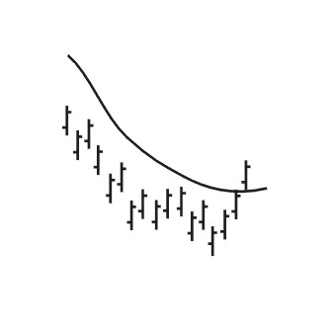

Trading Considerations
Moving averages are lagging indicators because they use historical information. Using them as indicators will not get you in at the bottom and out at the top but will get you in and out somewhere in between.
They work best in trending price patterns, where an uptrend or downtrend is firmly in place.
In trending markets, moving averages can provide a very simple and effective method of identifying trends.
Moving averages also act as support areas. You will often see a stock in an uptrend rise well above its 21 day moving average, return to it and then rise again.
Moving averages also act as resistance areas. When a stock trades under a moving average, that average will serve as a resistance price and it will be difficult for the stock to move above it. This is often very true when a stock has fallen below its 200 day moving average.

Double Moving Average Crossover:

Description
A moving average is an indicator that shows the average value of a security's price over a period of time. This type of Technical Event® occurs when a shorter and longer moving average cross each other. The supported crossovers are 21 crossing 50 (a short term signal) and 50 crossing 200 (a long term signal).
A bullish signal is generated when the shorter moving average crosses above the longer moving average. A bearish signal is generated when the shorter moving average crosses below the longer moving average.
These events are based on simple moving averages. A simple moving average is one where equal weight is given to each price over the calculation period. For example, a 21-day simple moving average is calculated by taking the sum of the last 21 days of a stock's close price and then dividing by 21. Other types of moving averages, which are not supported here, are weighted averages and exponentially smoothed averages.
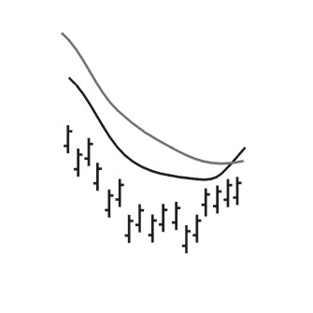

Trading Considerations
Moving averages are lagging indicators because they use historical information. Using them as indicators will not get you in at the bottom and out at the top but will get you in and out somewhere in between.
They work best in trending price patterns, where an uptrend or downtrend is firmly in place.
Using a crossover moving average as an indicator is considered to be superior to the simple moving average because there are two smoothed series of prices which reduces the number of false signals.

EDU COMPUTERS:
EDU computers is an IT industries script with the lot size of 75

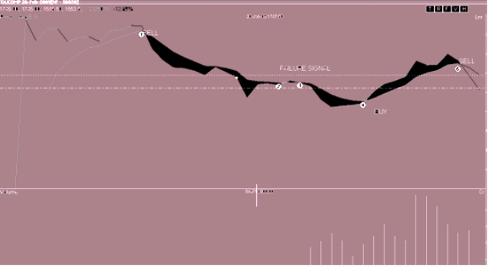

The future prices at SELL and BULL Signals:

CASE1:
The price at sell signal 2440
The price at buy signal 1663

Profit = selling price – buying price

= 2440 – 1663
=777

Now,
the total profit = Lot size * Profit
= 75 * 777

TOTAL PROFIT=58275

CASE2:
The price at sell signal 1665
The price at buy signal 1663

Profit = selling price – buying price

= 1665-1663
=2
Now,
the total profit = Lot size * Profit
= 75 * 2
TOTAL PROFIT=150

CASE3
The price at sell signal 1665
The price at buy signal 1374

Profit = selling price – buying price

= 1665 - 1374
=291
Now,
the total profit = Lot size * Profit
= 75 * 291
TOTAL PROFIT=21825

CASE4
The price at sell signal 1945
The price at buy signal 1374

Profit = selling price – buying price

= 1945 - 1374
=571
Now,
the total profit = Lot size * Profit
= 75 * 571
TOTAL PROFIT=42825

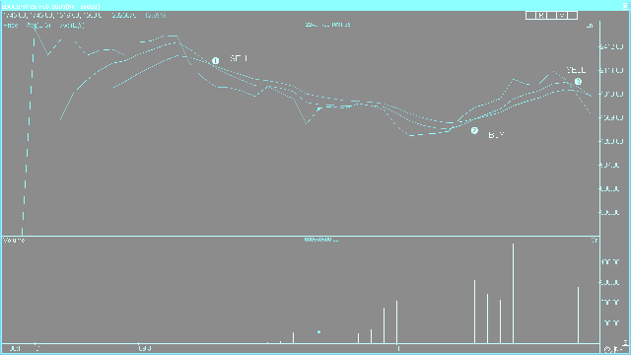

The future prices at SELL and BULL Signals:
CASE1:
The price at sell signal 2184
The price at buy signal 1499

Profit = selling price – buying price

= 2184 - 1499
=685
Now,
the total profit = Lot size * Profit
= 75 * 685
TOTAL PROFIT=51375

CASE2:
The price at sell signal 1795
The price at buy signal 1499

Profit = selling price – buying price

= 1795 - 1499
=296
Now,
the total profit = Lot size * Profit
= 75 * 296
TOTAL PROFIT=22200

CONCLUSIONS

- Derivatives market is an innovation to cash market. Approximately its daily turnover reaches to the equal stage of cash market. The average daily turnover of the NSE derivative segments

- In cash market the profit/loss of the investor depend the market price of the underlying asset. The investor may incur Hugh profit ts or he may incur Hugh loss. But in derivatives segment the investor enjoys Hugh profits with limited downside.

- In cash market the investor has to pay the total money, but in derivatives the investor has to pay premiums or margins, which are some percentage of total money.

- Derivatives are mostly used for hedging purpose.

- In derivative segment the profit/loss of the option writer is purely depend on the fluctuations of the underlying asset.

SUGGESTIONS
- In bullish market the call option writer incurs more losses so the investor is suggested to go for a call option to hold, where as the put option holder suffers in a bullish market, so he is suggested to write a put option.
- In bearish market the call option holder will incur more losses so the investor is suggested to go for a call option to write, where as the put option writer will get more losses, so he is suggested to hold a put option.
- In the above analysis the market price of ONGC is having low volatility, so the call option writer enjoys more profits to holders.
- The derivative market is newly started in India and it is not known by every investor, so SEBI has to take steps to create awareness among the investors about the derivative segment.
- In order to increase the derivatives market in India, SEBI should revise some of their regulations like contract size, participation of FII in the derivatives market.
- Contract size should be minimized because small investors cannot afford this much of huge premiums.
- SEBI has to take further steps in the risk management mechanism.
- SEBI has to take measures to use effectively the derivatives segment as a tool of hedging.

BIBLIOGRAPHY

- BOOKS :-

- Derivatives Dealers Module Work Book - NCFM
- Financial Market and Services - Gordan & Natrajan
- Financial Management - PRASANNA CHANDRA

  - NEWS PAPERS :-

    - Economic times
    - Times of India
    - Business Standard

- MAGAZINES :-

  - Business Today
  - Business world
  - Business India

- WEBSITES :-

- www.derivativesindia.com
- www.indianinfoline.com
- www.nseindia.com
- www.bseindia.com
- www.sebi.gov.in
- www.google.com(Derivatives market)

MARKET WATCH WINDOWS

BLUE COLOUR INDICATE SHARE VALUE INCREASE
RED COLOUR INDICATE SHARE VALUE DECREASE

NSE Scrip’s

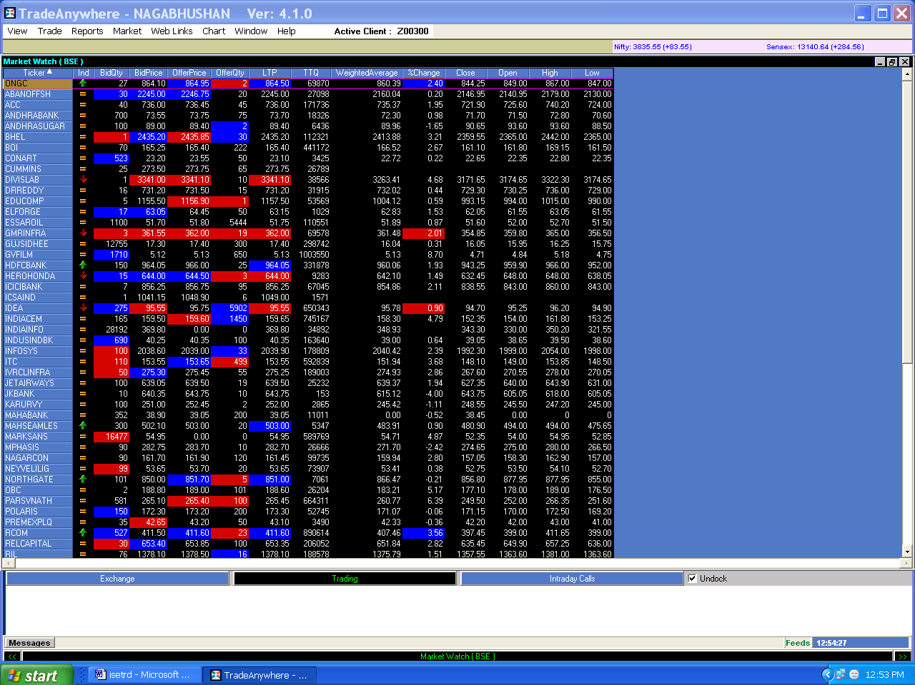

Figure 7.1

NSE & BSE Scrip’s

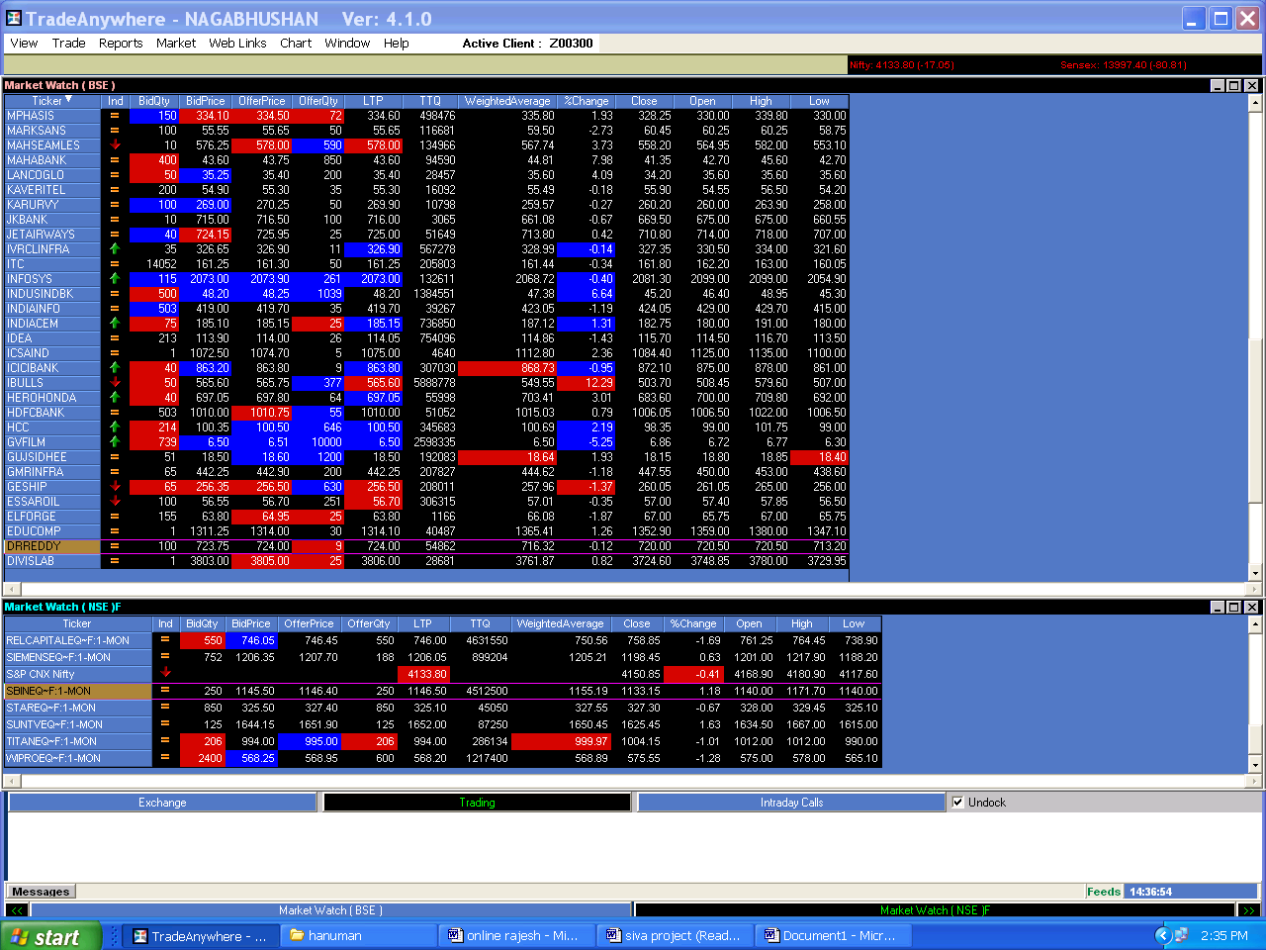

Figure 7.2

Buy order form

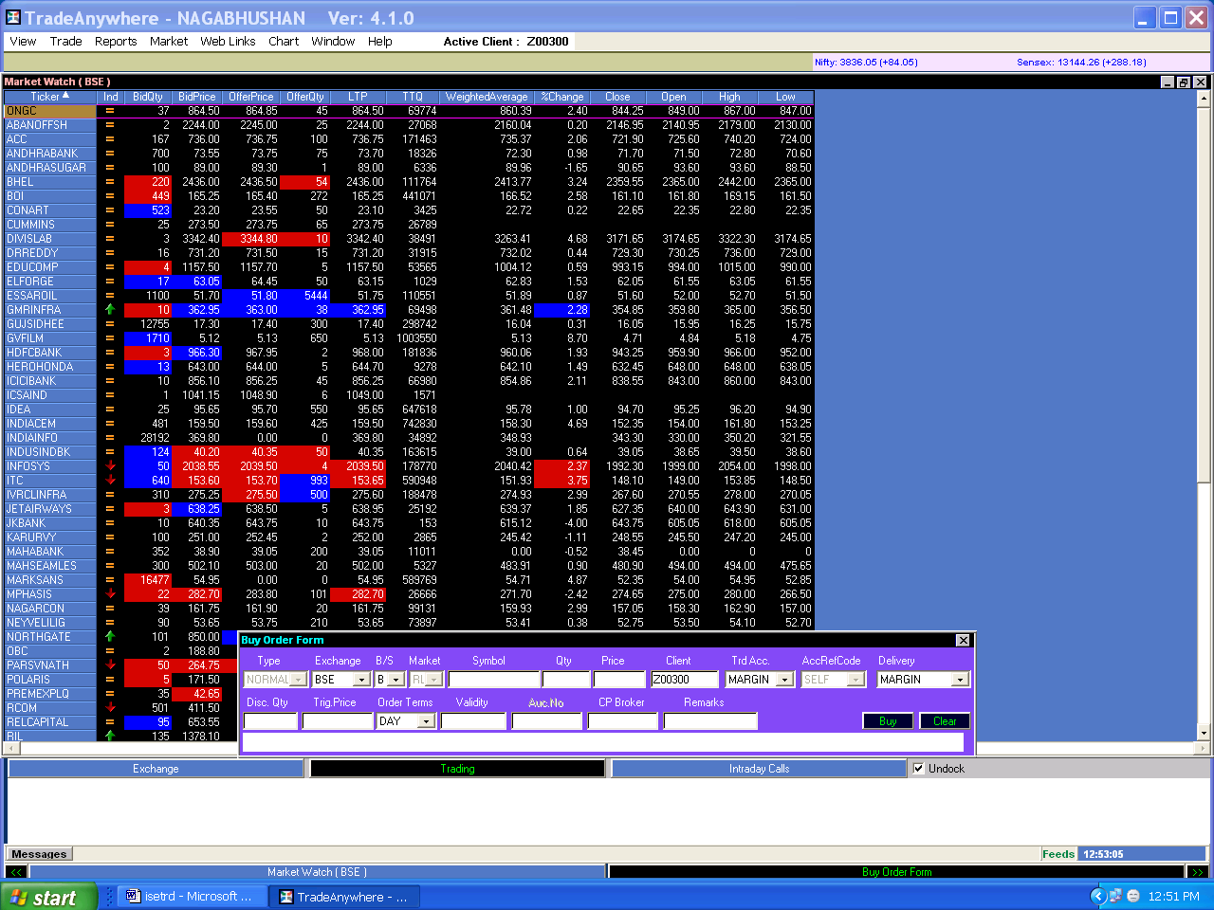

Figure 7.3

Sell order form

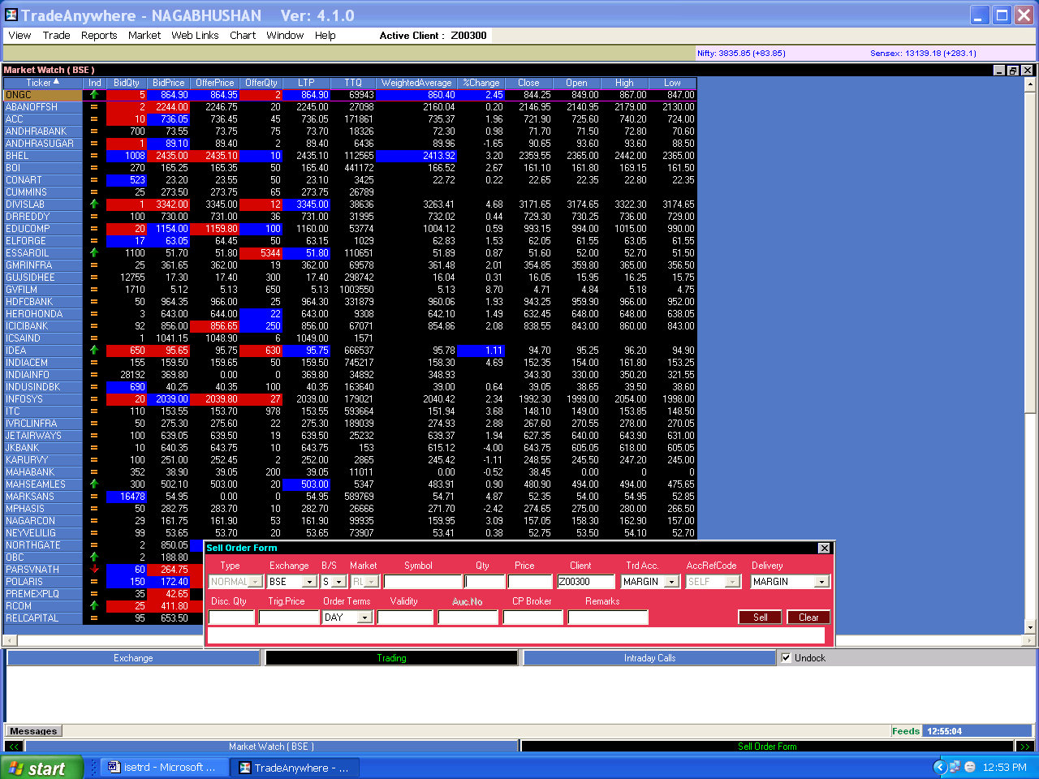

Figure 7.4

Market depth

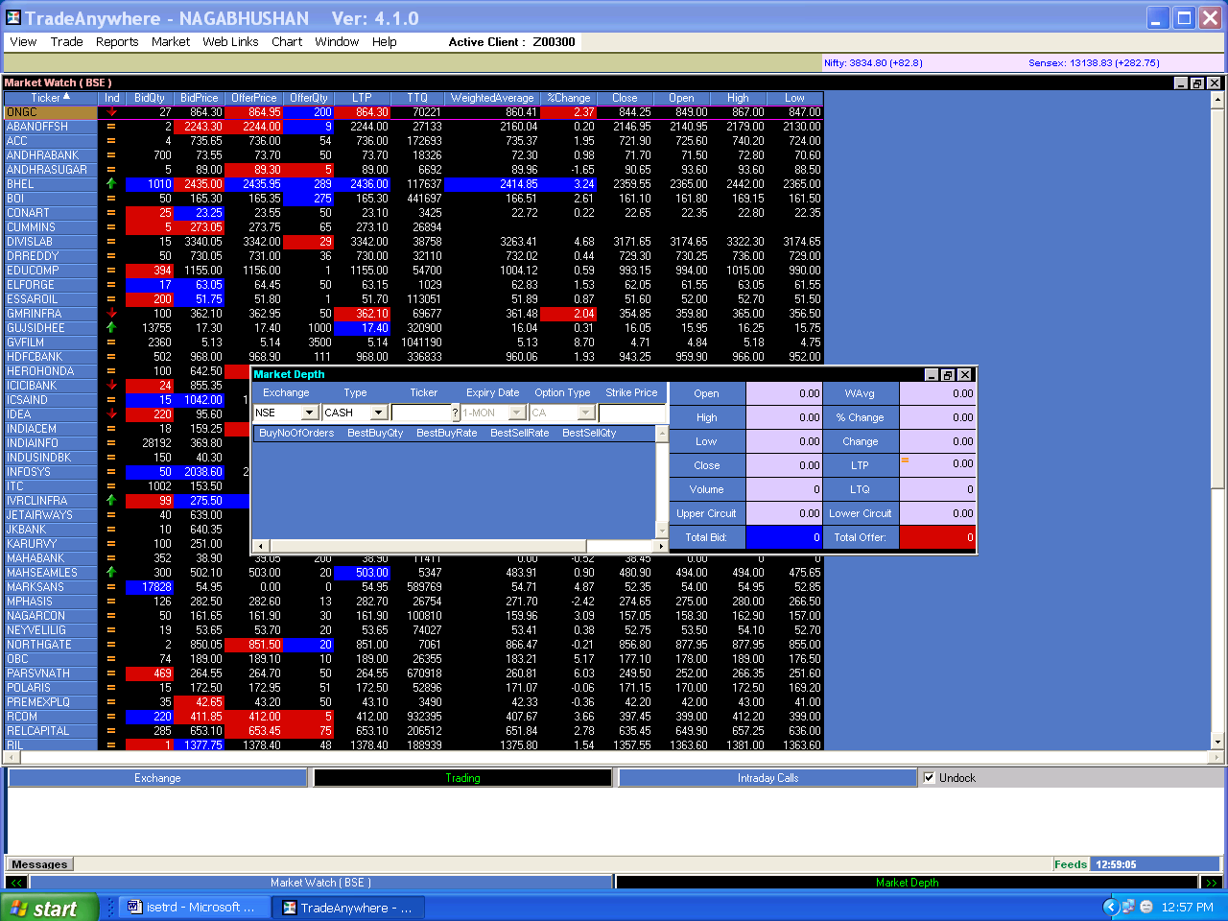

Figure 7.5

TRADE BOOK

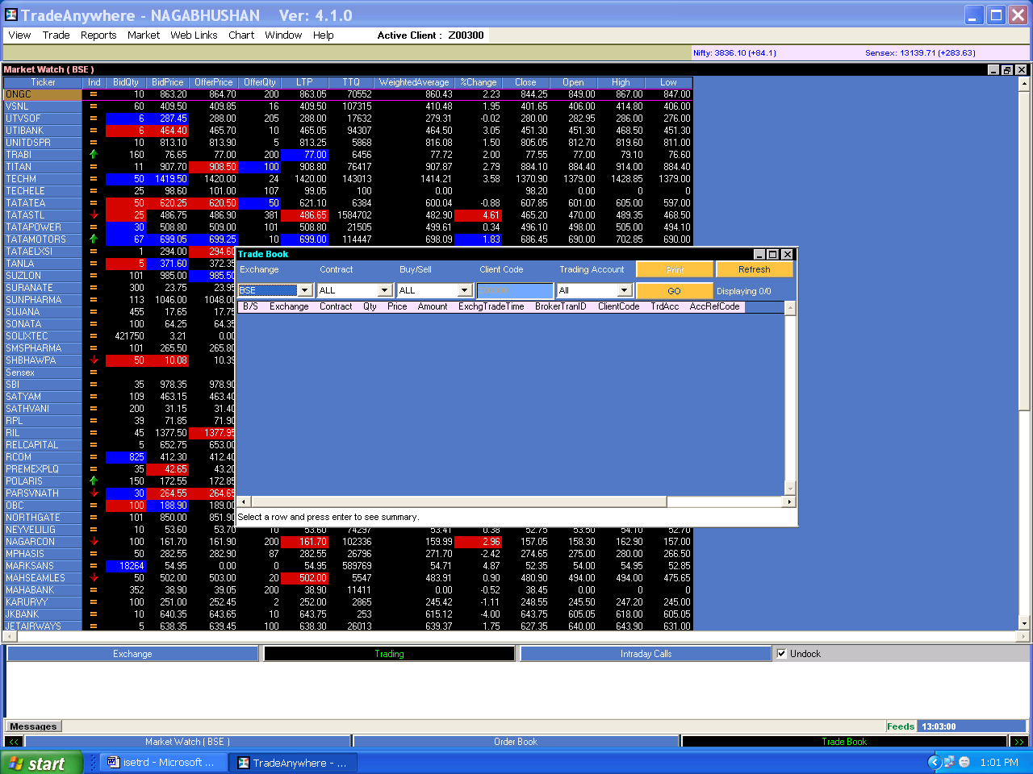

Figure 7.6

Client Margin

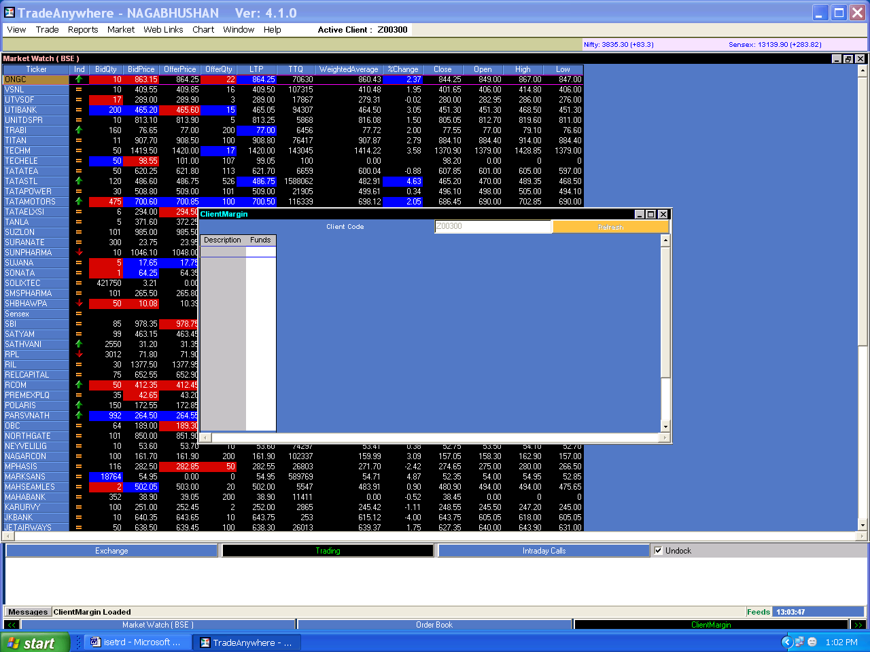

Figure 7.7

ORDER Book

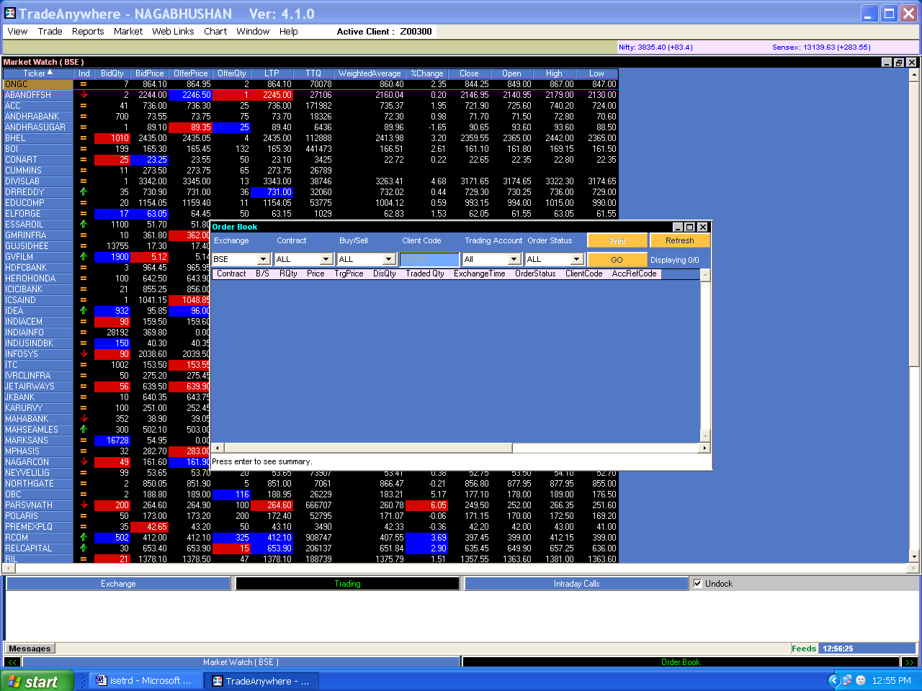

Figure 7.8

Client Activity Report

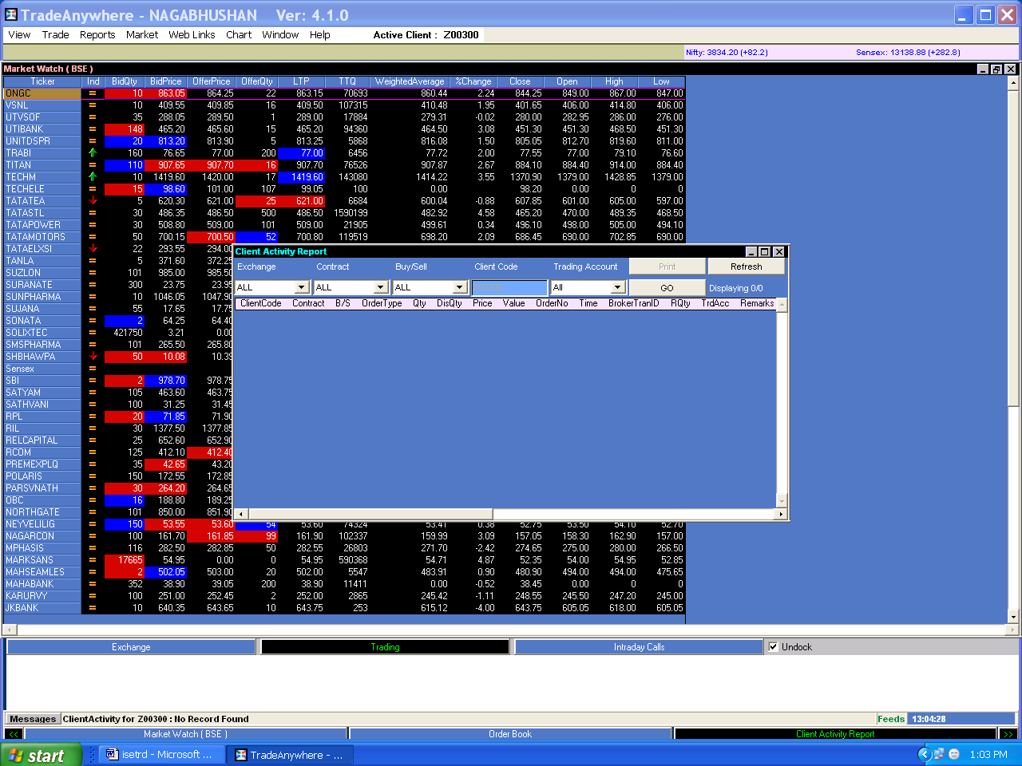

Figure 7.9

Message Report

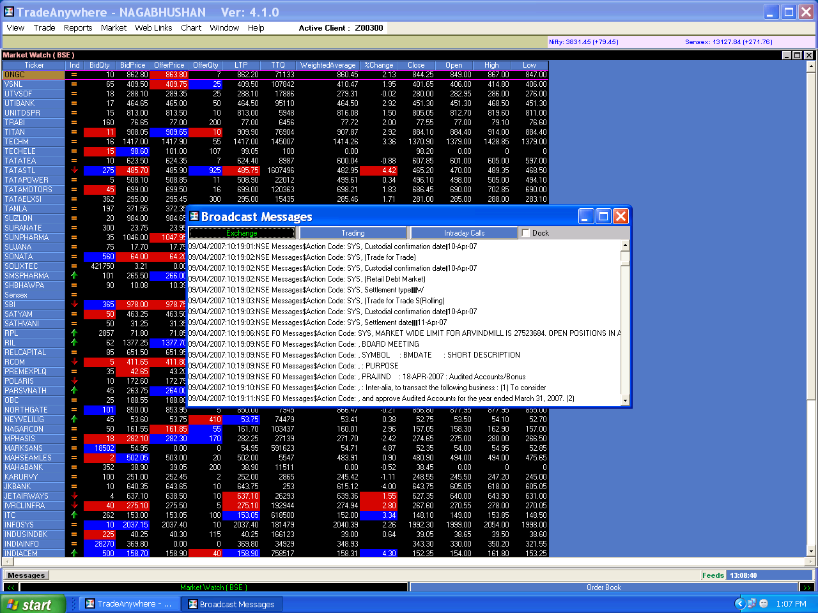

Figure 7.10

Exercise Report

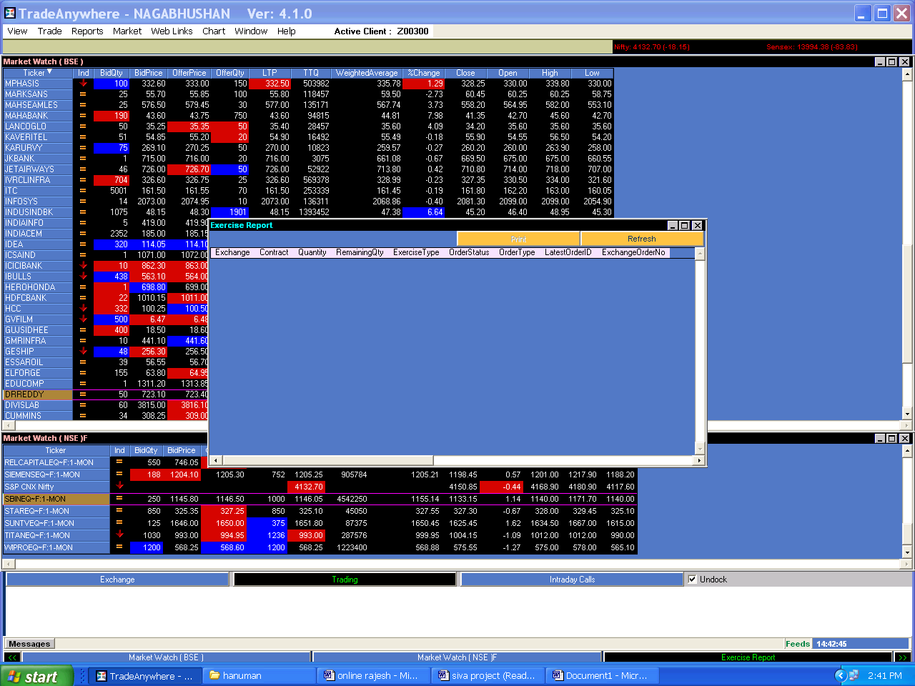

Figure 7.11

Trading Scrip’s in dialogue box

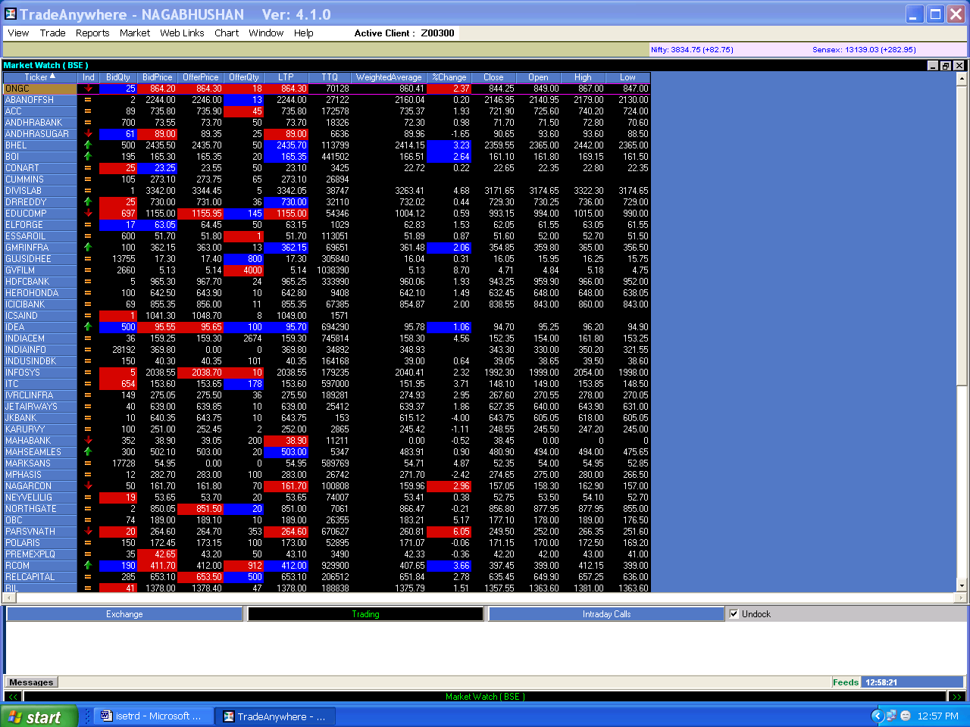

Figure 7.12

List of Abbreviations

BSE Bombay Stock Exchange
NSE National Stock Exchange
ISE Inter-connected Stock Exchange
ABC Additional Base Capital
BMC Base Minimum Capital
NSDL National Securities Depository Ltd.
CDSL Central Depositories Services Ltd.
CM Capital Market
Co. Company
DCA Department of Company Affairs
DEA Department of Economic Affairs
DP Depository Participant
DPG Dominant Promoter Group
DQ Disclosed Quantity
DvP Delivery versus Payment
FI Financial Institution
FII Foreign Institutional Investors
F&O Futures and Options
FTP File Transfer Protocol
IOC Immediate or Cancel
IPF Investor Protection Fund
ISIN International Securities Identification Number
LTP Last Trade Price
MBP Market by Price
MTM Mark to Market
NSCCL National Securities Clearing Corporation Limited
OTC Over the Counter
NEAT National Exchange for Automated Trading
NCFM NSE's Certification in Financial Markets
RBI Reserve Bank of India
RDM Retail Debt Market
SAT Securities Appellate Tribunal
SBTS Screen Based Trading System
SC(R)A Securities Contracts (Regulation) Act, 1956
SC(R)R Securities Contracts (Regulation) Rules, 1957
SEBI Securities and Exchange Board of India
SGF Settlement Guarantee Fund
SRO Self Regulatory Organization
T+2 Second day from the trading day
TM Trading Member
UTI Unit Trust of India
VaR Value at Risk
VSAT Very Small Aperture Terminal
WDM Wholesale Debt Market

