CONTENTS
CHAPTER NO. | TITLE | PAGE NO.
1. | INTRODUCTION | 1-15
2. | RESEARCH DESIGN OF THE STUDY | 16-19
3. | COMPANY PROFILE
 | - INDUSTRY PROFILE | 21-23
 | - PRODUCT PROFILE | 24-42
4. | ANALYSIS AND INTERPRETATION | 43-62
5. | FINDINGS, SUGGESTIONS AND SOLUTIONS | 63-66
6. | ANNEXURE | 67-72
7. | BIBLIOGRAPHY | 73-74

CHAPTER-1

INTRODUCTION

INTRODUCTION TO WORKING CAPITAL
MEANING
Working capital is the difference between current assets and current liabilities. The term current assets refer to those assets which ordinary course of business can be turned into cash within one year without order going a diminution in value and without disrupting the operation of the firm.
DEFINITION
Working capital is commonly defined in accounting and financial analysis as “net current assets consisting of inventories, including goods, net receivables, marketable securities, bank balances and cash in hand”.
WORKING CAPITAL MANAGEMENT
Working capital is needed for the smooth conduct of day to day business activities. It is needed to finance the current assets of the firm. The working capital should neither be in excess nor should it be inadequate. Excessive investment in current assets would have a negative impact of the firm’s profitability because of idle investment on the hand, inadequate working capital would lead to inability to meet the current obligations which would hamper the firm’s creditability and there by its reputation.
Usually the current assets are maintained at twice the level of the current liabilities i.e. the current assets ratio is 2:1.

CONCEPTS OF WORKING CAPITAL
- From the point of view of concept
- Net working capital
- Gross working capital
- From the point of view of time
- Permanent working capital
- Temporary working capital

ON THE BASIS CONCEPT
NET WORKING CAPITAL
This is the difference between current assets and current liabilities. Current liabilities are those that are expected to mature within on accounting year and include creditors, bills payable and outstanding express.
An investment in current assets represents a very significant portion of the total investment in assets.
The working capital needs increase as the firm’s grow as sales grow; the firm needs to invest more in debtors and inventories.
GROSS WORKING CAPITAL
Gross working capital refers to the firm’s investment in current assets. Current assets are the assets which can be converted into cash within a short period say, an accounting year. Current assets include cash, debtors, bills, receivables, short term securities etc.
It is equal to the total sum of the current assets and may represent both owned capital and loan capital.

ON THE BASIS OF TIME
PERMANENT WORKING CAPITAL
Permanent working capital is permanently locked up in the circulations of current assets. It covers the minimum amount requested for maintaining the circulation of current assets.
1. INITIAL WORKING CAPITAL
At its inception and during the formative period of funds to meet its obligations. The need for initial working capital is for every company to consolidate its position.
2. REGULAR WORKING CAPITAL
It refers to the medium amount of liquid capital required to keep up the circulation of the capital from the cash inventories to accounts receivable and from accounts receivable to back again cash.
VARIABLE WORKING CAPITAL
It refers to the past of the working capital which changes with the volume of business, it may be divided into two classes.

1. SEASONAL WORKING CAPITAL
There are many lines of business where the volume of operations is different and hence the amount of working capital varies with the seasons. The capital required to meet the seasonal working capital.

2. SPECIAL WORKING CAPITAL
The capital required to meet any special operations such as experiments with new products or new technique of production and making interior advertising campaign etc are also known as special working capital.

DETERMINANTS OF WORKING CAPITAL
1. NATURE OF BUSINESS
The nature of the business effects the working capital requirements to a great extent. For instance public utilities like railways, electric companies, etc need very little working capital because they need not hold large inventories and their operations are mostly on cash basis, but in case of manufacturing firms and trading firms, the requirements of working capital is sufficiently large as they have to invest substantially in inventories and accounts receivables.
2. PRODUCTION POLICIES
The production policies also determine the working capital requirement. Through the production schedule i.e. the plan for production, production process etc. The KS & DL has big production process.
3. CREDIT POLICY
The credit policy to sales and purchase also affects the working capital. The credit policy influences the requirements of working capital in two ways. The credit terms granted to customers have a bearing on the magnitude of working capital determining the level of book debt. The credit sale results is higher book debt (re available) higher book debt means more working capital.
On the other hand, if liberal credit terms are available from the suppliers of goods [trade or], the need for working capital is less. The working capital requirement of business is thus affected by the terms of purchase and sales and role given to credit by a company by in its dealing with Cr and Dr.

4. INVENTORY POLICY
The inventory policy of a ks & dl also has impact on the working capital requirements. Since a large amount of funds is normally locked up in inventories. An efficient firm may stock raw material for a smaller period and may, therefore, require lesser amount of working capital.

5. MARKET CONDITIONS
Working capital requirements are also affected by market conditions like degree of competition. Large inventory is essential as delivery has to be off the shells of credit has to be extended on liberal terry when competitions is fierce or market is not very strong or is a buyer’s market.
6. CONDITION OF SUPPLY
If prompt and adequate supply of raw materials. Spares, stores, etc. is available it is possible to manage with small investment in inventory or work on just in time inventories principles. However if supply is erratic, scant, seasonal, canalized through Govt. agencies etc. it is essential to keep larger stocks increasing working capital requirements.
7. BUSINESS CYCLE
Business fluctuation leads to cyclical and seasonal changes in production and affect the working capital requirements.
8. GROWTH AND EXPANSION
The growth in volume and growth in working capital go hand in hand, however, the change may not be proportionate and the increased need for working capital is felt right from the initial stages of growth.
9. DIVIDEND POLICY
Payment of dividend utilizes cash while retaining profits acts as a source as W.C. Thus working capital gets affected by dividends policies. The Bemul follows a liberal dividends policy will require more W.C than co. that follows strict dividends policy.
10. PROFIT LEVEL
Profit level also affects the working capital requirements as a concern higher profit margin results in higher generation of internal sands and more contributing to working capital.

SOURCES OF WORKING CAPITAL
SOURCES OF WORKING CAPITAL

SHORT TERM SOURCES
LONG TERM SOURCES

TRADE CREDIT
BANK CREDIT
CREDIT PAPER
CUSTOMER CREDIT
DEPRECIATION FUNDS
PROVISION FOR TAXATION
ACCRUED EXPENSES
EXTERNAL
INTERNAL
ISSUE OF SHARES
ISSUE OF DEBENTURES
RETAINED PROFIT
RESERVES AND SURPLUS
LONG TERM LOAN
ARRANGEMENT OF WORKING CAPITAL

The trade credit and cash creditors are two primary sources of working capital in India. Bank loan and trade creditors’ together for finance about 75% of working capital credit requirements of industry. The bankers after granting of the loans and applications on the suggested by reserve bank of India determine the maximum line of credit permissible for the period based on the margin requirement of the security offered. After getting the overall credit limit sanctioned by the banker the company actually draws the funds needed from time to time using all or any of the following forms of credit.
LOAN ARRANGEMENT

The entire amount of loan is credited by the bank to the people account. Interest is payable on the entire amount or when loan is repaid in installments on the actual balance of outstanding.
OVERDRAFT ARRANGEMENT

The party is permitted to over draft on his current account with his banker up to a specified amount and during specified repayments is permitted.
CASH CREDIT ARRANGEMENT

The borrower is allowed to withdraw funds from the bank up to the sanctioned credit once rather he can draw periodically to the extent of his requirements and repay by depositing surplus funds in his cash credit amount.
TERM LOAN FOR WORKING ARRANGEMENT

Under this arrangement borrower can obtain a loan for appeared three to five year and the said amount in nearly or half yearly installments.

BILL PURCHASED AND BILL DISCOUNTED
Bills are purchased by banker and advance bills are discounted whether bills are purchased as discounted the amount need available under this arrangement is covered by cash and over draft element. In obtaining commercial bank credit the various modes of security are such as.
HYPOTHECATION

Under hypothecation money is borrowed by owner of goods on the security of movable property (normal inventories) without parting with the possession of movable property. The right of the hypothecation depends upon the term of the contract between parties.

OPERATING CYCLES OF WORKING CAPITAL

It is essential that the operating cycle should be kept up continuously. Other the fixed assets will remain idle and to the cost without bringing any reserve. So long with fixed capital ready and adequate working capital is necessary to get the understanding successful on a sound pedestal.

IMPORTANCE OF WORKING CAPITAL
Adequate working capital creates certainty, security, and confidence in the minds of the persons in the management as well as in the minds of creditors and workers. It creates a good credit standing for the firm because credit standing depends upon the ability to pay promptly. A company with adequate working capital is always able to meet current abilities.
- It ensures solvency and stability of the enterprises it also ensures continuity in production and sales.
- It enables and company to take advantage of cash discount offered by the suppliers of raw materials or merchandise.
- It enhances the prestige of the company and moral of its workers because a company with adequate working capital is always able to pay wages and salaries promptly and regularly.
- It enables the company to procure loans from banks on easy competitive terms.
- In times of boom, it enables the company to meet increasing demands for its products.
- In times of depression the company to overcome the crisis successfully.
- It enables the company to carry on its business successfully and continued progress and prospective.
- It enables the company to carry on its business successfully and active continued progress and prosperity.

TECHNIQUES OF WORKING CAPITAL MANAGEMENT
Working capital management involves deciding upon the amount and compositions of current assets and how to finance the assets. These decisions involve tradeoff between risk and profitability.
Working capital balances are measured from the financial data of the company’s balance sheet. A study of the cause of changes of working capital that take place in the balance from time to time is necessary. These changes can be measured in rupee amounts and also in percentage by comparing current assets, current liabilities and working capital over the given period.
The important tools of working capital are;
- Ratio analysis of working capital
- Funds flow analysis of working capital
- Working capital budget
- Trend analysis.
1. RATIO ANALYSIS OF WORKING CAPITAL

The ratio of working capital can be used by management as a means checking upon the efficiency with which working capital is being in the enterprise. The important ratios of working capital management are:
A .TURN OVER OF WORKING CAPITAL RATIO

It can be calculated as net sales divided by average net working capital. The turnover of net working capital ratio measures the rate of working capital utilization. The ratio shows how many times working capital turns over in trading transactions.
Net sales
Formula: Turnover working capital = ----------------------------
Net working capital
B .CURRENT RATIO
Current assets
Formula: Current ration = ---------------------------
Current liabilities
It can be calculated as current asset divided by current liabilities. The current ratio measures the relative ability of a company to pay its short terms debt. The ratio is used to reveal how well a company could meet a sudden demand to pay off its short term creditors.

C . CURRENT DEBT TO TANGIBLE NET WORTH
It can be calculated as current liabilities divided by tangible net worth. The ratio of current liabilities to tangible net worth shows how much capital used in the enterprises has been provided by the short creditors and how much by the owners.
Current liabilities
Formula: Current debt tangible network= --------------------------------
Total net worth

D. QUICK RATIO(ACID TEST RATIO)

Quick ratio can be calculated as quick assets divided by current liabilities. Quick ratio establishes relationship between quick or liquid assets and current liabilities and asset is liquid or quick if it can be converted into cash immediately or reasonably soon without a loss of value.

Quick assets
Formula: Quick ratio= ------------------------------------
Current liabilities

E .INVENTORY TURNOVER RATIO

Turnover ratio can be calculated at cost of goods sold by average inventory. It shows the number of times the stock in trade is turned over in business during a period. This ratio may be used to arise stock utilization and efficiency of the firm in selling its products.
Cost of goods sold
Formula: Inventory turnover ratio= -------------------------------------
Average inventory

F .DEBTORS TURNOVER RATIO

It can be calculated as sales divided by debtors. Debtor’s turnover indicates the number of times the debtors are turnover during a year.
Sales
Formula: Debtors turnover= ----------------------
Debtors

2. FUNDFLOW ANALYSIS OF WORKING CAPITAL
- How it was possible to distribute divided in excess of current earning and in the present of a net loss for the period.
- How was the expansion in equipment, plant and machinery financed?
- What happened to the proceeds of sales and plant equipment?
- How was the retirement of department accomplished?

What becomes to the process of share issue or. It is an effective management tool to study how funds have been procured for a business and how they have been employed. This technique helps to analyze changes in working capital components between two data. The comparison of current assets and current liabilities, at the beginning and at the end of specific period shows changes in such type of current assets and resources from which working capital has been obtained. Funds flow statement contributes materially to the financial aspects of the answers to such questions.
- Why the net current were down through the net income was upon vice versa.
- Debenture issue.
- How was the increase in working capital financed?

3. WORKING CAPITAL BUDGET
The working capital budget is an important phase of overall financing budgeting. This budget should be distinguished from a cash budget. That is designed to measure all the financial requirements of a business including funds for fixed assets, repayments of a business including funds for fixed assets, repayment of loans, and similar items on the other hand working capital assures that they are duly provided for. The objectives are to secure an effective utilization of investment.

4. TREND ANALYSIS
A trend analysis includes the changes which have been taking place from time to time an individual item of current assets. Current liabilities and net working capital on the basis of some standard year and its effect on working capital portion. It enables to evaluate the upward and downward trend of current assets and current liabilities. These are usually measured from review of the comparative balance sheets of a concern at the end of the accounting years and results are drawn on the basis of trend shown by time.

CASH MANAGEMENT STRATEGIES
- The strategic that should be the enterprise in managing its cash are as follows.
- Pay accounts payable as much as possible on time without demanding the firm’s credit rating but take advantage of any favorable cash discounts.
- Turnover the inventory as quickly as possible, avoiding stock out that might result in shutting down the production line or result in a loss of sale.
- Collect accounts receivables as early as possible without losing future sales because of high pressure collection techniques. Cash discounts if they are economically justified may be used to accomplish this objective.
OBJECTIVES OF KEEPING CASH BALANCE
- The following are the general objectives for keeping cash balance in every firm.
- For meeting daily obligation.
- To take benefits of favorable market condition.
- To meet contingencies
- To secure cash discount from suppliers.
WHAT IS CASH?
The term cash with reference to cash management is used in two sense in a narrow sense it include, coins, currency notes, cheque, bank draft held by a firm with it and the demand deposit held by it in bank. In broader sense it also include near cash assets such as marketable securities and time deposit with banks such deposit can immediately be sold or converted into cash if the circumstances so require the term cash management is generally used for management of both cash and near current assets.

FACTS OF CASH MANAGEMENT
1. CASH PLANNING
It is a technique to plan and control the use of cash it protects the financial condition of the firm by developing projected cash statement from forecasting of expected cash inflows and out flows for a given period the forecasts may be used on the present operation or the anticipated future operations cash planning is very crucial in developing the overall operating plans of the firm.
2. CONTROLLING THE LEVEL OF CASH BALANCES
As one of the basic objectives of cash management is to minimize the level of cash balance, controlling the level of cash balance does not mean just minimizing the level of cash balance within the firm it means neither ensuring that the level of cash balance is neither excessive not inadequate .(i.e. optimum).
B .OPTIMUM CASH LEVEL
Company must decide about the appropriation level of cash balances to be maintained. Both the cost of excess cash and danger of cash deficiency have to be matched to arrive at optimum level of cash balance.
C .INVESTMENT SURPLUS CASH
All surplus cash has been properly invested so as to earn profit the company has to decide about the division of such cash balance borrowed from bank deposit, marketable securities on inter corporate loan.
An idea cash management system depends on the company’s product, organization structure, culture and option available.

PRINCIPLES OF WORKING CAPITAL MANAGEMENT
1. PRINCIPLE OF RISK VARIATION
“Risk” here refers to the inability of the firm to meet its obligation as and when they become due for payment. Larger investments in current assets less dependence on short term borrowings increase liquidity, reduce risk and thereby decrease the opportunity for gain on the other hand, less investment in current with great dependence on short term borrowings increase risk reduces liquidity and increases profitability. However the goal of the management should be to establish a suitable trade of between profitability and risk.
2 .PRINCIPLE OF COST OF CAPITAL
The various sources raising working capital finance has different source of capital and the degree of risk involved. Generally, higher the risk lowers is he cost, and lower the risk higher is the cost. A sound working capital management should always be maintained to achieve a proper balance between these two.
3. PRINCIPLE OF EQUITY POSITION
This principle is concerned with planning the total investment is current assets. According to this principle, the amount of working capital invested in each component should be adequately justified by firm’s equity position. Every rupee invested should contribute to the net worth of the firm.
4. PRINCIPLE OF MATURITY OF PAYMENT
This principle is concerned with planning the source of finance for working capital. According to this principle, a firm should make every effect to relate maturities of payment to its flow of internally generated funds.
NEED FOR WORKING CAPITAL MANAGEMENT
The need for working capital (gross) or current assets can’t be overemphasized the main objective of financial decision-making is to maximize the share holders wealth to achieve this it is necessary to generate sufficient profit. The extent of which profits can be earned will naturally depend upon the magnitude of sales, among the other things a successful sales programmed instantly there is invariability a time lag between the sales of goods and the receipt of cash there is therefore, a need for different form of current assets to deal with the problem arising out of the lack of immediate realization of cash against goods sold. Therefore sufficient working capital is necessary to keep the containing flow for the length of time necessary to complete the following events.

a. Conversion of cash into inventory
b. Conversion of inventory into receivables
c. Conversion of receivable to cash
If it were possible to complete the sequence instantaneously, there would no need for current assets but since it is not possible the firm is forced to have current assets; since cash inflow and cash out flow do not match, firms have to necessarily keep cash or invest in short time liquid securities so that they will be in a position to meet obligation when they become due. Similarly firms must have adequate inventory to against the possibility of not being able to meet demand for their products adequate inventory, therefore, provides a cushion against being out of stock. If firms to be competitive, they must sell goods to their customers on credit which is necessitates the holdings of accounts receivable. It is in these ways that an adequate level of working capital is absolutely necessary for smooth sales activity in turn enhance the owners wealth.

PREPARATION OF CASH REPORTS
The preparation of cash budget sets the frame work for management of cash flows and cannot be considered as a financial act in cash management process. The operation of the business enterprise may often deviate from the planned course with immediate changes in cash requirement exercise. The preparation of cash budget is relatively smooth exercise for controlling the cash inflows effectively the crux of effective cash management lies in synchronizing the cash flows this can be achieved by preparing periodical cash reports. The cash budget is the planning or forecasting instrument where as cash reports help in comparing the actual cash flow with projected cash flow. This helps in financial exercise which determines the future cash needs and plan financing of these needs and control over cash and liquidity of the firm.

CHAPTER-2

RESEARCH DESIGN

RESEARCH DESIGN

INTRODUCTION
Every business needs adequate liquid resources in order to maintain day-yo-day cash flow. It needs enough cash to pay wages and salaries as they fall due and to pay creditors if it is to keep its workforce and ensure its supplies.
Maintaining adequate working capital is not just important in the short-term. Sufficient liquidity must be maintained in order to ensure the survival of the business in the long-term as well.
Even a profitable business may fail if it does not have adequate cash flow to meet its liabilities as they fall due. Therefore, when business make investment decisions they must not only consider the financial outlay involved with acquiring the new machine or the new building, etc, but must also take account of the additional current assets that are usually involved with any expansion of activity.

TITLE OF THE STUDY
“A STUDY ON WORKING CAPITAL MANAGEMENT WITH SPECIAL REFERENCE TO KARNATAKA SOAPS AND DETERGENTS LIMITED (KS & DL)”.

OBJECTIVES OF THE STUDY:
The primary objectives for taking up this study is to learn financial matters at KS & DL pragmatically.
- To have a brief account of operation and position of KS & DL.
- To know the business policies, systems and procedures followed to manage working capital at KS & DL.
- To know what role of working capital is managed at KD & DL and to know working capital has contributed to the profit & loss of the company.
- To prepare the management of inventories, account receivables and cash in KS & DL.
- To study the management of inventories, account receivables and cash in KS&DL.
- To suggest some work instructions regarding the defect in the working found if any.
- To study the ratio analysis of KS&DL.

SCOPE OF THE STUDY
The project contains the profile of the company i.e. KS&DL where the project work was undertaken. It contains details regarding how working capital is managed at KS&DL. It also provides details regarding cash, receivables and inventory management at KS&DL.
This study gives the information about financial aspects of KS&DL from to 2007 to 2012.This study was done in the time duration of 4 weeks from the information provided by concerned officials of KS&DL.

PERIOD OF STUDY
The research was done in the company i.e. KS&DL for approximately 4 weeks
SOURCES OF THE STUDY
SECONDARY DATA
The secondary data has been collected from various published sources like journals, magazines etc. It is also obtained from published sources like annual reports, company profile, books of accounts, other relevant textbook etc.
METHODOLOGY OF DATA COLLECTION:
The chief criteria for the validity of any research study lies in its methodology. An enquiry would prove a failure if it is not done along certain methodical lines.
The method of study adapted to carry out the project work is mainly through personal enquiry with the Account’s manager. The study comprises of the company’s operations and the techniques followed by them.
The data extracted from the annual reports of the company was analyzed and further reduced to tables. To make it pictorial and easier to grasp and understand the data was represented in graphical forms.
This is the study entirely based on:
- Personal discussion.
- Annual reports of K.S.D.L.
- Published sources.
- Simple statistical analyses.

LIMITATIONS
- Study of working capital management is limited to the information gathered through the enquiry and discussions with the company officials and executives.
- Ratio analysis is used for analysis, which has its own limitations.
- The study deals with the current assets particularly inventory, debtors, and cash. These techniques have their own limitations.
- The period of study was very less.
- Some important working capital ratios have been considered for analysis.
CHAPTER SCHEME
INTRODUCTION
This chapter gives a bird’s eye view of the project. It contains introduction for the finance, financial management and working capital management, meaning, features, types, sources, determinants of working capital management etc.,
RESEARCH DESIGN
This chapter contains the title of the study and deals with the methodology, sources of data, overview of the study problem of the study, objectives of the study, scope and limitations of the study.
COMPANY PROFILE
This chapter deals with profile of the company, departments, production process followed, products produced and profile of the industry etc.
DATA ANALYSIS AND INTERPRETATION
By using the ratio analysis applied to the data relating to working capital, which are taken from financial statements.
SUMMARY OF FINDINGS:
Recommendations and conclusions
This chapter deals with findings of the study and the conclusion is drawn based on the set objective.

CHAPTER-3

COMPANY PROFILE

INDUSTRY PROFILE
Soap is one of the commodities which have become an indispensable part of the life of modern world. Since it is non durable consumer goods, there is a large market for it. The whole soap industry is experiencing changes due to innumerable reasons such as government relations environment and energy problems increase in cost of raw material etc.

The changing technology and ever existing desire by the individual and the organization to produce a better product at a more economical rate has also acted as catalyst for the dynamic process of change.

More and more soap manufacturers are trying to capture a commanding market share by introducing and maintaining acceptable products. The soap industry in India faces a cut throat competition while multinational companies dominate the market. They are also facing severe threat from dynamic and enterprising new entrance especially during 1991-92.

If we look back into the history of soaps & detergents, mankind knew about soaps nearly 2000 years back i.e. in 70 A.D. When Mr. Elder accidentally discovered the soap, when roasted meat over flowed on the glow in ashes. This lump like product was soap & had foaming & cleansing character. In 1192 A.D. the first commercial batch of soaps was made & marketed by M/s Bristol soap market in London, from there in 1662 A.D. the first patent for making soap was taken in London. The world consumption of soap in 1884 A.D. was said to be 2 lakh tones p.a.

HISRORY OF THE SOAP:
Soap manufacturing was started in North America. Some American companies with well known names were stared 200 years ago. During middle age soap was made at various places in Italy, France, England & other countries. France became famous & many small factories were established there.

INDIAN SOAP INDUSTRY
Size of the industry | The Indian Soap Industry includes about 700 companies with combined annual revenue of about $ 17 billion.
Geographical distribution | All the major metropolitan cities.
Output per annum | Indian per capital consumption of soap is at 460gms per annum.
Market capitalization | 70% of Indian’s population resides in the rural areas and around 50% of the soaps are sold in the rural markets.
HISTORY
During the British rule the Lever Brothers, England introduced modern soap by importing and marketing them in the country. The first company created was North West Soap Company, the soap manufacturing plant in India situated in the city of Meerut, in the state of Uttar Pradesh. In 1897, they started marketing cold process soaps. In 1918, Mr. Jamshedji Tata set up India’s first indigenous soap manufacturing unit when he purchased the coconut oil Mills at Cochin Kerala. OK Mills crushed and marketed coconut oil for cooking and manufactured crude cold process laundry soaps that were sold locally and it was renamed The Tata Oil Mills Company and its first branded soaps appeared on the market in the early 1930’s.
Soap became a necessity for the moneyed class by around 1937. Today with increase in disposable incomes all around the world along with India, growth in rural demand is expected to increase because consumers are moving up towards premium products. However, in the recent past there has not been much change in the volume of premium soaps in proportion to economy soaps, this was due to the increase in price which has led some consumers to look for cheaper substitutes. The major players in the market for the personal wash (soap) market are HLL, Norma and P&G.
The toilet soaps market is estimated at 530,000 TPA including small imports where the Hindustan Lever is the market leader. The market has several, leading national and global brands and a large number of small brands. The popular brands include Lifebuoy, Lux, Cinthol, Liril, Rexona, and Nirma. Premium soaps are estimated to have a market volume of about 80,000 tones. This translates into a share of about 14 to 15%. However, by value it is as much as 30%.

BRIEF INTRODUCTION
Soaps are categorized into men’s soaps, ladies’ soaps and common soaps. There are few specialty soaps like the Glycerin soaps, sandal soaps, specially flavored soaps, medicated soaps and baby soaps. Specialty soaps are high valued which enjoy only a small share of the market in value terms. The market is growing at 7% a year. This means that the incremental demand generation is 5% over and above the population growth. With increasing awareness of hygienic standards, the market for the soaps could grow at a rate higher than 8% annually. Interestingly, 60% of the market is now sourced from the rural sector. This means that the variance between the two segments is not very large. Since upper-end market focus is the urban areas, margins come from the urban sector.
Soap is a product for many people and the lathering up can be a treasured part of a morning or nightly routine. Whether it might be scented or unscented, in bars, In the United States, soap is a 1.390 million (US$) industry with over 50 mass market brands. But in Indian markets the sales potential for soap is only beginning to be realized. At the end of the year 2000, soap was a $1.032 million (US$) business in India.
India is a country with a population of 1,030 million people. With the household penetration of soaps is 98%. People belonging to different income levels use different brands, which fall under different segments, but all income levels use soaps, making it the second largest category in India. Rural consumers in India constitute 70% of the population. Rural demand is growing, with more and more soap brands being launched in the discount segment targeting the lower socio-economic strata of consumers. Soaps manufacturers originally targeted their products to the lowest income strata in urban as well as rural areas, positioning their brands as a way to remove dirt and clean the body. For some brands, that positioning persists even today with a focus on removal of body order and keeping the user healthy. However, soap positioning is moving towards skin care as a value-added benefit.
Soap is primarily targeted towards women, as they are the chief decision-makers in terms of soap purchase and for Medicated positioning like germ killing and anti-bacterial are marketed to families. About 75% of soap can be bought through the different types of outlets. This is the most common source for buying soap, which usually forms a part of the month’s grocery list. Pan-Beedi shops: These are really small shops, almost like handcarts, and they are primarily set up to dispense cigarettes and chewing tobacco.
Total annual soap sales by companies marketing their brands at national or state levels is estimated at 14,000 tones of a total soap market considered to be about 126,000 tones.

MARKET CAPITLISATION
Today in the Indian economy the popular segments are 4/5ths of the entire soaps market. The penetration level of toilet soaps is 88.6. Indian per capita consumption of soap is at 460 Gms per annum, while in Brazil it is at 1,100 grams per annum. In India, available stores of soaps are five million retail stores, out of which, 3.75 million retail stores are in the rural areas. 70% of India’s population resides in the rural areas and around 50% of the soaps are sold in the rural markets.

SIZE OF THE INDUSTRY
The Indian soap industry includes about 700 companies with combined annual revenue of about $17 billion. Major companies in this industry include divisions of P&G, Unilever, and Dial. The Indian soap Industry is highly concentrated with the top 50 companies holding almost 90% of the market. The market size of global soap and detergent market size was estimated to be around 31M tone in 2004, which is estimated to grow to 33M tone in the coming years. Toilet soaps account for more than 10% of the total market of soap and detergents. In Asia, the countries like China and India are showing rapid growth in the toilet soap section. Market share of body wash was estimated to be around 2% in 2004 and is showing signs of healthy growth in these markets. India’s soap market is Rs 41.75 billion.
Indian soap Industry volume is Rs 4,800-crore. For the purpose of gaining a competitive edge, Indian companies are now re-launching their brands with value-additions to woo consumers across India. For instance, Hindustan Lever Ltd (HLL) has recently launched a host of toilet soap brands which include Lifebuoy, Lux, Breeze and Liril-with value additions. Also is in the process of rolling out ‘Ayush’ ayurvedic soap. The aim is to meet the evolving needs of customers.
One of the factors which affect the demand of soaps is the penetration, which the products have in market. In case of soaps this has not been a major issue as the penetration in the rural area is as high as 97% and that for urban area is around 99%. Thus approximately the penetration is around 99% for overall India.
TOTAL CONTRIBUTION TO THE ECONOMY/SALES
In terms of market share for India soap Industry the date indicates that HLL had a market share of 64% in the soap market, followed by Nirma at 16.8% and Godrej at 4.4%. Nirma’s market share was in the northern region was 21%. The largest contributor to the toilet soaps market in Indian market is Hindustan Lever with the total contribution to the economy & enjoys almost a two-third share, with the second ranked Nirma soaps placed at distantly low share of 16.8%. Lux and lifebuoy have held the sway of the market for almost fifty years.
TOP LEADING COMPANIES
In the Rs 4,800-crore Indian toilet soaps market, the lead players include:
- HLL
- Godrej consumer products Ltd
- Colgate Palmolive Ltd and
- Wipro consumer care

EMPLYOMENT OPPORTUNITIES
Indian soap Industry has tremendous opportunities in the manufacturing companies of soaps for Graduates and post graduates in the areas of Marketing, Finance, Administration, Advertising and even opportunities for the models to act in ads for the soaps.
COMPETITORS INFORMATION AND THEIR MARKET SHARE:
- HUL 70%
- Godrej 4%
- Procter & gamble 10%
- KSDL 11%
- Others 5%

COMPANY AND PRODUCT PROFILE
Soap is one of the commodities which have become an indispensable part of the life of modern fantasy world. Since it is non durable consumer goods, there is a large market for it. The whole soap industry is experiencing changes due to innumerable reasons such as government relations environment changes due to innumerable reasons such as government relations environment and energy problems increase in cost of raw material etc.
Following Swedish movement in 1905, few factories were set up and they were:
- Mysore Government soap factory at Bangalore.
- Godrej soaps at Bombay.
The changing technology and ever existing desire by the individual and the organization to produce a better product at a more economical rate has also acted as catalyst for the dynamic process of change. More and more soap manufactures are trying to capture a commanding market share by introducing new products. The soap industry in India faces a cut throat competition with multinational companies dominate the market.
THE INDIAN SOAP INDUSTRY SCENARIO:
The Indian soap industry has long been dominated by hand full of companies such as:
I . HINDUSTAN LEVERS LIMITED
ii. TATA OIL MILLS (taken over by HLL)
iii .ODREJ SOAPS PRIVATE LIMITED
iv. RECENT ENTRANTA INCLUDE-
- COLGATE PALMOTIVE LTD
- PROCTOR AND GAMBLE LTD
- NIRMA SOAP WORKS
- WIPRO LTD
The Indian soap industry continued to flourish very well until 1967-68, but began to stagnate. Soon it started to recover & experienced a short upswing in 1974. This increase in demand can be attributed due to:
1. Growth of population.
2. Income & consumption increase.
3. Increase in urbanization.
4. Growth in degree of personal hygiene.
Soap manufacture has are classified as organized and unorganized sectors.
KSDL comes under organized sector.

PRESENT STATUS:
MARKET SCENARIO

India is the ideal market for cleaning products. Hindustan liver, which towers over the cleaning business, sells in all over the cleaning business but the tiniest of Indian settlements. The 7.4 lakhs tons per annum soap market in India in crawling along at 4%. The hope lies in raising Rupee worth, the potential for which is high because the Indian soap market is pseudo in nature & it is amazingly complex being segmented only on the basis of price benefits, but even a range of emotions within that outlining framework.
PROBLES OF SOAPS & DETERGENTS INDUSTRY:
Soap industry faces some problems in case of raw materials. The major ingredients are soap ash, linear alkyl, benzene & sodium. Tripoli phosphate poses number of serious problems in terms of availability. The demand supply gap for vegetable oil is 1.5 to 2lakh tons & is met through imports. In recent times, caustic soda and soap ashes in the cheaper varieties of soaps are quite high.

HISTORY
Indian is a rich land of forest; ivory, silk, sandal; precious gems are magical charms of centuries. The most enchanting perfumes of the world got their exotic spell with a twist of sandal. The world’s richest sandalwood resources are from one isolated stretch of forests land in south India is Karnataka.
The origin of sandalwood and its oil in Karnataka, which is used in making of Mysore sandal soaps is well known as Fragrant Ambassador of India & Sandalwood oil is in fact known as ”LIQUID GOLD”.
By the inspiration of his Highness Maharaja of Mysore of Mysore late Jayachamarajendra Wodeyar, the trading of sandalwood logs started which was exported to Europe and New destinations, but with commencement of First world war India faced severe Crisis on the business of sandalwood.
This situation gave rise to start of an industry, which produces value added products i.e., of sandalwood oil. His Highness Maharaja of Mysore created this situation as an opportunity by sowing the seed of the Government Sandalwood Oil factory, which is the present KD&DL. The project was shaped with the engineering skills and expertise of the top level. Late Sir M .Visvesvaraja, the great Engineer was the man behind the project.
Today’s famous Mysore sandal soaps credit goes to late Sri So sale Garalapuri Shastri who incorporated the process of soap making using sandalwood oil. He was an eminent scientist in the field working at Tata Institute, Bangalore. He was sent to England to master the fine aspects of soap manufacturing.
The Maharaja of Mysore & Divan Sir. M. Visvesvaraya established the Government soap factory during the year.1918. The factory was started as a very small unit near K.R.Circle, Bangalore with the capacity of 100 tons P.A. In November 1918 the Mysore sandal soap was put into market after sincere effort and experiments were undertaken to evolve a soap perfume blend using sandalwood oil as the main base to manufacture toilet soap. The factory shifted its operation to Rajajinagar industrial area. Bangalore in July 1957, where the present plant is located. The plant occupies an area of 39 acres (covering soaps, detergents and Fatty Acid divisions), on the Bangalore-Pune Highway, easily accessible by transport services and communication. Another sandal wood oil division was established during the year 1944 at shimoga, which stopped its operation in the year 2000 for want of Natural sandalwood.
This factory started at a moderate scale in year 1916. The first product was washing soap in addition to the toilet soap in the year 1918. The toilet soap of the company was made up of sandal wood oil.
In 1950 Government decided to expand the factory in two stages. The first stage of expansion was done to increase the output to 700 tons per year and was completed in the year and was completed in the year 1952 in the old premises.
The next stage of expansion was implemented in 1954 to meet growing demand for Mysore sandal soap and for this purpose Government of India sanctioned license to manufacture 1500 tons of soaps and 75 of glycerin per year. The expansion project worth of Rs 21 lakhs includes the shifting of the factory to a newly laid industrial suburban of Bangalore.
The factory started functioning in this new premise {i.e. present one} from 1st July 1957. From this year onwards till date the factory had never looked back, it has achieved growth and development in production scales and profits.
The industry has 2 more divisions one at Shimoga and another at Mysore where sandal oil is extracted. The Mysore division started functioning from 1917 and only during 1984 manufacturing of perfumed and premiere quality Agarbathies at was started. Right from the first lpg of sandalwood that rolled into the boiler room in 1916, the company has been single-minded pursuit of excellence. The project took shape with the engineering skills and expertise of top-level team under the leadership of Sir. M. Visvesvaraya, Prof. Watson and Dr.Sudbrough. Like this soap factory was started as a small unit and now it has grown up to a giant size.

RENAMING
On 1st October 1980, the Government soap factory was renamed at “Karnataka soaps and Detergents Limited”. The company was registered as a public company. Today company produce varieties of products in the toilet soaps, detergents, Agarbathies and cosmetics.
OBJECTIVES OF KSDL
- To serve the National economy.
- To attain self-reliance.
- To promote purity & quality products and thus enhance age old-charm of sandalwood oil.
- To maintain the Brand loyalty of its customers.
- To build upon the reputation of Mysore sandal soap based on pure sandal oil.
- To promote and uphold its image as symbol of traditional products.
- To supply the products mentioned above at most reasonable and competitive.

VISION STATEMENT
- Keeping pace with globalization, global trends and the state’s policy for using technology in every aspect of governance.
- Ensuring global presence of Mysore sandal products while leveraging its unique strengths to take advantage of the current Tech scenario by intelligent & selective diversification.
- Secure all assistance & prime status from Government India all Tech alliances. Further, ensure Karnataka’s pre-eminent status as a proponent & provider of Tech services to the world, nation, & private sectors.
- Further, ensure Karnataka’s pre-eminent status as a proponent and provider of technology services to the world, nation, other states public and private sectors.
- Making available technology product and services at the most affordable price to the people at large, in keeping with the policy of a welfare state.
- Most importantly to earn the invaluable foreign exchange, both to the state ad to the country.

COMPETITORS INFORMATION AND THEIR MARKET SHARE:
- M/S Hindustan Unilever Ltd.,
- M/S Godrej soaps Private Ltd.,
- M/S Procter & Gamble.
- M/S Wipro.
- M/S Nirma soaps private Ltd.,
- M/S Jyothi Laboratories.
FUNCTIONAL DEPARTMENTS OF KS&DL
1. Human Resource Department. (HRD)
2. Production & Maintenance Department. (P & M)
3. Marketing Department. (MKTG)
4. Finance A/c & Audit Department. (Finance)
5. Material & stores Department (MTLS & Strs)
6. Research & Development (R & D).
7. Foreign Trade (FTD).
8. Quality Control Department.
9. Welfare Department.
HRD DEPARTMENT:
Importance of HRD Department:
1. Management of human resources
2. Co-operation
3. Assisting the management in HR matters
4. Development of work force
5. Work together to achieve organization goals
6. Profit and growth
KEY FUNCTIONS OF HRD:
1. Recruitment
2. Implementing
3. Training
4. Cordial relationship of Industry
5. Disciplinary matters
6. Performance appraisal

TRADEMARK OF KS&DL:
THE “SHARABHA”

The Sharabha is a mythological creation from the “PURANAS” which has a body of a lion and head of elephant, which embodies the combined virtues of wisdom and strength. It is adopted as an official emblem of KS&DL to symbolize the philosophy of the company.
The Sharabha thus symbolized a power that removes imperfection and impurities. The Maharaja of Mysore as his official emblem adopted it. And soon took its pride of place as the symbol of the Government soap Factory of quality that reflects a standard of excellence of Karnataka soaps and Detergents Limited.

SLOGAN:
“NATURAL PRODUCTS WITH EXOTIC FRAGRANCES”
KS&DL has a long tradition of maintaining the highest quality standard, right from the selection of raw materials to processing and packing of the end product. The reasons why its produce are much in demand globally and are exported regularly to UAE, Beharen, Saudi-Arabic, Kuwait, Qatar, South America. The entire toilet soaps of KS&DL are made from raw materials of vegetable origin and are totally free from animal fats.
POLICY OF KS&DL:
- Seeds purchase of goods and services from environment responsible suppliers.
- Communication its environment policy and best practices to all its employees implications.
- Set targets and monitor progress though internal and external audits.
- Strive to design and develop products, which have friendly environmental impact during manufacturing.
- Reuse and recycle materials wherever possible and minimize energy consumption and waste.
- Marketing Mix: it is policy adopted by the manufactures to get success in the field of marketing.
- Product policy: It includes both the development and improvement produced or existing products. This all totally done by KSDL both marketing and research and development.
- Distribution policy: The manufactured product of KSDL is suppliers to the factory depots. There are various depots in various states & stored there.
- Sales & promotion: The drawback is poor advertising & sales promotion.
- Packing: Use different materials for different products, card board boxes synthetic cover.
- Market share: The KSDL production strategy is more expensive when compared to other product. At present co, holding market share of 18% in south India & 8% throughout India basis for premium soaps.

SWOT ANALYSIS OF KS&DL

STRENGTH:
- Only soap in India that contain pure sandal and almond oil certified by ISO
- Worldest largest production of sandalwood oil.
- Brand name from decades in sandal mark.
- It has very good dealership nature in south which ensures that the products reach every customer.
- Diversified product range helps the company to maintain stability.
WEAKNESS:
- Distribution networks area in North and East
- Absence of t.v advertisements.
- Neglecting freshness aspects.
- Increasing oriented cost due to excessive labour force.
- Low turnover resulting in less profit.
OPPORTUNITIES:
- Traditional benefits that is good for shine.
- Skin care is just gaining importance among consumer.
- Government support and large production for a long time.
- Advertisement of being in the industry for a long time.
- Existence of vast market and huge clearance.
THREATS:
- Other company products such as rexona, santoor, dove.
- There is a need for renovation of project and management.
- Government policy may reduce growth potential.
- Other sandal soaps in the market.

BIRDS EYE VIEW OF KS&DL:
1918- Govt. soap factory started by Maharaja of Mysore & the Mysore sandal soap was introduced into the market for the first time. 1950- The factory output rose to find terms.
1. Renovating the whole premises.
2. Installing a new boiler soap building plant & drying chamber.

1954- Received License from government to manufacture 1500 tons of soap & 75 tones of glycerin per year.
1957- Factory shifted its operations to Rajajinagar industrial area.
1975- Rs 3 crore synthetic Detergent plant was installed based on Ballestra SPA (Italy) technology.
1981- a. production of capacity was increased to 6000 tons. b. Rs 5 crore Fatty acid plant was installed with technical collaboration from Europe.
1992- The Board for Industrial & Financial Reconstruction (BIFR), New Delhi in December for rehabilitation.
1996- The BIFR approved the Rehabilitation scheme in September.
1999- ISO 14001 Certificate for quality assurance in production, installation and servicing.
2000-ISO -9002.Certificate pertaining to Environmental
Management system
2003- The entire carried forward loss of Rs.98 crores wiped out and in May BIFR, declared the company to be out of its purview. The company is making profit continuously it is only state profit continuously it is only state public sector until that has come out of BIFR.
2004- The company launched Herbal care soap.

PRESENT STATUS OF THE COMPANY:
The company is mainly dependent on southern market. The product availability in retail outlets particularly for Mysore sandal soap is almost comparable to any other similar industries products in the premium segment in the south. Whereas in order parts like Eastern & Northern markets penetration of KS&DL products is relatively poor, which depends on the company’s distribution structure, stockiest and field personnel strength.
With increased trust on distribution, the company does not foresee any problems to achieve the projected sales through the redistribution package.
Further, the policy of Indian Government also sees the public sector enterprises enter the industry in a large way there by making the products available to the consumers at reasonable prices.
Being located in the center of southern part of India for Government soap factory claims preferential treatment for expansion programme in view of availability of exotic natural sandalwood oil.
AN ISO-9001-2004 COMPANY:
KS&DL with a tradition of excellence of over eight decades is committed to customer delight, through total quality management and continuous improvement through the involvement of all employees. KS&DL has got ISO 9002 certificate.
To improve the quality management system and to facilitate TQM in the process of soap and detergent, the management took decision to obtain ISO 9002 by end of March 1999. According action plan was drawn and committee was set up for the purpose during October 1998 with a mission statement.
The company gives initial training including conducting employees awareness programme, document quality manual and quality system procurement.
In this direction company obtained the guidance form consultancies, Bangalore and Bureau of India Standards, Bangalore. Accordingly, company standards registered for ISO 9002 by the end of March to the Bureau of Indian standards. Obtained the certificate by the end of March 1999 itself.
This is to project in the national and international market and also to improve quality of products offered to the consumers with the assurance of quality in the message.
The company got itself upgraded to ISO 9001-2004, Quality systems in the year 2004-05.

ISO 14001:
The company is located in the heart of the Bangalore city. The management of the company took a decision to get the ISO-14001 and become model to other public sector for the techniques used and also to other Government units to spread the message of maintenance of environment.
ISO-14001 and ISO-9001 will facilitate to improve the corporate brands in the global market and it will help the company to improve the profits, year to year on long term basis. The environment management system in the company through this motive as follows:
- Conservation of energy
- Conservation of surrounding
- Conservation of resources.
Equipped with latest technology and backed by full-fledged quality control and R&D support, KS&DL is marching confidentially ahead in the new millennium. The company is developing new products to meet the changing preferences of its customers.

- Is committed to preserve the natural environment in the production of its quality products to the satisfaction of its customer.
- Will comply with all statutory & regulatory requirements pertaining to environment stipulated both state & central authorities.
- Would invite & implement action to reduce all impacts that are likely to be a source of concern to the environment.
- World strive & set and example in protection & promotion of an eco-friendly environment.
- Is committee to prevent & minimize risks to the environment & conserve natural resources by waging a war against wastes?
- Will motivate every employee of the company in preserving the environment by providing appropriate training.
- Will make available a copy of environment policy, under environment management system on a written request to its manager (Environment & Policy).
OWNERSHIP PATTERN:
“Wholly owned by Government of Karnataka”
ACHIEVEMENTS/AWARD
1. Government of Karnataka Dept of Industries
2. Detergent plant M/s chemical Bombay have given 1st price for the year 1980-81
3. Geographical Indication GI-2005
4. ISO 9001-2000 in the year 1999
5. ISO 14001-2004 in the year 2000
FUTURE GROWTH AND PROSPECTUS
1. Introduction of anti-bacteria, herbal transparent soap, made out of 33 essential oil based perfume, Aloe vera, Vitamin-E etc as additive and suitable for all types of skin and all seasons.
2. Improvement in existing products Mysore sandal classic improved moisturizers & skin conditions.
3. Introduction of sandalwood powder in 50gms, 100gms to meet the growing demand for religious purpose.
4. Introduction of new higher powered detergent powder for institutional sales in bulk packaging.
5. To attain market leadership.
6. Introduction of new trade schemes to increase sales.
7. Aggressive advertisement and publicity as part of sales promotion.
8. Reduction in distribution expenses.
9. Cost-reduction in all areas.
10. Instant decision making in certain procurement activities.
11. Timely introduction and implementation of market driven decision.
12. Ensuring effective internal control
BOARD OF DIRECTORS
Sl No NAME DESIGNATION
1. Sir.v. YESWANTH IAS Managing Director

2. Sir. K, SHIVARAM IAS Principal Secondary of
Government Department of
Public enterprise
3. Sir. SHIVANANDA NAIK Export Minister Chairman
4. Sir. CHANDRASHEKARAN Prof & chairman Department
Of organic chemistry
Indian Institute of science
5. Sir. Mithilaeshwarjha Prof of Marketing
Indian Institute of
Management
6. Sir. G T Adagatti KAS Joint secretary of government
Commerce of Industrialization
Department
7. Sir. A K VARMA IFS Principal chief conservation of
Forest
STRATEGY
The concept of strategy purpose, vision, objectives, goals and major action policy and procedures. A strategy reflects a company awareness of how, when, and where it should complete, and for what purpose it should complete.
The strategies of KS&DL are

Low Cost Strategy
The low cost strategy is applied in R&D Department to differentiation cost of production.
Differentiation Strategy
Differentiation strategy of KS&D is that it is producing the soaps using pure sandalwood oil. The use of chemicals is comparatively less than other brands.
Focused Strategy
Company is focusing on the customer satisfaction and improving the quality of existing products also to introduce the new products.
SYSTEM
The organization system of KS&DL consists of 4 levels, the daily activities and events that staff members do in following ordered system they are
LEVELS OF ORGANISATION
The organization of KD&DL consists of 4 levels, they are:
TOP LEVEL
Consisting of BOD’S and M.D
SECOND LEVEL
Consisting of Directors of Finance and special officers.
THIRD LEVEL
Consisting of senior managers, deputy managers and officers.
FOURTH LEVEL
Consisting of clerks, Assistants and Attendees.
FINANCE:
It is the life blood of every organization. It is concerned with managerial decision making. This department is concerned with proper utilization of cash. It identifies the source of finance where to borrow i.e. ICICI, IRBI, IDBI, Corporation bank etc.
It has abundant of function which can be enumerated as follows:
1. Effective funds management which is inverted in beneficial projects.
2. Decision making regarding fixing of cash account.
3. Obtaining trade credit.
4. Profit Maximization.
5. Wealth Maximization.
6. Preparation of cash budgets.
7. Systematic approach to working capital management.
8. Pricing of raw materials & valuation of stores.
9. To protect financial interest of the company.

THE BIRTH OF A LEGEND
The early year of the 20th century witnessed the birth of a magical formula, created from the finest and purest sandalwood oil, better known as “LIQUID GOLD”, distilled exclusively at our division in Karnataka- Mysore, enriched with all the goodness of natural sandalwood oil, this unique soap captured for the state of Karnataka. Karnataka soaps Detergents limited is the true inheritor of this golden legacy of India. Continuing the tradition of excellence for over eight decades, using only the best grade sandalwood oil in its product range, KS&DL today in one of the largest producer of sandalwood oil and sandalwood in the world.
PRODUCT MANUFACTURED BY KS&DL

TOILET SOAPS
Name of the product | Unit of grams
Mysore sandal soap | 75,125
Mysore sandal classic soap | 75
Mysore sandal gold soap | 75,125
Mysore sandal Baby soap | 75
Mysore Special sandal soap | 75
Mysore Rose soap | 100
Mysore sandal Herbal care soap | 100,125
Mysore Jasmine soap | 100
Wave soap | 100
Mysore lavender soap | 150
Mysore sandal Bath tablet | 150
Mysore sandal Classic bath tablet | 150
Mysore Jasmine bath tablet | 150
Mysore Special sandal tablet | 150
Mysore Rose tablet | 150
Mysore Guest tablet | 17

Gift range
SBT
SJR
06 in 01
Gold sixer

DETERGENTS
Name of the product | Units in gram
Mysore detergent powder | 1000
Mysore detergent powder | 500
Mysore detergent cake | 125
Mysore detergent cake | 250

TALCUM POWDERS
Name of the product | Units in grams
Mysore sandal talc | 20,50,100,300
Mysore sandal baby talc | 100,200,400

AGARBATHIES
Name of the product
Mysore sandal premium
Mysore sandal regular
Mysore Rose
Nagachampa
Suprabhatha
Mysore Jasmine
Parijatha
Sir. M.V. 100
Bodhisathva
Venkateshwara
Durga
Ayyappa
Alif laila
Meditation

CLASSIFICATION OF EMPLOYEES AT KS&DL
1. Permanent Employees: One who has been engaged for work on a permanent basis,
2. Temporary Employees: One who has been engaged for work, which is essentially of temporary nature and likely to be finished within a limited period.
3. Probationary Employees: One who is provisionally employed to fill a permanent vacancy.
4. Casual Work man: One who is engaged and day to day basis, for casual or non recurring work.
5. Trainee: Trainee is a learner who may or may not be paid stipend during the period of training.

MAN POWER OF PLANNING
Group | Bangalore | Mysore  SOD | Marketing/  Branches | Duty paid go down shimoga | Total
Executives | 112 | 13 | 63 | 1 | 189
Non executive | 479 | 23 | 36 | 13 | 851
Total | 591 | 36 | 99 | 14 | 1040

CHAPTER-4

ANALYSIS AND
INTERPRETATION

CURRENT RATIO
Current assets
Current ratio = ---------------------------------
Current liabilities

TABLE NO.1
TABLE SHOWING CURRENT RATIO
YEAR | CURRENT ASSETS | CURRENT LIABILITIES | RATIO
2007-2008 | 911689555 | 475523005 | 1.917
2008-2009 | 1091372587 | 451607354 | 2.416
2009-2010 | 1239560593 | 561527841 | 2.207
2010-2011 | 978131731 | 227350353 | 4.302
2011-2012 | 1120640446 | 373557127 | 2.999

Analysis:
From the above table it is clear that the current ratio is higher in the year 2010-2011 i.e., 4.302 and lower in the year 2007-2008 i.e., 1.917.

GRAPH NO.1
GRAPH SHOWING THE CURRENT RATIOS
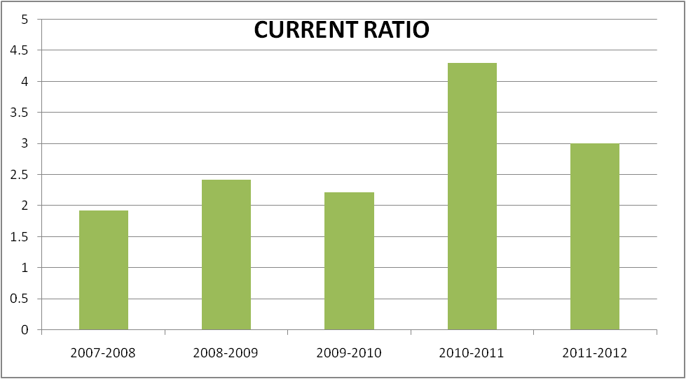
INTERPRETATION:
From the above graph it is clear that the current ratio is higher in the year 2010-2011 i.e., 4.302 and lower in the year 2007-2008 i.e., 1.917.
This is because, it is inferred that the short term solvency of the company is very good. But in the year 2008-2009, the company had maintained a high current ratio indicating that the company had engaged itself in under trading.

QUICK RATIO
Liquid assets
Quick ratio = -------------------------
Current liabilities

TABLE NO.2
TABLE SHOWING QUICK RATIO
YEAR | LIQUID ASSETS | CURRENT LIABILITIES | RATIO
2007-2008 | 585673733 | 475523005 | 1.231
2008-2009 | 683920100 | 451607354 | 1.515
2009-2010 | 721954754 | 561527841 | 1.285
2010-2011 | 452897173 | 227350353 | 1.992
2011-2012 | 631126126 | 373557127 | 1.689

ANALYSIS:
From the above table it is clear that the quick ratio is little higher in the year 2010-2011 i.e., 1.992 and little lower in the year 2007-2008 i.e., 1.231.
GRAPH NO 2
GRAPH SHOWING THE CURRENT RATIOS

INTERPRETATION:
From the above it is clear that the quick ratio is little higher in the year 2010-2011 i.e., 1.992 and little and lower in the year 2007-2008 i.e., 1.231.
This is because it is inferred that the financial liquidity of the organization is very good. It also indicates that the firm is indulged in efficient inventory management by not maintaining huge inventory, hence by cutting the inventory cost.

ABSOLUTE LIQUID RATIO:
Absolute liquid assets
Absolute liquid ratio = --------------------------------
Current liabilities
TABLE NO 3
TABLE SHOWING ABSOLUTE LIQUID RATIO
YEAR | ABSOLUTE LUQID ASSETS | CURRENT LIABILITIES | RATIO
2007-2008 | 334385423 | 308752365 | 1.083
2008-2009 | 255132910 | 246650794 | 1.034
2009-2010 | 285359727 | 292361773 | 0.976
2010-2011 | 318161611 | 273532955 | 1.163
2011-2012 | 482063404 | 373557127 | 1.290

ANALYSIS:
From the above table it is clear that the absolute liquid ratio is higher in the year 2011-2012 i.e., 1.290 and is lower in the year 2009-2010 i.e., 0.976.

GRAPH NO 3
GRAPH SHOWING ABSOLUTE LIQUID RATIO
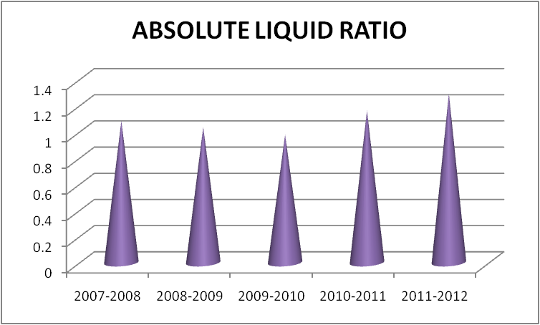
INTERPRETATION:
From the above table it is clear that the absolute liquid ratio is higher in the year 2011-2012 i.e., 1.290 and is lower in the year 2009-2010 i.e., 0.976.

DEBTORS TURNOVER RATIO
Total sales
Debtors turnover ratio = ------------------------
Sundry debtors

TABLE NO 4
TABLE SHOWING DEBTORS TURNOVER RATIO
YEAR | TOTAL SALES | SUNDRY DEBTORS | RATIO
2007-2008 | 1286462008 | 113610156 | 11.323
2008-2009 | 1533703531 | 154938144 | 9.898
2009-2010 | 1647774737 | 168085689 | 9.803
2010-2011 | 1810681622 | 15368861 | 10.734
2011-2012 | 2118438529 | 141899142 | 14.929

ANALYSIS:
From the above ratio it is clear that the debtor’s turnover ratio is higher in the year 2011-2012 i.e., 14.929 and lower in the year 2009-2010 i.e., 9.803.
GRAPH NO 4
GRAPH SHOWING DEBTORS TURNOVER RATIO

INTERPRETATION:
From the above ratio it is clear that the debtor’s turnover ratio is higher in the year 2011-2012 i.e., 14.929 and lower in the year 2009-2010 i.e., 9.803.
This is because the ideal debt payment period is 30 days. The organization has allowed the credit period
More than the ideal debt collection period & the actual debt payment period of the organization
Which indicating that the organization’s credit collection period is inefficient & is in alarming situation.
CREDITORS TURNOVER RATIO:
Annual credit purchases
Creditors turnover ratio = ----------------------------------
Sundry creditors

TABLE NO 5
TABLE SHOWING CREDITORS TURNOVER RATIO
YEAR | CREDIT PURCHASES | SUNDRY CREDITORS | RATIO
2007-2008 | 518909473 | 70184312 | 7.393
2008-2009 | 847238335 | 69771273.5 | 12.143
2009-2010 | 958986877 | 6440999 | 14.877
2010-2011 | 969031446 | 45405580.5 | 21.341
2011-2012 | 1226935401 | 39175572 | 31.318

ANALYSIS:
From the above table it is clear that the credit turnover ratio is higher in the year 2011-2012 i.e., 31.318 and lower in the year 2007-2008 i.e., 7.393.

GRAPH NO 5
GRAPH SHOWING CREDITORS TURNOVER RATIO
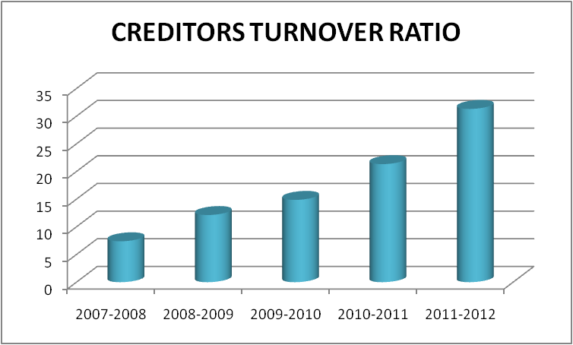
INTERPRETATION:
From the above table it is clear that the credit turnover ratio is higher in the year 2011-2012 i.e., and lower in the year 2007-2008 i.e., 2007-2008 i.e., 7.393.
This is because the ideal Debt payment period is 30 days. The organizations has received the credit period lesser than the ideal Debt payment period, hence it can be inferred that the organization has not received sufficient period of credit from its creditors.

WORKING CAPITAL TURNOVER RATIO:
Net sales
Working capital turnover ratio= -----------------------------------
Net working capital

TABLE NO 6
TABLE SHOWING WORKING CAPITAL TURNOVER RATIO

YEAR | NET SALES | NET WORKING CAPITAL | RATIO
2007-2008 | 1286462008 | 436166550 | 2.949
2008-2009 | 1533703531 | 639765233 | 2.397
2009-2010 | 1647774737 | 678032752 | 2.430
2010-2011 | 1649723232 | 637692903 | 2.587
2011-2012 | 2118438529 | 747083319 | 2.835

ANALYSIS:
From the above table it is clear that the working capital turnover ratio is higher in the year 2007-2008 i.e., 2.949 and lower in the year 2008-2009 i.e., 2.397

GRAPH NO- 6
GRAPH SHOWING WORKING CAPITAL TURNOVER RATIO

INTERPRETATION:
From the above table it is clear that the working capital turnover ratio is higher in the year 2007-2008 i.e., 2.949 and lower in the year 2008-2009 i.e., 2.397.

DEBT EQUITY RATIO
Debt
Debt equity ratio= -----------------------------
Equity

TABLE NO 7
TABLE SHOWING DEBT EQUITY RATIO
YEAR | DEBT | EQUITY | RATIO
2007-2008 | 89995436 | 455047041 | 0.197
2008-2009 | 83506504 | 587709487 | 0.142
2009-2010 | 83506504 | 661700146 | 0.126
2010-2011 | 103338903 | 709741693 | 0.145
2011-2012 | 79109935 | 812822955 | 0.097

ANALYSIS:
From the above table it is clear that debtors turnover ratio is higher in the year 2007-2008 i.e., and lower in the year 2011-2012 i.e., 0.097.

GRAPH NO 7
GRAPH SHOWING DEBT EQUITY RATIO
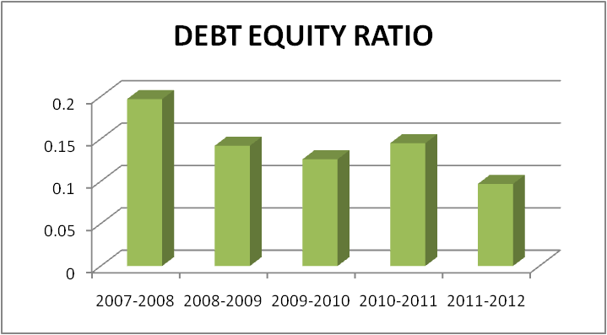
INTERPRETATION:
From the above table it is clear that the debtors turnover ratio is higher in the year 2007-2008 i.e., and lower in the year 2011-2012 i.e., 0.097.

FIXED ASSETS TO NETWORK RATIO
Net fixed assets
Fixed assets to network ratio = -------------------------------
Share holders funds

TABLE NO 8
TABLE SHOWING FIXED ASSETS TO NETWORK RATIO
YEAR | NET FIXED ASSETS | SHARE HOLDERS FUND | RATIO
2007-2008 | 59055326 | 455047041 | 0.129
2008-2009 | 69775760 | 587709487 | 0.118
2009-2010 | 85830957 | 661700146 | 0.129
2010-2011 | 92983953 | 709741693 | 0.131
2011-2012 | 96957604 | 812822955 | 0.119

ANAYLYIS:
From the above table it is clear that the fixed assets to network ratio is higher in the year 2010-2011 i.e., 0.131 and lower in the year 2008-2009 i.e., 0.118.

GRAPH NO 8
GRAPH SHOWING FIXED ASSETS TO NETWORK
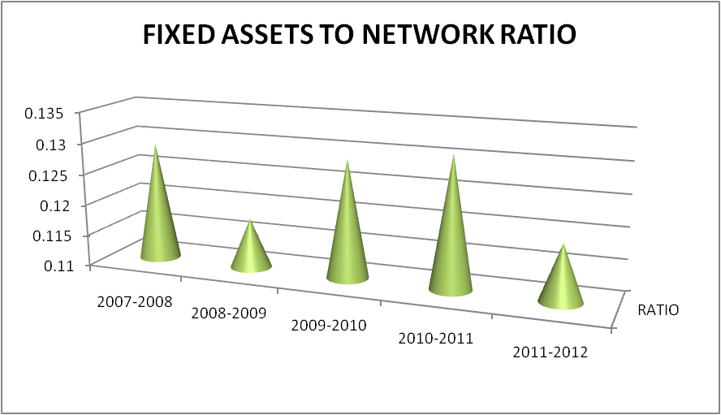

INTERPRETATION:
From the above table it is clear that the fixed assets to network ratio is higher in the year 2010-2011 i.e., 0.131 and lower in the year 2008-2009 i.e., 0.188.

FIXED ASSETS RATIO:
Net fixed assets
Fixed assets ratio = --------------------------
Total long term fuds

TABLE NO 9
TABLE SHOWING FIXED ASSETS RATIO
YEAR | NET FIXED ASSETS | LONG TERM FUNDS | RATIO
2007-2008 | 59055326 | 555408013 | 0.016
2008-2009 | 69775760 | 778420599 | 0.089
2009-2010 | 85830957 | 825299050 | 0.103
2010-2011 | 92983953 | 9563532 | 9.722
2011-2012 | 96957604 | 9563532 | 10.138

ANALYSIS:
From the above table it is clear that the fixed asset ratio is higher in the year 2011-2012 i.e., 10.138 and lower in the year 2008-2009 i.e., 0.089.

GRAPH NO 9
GRAPH SHOWING FIXED ASSET RATIO
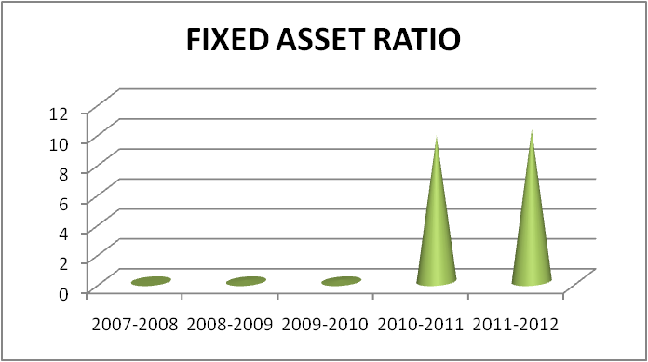
INTERPRETATION:
From the above table it is clear that the fixed asset ratio is higher in the year 2011-2012 i.e., 10.138 and lower in the year 2008-2009 i.e., 0.089.

PROPRIETORS RATIO:
Share holders fund
Proprietors ratio = ----------------------------
Total assets

TABLE NO 10
TABLE SHOWING PROPRIETORS RATIO

YEAR | SHARE HOLDERS FUNDS | TOTAL ASSETS | RATIO
2007-2008 | 455047041 | 1002891528 | 0.453
2008-2009 | 585940129 | 1213653313 | 0.482
2009-2010 | 661700146 | 1386826891 | 0.477
2010-2011 | 709741693 | 1356695412 | 0.523
2011-2012 | 812822955 | 1488037248 | 0.546

ANALYSIS:
From the above it is clear that the proprietors ratio is higher in the year 2011-2012 i.e., 0.546 and lower in the year 2007-2008 i.e., 0.453.
GRAPH NO 10
GRAPH SHOWING PROPRIETORS RATIO

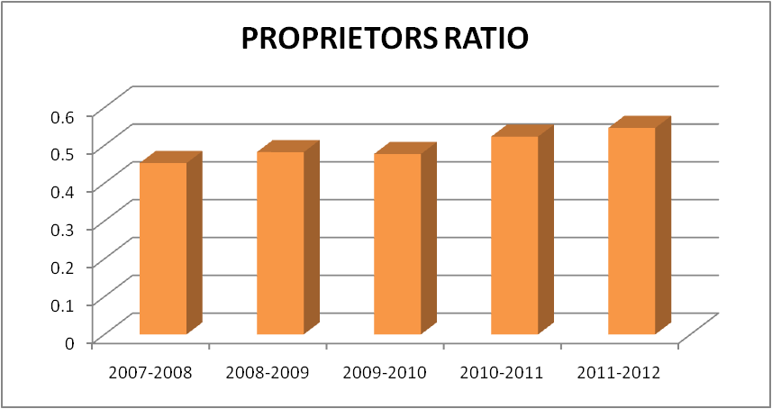
INTERPRETATION:
From the above table it is clear that the proprietors ratio is higher in the year 2011-2012 i.e., 0.546 and lower in the year 2007-2008 i.e., 0.453.
OPERATING PROFIT RATIO:
Operating profit
Operating profit ratio = ---------------------------
Sales

TABLE NO 11
TABLE SHOWING OPERATING RATIO

YEAR | OPERATING PROFIT | SALES | RATIO
2007-2008 | 122444174 | 1286462008 | 9.517
2008-2009 | 124361250 | 1533703531 | 8.108
2009-2010 | 143183402 | 1647774737 | 8.689
2010-2011 | 102759224 | 1649723232 | 6.228
2011-2012 | 201747457 | 2118438529 | 9.523

ANALYSIS:
From the above table it is clear that the operating profit ratio is higher in the year 2011-2012 i.e., 9.523 and lower in the year 2010-2011 i.e., 6.228.

GRAPH NO 11
GRAPH SHOWING OPERATING PROFIT RATIO
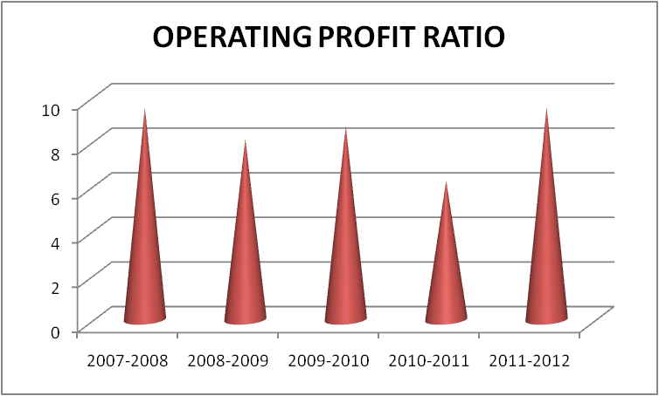
INTERPRETATION:
From the above table it is clear that the operating profit ratio is higher in the year 2011-2012 i.e., and lower in the year 2010-2011 i.e., 6.228.

NET PROFIT RATIO:
Net profit after tax
Net profit ratio = -----------------------------
Net sales

TABLE NO 12
TABLE SHOWING NET PROFIT RATIO

YEAR | NET PROFIT AFTER TAX | NET SALES | RATIO
2007-2008 | 120386357 | 1286463008 | 9.357
2008-2009 | 116814479 | 1533703531 | 7.616
2009-2010 | 93112149 | 1647774737 | 5.650
2010-2011 | 63952597 | 1649723232 | 3.876
2011-2012 | 134518037 | 2118438529 | 6.349

ANALYSIS:
From the above it is clear that the net profit ratio is higher in the year 2001-2008 i.e., 9.357 and lower in the year 2010-2011 i.e., 3.876.
GRAPH NO 12
GRAPH SHOWING NET PROFIT RATIO
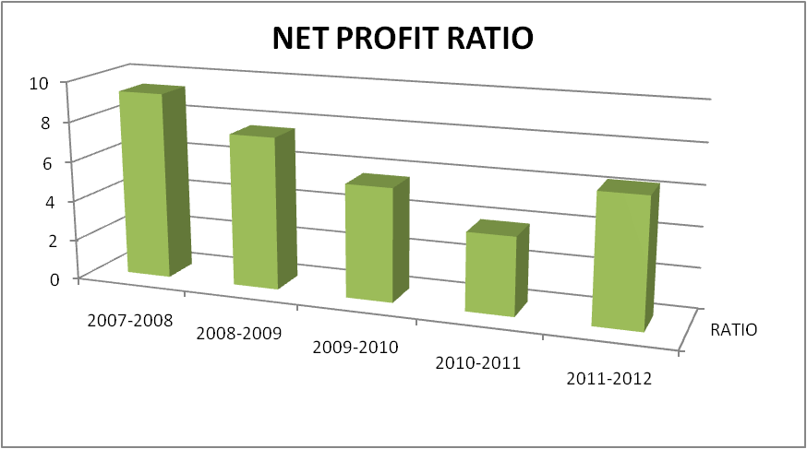

INTERPRETATION:
From the above table it is clear that the net profit ratio is higher in the year 2007-2008 i.e., 9.357 and lower in the year 2010-2011 i.e., 3.876.
This is because

CHAPTER-5

FINDINGS , SUGGESTIONS AND CONCLUSION
FINDINGS
- It seems that the company has invested lesser amount in outside investment. If the interest rate is more than the alternate channels of funds needed that company must think about investment in outside organization.
- The company has been able to improve it’s performance year and year by effective utilization of resources supported by sound technical back ground will knit management team and strong brand equity of KS & DL.
- The company has high liquidity towards working capital management which is very effective for the management of inventories.
- The finance department has been successful in adhering to the needs and recommendations of the tender/ chore committee.
- All the payments to creditors are made through cheque, even other expenses are paid through cheque; wages, salary excise duty are paid monthly.
- The company has sufficient quick assets like book debts and cash to cover its short term obligation and the observed ratios is more than normal standard of 1:1 are far above the safety margin.
- Lot of investments is done in fixed assets were the amount in blocked in depreciation.
- No outside investment is done which remained constant throughout the year.
- There is efficient management of working capital which has doubled in the year 2008-2009 due to the investments made in inventories.
- As far as Comparative Balance Sheet in concerned, KS & DL’s short term financial position has been showing a good sign where it has an ability to pay its short term obligations. But its liquidity position has been quite satisfactory because there is a decreasing trend of cash in the year 2008-2009.
- Long Term Financial Position of the company in not satisfactory as secured loan has been showing and increasing trend where it has financed a part of mount in fixed assets in turn it hesitates other suppliers to give credit period due to the debt of the company.
- The profitability of the concern it is improving but lot of amount is block in the interest payment which has to be paid to banks and financial institutions.

SUGGESTIONS
In the light of finding of the study of following suggestions are made for the improvement of the working capital management in KS & DL.
- KS&DL should check it is financial performance every 3 months. It will be better to know the current positions of the company and also helpful at active the goods.
Commencement of effective forecasting of the working capital.
- It will be better if KS&DL diverts a little portion of its funds to find assets which will help the enterprise in undertaking expansion activities and ultimately enhancing its sales and profitability.
- The requirements of working capital should be properly assessed by considering various aspects such as production schedule, labor cost and net sales.
- It has to maintain its cash and bank balance as it is highly liquid which will help in smooth running of working capital.
- The company should adopt good planning towards recovery of debt that is by adopting good credit policy etc.
- KS&DL has to reduce its debt where the amount is paid as interest to the banks and financial institutions.
- It will be better if KS&DL diverts a little portion of funds in undertaking expansion activities and ultimately enhancing its sales and profitability.
- It has make outside investments which helps a company to earn some return out of it or atheist in short term where small amount of return can be earned. Otherwise it loses its opportunities which would not be a good sign for a company.
- The company is suggested to have a continuous check of all cash and bank balance.
In case if the cash is laying idle so that it can be brought to the notice of laying idle so that it can be invested in various short term investment opportunities to earn interest. Forecasting of cash should be made to meet requirements of business.
- KS&DL is suggested that working capital should be financed by an appropriate mix of long term and short term sources of funds.
- The requirement of working capital should be properly assessed by considering various aspects such as production schedule, labor cost, sales etc.
- The working capital neither it should not be in excessive not it should be a shortage.
So it has to see that working capital is maintained in such a way there is a optimum working capital.
However, out of the tow it is the inadequacy of working capital which is more dangerous as its shorter liabilities in time and it will lose its reputation and shall not be able to get good credit facilities and cannot pay due to day expenses of its operations. If there is adequate working capital it may lead to unnecessary purchasing and accumulation of inventories causing more chances of theft, excessive debtors has to keep a credit policy which may cause higher incidence of bad debts. So company has to keep a track of working capital were it should be optimum to meet its day to day expenses.

CONCLUSION:
Despite difficult economic conditions and an overall slowdown of industrial growth in our country, KS&DL has a good demand for products; its market is steadily increasing.
KS&DL has a very good quality system. It is known for its quality products in the market, It manufactures 80% of good quality sandalwood products and 20% non sandalwood which is famous world wide for its brand and quality. It has been awarded ISO 9002 certificate. It is a major achievement.
A company has good name in the market because it provides competition. KS&DL has been able to increase its presence prices of product diversification by effective utilization of manpower and resources supported by sound technological background, efficient management team and strong brand equity of KS&DL.
The process of reforms and liberalization result higher industrial growth adopted group technology. KS&DL markets after excellent opportunity to Global Markets

CHAPTER – 6

ANNEXURE

STATEMENT SHOWING CHANGES IN WORKING CAPITAL FOR THE YEAR ENDED 2007-2008
PARTICULARS | 2007 | 2008 | INCREASSE | DECREASE
CURRENT ASSETS
INVENTORIES | 350855723 | 296012822 |  | 54842901
SUNDRY DEBTORS | 80873641 | 146346670 | 65473029
CASH & BANK BAL | 312345581 | 334385423 | 22039842
LOANS & ADVANCES | 72546525 | 104944640 | 32398115
TOATAL – A | 816621470 | 881689555
CURRENT LIABILITIES
LIABILITIES | 280039861 | 30872365 | 249167496
PROVISIONS | 128527890 | 166770640 |  | 38242750
TOTAL – B | 408567751 | 19763005
NET INCREASE IN WORKING CAPITAL | 275992831
TOTAL | 684046550 | 684046550 | 369078482 | 369078482

STATEMENT SHOWING CHANGES IN WORKING CAPITAL FOR THE YEAR ENDED 2008-2009
PARTICULARS | 2008 | 2009 | INCREASE | DECREASE
CURRENT ASSETS
INVENTORIES | 296012822 | 407452487 | 111439665
SUNDRY DEBTORS | 146346670 | 163529618 | 17182948
CASH & BANK BAL | 334385423 | 255132910 |  | 72952513
LOANS & ADVANCE | 104944640 | 215257572 | 110312932
TOTAL – A | 881689555 | 1041372587
CURRENT LIABILITIES
LIABILITIES | 30872365 | 246650794 | 62101571
PROVISSIONS | 166770640 | 204956560 |  | 38185920
TOTAL – B | 19763005 | 451607354
NET INCREASE IN WORKING CAPITAL | 183598683 |  |  | 183598683
TOTAL | 589765233 | 589765233 | 301037116 | 301037116

STATEMENT SHOWING CHANGES IN WORKING CAPITAL FOR THE YEAR ENDED 2009-2010
PARTICULARS | 2009 | 2010 | INCREASE |  | DECREASE
INVENTORIES | 407452487 | 517605839 | 110153352
SUNDRY DEBTORS | 163529618 | 172641760 | 9112152
CASH & BANK BAL | 255132910 | 285359727 | 30226817
LOANS & ADVANCE | 215257572 | 213953267 |  |  | 1304305
TOTAL – A | 1041372587 | 1189560593
CURRENT LIABILITIES
LIABILITIES | 246650794 | 292361773 |  |  | 45710979
PROVISIONS | 204956560 | 269166068 |  |  | 64209508
TOTAL – B | 451607354 | 561527841
NET INCREASE IN WORKING CAPITAL | 38267519 |  |  |  | 38267709
TOTAL | 628032752 | 628032752 |  | 149492501 | 149492501

STATEMENT SHOWING CHANGES IN WORKING CAPITAL FOR THE YEAR ENDED 2010-2011
PARTICULARS | 2010 | 2011 | INCREASE | DECREASE
CURRENT ASSETS
INVENTORIES | 517605839 | 52534558 | 7628719
SUNDRY DEBTORS | 172641760 | 165859183 |  | 6782577
CASH & BANK BAL | 285359727 | 240314138 |  | 45045589
LOANS & ADVANCES | 213953267 | 18972241 |  | 24221026
TOTAL – A | 1189560593 | 1121140120
CURRENT LIABILITIES
LIABILITIES | 292361773 | 273532955 | 18828818
PROVISIONS | 269166068 | 289914262 |  | 20748194
TOTAL- B | 561527841 | 563447217
NET DECREASE IN WORKING CAPITAL |  | 70339849 | 70339849
TOTAL | 628032752 | 628032752 | 96797386 | 96797386

STATEMENT SHOWING CHANGES IN WORKING CAPITAL FOR THE YEAR ENDED 2011-2012
PARTICULARS | 2011 | 2012 | INCREASE | DECREASE
CURRENT ASSETS
INVENTORIES | 525234558 | 489514320
SUNDRY DEBTORS | 134735562 | 149062722 | 14327160
CASH & BANK | 240314138 | 377803712 | 137489574
LOANS & ADVANCES | 77847473 | 104259692 | 28412219
TOTAL – A | 978131731 | 1120640446
CURRENT LIABILITIES
TRADE PAYABLE | 18521787 | 59829357 |  | 41307570
LIABILITIES | 128835682 | 167055833 |  | 38220151
PROVISIONS | 79992885 | 146671937 |  | 66679052
TOTAL – B | 227350354 | 373557127
NET DECREASE IN WORKING CAPITAL |  | 3698058 | 3698058
TOTAL | 750781377 | 750781377 | 181927010 | 181927010

CHAPTER – 7

BIBLIOGRAPHY

AUTHORS | LIST OF BOOKS
PRASANNA CHANDRA | FINANCIAL MANAGEMENT
M.N. ARORA | MANAGEMENT ACCOUNTING
I. M. PANDAY | FINANCIAL MANAGEMENT

E – MAIL | mysoresandal@vsnl.com
WEBSITE | www.mysoresandsl.com

