**CHAPTER - 1**

**INTRODUCTION**

**1.1.1 Introduction**

The important task before every manager is to secure optimum performance from each of his subordinates. The performance of the subordinate, in turn, is determined by his ability to work and the extent to which he is motivated.

Motivation is the process of inducing and instigating the subordinates to put in their best. Motivation is influenced significantly by the needs of a person and the extent to which these have been fulfilled. To motivate the subordinates, the manager must, therefore, understand their needs.

The term ‘motivation’ has been derived from the word ‘motive’. Motive is the urge, need, want or desire that induces a person to work.

**ORIGIN**

The term motivation is derived from the “Latin” word “motive” which means induces or desire to work.

Motivation is the process of attempting to influence others to do your will through the possibility of gain or reward.- **Edwin B. Flippo**

Motivation means a process of stimulating people to action to accomplish desired goals. **W.G.Scott**

* + 1. **NATURE AND CHARACTERISTICS OF MOTIVATION**

1. **Motivation is a psychological concept**

The needs of person influence his behavior. A subordinate, whose needs have been fully satisfied, feels mentally relieved.

2. **Motivation is always total and not piece-meal**

It means that a person cannot be motivated in instalments. An employee will not be motivated if some of his needs are partly satisfied.

3. **Motivation may be financial or non-financial**

An employee may be motivated through financial or non-financial incentives.

4. **Motivation may be positive as well as negative**

Many people think that the method of motivation should always be positive. It may even be negative.

5. **Motivation is continues process**

Man is a wanting animal. As soon as one need is satisfied another appears in its place. This is an unending process.

* + 1. **IMPORTANCE OF MOTIVATION**

1. Inducement of employees
2. Higher efficiency
3. Optimum use of resources
4. Avoidance of loss due to mishandling and breakage
5. No complaints and grievances
6. Better human relations
7. Avoidance of strikes and lock-outs
8. Reduction in labour turnover
   * 1. **PROCESS OF MOTIVATION**
9. Recognition of an unfulfilled need
10. Finding the way out to satisfy the same
11. Fulfilments of the need
12. Discovery of new need
    * 1. **TYPES OF MOTIVATION**

|  |  |  |
| --- | --- | --- |
| S.NO | **Financial motivation** | **Non-Financial motivation** |
| 1 | Higher wages and salary | Job security |
| 2 | Bonus | Recognize |
| 3 | Profit sharing | Better designation |
| 4 | Commission | Participation in decision making |
| 5 | Increment | Job rotation |

**1.4 IDENTIFIED PROBLEM**

* Motivation is an important factor for the organization. It helps in moulding the employees to a greater extent. Interest level of the employees to perform their job gets increased due to this motivation.
* So in order to analyses the motivational factors in “Titan Industries” is identified as the problem for the study.

**1.5 NEED FOR THE STUDY**

* This study is emphasis on improvement of motivation and to bring in balance of work and life helps the Titan Industries to achieve its goals and targets in turn.
* This research focused on the employee satisfaction on motivational measures of the company.
* To analyses the employee motivation scenario in “Titan Industries Chennai”
* To identify methods of the organization motivates the employees.

**1.5 SCOPE OF THE STUDY**

* The important of studying employee’s motivation is to understand the internal satisfaction in the minds of every employee. This study helps to know some employees satisfaction level. The finding of this study helps the company to implement the expectations from the employees.
* The study helps the company to know whether the motivations are undertaken strongly accepted and also to know the lacking in the employee motivation.

**1.6 OBJECTIVES OF THE STUDY**

**Primary Objectives**:

1. To identify the motivational factors for the employees in “Titan Industries”.
2. To evaluate the opinion of the employees about the factors such as contents of the job, training and development.

**Secondary Objectives:**

1. To find out the factors that influence the employee’s motivation provided by an organization.
2. To identify the significance of motivation that has an impact on productivity.
3. To identify the factors which bring high level of satisfaction.

**1.6 LIMITATIONS OF THE STUDY**

* The study has been carried out with the assumption that the responses from the workers are real.
* The study has been conducted and it is applicable only to in- house motivational level of Titan Industries.
* Hesitation and a little difficulty of the employees to express their views was an obstacle to the investigator.
* Certain employees of the company are not aware of what factors motivates them.
* Most of the employees didn’t come forward to give opinion about the management. Hence it doesn’t provide them to derive a concrete solution.
* The study was conducted only for a short period of time.

### **1.Industry Profile**

### **History of the watch market**

### **The Indian watch industry began in the year 1961 with the commissioning of the watch division of HMT. The first watch model manufactured by HMT was the Janata model in the year 1962. HMT was the leader in the watch market till the Tatas formed Titan Watches in association with Tamil Nadu Industrial Development Corporation in the year 1987. They took a major strategy decision, which later changed the face of the Indian watch market- to manufacture only quartz watches. Liberalization in 1992 and the removal of quantitative restrictions due to WTO has opened the doors for many foreign brands in the Indian market viz. Tissot, Swatch, Omega, Rado, TAG Heuer, Rolex and many others. The import duties on watches are falling which makes the Indian market look attractive for the global majors like Casio, Swatch and Citizen.**

### **Titan Industries Limited is engaged in manufacturing of watches, jewelry, precision engineering and Eyewear. The Company has four divisions: watches, jewellery, precision engineering and eyewear. As of March 31, 2012, the Company had 311 World of Titan stores. The Company sold its products through departmental stores, such as Shoppers’ Stop, Central, Lifestyle, Westside, Pantaloons and Reliance Retail. During the fiscal year ended March 31, 2012, the Company launched collection of watches, such as Purple by Titan, an offering of fashion watches; Raga Aqua, a new collection whose evocative designs were inspired by the oceans and seas; Tycoon by Titan, a new collection of gold look watches; and new products in the automatic watches range, which cater to premium consumers. As of March 31, 2012, the Company had 120 Tanishq stores, 29 Gold Plus stores and two Zoya stores in jewelry division. As of March 31, 2012, the Company had approximately150 exclusive eyewear stores.**

### **[http://t3.gstatic.com/images?q=tbn:ANd9GcRjMBnt5gHMbMk7NJN3Jju5F6R9vsyPoVuiSno91HTT8EufvGd6fauq0Q](http://search.babylon.com/imageres.php?iu=http://www.krishnagiri.tn.nic.in/images/titan.jpg&ir=http://www.krishnagiri.tn.nic.in/Industry.htm&ig=http://t3.gstatic.com/images?q=tbn:ANd9GcRjMBnt5gHMbMk7NJN3Jju5F6R9vsyPoVuiSno91HTT8EufvGd6fauq0Q&h=188&w=200&q=company+profile+of+titan+industries+ltd&babsrc=HP_ss)**

### **Titan Industries is the organization that brought about a paradigm shift in the Indian watch market when it introduced its futuristic quartz technology, complemented by international styling. With India's two most recognized and loved brands Titan and Tanishq to its credit, Titan Industries is the fifth largest integrated watch manufacturer in the world.**

### **The success story began in 1984 with a joint venture between the Tata Group and the Tamil Nadu Industrial Development Corporation. Presenting Titan quartz watches that sported an international look, Titan Industries transformed the Indian watch market. After Sonata, a value brand of functionally styled watches at affordable prices, Titan Industries reached out to the youth segment with Fastrack, its third brand, trendy and chic. The company has sold 135million watches world over and manufactures 13 million watches every year.**

### **With a license for premium fashion watches of global brands, Titan Industries repeated its pioneering act and brought international brands into Indian market. Tommy Hilfiger and FCUK as well as the Swiss made watch – Xylys owe their presence in Indian market to Titan Industries.**

### **Entering the largely fragmented Indian jewellery market with no known brands in 1995, Titan Industries launched Tanishq, India’s most trusted and fastest growing jewellery brand. Gold Plus, the later addition, focuses on the preferences of semi-urban and rural India. Completing the jewellery portfolio is Zoya, the latest retail chain in the luxury segment.**

### **Titan Industries has also made its foray into eyewear, launching Fastrack eyewear and sunglasses, as well as prescription eyewear. The organization has leveraged its manufacturing competencies and branched into precision engineering products and machine building.**

### **With over 826 retail stores across a carpet area of over 10,08,083 sq. ft. Titan Industries has India’s largest retail network. The company has over 331exclusive ‘World of Titan' showrooms and over 83 Fastrack stores. It also has a large network of over 700 after-sales-service centers. Titan Industries is also the largest jewellery retailer in India with over 130 Tanishq boutiques and Zoya stores, over 31 Gold Plus stores. It also sports over 204 Titan Eye+ stores. The company has two exclusive design studios for watches and jewellery**

### **Backed by over 6,000 employees, two exclusive design studios for watches and jewellery, 9 manufacturing units, and innumerable admirers world over, Titan Industries continues to grow and sets new standards for innovation and quality. The organization is all geared to repeat the Titan and Tanishq success story with each new offering.**

### **Present Situation of the Indian Watch Market**

### **The Indian watch market is today of 40 million units, out which 60% is in the unorganized sector in which the maximum number of watches are sold are below Rs.300. Quartz watches form two thirds of the organized sector and the rest is split between mechanical and digital watches. Even in the organized sector, three fourth of the sales by volume comes from watches that are priced below Rs.1000.**

### **Watch is one of the consumer durables whose replacement rate is very high. The replacement rate of watch is 33.8% (Source: India market demographics report, 1998). This is also due to the fact that the estimated scrap rate of wrist watches is 7.8%, which is applicable after 6 years (Source: India market demographics report, 1998). So due to high scrap rate, outdated models, and the shift from the mechanical watches to the quartz watches is causing a very high replacement demand for watches. This along with the low penetration levels represent the untapped market potential for watches in India.**

### **Major brands in the Indian watch market:**

### **The major players in the Indian watch market include HMT, Titan and Timex. The other players include Westar, Shivaki, Maxima, SITCO. Foreign brands such as Cartier, Piaget, Omega, Tiffany’s and Corrum, Gucci, Longines, Casio, Citizen, Tag Heuer and Espirit are also making an inroad into the Indian market.**

### **Titan has been consolidating its market share over the past decade. Timex watches, which entered in India with collaboration with Titan, now independently has also gained substantial market share.**

### **2. COMPANY PROFILE**

### **Titan Industries is the organization that brought about a paradigm shift in the Indian watch market when it introduced its futuristic quartz technology, complemented by international styling. With India's two most recognized and loved brands Titan and Tanishq to its credit, Titan Industries is the fifth largest integrated watch manufacturer in the world.**

### **History of Titan**

### **In 1984**

### **The Company was Incorporated on 26th July, at Chennai. The Manufacture analog electronic watches with a choice of over 150 designs. The company was promoted jointly by Questar Investments, Ltd., a Tata Company with its associates Tata Sons, Ltd., and Tata Press, Ltd., and Tamil Nadu Industrial Development Corporation, Ltd. (TIDCO). The main objective of the company is to manufacture analog electronic watches with a choice of over 150 designs.**

### **The Company undertook to set up a plant for the manufacture of quartz analog electronic watches in the State Industries Promotion Corporation of Tamil Nadu, Ltd. Industrial area at Hosur.**

### **The Company entered into a collaboration agreement with France Ebauches (FE) of France, manufacturers of watch movements and components, for technical documentation, assistance in procurement of manufacturing equipments, raw materials, etc.**

### **The Company proposed to manufacture 2 million digital and ana-digi watches in collaboration with Casio Computer Company of Japan. A MOU was signed between the Company and Casio in November, 1986.**

### **In 1987**

### **The Company established a manufacturing facility at Hosur for the manufacture of components for watches.**

### **In April the Company also issued 5,25,000 - 13.5% secured redeemable partly convertible debentures of Rs 300 each for cash at par. The debentures were allotted on preferential basis: (i) 26,250 debentures to employees/workers of the Company and associate companies (ii) 52,500 debentures to shareholders of Tata Press Ltd. and (iii) 1,31,250 debentures to NRIs on repatriation basis. The remaining 3,04,500 debentures along with the unsubscribed portion of 78,900 debentures from the preferential quota were offered for public subscription during April. Additional 1,31,250 debentures were allotted to retain over-subscription.**

### **The convertible portion of Rs 100 of the face value of each debenture was converted into 10 equity shares of Rs 10 each at the end of three months from the date of allotment of debentures (65,62,500 equity shares were allotted accordingly).**

### **The non-convertible portion of Rs 200 of the face value of each debenture was to be redeemed at par at the end of the 10 years from the date of allotment of debentures.**

### **In 1989**

### **A new range of watches called `Aqura' was launched in December.**

### **The case plant at Hosur was commissioned. The plant was to produce 1.5 million watch cases. The project cost was financed partly through internal resources and largely through borrowings from IFC, Washington and the Tamil Nadu Industrial Development Corporation, Ltd**

### **The Company set up a satellite case plant at Dehra Dun in Uttar Pradesh with a capacity of 5,00,000 watch cases per annum to improve operating efficiency and reduce costs.**

### **During August, the Company issued 2,52,000 - 12.5% convertible debentures of Rs 500 each as follows: (i) 2,40,000 debentures on rights basis in the proportion 1 debenture: 100 equity shares held and (ii) 12,000 debentures to employees/workers of the Company on an equitable basis. A total of 2,84,455 debentures were allotted under this issue including retention of oversubscription.**

### **Part `A' of each debenture of face value of Rs 100 was compulsorily and automatically converted into 10 equity shares of Rs 10 each at par on expiry of six months from the date of allotment of debentures.**

### **Part `B' of each debenture of the face value of Rs 200 was converted into 4 equity shares of Rs 10 each at a premium of Rs 50 per share on 1.10.92.**

### **Part `C' the non-convertible portion of each debenture of face value of Rs 200 was to be redeemed at par at the end of the 10th year from the date of allotment of debentures.**

### **The proceeds of the issue were to be utilised to meet a part of the fund requirement of the company's project to manufacture watch cases and other critical components inhouse.**

### **The Company proposed to offer 40,26,700-12.5% fully convertible debentures of Rs 100 each on Rights basis in the proportion 2 debs: 20 equity shares held. Another 2,012,340 - 12.5% debentures were to be issued to the employees' on an equitable basis.**

### **Rs 40 of the face value of each debenture was to be converted into 1 equity share of Rs 10 each at a premium of Rs 30 per share on or before 30th September, 1995.**

### **Rs 60 of the face value of each debenture was to be converted into 1 equity share of Rs 10 each at a premium not exceeding Rs 50 per share on or before 30th September, 1996.**

### **A joint venture Company along with Economic Development Council of Goa, Daman & Diu Ltd., in the name of Titan Time Products, Ltd., was set up at Goa, for the manufacture of Electronic Circuit Blocks.**

### **The company undertook to set up a jewellery business at Hosur. The jewellery repertoire was to include both daily-wear jewellery and luxury products.**

### **Grant Walker, a U.K. based firm, was to provide the necessary consultancy services and the marketing was to be undertaken worldwide through an offshore company controlled by Titan Watches Ltd., with its mainbase in London.**

### **The Company along with other Tata Associates were to participate in the equity of Timex, who were to offer equity shares of Rs 10 each at a premium of Rs 40 per share. It was also proposed to make a Partly convertible debenture of nearly Rs 60 crores.**

### **In 1992**

### **Over 150 new models were introduced of which `Raga' introduced in June, `Spectra' a range of watches in steel and gold plated was reintroduced with a new look in August. It was proposed to introduce a host of new products based on new movements.**

### **It was also proposed to sell the brand name `Aqura' and the right to make Aqura products to Timex, with a view to move up market With a view to streamling the Company's international operations, it was decided to set up a wholly owned subsidiary "Titan Holdings BV" in Netherlands. Approval was received for investment of share capital of 2 million U.S. $ in that Company.**

### **Titan Time Products, Ltd., is a joint sector project set up with the Economic Development Council of Goa, Daman and Diu.**

### **Titan Properties Ltd., was incorporated to undertake land development and housing scheme for the Company's employees at Hosur.**

### **The Company issued 134,22,300 Rights equity shares of Rs 10 each for cash at a premium of Rs 40 per share in the proportion 1:2 (all were taken up).**

### **Another 5,69,000 No. of equity shares of Rs 10 each were issued at a premium of Rs 40 per share in proportion 2 shares: 1 debenture held to Part B holders of 12.5%. Convertible debentures issued in 1989. (all were taken up).**

### **6,99,600 No. of equity shares of Rs 10 each were offered at a premium of Rs 40 per share to employees of the Company and those of promoter companies on an equitable basis (only 3,02,600 shares taken up).**

### **In 1993**

### **The name of the Company was changed with effect from 21st Sept. from Titan Watches, Ltd. to Titan Industries Ltd., in view of the fact that the Company's products consisted of not only watches but also jewellery.**

### **In 1994**

### **The Company introduced `Tanishq' range of watches made of 18 carat gold and studded with precious stones. A new range of watch `Insignia' manufactured for the European market likely to be introduced in the domestic market.**

### **The Company proposed to expand the watch manufacturing to 5 million pieces by adding some balancing equipment and productivity devices in the component manufacturing plants.**

### **The Company proposed to establish new facilities for the manufacture of table clocks with a capacity of 1.5 million pieces per annum. New facilities were also being established for the manufacture of complex integrated metal bracelets with a capacity of 1.2 million bracelets with technical assistance from a reputed manufacturer in Japan.**

### **A new Company was established in Singapore to market products in South and South East Asian countries.**

### **In 1995**

### **The Company proposed to set up a joint venture company with Hour Glass of Singapore to set up watch boutiques in leading Indian cities for the sale of luxury watches and also be responsible for wholesale and after-sales operations.**

### **In 1996**

### **The Company has introduced new economy range of watches called "Sonata" and Tanistiq's 22 Karat ethnic Jewellery during the year.**

### **23,00,000 Pref. shares issued on private placement basis.**

### **In 1998**

### **3.5%, 14% and 12% redeemable cumulative preference shares has been fully redeemed.**

### **The Company now has 102 exclusive Titan Showrooms and a chain of 83 Timezone outlets in addition to being present in over 5400 dealer outlets in 1300 towns and cities across the country.**

### **Mr A C Mukherji and Mr T K Balaji retire by rotation and are eligible for reappointment.**

### **During the year, the Tamilnadu Industrial Development Corporation (TIDCO) nominated Mr R Gopalan, their Chairman and Managing Director.**

### **The Research & Development Group has developed a slim movement with date which has been introduced in the market.**

### **In 2000**

### **Titan Industries has announced the launch of Cyber, a range of digital clocks.**

### **ICRA has withdrawn the A1+ rating assigned to the Rs 15 crore CP programme of the company as there is no outstanding against the instrument.**

### **Titan Industries has been conferred the award for excellence in electronics for the year 1998 by the ministry of information technology (MIT).**

### **Titan has launched a new `Style at Work' collection under its Classique range.**

### **Tanishq, the jewellery division of Titan Industries Ltd, has opened its second showroom in Kerala.**

### **Pizza Hut has introduced baarah nahi toh tera, a new deal in which a customer who orders a `speed lunch' gets it in 12 minutes, or gets it free. As part of the offer, Pizza Hut has entered into a tie-up with Titan, through which a Titan Fast-track watch will be displayed on every table to mark the 12 minute countdown.**

### **Titan Industries' jewellery arm Tanishq is getting into an memorandum of understading with Canara Bank and Corporation Bank to convert gold articles into slabs.**

### **Titan Industries is considering launching a `third brand' for the upper end.**

### **Titan Industries unveiled a new range of wrist-watches, called the Classique range, for Corporate Executives.**

### **Titan Industries has announced a new range of Fastrack watches for young women in the city**

### **In 2001**

### **Titan Industries Ltd. has launched three new collections of its popular Dash brand of watches for kids -- Popeye, Digital and Lumibrite.**

### **Titan Industries on June 27 reported its profit rose 21.8 per cent in the past year to March, reflecting strong sales growth by its jewellery division.**

### **In 2002**

### **Titan Industries Ltd informs that the Board of Directors have appointed Mr. V.K.Jeyakodi, IAS, Executive Director, Tamil Industrial Development Corporation Ltd as a Director of the Company, in place of Mr. Hemant Kumar Sinha who has resigned.**

### **Titan Industries Ltd informs that Mr Bhaskar Bhat is appointed as Managing Director of the Company.Mr Bhaskar Bhat succeeds Mr Xerxes Desai who steps down as Managing Director on March 31, 2002, at the end of his tenure.**

### **Titan Industries Ltd, the Board of Directors have appointed Mr M Kalaivanan, appointment in place of Mr V K Jeyakodi who has resigned from the Board on March 27, 2002.The Board of Directors have also appointed Mr Krishnadas Nair as an additional independent Director on the Board of the Company effective May 02, 2002.**

### **At the Board meeting of Titan Industries Ltd held today (June 26, 2002), the Board of Directors noted and accepted the resignation of Mr A Gowrishankar as Chairman and Director and Mr M Kalaivanan as a Director, both of them were nominee directors of TamilNadu Industrial Development Corporation Ltd (Tidco) The Directors have also approved the appointment of Dr R Vijaykumar as a Nominee Director of Tidco in place of Mr M Kalaivanan.**

### **Titan Industries Ltd decides that it would be in the long-term interest of the company to rationalise its manpower and to improve productivity. With a view to achieve this objective and keeping the best interests of both employees and the company in mind the company has decided to introduce a Voluntary Retirement Scheme to its permanent employees. The scheme has been notified today July 25, 2002 to the employees of the company.**

### **Arun Kumar appointed as Director & Chairman of Titan Industries.**

### **In 2003**

### **Tanishq steps into a new segment Silverware. The silverware range has been designed by Michael Folly, the designer for Titan. We have introduced silverware in all metros, said YL Saroja, group manager, sales and marketing, Tanishq. This is a Rs 5,000 crore market and has few organised and branded players.**

### **Management decided to declare partial lock-out at the company's manufacturing facilities at Hosur.**

### **Floats towards automotive and aerospace precision mechatronics for aviation and auto tools.**

### **Mr Jacob Kurian, Chief Operating Officer gives his resignation to the company.**

### **Soldbusiness of publishing Readers Digest Magazine for a lumpsum consideration of Rs 150 million to Living Media India Ltd.**

### **In 2004**

### **GVM International Ltd., a licensee of Tommy Hilfiger Licensing Inc (a wholly-owned subsidiary of Tommy Hilfiger Corporation), and a member of the Murjani Group, enters into an exclusive sub-licensing agreement with Titan Industries Ltd to market and distribute Tommy Hilfiger watches in the country**

### **Relaunches 'Raga', the women's watch range**

### **Titan has announced the launch of a new collection of women's watches called 'Raga Miniatures'. Small and delicate in size the watches bracelets in 15 varieties of gold and steel and is priced at Rs 2995 onwards.**

### **Titan Industries Ltd announced the launch of the customer service `Original Spares' logo**

### **Titan has announced the launch of Raga 9 to 5 collection of watches aimed at working women. The collection comprises around 40 designs and is targeted at women in the age group of 25 to 45. The new range is available at a price ranging from Rs 1650 to Rs 5000.**

### **Titan Industries on June 18, 2004, announced the launch of the Tommy Hilfiger watch collection in India. Titan has entered into an exclusive sub-licensing arrangement with GVM International Ltd, a member of the Murjani Group, for the marketing and distribution of Tommy Hilfiger watches in India**

### **Watch and jewellery manufacturer Titan Industries forayed into the fashion accesssories industry with the launch of sunglasses, a Rs 330-crore market**

### **Rolls out new range of designer eyewear in Chennai**

### **Titan Industries on July 22, 2004, launched the Flip collection - a dual-faced watch that incorporates two watch movements embedded in a single case**

### **Titan rolls out new range of jewellery watches under the 'Nebula' brand**

### **Titan Industries launches Crown Collection watches**

### **Titan partners with LVMH Group**

### **Titan Industries launches Cal Track**

### **In 2005**

### **Titan re-introduces Fastrack range of watches**

### **Titan introduces new gold & steel collection in Coimbatore**

### **Titan rolls out bi-metal range of watches in Vizag**

### **Titan launches multiple watches under Raga coordinate range**

### **In 2006**

### **Titan Industries Ltd has informed that Mr. Harish Bhat is being appointed as Chief Operating Officer (COO) - Watches and Licensing & Accessories Division of the Company.**

### **Titan to set up Tanishq exclusive stores in US**

### **Titan Industries unveils Xylys watche**

### **Titan Ind sets up boutique in Banjara Hill**

### **In 2008**

### **Titan Industries Ltd has informed that Mr. Sunil Paliwal, IAS, Executive Director, Tamilnadu Industrial Development Corporation Ltd (TIDCO) has been inducted as an Additional Director in the Board of the Company with effect from February 26, 2008.**

### **Titan Industries Ltd has informed that the Board of Directors of the Company at its meeting held on October 29, 2008, inter alia, has appointed Mr. Kumar Jayant, IAS, nominee Director, Tamilnadu Industrial Development Corporation Ltd as an Additional Director in the Board of the Company with effect from October 29, 2008.**

### **Mr. Sunil Paliwal, IAS, nominee Director, Tamilnadu Industrial Development Corporation Ltd has resigned as Director of the Company. 2009 :TIL ties up with Sankara Nethralaya**

### **In 2010:**

### **Titan Industries Ltd has appointed Mrs. Anita Praveen, IAS, Chairperson & Managing Director of Tamilnadu Industrial Development Corporation Ltd (TIDCO) as an Additional Director of the Company with effect from June 01, 2010.**

### **The success story began in 1984 with a joint venture between the Tata Group and the Tamil Nadu Industrial Development Corporation. Presenting Titan quartz watches that sported an international look, Titan Industries transformed the Indian watch market. After Sonata, a value brand of functionally styled watches at affordable prices, Titan Industries reached out to the youth segment with Fastrack, its third brand, trendy and chic. The company has sold over 135million watches world over and manufactures 13 million watches every year.**

### **With a license for premium fashion watches of global brands, Titan Industries repeated its pioneering act and brought international brands into Indian market. Tommy Hilfiger and FCUK as well as the Swiss made watch Xylys owe their presence in Indian market to Titan Industries.**

### **Entering the largely fragmented Indian jewellery market with no known brands in 1995, Titan Industries launched Tanishq, India's most trusted and fastest growing jewellery brand. Gold Plus, the later addition, focuses on the preferences of semi-urban and rural India. Completing the jewellery portfolio is Zoya, the latest retail chain in the luxury segment.**

### **Titan Industries has also made its foray into eyewear, launching Fastrack eyewear and sunglasses, as well as prescription eyewear. The organization has leveraged its manufacturing competencies and branched into precision engineering products and machine building.With over 827 retail stores across a carpet area of over 10,08,083 sq. ft. Titan Industries has India’s largest retail network spanning over 155 towns. The companyhas over 340 exclusive ‘World of Titan' showrooms and over 125 Fastrack stores. It also has a large network of over 700 after-sales-service centers.**

### **Titan Industries is also the largest jewellery retailer in India with over 130 Tanishq boutiques and Zoya stores, over 31 Gold Plus stores. It also sports over 204 Titan Eye+ stores. The company has two exclusive design studios for watches and jewellery.**

### **Backed by over 6,000 employees, two exclusive design studios for watches and jewellery, 9 manufacturing units, and innumerable admirers world over, Titan Industries continues to grow and sets new standards for innovation and quality. The organization is all geared to repeat the Titan and Tanishq success story with each new offering.**

### 

### Titan Industries is the organization that brought about a paradigm shift in the Indian watch market when it introduced its futuristic quartz technology, complemented by international styling. With India's two most recognized and loved brands Titan and Tanishq to its credit, Titan Industries is the fifth largest integrated watch manufacturer in the world.

### The success story began in 1984 with a joint venture between the Tata Group and the Tamil Nadu Industrial Development Corporation. Presenting Titan quartz watches that sported an international look, Titan Industries transformed the Indian watch market. After Sonata, a value brand of functionally styled watches at affordable prices, Titan Industries reached out to the youth segment with Fastrack, its third brand, trendy and chic. The company has sold over 135million watches world over and manufactures 13 million watches every year.

### With a license for premium fashion watches of global brands, Titan Industries repeated its pioneering act and brought international brands into Indian market. Tommy Hilfiger and FCUK as well as the Swiss made watch Xylys owe their presence in Indian market to Titan Industries.

### Entering the largely fragmented Indian jewellery market with no known brands in 1995, Titan Industries launched Tanishq, India's most trusted and fastest growing jewellery brand. Gold Plus, the later addition, focuses on the preferences of semi-urban and rural India. Completing the jewellery portfolio is Zoya, the latest retail chain in the luxury segment.

### Titan Industries has also made its foray into eyewear, launching Fastrack eyewear and sunglasses, as well as prescription eyewear. The organization has leveraged its manufacturing competencies and branched into precision engineering products and machine building.With over 827 retail stores across a carpet area of over 10,08,083 sq. ft. Titan Industries has India’s largest retail network spanning over 155 towns. The companyhas over 340 exclusive ‘World of Titan' showrooms and over 125 Fastrack stores. It also has a large network of over 700 after-sales-service centers.

### Titan Industries is also the largest jewellery retailer in India with over 130 Tanishq boutiques and Zoya stores, over 31 Gold Plus stores. It also sports over 204 Titan Eye+ stores. The company has two exclusive design studios for watches and jewellery.

### **BOARD OF DIRECTORS**

|  |  |  |
| --- | --- | --- |
| **S.No** | **Name** | **Designation** |
| **1** | **N Sundaradevan** | **Chairman** |
| **2** | **Bhaskar Bhat** | **Managing Director** |
| **3** | **A R Rajaram** | **Company Secretary** |
| **4** | **N Sundaradevan** | **Director** |
| **5** | **Das Narayan Das** | **Director** |
| **6** | **K Dhanavel** | **Director** |
| **7** | **T K Balaji** | **Non Executive Independent Director** |
| **8** | **C G Krishnadas Nair** | **Non Executive Independent Director** |
| **9** | **Vinita Bali** | **Non Executive Independent Director** |
| **10** | **Hema Ravichandar** | **Non Executive Independent Director** |
| **11** | **R Poornalingam** | **Non Executive Independent Director** |
| **12** | **V Parthasarathy** | **Non Independent & Non Executive Director** |
| **13** | **Ishaat Hussain** | **Non Independent & Non Executive Director** |
| **14** | **N N Tata** | **Non Independent & Non Executive Director** |

### **Brand profile:-**

### **TITAN:-**

### **Titan is one of India's leading watch brands that brought about a paradigm shift in the Indian watch market, offering quartz technology with international styling. The Titan portfolio owns over 60% of the domestic market share in the organized watch market.**

### **The brand Titan is committed to offering its consumers watches that represent the compass of their imagination. The brand regularly introduces exciting new collections, which connect with the various facets of deep-rooted human yearnings for self-expression. The new brand philosophy of Titan, encapsulated in the catchphrase ‘Be More’, touches this as well as all other aspects of the brand.**

### **The Titan brand architecture comprises several collections and sub-brands, each of which is a leader in own space. Notable among them are: Titan Edge - world's slimmest watch based on the philosophy ‘less is more’, Titan Raga - feminine and sensuous accessory for today's woman, Nebula - crafted with solid 18k gold and precious stones. Several other popular collections like Heritage, Aviator, Automatic, Regalia, Obaku also form a part of the Titan portfolio.**

### **The watch division boasts of over 300 exclusive showrooms christened ‘World of Titan', placing the brand amongst the largest chains in its category backed by over 650 after-sales-service centres. The division has a world-class design studio that constantly invents new trends in wrist watches.**

### **SONATA:-**

### **Sonata, India's largest selling watch brand, offers stylish looks at affordable prices. The thoughtfully crafted designs encompass the aspirations of young India. The boldness and uniqueness of each design reflects the confidence of the wearer The brand offers a variety of looks, to suit every occasion and every wallet:**

### **Dressy Sona Sitara watches for special occasions**

### **Bold Yuva watches crafted in steel for today’s confident youth**

### **Contemporary Office Wear watches with formal appearance and leather strap**

### **Stylish and Strong Super Fibre watches**

### **FASTRACK:-**

### **Fastrack was launched in 1998 as a sub-brand of Titan. It was spun off as an independent brand of watches targeting the urban youth in 2005. Since then, it has carved a niche for itself with designs that were refreshingly different and affordable. During that time, Fastrack also extended its footprint into eye gear and in the last 4 years has quickly notched up the title of being the largest sunglass brand in the country.**

### **Fastrack has now chartered into newer categories – bags, belts, wallets and wrist bands – as part of its vision to become a complete fashion brand for the youth. With enough categories to fill up one cool store, Fastrack has ‘moved on’ to open its own stores for its young consumers. The store is positioned as a complete**

### **accessories destination with all Fastrack gear under one roof. The first store was opened in Pune in 2010. Fastrack plans to have 100 such stores by 2012.**

### **Fastrack BeltsFastrack - bags,wallets, wrist bands Fastrack watches**

### **XYLYS:-**

### **Xylys, is an exclusive brand of Swiss made watches from Titan.**

### **The tagline (you don’t possess a Xylys, it possesses you), says it succinctly. And if that doesn’t convince you, one look at a Xylys timepiece will. Crafted and designed with the legendary Swiss eye for detail and perfection, every Xylys watch is an experience of love at first sight. Priced between Rs. 8500 and Rs. 24000, the Xylys range of watches comes in three collections - Contemporary, Classic and Sport and offers over 100 distinctive models.**

### **INTERNATIONAL BRANDS:**

### **Tommy Hilfiger Watches**

### **Titan Industries Limited has made Tommy Hilfiger Watches available in India at most ‘World of Titan’ stores, leading multi-brand watch outlets, and department stores like Shoppers Stop, Central and Lifestyle.**

### **Hugo Boss Watches**

### **Hugo Boss, one of the world’s most popular European brands, has its roots in Germany. Hugo Boss is known for shoes, accessories, and fragrances. Watches complement and complete the portfolio. Hugo Boss watches were launched globally early this year. The Hugo Boss watch designs connote European elegance and couture and are a symbol of power and sophistication.**

### **Hugo Boss watches are now available in India, thanks to Titan Industries Limited.**

### **International brand - Tommy hilfiger watches International brand - Tommy hilfiger watches International brand - Hugo Boss watches**

### **D. PRODUCTS PROFILE:**

### **PRODUCTS:**

### **Titan Industries, best known as India's pioneering manufacturer of quartz watches, has also etched a niche for itself in some of the most competitive spaces in the fashion industry such as jewellery and eyewear.**

### **Watches:**

### **Being the world's fifth largest integrated watch manufacturer, Titan Industries has created and sold more than a 110 million pieces the world over.**

### **With a production rate of over 12 million watches per annum and a customer base of over 100 million, Titan Industries owns**

### **manufacturing and assembly operation centers in Hosur in Karnataka, Dehradun, Roorkee and Pant Nagar in Uttaranchal, Baddi in Himachal Pradesh, and an Electronic Circuit Boards (ECB) plant in Goa.**

### **Capturing the important market segments and the changing fashion trends, Titan Industries has brought forth four core watch brands:**

### **Titan is designed for the mid-premium segment.**

### **Fastrack is crafted to fit the trendy fashion space with a focus on the youth.**

### **Sonata is created for the mass market and has emerged as India’s largest selling watch brand.**

### **Xylys is fashioned for the premium market, aiming at the high-end connoisseur and new-age achiever.**

### **The Titan brand architecture comprises several sub-brands, each of which is a market leader in own space. Notable among them are: Titan Edge, Titan Raga, Nebula, Heritage and several other collections like WWF, Zoop, Orion, Purple, Obaku and the Automatic series. The Titan portfolio owns over 60% of the domestic market share in the organized watch market.**

### **Titan Industries’ pride possession, a world-class design studio for watches and accessories, is the place where some of the most coveted creations have been conceptualized.**

### **Exclusive World of Titan and Fastrack showrooms and over 12,000 outlets in more than 2,554 cities in India make these much-sought-after watches available to the buyers. The watches are also offered internationally in 30 countries, with a special focus on the Middle East and Asia Pacific regions. The after-sales service, a benchmarked operation with a large network of exclusive service centers spread across the country, is one of the operation units with the fastest turnaround time in the world.**

### **Jewellery:**

### **Following the suit of time products, Titan Industries’ Tanishq has been India’s largest, fastest growing and most popular jewellery brand.**

### **Tanishq offers a premium range of innovatively created gold jewellery with an aesthetic use of diamonds and precious, semi-precious stones in various hues. Arresting designs in 22kt pure gold as well as platinum are among the most admired products on the company’s list. GoldPlus the recent retail plain gold jewellery offering, is specifically created for semi urban and rural Indian market. The brand offers gold jewellery, as well as unique designs crafted with diamonds, American diamonds and other precious stones.**

### **Titan Industries boasts of 119 Tanishq boutiques, 2 Zoya stores and 29 Gold Plus stores in India. The enchanting jewellery patterns that are part of these brands originate in the well-equipped exclusive jewellery design studio of Titan Industries.**

### **Eye wear:**

### **Titan Eye+ of Titan Industries offers sunglasses under its Fastrack brand. Prescription eyewear such as lenses and contact lenses is also part of the range. Titan Eye+ offers frames, sunglasses, and accessories of Titan Industries’ in-house brands as well as other premium brands.**

### **Precision Engineering:**

### **The Precision Engineering division of Titan Industries supplies precision components to the aviation and the automotive industry. As an Original Equipment Manufacturer (OEM), the company makes dashboard clocks for car manufacturers in Europe and America**

### **E. AREA OF OPERATION:**

### **The area of operation of M/S TITAN INDUSTRIES LTD. Is as follows-**

### **The manufacturing of the products is limited to national where as in HONGKONG there is another unit of manufacturing the marketing and the selling and distribution is global operated activity.**

### **Business Overview:-**

### **In its silver jubilee year, Titan Industries indeed came up with a sterling performance, in spite of a backdrop of a challenging economic scenario. The recovery of the Indian economy in the second half of the year is well reflected by our best ever performance, attributed to initiatives both of revenue growth and cost reduction undertaken by the Company. Income grew by 22% from Rs.3, 848crores last year to Rs. 4,703crores this year while Net Profit grew by 57% from Rs. 158.96crores last year to Rs. 250.32crores this year.**

### **The Company was incorporated on 26th July, at Chennai. They manufacture analog electronic watches with a choice of over 150 designs. The Comp. was promoted jointly by Questar Investments Ltd., a Tata Comp. with its associates Tata Sons, Ltd., & Tata Press, Ltd., & Tamil Nadu Industrial Development Corporation, Ltd. [TIDCOs]. The main objective of Comp. is to manufacture analog electronic watches with a choice of over 150 designs.**

### **The Comp. undertook to set up a plant for manufacture of quartz analog electronic watches in the State Industries Promotion Corporation of Tamil Nadu, limited Industrial area at Hosur.**

### **The Comp. entered into a collaboration agreement with France Ebauches [FEs] of France, manufacturers of watch movements and components, for technical documentation, assistance in procurement of manufacturing equipments, raw materials, etc**

### **B. NATURE OF BUSINESS CARRIED:**

### **M/S Titan Industries Ltd. is basically a manufacturing industry which is dealt in manufacturing of stylish and the brand watches to satisfy the needs of the public.**

### **Working capital requirement is considerably influenced by the nature of business. Example: for trading concerns the working capital requirement is more and requirement of fixed assets will be less. For manufacturing concern requirement of working capital is moderate and for public utility services like Railways, Hotels, Electricity, Transport the requirement of working capital is less.**

### **C. VISION AND MISSION STATEMENTS:**

### **Our Vision: To be a world-class, innovative and progressive organisation and to build India’s most desirable brands.**

### **Our Mission: To create wealth for all our stakeholders by building highly successful businesses based on a customer-centric approach, and to contribute to the community.**

### **Our Values and Standards:**

### **Total customer orientation - Customers take precedence over all else, always.**

### **Employee appreciation - We value and respect Titanium and Endeavour to fulfill their needs and aspiration.**

### **Performance culture and teamwork - At Titan Industries, high performance is but a way of life and is nurtured by teamwork.**

### **I.ACHIVEMENTS OR AWARDS:**

### **Over the years, Titan Industries has received several prestigious awards and distinctions. Some of the recent and most noteworthy recognitions are:**

### **Titan Industries received the Award for the Most Admired Timewear Brand of the Year in   2010 for the ninth successive year for Titan and the Most Admired Jewellery Brand of the Year for the seventh consecutive year for Tanishq.**

### **Gold plus bags 2 dragons and 2 certificates of merits at the Promotion marketing awards of Asia 2010.**

### **Jewellery Division was declared the winner of the “GOLD AWARD" in FMCG sector in the Genentech Environment Excellence Award 2010.**

### **Jewellery Division wins first prize in “Innovation in Supply Chain Management” organized by Indian Institute of Material Management for the second consecutive year and ranked amongst the top five amongst 50 global entries at European Business School, Wiesbaden Germany**

### **Titan brand won the “Most Valuable Brand in the State” award at the IIPM & The Sunday Times STATE EXCELLENCE AWARD.**

### **Titan Industries bagged 19th position across all industry categories and 1st position in the Retail Industry category in the Economic Times – Great Place to Work Institute study.**

### **G.COMPETITORS INFORMATION:**

### **Titan sells around 7 million watches annually,**

### **Timex sells under 1.2 million watches,**

### **Other Brands (all put together sell less than 0.5 million watches)**

### **The Japanese – Citizen, Casio, have been present, while Seiko has not made any significant moves in India.**

### **The Swiss – Rolex, Omega, Rado, Tissot, Tag, Longines, Cartier, Ebel**

### **The fashion brands – Esprit, Giordano, Tommy Hilfiger,Calvin Klien, Fossil, Swatch.**

### **3.THE MCKINSEY 7S FRAMEWORK**

### **“Ensuring that all parts of your organization work in harmony”**

### **How do you go about analyzing how well your organization is positioned to achieve its intended objective? This is a question that has been asked for many years, and there are many different answers. Some approaches look at internal factors, others look at external ones, some combine these perspectives, and others look for congruence between various aspects of the organization being studied. Ultimately, the issue comes down to which factors to study. While some models of organizational effectiveness go in and out of fashion, one that has persisted is the McKinsey 7S framework.**

### **It's all very well devising a strategy, but you have to be able to implement it if it's to do any good. The Seven S Framework first appeared in "The Art of Japanese Management" by Richard Pascale and Anthony Athos in 1981.  They had been looking at how Japanese industry had been so successful, at around the same time that Tom Peters and Robert Waterman were exploring what made a company excellent.  The Seven S model was born at a meeting of the four authors in 1978.  It went on to appear in "In Search of Excellence" by Peters and Waterman, and was taken up as a basic tool by the global management consultancy McKinsey: it's sometimes known as the McKinsey 7S model.**

### **The Seven-Ss is a framework for analyzing organizations and their effectiveness. It looks at the seven key elements that make the organizations successful, or not: strategy; structure; systems; style; skills; staff; and shared values.**

### **The model shows that organizational immune systems and the many interconnected variables involved make change complex, and that an effective change effort must address many of these issues simultaneously.**

### **7-S Model – A Systemic Approach to Improving Organizations**

### **The 7-S model is a tool for managerial analysis and action that provides a structure with which to consider a company as a whole, so that the organization's problems may be diagnosed and a strategy may be developed and implemented.**

### **The 7-S diagram illustrates the multiplicity interconnectedness of elements that define an organization's ability to change. The theory helped to change manager's thinking about how companies could be improved. It says that it is not just a matter of devising a new strategy and following it through. Nor is it a matter of setting up new systems and letting them generate improvements.**

### **To be effective, your organization must have a high degree of fit, or internal alignment among all the seven Ss. Each S must be consistent with and reinforce the other Ss. All Ss are interrelated, so a change in one has a ripple effect on all the others. It is impossible to make progress on one without making progress on all. Thus, to improve your organization, you have to master** [**systems thinking**](http://www.1000ventures.com/business_guide/crosscuttings/thinking_systems.html) **and pay attention to all of the seven elements at the same time.**

### **There is no starting point or implied hierarchy - different factors may drive the business in any one organization.**

### The 7S McKinsey Model

### 7S

### http://www.buildingbrands.com/images/14_image_b.png

### **The 7S McKinsey model**

|  |  |
| --- | --- |
| **Hard “Ss”** | **Soft “Ss”** |
| **Strategy****Structure****Systems** | **Shared Values****Skills****Style****Staff** |

|  |  |
| --- | --- |
|  |  |

### **The 3Ss across the top of the model are described as 'Hard Ss':-**

### **Structure**

### **Organisation structre**

### **organigram eng**

### **Structure is the organizational chart and associated information that shows who reports to whom and how tasks are both divided up and integrated. In other words, structures describe the hierarchy of authority and accountability in an organization, the way the organization's units relate to each other: centralized, functional divisions (top-down); decentralized (the trend in larger organizations); matrix, network, holding, etc. These relationships are frequently diagrammed in organizational charts. Most organizations use some mix of structures - pyramidal, matrix or networked ones - to accomplish their goals.**

### **Strategy**

### **Strategies are plans an organization formulates to reach identified goals, and a set of decisions and actions aimed at gaining a** [**sustainable advantage over the competition**](http://www.1000ventures.com/business_guide/crosscuttings/sca_main.html)**.**

### **It is the direction and scope of the company over the long term.It is the plan devised to maintain and build competitive advantage over the competitors.**

### **Systems**

### **Systems define the flow of activities involved in the daily operation of business, including its core processes and its support systems. They refer to the procedures, processes and routines that are used to manage the organization and characterize how important work is to be done.**

### **Systems in Business System:-**

### [**Business Process Management System**](http://www.1000ventures.com/business_guide/bpms.html) **(BPMS)**

### **Management information system**

### [**Innovation system**](http://www.1000ventures.com/business_guide/innovation_system.html)

### [**Performance management system**](http://www.1000ventures.com/business_guide/mgmt_performance.html)

### **Financial system/capital allocation system**

### **Compensation system/**[**reward system**](http://www.1000ventures.com/business_guide/crosscuttings/motivating_reward_system.html)

### [**Customer satisfaction**](http://www.1000ventures.com/business_guide/crosscuttings/customer_satisfaction.html) **monitoring system etc.**

### **The 4Ss across the bottom of the model are less tangible, more cultural in nature, and were termed 'Soft Ss' by McKinsey. These are :-**

### **Shared Values**

### **“The interconnecting center of McKinsey's model is: Shared Values”**

### [**Shared values**](http://www.1000ventures.com/business_guide/crosscuttings/shared_values.html) **are commonly held beliefs, mindsets, and assumptions that shape how an organization behaves – its** [**corporate culture**](http://www.1000ventures.com/business_guide/crosscuttings/culture_corporate.html)**. Shared values are what engender** [**trust**](http://www.1000ventures.com/business_guide/crosscuttings/relationships_trust.html)**.**

### **Values are the identity by which a company is known throughout its business areas, what the organization stands for and what it believes in, it central beliefs and attitudes. These values must be explicitly stated as both corporate objectives and individual values.**

### **When the model was first developed, these are the core values of the company that are evidenced in the corporate culture and the general work ethic.**

### **Style**

### **"Style" refers to the culture of the organization, how key managers behave in achieving the organization's goals, how managers collectively spend their time and attention, and how they use symbolic behaviour . How management acts is more important**

### **than what management says.**

### **Style represents the leadership approach of top management and the company's overall operating approach.**

### **Staff**

### **"Staff" refers to the number and types of personnel within the organization and how companies develop employees and shape basic values. It is the company's people resources and how they are developed, trained, and motivated.**

### **Skills**

### **"Skills" refer to the dominant** [**distinctive capabilities**](http://www.1000ventures.com/business_guide/crosscuttings/capabilities_corporate.html) **and competencies of the personnel or of the organization as a whole.**

### **"Hard" elements are easier to define or identify and management can directly influence them: These are strategy statements; organization charts and reporting lines; and formal processes and IT systems.**

### **"Soft" elements, on the other hand, can be more difficult to describe, and are less tangible and more influenced by culture. However, these soft elements are as important as the hard elements if the organization is going to be successful.**

### **The way the model is presented in Figure above depicts the interdependency of the elements and indicates how a change in one affects all the others.**

### **For example, a change in HR-systems like internal career plans and management training will have an impact on organizational culture (management style) and thus will affect structures, processes, and finally characteristic competences of the organization.**

### **In change processes, many organizations focus their efforts on the hard S’s:- Strategy, Structure and Systems. They care less for the soft S’s, Skills, Staff, Style and Shared Values. Peters and Waterman in “In Search of Excellence” commented however, that most successful companies work hard at these soft S’s. The soft factors can make or break a successful change process, since new structures and strategies are difficult to build upon inappropriate cultures and values. These problems often come up in the dissatisfying results of spectacular mega-mergers. The lack of success and synergies in such mergers is often based in a clash of completely different cultures, values, and styles, which make it difficult to establish effective common systems and structures.**

### 

### **4.SWOT ANALYSIS:**

### **Appraising a company’s resource strengths and weaknesses and its external opportunities and threats, commonly known as SWOT analysis, it provides a good overview of whether its overall situation is fundamentally healthy of unhealthy. SWOT analysis provides the basis for crafting a strategy that capitalizes in the company’s resources aims squarely at capturing the company’s best opportunities and defends against the threats to its well being.**

### **Strengths**

### **The varied offerings to diverse segments with a clear cut**[**positioning**](http://www.marketing91.com/positioning/)**.**

### **b) The quality of watches is impressive.**

### **c) Innovation is core to its**[**strategy**](http://www.marketing91.com/strategy/)**.**

### **d) Visual Merchandizing has been Titan’s strength ever since its inception.**

### **e) Good retail network by “WORLD OF TITAN”**

### **f) Excellent customer service.**

### **g) International tie-ups with Hugo Boss and Tommy Hilfiger.**

### **Weaknesses**

### **Waterproof watches not a part of its kitty.**

### **Rural India does not form a substantial part of customer base.**

### **Kids are fascinated with mobile phones rather than watches and incidentally, they show the time.**

### **Opportunities**

### **Under-penetrated market for watches as only 35% (approximately) of Indian population possesses watches.**

### **Watches positioned as a fashion wear rather than just utility products.**

### **With a changing consumer attitude, people like to possess multiple watches for different occasions and events.**

### **Huge market in the exchange business.**

### **Introducing waterproof watches.**

### **.Rural market may be tapped.**

### **Threats**

### **From competitors –**

### **1.  Japanese- Citizen, Casio**

### **2. Swiss- Rolex, Omega, Rado, Tissot, Tag Heur, etc.**

### **3.Chinese watches**

### **4.Mobile phones and wall clocks are a substitute to watches.**

**2.1 RESEARCH REVIEW**

Young (2000, p1) suggest that motivation can be defined in a variety of ways, depending on who you ask .Ask someone on the street, you may get a response like “it’s what drives us” or “it’s what make us do the things we do.” Therefore motivation is the force within an individual that account for the level, direction, and persistence of effort expended at work.”

Stephen P. Robbins (2001) explains Motivation is a general inspirational process which gets the members of the team to pull their weight effectively, to give their loyalty to the group, to carry out properly the tasks that they accepted and generally to play an effective part in the job tat group has undertaken. Motivation means a process of stimulating people to action to accomplish desired goals.

Motivation and its application has been the centred issue in the human resource department. The motivation and its different philosophical views create a link between the employee’s knowledge and skills and also the nature of their work. (Wright, 2001)

The productivity may appear in every employee and that is very beneficial in the organization. The decision for the promotion is very good for employee. In the continuous reflection of the organization towards the certain changes, the challenges that happen to effect the entire organization can be minimize (kreisman, 2002).

Archna Tyagi (2002) says that motivation is the extent to which persistent effort is directed toward a goal. Intrinsic motivation stems from the direct relationship between the worker and the task and is usually self-applied. Extrinsic motivation stems from the environment surrounding the task and is applied by others.

The definition of motivation by Greenberg & Baron (2003) is adopted, as it is more realistic and simple as it considers the individual and his performance. Greenberg Baron defines motivation as: “The set of processes that arouse, direct, and maintain human behaviour towards attaining some goal”.

The employees that will create a great factor or contribution such as improvement in their field of work will definitely feel the job satisfaction and indeed, might reflect in their compensate (egan,yang, and Bartlett,2004)

Schaeffer (2005), a contributor to the Insurance Journal, explains that incentives should be in a three tier incentive scheme: recognition, short-term, and long term. The basic concept is to allow for incentives that will motivate different personality types. For example, some people enjoy immediate satisfaction and some enjoy satisfaction that is delayed but has taken time to build up. Recognition is a key role in motivating which is a non-financial incentive that reflects feedback.

Motivation is fundamental to human behavior and theorists and practitioners continue to look for universal laws or motivational techniques that can be applied among the different cultural groups in the world. (Glen, 2006)

Motivation is still a complex concept and elusive concept, it have been much discussed topic in managerial level (MacKay, 2007)

Some people think that motivation as being limited within the individual but others think it is affected by outside sources. Motivation is the internal or external forces to a person that stimulate eagerness and perseverance to follow a certain course of act. External motivation viewed as somewhat exterior the individual (John et al, 2008)

Employee motivation is one of the policies of managers to increase effectual job management amongst employees in organizations (Shadare et al, 2009). A motivated employee is responsive of the definite goals and objectives he/she must achieve, therefore he/she directs its efforts in that direction.

Azoulay, Graff-Zivin, Manso (2010), professors at Massachusetts Institute of Technology and University of California, Santa Barbara, published a paper titled “Incentives and Creativity :Evidence from the Academic Life Sciences” indicating that long term rewards rather than rewards helped to motivate scientists in their work and to promote overall greater creativity. The application of this study suggests that short term rewards, that are common in many businesses, may truncate motivation and hinder innovation.

Motivation is a complicated procedure with three major components: what man oeuvre the behavior, what drives a person to perform in certain ways and what preserve the individual behavior. Satisfying employee’s needs is not very easy because each employee has dissimilar characteristics that affect performance and behaviors (Bristow et al, 2011).

Motivation is both simplest and complex matter for management; motivation is simple because it is what people want that can boost their performance, so motivation employees can be easy is managers can find out what factors can motivate an employee of their organization. (Kolstrup, 2012).

**2.2 THERORETICAL FRAMEWORK**

From the literature gathered for the study, the factors that enhance employees motivation are fair pay, incentives, special allowances, fringe benefits, leadership, encouragement, trust, respect, joint decision making, quality of supervision, adequate working relationships, appreciation, chances for growth, identification and fulfilment of their needs, reorganisation, empowerment, inspiration, safe working condition, training and information availability and communication to perform action. Independent variables based on the concept rewards and recognition, satisfaction with supervision, works itself. Dependent variables based on the concept job satisfaction and total outcome concept intrinsic motivation.

**EMPLOYEES MOTIVATION**

**3. RESEARCH METHODOLOGY**

**3.1TYPE OF PROJECT:**

This study is exploratory in nature. The study has been conducted in the form of survey, so that the inputs can be received from the respondents. This study identifies the major factors for knowledge sharing and attempts to capture the areas of improvement if any so as to increase and fine tune the benefits of implementing new ideas at right time.

**3.2 TARGET RESPONDENTS:**

The target respondents are the employees belonging to the various teams [Training and development, Gds cell, Human resources department] of the organization. Questionnaire has been designed and the responses from the employees are obtained and analyzed.

**3.3 RESEARCH APPROACH**

Research can be defined as a systematic and scientific search for pertinent information. It is the manipulation of things, concept or symbols for the purpose of generalizing to extend or verify knowledge aids in construction of theory or in the practice of an art. Research methodology is the method by which a research is conducted. It is a way to systematically solve a problem. In research methodology the researcher studies the various steps that are generally adopted in studying a research problem along with the logic behind them.

**Research design**

A research design is the arrangement of conditions for collections and analysis of data in a manner that aims to combine relevance to the research purpose with economy in procedure. The research design is the conceptual structure within which research is conducted; it constitutes the blueprint for the collection, measurement and analysis of data.

Descriptive research design is used for this study where the pilot study was conducted among the employees and with that knowledge, questionnaires were given to the respondents.

Research design includes:

* Formulating the objectives of the study.
* Designing the methods of data collection.
* Selecting the sample.
* Collecting the data.
* Processing and analyzing the data.
* Reporting the findings.

**Sources of data**

The task of data collection begins after a research problem has been defined and research design plan chalked out. The primary data are those, which are collected afresh and for the first time, and thus happen to be original in character. The secondary data are those which have already existing collected data by some other else and which have already been passed through the statistical process.

**Primary data**

The Primary data was collected using structured questionnaire on “A Study on Effectiveness of Employees motivation in Hyundai Motor India Ltd.” from the employees of the organization.

**Secondary data**

Secondary sources of information are summaries of information gathered from translations, summaries and review of research abstracts, guide books, internet and other publications regarding the company & industry processes.

**Research instrument**

The questionnaire is prepared with Multiple Five Point scale.

The questionnaire was administered in the following way:-

**Scales Scores**

|  |  |
| --- | --- |
| **SCALES** | **SCORES** |
| Strongly Agree | 5 |
| Agree | 4 |
| Neutral | 3 |
| Disagree | 2 |
| Strongly Agree | 1 |

**3.4 Sample design**

A sample design is a definite plan for obtaining a sample from a given population. It refers to the technique or the procedure the researcher would adopt in selecting items for the sample. Sampling design, this deals with the method of selecting items to be observed for the given study. The researcher conducted field survey and used questionnaire as the instrument for collecting data.

**Sampling unit**

A decision has to be taken concerning a sampling unit before selecting sample. Employees of Hyundai India Pvt. Ltd. are taken as sampling unit as the study was conducted only at Hyundai India Pvt. Ltd**.**

**Sample size and Populations:**

Nearly 68,000 employees are working in Titan Industries Chennai. Out of which we have consider 120 respondents for our study. Since these members are actively involved in this particular’s project [Training and development, Gds cell, Human resource department]. Responses of 100 employees are meeting our questionnaire expectation. So we have taken the sample size of our project to be 100. Since out of those three departments we have randomly chosen 120 employees for our project. So, random sampling method has been used in this study.

**Sampling procedure**

The researcher must decide about the technique to be used in selecting the items for the sample. Convenient sampling method is used for the study.

**3.5 DATA PROCESSING**

The data thus gathered were appropriately summarized and analyzed using the following methods:

**Percentage Method**

We analyses our data by using the Percentage method. This method helps in reducing number to a common base, which is turn helps in comparisons. The following formula is used to analysis the data.

Formula:

**PERCENTAGE =**

**3.6 TOOLS FOR ANALYSIS:**

* **Chi-Square Test**

It is a non parametric test used most frequently to test the hypothesis. This aims at determining whether difference exists among groups of data or whether differences are due to sampling. It describes the discrepancy between the theory and observation. This test is done to find the dependence of one factor over the other. Chi-square is a statistical test commonly used to compare observed data with data we would expect to obtain according to a specific hypothesis.

Formula:

**χ2 =**∑

Where ‘E is the expected frequency

‘O’ is the observed frequency

Degree of freedom =

**Rank Correlation**

Rank correlation is a technique of determining the degree of correlation between two variables in the case of ordinal data ranks are given to the different values of the variables. This coefficient is determined as under.

**Spearman’s coefficient of Correlation (or)**

**r = 1- _6Σd²_**

**n (n²-1)**

* **Percentage**

Percentage analysis was mainly used by the research to analyze and interpret the data. The percentage refers to special kinds of ratio. Percentage is used in making comparison between two or more series of data.

* **Mean score Value**

The questionnaire is framed using five- point type scaling techniques. The responses to various statements are scored in such a way that responses indicative of strongly agree is given the highest score of 5 and agree is given the score of 4 and neutral is given the moderate score of 3, disagree is given the score of 2 and that with the strongly disagree is given the lowest score of 1.

**3.7 TECHNIQUES USED FOR REPRESENTATION OF DATA**

* **Bar charts:**

It is a Clustered column with 2 visual effect. The bars are of same width and only the length varies.

**4 DATA ANALYSIS & INTERPRETATION**

**4.1. ANALYSIS AND INTERPRETATION**

Analysis means the computation of certain indices or measures along with searching for patterns of relationship that exist among the data groups. Analysis, particularly in case of survey or experimental data, involves estimating the values of unknown parameters of the population.

Interpretation refers to the task of drawing inferences from the collected facts after an analytical and/or experimental study. It is essential for the simple reason that the usefulness and utility of research finds lie in proper interpretation.

The data after collected has been processed and analyzed in accordance with the outline laid down for the purpose at the time of developing the research plan. This is essential for a study and for ensuring that we have all the relevant data for making comparisons and analysis.

The real value of this research lies in its ability to arrive at central generalization. So the data collected for analyzing the motivational level of employees in Hyundai India Pvt. Ltd., has been tabulated, analyzed interpreted and presented in this chapter.

The analysis is based on the following tools

*  Percentage
*  Mean Square Value (MSV)

**TABLE 4.1.1 AGE OF THE RESPONDENT**

|  | **AGE** | **Frequency** | **Percent** | **Valid Percent** | **Cumulative Percent** |
| --- | --- | --- | --- | --- | --- |
| **Valid** | **20-30** | **49** | **49.0** | **49.0** | **49.0** |
| **30-40** | **37** | **37.0** | **37.0** | **86.0** |
| **40-50** | **14** | **14.0** | **14.0** | **100.0** |
| **Total** | **100** | **100.0** | **100.0** |  |

**INTERPERTATION:**

It prevails from the above table 49% of respondents are in the age group of 20-30. 37% of respondents are in the age group of 30-40. 14% of respondents are in the age group of 40-50.

**CHART 4.1.1 AGE OF THE RESPONDENT**

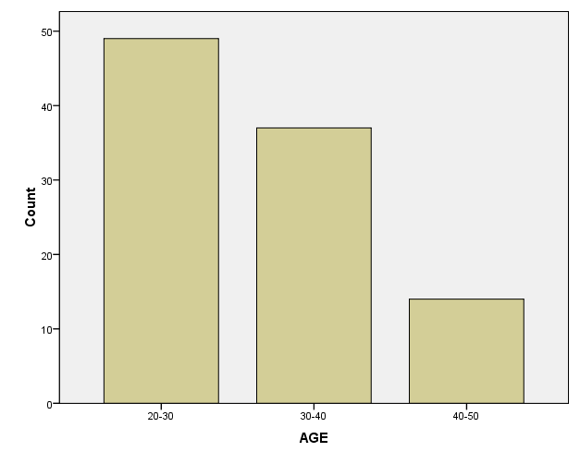

**TABLE 4.1.2 GENDER OF THE RESPONDENTS**

|  | **GENDER** | **Frequency** | **Percent** | **Valid Percent** | **Cumulative Percent** |
| --- | --- | --- | --- | --- | --- |
| **Valid** | **MALE** | **81** | **81.0** | **81.0** | **81.0** |
| **FEMALE** | **19** | **19.0** | **19.0** | **100.0** |
| **Total** | **100** | **100.0** | **100.0** |  |

**INTERPRETATION:**

It is clearly analyses from the above table81%of respondents are male.19% of respondents are female.

**CHART 4.1.1 GENDER OF THE RESPONDENT**

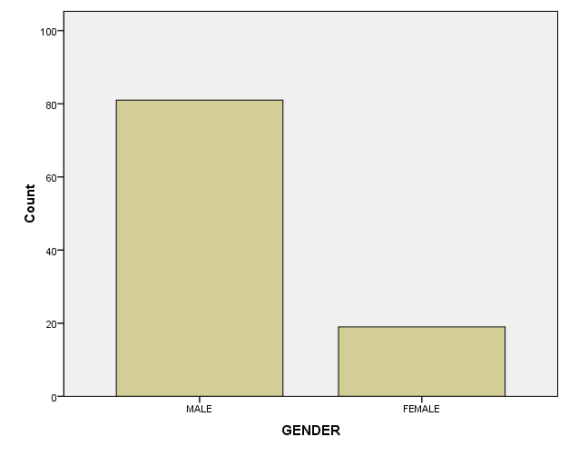

**TABLE4.1.3 CADRE OF THE RESPONDENTS**

|  | **CADRE** | **Frequency** | **Percent** | **Valid Percent** | **Cumulative Percent** |
| --- | --- | --- | --- | --- | --- |
| **Valid** | **EXECUTIVES** | **59** | **59.0** | **59.0** | **59.0** |
| **JUNIOR EXECUTIVES** | **41** | **41.0** | **41.0** | **100.0** |
| **Total** | **100** | **100.0** | **100.0** |  |

**INTERPRETATION:**

The above table shows that 59% of employee’s are executives. 41% of employee’s are Junior executives.

**CHART 4.1.3 CADRE OF THE RESPONDENTS**

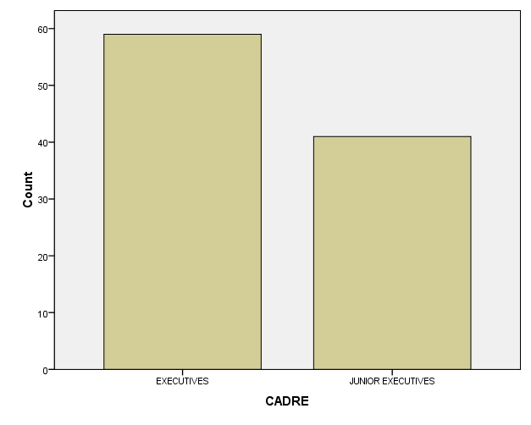

**TABLE 4.1.4 EXPERIENCE OF THE RESPONDENTS**

|  | **EXPERIENCE** | **Frequency** | **Percent** | **Valid Percent** | **Cumulative Percent** |
| --- | --- | --- | --- | --- | --- |
| Valid | **0-5** | **60** | **60.0** | **60.0** | **60.0** |
| **6-10** | **29** | **29.0** | **29.0** | **89.0** |
| **11-15** | **8** | **8.0** | **8.0** | **97.0** |
| **16-20** | **3** | **3.0** | **3.0** | **100.0** |
| **Total** | **100** | **100.0** | **100.0** |  |

**INTERPERTATION:**

It prevails from the above table 60% of respondents are in the experience of 0-5. 29% of respondents are in the experience of 6-10. 8% of respondents are in the experience of 11-15. 3% of respondents are in the experience of 16-20.

**CHART 4.1.4 EXPERIENCE OF THE RESPONDENTS**

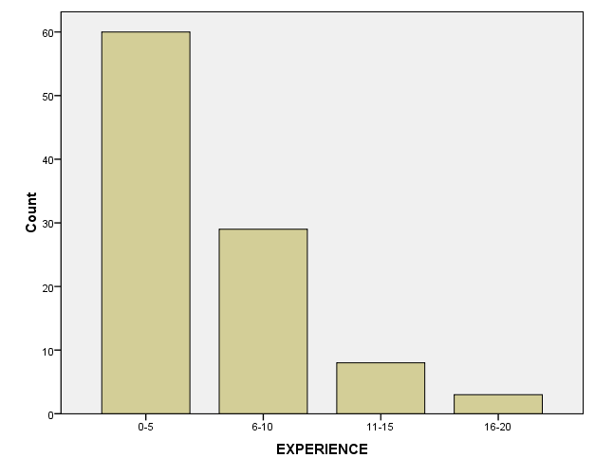

**TABLE 4.1.5 SATISFACTION OF THE ORGANIZATION**

|  | **LEVEL OF SATISFACTION** | **Frequency** | **Percent** | **Valid Percent** | **Cumulative Percent** |
| --- | --- | --- | --- | --- | --- |
| **Valid** | **STRONGLY DISAGREE** | **10** | **10.0** | **10.0** | **10.0** |
| **DISAGREE** | **7** | **7.0** | **7.0** | **17.0** |
| **NEUTRAL** | **14** | **14.0** | **14.0** | **31.0** |
| **AGREE** | **51** | **51.0** | **51.0** | **82.0** |
| **STRONGLY AGREE** | **18** | **18.0** | **18.0** | **100.0** |
| **Total** | **100** | **100.0** | **100.0** |  |

**INTERPRETATION:**

It is clearly analyses from the above table 51% of respondents agree with the satisfaction of the organization.18%of respondents strongly agree with the satisfaction of the organization.14%of respondents neutral with the satisfaction of the organization.10%of respondents strongly disagree with the satisfaction of the organization.7%of the respondents disagree with the satisfaction of the organization.

**CHART 4.1.5 SATISFACTION OF THE ORGANIZATION**

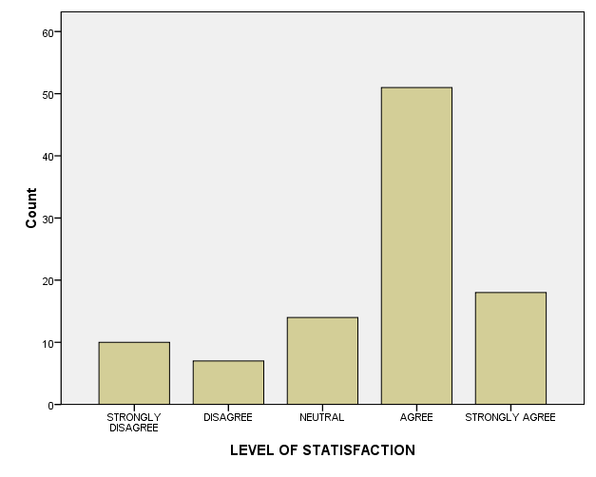

**TABLE4.1.6 MOTIVATING OF THE EMPLOYEE’S**

|  | **MOTIVATING EMPLOYEES** | **Frequency** | **Percent** | **Valid Percent** | **Cumulative Percent** |
| --- | --- | --- | --- | --- | --- |
| **Valid** | **STRONGLY DISAGREE** | **1** | **1.0** | **1.0** | **1.0** |
| **DISAGREE** | **10** | **10.0** | **10.0** | **11.0** |
| **NEUTRAL** | **22** | **22.0** | **22.0** | **33.0** |
| **AGREE** | **45** | **45.0** | **45.0** | **78.0** |
| **STRONGLY AGREE** | **22** | **22.0** | **22.0** | **100.0** |
| **Total** | **100** | **100.0** | **100.0** |  |

**INTERPRETATION:**

The above table shows that 45% of respondents agree with motivating of the employee’s.22% of respondents neutral with motivating of the employee’s. 22% of respondents strongly agree with motivating of the employee’s. 10% of respondents disagree with motivating of the employee’s. 1% of respondents strongly disagree with motivating of the employee’s.

**CHART 4.1.6 MOTIVATING OF THE EMPLOYEE’S**

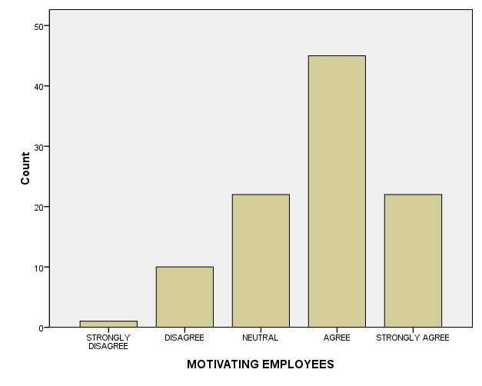

**TABLE 4.1.7 FEEL SECURED IN THE ORGANIZATION**

|  | **FEEL SECURED** | **Frequency** | **Percent** | **Valid Percent** | **Cumulative Percent** |
| --- | --- | --- | --- | --- | --- |
| **Valid** | **STRONGLY DISAGREE** | **5** | **5.0** | **5.0** | **5.0** |
| **DISAGREE** | **6** | **6.0** | **6.0** | **11.0** |
| **NEUTRAL** | **28** | **28.0** | **28.0** | **39.0** |
| **AGREE** | **42** | **42.0** | **42.0** | **81.0** |
| **STRONGLY AGREE** | **19** | **19.0** | **19.0** | **100.0** |
| **Total** | **100** | **100.0** | **100.0** |  |

**INTERPRETATION:**

It prevails from the above table 42% of respondents agree to feel secured in their job. 28% of respondents neutral to feel secured in their job. 19% of respondents strongly agree to feel secured in their job. 6% of respondents disagree to feel secured in their job. 5% of respondents strongly disagree to feel secured in their job.

**CHART 4.1.7 FEEL SECURED IN THE ORGANIZATION**

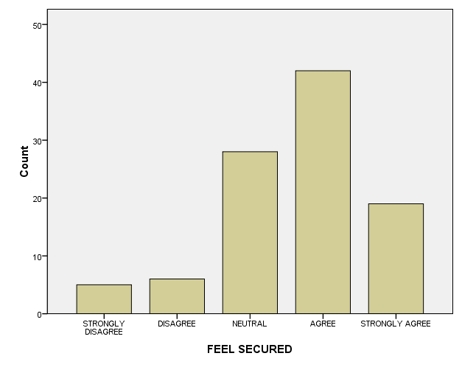

**TABLE 4.1.8 GOOD RELETIONSHIP IN THE ORGANIZATION**

|  | **GOOD RELATIONSHIP** | **Frequency** | **Percent** | **Valid Percent** | **Cumulative Percent** |
| --- | --- | --- | --- | --- | --- |
| **Valid** | **STRONGLY DISAGREE** | **6** | **6.0** | **6.0** | **6.0** |
| **DISAGREE** | **7** | **7.0** | **7.0** | **13.0** |
| **NETURAL** | **16** | **16.0** | **16.0** | **29.0** |
| **AGREE** | **46** | **46.0** | **46.0** | **75.0** |
| **STRONGLY AGREE** | **25** | **25.0** | **25.0** | **100.0** |
| **Total** | **100** | **100.0** | **100.0** |  |

**INTERPRETATION:**

It is clearly analyses from the above table 46%of respondents agree with the good relationship in the organization. 25%of respondents strongly agree with the good relationship in the organization. 16%of respondents neutral with the good relationship in the organization. 7%of respondents disagree with the good relationship in the organization. 6%of respondents strongly disagree with the good relationship in the organization.

**CHART 4.1.8 GOOD RELETIONSHIP IN THE ORGANIZATION**

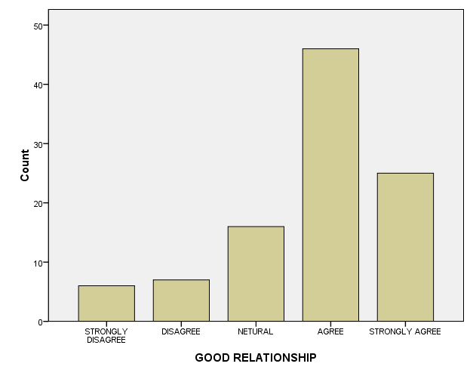

**TABLE 4.1.9 DECISIONS REGARDING THE WORK**

|  | **DECISION MAKING** | **Frequency** | **Percent** | **Valid Percent** | **Cumulative Percent** |
| --- | --- | --- | --- | --- | --- |
| **Valid** | **STRONGLY DISAGREE** | **8** | **8.0** | **8.0** | **8.0** |
| **DISAGREE** | **10** | **10.0** | **10.0** | **18.0** |
| **NEUTRAL** | **20** | **20.0** | **20.0** | **38.0** |
| **AGREE** | **32** | **32.0** | **32.0** | **70.0** |
| **STRONGLY AGREE** | **30** | **30.0** | **30.0** | **100.0** |
| **Total** | **100** | **100.0** | **100.0** |  |

**INTERPRETATION:**

The above table shows that 32%of respondents agree with decision taken in the organization. 30%of respondents strongly agree with decision taken in the organization. 20%of respondents neutral with decision taken in the organization. 10%of respondents disagree with decision taken in the organization. 8%of respondents strongly disagree with decision taken in the organization.

**CHART 4.1.9 DECISIONS REGARDING THE WORK**

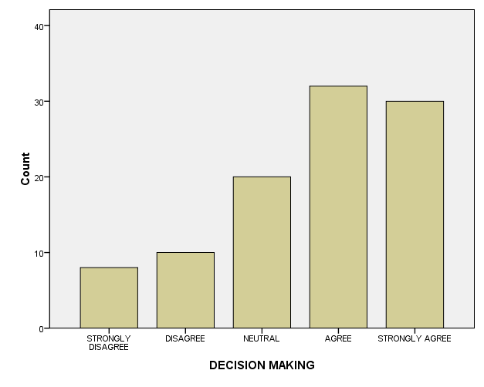

**TABLE 4.1.10 PERFORMANCE APPRAISAL ACTIVITIES**

|  | **PERFORMANCE APPRAISAL** | **Frequency** | **Percent** | **Valid Percent** | **Cumulative Percent** |
| --- | --- | --- | --- | --- | --- |
| **Valid** | **STRONGLY DISAGREE** | **12** | **12.0** | **12.0** | **12.0** |
| **DISAGREE** | **16** | **16.0** | **16.0** | **28.0** |
| **NEUTRAL** | **24** | **24.0** | **24.0** | **52.0** |
| **AGREE** | **36** | **36.0** | **36.0** | **88.0** |
| **STRONGLY AGREE** | **12** | **12.0** | **12.0** | **100.0** |
| **Total** | **100** | **100.0** | **100.0** |  |

**INTERPRETATION:**

It prevails from the above table 36%of respondents agree with the performance appraisal activities in the organization. 24%of respondents neutral with the performance appraisal activities in the organization. 16%of respondents disagree with the performance appraisal activities in the organization. 12%of respondents strongly disagree with the performance appraisal in the organization. 12%of respondents strongly agree with the performance appraisal activities in the organization.

**CHART 4.1.10 PERFORMANCE APPRAISAL ACTIVITIES**

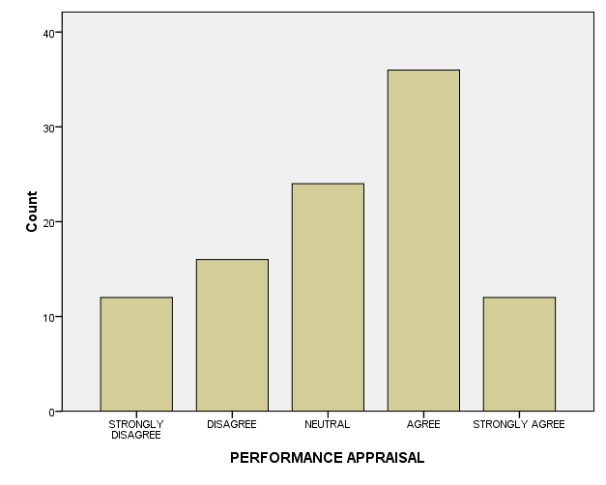

**TABLE 4.1.11 CAREER DEVELOPMENT OPPORTUNITIES**

|  | **CAREER DEVELOPMENT** | **Frequency** | **Percent** | **Valid Percent** | **Cumulative Percent** |
| --- | --- | --- | --- | --- | --- |
| Valid | STRONGLY DISAGREE | 2 | 2.0 | 2.0 | 2.0 |
| DISAGREE | 12 | 12.0 | 12.0 | 14.0 |
| NEUTRAL | 29 | 29.0 | 29.0 | 43.0 |
| AGREE | 44 | 44.0 | 44.0 | 87.0 |
| STRONGLY AGREE | 13 | 13.0 | 13.0 | 100.0 |
| Total | 100 | 100.0 | 100.0 |  |

**INTERPRETATION:**

It is clearly analyses from the above table 44%of respondents agree with career development in the organization. 29%of respondents neutral with career development in the organization. 13%of respondents strongly agree with career development in the organization. 12%of respondents disagree with career development in the organization. 2%of respondents disagree with career development in the organization.

**TABLE 4.1.11 CAREER DEVELOPMENT OPPORTUNITIES**

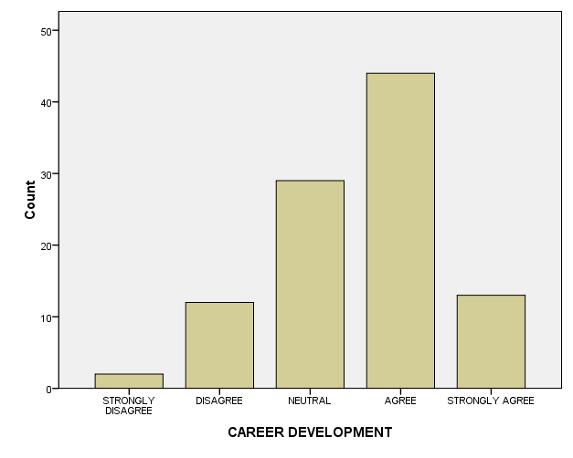

**TABLE 4.1.12 ACHIEVING POLICIES OF THE ORGANIZATION**

|  | **POLICIES** | **Frequency** | **Percent** | **Valid Percent** | **Cumulative Percent** |
| --- | --- | --- | --- | --- | --- |
| **Valid** | **STRONGLY DISAGREE** | **1** | **1.0** | **1.0** | **1.0** |
| **DISAGREE** | **12** | **12.0** | **12.0** | **13.0** |
| **NEUTRAL** | **32** | **32.0** | **32.0** | **45.0** |
| **AGREE** | **40** | **40.0** | **40.0** | **85.0** |
| **STRONGLY AGREE** | **15** | **15.0** | **15.0** | **100.0** |
| **Total** | **100** | **100.0** | **100.0** |  |

**INTERPRETATION:**

The above table shows that 40%of respondents agree with policies in the organization. 32%of respondents neutral with policies in the organization. 15%of respondents strongly agree with policies in the organization. 12%of respondents disagree with policies in the organization. 1%of respondents disagree with policies in the organization.

**CHART 4.1.12 ACHIEVING POLICIES OF THE ORGANIZATION**

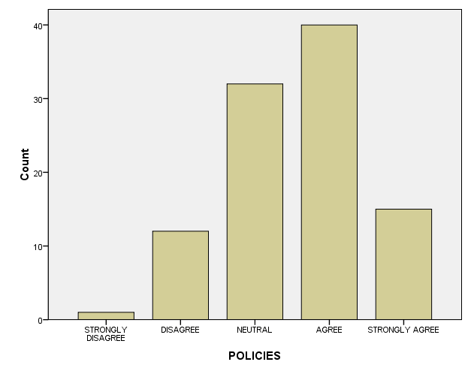

**TABLE 4.1.13 SUCCESS OF THE CAREER OBJECTIVES**

|  | **CAREER OBJECTIVES** | **Frequency** | **Percent** | **Valid Percent** | **Cumulative Percent** |
| --- | --- | --- | --- | --- | --- |
| **Valid** | **STRONGLY DISAGREE** | **1** | **1.0** | **1.0** | **1.0** |
| **DISAGREE** | **8** | **8.0** | **8.0** | **9.0** |
| **NEUTRAL** | **23** | **23.0** | **23.0** | **32.0** |
| **AGREE** | **43** | **43.0** | **43.0** | **75.0** |
| **STRONGLY AGREE** | **25** | **25.0** | **25.0** | **100.0** |
| **Total** | **100** | **100.0** | **100.0** |  |

**INTERPRETATION:**

It prevails from the above table 43%of respondents agree attaining the career objectives in the organization. 25%of respondents strongly agree with attaining the career objectives in the organization. 23%of respondents neutral with attaining the career objectives in the organization. 8%of respondents disagree with attaining the career objectives in the organization. 1%of respondents strongly disagree with attaining the career objectives in the organization.

**CHART 4.1.13 SUCCESS OF THE CAREER OBJECTIVES**

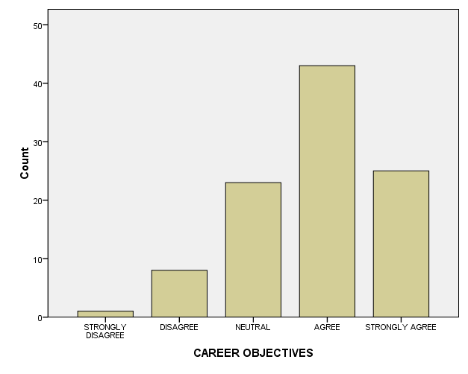

**TABLE 4.1.14 FREEDOM TO THE JOB**

|  | **FREEDOM** | **Frequency** | **Percent** | **Valid Percent** | **Cumulative Percent** |
| --- | --- | --- | --- | --- | --- |
| **Valid** | **STRONGLY DISAGREE** | **9** | **9.0** | **9.0** | **9.0** |
| **DISAGREE** | **4** | **4.0** | **4.0** | **13.0** |
| **NEUTRAL** | **18** | **18.0** | **18.0** | **31.0** |
| **AGREE** | **39** | **39.0** | **39.0** | **70.0** |
| **STRONGLY AGREE** | **30** | **30.0** | **30.0** | **100.0** |
| **Total** | **100** | **100.0** | **100.0** |  |

**INTERPRETATION:**

It is clearly analyses from the above table 39%of respondents agree with freedom to do the job in the organization. 30%of respondents strongly agree with freedom to do the job in the organization. 18%of respondents neutral with freedom to do the job in the organization. 9%of respondents strongly disagree with freedom to do the job in the organization. 4%of respondents disagree with freedom to do the job in the organization.

**CHART 4.1.14 FREEDOM TO THE JOB**

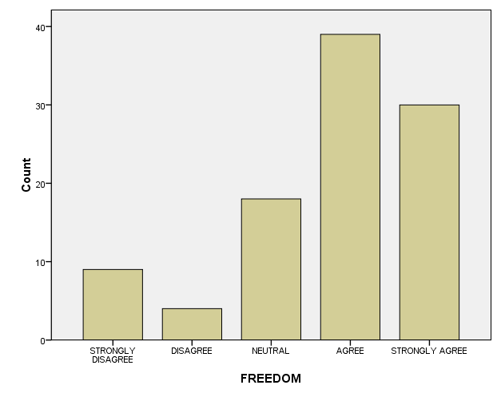

**TABLE 4.1.15 TRAINING CONDUCTED IN THE ORGANIZATION**

|  | **TRAINING AND DEVELOPMENT** | **Frequency** | **Percent** | **Valid Percent** | **Cumulative Percent** |
| --- | --- | --- | --- | --- | --- |
| **Valid** | **STRONGLY DISAGREE** | **4** | **4.0** | **4.0** | **4.0** |
| **DISAGREE** | **7** | **7.0** | **7.0** | **11.0** |
| **NEUTRAL** | **28** | **28.0** | **28.0** | **39.0** |
| **AGREE** | **47** | **47.0** | **47.0** | **86.0** |
| **STRONGLY AGREE** | **14** | **14.0** | **14.0** | **100.0** |
| **Total** | **100** | **100.0** | **100.0** |  |

**INTERPRETATION:**

The above table shows that 48%of respondents agree with training conducted in the organization. 288%of respondents neutral with training conducted in the organization. 14%of respondents strongly agree with training conducted in the organization. 7%of respondents disagree with training conducted in the organization. 4%of respondents strongly disagree with training conducted in the organization.

**CHART 4.1.15 TRAINING CONDUCTED IN THE ORGANIZATION**

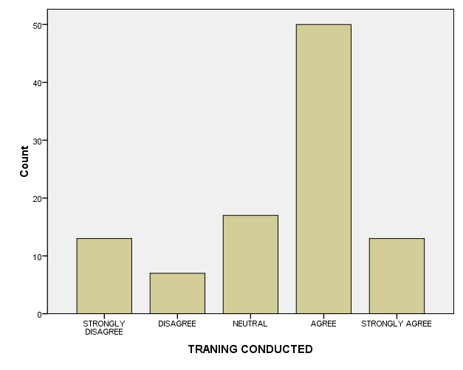

**TABLE 4.1.16 FAIRLY AND EQUALLY OF THE EMPLOYEE’S**

|  | **FAIRLY AND EQUALLY** | **Frequency** | **Percent** | **Valid Percent** | **Cumulative Percent** |
| --- | --- | --- | --- | --- | --- |
| **Valid** | **STRONGLY DISAGREE** | **3** | **3.0** | **3.0** | **3.0** |
| **DISAGREE** | **15** | **15.0** | **15.0** | **18.0** |
| **NEUTRAL** | **22** | **22.0** | **22.0** | **40.0** |
| **AGREE** | **43** | **43.0** | **43.0** | **83.0** |
| **STRONGLY AGREE** | **17** | **17.0** | **17.0** | **100.0** |
| **Total** | **100** | **100.0** | **100.0** |  |

**INTERPRETATION:**

It prevails from the above table 43%of respondents agree with treated fairly and equally in the organization. 22%of respondents neutral with treated fairly and equally in the organization. 17%of respondents strongly agree with treated fairly and equally in the organization. 15%of respondents disagree with treated fairly and equally in the organization. 3%of respondents strongly disagree with treated fairly and equally in the organization.

**CHART 4.1.16 FAIRLY AND EQUALLY OF THE EMPLOYEE’S**

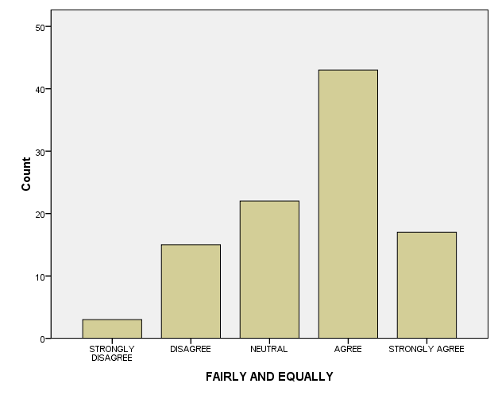

**TABLE 4.1.17 TRAINING AND DEVELOPMENT OF THE EMPLOYEE’S**

|  | **TRAINING AND DEVELOPMENT** | **Frequency** | **Percent** | **Valid Percent** | **Cumulative Percent** |
| --- | --- | --- | --- | --- | --- |
| **Valid** | **STRONGLY DISAGREE** | **4** | **4.0** | **4.0** | **4.0** |
| **DISAGREE** | **7** | **7.0** | **7.0** | **11.0** |
| **NEUTRAL** | **28** | **28.0** | **28.0** | **39.0** |
| **AGREE** | **47** | **47.0** | **47.0** | **86.0** |
| **STRONGLY AGREE** | **14** | **14.0** | **14.0** | **100.0** |
| **Total** | **100** | **100.0** | **100.0** |  |

**INTERPRETATION:**

It is clearly analyses from the above table 47%of respondents agree with training and development in the organization. 28%of respondents neutral with training and development in the organization. 14%of respondents strongly agree with training and development in the organization. 7%of respondents disagree with training and development in the organization. 4%of respondents strongly disagree with training and development in the organization.

**TABLE 4.1.17 TRAINING AND DEVELOPMENT OF THE EMPLOYEE’S**

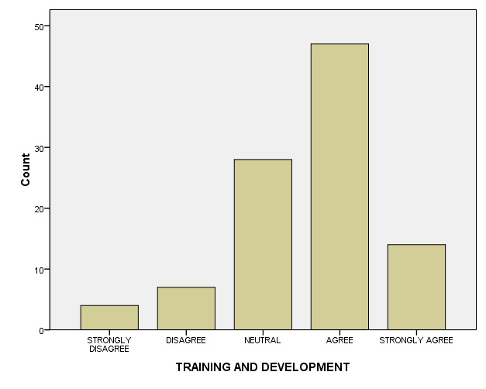

**TABLE 4.1.18 SATISFIED WITH THE HUMAN RESOURCE DEPARTMENT**

|  | **HUMAN DEPARTMENT** | **Frequency** | **Percent** | **Valid Percent** | **Cumulative Percent** |
| --- | --- | --- | --- | --- | --- |
| **Valid** | **STRONGLY DISAGREE** | **6** | **6.0** | **6.0** | **6.0** |
| **DISAGREE** | **11** | **11.0** | **11.0** | **17.0** |
| **NEUTRAL** | **20** | **20.0** | **20.0** | **37.0** |
| **AGREE** | **47** | **47.0** | **47.0** | **84.0** |
| **STRONGLY AGREE** | **16** | **16.0** | **16.0** | **100.0** |
| **Total** | **100** | **100.0** | **100.0** |  |

**INTERPRETATION:**

The above table shows that 47%of respondents agree with satisfaction of human resource department in the organization. 20%of respondents neutral with satisfaction of human resource department in the organization. 11%of respondents disagree with satisfaction of human resource department in the organization. 16%of respondents strongly agree with satisfaction of human resource department in the organization. 6%of respondents strongly disagree with satisfaction of human resource department in the organization.

**CHART 4.1.18 SATISFIED WITH THE HUMAN RESOURCE DEPARTMENT**

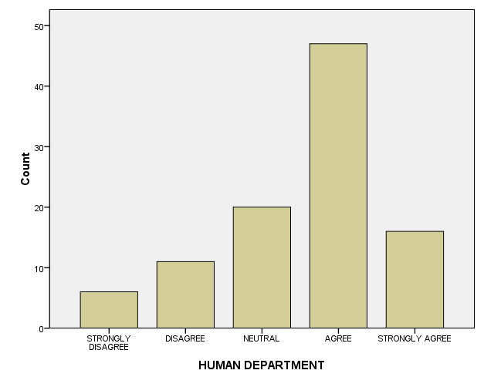

**TABLE 4.1.19 INTERESTED IN MOTIVATING THE EMPLOYEE’S**

|  | **INTEREST IN MOTIVATION** | **Frequency** | **Percent** | **Valid Percent** | **Cumulative Percent** |
| --- | --- | --- | --- | --- | --- |
| Valid | STRONGLY DISAGREE | 4 | 4.0 | 4.0 | 4.0 |
| DISAGREE | 7 | 7.0 | 7.0 | 11.0 |
| NEUTRAL | 20 | 20.0 | 20.0 | 31.0 |
| AGREE | 41 | 41.0 | 41.0 | 72.0 |
| STRONGLY AGREE | 28 | 28.0 | 28.0 | 100.0 |
| Total | 100 | 100.0 | 100.0 |  |

**INTERPRETATION:**

It prevails from the above table 41%of respondents agree with motivating the employee’s in the organization. 28%of respondents strongly agree with motivating the employee’s in the organization. 20%of respondents neutral with motivating the employee’s in the organization. 7%of respondents disagree with motivating the employee’s in the organization. 4%of respondents strongly disagree with motivating the employee’s in the organization.

**CHART 4.1.19 INTERESTED IN MOTIVATING THE EMPLOYEE’S**

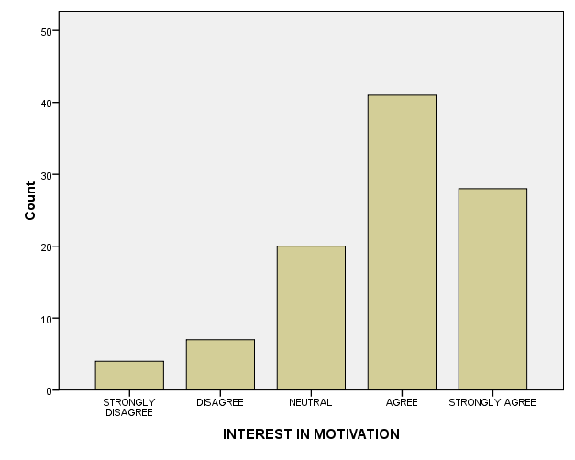

**TABLE 4.1.20 PERIODICAL INCREASE IN SALARY**

|  | **SALARY** | **Frequency** | **Percent** | **Valid Percent** | **Cumulative Percent** |
| --- | --- | --- | --- | --- | --- |
| **Valid** | **STRONGLY DISAGREE** | **13** | **13.0** | **13.0** | **13.0** |
| **DISAGREE** | **12** | **12.0** | **12.0** | **25.0** |
| **NEUTRAL** | **21** | **21.0** | **21.0** | **46.0** |
| **AGREE** | **36** | **36.0** | **36.0** | **82.0** |
| **STRONGLY AGREE** | **18** | **18.0** | **18.0** | **100.0** |
| **Total** | **100** | **100.0** | **100.0** |  |

**INTERPRETATION:**

It is clearly analyses from the above table 36%of respondents agree with salary increases in the organization. 21%of respondents neutral with salary increases in the organization. 18%of respondents strongly disagree with salary increases in the organization. 13%of respondents strongly disagree with salary increases in the organization. 12%of respondents disagree with salary increases in the organization.

**CHART 4.1.20 PERIODICAL INCREASE IN SALARY**

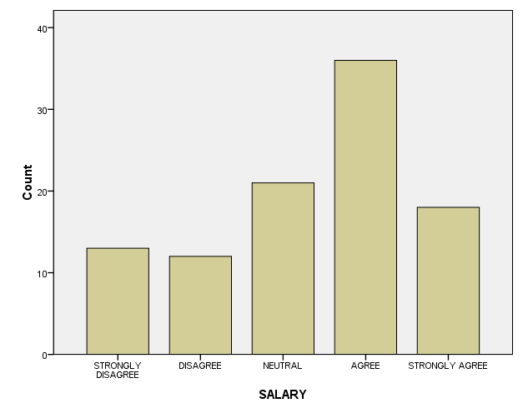

**TABLE 4.1.21 RETIREMENT BENEFITS OF THE EMPLOYEE’S**

|  | **RETIREMENT BENEFITS** | **Frequency** | **Percent** | **Valid Percent** | **Cumulative Percent** |
| --- | --- | --- | --- | --- | --- |
| **Valid** | **STRONGLY DISAGREE** | **3** | **3.0** | **3.0** | **3.0** |
| **DISAGREE** | **10** | **10.0** | **10.0** | **13.0** |
| **NEUTRAL** | **27** | **27.0** | **27.0** | **40.0** |
| **AGREE** | **43** | **43.0** | **43.0** | **83.0** |
| **STRONGLY AGREE** | **17** | **17.0** | **17.0** | **100.0** |
| **Total** | **100** | **100.0** | **100.0** |  |

**INTERPRETATION:**

The above table shows that 43%of respondents agree with retirement benefits in the organization. 27%of respondents neutral with retirement benefits in the organization. 17%of respondents strongly agree with retirement benefits in the organization. 10%of respondents disagree with retirement benefits in the organization. 3%of respondents strongly disagree with retirement benefits in the organization.

**CHART 4.1.21 RETIREMENT BENEFITS OF THE EMPLOYEE’S**

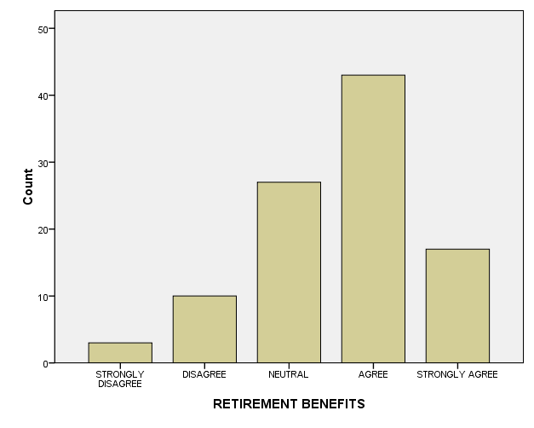

**TABLE 4.1.22 JOB SECURITY IN THE ORGANIZATION**

|  | **JOB SECURITY** | **Frequency** | **Percent** | **Valid Percent** | **Cumulative Percent** |
| --- | --- | --- | --- | --- | --- |
| **Valid** | **STRONGLY DISAGREE** | **2** | **2.0** | **2.0** | **2.0** |
| **DISAGREE** | **12** | **12.0** | **12.0** | **14.0** |
| **NEUTRAL** | **26** | **26.0** | **26.0** | **40.0** |
| **AGREE** | **44** | **44.0** | **44.0** | **84.0** |
| **STRONGLY AGREE** | **16** | **16.0** | **16.0** | **100.0** |
| **Total** | **100** | **100.0** | **100.0** |  |

**INTERPRETATION:**

The above table shows that 44%of respondents agree with job security in the organization. 26%of respondents neutral with job security in the organization. 16%of respondents strongly agree with job security in the organization. 12%of respondents disagree with job security in the organization. 2%of respondents strongly disagree with job security in the organization.

**CHART 4.1.22 JOB SECURITY IN THE ORGANIZATION**

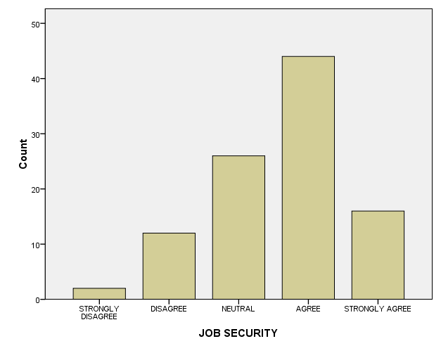

**TABLE 4.1.23 PROMOTIONAL OPPORTUNITIES IN THE ORGANIZATION**

|  | **PROMOTION** | **Frequency** | **Percent** | **Valid Percent** | **Cumulative Percent** |
| --- | --- | --- | --- | --- | --- |
| **Valid** | **STRONGLY DISAGREE** | **6** | **6.0** | **6.0** | **6.0** |
| **DISAGREE** | **6** | **6.0** | **6.0** | **12.0** |
| **NEUTRAL** | **17** | **17.0** | **17.0** | **29.0** |
| **AGREE** | **45** | **45.0** | **45.0** | **74.0** |
| **STRONGLY AGREE** | **26** | **26.0** | **26.0** | **100.0** |
| **Total** | **100** | **100.0** | **100.0** |  |

**INTERPRETATION:**

It prevails from the above table 45%of respondents agree with promotion opportunities to the employee’s in the organization. 26%of respondents strongly agree with promotional opportunities to the employee’s in the organization. 17%of respondents neutral with promotional opportunities to the employee are in the organization. 6%of respondents disagree with promotional opportunities to the employee’s in the organization. 6%of respondents strongly disagree with promotional opportunities to the employee’s in the organization.

**CHART 4.1.23 PROMOTIONAL OPPORTUNITIES IN THE ORGANIZATION**

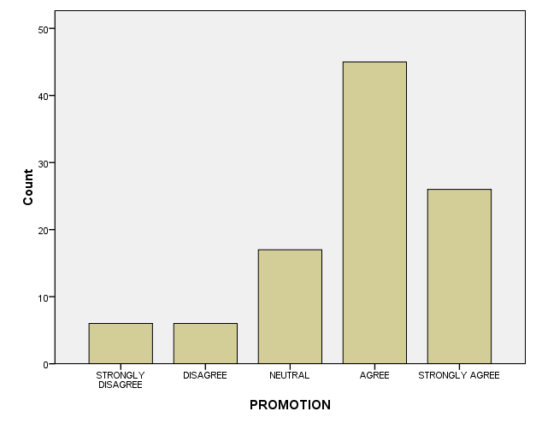

**TABLE 4.1.24 CAR OR BIKE FACILITIES TO THE EMPLOYEE’S**

|  | **CAR OR BIKE** | **Frequency** | **Percent** | **Valid Percent** | **Cumulative Percent** |
| --- | --- | --- | --- | --- | --- |
| **Valid** | **STRONGLY DISAGREE** | **7** | **7.0** | **7.0** | **7.0** |
| **DISAGREE** | **11** | **11.0** | **11.0** | **18.0** |
| **NEUTRAL** | **19** | **19.0** | **19.0** | **37.0** |
| **AGREE** | **33** | **33.0** | **33.0** | **70.0** |
| **STRONGLY AGREE** | **30** | **30.0** | **30.0** | **100.0** |
| **Total** | **100** | **100.0** | **100.0** |  |

**INTERPRETATION:**

It is clearly analyses from the above table 33%of respondents agree with car or bike provide to the employee’s in the organization. 30%of respondents strongly agree with car or bike provide to the employee’s in the organization. 19%of respondents neutral with car or bike provide to the employee’s in the organization. 11%of respondents disagree with car or bike provide to the employee’s in the organization. 7%of respondents strongly disagree with car or bike provide to the employee’s in the organization.

**CHART 4.1.24 CAR OR BIKE FACILITIES TO THE EMPLOYEE’S**

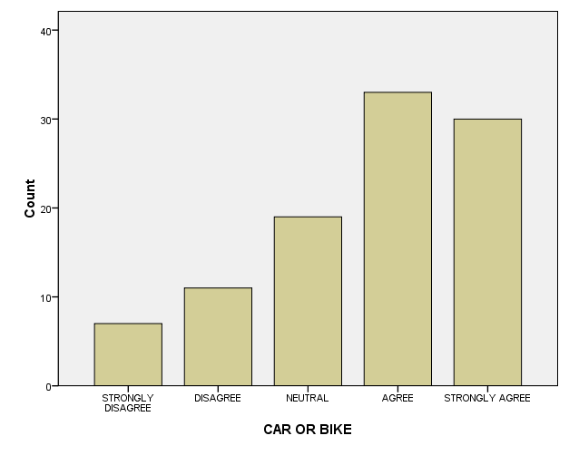

**TABLE 4.1.25 EMPLOYEE’S WELFARE SCHEME’S BY THE ORGANIZATION**

|  | **WELFARE SCHEME'S** | **Frequency** | **Percent** | **Valid Percent** | **Cumulative Percent** |
| --- | --- | --- | --- | --- | --- |
| **Valid** | **STRONGLY DISAGREE** | **18** | **18.0** | **18.0** | **18.0** |
| **DISAGREE** | **11** | **11.0** | **11.0** | **29.0** |
| **NEUTRAL** | **17** | **17.0** | **17.0** | **46.0** |
| **AGREE** | **32** | **32.0** | **32.0** | **78.0** |
| **STRONGLY AGREE** | **22** | **22.0** | **22.0** | **100.0** |
| **Total** | **100** | **100.0** | **100.0** |  |

**INTERPRETATION:**

The above table shows that 32%of respondents agree with welfare schemes in the organization. 22%of respondents strongly agree with welfare schemes in the organization. 18%of respondents strongly disagree with welfare schemes in the organization. 17%of respondents neutral with welfare schemes in the organization. 11%of respondents disagree with welfare schemes in the organization.

**CHART 4.1.25 EMPLOYEE’S WELFARE SCHEME’S BY THE ORGANIZATION**

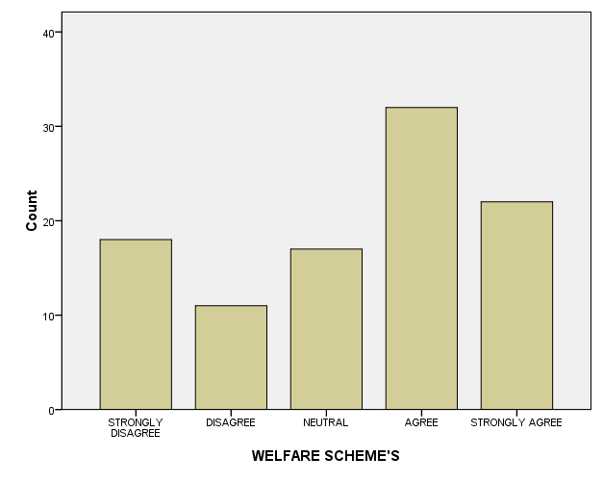

**TABLE 4.1.26 SATISFIED OF THE CANTEEN FACILITIES**

|  | **CANTEEN FACILITIES** | **Frequency** | **Percent** | **Valid Percent** | **Cumulative Percent** |
| --- | --- | --- | --- | --- | --- |
| **Valid** | **STRONGLY DISAGREE** | **4** | **4.0** | **4.0** | **4.0** |
| **DISAGREE** | **14** | **14.0** | **14.0** | **18.0** |
| **NEUTRAL** | **22** | **22.0** | **22.0** | **40.0** |
| **AGREE** | **39** | **39.0** | **39.0** | **79.0** |
| **STRONGLY AGREE** | **21** | **21.0** | **21.0** | **100.0** |
| **Total** | **100** | **100.0** | **100.0** |  |

**INTERPRETATION:**

It prevails from the above table 39%of respondents agree with canteen facilities to the employees in the organization. 22%of respondents neutral with canteen facilities to the employees in the organization. 21%of respondents strongly agree with canteen facilities to the employees in the organization. 14%of respondents disagree with canteen facilities to the employees in the organization. 4%of respondents strongly disagree with canteen facilities to the employees in the organization.

**CHART 4.1.26 SATISFIED OF THE CANTEEN FACILITIES**

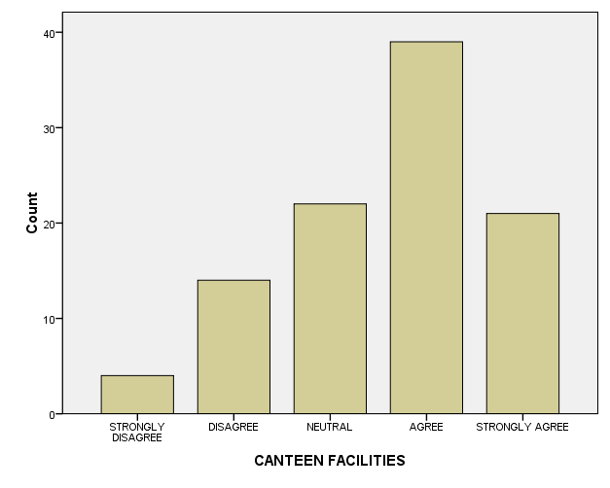

**TABLE 4.1.27 WORKING ROOM ATMOSPHERE**

|  | **WORKING ROOM** | **Frequency** | **Percent** | **Valid Percent** | **Cumulative Percent** |
| --- | --- | --- | --- | --- | --- |
| **Valid** | **STRONGLY DISAGREE** | **5** | **5.0** | **5.0** | **5.0** |
| **DISAGREE** | **11** | **11.0** | **11.0** | **16.0** |
| **NEUTRAL** | **18** | **18.0** | **18.0** | **34.0** |
| **AGREE** | **38** | **38.0** | **38.0** | **72.0** |
| **STRONGLY AGREE** | **28** | **28.0** | **28.0** | **100.0** |
| **Total** | **100** | **100.0** | **100.0** |  |

**INTERPRETATION:**

It is clearly analyses from the above table 38%of respondents agree with working atmosphere in the organization. 28%of respondents strongly agree with working atmosphere in the organization. 18%of respondents neutral with working atmosphere in the organization. 11%of respondents disagree with working atmosphere in the organization. 5%of respondents strongly disagree with working atmosphere in the organization.

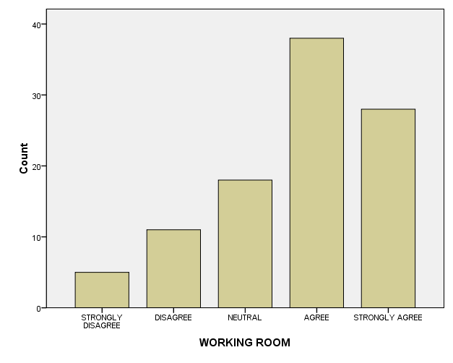**CHART 4.1.27 WORKING ROOM ATMOSPHERE**

**TABLE 4.1.28 FACILITIES FOR FIRST AID**

|  | **FIRST AID** | **Frequency** | **Percent** | **Valid Percent** | **Cumulative Percent** |
| --- | --- | --- | --- | --- | --- |
| **Valid** | **STRONGLY DISAGREE** | **4** | **4.0** | **4.0** | **4.0** |
| **DISAGREE** | **8** | **8.0** | **8.0** | **12.0** |
| **NEUTRAL** | **18** | **18.0** | **18.0** | **30.0** |
| **AGREE** | **47** | **47.0** | **47.0** | **77.0** |
| **STRONGLY AGREE** | **23** | **23.0** | **23.0** | **100.0** |
| **Total** | **100** | **100.0** | **100.0** |  |

**INTERPRETATION:**

The above table shows that 47%of respondents agree with first aid facilities in the organization. 23%of respondents strongly agree with first aid facilities in the organization. 18%of respondents neutral with first aid facilities in the organization. 8%of respondents disagree with first aid facilities in the organization. 4%of respondents strongly disagree with first aid facilities in the organization.

**CHART 4.1.28 FACILITIES FOR FIRST AID**

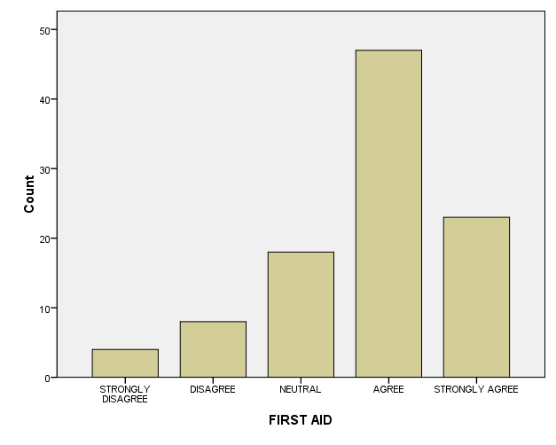

**TABLE 4.1.29 FACILITIES FOR DRINKING WATER**

|  | **DRINKING WATER** | **Frequency** | **Percent** | **Valid Percent** | **Cumulative Percent** |
| --- | --- | --- | --- | --- | --- |
| **Valid** | **STRONGLY DISAGREE** | **13** | **13.0** | **13.0** | **13.0** |
| **DISAGREE** | **3** | **3.0** | **3.0** | **16.0** |
| **NEUTRAL** | **8** | **8.0** | **8.0** | **24.0** |
| **AGREE** | **36** | **36.0** | **36.0** | **60.0** |
| **STRONGLY AGREE** | **40** | **40.0** | **40.0** | **100.0** |
| **Total** | **100** | **100.0** | **100.0** |  |

**INTERPRETATION:**

It prevails from the above table 40%of respondents strongly agree with drinking water facilities in the organization. 36%of respondents agree with drinking water facilities in the organization. 13%of respondents strongly disagree with drinking water facilities in the organization. 8%of respondents neutral with drinking water facilities in the organization. 3%of respondents disagree with drinking water facilities in the organization.

**CHART 4.1.29 FACILITIES FOR DRINKING WATER**

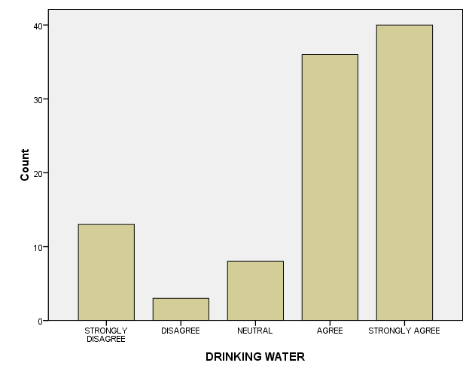

**4.2 Correlations**

| **Descriptive Statistics** | | | |
| --- | --- | --- | --- |
|  | Mean | Std. Deviation | N |
| TRAINING AND DEVELOPMENT | 3.6000 | .95346 | 100 |
| HUMAN DEPARTMENT | 3.5600 | 1.07609 | 100 |

| **Correlations** | | | |
| --- | --- | --- | --- |
|  |  | TRAINING AND DEVELOPMENT | HUMAN DEPARTMENT |
| TRAINING AND DEVELOPMENT | Pearson Correlation | 1 | .289** |
| Sig. (2-tailed) |  | .003 |
| N | 100 | 100 |
| HUMAN DEPARTMENT | Pearson Correlation | .289** | 1 |
| Sig. (2-tailed) | .003 |  |
| N | 100 | 100 |
| **. Correlation is significant at the 0.01 level (2-tailed). | | |  |

**INFERENCE:**

This means that there is a strong relationship between two variables. This means that changes in one variable are strongly correlated with changes in the second variable. In our example, Pearson’s r is 0.289. This number is very close to 1. For this reason, we can conclude that there is a positive relationship between training and development and human resource department .

**4.3 CHI – SQUARE TEST**

H0: There is a relationship between the experience and the salary

H1: There is no relationship between the experience and the salary

| **Descriptive Statistics** | | | | | |
| --- | --- | --- | --- | --- | --- |
|  | **N** | **Mean** | **Std. Deviation** | **Minimum** | **Maximum** |
| **EXPERIENCE** | **100** | **1.5400** | **.77094** | **1.00** | **4.00** |
| **SALARY** | **100** | **3.3400** | **1.27303** | **1.00** | **5.00** |

**Chi-Square Test**

**Frequencies**

| **EXPERIENCE** | | | |
| --- | --- | --- | --- |
|  | **Observed N** | **Expected N** | **Residual** |
| **0-5** | **60** | **25.0** | **35.0** |
| **6-10** | **29** | **25.0** | **4.0** |
| **11-15** | **8** | **25.0** | **-17.0** |
| **16-20** | **3** | **25.0** | **-22.0** |
| **Total** | **100** |  |  |

| **SALARY** | | | |
| --- | --- | --- | --- |
|  | **Observed N** | **Expected N** | **Residual** |
| **STRONGLY DISAGREE** | **13** | **20.0** | **-7.0** |
| **DISAGREE** | **12** | **20.0** | **-8.0** |
| **NEUTRAL** | **21** | **20.0** | **1.0** |
| **AGREE** | **36** | **20.0** | **16.0** |
| **STRONGLY AGREE** | **18** | **20.0** | **-2.0** |
| **Total** | **100** |  |  |

| **Test Statistics** | | |
| --- | --- | --- |
|  | **EXPERIENCE** | **SALARY** |
| **Chi-Square** | **80.560a** | **18.700b** |
| **df** | **3** | **4** |
| **Asymp. Sig.** | **.000** | **.001** |
|  | | |
|  | | |

| 1. 0 cells (.0%) have expected frequencies less than 5. The minimum expected cell frequency is 25.   b. 0 cells (.0%) have expected frequencies less than 5. The minimum expected cell frequency is 20. |
| --- |

**INFERENCE:**

We can conclude there is no relationship between the experience and the employee’s salary.

Hence it is accepted.

**5.1 FINDINGS**

* 83% of the employees have a good opinion and satisfaction with the organization.
* 45% of the employees have chosen “Agree” option for their motivation level from the organization. 22% employees have chosen strongly agree option and 22% of them neutrally responded.
* Nearly 89% of the employees feel secured about their job.
* 71% of the employees have said that they have a very good relationship in the organization.13% of the employees have shown a negative opinion in this regards.
* Nearly 81% of the employees have said that they are considered in the decision making process at their work.
* 36% of the employees gave agree rating and 12% of the employees have given strongly agree rating for the performance appraisal activities in the organization. 24% of the employees have chosen neutral options and 28% of them are against these.
* 57% of the employees have said that they have career development opportunities in the organization.
* Almost all the employees have given a good feedback on the process of achieving their aims and objectives of the organization.
* Nearly 91% of the employees have agreed that they are successful in achieving their career objectives.
* Almost all the employees have agreed that they are given maximum freedom to do their job.
* 89% of the employees have agreed that the training conducted in the organization is going good.
* 82% of the employees have said that they are treated fairly and equally during the training period
* The employees have given a good feedback on the periodical scheduling of the training and development program.
* Almost 83% of the employees are satisfied with the human resources department. 17% of the respondents have given a negative opinion.
* Nearly 89% of the employees have said that the organization is showing a great interest in motivating the employees.
* 36% of the employees have chosen agree option and 18% of them have chosen strongly agree option, regarding the periodical increase in salary. 25% of them have disagree with this and 21% of them are neutral.
* 87% of the employees have agreed that they have their retirement benefits through the organization.
* 60% of the employees have agreed that they have their job security in the organization with regards to intrinsic motivation.
* Nearly 88% of the employees have shown a good sign on the promotional opportunities in the organization.
* Almost all the employees have said that they are provided transport facilities within the official working sites. 18% of the employees have chosen negative responses.
* 54% of the employees have given a good feedback about the employees welfare schemes provided by the organization. 17% of the employees are neutrally satisfied.
* Nearly 82% of the employees are satisfied with the canteen facilities in the organization.
* 66% of the employees have agreed that they are provided a good working room atmosphere. 16% of them have disagreed with this.
* A good feedback is given about the first aid facilities available in the organization.
* Around 84% of the employees have given a good opinion about the drinking water facilities available in the organization.16% of them have disagreed with this.
* Performance level of the employees has increased greatly due to the organization motivations.

**5.2 SUGGESTIONS AND RECOMMENDATIONS**

* The organization could attend on training of employees in various skills my study confirms that the employees around that some are not happy with the current training. Hence could suggest improve their aspect.
* The feedback from the employees should be regularly obtained in order to understand effectiveness and employees motivation.
* Relationship between employees and employer needs to be improved.
* The management should pay more attention for the employee’s involvement in decision making.
* The organization should take measure to improve promotional opportunities.
* Employees safety and welfare measures provided by the organization needs to be improved.
* The management should Recognize and reward the employee who performs well.
* Training on technical assistance can be given to the employees based on their educational background and their role in the project involved in the organization.
* Every respondents needs to be motivated to work hard to gain the desired knowledge and skills in the organization.
* The higher management’s awareness about the importance of motivations and its various ways of achieving their goals in the organization.

**5.3 CONCLUSION**

* Motivation is one of the cores of management.
* Motivation creates an environment where willingness is created in the minds of employees to work efficiently and to increase the productivity.
* The study helped to find motivational programmers’ which are conducted in the organization.
* The employees are properly motivated they work efficiently and effectively in the organization.
* There are various factors that motivate the employees such as salary, working conditions, welfare measures, and promotion policies and so on. Motivation is ultimate function of so many individuals attitudes in the organization.
* From the study I concluded that the company uses various factors to motivate employees and it was found to be effective.

The study has been made at Titan Industries, sriperambudur, Chennai has shown that generally the employees are highly motivated in all the areas contributing towards the motivation except for a few factors like requirement of the on- the job training, grievances redresses procedure, non- financial motivators and canteen facilities.

There is no simple answer to the question of how to motive the people. Can money motivate? Yes, but money alone is not enough though it does help. More than the monetary benefits the employee expects many things. And so, from the study it is found that the management should take more care in employee benefits. Not only by providing the benefits more than that the employee should be motivated by boosting him. The management should consider many things that discussed in the study. To conclude, HIGHLY MOTIVATED EMPLOYEE IS AN ASSET FOR THE ORGANISATION.

**BOOKS REFERRED:**

* **Stephen P. Robbins,** Organization Behavior, Twelfth Edition, Pg. 184.
* **P C Tripathi,** Principles of Management, Fourth Edition, Pg. 255.
* **Kothari.C.R.** Research Methodology, New Age international Publishers, 2nd Edition.

**TECHNICAL REFERENCE:**

[www.google.com](http://www.google.com)

[www.scribd.com](http://www.scribd.com)

[www.managementparadise.com](http://www.managementparadise.com)

[www.hyundai.com](http://www.hyundai.com)

ANNEXURE

Dear Sir/Madam,

NAME (OPTIONAL):

AGE:

1. 20-30 b) 30-40 c) 40-50

DESIGNATION:

GENDER: a) MALE b) FEMALE

CADER: a) EXE b) JEX

EXPERIENCE (in HMI): a) 1-5 b) 6-10 c) 11- 15 d) 16-20

**RELATIONSHIP BETWEEN SUPERVISOR & EMPLOYEES**:

|  |  |  |  |  |  |  |
| --- | --- | --- | --- | --- | --- | --- |
| S.NO | QUESTIONNAIRE | STRONGLY  DISAGREE | DISAGREE | NEUTRAL | AGREE | STRONGLY AGREE |
| 1. | Satisfied with the working culture of the organization |  |  |  |  |  |
| 2. | Management is interested in motivating the employees |  |  |  |  |  |
| 3. | Employees in the organization feel secured in their job |  |  |  |  |  |
| 4. | Good relationship with co staff members |  |  |  |  |  |
| 5. | Employees have a voice in major decisions regarding changes in the work |  |  |  |  |  |

**CAREER ADVANCEMENT**:

|  |  |  |  |  |  |  |
| --- | --- | --- | --- | --- | --- | --- |
| S.NO | QUESTIONNAIRE | STRONGLY  DISAGREE | DISAGREE | NEUTRAL | AGREE | STRONGLY AGREE |
| 6. | Performance appraisal activities are motivating |  |  |  |  |  |
| **7.** | Carrier development opportunities motivates the employees |  |  |  |  |  |
| 8. | Organizational Policies motivates for achieving its aims and objectives |  |  |  |  |  |
| 9. | Successful in attaining the career objectives |  |  |  |  |  |
| 10. | Satisfied with the freedom to do the job |  |  |  |  |  |

**TRAINING & DEVELOPMENT**:

|  |  |  |  |  |  |  |
| --- | --- | --- | --- | --- | --- | --- |
| S.NO | QUESTIONNAIRE | STRONGLY  DISAGREE | DISAGREE | NEUTRAL | AGREE | STRONGLY AGREE |
| 11. | The training sessions conducted in the organization is very useful |  |  |  |  |  |
| 12. | Employees are treated fairly & equally |  |  |  |  |  |
| 13. | Satisfied with the training & development of employees |  |  |  |  |  |
| 14. | Satisfied with the support from HR department |  |  |  |  |  |
| 15. | Management is really interested in motivating the employees |  |  |  |  |  |

**PAY AND PROMOTION**:

|  |  |  |  |  |  |  |
| --- | --- | --- | --- | --- | --- | --- |
| S.NO | QUESTIONNAIRE | STRONGLY  DISAGREE | DISAGREE | NEUTRAL | AGREE | STRONGLY  AGREE |
| 16. | Reasonable periodical increase in salary |  |  |  |  |  |
| 17. | The retirement benefits available to the employees are useful |  |  |  |  |  |
| 18. | Job security exist in the organization |  |  |  |  |  |
| 19. | Effective promotional opportunities in the organization |  |  |  |  |  |
| 20. | Provides car or bike to the employees for company purpose |  |  |  |  |  |

**SAFETY AND WELFARE MEASURES**:

|  |  |  |  |  |  |  |
| --- | --- | --- | --- | --- | --- | --- |
| S.NO | QUESTIONNAIRE | STRONGLY  DISAGREE | DISAGREE | NEUTRAL | AGREE | STRONGLY  AGREE |
| 21. | Satisfied with the employees welfare scheme’s given by the organization |  |  |  |  |  |
| 22. | Satisfied with the canteen facilities |  |  |  |  |  |
| 23. | Satisfied with the working room atmosphere |  |  |  |  |  |
| 24. | Facilities for first aid |  |  |  |  |  |
| 25. | Facilities for drinking water |  |  |  |  |  |