**CONTENTS**

**CHAPTER-:1**

**INTRODUCTION**

* INTRODUCTION
* OBJECTIVE OF THE STUDY
* METHODOLOGY OF THE STUDY
* LIMTATION OF THE STUDY

**CHAPTER-:2**

**COMPANY PROFILE**

* VISION&MISION OF THE COMPANY
* HISTORY OF THE COMPANY
* AWARDS&ACHIVEMENT OF THE COMPANY
* STRUCTURE OF THE COMPANY
* ORGANOGRAM OF THE COMPANY
* STRUCTURE OF THE COMPANY.

**CHAPTER -:3**

**INRODUCTION OF TOPIC (RECRUITMENT & SELECTION)**

**Recruitment**

* OBJECTIVE OF THIS PROJECT
* Definition of RECRUITMENT
* Need and Importance
* PROCESS of RECRUITMENT
* RECRUITMENT CYCLE
* FACTOR AFFECTING RECRUITMENT
* RECRUITMENT PROCESS IN COCA COLA KHURDA

**Selection**

* Meaning of Selection.
* Process of Selection.
* Interview.
* Process of Interview.
* Interview Evaluation.

**CHAPTER-:4**

* SUGGESTIONS
* FINDING
* CONCLUSIONS

**Introduction**

This project is about Interview Evaluation process which I have done in Hindustan Coca Cola Beverages Pvt. Ltd. KHURDA , Orissa which will be helpful for the organization to know the different Para meters, that are taken into consideration while recruitment. The study gives a brief idea about the company, its history and what strategies the company should adopt that will reduce the time and cost in recruitment process. Recruitment has been regarded as the most important function of the HR department , because unless the right type of people are hired, even the best plans, organization chart and control system would not do much good. Recruitment is the discovering of potential applicant for actual or anticipated organizational vacancies. Recruitment is starting from identifying job vacancies/ Manpower Planning to on boarding of candidates.

**OBJECTIVE Of The Study**

1. To study the recruitment and selection procedure followed in Coca Cola, KHURDA.

2: To study the various sources of recruitment.

4: To search the general parameters that are taken into consideration, while Recruitment.

**METHODOLOGY OF THE STUDY**

In everyday life human being has to face many problems viz. social, economic, financial problems. These problems in life call for acceptable and effective solutions and for this purpose, research is required and a methodology applied for the solutions can be found out.

Research was carried out at Hindustan Coca Cola Beverages Pvt .Ltd to find out the “Recruitment and selection process” and doing research on how to reduce the turnaround time in recruitment process at Coca Cola, **KHURDA** are unit.

**DATA COLLECTION:**

For this project I have collected data by studying the Coca Cola own recruitment process and by surfing in the net. I have found that interview evaluation is very important for any organization, because without knowing the employees quality like, leadership, communication skill, problem solving, team work,etc.if they recruit him/her it can’t be effective for the organization. Bye Inter Evaluation the recruiter can know the the quality that the candidate have, so that it will help them in recruitment process.

**Primary Data:**

Primary data was collected through studying and understanding the process followed in recruitment at Coca Cola , Khurda unit.

**Secondary Data:**

Data was collected from books, magazines, web sites, going through the records of the organisation, etc. It is the data which has been collected by individual or someone else for the purpose of other than those of our particular research study. Or in other words we can say that secondary data is the data used previously for the analysis and the results are undertaken for the next process.

**Limitation Of The Study**

* Recruitment process is very lengthy one in Coca cola, Khurda, and Odisha.
* It takes quite long time to recruit a person who will fitted for the company or may be not..
* If the decision is wrong then the company bear loss as well as waste time.
* So the company should use modern techniques for recruitment some of which given below in my findings which will beneficial for the organization.

***CHAPTER:-2***

THE COCA- COLA,ATLANTA, GEORGIA

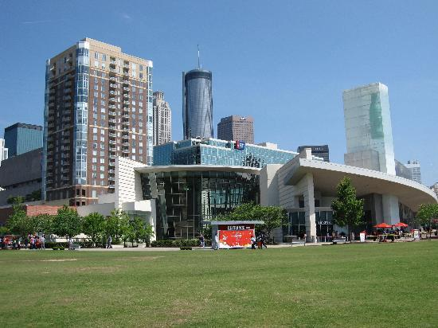

**The Coca-Cola Company** is an American multinational beverage corporation and manufacturer, retailer and marketer of non-alcoholic beverage concentrates and syrups. The company is best known for its flagship product [Coca-Cola](http://en.wikipedia.org/wiki/Coca-Cola), invented in 1886 by pharmacist [John StithPemberton](http://en.wikipedia.org/wiki/John_Stith_Pemberton) in [Columbus, Georgia](http://en.wikipedia.org/wiki/Columbus,_Georgia). The Coca-Cola formula and brand was bought in 1889 by [Asa Candler](http://en.wikipedia.org/wiki/Asa_Candler" \o "Asa Candler) who incorporated The Coca-Cola Company in 1892. Besides its namesake Coca-Cola beverage, Coca-Cola currently offers more than 500 brands in over 200 countries or territories and serves over1.7 billion Servings each day. The company operates a [franchised](http://en.wikipedia.org/wiki/Franchising) distribution system dating from 1889 where The Coca-Cola Company only produces syrup concentrate which is then sold to various [bottlers](http://en.wikipedia.org/wiki/Bottler_(company)) throughout the world who hold an exclusive territory. The Coca-Cola Company owns its [anchor bottler](http://en.wikipedia.org/wiki/Anchor_bottler) in North America, Coca-Cola Refreshments. The Coca-Cola Company is headquartered in [Atlanta](http://en.wikipedia.org/wiki/Atlanta), [Georgia](http://en.wikipedia.org/wiki/Georgia_(U.S._state)), United States. Its stock is listed on the [NYSE](http://en.wikipedia.org/wiki/New_York_Stock_Exchange) and is part of [DJIA](http://en.wikipedia.org/wiki/Dow_Jones_Industrial_Average), [S&P 500 Index](http://en.wikipedia.org/wiki/S%26P_500_Index), the [Russell 1000 Index](http://en.wikipedia.org/wiki/Russell_1000_Index) and the Russell 1000 Growth Stock Index**. Its current chairman and chief executive is [Muhtar Kent](http://en.wikipedia.org/wiki/Muhtar_Kent" \o "Muhtar Kent).**

**History of Coke**

The Early Days

Coca-Cola was created in 1886 by John Pemberton, a pharmacist in Atlanta, Georgia, who sold the syrup mixed with fountain water as a potion for mental and physical disorders. The formula changed hands three more times before Asa D. Candler added carbonation and by 2003, Coca-Cola was the world’s largest manufacturer, marketer, and distributor of non-alcoholic beverage concentrates and syrups, with more than 400 widely recognized beverage brands in its portfolio. With the bubbles making the difference, Coca-Cola was registered as a trademark in 1887 and by 1895, was being sold in every state and territory in the United States. In 1899, it franchised its bottling operations in the U.S., growing quickly to reach 370 franchisees by 1910.Headquartered in Atlanta with divisions and local operations in over 200 countries worldwide, Coca-Cola generated more than 70% of its income outside the United States by 2003 .

**International expansion**

Coke’s first international bottling plants opened in 1906 in Canada, Cuba, and Panama. By the end of the 1920’s Coca-Cola was bottled in twenty-seven

Countries throughout the world and available in fifty-one more. In spite of this reach, volume was low, quality inconsistent, and effective advertising a

Challenge with language, culture, and government regulation all serving as barriers. Former CEO Robert Woodruff’s insistence that Coca-Cola wouldn’t

“Suffer the stigma of being an intrusive American product,” and instead would use local bottles, caps, machinery, trucks, and personnel contributed to Coke’s challenges as well with a lack of standard processes and training degrading quality. Coca-Cola continued working for over 80 years on Woodruff’s goal: to make Coke available wherever and whenever consumers wanted it, “in arm’s reach of desire.” The Second World War proved to be the stimulus Coca-Cola needed to build effective capabilities around the world and achieve dominant global market share. Woodruff’s patriotic commitment “that every man in uniform gets a bottle of Coca-Cola for five cents, wherever he is and at whatever cost to our company” was more than just great public relations. As a result of Coke’s status as a military supplier, Coca-Cola was exempt from sugar rationing and also received government subsidies to build bottling plants around the world to serve WWII troops.

**Indian History**

India is home to one of the most ancient cultures in the world dating back over 5000 years. At the beginning of the twenty-first century, twenty-six different languages were spoken across India, 30% of the population knew English, and greater than 40% were illiterate. At

this time, the nation was in the midst of great transition and the dichotomy between the old India and the new was stark. Remnants of the caste system existed alongside the world’s top engineering schools and growing metropolises as the historically agricultural economy shifted into the services sector. In the process, India had created the world’s largest middle class, second only to China.

A British colony since 1769 when the East India Company gained control of all European trade in the nation, India gained its independence in 1947 under Mahatma Ghandi and his principles of non-violence and self-reliance. In the decades that followed, self-reliance was taken to the extreme as many Indians believed that economic independence was necessary to be truly independent. As a result, the economy was increasingly regulated and many sectors were restricted to the public sector. This movement reached its peak in 1977 when the Janta

party government came to power and Coca-Cola was thrown out of the country. In 1991, the first generation of economic reforms was introduced and liberalization began.

**Coke in India**

Coca-Cola was the leading soft drink brand in India until 1977 when it left rather than reveal its formula to the government and reduce its equity stake as required under the Foreign. Exchange Regulation Act (FERA) which governed the operations of foreign companies in India. After a 16-year absence, Coca-Cola returnedto India in 1993, cementing its presence with a deal that gave Coca-Cola ownership of the nation's top soft-drink brands and bottling

network. Coke’s acquisition of local popular Indian brands including Thums Up (the most trusted brand in India), Limca, Maaza, Citra and Gold Spot provided not only physical manufacturing, bottling, and distribution assets but also strong consumer preference. Thiscombination of local and global brands enabled Coca-Cola to exploit the benefits of global branding and global trends in tastes while also tapping into traditional domestic markets.Leading Indian brands joined the Company's international family of brands, including Coca- Cola, diet Coke, Sprite and Fanta, plus the Schweppes product range. In 2000, the company launched the Kinley water brand and in 2001, Shock energy drink and the powdered concentrate Sunfill hit the market.From 1993 to 2003, Coca-Cola invested more than US$1 billion in India, making it one of the country’s top international investors.22 By 2003, Coca-Cola India had won the prestigious Woodruf Cup from among divisions of the Company based on three broad parameters of volume, profitability, and quality. Coca-Cola India achieved 39% volumegrowth in 2002 while the industry grew 23% nationally and the Company reached breakeven profitability in the region for the first time. Encouraged by its 2002 performance, Coca-Cola India announced plans to double its capacity at an investment of $125 million(Rs. 750 crore) between September 2002 and March 2003. Coca-Cola India produced its beverages with 7,000 local employees at its twenty-seven wholly-owned bottling operations supplemented by seventeen franchisee-owned bottling operations and a network of twenty-nine contract-packers to manufacture a range of products

for the company. The complete manufacturing process had a documented quality control and assurance program including over 400 tests performed throughout the process .

The complexity of the consumer soft drink market demanded a distribution process to support 700,000 retail outlets serviced by a fleet that includes 10-ton trucks, open-bay three wheelers, and trademarked tricycles and pushcarts that were used to navigate the narrow

alleyways of the cities.In addition to its own employees, Cokeindirectly created employment for another 125,000 Indians through its procurement, supply, and distribution networks.

**PRODUCTS OF COCA COLA**

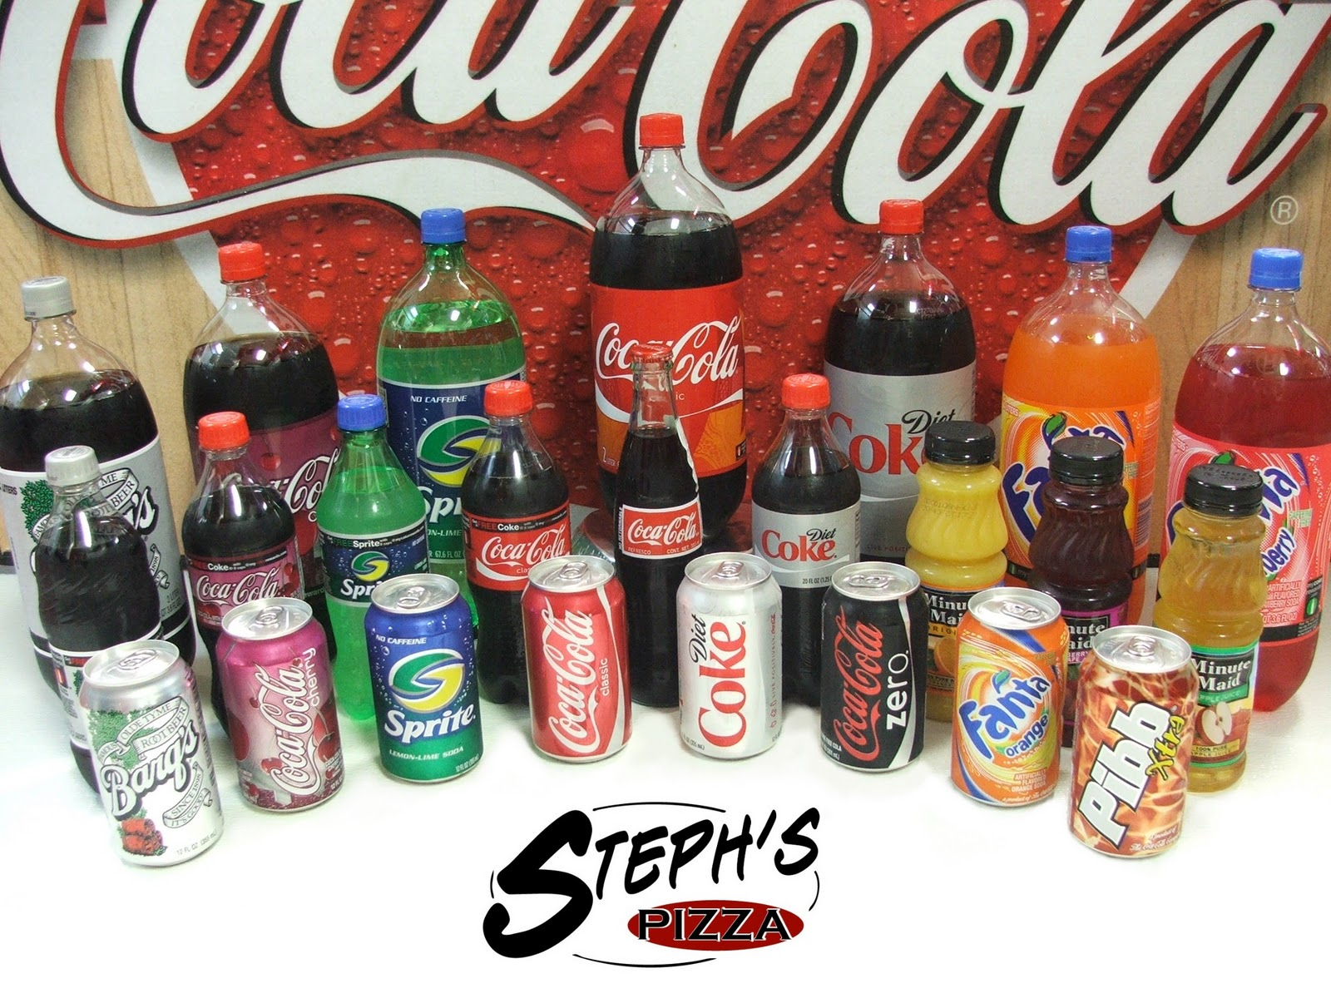

The Coca-Cola Company’s brands in India include ***Coca-Cola, Fanta Orange, Fanta Apple, Limca, Sprite, Thums Up, Burn, Kinley, Maaza, Maaza Milky Delite, Minute Maid Pulpy Orange, Minute Maid Nimbu Fresh and Nestea Iced tea, the Georgia Gold range of teas and coffees and Vitingo***(a beverage fortified with micro-nutrients).

**Coca- Cola Products**

Coca-cola has a truly remarkable heritage. From a humble beginning in 1886, it's now the flagship brand of the largest manufacturer, marketer and distributor of non alcoholic beverages in the world

* **Diet Coke.**
* **Thums Up.**
* **Sprite.**
* **Fanta.**
* **Limca.**
* **Maaza.**
* **Milky Maaza**
* **Burn. .. ......**
* **Kinley.**
* **Kinley Soda.**

* **Schweppes.**
* **GEORGIA Gold.**

**Mission**

To create a consumer driven, customer focused, profitability and sustainability, socially responsible business in India.

**Our Vision**

To make every Indian’s first choice of refreshment available within easy reach.

**Our Winning Culture**

Our Winning Culture defines the attitudes and behaviours that will be required of us to make our 2020 Vision a reality.

**Live Our Values**

Our values serve as a compass for our actions and describe how we behave in the world.

**1. Leadership.**

**2. Empowerment.**

**3. Passion for Winning.**

**4. Citizenship.**

**5. Intigrity.**

**6. Accountability.**

**7. Team Work.**

**Awards and achievements**

* Argentina's Most Admired Companies Ranking (October 2006)
* 2006 Corporate Social Responsibility Award, American Chamber in Shanghai (September 2006)
* Leader in Corporate Social Responsibility, *Gerente* (September 2006)
* Citizenship efforts, Committee for Economic Development (June 2006)
* Social reporting transparency, Roberts Environmental Center (January 2006)
* Golden Flame Award, "Water is Life" video, International Association of Business Communicators (IABC) (October 2006)
* 2006 Cooling Industry Awards (October 2006),
* United States Environmental Protection Agency Climate Protection Award, "Refrigerants, Naturally," (industry alliance co-founded with McDonald's and Unilever) (2006)
* Ministry of the Environment Award, Coca-Cola Korea Bottling Company (July 2006)
* Jilin Environment Friendly Enterprise, Jilin COFCO Coca-Cola Beverages Co., Ltd., China (2006)
* Pollution Control Award 2005-2006, Coca-Cola India Patna Unit, Bihar State Pollution Control Board (June 2006)
* Golden Peacock Environment Management Special Commendation Award, World Environment Foundation (June 2006)
* Bhagidari Award, Coca-Cola India water conservation and environmental management, Delhi government (2005)
* Environmental Protection Award for Corporate Citizens, American Chamber of Commerce in Shanghai (November 2005)
* Golden Peacock Environment Management Award, Coca-Cola India bottling plant at Kaladera, World Environment Foundation (WEF) (2005

**HISTORY OF BOTTLING**

Coca-Cola originated as a soda fountain beverage in 1886 selling for five cents a glass. Early growth was impressive, but it was only when a strong bottling system developed that Coca-Cola became the world-famous brand it is today.

**YEAR WISE HISTORY OF BOTTLING:**

**Year 1894: A modest start for a bold idea**

In a candy store in Vicksburg, Mississippi, brisk sales of the new fountain beverage called Coca-Cola impressed the store's owner, Joseph A. Biedenharn. He began bottling Coca-Cola

to sell, using a common glass bottle called a Hutchinson. Biedenharn sent a case to Asa Griggs Candler, who owned the Company. Candler thanked him but took no action. One of his nephews already had urged that Coca-Cola be bottled, but Candler focused on fountain sales.

**Year 1899: The first bottling agreement**

Two young attorneys from Chattanooga, Tennessee believed they could build a business around bottling Coca-Cola. In a meeting with Candler, Benjamin F. Thomas and Joseph B. Whitehead obtained exclusive rights to bottle Coca-Cola across most of the United States for a sum of one dollar. A third Chattanooga lawyer, John T. Lupton, soon joined their venture.

operating, most of them family-owned businesses. Some were open only during hot-weather months when demand was high.

**In the 1960s: Introduction of new brands**

Sprite, Fanta, Fresca and TAB joined brand Coca-Cola in the 1960s. Mr. Pibb and Mello Yello were added in the 1970s. The 1980s brought diet Coke and Cherry Coke, followed by PowerAde and Fruitopia in the 1990s. Today scores of other brands are offered to meet consumer preferences in local markets around the world.

**21st Century: Coca-Cola today**

The Coca-Cola bottling system grew up with roots deeply planted in local communities. This heritage serves the Company well today as consumers seek brands that honor local identity and the distinctiveness of local markets. As was true a century ago, strong locally based relationships between Coca-Cola bottlers, customers and communities are the foundation on which the entire business grows.

**HINDUSTAN COCA-COLA BEVERAGES**

**PRIVATE LIMITED (HCCBPL) COCA COLA INDIA**

**_______________________________________________**

**3.1: ABOUT THE COMPANY**

Coca-Cola was the leading soft drink brand in India until 1977, when it left rather than reveal its formula to the Government and reduce its equity stake as required under the Foreign Regulation Act (FERA) which governed the

operations of foreign companies in India. Coca-Cola re-entered the Indian market on 26th October 1993 after a gap of 16 years, with its launch in Agra. An agreement with the Parle Group gave the Company instant ownership of the top soft drink brands of the nation. With access to 53 of Parle’s plants and a well set bottling network, an excellent base for rapid introduction of the Company’s International brands was formed. The Coca-Cola Company acquired soft drink brands like Thumps Up, Goldspot, Limca, Maaza, which were floated by Parle, as these products had achieved a strong consumer base and formed a strong brand image in Indian market during the re-entry of Coca-Cola in

1993.Thus these products became a part of range of products of the Coca-Cola Company.

In the new liberalized and deregulated environment in 1993, Coca-Cola made its re-entry into India through its 100% owned subsidiary, HCCBPL, the Indian bottling arm of the Coca-Cola Company. However, this was based on numerous commitments and stipulations which the Company agreed to implement in due

course. One such major commitment was that, the Hindustan Coca-Cola Holdings would divest 49% of its shareholding in favor of resident shareholders by June 2002.

Coca-Cola is made up of 7000 local employees, 500 managers, over 60 manufacturing locations, 27 Company Owned Bottling Operations (COBO), 17 Franchisee Owned Bottling Operations (FOBO) and a network of 29 Contract Packers that facilitate the manufacture process of a range of products for the company. It also has a supporting distribution network consisting of 700,000 retail outlets and 8000 distributors. Almost all goods and services required to

cater to the Indian market are made locally, with help of technology and skills within the Company. The complexity of the Indian market is reflected in the distribution fleet which includes different modes of distribution, from 10-tonne trucks to open-bay three wheelers that can navigate through narrow alleyways of Indian cities and trademarked tricycles and pushcarts.

“Think local, act local”, is the mantra that Coca-Cola follows, with punch lines like “Life ho to aisi” for Urban India and “Thanda Matlab Coca-Cola” for Rural India. This resulted in a 37% growth rate in rural India visa-vie 24% growth seen in urban India. Between 2001 and 2003, the per capita consumption of cold drinks doubled due to the launch of the new packaging of 200 ml returnable glass bottles which were made available at a price of Rs.5 per bottle. This new market accounted for over 80% of India’s new Coca-Cola drinkers. At Coca-Cola, they have a long standing belief that everyone who touches their business should benefit, thereby inducing them to uphold these values, enabling the Company to achieve success, recognition and loyalty worldwide.***Atul Singh*** is the President & CEO , *Coca-Cola India*& South West Asia business unit.

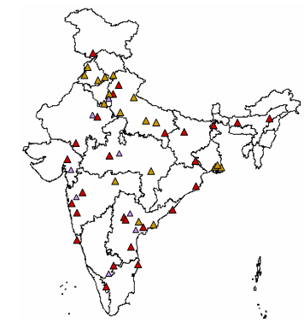



***FIGURE 3: LOCATIONS OF COBO, FOBO & CONTRACT PACKAGING IN INDIA***

**Overview of Hindustan Coca cola Beverages Pvt Ltd.Orissa,Khurda**

**Unit Profile- Khurda**

Khordha is the headquarter of the district of the same name and is situated in 85 degree 37'30"E and 20 degree 11'N. onthe National Highway No.5. The town is 11 km. from KhurdaRoad railway station, with which it is connected by a metalled road. The local name of the place is Jajarsingh, which originally was a small village. Probabaly the placewas also formerly known as Kurada, which means 'foulmouthed'. Khurda came into prominence when the first [RAJA OF KHORDHA](http://khordha.nic.in/raja.htm) dynasty,Ramachandra Deva, made it

The capital of his kingdom during the last part of the 16thcentury A.D. The Bhoi kings lived in a part of the foot of the [BARUNAI](http://khordha.nic.in/barunai.htm) Hill, about 1.6 km. to the south of the town. This site was apparently selected because it was protected onone side by the Barunai

Hill, which was easily defended, andon the other by dense jungle. The fort is now completely ruins, only a few traces remaining here and there which reminds one for its former glory. Khurda suffered repeatedonslaughts from Muslim and Maratha cavalry but its royalhouse retained much of its independence till 1804 when thethen Raja, Mukunda Deva under the guidance of JayakrushnaRaiguru, rebelled against the British domination and wasdispossessed of his territory. Khurda is also memorable asthe centre of activity of the "[PAIKA REBELLION](http://khordha.nic.in/paika.htm)" of 1817-18

under the leadership of Bakshi Jagabandhu Bidyadhar.

**Brief description about khurda unit:**

Orissa is a [state](http://en.wikipedia.org/wiki/States_and_territories_of_India) which is also known as temple city rich with pre historic culture. There are 30 districts in Orissa. The major cities in Orissa are Bhubaneswar, Cuttack, Rourkela, Brahmapur, Bolangir, Sambalpur, Kendrapara, Balasore, and Puri. It has two plants, which are situated at Khurda (COBO) & another in Rourkela (FOBO).

This unit of Khurda was first started in 1999 under the name “Hindustan Coca-Cola Beverages Pvt. Ltd. The plant is spread in around 37.78 Acres i.e. 16, 4, 5697 Square Feet area.

The Plant has two PET line - Kronze and old PET which has the capacity of yielding 600 bottles, per minute and 140 bottles per minute respectively, two RGB (Returnable glass bottles) lines –Maaza and CSD (carbonated soft drink) which yields 600 bottles per minute each and one Kinley water line which has the capacity if yielding 90 bottles per minute. Tetra pack line would start shortly.

There are nine depots for the Orissa and Jharkhand zone they are:

Khurda - F1, Bhubaneswar –F4, Bhabani Patna –F5, Rourkela –F2, Rourkela Direct –F3, Ranchi -X8, Ranchi Direct –X9 , Jamshedpur - X4 ,Deoghar-X6.

Khurda location has total 230 distributors and ­­­more than 92,831customers all across the length and breadth of Orissa.

**ORGANOGRAM**

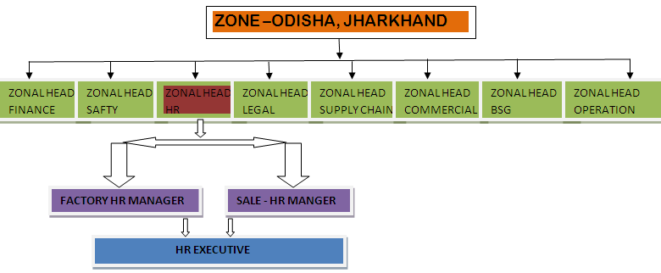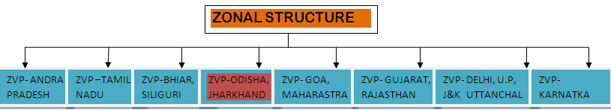**Figure 1 : Organization Structure - Odisha & Jharkhand Zone**

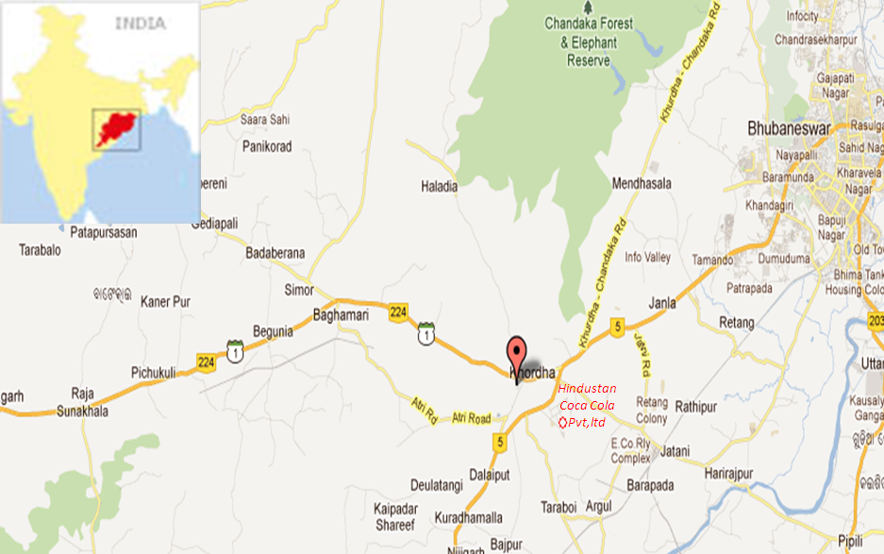

Figure 2 : Map of plant location

**MANIFESTO FOR GROWTH**

**.VALUES:**

The values that the employees in the Company are expected to keep up to and work by regularly are as follows:

* **LEADERSHIP:** To take an initiative and lead, motivate and drive the team with energy and zeal, to deliver outstanding results.
* **INNOVATION:** To continuously strive for progress and reach the next level of excellence in everything we do.
* **PASSION:** To be deeply committed and display drive and energy in the quest to deliver outstanding performance.
* **TEAMWORK :**To unite for greater strength and work collectively as a group towards the achievement of common goals.
* **OWNERSHIP:** To think and act like owners at all levels; to have decisions taken at the lowest appropriate level.
* **ACCOUNTABILITY:** To be individually and transparently accountable to our colleagues for delivering agreed targets and goals.

**VISION FOR SUSTAINABLE GROWTH**

To provide exceptional strategic leadership in the Coca-Cola India System-resulting in consumer and customer preference and loyalty, through Coca-Cola’s commitment to them, and in a highly profitable Coca-Cola Corporate branded beverages system.

**MISSION**

To create consumer products, services and communications, customer service and bottling system strategies, processes and tools in order to create competitive advantage and deliver superior value to;

* Consumers as a superior beverage experience
* Consumers as an opportunity to grow profits through the use of finished drinks
* Bottlers as an opportunity to grow profits in volumes
* Bottlers as a trademark enhancement and positive economic value added
* Suppliers as an opportunity to make reasonable profits when creating real value-added in an environment of system-wide team work, flexible business system and continuous improvement
* Indian society in the form of a contribution to economic and social development.

**QUALITY POLICY**

“To ensure customer delight, we commit to quality in our thoughts, deeds and actions by continually improving our processes…Every time.”

**ORGANIZATION STRUCTURE OF COCA-COLA IN INDIA**

***FIGURE 5: ORGANIZATION STRUCTURE IN COCA-COLA, INDIA***

***FIGURE 6: ORGANIZATION STRUCTURE OF THE SALES DEPARTMENT***

**MANUFACTURING UNIT OF HCCBPL**

The manufacturing unit of HCCBPL, Khurda Orissa is one of the bottling operations owned by the company. The Plant has one PET line which has the capacity of yielding 209 bottles, per minute, two RGB (Returnable glass bottles) lines which yields 600 bottles per minute each and one Juice line which yield 155 bottles per minute. It caters to the whole of South Karnataka through a network of more than 80 distributors. There are three depots in Bangalore; North Depot, East Depot and Mega Depot.

**Manufacturing Plant**

**Sales and Distribution Operations**

**Distributors**

**Outlets**

**Outlets**

***FIGURE 7: CHAIN FOLLOWED FROM MANUFACTURE TO DISTRIBUTION***

**MANUFACTURING PROCESS AT HCCBPL**

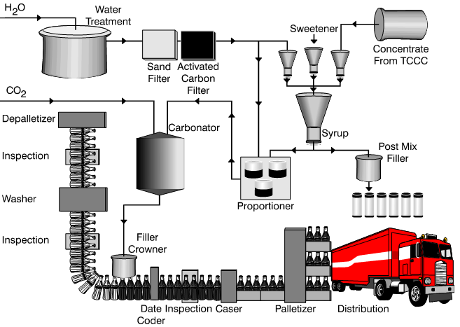

***FIGURE 8: MANUFACTURING PROCESS***

The manufacturing of the products of Coca-Cola involves the following steps:

* Water is received from the River Cauvery and it passes through the water treatment plant, further passing through the sand filter and the activated carbon filter, so as to attain pure cleansed water.
* In the syrup room, the concentrate received from another bottling plant situated at Pune, is blended with the sugar syrup
* Once both the water and the final syrup are ready, they are both mixed together and sent to the carbonator section where Carbon Dioxide is added to the mixture to form the final product.
* On the other hand, simultaneously, the returnable glass bottles are depalletized, inspected and washed for the purpose of filling in the final product in it. This step does not take place in the PET bottle line as the bottles once used are disposed.
* The product is finally filled in the bottles, crowned (in case of RGB)/ capped (in case of PET bottles), labeled and cased in order to be sent into the warehouse for distribution.

**COMPETITORS TO HCCBPL**

The competitors to the products of the company mainly lie in the non-alcoholic beverage industry consisting of juices and soft drinks.

The key competitors in the industry are as follows:

**PepsiCo:** The PepsiCo challenge, to keep up with archrival, the Coca-Cola Company never ends for the World's # 2, carbonated soft-drink maker. The company's soft drinks include Pepsi, Mountain Dew, and Slice. Cola is not the company's only beverage; PepsiCo sells Tropicana orange juice brands, Gatorade sports drink, and Aquafina water. PepsiCo also sells Dole juices and Lipton ready-to-drink tea. PepsiCo and Coca-Cola hold together, a market share of 95% out of which 60.8% is held by Coca-Cola and the rest belongs to Pepsi.

* **Nestlé:** Nestle does not give that tough a competition to Coca-Cola as it mainly deals with milk products, Baby foods and Chocolates. But the iced tea that is Nestea which has been introduced into the market by Nestle provides a considerable amount of competition to the products of the Company. Iced tea is one of the closest substitutes to the Colas as it is a thirst quencher and it is healthier when compared to fizz drinks. The

flavored milk products also have become substitutes to the products of the company due to growing health awareness among people.

* **Dabur:** Dabur in India, is one of the most trusted brands as it has been operating ever since times and people have laid all their trust in the Company and the products of the Company. Apart from food products, Dabur has introduced into the market Real Juice which is packaged fresh fruit juice. These products give a strong competition to Maaza and the latest product Minute Maid Pulpy Orange.

**Human Resource Management at Coca Cola, Khurda**

Human Resource Management may be defined as that specialized branch of management which is concerned with solving the human problem of an organization intelligently and equitably in a manner that not only the employees, potentials are developed but maximum satisfaction is also achieved by the individual

**Role of Personal Manager/HR Manager:**

* [**Recruitment**](http://www.acclimited.com/newsite/hr.asp#rct#rct)
* [**Performance Management System**](http://www.acclimited.com/newsite/hr.asp#pmt#pmt)
* [**Training & Development**](http://www.acclimited.com/newsite/hr.asp#tad#tad)
* [**Employee welfare & perquisites**](http://www.acclimited.com/newsite/hr.asp#ewp#ewp)
* [**Employee Satisfaction**](http://www.acclimited.com/newsite/hr.asp#es#es)

Coca Cola has a large workforce of about 9,000 people, comprising experts in various disciplines assisted by a dedicated workforce of skilled persons. ACC employees, referred to as the Coca Cola Family, come from all parts of the country and belonging to a variety of ethnic, cultural and religious backgrounds.

Coca Cola employees display a strong sense of loyalty to the Company and their special stellar qualities as ‘value-adding’ human capital are well known in the industry.

Coca Cola has clearly stated guidelines concerning recruitment, termination, career advancement, performance appraisal, professional and employee ethics and code of conduct. The Company’s personnel policies and processes enshrine equal opportunities to all and non-discrimination with regard to gender, caste, creed, ideology or other opinion, whether social, political or religious. Also ensured is a due process for employee consultation and participation in organizational development and policy formulation.

**Recruitment:**Recruitment in Coca Cola is a very fair and transparent process with adequate opportunities to look for suitable candidates internally as well as from outside. Applicants are generally invited on the basis of specific advertisements in newspapers and websites.

A Committee of officers called the Central Recruitment Committee handles the entire recruitment process comprising screening of applications, preliminary short-listing, interviews and final selection. Every attempt is made to make the selection process as objective as possible by incorporating tests of competence. In some cases, outside consultants are retained. All decisions of the recruitment committee are recorded in respect of each candidate. Candidates are informed of their short-listing and selection immediately after the interview or at the earliest thereafter.

[**Perfomance Management System:**](http://www.acclimited.com/newsite/hr.asp#pmt#pmt)

The Company’s performance management system is in itself a benchmark that provides ample opportunities and motivational incentives to employees so as to reward and retain good talent within the Company.

These incentives include Performance Linked Incentives, Good Work Awards, Letters of Appreciation, Special Increments, Promotions, Nomination to external training programs in India and abroad, public felicitation and appreciation. Some plants have Best Employee and Employee of the Month Awards and recognition. Competent employees and those who display aptitude are invited to become Trainers themselves and receive Train the Trainer facilitation.

**CHAPTER:-3**

**INTRODUCTION OF TOPIC**

**Human Resource is a basic need of any work to be done. According to “ARTHUR LEWIS”**

***“There are great differences in development between countries which seem to have roughly equal resources, so it is necessary to enquire into the difference in human behaviours”***

The project report is all about recruitment and my project topic is

“**INTERVIEW EVALUATION**” in recruitment process that’s an important part of any organization. Recruitment highlights each applicant’s skills, talents and experience. Their selection involves developing a list of qualified candidates, defining a selection strategy, identifying qualified candidates, thoroughly evaluating qualified candidates and selecting the most qualified candidate. It is said if right person is appointed at right place the half work has been done. In this project I have tried to cover all the important point that should be kept in mind while recruitment and selection process and have conducted a research study on this topic and tried to find out which methods and various other information related to recruitment and selection and tries to come to a conclusion at what time mostly the manpower planning is don’t , what the various method used for recruiting the candidates and on what basic the selections is done .

**Meaning of HUMAN RESORCE MANAGEMENT**

Human resource management is the management of employee’s skill, knowledge abilities, talent, aptitude, creativity, ability etc. different terms are used for denoting Human Resource Management. They are labour management,

labour administration, labour management relationship, employee –employer relationship, industrial relationship, human capital management, human assent Management etc. Though these terms can be used differently widely, the basic nature of distinction lies in the scope or coverage and evolutionary stage. In simple sence, human resource management means employing people,

developing their resources, utilizing, maintaining and compensating their services in tune with the job and organizational requirements.

**FUNCTIONS OF HUMAN RESOURCE MANAGEMENT**

**Administration:**

Strategic planning, organizational evaluation, County Board relations, policy recommendations, supervision of department staff

**Benefits:**

Health insurance, dental insurance, life insurance, disability insurance, retirement benefits, vacation, sick leave, paid holidays, section 125 plan, donor program, educational incentive, uniform allowance, and others.

**Compensation:**

Salary and benefit surveys, job evaluation, job descriptions evaluation, job descriptions

**Employee relations:**

Enrolment in benefits, employee discounts for recreational spots, resolution of enrolment or claim problems, employee newsletter. Educational assistance employee service awards

**Fiscal:**

Staffing budgets, departmental budget, accounts payable, insurance receivables, insurance fund management, total package costing. Insurance receivables, insurance fund management, total package costing.

**Health and safety:**

Employee assistance, workers compensation claims, drug testing, safety compliance and training.

**Leaves of absence:**

State and/or Federal Family and Medical Leave rights, County approved leaves of absence, rights upon return to work, light duty assignments for temporary periods.

**Payroll administration:**

Computer-based or manual evaluation systems, supervisory training, compliance with timeliness standards

**Performance appraisal:**

Employee files, litigation files, payroll records, safety records and other administrative files

**Record-keeping:**

Job posting, advertising, testing administration, employment interviews, background investigations, post-offer employment testing.

**Recruitment:**

Recruitment is defined as a process to discover the sources of manpower to meet the requirement of the staffing schedule and to employ effective measures fir meet the requirement of the staffing schedule and to employ to employ effective measures for attracting the manpower in adequate numbers to facilitate effective selection of an effective workforce.

**Selection:**

After identifying the sources of human resources, searching for prospective employees and stimulation helps too apply for jobs in an organization, the management has to perform the function of selecting the right man at right job and at the right time.

**Separations and terminations:**

Rights upon termination of employment, severance benefits, unemployment compensation, exit interviews.

**Training and development:**

County-wide needs assessment, development of supervisory and management skills, employee training and workshops. Benefits orientation for new and transferring employees, Supervisory newsletter.

**Salary and benefits:**

Salary/wage plans, employee benefits

**RECRUITMENT**

Recruitment is “hiring” of employees from outside. Recruitment has been regarded as the most important function of the HR department , because unless the right type of people are hired, even the best plans, organization chart and control system would not do much good.

Recruitment is the discovering of potential applicant for actual or anticipated organizational vacancies. Accordingly the purpose of recruitment is to locate sources of manpower to meet the job requirements and job specification.

It is defined as „ a process to discover the sources of manpower to meet the requirements of staffing schedule and to apply effective measures for attracting the manpower to adequate number to facilitate effective selection of an effective workforce‟ **Yoder** points out that recruitment is a process to

Discover the sources of manpower to meet the requirement of the staffing schedule and to employee effective measures to attracting that manpower in adequate number to facilitate effective selection of an effective workforce.

***Edwin B Flippo defines*** recruitment as „the process of searching for prospective employees and stimulating them to apply for the jobs in the organization.‟

“It is the process of finding and attracting capable applicants for employment. The process begins when new recruits are sought and ends when their

Applications are submitted. The result is a pool of applicants from which new employees are selected.”

**Objective of recruitment**

1: To attract with multi dimensional skills and experience that suite the present and future organization strategies.

2: To induct outsider with new perspective to lead the company.

3: To infuse fresh blood at all levels of organization.

4: To develop an organizational culture that attracts competent people to the company.

5: To search or headhunt people whose skill fit the company‟s values.

6: To seek out non-conventional development grounds of talent

7: To devise methodology for assessing psychological traits.

8: To search for talent globally not just with in the company.

9: To design entry pay that competes on quality but not on quantum.

10: To anticipate and find people for position that doesn‟t exists yet.

**Factors affecting Recruitment**

There are two types of factors that affect the Recruitment of candidates for the company.

**1: Internal factors**: These includes

- Company‟s pay package

- Quality of work life

- Organizational culture

- Company‟s size

- Company‟s product

- Growth rate of the company

- Role of trade unions

- Cost of recruitment

**2: External factors**: These include

* + Supply and demand factors
  + Employment rate
  + Labour market condition
  + Political, legal and government factors
  + Information system

**Factors to be undertaken while formulating recruitment policies**

The following factors should be undertaken while formulating the policies -

- Government polices

- Recruitment sources

- Recruitment needs

- Recruitment cost

- Organizational and personal policies

**Theories Regarding Recruitment**

Recruitment is two way street: it takes a recruiter has a choice whom to recruit, same way the prospective employee also has taken the decision whether or not to apply for the given job vacancy. The individual take the decision usually on three different basic:

**1: The objective factors.**

**2: The critical contact.**

**3: The subjective factor.**

**The objectives theory** views that the process of organizational choice as being one of weighing and evaluating set of measurable characteristic of employment

offers, such pay, benefits , location, opportunity for advancement, the nature of job to performed, and education opportunities.

Whereas, **the critical contact theory** suggests that the typical candidates is unable to make a meaningful differentiation of organization‟s offers in terms of objective or subjective factors, because of his limited or very short contact with the organisation. Choice can be made only when applicant can readily perceive

the factors such as the behaviour of the recruiters, the nature of the physical facilities, and such as the efficiency in processing paper work association with the application.

On the other hand, **the subjective theory** emphasizes the congruence. Here the choices are made on highly personal and emotional basis.

**Recruitment cycle**

**Planning**

Before recruitment, check the duties and responsibilities

your organisation needs to have performed:

• Is the current job description really what the

organisation needs?

• Do they fit with the organisation’s strategic and

business plans?

• What are the legislative requirements?

• What recruitment policies and procedures need to

be followed?

**Recruitment**

Ads in the local paper is only one way of recruiting, other

options include:

• Internal notices such as newsletters or email messages

• Notices on public noticeboards either within your

organisation or in other places

• Existing networks and word of mouth advertising are

cheap and effective

• Recruitment agencies can help sort out potential

applicants and therefore save you time.

**Advertising**

What goes in an advertisement:

• Title and job description

• Job status and salary

• Required skills and knowledge

• Contact details

• Application closing dates

You must not break anti-discrimination laws and job

advertisements must be clear and truthful!

**Selecting staff**

You need a good quality selection criteria and an informed

and organised interview panel!

Short listing candidates will save lots of time.

Questions you ask at the interview must be consistent for

all applicants and the questions must relate to the position.

You can ask about existing injuries if it is relevant to the

position, but be careful – obviously they have to be able

to do the job however it is illegal to discriminate on the

grounds of disabilities!

Obviously you will ask if people can do the job to the ability

**Reference Checks**

Obviously you will ask if people can do the job to the ability

they claim and its still an important process.

It is also a good time to find out what are things that

motivate your potential employee and what

de-motivates them!

**Induction**

This is really good time to get to know your staff personally,

so use it as a time for them to not only get to know the

organisation but for you to get to know them a bit better.

It is vital you give your employee induction into OH&S

policies and procedures. Other policies and procedures

need to be covered but OH&S is absolutely essential!

Most inductions start with the individual roles and

responsibilities and work out to the big picture stuff!

Appointing a buddy can help someone feel welcome

and supported.

**Identifying Training Needs**

Use the probation period to identify the strengths of your

new worker as well as the areas they will benefit from extra

training.

It is easier to train the right person for the position than

change poor attitude or work habits even if the person is

highly skilled!

It is important to know whether the training or professional

development has actually benefited the individual and the

organisation.

Make sure you evaluate the activities and a good way to

‘value add’ to the training or development is to ask the

worker to give a brief presentation to the next team meeting.

**Performance Apprisals**

Usually performance appraisals are done at the end of the

probation period and then annually.

It is important the employee feels supported during this

time so make sure you have some positives as well as

negatives to discuss.

Break the position down into differing tasks and offer

clear examples of the employees strengths and areas to

be improved.

**Moving On**

No matter how good a boss you might be, people do need

to move on. Make sure you have some strategies to retain

the corporate knowledge – it could be record books, on line

logs or any other record keeping strategy.

Sometimes we have to move people as they are not able

to perform to the required level. If you think this may be

the case, make sure you have good record keeping

procedures in place and follow the policies and procedures

in your organisation.

Is it possible for under-performers to be placed in a

different role in your organisation? It would save time,

money and anxiety for all involved if alternatives to losing

the staff member could be found.

**Recruitment Process**

**Personnel Planning**

**Job Analysis**

**Employee Requisition**

**Job Vacancies**

**Recruitment Planning, Number, Type**

**Strategy Development**

**Application Population**

**TO selection**

**Evaluation and Control**

**Potential Hires**

**Applicant Pool**

**Screening**

**Searching Activation through internal and external sources**

**SOURCES OF RECRUITMENT**

***EXTERNAL SOURCES***

***INTERNAL SOURCES***

**PRESENT EMPLOYEES**

**PREVIOUS APPLICANTS**

**FORMER EMPLOYEES**

**EMPOLYEE REFERRALS**

**E-RECRUITING**

**R**

**E**

**C**

**R**

**U**

**I**

**T**

**M**

**E**

**N**

**T**

**COMPETITORS**

**ACQUISITIONS AND MERGERS**

**RADIO AND TELEVISION**

**DISPALCED PERSON**

**CONTRACTORS**

**CONSULTANTS**

**WALK-IN & WRITE IN**

**CAMPUS RECRUITMENT**

**EMPOLYMENT EXCHANGE**

**ADVERTISEMENTS**

**TRADE PROFFESSIONALS**

**Evaluation of recruitment process**

The following are the evaluation of the recruitment process:

1: Return rate of application sent out.

2: Number of suitable candidates for selection.

3: Retention and performance of the candidate selection.

4: Cost of recruitment

5: Time lapsed data.

6: Comments on image projected.

**RECRUITMENT PROCESS AT COCA COLA, KHURDA**

**Time Line 18 days**

**Create and open Position Requisition**

**Create New Job**

**Time Line 14 days**

**Update Job**

**Determine talent availability and Internal Posting**

**Time Line 8 days**

**Internal Application**

**Source External Talent -**

**Time Line 17 days**

**Employee Referral**

**Monitor Referral Reward**

Time Line 4 days

**Screen Candidates**

**Time Line 8 days**

**Close position within 21 days**

**Interview and Select candidates**

**Time line 12 days**

**Prepare Rejection**

**Within 5 days**

**Prepare Job Offer**

**Receive Offer Acceptance**

**Within 7 days**

**Within 30-60 days**

**Pre-employment Due Diligence, Pre Employment Medical check up**

**Document New Hire data**

**Assign Company Property**

**Selection**

Selection Means, it is the process of hiring, choosing & selecting the right candidate from the pool of candidates to do a particular job. After identifying the human resources, searching for prospective employees and stimulating them to apply for jobs in an organization, the management has to perform the function of selecting the right employees at the right time. The objective of selection decision is to choose the individual who can most successfully perform the job from the pool of qualified candidate. The selection Procedure is the system of functions and devices adopted in a given company to ascertain whether the candidates ‘specification are matched with the job specification and requirement or not. The selection process cannot be effective until and unless.

1. Requirements of the job to be filled, have been clearly specified (Job Analysis, etc.)
2. Employee specification (physical, mental, social, behavioural,etc.)Have been clearly specified.
3. Candidate for screening have been attracted.

Thus, the development of job analysis, human recourse planning and recruitment are necessary prerequisites to the selection process. A break down in any of these processes can make even the best selection system ineffective.

SELECTION PROCESS

R ***Rejection***

***P Promotion For Next stage***

***J o i n i n g***

***Physical Examination***

***Final Interview***

***Selection Test***

***Application Blank***

***Final Approval***

***Employee Referral***

***Priliminary Interview***

Rejection

**Introduction of the Company**

**Application Blank**

It is an application form which is given to the candidate for getting information regarding Identifying information, Personal Detail, Physical Information, Experience Achivement,Extra curricular Activity, Family back ground etc.

**Selection Test**

This is mostly done to know the attitude, ability, achievement, Personality and interest of the candidate.

Irrespective of these there is some other test like Graphology test, polygraphy test emotional test, leading test etc.

**Final Interview**

Final interview is usually followed by testing. This is the most essential step in the process. In this step the inter viewer matches the information obtained about the candidate through various means to the job requirements and to the information obtained through his own observation during interview.

**Physical examination**

Test the health level of the candidate to the physically sound or not.

**Employee Referral**

To test the reference of the employee which is gave by him.

**Final Approval**

Final test to join in the job.

**Interview**

An Interview is a procedure designed to obtain information from a person through oral responses to oral inquiries.

Since the interview is only one of the several selection tools, the interview is one of the most widely used personnel selection procedure while all not employers use tests or even reference check, it would be highly unusual for a manager not to interview some one before hiring them .Interviewing is thus an indispensable management tools.Most people tend to think they’re better interviewer than they really are.In one study ,less then 34%of interviewers had formal interviewing traning but interviewers were confident that they could identify the best candidates regardless of the amount of interview structured employed.

**Interview Process**

(a)Preparation for Appropriate Type of

Interview. Interview.

The areas to be tested.

Type &No of interview.

Review The Information.

Open the interview

(b)Conduct the

Interview. Get complete&

Accurate information.

Record,observatio&.

Impression.

Guide thInterview

Check the success of

Interview .

(c)close the interview

(d)Evaluate interview results.

**Evaluation Of Interview**

The interviewer/the board of interviewers evaluate the candidates strength and weakness against the job and organization requirements. The evaluation is generally based on the observation impression and information collected during the course of interview. However the final decision about suitability of candidate to the final decision about suitability of candidate to the job made on the basic of the result of all selection techniques. But the interview result influence the selection decision much more than any another technique.

The evaluation may be in descriptive form or grading from or rating form .The interviewer has to strike a fine balance between job requirement and employee value, skill knowledge etc.

In View of the error in evaluation the interview has to write explanation of rating on each factor which clarifies his thinking and enables discussion among the interviewers. The educational record, physical attributes, attitudes, sociability and social intelligence, flexibility in behaviour, tact, manner temperament,dependability,self confidence of the candidate with a view to minimize error in evaluation and evaluate the candidate effectively, in general.

**OBJECTIVE OF CANDIDATE EVALUATION METHODS**

The quality of hiring decisions is directly related to the quality of information used to support these decisions. While the logic behind this is irrefutable, many organizations fail to consider the quality of the information they gather from candidates. This leads us to the question: what is the most effective way to gather information that will best inform hiring decisions?

A wide range of research has given us the answer--hiring processes that incorporate objective candidate evaluation methods achieve higher levels of candidate job-fit. The value of candidate job-fit can be measured in on-the-job performance. Candidates with a higher degree of job-fit achieve measurably higher levels of productivity. Differences in productivity levels have substantial economic value, and the return on investment of a selection process using more, as opposed to less, objective methods can thus be documented.

An objective evaluation method is defined as an information discovery technique that provides descriptive information, in numeric form, about a candidate, which is consistent, reliable and free from the influence of the evaluator. Various objective evaluation methods exist, including aptitude, ability or achievement tests, scorable biodata and work style profiles, as well as simulations and virtual job tryouts.The purpose of using objective candidate job-fit measures is to get more reliable, impartial information than can be obtained through the subjective process of interviewing. In fact, in some cases, objective measures produce entirely different information than that acquired during an interview. While the interview is the most widely used candidate evaluation method, it is only a modest predictor of job performance; therefore, interviews should serve as only one of several components of a candidate evaluation process. Properly incorporating the use of objective candidate evaluation methods holds the potential to improve the overall quality of hiring decisions and contribute to improved levels of employee productivity and performance. This paper presents the results of an in-depth survey investigating the extent to which organizations use various objective candidate evaluation methods in their hiring processes. The survey was a Survey of the Week conducted by the SHRM Workforce, Staffing and Development Special Expertise Panel on the SHRM Web site in March of 2005. Participants responded to a series of questions about their company’s current and planned use of objective candidate evaluation methods. From a random sample of 2,229 invitations sent, 282 responses were received, resulting in a 13% response rate. The 282 survey participants represented both small and large companies from most industry sectors. As such, the findings from this survey provide a representative view of what companies are doing in the area of objective candidate evaluation. This white paper focuses on survey results that tie specifically to company use of objective candidate evaluation methods.

**Overall Observations**

The following observations were made from an analysis and review of the survey results.

1. Companies are ignoring or choosing not to take advantage of proven resources and methods that would add value to their recruiting process.

2. Companies appear to be satisfied with their current candidate evaluation methods.

3. The largest planned initiatives for the coming year are adding skill and aptitude testing to the candidate evaluation process.

4. The power of scorable questionnaires such as biodata is grossly underutilized for evaluating candidates.

5. Larger companies (i.e., those hiring 500 or more employees per year) tend to have more objective evaluation methods in place.

6. Regardless of company size, there appears to be little initiative to add objective methods to the candidate evaluation process.

**Interviewing**

40% of companies reported not using written behavioral interview questions, indicating that these organizations were using unstructured interviews in their candidate evaluation process. This is concerning because unstructured interviews have little validity in the prediction of candidate job performance. In fact, published research on the validity of unstructured interviews suggests that making hiring decisions based on school class rank, itself a weak predictor at best, may be more accurate than using an unstructured interview to identify the best candidate. In addition, with only 5% of companies reporting a plan to change this practice, the less effective method of interviewing by the “seat of your pants” will continue to allow more subjective and biased information to influence the hiring decision. Behaviourally anchored rating scales provide a structure for evaluating candidate responses to interview questions. While 55% of companies reported they had written interview questions, only 24% had committed the resources to create an objective method to evaluate candidate responses to these questions. Thus, while the interview may be prepared in advance, the interpretation and rating of the candidate responses remain subjective.

**Scorable Questionnaires**

Biodata questionnaires and scorable job applications were used by less than 15% of companies. Instead, a common staffing practice was to review a resume or job application for key criteria and then place it into a “yes” or “no” pile. In doing so, the recruiter is applying some form of scoring at this point, placing value on data points in the resume. While many applicant tracking systems can aid recruiters by enabling them to search or sort candidates based on selected criteria, few can place a defined, objective value on one or a collection of experiences. In lieu of the subjective, inconsistent resume review process, the power of the Internet can turn screening into a fair, consistent and reliable process. With the appropriate research, a questionnaire can be developed to improve the objectivity of candidate screening, yet less than 3% of companies planned to take advantage of adding these valuable and proven methodologies over the next 12 months.

**Standardized Testing.**

Of the objective evaluation methods, skill and aptitude testing were two of the most frequently used methods. A broad range of off-the-shelf resources for traditional testing are readily available, making it easy for companies to implement these practices. In fact, these two evaluation methods were targeted by the greatest number of surveyed companies as a new initiative planned over the next year. However, as fewer than 10% of those surveyed planned to incorporate skill and/or aptitude testing, this rate of implementation leaves a significant opportunity gap for companies to adopt more effective candidate evaluation methods.

**Work Style or Occupational Personality**

With a utilization rate in the same range as aptitude and skills testing, profiling a candidate’s preferred work style or occupational personality are also used in well below half of the companies surveyed. As illustrated in Figure 7, the results indicate this utilization rate will remain at that level due to the small number of companies planning to implement this type of candidate evaluation in the next 12 months.

**Simulation and Virtual Job Tryouts**

The hiring practice often referred to as “temp to perm” (hiring someone through an agency first to see if the individual will work out) is a form of job tryout. Simulations and virtual job tryouts are emerging as high-tech approaches companies can use to more quickly and less expensively evaluate how well a candidate will perform on the job. These two methods place the candidate in structured exercises that, to some degree, replicate the tasks, problem-solving situations or operational settings they may encounter on the job. By administering these exercises on a computer, the results are more consistent and reliable. When these approaches are developed in accord with the Uniform Guidelines on Employee Selection Procedures, they can be refined into extremely powerful predictors of job performance. According to the survey, a relatively small percentage of companies were investing in this technology-based approach to candidate evaluation, However, candidates are beginning to expect more from the recruiting process. The value of high-tech candidate evaluation methods is demonstrated not only in their ability to predict candidate job performance, but also in their ability to provide the candidate with an interactive, informative online experience. This type of experience is more in line with the multimedia, interactive nature of the learning and entertainment environment younger candidates are experiencing. It is only fitting that candidates experience interactive elements in the recruiting process as well. Thus, it is fair to assume this format of candidate evaluation will see significant growth over the coming years.

**A Final Point on Current Use of Objective Evaluation Methods**

There is no shortage of resources for staffing professionals who seek to improve the objectivity of the candidate evaluation process. However, this area of practice requires a thoughtful and educated approach. One question practitioners have frequently asked is whether there is a legal risk associated with the use of objective candidate evaluation methods. The simple answer is that the risk is less than the legal risk of using unstructured interview questions. Both the interview and objective evaluation methods are treated the same under the Uniform Guidelines on Employee Selection Procedures. Methods used to evaluate a candidate and provide information to support hiring decisions are subject to the same level of scrutiny and legal review. Hiring decisions based upon interviews without defined questions, corresponding rating scales and notes are more susceptible to bias, inconsistencies and unfair outcomes. This means more legal risk for companies using a candidate evaluation process that is solely based upon subjective interview results. In contrast, objective evaluation methods provide a numeric outcome. An analysis of this data can demonstrate the job relevance of this methodology and document the fair and consistent treatment of candidates. A generalized review of litigation stemming from the use of objective candidate evaluation methods points out two issues of concern. Both issues focus on the user and interpretation of results, not on the evaluation method itself. In short, litigation rarely challenges the evaluation method. More often, claims or suits are filed due to:

• Improper use of an assessment--a good evaluation tool being used in the wrong manner or for the wrong purpose, i.e., not relevant to the particular job in question.

• Improper interpretation of scoring--lack of evidence that a certain score is

required in order for a candidate to effectively perform the job, i.e., arbitrary

# What Is the Important to Have an Interview Evaluation Sheet?

X



Mary Jane

Based in Toronto, Mary Jane has been writing for online magazines and databases since 2002. Her articles have appeared on the Simon & Schuster website and she received an editor's choice award in 2009. She holds a Master of Arts in psychology of language use from the University of Copenhagen in Denmark.

When a recruiter interviews several candidates for a single job opening, he must evaluate each candidate to determine whether they are right for the job. Havng an evaluation sheet allows the recruiter to analyze each candidate based on specific criteria developed by the company for the job in question. The evaluation sheet sets forth what the employer is looking for so he can find the right person for the job.

## Finding Right Candidates

* + Just because all the candidates chosen for the job interview may be nice and friendly, not all of them will thrive in a particular job. The interview evaluation sheet helps the recruiter determine whether each candidate has the particular drive and attitude to complete the job in question. For example, sales and customer service employers can evaluate their interviewees based on their public speaking skills and approachability to weed out any who come across as shy or introverted.

## Company Need

* + The interview evaluation sheet allows the recruiter to compare the qualifications and skills of the candidates to the needs and demands of the job position. Alone, a candidate's resume can look impressive, but if it does not match the demands of the position, it may not be useful for the company. The interview evaluation sheet gives the recruiter a framework to follow in determining which candidate fits with what the company needs.

Training

* + Part of the hiring process includes determining how much training the new hire will need if he is chosen for the job. People who have worked in a similar position may not need as much practical training, which can save the company both time and money. One of the reasons for having an interview evaluation sheet is to compare the past work experiences of the candidates and choose the one who may best ease into the position without feeling lost or intimidated

**Top 3 Benefit of an Interview Evaluation Form**

The term **interview evaluation form** sounds like just another piece of paper created by a bureaucrat. In truth, if done correctly, such a tool will serve to minimize hiring mistakes.

Specifically the improvement come in three areas; consistency improved notes and less personal bias in hiring recommendations. Here are the 3 top reasons to use an interview evaluation tool like a form.

**Interview Consistency**

Below we have included an example form you can download. In this example the questions being asked in the interview are included as part of the form. Additionally space is include for the interviewers notes. Having the questions on single piece of paper will likely lead to a thorough interview as the interviewer can just go down the list. It also insures each candidate gets a chance to answer the same questions. This will lead to a more consistent evaluation allowing you to comparing apples to apples in the interview.

**Better Interviewer Notes**

The sample interview evaluation form is purposely laid out with a notes section for each question. This allows the interviewer to capture notes for each question. The result will be better notes with more clarity.

**More Impartial Results**

Finally at the end of the interview, the interview, with all the notes in hand can go about the task of rating the candidates. In this example the interviewer assigns a rating of 1 to 4 with 4 being the top grade. The interviewer is now done.

The completed form is sent to the hiring coordinator. The coordinator then applies a weight to each criteria. The weight is derived from the importance of the criteria in the job. The product of the weight and the rating creates a score. Then the scores are summed to generate interview score. This score can them used be to compare to other candidates in the interview process.

This information typically is gathered through direct observations of the person across various environments, as well as through a review of the person’s records. After reviewing the information and observing the person, it is necessary for the team to develop a hypothesis regarding what they consider to be the reason(s) for the behavior. The most frequent possibilities include seeking attention, task or social avoidance, sensory input, physical illness, and/or mental health concerns.

***Behaviour***. The behaviour of concern must be defined in detail so that all persons involved can reliably measure it when it occurs. Simply recording “aggression” is not good enough – what kind of aggression? Verbal? Physical? Against property or others? Hitting, kicking, spitting, biting, slapping, or all of the above? Precise definitions allow the team to know the data is reliable, thus promoting good treatment decisions.

**A: *Antecedents***. These are events that seem to reliably predict the occurrence of the behavior. These might be relatively complex things such as requests to complete work assignments, changes in lighting or noise levels within a setting, the onset of a headache or other physical illness, or an increase in screaming by peers within an environment. Sometimes antecedents can be seemingly simple events, such as flipping a light switch, changing directions in a car, or even physical affection.

**Conducting a Functional Behavior Assessment**

Current thinking regarding challenging behavior recognizes the success of an intervention depends on understanding why a person responds in a certain way, and teaching the person a more suitable method of getting that same need met. The process of uncovering why a person responds in a particular way is called a functional behavior assessment, or FBA. Conducting a functional behavior assessment is the first step when starting to create a behavior support plan, and it helps the team understand what factors in the environment influence behavior.

One fundamental component of the FBA process is an A-B-C analysis, where “A” stands for antecedent events, “B” for the precisely defined behavior, and “C” for any consequences following the behavior. Most often, every time the behavior occurs, a parent or other caregiver will complete a data sheet on which information is detailed about these three factors.

Another helpful component is the scatterplot analysis, which provides temporal details about challenging behaviors over the course of each day. Scatterplot analyses help uncover whether specific behaviors occur around predictable periods of time. If this is the case, changes in routines or schedules should occur in order to prevent these situations. A portion of a sample scatterplot is shown below:

• An understanding of what happens right after the behavior (consequences).

• An understanding of events which occur immediately before the behavior (antecedents or stress triggers).

**Fundamental Components of FBA’s**

• Previously used treatment efforts and their relative effect or impact on the behavior.

It is important remember that the function of a behavior can change over time. Though initially a behavior may serve to avoid an unpleasant task or request, later that same behavior might serve to gain attention from peers or other caregivers. Consequently, it is helpful to continue the assessment process even after starting a treatment intervention, as this allows the team to understand any changes in the behavior that might occur, and make changes in the support plan based on a function that might change.

**C**: ***Consequences***. These are events which occur immediately after the behavior and the goal is to identify the specific activities, food items, forms of attention, and/or other reinforcing events that help maintain the behavior. Once identified, these reinforcers can often be rearranged to help teach appropriate replacemebt behaviours and mi nimize the occurrence if the challenging behavior.

**INTERVIEW QUESTIONARIES**

|  |
| --- |
| * [**Tell me about yourself.**](http://www.indiabix.com/hr-interview/tell-me-about-yourself/) |
| * [**Why should I hire you?**](http://www.indiabix.com/hr-interview/why-should-i-hire-you/) |
| * [**What are your strengths and weaknesses?**](http://www.indiabix.com/hr-interview/what-are-your-strengths-and-weaknesses/) |
| * [**Why do you want to work at our company?**](http://www.indiabix.com/hr-interview/why-do-you-want-to-work-at-our-company/) |
| * [**What is the difference between confidence and over confidence?**](http://www.indiabix.com/hr-interview/what-is-the-difference-between-confidence-and-over-confidence/) |
| * [**What is the difference between hard work and smart work?**](http://www.indiabix.com/hr-interview/what-is-the-difference-between-hard-work-and-smart-work/) |
| * [**How do you feel about working nights and weekends?**](http://www.indiabix.com/hr-interview/how-do-you-feel-about-working-nights-and-weekends/) |
| * [**Can you work under pressure?**](http://www.indiabix.com/hr-interview/can-you-work-under-pressure/) |
| * [**Are you willing to relocate or travel?**](http://www.indiabix.com/hr-interview/are-you-willing-to-relocate-or-travel/) |
| * [**What are your goals?**](http://www.indiabix.com/hr-interview/what-are-your-goals/) |
| * [**What motivates you to do good job?**](http://www.indiabix.com/hr-interview/what-motivates-you-to-do-good-job/) |
| * [**What makes you angry?**](http://www.indiabix.com/hr-interview/what-makes-you-angry/) |
| * [**Give me an example of your creativity.**](http://www.indiabix.com/hr-interview/give-me-an-example-of-your-creativity/) |
| * [**How long would you expect to work for us if hired?**](http://www.indiabix.com/hr-interview/how-long-would-you-expect-to-work-for-us-if-hired/) |
| * [**Are not you overqualified for this position?**](http://www.indiabix.com/hr-interview/are-not-you-overqualified-for-this-position/) |
| * [**Describe your ideal company, location and job.**](http://www.indiabix.com/hr-interview/describe-your-ideal-company-location-and-job/) |
| * [**What are your career options right now?**](http://www.indiabix.com/hr-interview/what-are-your-career-options-right-now/) |
| * [**Explain how would be an asset to this organization?**](http://www.indiabix.com/hr-interview/explain-how-would-be-an-asset-to-this-organization/) |
| * [**What are your outside interests?**](http://www.indiabix.com/hr-interview/what-are-your-outside-interests/) |
| * [**Would you lie for the company?**](http://www.indiabix.com/hr-interview/would-you-lie-for-the-company/) |
| * [**Who has inspired you in your life and why?**](http://www.indiabix.com/hr-interview/who-has-inspired-you-in-your-life-and-why/) |
| * [**What was the toughest decision you ever had to make?**](http://www.indiabix.com/hr-interview/what-was-the-toughest-decision-you-ever-had-to-make/) |
| * [**Have you considered starting your own business?**](http://www.indiabix.com/hr-interview/have-you-considered-starting-your-own-business/) |
| * [**How do you define success and how do you measure up to your own definition?**](http://www.indiabix.com/hr-interview/how-do-you-define-success-and-how-do-you-measure-up-to-your-own-definition/) |
| * [**If you won $10 million lottery, would you still work?**](http://www.indiabix.com/hr-interview/if-you-won-$10-million-lottery-would-you-still-work/) |
| * [**Tell me something about our company.**](http://www.indiabix.com/hr-interview/tell-me-something-about-our-company/) |
| * [**How much salary do you expect?**](http://www.indiabix.com/hr-interview/how-much-salary-do-you-expect/) |
| * [**Where do you see yourself five years from now?**](http://www.indiabix.com/hr-interview/where-do-you-see-yourself-five-years-from-now/) |
| * [**On a scale of one to ten, rate me as an interviewer.**](http://www.indiabix.com/hr-interview/on-a-scale-of-one-to-ten-rate-me-as-an-interviewer/) |
| * [**Do you have any questions for me?**](http://www.indiabix.com/hr-interview/do-you-have-any-questions-for-me/) |

**Category :: HR Interview Questions For Experienced**

|  |
| --- |
| * [**Why did you resign from your previous job?**](http://www.indiabix.com/hr-interview/why-did-you-resign-from-your-previous-job/) |
| * [**Why have you been out of work so long?**](http://www.indiabix.com/hr-interview/why-have-you-been-out-of-work-so-long/) |
| * [**Why have you had so many jobs?**](http://www.indiabix.com/hr-interview/why-have-you-had-so-many-jobs/) |
| * [**Tell me about a situation when your work was criticized.**](http://www.indiabix.com/hr-interview/tell-me-about-a-situation-when-your-work-was-criticized/) |
| * [**Could you have done better in your last job?**](http://www.indiabix.com/hr-interview/could-you-have-done-better-in-your-last-job/) |
| * [**Tell me about the most boring job you have ever had.**](http://www.indiabix.com/hr-interview/tell-me-about-the-most-boring-job-you-have-ever-had/) |
| * [**May I contact your present employer for a reference?**](http://www.indiabix.com/hr-interview/may-i-contact-your-present-employer-for-a-reference/) |
| * [**How many hours a week do you normally work?**](http://www.indiabix.com/hr-interview/how-many-hours-a-week-do-you-normally-work/) |
| * [**What was the toughest challenge you have ever faced?**](http://www.indiabix.com/hr-interview/what-was-the-toughest-challenge-you-have-ever-faced/) |
| * [**Have you been absent from work more than a few days in any previous position?**](http://www.indiabix.com/hr-interview/have-you-been-absent-from-work-more-than-a-few-days-in-any-previous-position/) |
| * [**What changes would you make if you came on board?**](http://www.indiabix.com/hr-interview/what-changes-would-you-make-if-you-came-on-board/) |
| * [**What would you say to your boss if he is crazy about an idea, but you think it stinks?**](http://www.indiabix.com/hr-interview/what-would-you-say-to-your-boss-if-he-is-crazy-about-an-idea-but-you-think-it-stinks/) |
| * [**How could you have improved your career progress?**](http://www.indiabix.com/hr-interview/how-could-you-have-improved-your-career-progress/) |
| * [**Tell me honestly about the strong points and weak points of your boss (company, management team, etc.)**](http://www.indiabix.com/hr-interview/tell-me-honestly-about-the-strong-points-and-weak-points-of-your-boss/) |
| * [**Looking back on your last position, have you done your best work?**](http://www.indiabix.com/hr-interview/looking-back-on-your-last-position-have-you-done-your-best-work/) |
| * [**Why should I hire you from the outside when I could promote someone from within?**](http://www.indiabix.com/hr-interview/why-should-i-hire-you-from-the-outside-when-i-could-promote-someone-from-within/) |
| * [**How do you feel about reporting to a younger person?**](http://www.indiabix.com/hr-interview/how-do-you-feel-about-reporting-to-a-younger-person/) |
| * [**Looking back, what would you do differently in your life?**](http://www.indiabix.com/hr-interview/looking-back-what-would-you-do-differently-in-your-life/) |
| * [**Why are not you earning more money at this stage of your career?**](http://www.indiabix.com/hr-interview/why-are-not-you-earning-more-money-at-this-stage-of-your-career/) |

Hindustan Coca-Cola Beverages Pvt.Ltd.

INTERVIEW EVALUATION FORMAT

|  |
| --- |
| Name: Post Applied For:    Interviewer’s Name: Date: |

|  |  |  |  |
| --- | --- | --- | --- |
| Functional Parameters | Very Suitable | Suitable | Not Suitable |
| Engineering Knowledge: Basic Concept Of Branch in which he is Qualified |  |  |  |
| Process Knowledge: Current process which is handling |  |  |  |
| Safety &Quality system knowledge of current product he is handling |  |  |  |
| Man power Management: Managing Emotion & Aspiration |  |  |  |

|  |  |  |  |
| --- | --- | --- | --- |
| Generic Parameters | Very Suitable | Suitable | Not Suitable |
| Trade Knowledge Complete |  |  |  |
| Communication Ability |  |  |  |

|  |
| --- |
| Any Other Comments: |

|  |
| --- |
| Out Come:  Definite Offer: Hold: Regret:  Signature: |

Classified - Internal Use

**CONCLUSION**

This presents the summary of the study and research done in relation to the Recruitment on the topic “**Interview Evaluation**” in HCCBPL, Khurda, Odisha. The conclusion is drawn from the study and Research of the company regarding the Recruitment and Selection process carried out here and through surfing net. The recruitment process at HCCBPL, Khurda is very lengthy and thus time consuming. That is why I have done research on some modern techniques which will be help for time saving and cost effective recruitment process in future. The Recruitment process is very good but changes are required according to the changing scenario as recruitment process has a great impact on the working of the company as a fresh blood, new idea enters in the company. Selection process is good but it should also be modified according to the requirements and should job profile so that main objective of selecting the candidate could be achieved. At Last but not the least here in this organization all staff are very co-operative, very down to earth and very goodbye nature and also are very dedicated to their work and these things inspired me a lot. During this project I learned many works related to HR department and this will help me in my future prospect.