INTRODUCTION

Every organization needs to have effective Human Resource functions, which include ‘Recruitment’, ‘Selection’ and ‘Induction’ etc., while forecasting the Manpower requirements by different methods. Now this study reveals the procedure of Recruitment in Nutrine Confectionary Company Limited, which is located in Chittoor.

The study is bounded up to the Recruitment Procedure only and to exactly focus the effiency, best source and satisfactory rate a study was conducted with a well-structured questionnaire and discussion with higher authorities. After that a final analysis was conducted to elaborate the statement of the problem and to give the conclusion about the study.

Organization. The Recruitment and selection is a strategy for acquiring and placing human resource process and are often used interchangeably. Recruitment refers to the process of identifying and encouraging prospective employees to apply for jobs; selection is concerned with picking the right candidates from a pool of applications. Recruitment is said to be positive in the approach as it seeks to attract as many candidates as possible. Selection on other hand is negative in its application in as much as it seeks to eliminate as many qualified applications as possible in order to identify the right candidates. The most valuable asset to any large-scale organization is right caliber personnel, individuals, differ in their ability to perform the different types of activities. They differ in their physical characteristics, intelligence, and intellectual aptitudes, in interests, in temperament, and in character. Because of these large differences in human abilities, the problems of proper selection become a very important one.

INDUSTRY PROFILE

Introduction to chocolate or confectionery
Candy bars, Milk shakes, cookies flavored coffee, even cereal and Medicine chocolate is a key ingredient in many foods in fact it ranks as the favorite flavor of Most Americans and yet few of as know the unique origins of this popular treat.

The story of chocolate spans more than 2000 years and now circles the globe. The tale began in the tropical rain forest of central and South America where cacao (kah kow) first grew. Chocolate is made from the seeds of the cacao tree.

Chocolate History
The tasty secret of the cacao (kah khow) tree was discovered 2000 years ago in the tropical rain forests of the Americans. The pods of this tree contain seeds that can be processed into chocolate. The story of how chocolate grew from a local Mesoamerican beverage into a global sweet encompasses Many cultures and continents.

The first people known to have made chocolates were the ancient cultures of Mexico and Central America. These people including the Maya and Aztecs Mixed ground cacao seeds with various seasoning to make a spicy, frothy drink.

Later, the Spanish conquistadors brought the seeds back home to Spain, where new recipes were created. Eventually, the drinks popularity spread through out Europe. Since then, new technologies and innovations have charged the texture and taste of chocolate, but it still remains one of the world’s favorite flavors. Select which part of chocolate’s long history you’d like to explore first.

INTODUCTION: Chocolate’s History at a glance.

Chocolate’s roots in Ancient Mesoamerica

We tend to think of chocolate as a sweet candy created during modern times. But actually, Chocolate dates back to the ancient peoples of Mesoamerica who drink chocolates as a better beverage.
For these people, chocolate wasn’t just a favorite food – it also played an important role in their religious and social lives.

The ancient Maya grew cacao and made it into a beverage
The first people clearly known to have discovered the secret of cacao were the classic period Maya (250 – 900 C.E[A.D]). The Maya and their ancestors in Mesoamerica took the tree from the rain forest and grew it in their own back up roll, where they harvested, fermented, roasted and ground the seeds into a paste.
When mixed with water, Chile peppers, corneal, and other ingredients, this paste made a frothy, spicy chocolate drink.

The Aztecs adopted cacao
By 1400, the Aztec empire dominated a sizeable segment of Mesoamerica. The Aztecs traded with Maya & other peoples for cacao & often required that citizens and conquered peoples pay their tribute on cacao seeds a form of Aztec Money.
Like the earlier Maya, the Aztecs also consumed their bitter chocolate drink seasoned with spices – sugar was an agricultural product unavailable to the ancient Mesoamericans.

Drinking chocolate was on important part of Maya and Aztec life
Many people on classic period Maya society could drink chocolate at least on occasion although it was a particularly favored beverage for loayality. But in Aztec society, primarily rules, priests, decorated soldiers, and honored Merchants could partake of this sacred brew.
Chocolate also played a special role on both Maya and Aztec royal and religious events priests represented cacao seeds on offering to the goods and served chocolate drinks during sacred ceremonies.

Chocolate: A contemporary confection: For hundreds of years, the chocolate making process remained relatively unaltered. But by the mid 1700’s the blossoming industrial revolution saw the emergence of innovations that changed the future of chocolate.
A steady stream of new inventions and advertising helped set stage for solid chocolate candy to become the globally favored sweet it is today.
Take a more detailed look below at the different ways people obtained, Made and used cacao in the recent past & present.

The creamy chronicle of chocolate
Did you know that chocolate was first cultivated and consumed by the Mayans and Aztecs? By the year 1000 AD. The beans were being used as currency. The Aztecs believed that drinking chocolate, which was the undiluted, on sweetened liquor from the fermented cacao beans, would bring great wisdom understanding and energy. Its use was reserved for the rating and priestly classes.
In 1492 Columbus was given some of the cacao beans and took then back to Spain, but he didn’t know how to process and ferment them. In 1519 Cortez descended upon the Aztecs were convinced that Quetzalcoatl had returned as prophesied and they tried to get him to leave by once again playing him with chocolate.

The 100-years secret
It didn’t work very well, as Cortez organized the area as a Spanish colony but it did introduce Cortez to not only the consumption but the processing of chocolates. They took the beans and the process back to Spain. The Spanish added sugar and honey to the bitter liquid and then fell in love with it. As in the Americans, its use was reserved for member of the court. Chocolate was kept a secret by the Spanish court for almost a hundred years.

Baker’s chocolate
In 1755 the processing of chocolate Moved back to the new world when john Hanau and James baker opened a processing house in Massachusetts which was beginning of the company now known as baker’s chocolate.

Now for the science staff
Cocoa batter as a trigly cevide which begins to soften at 75 f., and Melts at 97 f. It is a highly saturated fat which consists principally of the fatty acid stearic acid, which is found in higher concentration in chocolate that in any other food. Stearic acid is rapidly converted by the liver into oleic acid , a mono unsaturated that neither raises nor lowers serum cholesterol oleic acid is also a present in olive and canola oils.
Chocolate does contain caffeine, but not much one ounce of milk chocolate usually contains 5 Mg of caffeine, one ounce of semi-sweet usually has 5-long and a six-ounce cup of cocoa usually has 10Mg. For comparison, a six-ounce cup of coffee contains 100-150 Mg. Chocolate does not cause acne. It does obtain a protein that in habits bacterial growth on teeth and since it meets at body temperature and melts off one’s teeth, the sugar in chocolate does not cling to one’s teeth.

Why we love Chocolate
The loveliest thing about chocolate, the thing that makes us all so happy when we eat it is that it contains the highest concentration in any food of phenyl ethylamine, which is the chemical produced in the brain when a person is in love. Watch this space for more information about chocolate from peter book chocolatier, where we fall in love with chocolate a new every day.

How Phyllis invented chocolate covered popcorn

Phyllis Lockwood Geiger, owner of peter Brooke chocolatier says the company is chocolate covered popcorn which she calls a “pare gift from God was created by accident”. It was back in 1984 when I had my first little.
Chocolate shop on San macro square, that I inadvertently invented it. “She said: All the San macro merchants were giving away from samples at the annual holiday magic celebration, and I had a shop fall of very expensive hand made items that I couldn’t afford to give away. I ran down to the theater, got some fresh popcorn and sprinkled chocolate on it so we have something to give too. This past holiday seasons peter Brooke sold more than 5tons of chocolate covered popcorn”. It’s turned into our most popular item,” laughs Geiger. “A true holiday blessing!”.

Introduction to confectionery
In India confectionery industry is one among the earliest establishment industries. It has a large market and potential to grow so many folds.
At the national companies that are in market are Nutrine. Parry’s, ravalgon, parley, perfetty, van Elle, Cadbury’s, National products etc.
Confectionery consumption is primarily confined to children. The competition resulting in plenty of varieties. The consumer can choose whatever he wants from the market.
Confectionery as a product is in early growth stage. But the demand has been observed to be increasing gradually over a long period of time.
The word “confectionery” was derived from the Latin word “confection” which means “Preparation”. In other words “A place where the sweets are made” is called “confectionery”. It consists of both chocolates and biscuits.
Confectionery is of two types:-
- Sugar Confectionery.
- Flavors confectionery.

Sugar Confectionery
Sugar confectionery means sweets in which sugar is the main ingredient either they consists of sugar in very fine crystal from dispersed in sugar maintained in a solution of careful blend of different types as sugar i.e. boiled sweets, toffees or caramels, fate, milk, nuts are employed to obtain a variety of flavors and textures. Before the 9th century sweets candies were the monopoly of apothecaries who made them to hide the taste of their drugs.

Flavors Confectionery
Flavors confectionery consists of parties and fancy cakes having flavours as their basis sweetens and mixed with variety dairy products such as butter and eggs.

COCOA AND CHOUDATE
Chocolate was derived from “cocoa” been see of tree “Theo bream Cocoa” originally wild in central America and is not cultivated in the tropical bet coca powder contains cocoa butter added to compensate for increased bulk due to inclusion of sugars.

Eating Chocolate can be derived into two types
- Molded confectionary
- Covertures
Confectionery covertures for converting fruits, nut biscuits, preserves and other centers need high proportion of better than chocolate for molding into block. The manufactures of sugar coated nuts etc., known as DRAGEES is said to have been introduced by ROMAN, JULIUS, DRAGATUS, and BONSONS were first made in the 13th century. Pastries in the 15th century and fondants in the 17th. The great present day volume of manufactures is due to introduction of automatic and semi automatic machines about the middle of the century.

Confectionery industry of India
In literal sense confectionery means hard boiled sweets. If it is a cold profession family confectioneries were there from 18th century India. Thus industry can be classified into two sectors they are:
- Organized sector
- Un Organized Sector

Organized sector
Major confectioneries in the organized sector are as follows:-
- Nutrine
- Parry’s
- Parle
- Ravalgon
- Cadbury
- Nestle
- Ninkeys
- Orton
- Gypteen
- Hicksets

There are six firms producing in organized sector

They are
- Nutrine confectionery co. LTD
- Parry’s confectionery co. LTD
- Cadbury’s confectionery co. LTD
- Parle Confectionery co.LTD
- Ravalgon Confectionery co. LTD
- Nestle Confectionery co. LTD
Each company is having specialization in their respective field.

Unorganized sector
It consists of small scale units of confectionery whose scale of operations is limited to their local areas they are firms producing in organized sector. They are:-
- Nutrine
- Parry’s
- Parle
- Ravalgon
- Cadbury
- Nestle
Each company is having specialization in their respective fields

Nutrine also contributes to the Agro Industry as follows:-
- Nutrine is the largest industrial consumes f India liquid glucose in the country.
- Nutrine is one of the largest industrial consumers of crystallize sugar in the country.
- Nutrine is one of the largest consumers of flavours in the country.
- Nutrine consumes substantial quantities of soya Powder for protein environment in confectionery.
- Nutrine has also developed a unique bio catalyst process for production of liquid glucose.

COMPANY PROFILE

Introduction
Nutrine confectionery company limited (NCCL) is the flags ship company of nutrine group spanning diverse products and services like confectionery, fruit bars, chewing gum, granite marketing and surface transport. The NCCL is the manufacturing and Marketing of confectionery products since 1952. Market research and product quality and range have been the key factors of success.

Establishment
NCCL was established in 1952 by late B.V. Reddy a graduate from national University, Adyar, (Madras). The chanedor of this university then was Sri. Rabindranath Tagore, Noble laureate NCCL was started as a small Manufacturing unit to produce different type of candies. After the demise of Sri. B. V. Reddy, his son Sri V. Dwarakanath Reddy, M.Sc., Chemical Engineering, USA, took over reins of the industry Sri. V. Dwarakanath Reddy gains in valuable insight into the confectionery manufacturing and Marketing. He is a visionary bound by an obsessive commitment to quality and uncompromising faith in business ethics.
The management of the Nutrine group & currently headed by Sri. V. Dwarakanath Reddy nephew Sri. V. Vikram Reddy, Managing director, has been given valuable guidance to the functional management. Crucial functional area are being efficiently monitoring by directors Sri. V. Madhusudhan Reddy and Sri. V. Dinesh Reddy.

Company Status : India’s highest selling sweets. The leader in the

confectionery industry in India as well as an

organized sector. Its holds 35% market share in India.
Nutrine of the Business : Sugar Boiled Confectionery.
Year of Establishment : The NCCL was established on February 1953 by
Late Sri. B. Venkatarama Reddy, a graduate form national University, Adyar.
No. of workers : Around 482 workers on all over factory.
Annual Sales turnover : 225.3 Crores 2009 – 2010
Company Capital : 30 Crores in 2003.
Principal Export market : NCCL, Exports confectionery products to Various international markets via., Australia, Middle East Europe, south Africa and New Zealand. Every effort is being made to establish Nutrine household name as international player in order to establish the brand strength in many international markets.

Manufactures Products : More than 20 varieties of candies, toffees,
Fruit bars and lozenges.

Production setup : NCCL produces its confectionery with a main
Factory at Chittoor
Production setup : 100 tonnes per day (rated capacity)
No. of workers : Grade I - 7
Grade II - 43
Grade III - 319
Grade IV - 111

Total - 480
Number of staff : Mangers - 15
Officer - 56
Trainers - 8
Total - 79
Total number of employees working is - 559

No. of verities in PDN : 25
Mahalacto
Eclairs
Cookies
Assay
Deuble hit
Carmella

Nutrine Confectionery Company began as an idea around 1950 and became a reality in 1953. Well – meaning friends as also skeptics told him he had no chance against the old brand name that had been for decade’s synonyms for confectionary in India.
But, B.V. Reddy merely said, “They must be room for one better brand in this vast country”.

Quality
- Quality that was the key.
- Never compromise
- Profits will come in good time.
- Put yours money into quality.
- Maintain it at all cost

That was what B.V. Reddy thought us.
- He would fight for his rights that were a matter of principles.
- He would never knowingly trespass on another’s rights that too was a matter of principle.
- He left us in 1964. but the tradition has not left us it never will.

Location Factors
Nutrine Confectionery limited is situated in the border town of Chittoor on the national Highway–4 in AP. The company is established in an area when the basis raw materials milk, Sugar etc., are available in plenty and easily procurable. Chittoor lies in an advantageous, horticultural belt where tropical fruits like mango, banana and papaya are grown in abundance. Nutrine produce its confectionery with a main factory at various centers.

Diversification
Since 1985 Nutrine has diversified into other food products like chewing gums, instant feeds dehydrated fruit bars of mango, Banana, papaya, guava, fruit pulp, processed fruits .Nutrine has a wide range of more than 72 varieties of candies, toffees, lozenges etc. Being the leader in the industry for more than a decade.
Nutrine has always endeavored to satisfy the customers changing wants and desires with its special emphasis on quality range and cost effectiveness.

Research and Development
Nutrine is the only company in India producing dehydrated fruit bars, using an innovative technology. Nutrine has a well equipped research laboratory. Where continuous product testing and product development is organized nutrine produces its confectionery with a main factory at Chittoor and with packing arrangements at various centers nutrine enjoy a high market share of 34% in confectionary in the organized sector in china.

Exports
Nutrine exports confectionery gums and fruit bar’s to Canada, Djibouti, Malaysia, Mauritius, Myanmar, Mozambique, New Zeland, Nepal, Hallway. Saudi Arabia, Singapore, Bangladesh and Srilanka. While Nutrine does export some products to Dubai, New Zealand and Africa. It is concentrating mainly on the domestic market.

Company Growth & Performance
For a small scale unit, which manufactures only candies in the early 60’s Nutrine Confectionery (P) Ltd. Company has grown to multi market grains multi core, multi production and has been the single largest manufacturing company of confectionery and toffees in India since 1982.
The production strength and the quality assurance given to the market the company is due to the biz acumen of the bound members particularly chairman Sri. V. Dwarkanath Reddy and M.D. Sri. V. Vikram Reddy who have added a number of sophisticated machinery imported form many equipped R&D laboratory where continuous research and development and production of dimensions to biz philosophy by the nutrine corporate.

Manpower
Today Nutrine has more than 560 employee including worker on employment rolls. Nutrine CCL has build in a reputation of excellent employee relationship continuously reinforced by generous benefits offered which includes free uniform, Apron, shoes, Washing & Medical allowances subsidized tiffin and meals, free tea dresses intuits eve of the festival to the family school uniform, fees and stationery.
Current operations and future outlook
NCCL exports confectionery products to international market Via., Australia, Middle east south Africa, Europe, New Zealand, with the advert of WTO, Nutrine has international Marketing plans to reach the further markets.
Nutrine is actively planning to diversify into processed food processing units. with superior technology for maintaining high quality standard and hygiene factors at every stage of procurements, preservation, processing, canning and packaging. The new plant which would go into commercial production in April 2002 planned and commissioned on HACCP & ISO standards.

Corporate Image
Nutrine have built up an evitable corporate image among most consumers by effective advertising strategy and promotional input while investing in brand promotion. Nutrine identifies itself with popular sports like cricket, hockey etc., in its brand strategy in India.

IT Strategy
Nutrine is seriously perusing integrated IT strategy for Phased automation of all its business processes while strategically evolving SCM<CRM<ECOM. Technologies.

Board of Directors
Mr. A.B.Godrej - Chairman
Mr. Matthew Lindsey - Managing Director
Mr. S.Gunasekaran - EVP-pso
Mr.B.Gia Suddin - Unit Head
Mr.G.S.Srinivas - Manager HR

Employee Relationship
Nutrine Confectionery Company limited has built up a reputation of excellent relationship reinforced by generous benefits to the employees free clothing on the eve of festivals. There is only one recognized workers union out of two registered unions and the industrial relations are maintained peacefully.

Trade unions
The following are the trade unions commonly formed in NCCL.
- TNTUC
- INTUC

Working conditions
Working conditions in NCCL are very good, the employee have been provided good ventilation and good atmosphere at work place there are three shifts for workmen.
They are
1st shift
2nd shift
3rd shift
General shift

Computerized attendance recording system:-
Attendance recording system is working on computer. The employee will be given an identify card/punching card at the joining of company. The employee had to record their attendance by inserting their punch card in the punching machine at their entering and leaving the company at time office.
The employee should not leave the premises of the company without written permission.

Leave particulars
Earn leave : As per factory act
Casual leave : 12 days
National and festival holidays : 10 days

Various Departments in the Confectionery
Nutrine Confectionery Company limited has 10 sectors as its various departments like.

Raw Materials departments
The company has a raw materials department, which takes care or provision of raw materials required for the manufacture of products and also availability of raw materials.

Production Department
In this department the company looks after the production process, which further divided into three sub departments Viz.,

- Confectionery department
- Toffee department
- Wrapping department

Confectionery department
In this department the company produces more than 45 varieties of hard body confectioneries.

Toffee Department
In this Zone the company manufactures more than 75 varieties of toffees.

Wrapping Department
This department deals with the packing of the final products. The company has automated the wrapping section.

Quality controlled Department
This department looks after the quality of the product, which has a well equipped state of the art R&D laboratory to check the quality of the products.

Workshop
It has its own well-equipped workshop it deals with the machinery. This department under takes the repairs and snags besides Maintenance.
Finance department
This department looks after all the cost transactions & maintains looks of accounts from all the department of the company.

Competitions
In the confectionery field the major competitors of the Nutrine are
- Parle
- Parry’s
- Rovalgon
- Cadbury
- Nestle
- Vanmelle
- ITC

Popular & leading brands of Nutrine are
- Nutrine Mahalacto
- Nutrine cookies
- Honey fab
- Assay
- Chocolate éclairs
NCCL has a well equipped research a development laboratory where continuous product testing and product development is organized.
- During the recently held AD ASIA conference at Jaipur, Nutrine was selected as the BEST BRAND among fast moving consumer goods industry, become of its inherent, innovative product development capabilities.

The company has modernized its plant by importing sophisticated card manufacturing machinery from Robert Bosh of Germany for making hygienic confectionery. The markets imported are the 5 or 6 markets of its kind in the world with the use of these markets Nutrine sold to produce good quality confectionery with exacting standards.

17 with sustained supple from the valued stocked, Nutrine is growing stranger in the markets & retaining its no 1 position with the facilities available & those to be decided in the coming years, Nutrine will energy as one of the big food giants in the country on the next few years.

The Government of Andhra Pradesh has conferred “Best Management Award”. On 1st May, 2003 for then out standing performance in maintenance of industrial relations & labor welfare.

Product Profile

Products of Nutrine Confectionery company limited

  - Chocolate éclairs
  - Nutrine Maha lacto
  - Wild coffee
  - Amras
  - Super star delite
  - Ginger caps
  - Chumma – chumma
  - Dishum
  - Naturo fruit bar
  - Top cream assortments
  - Twin treat assortments
  - Espresso toffee
  - Nutrine royal (pista, badam, kajur, kesar)
  - Caramella (mango, coconut, chaco, kesar)
  - Nutrine gold
  - Nutrine white éclairs
  - Soft heart
  - Pineapple toffee
  - Orange candy
  - Lacto bon bon
  - Fruit mix candy
  - Sunshine fruit
  - Assorted confecionery
  - Gulkand
  - Mango soft center
  - Pineapple toffee
  - Clubby
  - Milky caramel
  - Assay
  - Nutrine cookies (coconut, elachi)
  - Maruel
  - Sunshine fruit
  - Nutrine lollipop
  - Bullest jar
  - Mixed caraways
  - Turkey eggs
  - Coconut punch

The Major brands of Nutrine are

Product Name | Product Code
Elachi cookies | NCK
Kakanaka Cookies | NCKS
Maha Lacto | NML
Assay | ASA
Nutrine Gold | NGL
Lollipop | LLP
Dishum | DSM

VARIOUS TYPES OF CONFECTIONEIES MANUFACTURED BY NUTRINE
Type of confectionery | Brand Name:  Kokanaka Cookies  elachi chocolate  chocolate éclairs | Flavor  coconut  Elachi  Chocolate Centre  Covered with  Geamy caramel
Haud Boiled | Mahalacto Nutrine,  Amras Nutrins Gold, Gulkland coconut crunch | Milk, Butter, Mall Mango, Vanilla, Rose, Coconut
Toffee | Wild keffy,  Assay,  super Assortment,  Dishum ,  Carmella | Coffee  Vanilla  Twin treat top delite cream coconut pineapple,  Orange grape coconut balck current mango.
Lollipops | Nutrine Lollipops | Lollipop
Lozenges | Coolers | Ginger, Gingermint, Eucalyptus (OLE)

The company is looking at introducing nut based chocolates, eclairs and candies with ethnic taste, Mango & Tamarind in the Rs.1/- soft for the organized sugar boiled confectionary industry, Rs.1/- currently is the highest price point and less than 10% of its market estimated at Rs.750/- crore, canes from it Nutrine is trying to increase the revenue share of its Rs.1/- category and 15% from the present 7%.

The company is planning to gradually face out the 25 paisa category which accounts for around 35% of its product portfolio in the next 2 or 3 years. This category results in maximum loses for the company as it does not enable it to pass on the excise duty it increase to the customer.

STATEMENT OF THE PROBLEM

Every Organization needs to have effective Human Resource Functions, which included Recruitment, Selection, Placement, and Induction etc., while forecasting the Manpower Requirements by different methods. Now this study reveals the procedure of recruitment in Nutrine Confectionery Company Limited. As there are different wings in this organization it becomes difficult to update the information regarding requirement or any matters.
The study is bounded up to the recruitment procedure only, and to exactly focus the efficiency, best source and satisfactory rate a study was conducted with a well-structured questionnaire and discussion with higher authorities. After a final analysis was conducted to elaborated the statement of problem and to give the conclusion about the study.

NEED FOR THE STUDY
Human Resource is the type of resource, which needs some policies and procedures for effective and smooth running of the Organization. Every Organization tries to perform itself at the most possible way, which again requires potential Manpower for that. So, the Recruitment Procedure plays a major role for getting the potential employees in to the organization. So, the need of the study is to know how the Recruitment Procedure exists in Nutrine Confectionery Company Limited.
Here it is also important to find out how the present topic effects the Organization either directly or indirectly. So, the present study is conducted.

OBJECTIVES OF THE STUDY

- To study the recruitment procedure existing in the organization and to focus on different services
- To study the satisfactory level of employees about recruitment procedure
- To focus the best source of recruitment procedure in Nutrine Confectionery Company Limited.
- To suggest whether they should bring any changes in recruitment policies

LIMITATIONS OF THE STUDY

- Following are the some of the limitations while conducting the research on Recruitment Procedure in Nutrine Confectionery
- The period of study. Having been very short hindered the duration of the project work. Hence the work was not taken up to the expected level.
- Due to the time constraint, only a small sample size was selected.
- Busy schedule of the executives also effected to some extent
- As all the departments are considered the study become somewhat risky.
- There is a chance for bias in the information given by the respondents.

RESEARCH METHODOLOGY
RESEARCH DESIGH
Research design is defined as the specification of methods and procedures for acquiring the information needed. It is a plan of organizing framework for doing the collection of data. Generally the research designs are three types, viz.., Exploratory, Descriptive and casual.
Now the total study is of Descriptive type because each and every item is clearly described.
RESEARCH INSTRUMENT
The Research Instrument that is used I this study is Questionnaire. A questionnaire consists of a set of questions presented to the respondents for their answer. The researcher has used questionnaire as the instruments of research. To collect the information. A questionnaire consists of both open ended and closed ended questions and personally administered to the respondents.
SAMPLE DESIGN
Sampling Unit: Respondents have been selected from different wings of the Nutrine Confectionary Company Ltd.,
Sample Size: Respondents are mostly selected from all Cadres so the Sample Size is limited to ‘50’ due to availability and the busy schedule of the employees.
SOURCES OD DATA:
Two types of data can be considered for any research. They are:
- Primary Data
- Secondary Data

Primary Data: This consists of original information gathered for specific purpose. The normal procedure is to interview the people individually and / or in a group. To get the required data.
Secondary Data: This consists of the information that already exists somewhere, either in some Annual Records or Magazines etc, having been collected for another purpose.
Here the researcher has both Primary as well as Secondary data.
METHODS OF SAMPLING:
The various methods of sampling can be grouped under 2 broad heads.
- Probability Sampling (Random)
- Non-Probability Sampling (non-Random)

Probability Sampling methods are those in which every item in the Universe has a known chance, or probability, of being chosen for sample. This implies that the selection of sample items is independent of the persons making the study that is the sampling operations is controlled, objectively that the items will be chosen strictly at random.
Non-Probability sampling methods are those, which do not provide every item in the universe with a known chance of being included in the sample. The selection process is, at least. Particularly subjective.

Sampling Methods

Non-Probability Samples Probability Samples
Judgment Sampling Stratified Sampling
Quota Sampling Systematic Sampling
Convenience Sampling Cluster Sampling

SIMPLE RANDOM SAMPLING
It refers to those sampling techniques in which each and every unit of the population lies an equal opportunity of being selected in the sample.3
In Simple Random sampling which items get selected in the sample is just a matter of chance- personal bias of the investigator does not mean haphazard-it rather means that the selection process is such that the chance only determines which items shall be included in the sample.
STATICAL TOOLS USED
Percentage Analysis
No. of Respondents X 100
Percentage of Respondents = ------------------------------------
Total No. of Respondents

Plan Analysis

In this research various percentage are identified in the Analysis and they are presented pictorially by way of Bar Diagrams and Pie Charts I order to have a better Quality.

DIRECT SCALING SYSTEM
- Two Point Scaling System
- Four Point Scaling System
- Five point Scaling System
REVIEW OF LITERATURE

Successful human resources planning should identify our human resource needs. Once we know these needs we will want to do something about meeting them. The next step is the acquisition function, therefore, is recruitment. This activity makes it possible for as to acquire the number and types of people necessary to ensure the continued operation for actual or anticipated organizational vacancies are from other perspective, it is a linking activity-bringing together with jobs to fill and those seeking jobs.

Once the required number & the kind of human resources are determined, the management has to find the place where required human resources are will be available and also work out strategies for attracting them towards the organization before selecting suitable candidates for jobs. This process is generally known as “Recruitment”. Some people use the team “recruitment” for employment. These two are not one and the same. Recruitment is only one of the steps in the entire employment process. Some others use the team recruitment for selection. These two teams are different. Technically speaking the functions of recruitment precedes the selection function and it includes only findings, developing the sources of prospective employees and attracting them to apply for the jobs in an organization. Where as the suitable candidate to the job out of the candidates attracted. Formal definition of recruitment would give clear-cut idea about the function of recruitment. Now, we shall study recruitment in the following lives.

The ideal recruitment effort will attract a large number of qualified applications who will take the job if it is offered. It should also provide information so that unqualified applicants can self-select themselves out of job candidacy; that is, a good recruiting program, should attract the qualified and not attract the unqualified. This dual objective will minimize the cost of processing unqualified candidates.

DEFINITIONS OF RECRUITMENT

“Recruitment” is the process to discover the sources of manpower to meet the requirements if the staffing and to employ effective selection of an efficient selection of an efficient working force.
-YODER

“It is the process of searching for prospective employees stimulating and encouraging them to apply for jobs in an organization”.
-FLIPPO

“Recruiting is the discovering of potential candidates for actual are anticipated organizational vacancies – it is the linking activity- bringing together those with the jobs to fill and those seeking jobs”.
-DAVID

“Recruiting involves seeking and attracting a pool of people from which qualified candidates for job vacancies can be chosen”.
-BYARS AND RUE

“It is the process of finding and attracting capable applicants for employment. The process beings when new recruits are sought and end when the applications are submitted. The result is a pool of applicants from which new employees are selected”.
-ASHWATHAPPA

IMPORTANCE:

The general purpose of recruitment is to provide a pool of potentially qualified job candidates. Specifically, the purposes are to:
- Determine the present and future requirements of the organization in conjunction, which it’s personal – planning, and job analysis activities.
- Increase the pool of job candidates at minimum cost.
- Help increase the success rate of the selection process by reducing the number of visibly under qualified are overqualified job applications.
- Help reduce the probability that job applicants, once recruited and selected, will leave the organization only after a short period of time.
- Begin identifying and preparing potential job applicants who will be appropriate candidates.
- Increase organizational and individual effectiveness in the short team and long term.
- Evaluate the effectiveness of various recruiting techniques and sources for all types of job applicants.

THEORITICAL BACKGROUND:

“Manpower” or “Human Resource” may be thought of as the total knowledge, skills, creative abilities, talents and aptitudes of an organization’s work force, as well as the values, attitudes and beliefs of an individual involved. It is the sum total of inherent abilities, acquired knowledge and skills represented by the talents and aptitudes of the employed persons”.

Human Resource Management includes all activities used to attract & retain employees and to ensure they perform at a high level in meeting organizational goals. It means employing people, developing their resources, utilizing, maintaining and compensating their services in tune with the job and organizational requirements.

These activities are made up of:
- Recruitment & selection.
- Training and development.
- Performance appraisal and feedback.
- Pay and benefits.
- Labor relations.

Recruitment
It is the process of searching for prospective employees and stimulating them to apply for jobs in the organization.

Recruitment Process
Human Resource Planning

Identify the human resource Requirement
Determine the number of level and
Criticality of variance

Analyze the cost and time involved
Start implementory the recruitment
Program
Select and hire the candidates in the
Program
Evaluate the program

Selection
The selection procedure is the system of functions and devices adopted in a given company, to ascertain whether the candidate’s specifications are matched with the job specifications and requirements or not.

Selection Process

Reception of application Resume

Initial screening Interviews
Reference checks
Analyze the application Form
Job offers
Core and departmental
Interviews

Conduct tests and evaluating performance
Preliminary Interviews
Medical examinations

Selection steps

Preparation for interviews

Physical settings

Conducting interviews

Closing interviews

Finalizing evaluation

Training

It refers to the teaching and learning activities carried on for the primary purpose of helping members of an organization, to acquire and apply the knowledge, skills, abilities and attitudes needed by a particular job and organization.

Development
Development:-Development is a systematic process of building workers skills to enable then to take on new duties.

Performance Appraisal and Feedback

Performance appraisal is; the system of measuring both qualitatively and quantitatively, an individual’s capacity and attitudes in relation to the job.

Pay and Rewards
These can be anything that attracts and employee’s attention and stimulates him to work.

Labor Relations
Considers all activities managers perform to ensure there is a good relationship with labor unions.

RECRUITMENT
Recruitment is “a process to discover the sources of manpower to meet the requirements of the staffing schedule and to employ effective measures for attracting that manpower in adequate numbers to facilitate effective selection of an efficient workforce”.
Recruitment of good employees is a key survival issue in business today. Executive and Managerial recruitment is even a more challenging and vital task, as they are be decision makers of the organization. Hence, the sources of recruitment should be selected very carefully and the formulation of the recruitment policy and procedures should be carried out after thorough job analysis, in line with the organization’s objectives, the existing competitive environment and the changing trends.

Objectives of Recruitment

- To attract people with multi-dimensional skills and experiences that suits the present and future organizational strategies,
- To induct outsiders with a new perspective to lead the company,
- To infuse fresh blood at all levels of the organization,
- To develop an organizational culture that attracts competent people to the company,
- To search or head hunt/head pouch people whose skills fit the company’s values,
- To devise methodologies for assessing psychological traits,
- To seek out non-conventional development grounds of talent,
- To search for talent globally and not just within the company,
- To design entry pay that competes on quality but not on quantum.

Methods or Techniques of Recruitment:
FOR INTERNAL CANDIDATES:
Promotions:
It is the transfer of an employee to a job which pays more money or one that caries some preferred status.
Transfers:
Employees will be stimulated to work in the new sections or places if management wishes to transfer them to the places of their choice.
FOR EXTERNAL CANDIDATES:
Present Employees:
Candidates can be recruited, through recommendations made by the present employees of the organization.
Scouting:
Scouting means sending the representative of the organizations to various sources of recruitment with a view to persuade or stimulate the candidates to apply for jobs.
Advertising:
It includes different media like newspapers, magazines of all kinds, radio, television, etc.
MODERN TECHNIQUES:
Walk-in:
As per this technique, the potential candidates are required to attend for an interview directly and without a prior application on a specified date, time and at a specified place.
Consult-in:
The busy and dynamic companies encourage the potential job seekers to approach them personally and consult them regarding the jobs.
Head-hunting:
These are also known as search consultants. The companies request the professional organizations to search for the best candidates particularly for the senior executive positions.
Body Shopping:
Professional organizations and the hi-tech training institutes develop the pool of human resources for the possible employment. The prospective employers contact these organizations to recruit to recruit the candidates. These professional and training institutions are called body shoppers and these activities are known as body shopping.
Business Alliances:
Business alliances like acquisitions, mergers and take-over help in getting human resources. The company with surplus human resources offers the services of their employees to other needy organizations.
Tele – Recruitment:
This technique involves the use of the Internet, to advertise job vacancies and also for the candidates to apply online.
SOURCES OF RECRUITMENT
Recruitment is more likely to achieve its objective if recruiting sources reflect the type or position to be filled. Certain recruiting sources are more effective than others for filling certain types of jobs. There are mainly two sources of recruitment and they are:
INTERNAL SOURCES:-
Most large organizations will attempt to develop their own employees for positions beyond the lowest level.
EXTERNAL SOURCES:-

These sources lie outside the organization. They usually include new entrants, the unemployed, etc,

INTERVIEW
An interview is an attempt to secure maximum amount of information from the candidate concerning his suitability for the job under consideration. It can be said to be a formal meeting in person, especially one arranged for the assessment of the qualifications of an applicant.
There are several different ways to structure and conduct valid selection interviews and it is important to select the one that best meets your needs, both in terms of the major job requirements that you have decided to measure as well as the time frame you have established to get a new person on board. Hence, the different types of interviews are:
TYPES OF INTERVIEW

Patterned
Or
Structured
Depth or
Action
Interview
Panel or
Board of
Interview
Tele-
Interview
Interview
Via the Internet

Non-directive or free
Interview
Group Discussion Interview
Stress
Interview

TYPES OR METHODS OF INTERVIEW

Patterned or Structured Interview:

This is the most common method of interview. The whole process of interview, from the kind of questions to be asked to the close of the interview is well structured and planned. Such interviews are also called standardized interviews for they are pre-planned to a high degree of accuracy and precision.
Non-directive or Free Interview

This type of interview is unstructured and is relatively non-planned as to format.

Depth or Action Interview:

It is semi-structured in nature and utilizes questions in keys areas, which have been studied in advance by the interviewer. This type of interview demands more mature understanding of human behavior and development and, therefore more careful selection of the interviewee.
Group Discussion Interview:

In this type of interview, groups rather than individuals are interviewed. The object of conducting such an interview is to see how well individuals perform on a particular task or in a particular situation.
Panel or Board Interview:

In case of such types interviews, a candidate is interviewed by a number of interviewers. Questions may be asked in turn or asked in random order as they arise on the topic.
Stress Interview:
In the stress interview, the interviewer assumes a hostile role toward the applicant. He deliberately puts him on the defensive by trying to annoy, embarrass or frustrate him. The purpose is to find out how a candidate behaves in a stress situation.

Tele-Interview:
This is one of the modern methods of interviewing. In such cases, interviews are conducted over the telephone.
Interview via the Internet:

In recent times, as candidates come from different places and due too constraint of time, many times interviews are conducted online through various ways, like e-mails, online chats, video conferencing, etc.

RECRUITMENT PROCEDURE IN NUTRINE CONFECTORY Ltd.,

- This company follows both internal as well as external methods.
- Three rounds of interviews conducted during the recruitment process.
- Written test
- Technical round
- H.R round
- The company prefers first the external and then the internal employees.
- Job analysis is done, Job description and job specification are prepared to determine job requirements and the quality of needed personnel.
- Finally see that they requirement matches the job description.

Method of recruitment:

Where the normal method of recruitment of any service, class or category is either solely by direct recruitment or solely by transfer but is both by direct recruitment and by transfer.
- The proportion or order in which the special regulations concerned may required vacancies to be filled by persons recruited direct and those recruited by transfer shall be applicable only to substantive vacancies in the permanent cadre:
- A person shall be recruited direct only against a substantive vacancy in such permanent cadre, and only if the vacancy is one which should be filled by a direct recruit under the special regulations referred to in clause (a); and
- Recruitment to all other vacancies shall be made by transfer; Provided that nothing in this regulation shall adversely affect any person who on the date of issue the special regulations referred to in Clause (a) was a probationer in such service, class or category, as the case may be.

DATA ANALYSIS AND INTERPRETATION
Table No. 1
- Table showing the responds about educational qualifying

Educational Qualification | No. Of Managers | % of Managers
Graduate | 20 | 20%
Post Graduate | 72 | 72%
Any Other | 8 | 8%
Total | 100 | 100%

Chart – 1
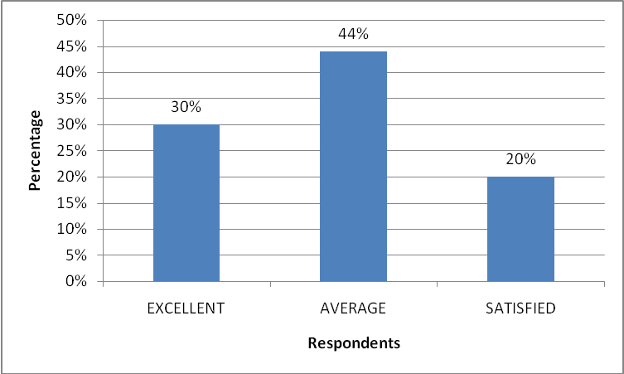

Interoretation:
It can be clearly made from the above graph that more than 70% of the respondents are post graduates and hence the option of theirs should be given high importance. Inference can be drawn that the sample size is high quality.

Table No. 2
(2) How many years of experience did you have, prior to joining this organization?
Year of Experience | No. of Mangers | % of Managers
0 to 1 | 16 | 16%
1to 3 | 24 | 24%
3 to 5 | 52 | 52%
5 to 7 | 8 | 8%
Total | 100 | 100%

CHART – 2
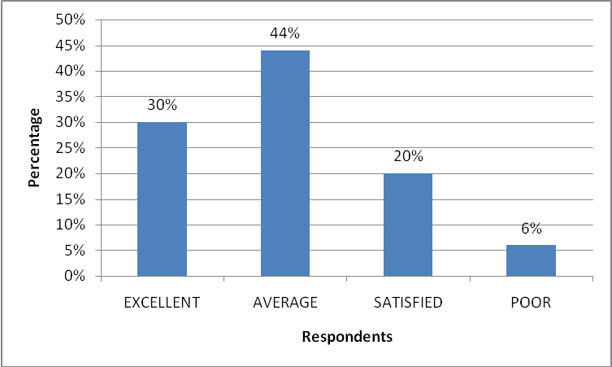
Interpretation:
The graph shows the experience of the managers before joining Nutrine Confectionery Company Limited. Inference can be drawn that the majority of the managers have experience between 3 to 5 years, which also means that apart from having quality education they also are very experienced and hence the views gives by them are of high importance
Table No. 3
(3) How many years you have been working in this organization?
Years of Experience | No. of Managers | % of Managers
0 to 1 | 28 | 28%
1 to 3 | 52 | 52%
Recently Joined | 20 | 20%
Total | 100 | 100%

CHART- 3
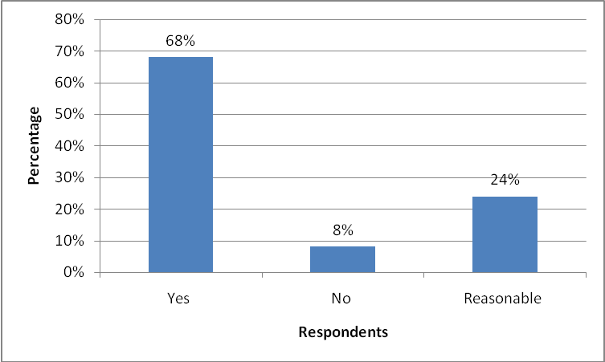

Interpretation:
The graph shows the association of the respondents with the Company. Nutrine Confectionery Company Limited is only 3 years old and 50% of the respondents were there from the starting itself, which means employed, retention is high in Nutrine Confectionery Company Limited, which is a good sign for any company.

Table No. 4
(4) Table showing the responses about the sources of Recruitment in the Organization

DIMENSION | NO. OF RESPONDENTS | PERCENTAGES
Internal | 14 | 14%
External | 42 | 42%
Both | 44 | 44%
Total | 100 | 100

CHART- 4

Interpretation
14% said ‘Internal’, 42% said ‘External’ and the remaining 44% respondents said both sources are used for recruiting manpower in the Organization

Table No. 5
(5) How did you come to know about the job vacancy in this company?
Job vacancy | No. of Managers | % of Managers
Internal Reference | 3 | 12%
Advertisement | 5 | 20%
Consultancy | 12 | 48%
Casual Application | 2 | 8%
Campus Recruitment | 3 | 12%
Total | 25 | 100%

CHART- 5
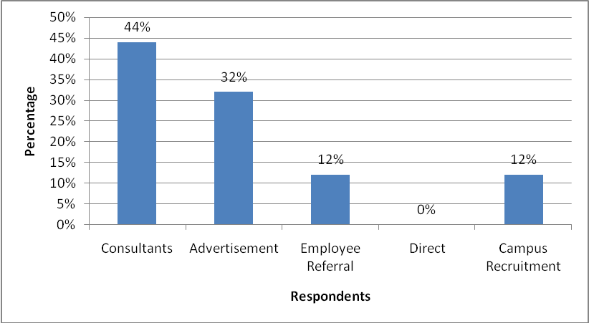

Interpretation:
This Chart shows the source from where the present employees came to know about the vacancy and it is found that the Consultancy is a good Source of Recruitment in Nutrine Confectionery Company Limited.

Table No. 6
(6) What attracted you to apply for this present job?
Attraction towards the job | No. of Respondents | % of Respondents
Vision of the Company | 8 | 8%
Good Working Environment | 8 | 8%
Organizations Repopulation | 40 | 40%
Growth Opportunities | 12 | 12%
Pay Package | 32 | 32%
Total | 100 | 100%

CHART- 6:

Interpretation:
The hart shows the reasons for attracting towards the present job of the respondents and an inference can be drawn that the Nutrine Confectionery Company Limited has got a good brand name which attracts majority of the people to join the organization. People are also happy with the salary and perks, which is given to them in this company.

Table No. 7
(7) Do you agree that the four round of interview are very tiring for a candidate?
Are four rounds of interview tiring? | No. of Managers | % of Managers
Yes | 16 | 16%
No | 36 | 36%
Appropriate | 48 | 48%
Total | 100 | 100%

CHART- 7

Interpretation:
The graph shows the opinion of the respondents who joined the Company after Four rounds of Interview and final interview, which is still practiced. Four rounds being Group discussion, Written Test, HR Interview and Final Interview and nearly 50% of them think that the rounds are appropriate but its being suggested to them company after the project was completed that they should make candidates for a long time when they come for interview

Table No. 8
(8) What is your opinion about the interview that had been conducted?
Opinion about the Interview | No. of respondents | % of Respondents
Very Good | 8 | 8%
Good | 28 | 28%
Satisfactory | 60 | 60%
Poor | 4 | 4%
Total | 100 | 100%

CHART- 8:

Interpretation:
The Inference can be drawn after seeing the above chart the majority of the people opine that the rounds of interview were satisfactory and only few said that it was very good which means room for improvement is there and Company should work for that.

Table No. 9
9. How do you rate the Recruitment Process followed by the Company?
Recruitment Process of the Company | No. of Managers | % of Managers
Good | 32 | 32%
Excellent | 16 | 16%
Average | 40 | 40%
Poor | 12 | 12%
Total | 100 | 100%

CHART- 9

Interpretation:
Manager’s view about the recruitment Process followed by the Company is not that great, which means company especially the HR Department should strive hard to build good rapport among the departments.

Table No. 10
The two forms of job advertisement (Newspaper & Internet) which are used by the company – do you think it’s effective?
Are Advertisements Effective? | No. of Managers | % of Managers
Effective | 60 | 60%
Not Effective | 8 | 8%
Should be more presentable | 32 | 32%
Total | 100 | 100%

CHART- 10

Interpretation:
The Chart shows the opinion of managers on the effectiveness of the job advertisement given by the company and inference can be drawn that the company should be more creative and should come out with advertisements which are more appalling and effective.

Table No. 11

Other means of Advertising | No. of Managers | % of Managers
Magazines | 36 | 36%
Trade Journals | 64 | 64%
Any Other | - | -
Total | 100 | 100%

CHART- 11

Interpretation:
Inference can be drawn from the above chart that the company should find new means of job advertising. Magazines and Trade Journals would be good means to try on a part from the usual Newspaper Advertisement.

Table No. 12
(12) Do you agree that the consultants are doing a good job for Nutrine Confectionery Company Limited?
Are Consultants doing a good job? | No. of Managers | % of Managers
Yes | 68 | 68%
No | 8 | 8%
Reasonable | 24 | 24%
Total | 100 | 100%

CHART- 12

Interpretation:
The Chart shows the respondents view when asked whether consultants were doing good job for Nutrine Confectionery Company Limited. Inference can be drawn that the Consultants are doing good job for the company.

Table No. 13
(13) What do you think is the best Consultant associated with Nutrine Confectionery Company Limited?
Best Consultant | No. of Managers | % of Managers
Corporate Buddha | 40 | 40%
Reach | 32 | 32%
Pearl | 20 | 20%
Resource Link | 8 | 8%
Total | 100 | 100%

CHART- 13

Interpretation:
The Chart shows the top four Consultants associated with Nutrine Confectionery Company Limited in which majority of the Respondents feel that Corporate Buddha is the number one Consultancy.

Table No. 14
Which Source of recruitment should be given more priority?
Priority to which source | No. of Managers | % of Managers
Consultants | 44 | 44%
Advertisement | 32 | 32%
Employee Referral | 12 | 12%
Direct | - | -
Campus Recruitment | 12 | 12%
Total | 100% | 100%

CHART- 14
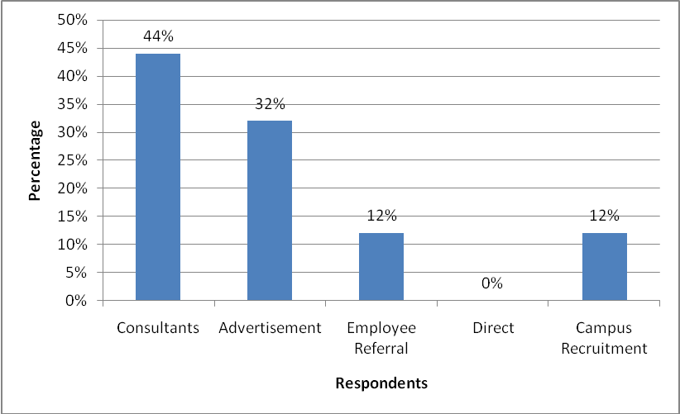

Interpretation:
Above chart shows the percentage of respondents voting for streamlining of different Sources of Recruitment. Inference can be drawn that there I more scope for improvement and that can be done by coming up with more incentive plans for Consultants.
Table No. 15
(15) Table showing the responses above the Technique / method used to attract Man Power foe Organization.
DIMEBSIONS | NO. OF RESPONDENTS | PERCENTAGES
Promotions | 96 | 96%
Transfers | 0 | 0%
Scouting | 0 | 0%
Advertising | 4 | 4%
Total | 100 | 100%

CHART- 15

Intertation:
The respondents said ‘salary & Perks’ are the Technique / Method used to attract Man Power for the Organization and the remaining about ‘Promotions’ and ‘Advertising’ are also used

Table – 16
Table showing the respondents opinion regarding any work experience before joining in this company
YES/NO | NO. of Respondents | Percentage
Yes | 58 | 58%
No | 42 | 42%
Total | 100 | 100%

CHART- 16
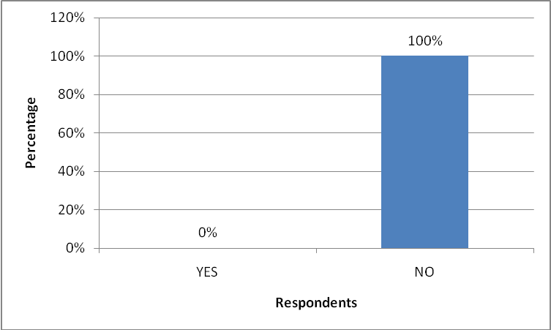

Interpretation:
From the above table it is inferred that 58% of the above employees are experienced before joining Nutrine Confectionery Company Limited, and 42% of respondents are not experienced before joining the company.

TABLE – 17
Table showing the respondent opinion regarding the recruitment process
OPINION | NO. OF RESPONDENTS | PERCENTAGES
INTERNAL SOURCES | 36 | 36%
EXTERNAL SOURCE | 64 | 64%
TOTAL | 100 | 100%

CHART- 17

Interpretation
From the above table it is inferred that 36% of above employees are selected from internal sources. And 64% of respondents are selected from External source

TABLE- 18
18. Table showing the respondent opinion regarding interview process

CONDITION | NO. OF RESPONDENTS | PERCENTAGES
GOOD | 38 | 38%
AVERAGE | 22 | 22%
SATISFIED | 40 | 40%
POOR | 0 | 0%
Total | 100 | 100%

CHART- 18

Interpretation
From the above table it is inferred that 40% of the above employees are felling satisfied regarding their interview process, 38% of respondents are feels that good, 22% of respondents are feels that average in their interview process.

TABLE – 19
19. Table showing the respondent option regarding the overall friendly of the interviewer during recruitment process.
CONDITION | NO. OF RESPONDENTS | PERCENTAGES
EXCELLENT | 30 | 30%
AVERAGE | 44 | 44%
SATISFIED | 20 | 20%
POOR | 6 | 6%
Total | 100 | 100%

CHART- 19

Interpretation
From the above table it is inferred that 44% of the above employees are feeling that average friendliness with their interviewer during the recruitment process, 30% of respondents are feels that excellent relationship, 20% of respondents are feels that they are satisfied with their relationship, 6% of respondents are feels that poor relationship to their interviewer

TABLE- 20
(20) Table showing the respondent opinion regarding science any employment contract to management.
YES / NO | No. of Respondents | Percentage
YES | 0 | 0%
NO | 100 | 100%
TOTAL | 100 | 100%

CHART- 20

Interpretion:
From the above table it is inferred that cent percent of employees can not done any signs in contracts

FINDINGS

- Majority of the respondence felt education qualification & work experience is given more importance in the company
- Majority of the respondence felt that that the requite process followed in Nutrine Confectionery Company Limited is average
- Majority of the respondence admit that consultants are the best source for the company.
- Majority of the respondence felt that both internal and external source is required.
- Majority of the respondence felt that the job advertisement mode by the company are not very effective
- Majority of the respondence felt that the time taken for conducting the interview process is too long.
- Most of the employees has experienced people before joining in Nutrine Confectionery Company Limited.
- Most of the respondents are selected from External sources.
- Most of the employees are satisfied with their interview process and good friendliness with the interviewer.
- In Nutrine Confectionery Company Limited permanent employees are more than temporary employees.
- Any one does not done any signs in employment contract.
- May employees feels that their work is based on their qualification.
SUGGSTIONS
Up to my observation and analysis there is definite Recruitment Procedure in the Organization, but to make it standardize some more steps are to be followed such as:
- The company has to conduct refreshment programs at least once in a year
- Group Discussions is the best way to know their communication skills.
- The company has to focus on the internal employees also for promotions
- The employers have to concentrate to build up their relations with their employees.
- The company has to retain the employees through rewarding, incentives.
- Interview planning should be perfect and it should be conduct at right time, which they were being gives to the candidate. They should not make the candidate to make long time.
- The company has to concentrate the fresher also not only the experienced people
- Negative marks should be introduced in the written test pattern so that it can filter the knowledge oriented ones
- It was suggested that the Organization should follow corporate culture in order to have a development in the Recruitment Procedure.

BIBLIOGRAPHY

- P. Subba Rao.
“Essentials of Human Resource Management and Industrial Relation.”
Himalaya Publishing House 2003 New Delhi.
- K. Aswthappa
“Human Resource and Personnel Management.”
Tata McGraw Hill 3rd Edition.

- Magazine: HRM REVIEW

WEBSITES
www.godrejhersheys.com
http://humanresources.about.com
http://www.humancapitalonline.com
www.google.com

QUESTIONNAIRE

Personal Details:-

NAME :

AGE :

DESIGNATION :

DEPARTMENT :

YEAR OF EXPERIENCE :

MARITAL STATUS :

ANNEXTURE
QUESTIONNAIRES ON RECRUITMENT AND SELECTED

- Educational Qualification
a) Graduate b) P.G. c) Any other ( )
- How many years of experience did you have prior to joining this organization
( )
a) 0-1 b) 1-3 c) 5 years
- How did you come to know about the job vacancy in this company ( )
- Internal Reference
- Advertisements in media/internet/website
- Human Resource Recruiting Consultancy
- What attached you to apply for the job ( )
- vision of the Company
- Good working Environment
- Organization’s Reputation
- Job it self
- Growth opportunities

- Do you agree that he four rounds of interview are very tiring for a candidate
( )
a) Yes b) No c) Appropriate
6. What is your opinion about the interview that had been conducted ( )
a) Very Good b) Good c) Satisfactory d) Poor
7. How do you rate the recruitment process followed by the company ( )
a) Excellent b) Good c) Average d) Poor
8. Do you agree that the consultants are doing a good job for NCCL ( )
a) Yes b) No c) Reasonable
9. What are the source of require in you for organization ( )
a) Internal b) External c) Both
10. Which media suits for your organization recruitment process ( )
a) News Paper b) T.V. c) Radio d) Internet
11. What techniques methods are used to attract manpower for the organization
( )
a) Promotion b) Transfer c) Advertising d) Scouring
12. Which level of the people out the recruitment process in organization ( )
a) Top level b) Middle level c) Company Executives
13. Did you have any work experience before joining NCCL ( )
a) Yes b) No
14. How did the company recruit you ( )
a) Internal Source b) External Source
15. Did you like your interview process ( )
a) Good b) Average c) Satisfied d) Poor
16. How do you rate the friend lines of the interviewer during recruitment process
( )
a) Excellent b) Good c) Satisfied d) Poor
17. Did you sign any employment contact to the management ( )
a) Yes b) No

