TABLE OF CONTENTS

- Summary
- Company profile
- objective of the study
- research methodology
- data analysis
- findings & ANALYSIS
- limitations
- Conclusion
- Recommendation
- QUESTIONNAIRE
- BIBLIOGRAPHY

1. INTRODUCTION

THEORETICAL BACKGROUND:
Training is a very important aspect of HRD. The three main areas involved are i.e., skills, knowledge and attitudes, but always with a definite purpose in mind. “Training is being used as a tool, it is upgrading Human Resource in some organization by design and in many others by default. It attempts to improve the performance of employees on the current job or prepare them for the future job.
Training and development being the most vital tools of HRD, generally forms a major part of the present HRD. It is essential from top to bottom, each an every employee is being trained in his cadre. In higher cadres training is a process of assisting managers to learn and improve their ability to perform managerial tasks with emphasis on learning management from the organization point of view and not from the individual view point of learning.
Training and development are the planned leaning experiences that teach workers how to perform their current as well as future jobs more effectively. Training and Development practices are designed to improve organizational performance through enhancing knowledge and skills of the employees. It is essential that all the activities relating to training should be in tune with the specific needs of both the organization and the employees.
There is also the need to assess the attitude and inclination of the trainees or employees regarding the training. It is also important to obtain feedback on, to what extent the training as brought and change in perception, attitude and behavior of the trainees, and also to that extent it is helping the individual to develop his skills, improving performance and also for the development of the employee.
Training:
Training makes a very important to the development of the organization of human resources and hence to the achievement of its aims and objectives. To achieve it’s purpose, training needs to be effectively managed so that the right training is given to the right form, at the right time and at the right costs.
The term “Training” indicates the process involved in improving the aptitudes, skills and abilities of the employees to perform specific jobs. Training helps in updating old talents and developing new ones.
According to Edwin B. Flippo. “Training is the act of increasing the knowledge and skills of an employee for doing a particular job”. Training involves the development of skills that usually necessary to perform a specific job. Its purpose is to achieve a change in the behavior of those trained and to enable them to do their jobs better. Training is necessary for newly employees to make them productive and also to old employees whenever new machines and equipment are introduced. In fact, training is a continuous process.
The word “Training” consists of eight letters, each of which could be attributed some significant meaning in the following manner:
T - Talent and Tenacity
R - Reinfor
A - Awareness
I - Interest
N - Novelties
I - Intensity
N - Nurturing
G - Grip
Development:
Development, in contrast, is considered to be more general than training and more oriented to individual needs in addition to the organizational needs and it is the most often aimed towards management of the people. Usually the intent of development is to provide knowledge and understanding that will enable people to carry out non-technical organizational functions more effectively, such as problem solving, decision making and relating to people.

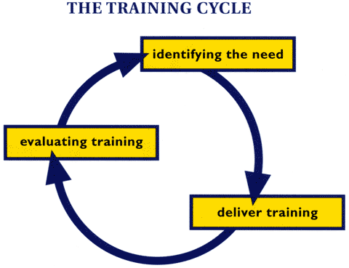

training and development needs
Fundamental to the delivery of any path project is the development of the team and the professional development of all individuals. At all levels there is an expectation that the skills, attitudes and knowledge required to deliver successful projects will be gained while these projects develop.
This section looks at how project managers can identify the skills and knowledge required to successfully deliver a competent project as well as provide the training and development required for both themselves and the project team. The intention here is to give an overview, as there are training and development texts that cover this subject in much more detail.
You should start with an analysis of the training and development that is required. The starting point and the subsequent steps can be represented in ‘The Training Cycle’ or ‘The Systematic approach to Training and Development’. This is a widely recognized and used model of the processes involved in professional development.

Meeting the need through training and development
It is not the intention here to go into detail of the many ways in which training and development can be delivered. Instead, this section will focus on three areas that are pertinent to the path manager: the manager, the team member and the team. However, at this point it is well worth taking into account that different individuals may prefer different ways of learning.

The path manager
As a result of the training needs analysis a number of routes to development may be decided. As part of their personal development plan (PDP) it is common practice for managers to put together a portfolio of evidence showing their progress. (In some professions this is actually compulsory in order to maintain professional status.)
The contents of the portfolio should include:
- an up-to-date CV;
- qualification and course certificates;
- a record of past training and development; any analysis carried out;
- appraisal reports;
- the PDP and reviews.
This portfolio should continually be updated, and in time will provide evidence of a commitment to lifelong learning. Team members should be encouraged to keep a portfolio to recognize their achievements. Further development of the team leader is discussed under team development below.

The team member (including the manager)
There are a wide variety of methods for an individual’s development. Some of these are related to a team’s needs, as discussed in the following section, but some of the needs may be very specific to the individual. A number of specific needs can be identified from the training needs analysis and PDPs. The team manager or trainer may then be required to determine how these needs can be met. There are a number of options.

External provision
Further education colleges and private training providers can be a source of training and development. If the courses provided match the needs identified in development plans, these can be very successful. Sometimes it is difficult to find courses that match needs completely; however, every effort should be made to ensure that the training is at the right level and will meet the identified needs.
If numbers justify it, it usually more cost-effective for external organisations to deliver in-house training to reach specific objectives that have been agreed between the training organisations and the client.

Open learning
A wide range of open-learning packages covering both technical and interpersonal skills are available. Such courses are widely used in, for example, management training; some qualifications for managers incorporate a certain amount of open learning, some of which may be supported by mentors or tutors in the workplace or in a learning centre. This is the model used extensively by the Open University and the Open Business School.
Projects and assignments here is very little difference between these two terms: assignments are generally written and projects are generally practical. Both start with an agreed objective or set of objectives and can be used at any level.

Evaluating the development

How was it for you?
In Identifying training and development needs we looked at the training cycle, in which a need for training and development was identified; Meeting the need then described how training can be delivered, whether it is for the path manager or for a team member.
It is important for the team and the individual to determine whether the training and development has been effective. Before you do this it is useful to look at a model of how people learn. This can be interpreted in the learning cycle.
‘If you don’t know where you are going, you will not know when you get there.’

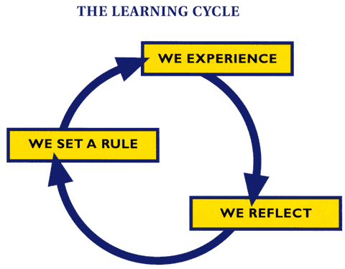

We experience
Think back to when you learned a certain task. Whether it was learning to ride a bike, drive a car or do a crossword, you have to start with an experience. That is, you attend a training course, try something out, are shown how to do something, watch a video or any other method which exposes you to the skill, method, task or knowledge.

We reflect
After instruction, if you wish to learn the task or knowledge, you reflect on it. You can either think through the process, such as doing crosswords or mathematical problems, or you can practice, such as first-aid training.

We set a rule
Having reflected or practiced, you can see how a task is performed and you set a rule that is the way something is done ‘clicks’. Having set the rule, you then go on to practice the task until it is ‘mastered’.
This is exactly the principle behind study skills in which the student learns a subject and then by writing essays or doing tests along with feedback from a tutor eventually understands a process.

Applying this to training and development
Training and development at any level wastes resources unless it correctly meets a need. The only way you can determine whether it has met a need is to evaluate the learning, taking into account the learning cycle. This applies to both managers and path team members.
Evaluation can exist at a number of levels, and unless you understand and use this you will not fully implement training that will meet the overall needs of the team.

Instant evaluation
We are familiar with instant evaluation sheets at the end of training courses. While these can be useful in an overall picture, they are generally of limited use as they only describe feelings at that time. They may also reflect what the learner has enjoyed rather than what he/she has actually learned.

Pre-briefing
It is more meaningful if team members are briefed by a manager before any training event to talk over the content of the training, to determine expectations and to set the scene for a debriefing.

Debriefing
Debriefing is a good way to ensure that the learner is focused and is going to be able to implement the training as soon as possible after the learning. It is also a vehicle for the manager evaluating whether this was the right training and whether it was value for money.

Learning
Many people attend courses or other training sessions but do not learn as efficiently as they could. There can be many reasons for this, including lack of motivation or poor teaching. You must determine whether any training and development is effective in assisting the learner to learn. This can be done through tests or examinations, but the most effective way in the workplace is to allow the learner to put the new knowledge into practice as soon as possible; if necessary, this can be carried out under supervision, and feedback given as soon as possible. Vocational qualifications were mentioned earlier; the assessment of skills in the workplace is a major benefit of this system.

Team learning
If you are concerned not only about the learning experienced by the individual but about the team, you have also to ask whether the training has had an effect on developing the team through either learning skills or changing attitudes.
That is, if you want to review team performance and the role of training in developing and achieving this then you should previously have set team development objectives using the SMART principles. The team development should contain objectives, for example:
- By the end of September 2003 two assessors will have been trained to certificate level, three coaches to skills level and five members of the team to SVQ Level 2.
- Only by evaluation can we guage the effectiveness of training and development.
We have here specific and measurable objectives that can be evaluated easily. This can be combined with evaluations from training courses and SVQs to form an overall picture.

Organisational learning
If the evaluation of team learning is important, so too is the evaluation of organisational learning. This can be compiled from team evaluation reports and take the form of a report on the overall impact of training and development on organisational objectives.
If the above approach is taken you can more easily compare what has been achieved with what was planned in the original training needs analysis and the individual, team and organisational development plans.

A checklist for evaluation
Below is a sample of the kind of questions which can and should be asked of any training and development. By no means comprehensive, it nevertheless gives guidance on what should be evaluated:
- Does the training delivered meet the identified need?
- Has the training met the individual, team or organizational objectives?
- Has the need been met completely or in part?
- What has prevented the need being met?
- Has the need been met both efficiently and in a cost-effective way?
- Was the training event satisfactory?
- Did the delivery of the training enhance learning?
- Has the learning been set at the right level?
- Has the learner been able to implement learning as soon as possible?
- Was the learner briefed and debriefed for the learning?
- Have all necessary resources been allocated to the training?
- Are these resources adequate?
- Has the development enhanced the learning needs of the team?
APPROACH OF TRAINING AND DEVLOPMENT
Traditional Approach
Most of the organizations before never used to believe in training. They were holding the traditional view that managers are born and not made. There were also some views that training is a very costly affair and not worth. Organizations used to believe more in executive pinching. But now the scenario seems to be changing.
modern approach
training and development is that Indian Organizations have realized the importance of corporate training. Training is now considered as more of retention tool than a cost. The training system in Indian Industry has been changed to create a smarter workforce and yield the best results
TRAINING AND DEVELOPMENT OBJECTIVES
The principal objective of training and development division is to make sure the availability of a skilled and willing workforce to an organization. In addition to that, there are four other objectives: Individual, Organizational, Functional, and Societal.
- Individual Objectives – help employees in achieving their personal goals, which in turn, enhances the individual contribution to an organization.
- Organizational Objectives – assist the organization with its primary objective by bringing individual effectiveness.
- Functional Objectives – maintain the department’s contribution at a level suitable to the organization’s needs.
- Societal Objectives – ensure that an organization is ethically and socially responsible to the needs and challenges of the society.

SUMMARY
MOST IMPORTANT NEED:
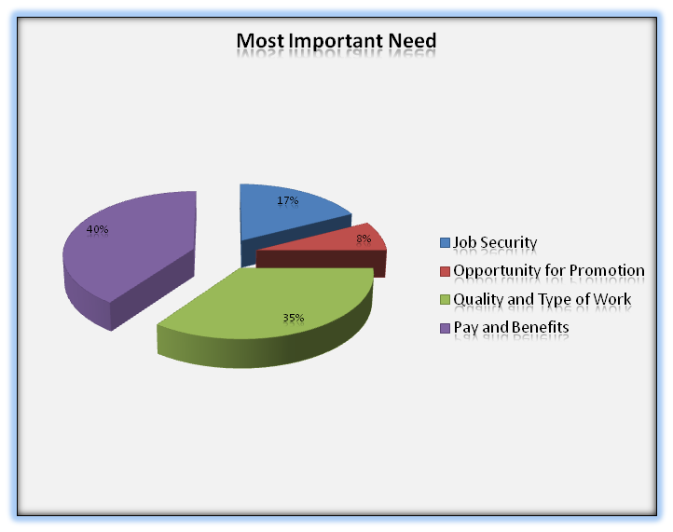
MOST IMPORTANT WELFARE MEASURES:
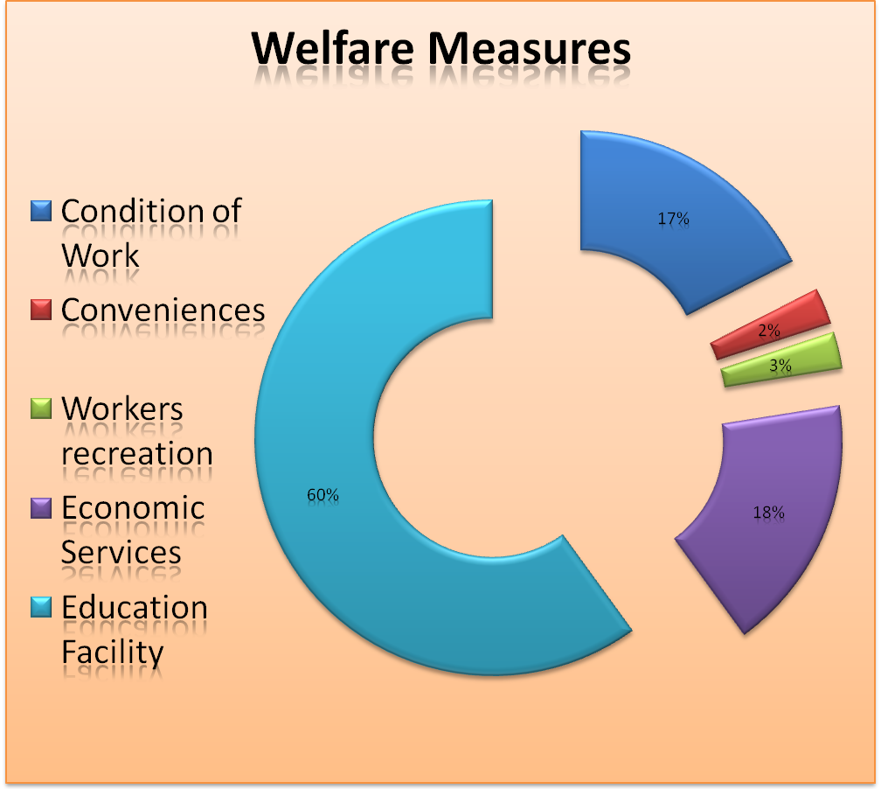

PAY SHOULD BE LINKED WITH THIS:
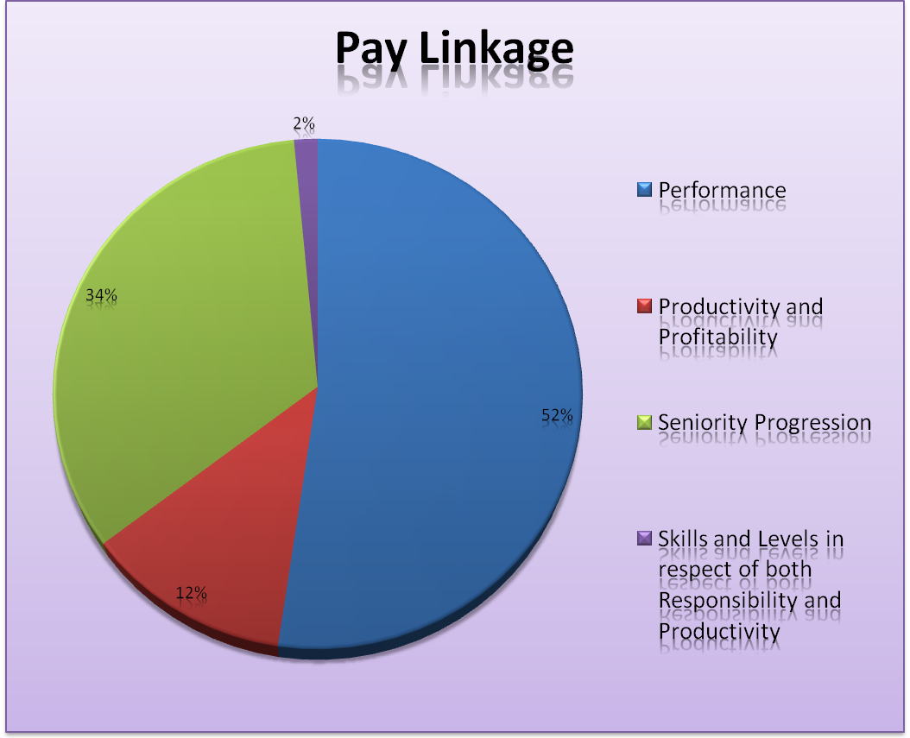

PERFORMANCE CAN BE IMPROVED BY THIS:

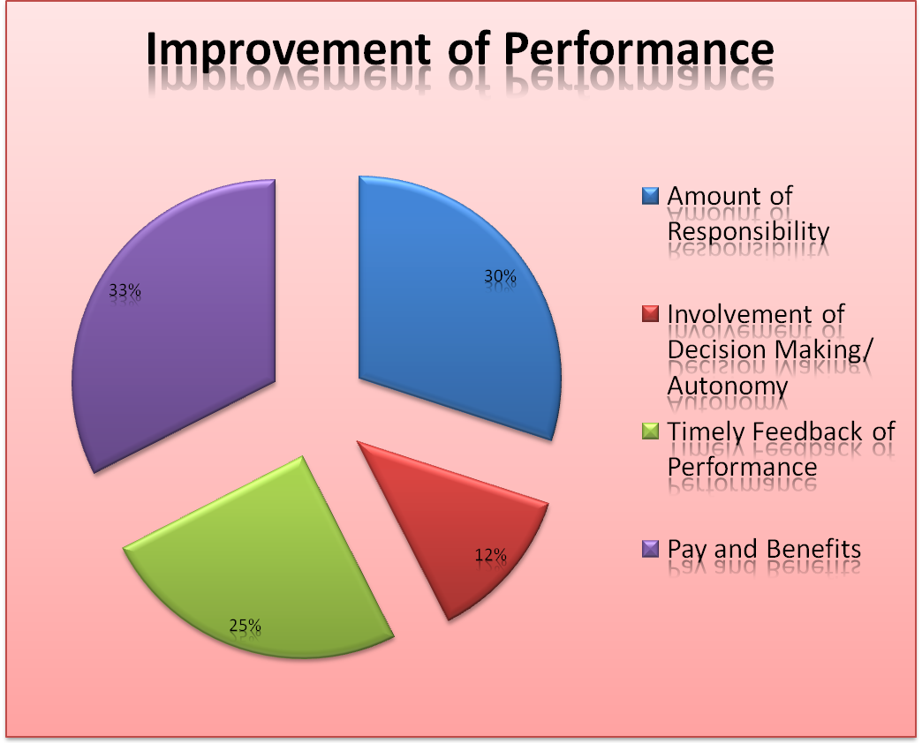
COMPANY PROFILE

Glimpses On The Birth Of Coca-Cola
John Smyth first introduced the refreshing taste of Coca Cola in Atlanta. It was May of 1886 when the pharmacist caramel syrup in a three legged brass kettle in his backyard. He first “distributed “ the new product carrying Coca-Cola in a jug down the street to Jacobs Pharmacy. For five cents, consumers could enjoy a glass of Coca-Cola at the Soda Fountain. Whether by design or accident carbonated water was teamed with the new syrup producing a drink that was proclaimed “ Delicious” And Refreshing.
Dr. Pemberton partner and bookkeeper frank M Robinson, suggested the name and panned Coca cola in the unique flowing script that is famous worldwide today. Mr. Robinson thought “ the two C,S would look well in advertising.”
By 1886, sales of Coca-Cola averaged nine drinks per day. That first year, Dr Pemberton sold 25 Gallons of syrup, shipped in bright red wooden kegs. Red has been a distinctive color associated with the No-1 soft drink brand ever since. For his effort, Dr Pemberton grossed $5o and spent $73.96 on advertising.
In 1891, Atlanta entrepreneur, Asa G. Candler had acquired complete ownership of the Coca-Cola business. With in four years, his merchandising flair helped expand consumption of Coca-Cola every state and territory. In 1919 Coca Cola Company was sold to group of inventors for $25 million. Robert W.Woodruff became president of the Coca Cola in 1923, and his more then six decades of leadership took the business to unrivalled heights of commercial success making Coca Cola an institution the world over.

Soft Drink Market In Present Scenario
The soft drink market all over the world has been witnessing a throat cut battle between two major players: coca cola &Pepsi, since very beginning. The thirst quenchers are trying hard to have the major piece of the apple of overall carbonated soft drink market. Both the players are spending energies in building capacity, infrastructure, promotional activities etc.
Coca cola, being 11 years older than Pepsi, has been dominating the scene in most of the soft drink market of world and enjoying the leadership in terms of the share.
But the coca cola people are finding it hard to deep away Pepsi, which has been narrowing the gaps regularly. The two are posing threats for each other in every nook and corner of the world. While coca cola has been earning most of the part of its red and butter through beverages sales but Pepsi has a multi product port folio with a handsome portion from the same business.
Both the competitors have a distinct vision and properties about the Indian soft drink market. though having so much difference and distances with each other ,they both consider India a huge potential market ,as per capita consumption here is a mere three serving annually against the world average of 80.therefore ,they are putting in their best effort to woe the India consumer who has to work for 1.5 hour to buy a bottle soft drink in comparison to the international norms of 5 minutes, a major hurdle to cross over for both the athletes or getting no.1 position.
Coca cola is well with its 53 bottling sites throughout the country giving it an edge over competition by processing a well built and distribution set up. On the other hand , Pepsi, with 2 more years in India , has been able to set an image of winner this time in India and get the pulse of India soft drink The soft drink giants are Leaving on stone unturned and her for the Long terms. Coca cola has been penetrating the market through its wide product range with a determination to change consumption pattern of soft drink in India. Firstly, they upgraded the whole industry by introducing 300 ml bottles, which in turn had given the industry a booming growth of 20% as compared to the earlier 5%. They want to develop a Coca culture and are working on a strategy to offer soft drink in every possible package. In Coca cola cap, the idea of competition has not come from Pepsi, but from the other beverages such as Tea, Coffee, Nimbu Pani, and Water etc.
Pepsi is quite aggressive in its approach to Indian consumer. They are desperately working on the strategy to be winners in the hot cola war between two big banners. According to Pepsi philosophy, it’s the madness encourages executive to think, to conjure up those creative tactics to knock the fizz out there competition. Pepsi had plumbed a large on the visibility of its blue red and white logo. They have been going with aggressive marketing by putting Sachin Tendulker, Akshay Kumar, and now Shahrukh Khan in their advertisement to endorse their brand, the role models for its targeted consumer the teenagers. They have increased the fizz in the market place by introducing the dispensers called Fountain Pepsi and has been enjoying a lead over its rival there.
Coca Cola on the other hand, has been working on the saying ‘slow and steady wins the race’, side by side retailing to every more of its competitor. They have produced the shield of Thums Up with a handsome Markey share in Indian soft drink market. Countering Pepsi’s international commercial that used two chimpanzees to cock a snoop at coke. Thums Up has been positioned now very near to that young image of Pepsi and giving it a tuff time.
These cool merchants have put every thing on fire .if coke get the status of the official drink of wills world cup, Pepsi blushed as nothing official about it. as Thums up projected as ‘sare jaha se accha’, Pepsi was passionate enough with ‘freedom to be’ and now the “yeh dil mange more”. When Thums up came with thunder blast.
The Coca -Cola company is the world" leading manufacturer and distributor of non-alcoholic bevarage concentrates and syrups, with world headquarters in Atlanta, Georgia. The company and its subsidiaries in nearly 200 countries around the world manufacture and sell over 230 other company soft drink brands.
By contract with the Coca-Cola Company and it's local subsidiaries, which employs nearly 34,000 people around the world, local businesses are authorized to bottle and sell company soft drinks within the local boundaries and under conditions that ensure the highest standards of quality and uniformity.
- Company's objectives
Company's mission must be turned in to specific objectives for each level of management in a system known as management by objectives the most common objectives are:
- Profitability
  - Sales growth
  - Market Share
  - Improvement
  - Risk Diversification
  - Innovation
  - Satisfy the customer

HISTORY OF SOFT DRINKS
Problem at that time was how to cure all these disease, since no remedy was present at that time. It was a big question for American people. So in 1885 Mr. John Paimwarlion who lives in Antonica made a drink and registered it as TRENCH WINE COLA. In the beginning this drink was made with mixture of cocaine and alcohol but later on it is named as COCO-COLA. A new brand named PEPSI COLA in the year 1887.
- Indian History
Around 1948 the first branded soft drink in the Indian market. This soft drink was named as Gold Spot. Before Coco-Cola entered the country to dominate the scene in 1950, Parle Exports Pvt.Ltd. was the first Indian company to introduce a lemon soft drink.This drink was known as Limca and it was introduced in 1970. However before this they had introduced Cola Pepine which was withdrawn in face of tough competition from Coca-Cola.
In the year 1977 Coca-Cola left Indian market and this brought in an opportunity for various Indian companies to show their caliber. At this time a new soft drink was introduced by Parle products and this was color. This drink was introduced with mighty saying "happy days are here again". As if happy days went away with Coca-Cola. There was another company named pure drink, which introduced the soft drink named Campa -Cola along with arrange and lemon / flavours.
Just after this many more companies entered the soft drink market. A soft drink name double. I had been introduced by a company Morden bakers. Another company Mohan meakins also came up with a Soft drink named Mary & puch up, Mc Dowell came with thrill.,. Push and Sprint.
Previously there was no competition in the Indian soft drink market but with all companies coming in the Indian market a huge competition was place with college advertisements. But in the year 1988 Pepsi was given permission to sell its soft drinks in the Indian market by the Government of Indian. Coca Cola also come back in the year 1993.
  - Coca-Cola in India
The Coca-Cola company entered India in early 1950, it setup four bottling plants at Bombay, Calcutta, Kanpur and Delhi.
In 1950, as were negligible companies in the Indian market therefore Coca-Cola did not faced much competition and they were accepted in Indian market more easily. The brand was accepted by all age group. The full credit must go to coca-cola for making soft drinks popular in Indian by end of 1977.Coca-Cola had captured more than 45% of market share in India Then Coca-Cola left Indian following public regulations the company was required to Indianise or close operation come to an end in July 1977.
Coca-Cola come back in the year 1993 after liberalization and was launched at Agra with the slogan "Old wave have come to Indian again". At the time parle was the leader in the soft drink market and had more than 60% of the total shore in soft drink. Coca-Cola joined hands with Parle and to enter India after 17 years. By striking a 40 million deal with Parle. Coke almost made a clear sweep and made its good as " To become all time all occasion drink not a special treat beverage."
BOARD OF DIRECTORS
 |  | Douglas N. Daft  Chairman, Board of Directors, and Chief Executive Officer  The Coca-Cola Company
 |  | Herbert A. Allen  President and Chief Executive Officer  Allen & Company Incorporated  (a privately held investment banking firm)
 |  | Ronald W. Allen  Consultant to, Advisory Director, and former Chairman of the Board, President, and  Chief Executive Officer, Delta Air Lines, Inc.
 |  | Cathleen P. Black  President  Hearst Magazines
 |  | Warren E. Buffett  Chairman of the Board and  Chief Executive Officer  The diversified holding company  Berkshire Hathaway Inc.
 |  | Barry Diller  Chairman of the Board and  Chief Executive Officer  USA Interactive
 |  | Susan B. King  President, The Leadership Initiative  (nonprofit consultants for leadership education) Duke University
 |  | Maria Elena Lagomasino  Chairman and CEO  J.P. Morgan Private Bank
 |  | Donald F. McHenry  Distinguished Professor in the Practice of Diplomacy and International Affairs at the School of Foreign Service  Georgetown University
 |  | Robert L. Nardelli  Chairman of the Board, President, and  Chief Executive Officer  The Home Depot, Inc.
 |  | Sam Nunn  Senior Partner in the law firm of King & Spalding  Co-chairman and Chief Executive Officer,  Nuclear Threat Initiative (NTI)
 |  | J. Pedro Reinhard  Executive Vice President and  Chief Financial Officer  The Dow Chemical Company
 |  | James D. Robinson III  Co-founder, Chairman and CEO of RRE Investors, LLC and General Partner of RRE Ventures GP II, LLC  (private information technology venture investment firms)
 |  | Peter V. Ueberroth  Chairman, Contrarian Group, Inc.  and Co-Chairman, Pebble Beach Company
HISTORY OF COCA COLA COMPANY
In the year of 1990, over one hundred years after the soft drink was invented, the Coca- Cola company opened up a museum like building which was designed to be a tribute to its famous soft drink product. It is also said to be a tribute to the countless number of consumers who drink Coca-Cola. The world of Coca-Cola, as it is called is located in Atlanta, Georgia right amidst the tourist district. And, its tribute to the soft drink is because it is so popular that it is now served daily in nearly two hundred countries.
Having the museum located in Atlanta is fitting because long before anyone had ever heard of Coca-Cola, a doctor by the name of Johan Stythe Pemberton, who was a druggist in Atlanta, mixed up his own concoction of medicinal syrup in May in the year of 1886, Dr. Pemberton used Africa.
Kola Nut extracts and coca leaves, which are both strong stimulants, in his potion. The result was Q thick caramel colored syrup. The purpose of the potion was to be an effective tonic which would help a person's brain and nerves function better.
True or not, it has been said that a customer came into the pharmacy
one day complaining or a headache. He asked for a glass of Coca-Cola to be made with carbonated water instead of plain water and the carbonated version of the soft drink was the born.
The first year, in 1886, Dr.Pemberton sold twenty five gallons of his syrup which earned him total revenue of just fifty dollars. By the next year, because of he is poor health condition, he began to sell off his company. Five years later, man by the name of Asa G.Candlar, had acquired total control of the Coca-Cola became a patented product in the United States.
Its popularly would not stay within the United States for long, though, because in the year of 1906, Cola-Cola was bottled in Cuba and in Panama. Bottling operations were soon start ed in Hawall the next year, then in the Philippines, France, Belgium, Bermunda, Colombia, the Honduras, Italy, Mexico, Haiti, and Burma in later years. By the year of 1940, the famous soft drink was bottled in forty country.

THE BOTTLING SYSTEM
The day Coca Cola reach consumers and customer around the world through a vast distribution network made up of local bottling companies. These bottlers are locate around the world, and most are independent business. Using concentrates and beverages bases produced by the Coca Cola company, our bottling partners package and market products, distributes them to more than & million customer and more than 2 million vending machines around the world.
The Coca Cola Company is committed to assisting its bottlers with the function of an efficient bottling operation. Quality contract, ministered constantly by the company is necessary to produce high quality soft drinks.

TRADE MARKS
Our trademarks are our most valuable assets. The trademark “Coca-Cola” was registered with the U.S. patent and trademark office in 1893, followed by “Coke” in 1945 the unique contour bottle, familiar to consumers every when, way granted registration is a trademark by the U.S. patent and trademark office in 1977, in honor awarded to few other packages. In 1982, the Coca Cola Company introduced Diet Coke is U.S. consumer marking the first extension of me company’s most precious trademark to another product later years saw the introduction dp additional products bearing the Coca Cola name which now EMCON passes a powerful line of six Coal products.
Today, the world’s favorite soft drink Coca Cola the world best known and most admired trademark; recognized by more than 90 percent of the world population.

Product ADVANCEMENT
In 1985, a new Cola emerged from laboratory research. Through internal evaluation and thousand by blind taste tests, consumer said they preferred it over both Coca Cola and its primary competition. As a result, in April 1985, the company proudly introduced the new taster of coke the first change in the secrete formula since my product way created in 1886.
The launch of Coke with the new taste took place in the United State and Canada. Consumer respected with an unprecedented and new famous out pouring of loyalty and offering for me original formula of Coca-cola returned & Coca-Cola classic. In 1986, Coca-Cola classic became and still remains, the nations top-selling soft drink.
PRODUCTS AND PACKAGING MYTHS & RUMORS
INGREDIENTS MYTHS & RUMORS
All our soft drinks are wholesome beverages manufactured in compliance with the U.S. Federal Food Laws, the laws of all U.S. states, and the laws of nearly 200 countries throughout the world where our product share marketed. Unfortunately, the incredible power of the Internet is sometimes used to spread false information about the ingredients in our products. There are several baseless rumours circulating on the Internet claiming that ingredients in our products can cause health problems. We've gathered some of those rumours here so that you can easily get the facts about these false claims.
Here are some rumours you may have seen or heard
- The acidity of cola drinks is strong enough to dissolve teeth and bones.
- Phosphoric acid in Coca-Cola leads to osteoporosis.
- Aspartame, a sweetener in low calorie beverages, causes headaches, brain tumours and other diseases.
- Caffeine in soft drinks is addictive.
- Saccharin causes cancer.
- Sugar in soft drinks makes people hyperactive.
- Caramel colouring produces genetic effects and causes cancer.
- The polyethylene glycol in soft drinks is also used as anti-freeze in automobiles and as an oil solvent.
- Some products of The Coca-Cola Company contain alcohol.

YOUR HEALTH AND THE BEVERAGES
There is growing confusion about what constitutes a healthy diet. With so much conflicting information available about health and nutrition, it can be very difficult to determine what is accurate and what is not.
The truth is that soft drinks and other beverages have a place in a healthy lifestyle. A healthy diet incorporates the basic principles of variety, balance and moderation without sacrificing enjoyment.
HEALTH AND THE BEVERAGES -- THE FACTS
Facts on Diabetes and Soft Drinks
- Soft drinks do not contribute to diabetes.
- Children who are obese have a greater risk of type 2 diabetes but this is not related to the sugar content in soda
Facts on Aspartame and Soft Drinks
Key Fact
- Aspartame is a safe low-calorie sweetener, approved by more than 90 nations and scores of health organizations, that has never been linked to any health risks.
Facts on Healthy Bones and Soft Drinks
Key Fact
- The caffeine and phosphoric acid in soft drinks does not affect bone health.
Facts on Hyperactivity and Soft Drinks
Key Fact
- The sugar in soft drinks does not cause children to be hyperactive.
Facts on Milk Consumption and Soft Drinks
Key Fact
- The consumption of soft drinks has not affected calcium consumption.
Facts on Sedentary Lifestyle and Obesity
Key Facts
- Rising obesity rates are due in large part to sedentary lifestyles and lack of physical activity.
- Soft drinks can be part of an active lifestyle
Facts on Sugar and Soft Drinks
Key Facts
- Sugar consumption has not been shown to cause obesity.
- There are no nutritional differences between sugars and the body uses them all the same way.
- The amount of sugar and calories in soft drinks is about the same as many fruit juices

Facts on Caffeine and Soft Drinks
Key Facts
- Soft drinks containing caffeine are not addictive.
- Caffeine has no negative impact on hydration or bone health.
- There is no connection between cardiovascular disease and caffeine
BOTTLING TODAY

Think local, act local
From the world's largest cities to its most remote villages, our bottling system is made up of locally rooted enterprises committed to quality. The Coca-Cola Company bottling partners are always local businesses, exerting a strong influence on economic development and actively participating in community life through local events and philanthropic activities.
Bottlers and Customers

Bottlers are a critical local link. They sell our brands to businesses and institutions, retail chains, supermarkets, restaurants, small neighbourhood grocers, sports and entertainment venues, schools and colleges, among others. These customers, in turn, are where you go when you want a Coke® or one of our other brands.

For each of our customers, providing the right mix of Company products and package at the right price is the foundation of mutual success. Local consumer tastes determine the brands and package types a particular customer wants us to supply. Bottlers in many countries offer tours of their facilities to schoolchildren and adult groups. Contact the local bottler in your region for more information on tours and other activities that our bottlers sponsor.
A Revolution in Plastics Recycling
If you ask Peter Anderson, project director of the Plastic Redesign Project (PRP), The Coca-Cola Company has spurred a revolution in the economics of plastics recycling, with its decision three years ago to establish a public goal for using recycled content in PET (Polyethylene Terephthalate) bottles.
The company made the ground-breaking commitment in 2000 to use 10% recycled content in its plastic bottles by 2005, culminating its years-long work to help commercialise recycling PET bottles from curb side programs into new bottles.In February 2003, The Coca-Cola Company received an award from the PRP, as it reached a milestone in that commitment, with 10% recycled content in 80% of its bottles. During the ceremony, Anderson expressed the industry's gratitude to the company's commitment, "We cannot begin to tell you how much we appreciate your bold decision to step up to the plate, following on your decade-long dedication to technology development with a public commitment."
The PRP is a coalition of local and state recycling officials. It works constructively with packagers to improve the economics of plastics recycling by designing plastic bottles for recyclability and by increasing the use of recycled content in plastic bottles.
According to Anderson, the PET recycling system had struggled financially for years. Because of the size and influence of The Coca-Cola Company, their 2000 commitment jolted the market and initiated an overall improvement to the industry. He revealed that the company can claim responsibility for increasing the demand for recycled PET, expanding the size of the RPET (Recycled PET) bottle market, creating a standard for other beverage companies to follow that should eventually double the impact, and helping to develop technological innovation that is anticipated to bring down the cost of upgrading technologies, making it less expensive to use recycled PET.
The PRP and the Coca-Cola Company also plan to work together to encourage bottle designs that consider their impacts on recycling, in an effort to protect the valuable new end markets for recycled PET that the company's commitment has created. Receiving the award for outstanding corporate responsibility on behalf of The Coca-Cola Company were Scott Vitter’s, Environmental Manager, and Jeffrey Hansen, Packaging Recycling System Manager.
Vitter’s explained that the Coca-Cola system has worked diligently over the past decade to develop sustainable recycling technologies. "We appreciate the recognition for these efforts and look forward to continuing to drive new innovation. The company continues ahead of schedule to meeting its goal.

WORKPLACE CULTURE
With the same spirited investment as the world's premier marketer and beverage industry leader for more than 116 years, we are focused on strategic workplace programs that help assure the success of our commitment to embracing the similarities and differences of people, cultures and ideas.
Cultural Sensations - This employee awareness program takes diversity beyond representation and provides employees an opportunity to learn about different cultures and regions of the world in which we do business. Our Cultural Sensations program is designed to foster dialogue about the similarities and differences of people, cultures and ideas through the use of art, music, dance, food and special events.
Diversity Advisory Council - The Company’s corporate Diversity Advisory Council consists of a representative group of employees from all levels, functions and business units of the organization. The Council develops recommendations for senior management on advancing the company's efforts towards achieving our diversity objectives.
Employee Forums - We believe that a sense of community enhances our ability to attract, retain, and develop diverse talent and ideas as a source of competitive business advantage. In the United States, through employee forums, employees can connect with colleagues who share similar interests and backgrounds. In those forums and elsewhere, employees support each other's personal and professional growth and enhance their individual and collective ability to contribute to the company. Forums that are currently active include:
WORKPLACE POLICIES
Within every large organization, there are always governing rules, and our company is no exception. The Coca-Cola Company and its subsidiaries maintain a long-standing commitment to equal opportunity, affirmative action and valuing the diversity of our employees. In order to foster an environment that is productive, healthy, safe, and successful for all of our employees, our company has policies to help guide the behaviour that shape our work environment.
Code of Business Conduct
Our Code of Business Conduct (English Translation) serves to guide the actions of our employees, officers and directors in ways that are consistent with our core values: honesty; integrity; diversity; quality; respect; responsibility; and, accountability. The Code helps our people play by the rules wherever we operate around the world. And, we have well-defined procedures for times when concerns arise, in The Code of Business Conduct Procedural Guidelines (English Translation).
Equal Opportunity
The Coca-Cola Company values all employees and the contributions they make. Consistent with this value, the company reaffirms its long-standing commitment to equal opportunity and affirmative action in employment, which are integral parts of our corporate environment. The company strives to create a work environment free of discrimination and physical or verbal harassment with respect to race, gender, colour, national origin, religion, age, disability, sexual orientation, or veteran status. We will make reasonable accommodations in the employment of qualified individuals with disabilities, for religious beliefs, and whenever else appropriate
The company maintains equal employment opportunity functions to ensure adherence to all laws and regulations, and to company policy in the areas of equal employment opportunity and affirmative action. All managers are expected to implement and enforce the company policy of non-discrimination, equal employment opportunity, and affirmative action, as well as to prevent acts of harassment within their assigned area of responsibility. Further, it is a part of every individual's responsibility to maintain a work environment that reflects the spirit of equal opportunity and prohibits harassment.
THE COCA-COLA PROMISE
The Coca-Cola Company exists to benefit and refresh every one it touches.
The basic proposition of our business is simple, solid and timeless. When we bring refreshment, value, joy and fun to our stakeholders, then we successfully nurture and protect our brands, particularly Coca-Cola. That is the key to fulfilling our ultimate obligation to provide consistently attractive returns to the owner so four business.
MARKETPLACE
More than a billion times every day, thirsty people around the world reach for Coca-Cola products for refreshment. They deserve the highest quality—every time. Our promise to deliver that quality is the most important promise we make. And it involves a worldwide, yet distinctively local, network of bottling partners, suppliers, distributors and retailers whose success is paramount to our own. Our investment in local communities in over 200 countries totals billions of dollars in jobs, facilities, and marketing, the purchase of local goods and services, and local business partnerships. Always and everywhere, we pursue continuous innovation in the products we offer, the processes we use to make them, the packages we develop and the ways we bring them to market.
WORKPLACE
The Coca-Cola system is one of the most diverse organizations on earth, with a rich mosaic of talented colleagues who bring a variety of intellectual, professional, ethnic and cultural perspectives to our enterprise. They reflect the nations, cultures and languages of the world.
Our policy is to foster an inclusive environment that encourages all employees to develop and perform to their fullest potential. Our workplace must be a place where everyone's ideas and contributions are valued. Our employees deserve equal treatment under our policies governing compensation, advancement, health, safety and other aspects of workplace life. We understand that fairness in the workplace, coupled with the opportunity to develop individual capabilities, fosters our collective success.
ENVIRONMENT
Responsible stewardship of the environment is a top priority for The Coca-Cola Company. By preserving and enhancing our natural world, we brighten the future for our planet and for each other. We put this principle into practice through The Coca-Cola Environmental Management System, known as ecosystem. We operate our business as stewards of the environment, with a commitment to continually move our business toward sustainability: striving to consume fewer natural resources, and to recover and reuse resources more extensively. Our commitment to protect the environment extends throughout our organization, involving officers, managers and employees at all levels. We are accountable for our actions, conducting assessments of our environmental performance and taking action toward continuous improvement in all that we do.
COMMUNITY
Society advances on the strength of community: people sharing their ideas and resources to reach common goals. We seek to strengthen local communities worldwide through our support for education, through partnerships with other organizations and through acts of citizenship by the people of Coca-Cola.
We support education because of its power to expand opportunities for individuals and increase understanding between cultures. We partner with national and international organizations to alleviate economic disadvantage and help improve the quality of life in local communities. Together with our local bottling partners, we strengthen communities by giving with our hands and our hearts, as partners in the promise of a better life.
WASTE MANAGEMENT
Every year, the world produces billions of tons of waste. Recycling and reusing waste materials is absolutely crucial if we are to maintain the health and beauty of the earth. The Coca-Cola® Company’s working constantly toward coming up with smart, creative ways to reuse waste. Here's a glance at what we're doing. To introduce innovative and environmentally friendly packaging, we opened a breakthrough facility in Sydney, Australia for the world's first PET bottles to be produced from recycled PET bottles. Today, one in four PET containers sold by our company in North America contains recycled content.
At Peru's famous Machu Picchu archaeological site, we organized an aggressive clean-up campaign, Campaña de Limpieza de Machu-Picchu, with the Machu Picchu Sanctuary Authority. The program systematically removes trash that constantly threatens the site - including PET bottles discarded by tourists, which are then recycled. The effort has collected more than 20 tons of garbage and has been highly praised by local authorities. More than 120 students have taken part.

Mission of the Coca-Cola company
The mission of the Coca-Cola Company is to increase share-owner value over time. The company accomplished the mission by working with its business partners to deliver satisfaction and value to customers and consumers through a worldwide system of superior brands and services, thus increasing brand equity on a global basis.

GUIDING PRINCIPLES OF COCA-COLA INDIA
- We will conduct ourselves and our business activities with the highest standards of honesty integrity and professionalism.
- We will recognize the positive contributions that we make as individuals and team members to produce our business success.
- We will encourage a learning environment where people can constantly grow, develop and contribute.
- We will strive for excellence and seek continuous improvement in everything we do.
- We will respect all stakeholders, including employees, partners and suppliers and instill them with a passion to deliver the highest quality goods and service.
- We will foster initiative and creativity by empowering individual to attain well-defined objectives.

VISION OF COCA-COLA INDIA
Provide exceptional strategic leadership in the Coca-Cola India System-resulting in consumer and customer preference and loyalty, through Coca-Cola’s commitment to them, and in a highly profitable Coca-Cola Corporation branded beverages system.

MISSION OF COCA-COLA INDIA
Create consumer products, services and communication customer service and bottling system strategies, processes and tools in order to create competitive advantage and deliver superiors value to:
- Consumer as a superior beverage experience.
- Consumers as an opportunity to grow profit through the use of finished drinks.
- Bottlers as an opportunity to grow profits and volume.
- Suppliers as an opportunity to make reasonable profits when creating real value-added in an environment of system wide teamwork, flexible business system and continuous improvement.
- Indian society in the form of a contribution to economic and socio development.

COCA-COLA AWARDS & RECOGNITION

Corporate Responsibility Awards
- One of Ten "Most–Admired" Companies in Germany, The Coca-Cola Company, Manager Magazine (February 2008)
- Philanthropist of the Year, Coca-Cola Ukraine, World of Child, Ukrainian Fund of Philanthropists and Ukraine 3000 (December 2007)
- World’s Most Accountable Corporations, One World Trust 2007 Global
- Accountability Report (December 2007)
- No. 2, India's Most Respected Fast Moving Consumer Goods Company, and – No. 7, Most Respected Multinational Corporation in India, Coca-Cola India, BusinessWorld, in conjunction with the Indian Market Research Bureau (November 2007)
- Argentina’s Most Admired Companies Ranking (October 2006)
- 2006 Corporate Social Responsibility Award, American Chamber in Shanghai (September 2006)
- Leader in Corporate Social Responsibility, Gerente (September, 2006)
- Citizenship efforts, Committee for Economic Development (June 2006)
- Social reporting transparency, Roberts Environmental Center (January 2006)
- Coca-Cola Mexico recognized by Mexican Alliance for Corporate Social Responsibility (AliaRSE) as a Socially Responsible Company for fourth consecutive year (sponsored by the Mexican Center for the Filantropía (CEMEFI)
- Coca-Cola Chile awarded "Most Socially Responsible Company in Chile" (third consecutive year), Mori National Survey, 2002
- Thai Pure Drinks awarded Royal Garuda in recognition of corporate citizenship efforts and important role in Thai society
- Corporate Citizenship Award for "Schools for a Change" program in Argentina (American Chamber of Commerce in Argentina)
- 2002 Corporate Excellence Award in Egypt by the US State Department for the company's involvement in community initiatives
- Junior Achievement Innovation Award for an environmental program in Argentina aimed at increasing the environmental awareness of 12-year-olds, created through a partnership between Junior Achievement and Coca-Cola de Argentina
- World’s Most Socially Responsible Company, according to 20-country consumer survey by the Chilean branch of Market & Opinion Research International (MORI)
- 2001 Corporate Citizenship Award from the United States Chamber of Commerce for working with Reading is Fundamental (RIF) to improve literacy across the United States
- "The Service to Peace through Corporate Responsibility Award" from the Pacem in Terris (Peace on Earth) Institute in recognition of the company's long-term commitment and large-scale initiatives in the economic and community development of Africa

Community Development Awards
- World’s Most Accountable Corporations, One World Trust 2007 Global
- Community Excellence Award for efforts to promote HIV/AIDS education and prevention in China, The Global Business Coalition on HIV/AIDS, Tuberculosis and Malaria (GBC) (June 2007)
- Coca-Cola in Vietnam awarded prestigious 2004 Golden Dragon Prize for contributions to development of Vietnam's economy (Vietnam Economic Times)
- Coca-Cola India received Bhagidari Award from Delhi Chief Minister Sheila Dikshit for Company's efforts and contributions towards community development programs
- The Coca-Cola Foundation in Mexico recognized by Mexican Philanthropic Society as a Socially Responsible Corporate Citizen for fourth consecutive year, and by Procura, one of Mexico's leading educational and training organizations, for its support of sponsorships, school programs and other non-profit initiatives

Environment Awards
- Golden Peacock Award for water management initiatives, Coca-Cola India, World Council for Corporate Governance (February 2008)
- National Award for Excellence in Water Management for the most "Water Efficient Unit," Coca-Cola India, Confederation of Indian Industry (CII) (December 2007)
- Bhagidari Award, Coca-Cola India water conservation and environmental management, Delhi government (February 2007)
- Strategic HR Leadership Award, Manifesto for Growth, Society for Human Resource Management (October 2007)
- Star Status for employee safety and health initiatives, Occupational Safety and Health Administration Voluntary Protection Program, Caribbean Refrescos Inc. concentrate plant (Puerto Rico) (August 2007)
- The World Environment Foundation (WEF) awarded the prestigious Golden Peacock Environment Management Award 2005 (GPEMA) to the Coca-Cola bottling plant at Kaladera, near Jaipur, India in recognition of its world-class environment practices
- Hindustan Coca-Cola Beverages Dasna plant in India received Golden Peacock Environment Management Award 2004
- International Standardization Organization (ISO) 14001 certificate to Coca-Cola Bottling Indonesia for environmental protection programs at its plants
- Coca-Cola India received a water conservation and pollution control award from Andhra Pradesh Government on World Environment Day (June 2003)
- 2002 U.S. Environmental Protection Agency's (EPA) Environmental Achievement Award
- Coca-Cola Fountain's Lehigh Valley Syrup Plant was recently honored with the 2001 Governor's Award for Environmental Excellence for outstanding achievement in the area of resource protection
- Recognition as the company that did the most for the environment in 2001, awarded by the weekly magazine Dossier del Medio Ambiente in Spain based on reader response
- Golden Peacock Award from the World Environment Foundation for effective environmental management at the Hindustan Coca-Cola plant at Ameenpur Village, near Hyderabad, India
- Recognition from the environmental division of The Society of Plastics Engineers for responsible stewardship of the environment
- Tunisian Ministry of Environment award for best initiative to reduce plastic waste

Health Awards
- F&N Coca-Cola (Singapore) Pte Ltd received Ministry of Health Bronze HEALTH Award (2004)
- The Coca-Cola Company received America's Second Harvest Donor of the Year Award (2004 Hunger's Hope Awards)
- Coca-Cola India recognized by Rajiv Gandhi Foundation (RGF) for participation in motorized tri-wheeler scheme for the disabled
- Coca-Cola Nigeria recognized by Hope Worldwide for its humanitarian involvement in fighting the HIV/AIDS epidemic (January 2003)

Marketplace Awards
- Coca-Cola India plant in Ameenpur, Hyderabad, took second place at prestigious Golden Peacock National Quality Awards
- Coca-Cola India ranked as top 10 most respected company in India
- Coca-Cola India placed in top ten of most respected companies survey (Businessworld, India's only business weekly)
- Most admired company in Argentina (Clarín Newspaper, 2002)
- Ballina Beverages, our company's newest and most advanced concentrate manufacturing plant, has received the Excellence Through People certification, developed by the Irish National Training Agency

Diversity Awards
- Diversity Leadership Award (November 2007)
- 40 Best Companies for Diversity, 3rd year in a row, Black Enterprise magazine (June 2007)
- The National Puerto Rican Coalition's "Corporate Social Responsibility Award" in recognition of The Coca-Cola Company's significant contributions to the Puerto Rican community (2005)
- "One of the Best Companies to Work for in the U.S." by LATINA Style magazine, a respected source of employment and career information for Hispanic women (2005)
- Hispanic Magazine's list of the "Top 50 Recruiting Companies in America for Hispanics" and "Top 100 Companies Providing the Most Opportunities for Hispanics" (2005)
- Hispanic Trends' list of "Top 50 Corporations for Supplier Diversity" (2005)
- LATINA Style 50, LATINA Style Magazine (2005)
- Corporation of the Year Award, U.S. Hispanic Chamber of Commerce (2004)
- LATINA Style 50, LATINA Style Magazine (2004)
- 50 Best Companies for Minorities, Fortune (2004)
- Corporation of the Year Award, Georgia Minority Supplier Development Council (2004)
- Top 50 Companies for Minorities, Diversity Inc. (2004)
- Top 50 Companies for Diversity, Diversity Inc. (2003/2004)
- Top 25 Corporations Doing Business with Women Business Entrepreneurs, Women's Business Enterprise Alliance (2003)
- Corporate Commitment to Minority Business Entrepreneurs Award, Houston Minority Business Council (2003)
- Corporate Commitment Award, Native American Chamber of Commerce (2003)
- Corporate Commitment Award, Houston Minority Business Development Council (2003)
- The Crystal Award, Georgia Minority Supplier Development Council (2003)
- America's Top Organization for Multicultural Business Opportunities, DIV 2000.com (2003)
- Diversity Award, Asian Pacific American Heritage Month Celebration Committee (2003)
- Corporate Member of the Year, Asian American Chamber of Commerce (2003)
- Onyx Business Trailblazer Award, Black Business Professionals and Entrepreneurs (2003)
- LATINA Style 50, LATINA Style Magazine (2003)
- 50 Best Companies for Minorities, Fortune (2003)
- Lifetime Stewardship Award, The Ronald McDonald House Charities (2003)
- Top-50 Most Diverse Companies in Corporate America, Diversity Inc. (2003)
- Top-50 American Company for Multicultural Business Opportunities, Div2000 (2002)
- Corporation of the Year Award, LaVision (2002)
- Hispanic's Corporate 100, Hispanic Magazine (2002)
- Outreach Award, Partnering for Diversity in Construction (2002)
- Appreciation Award, Department of Commerce - Minority Business Development Agency (2002)
- Governor's Mentor Protégé Program, Georgia Governor - Roy Barnes (2002)
- Trading Partner of the Year, Rainbow Push Peachtree Street Project (2002)
- Chairman's Award to Carl Ware, Antioch Urban Ministries, Inc. (2002)
- A Company that Cares, United Way of Metropolitan Atlanta (2002)
- A+ Award for Tutor Program, Atlanta Partners for Education (2002)
- Mexican Grocer's Association Award, Mexican Grocers Association (2002)
- Top 50 Diversity Employers, The Black Collegian (2002)
- Most Admired Company in Argentina, Clarin Newspaper (2002)
- Diversity Leadership Award, Diversity Best Practices (2002)
- 50 Best Companies for Minorities, Fortune Magazine (2002)
- 50 Best Companies for Latinas to Work in the United States, LatinaStyle Magazine (2002)
- Top 50 Companies to Work for in America, National Society of Black Engineers (2002)
- Frederick D. Patterson Award, United Negro College Fund (2002)
- 50 Best Companies for Minorities, Fortune Magazine (2001)
- Most Admired Company in South Africa, Makinor (2001)
- Top International Company in Malaysia, Far Eastern Economic Review (2001)
- Top 10: Most Admired Companies in Turkey, Capital Magazine (2001)
- Top-50 American Company for Multicultural Business Opportunities, Div2000 (2001)
- Asia's Most Admired Companies, Asian Business Magazine (2000)
World Environment Foundation Confers Golden Peacock Environment Management Special Commendation to Coca-Cola's Varanasi Unit
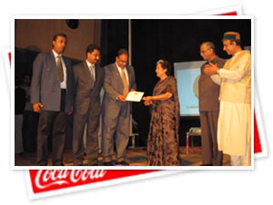
Hon'ble Minister for Power & Environment, Himachal Pradesh, Smt Vidhya Stokes giving away the Golden Peacock Award to Mr Ashutosh Bhardwaj, Area Operations Director, Hindustan Coca-Cola Beverages Pvt. Ltd.
The World Environment Foundation (WEF) conferred the “Golden Peacock Environment Management Special Commendation” for the year 2006 by a Jury headed by Justice P N Bhagwati, Former Chief Justice of India and Chairman UN Human Rights Commission to Hindustan Coca-Cola Beverages Private Limited, Mehandiganj, Varanasi.
The Special Commendation was presented by the Chief Guest Smt. Vidhya Stokes, Hon'ble Minister of Power and Environment, Government of Himachal Pradesh at a special ceremony on 10th June 2006 at Agricultural University Auditorium Palampur (HP).
This prestigious Golden Peacock Environment Management Special Commendation for the year 2006 is given in recognition for following world-class environment practices. Hindustan Coca-Cola Beverages Private Limited, Varanasi, is ISO 14001, ISO 9001 and HACCP based Food Safety Management System* certified bottling plant in UP. Hindustan Coca-Cola Beverages Private Limited, Varanasi unit was adjudged as winner by an eminent jury of experts after a thorough evaluation of the plant’s compliance with a WEF prescribed program assessment format related to environment management system implementation. The assessment covered a period of one year from 1st April 2005 to 31st March 2006.
More About Golden Peacock Environment Management (GPEM) Special Commendation
The GPEM Special Commendation is designed to encourage and recognize effective implementation of environmental management system and this achievement has been made possible by the plant’s adherence to Coca-Cola’s total quality program called The Coca-Cola Quality system (TCCQS). TCCQS encompasses management system (Total Quality) covering environment management and other business aspects such as Safety and Loss Prevention (SLP), product quality, packaging quality, process capability improvement and customer satisfaction.
World Environment Foundation is a non-profit NGO, which strives to foster partnerships and improve links between industry and environmentalists for developing innovative strategies to minimize the environmental degradation.
Cola-Cola India wins the bhadigari award from the delhi government for its efforts in community development
- The Company has already executed nearly 200 rain water harvesting structures across 17 states
- Coca-Cola India has plans to undertake 40 new rain water harvesting projects during the current year
- The company is also working with local communities in various states on projects like Paper & PET recycling, education and clean environment projects
Coca-Cola India won the 'Bhagidari award' on February 25, 2006,in New Delhi, for its contribution in water conservation & environment management programmes and for its contribution to community development, from the Delhi Government. This is the third year in a row that the company has won this award. Mr. Atul Singh, President & CEO, Coca-Cola India received the award from the Honble Chief Minister of Delhi, Ms. Sheila Dikshit on behalf of the company at a function during the Bhagidari Utsav at the Pragati Maidan in New Delhi. Coca-Cola India is supporting several rain water harvesting projects spread across 17 states with nearly 200 rain water harvesting structures. The company plans to take up another 40 such projects by the end of the year.
The company is currently engaged in such projects in the states of Andhra Pradesh, Assam, Bihar, Delhi, Gujarat, Goa, Jammu & Kashmir, Jharkhand, Kerala, Karnataka, Madhya Pradesh, Maharastra, Orissa, Rajasthan, Tamil Nadu, Uttar Pradesh and West Bengal. In addition to this, the company has also undertaken various projects in the areas of Paper & PET recycling and Education & clean environment in partnership with local communities in different states.
On receiving the award, Mr. Atul Singh, President & CEO, Coca-Cola India, said, Water is a subject that is loaded with urgency and even emotion. It is a critical global challenge and it will take a wide variety of efforts, most of them at a local level to overcome the problem. At Coca-Cola we have undertaken numerous projects across the country in partnership with local communities for their development and we continue to look for areas where private-public partnerships can bring about good results. We are honoured to get this award and we are thankful to the government and to the residents of the state for giving us an opportunity to partner them in some truly path breaking community development initiatives.
The Coca-Cola Company has always placed high value on good citizenship. At the heart of business is a mission statement called the Coca-Cola Promise. It says, quite simply, that The Coca-Cola Company exists to benefit and refresh everyone who is touched by our business". This basic proposition means that the companys business should refresh the markets, protect, preserve and enhance the environment and strengthen the community. Coca-Cola India provides extensive support for community programs across the country, with a focus on education, health and water conservation.
Laurels for Coca-Cola India, Kaladera unit, for efficient use of water
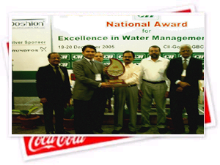
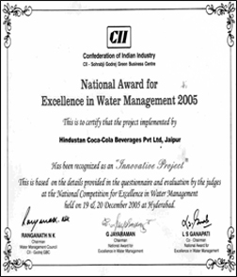
Mr Anupam Sharma- Asistant Production Manager recieving the award on behalf of the company
Coca-Cola India, Kaladera unit has been recognized as a ‘Water Efficient Unit’ across Industries at the ‘National Award for Excellence in Water Management’ held at CII-Godrej GBC, Hyderabad on December 19 & 20, 2005.It has been adjudged as one of the 27 most water efficient units for its Water Management practices. It has also been recognized as one of the top three units across industries in India for ‘Innovative Project Award’. Both the awards were presented by Dr K S Jawahar Reddy, IAS, Managing Director, Hyderabad Metropolitan Water Supply & Sewerage Board.
Mr Anupam Sharma- Asistant Production Manager, received the award on behalf of the Company The various facets of water management highlighted at the CII competition were water conservation efforts for reduction in Specific Water Consumption, reduction in waste water discharge, road map to achieve zero waste water discharge, Sustainability Projects, rain water harvesting and Community Involvement in Water Conservation.
Environment Appreciation Award to Coca-Cola, Jalpaiguri Unit.
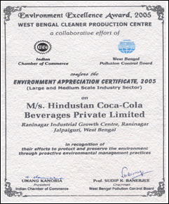
Coca-Cola India, Jalpaiguri unit was felicitated with the ‘Environment Appreciation Certificate, 2005’.It was presented under the aegis of ‘Environment Excellence Award, 2005”, an initiative of West Bengal Cleaner Product Centre. Shri Buddhadeb Bhattacharjee gave away the award to Mr Rahul Sharan, Area General Manager.
The award is given in recognition of the efforts to protect & preserve the environment through proactive environmental practices. The Company has done commendable efforts in the field of Rain Water Harvesting in the water deficient areas & recycling of used PET bottles.
Bhubaneshwar Team wins 2005 Pollution Control Excellence Award!
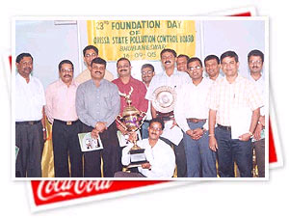
The winning Bhubaneswar Team with their trophy
The "Pollution Control Excellence Award" for 2005 has been awarded to HCCBPL Khurda unit, by the Orissa State Pollution Control Board. The award went to the Khurda team for achieving excellence in implementation of pollution control systems in the plant and for their constant efforts for protection of the environment.
The Pollution Control Excellence Award is an annual award given to industries that excel in environment protection. Khurda's multiple initiatives - PET recycling, Vermicomposting and Rain water harvesting, in addition to its Environment practices to prevent/control pollution bagged the unit this award. Khurda beat over 20 shortlisted industries throughout the state for the award.
The award was presented on the 23rd Foundation Day Celebration of the State Pollution Control Board, Orissa by S.P.Nanda, Principal Secretary, Dept of Environment & Forests Govt of Orissa on 16th September 2005. The Award was recieved by the Region - Vice President Mr. T. Krishna Kumar. Speaking on the occassion Mr. L.N.Pattnaik - PCB Chairman lauded the efforts of the company in the field of environment protection.
Hindustan Coca-Cola Beverages Private Limited, Dasna unit, bags the “Golden Peacock Environment Management Award 2004”
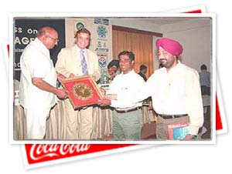
Dasna unit has won the Golden Peacock Environment Management Award 2004

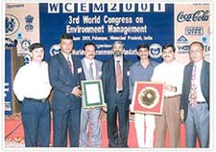
Ameenpur Unit, Andhra Pardesh awarded with Environment Management Award 2003
The Dasna unit near Delhi in Ghaziabad has been awarded the prestigious “Golden Peacock Environment Management Award – 2004 (GPEMA- 2004)” for excellent environment practices and effective control of environmental impact.
The Dasna unit won this award in the Food & Beverage Industry category for its environment practices among hundreds of entries received from across the country. The annual award winner is decided on the basis of a rigorous assessment procedure, which includes a visit to the facility by a team of experts.
Speaking on the occasion, Mr. Sanjiv Gupta, Division President and CEO, Coca-Cola India said, “We are proud to win this coveted award. At Coca-Cola we are committed to preserve, protect and enhance the environment and this simple belief guides us in everything that we do. We will continue to further improve our systems and are confident of making a significant positive impact on our environment in times to come.”
The award will be formally presented to the company shortly by Institute of Directors, an independent body that recognizes the achievements of manufacturing units under the categories of Environment, Quality and Corporate Governance, in association with World Environment Foundation (WEF), at an official function during the 6th World Congress on Environment Management.
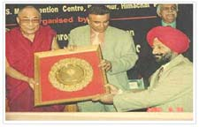
Baddi Unit Bags
Environment Management Award 2004
The Dasna plant achieved this distinction by adhering to The Coca-Cola Company’s internal global quality program called The Coca-Cola Quality System (TCCQS). TCCQS not only covers environment management, but also takes into consideration other business aspects such as safety and loss Prevention (SLP), product quality, packaging quality, process capability improvement and customer satisfaction. Strict compliance with TCCQS, often rated as a programme equivalent to the internationally reputed ISO 14001 System, has also enabled all the company-owned bottling plants in the country to successfully get the coveted ISO 14001 Certification from Det Norske Veritas (DNV).
The award has been granted after a thorough evaluation of Dasna plant’s compliance with a WEF prescribed program assessment format over a period of 1 year from 1st April 2003 to 31st Mach 2004 during which several environmental performance indicators were monitored and evaluated according to WEF’s stringent parameters: energy use, water use, wastewater discharge, compliance with Government regulations and resource utilization.
GPEMA has been instituted by the Institute of Directors in association with World Environment Foundation (WEF) and is designed to encourage and recognize effective implementation of environment management system. The award is given both in manufacturing and service sectors.
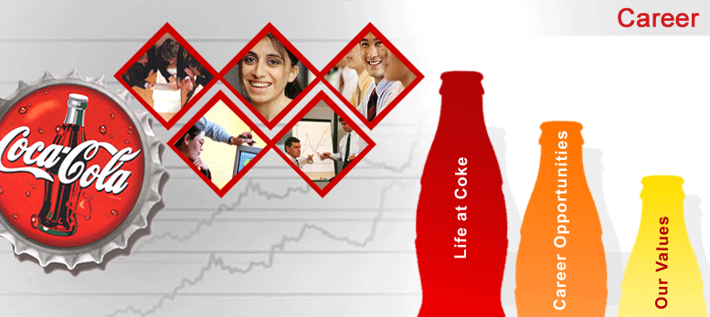
Government of Rajasthan invites Division President to head work group on Water Conservation
The Chief Minister of desert State Rajasthan, Ms. Vasundhara Raje, invited Mr. Sanjiv Gupta, President, India Division, to chair the Government's Working Group on Water Sector in recognition of Coca-Cola India's pioneering water conservation work in the State.
In addition to this position, the State Government has also invited Mr. Gupta to join another select group to develop a strategy for water conservation.
The Company has over the last few years initiated a large number of rainwater harvesting projects in partnership with local NGOs and the Rajasthan State Ground Water Department. The rain water harvesting initiatives, both near the Company's bottling plants and in other areas, have created a potential to recharge more water than what is drawn from the ground. These efforts have been appreciated by the local communities and recognized by the Government earlier as well.
This Government initiative is a strong reflection of the increasingly important role that the Company is playing in improving the lives of local communities and bringing joy to their lives.

OBJECTIVE OF THE STUDY

ASSOCIATE TRAINING PROGRAMME
OBJECTIVE
To build upon and enhance existing skill sets of associates through need based training.
The training process consists of the following elements
- Skill set identification
- Skill gap analysis
- Training need analysis
- Training calendar
- Identification of trainers
- Execution of training and feedback
- Training records and individual training records
- Evaluation of training effectiveness and review
PROCEDURE
- On the basis of the feedback received from the Performance Management Process, the training needs are collected and need based training programs are designed by the Training and Development Manager.
- The list of training programs will be documented in the Training calendar. The

Training Calendar is then shared with the executive Committee to get feedback.
- The Training Calendar will be released within one month of receiving appraisals.
The calendar will contain a brief description of the programs, the program schedule and the recommended target audience.
- A copy of the Training calendar will be circulated to all associates.
- At the end of every training program, the trainers along with the trainees will prepare a developmental plan on the application of all the inputs received during the training program.
- Associates will be nominated for need based external training program based on the recommendation of the immediate supervisor.
RESEARCH METHODOLOGY
Research design
First, a secondary research was conducted, keeping in mind the topic of study, to gain a clear insight of the topic .For this, I consulted many books, manuals and theories. This helped me in designing and framing the right kind of questions. The proper design helped in selection of relevant questions for the study .The following questions was then proposed to be studied, under descriptive research which helped me in analysis.
Selection of respondents
Our respondents had attended the following training programmes.
- ISO- 9000 awareness programme.
- Workers Education Programme.
- Supervisory Development Programme.
We met only those participants who were working either in “ A shift, B, shifts or in “ General” shift. To meet the participants who were in “C” shift, “B” shift or in “ General” shift. To meet the participants who were in “ C’ Shift at that time, was not possible for us. (“C Shift” is from 11.30p.m. to 7.30 a.m.)
We took interview of those with whom we could meet at work place. We took 30 interviews from participants and thereby filled Part -I Schedules. Alongwith which we took interview of D.Os. Internal Faculties, etc. by filling Part –II Schedules.
DESCRIPTIVE METHODS
Tool is an instrument, which is used in all types of work. In this study our tool were two types of schedules. One schedule was used for the trainees or participants and another one was used for the Trainers, D.Os etc. As we had to evaluate the training. Just after framing the schedules, Pilot Study was conducted for the purpose of pre-testing. Then both the schedules were finalized. we separately met both types of people and before taking interview, rapport was established for effective communication and coordination.
During the interview, interviewees were observed and I also talked on some out- of –topic matters so that interview became interest and interviewees showed their interest.
We tried our best for cultivating such feelings among the interviewees that they and their performance of any such activities were not being questioned and the confidentiality would be secured.
Analytical tools
For the representation of analysis of the research various analytical tools like bar diagrams, pie charts and line graphs have been used; these analytical tools have really proved to be of great help for the purpose of study for which % (Percentage) method has also been utilized.
sources of data
Primary source
Primary source of data collection is used under the study, questionnaire were prepared to conduct the study.
Sample space
Employees including executives and non-executives of Hindustan Coca Cola are distributed questionnaire. (100 questionnaires)
Secondary source
Secondary source of data collection was done to gain a clear insight of the topic. The research was conducted from various books, journal, and manuals for conducting primary research.
The information was mainly obtained from three sources.
- PRIMARY DATA: Informal conversations were the source of information regarding the training methods already followed and identification of the training needs of the workers.
- SECONDARY DATA: Information regarding the new methods that can be implemented was collected based on book research.
- Other INFORMATION: other important data was collected from Internet, companies Websites and few search engines.

Sample area - Dasna, Ghaziabad
Sample size – 100 People

6. Data analysis
Table No.6.1:- training necessity for the employees.

Dimensions | Respondents | Percentage %
Yes | 88 | 88
No | 12 | 12
Total | 100 | 100
(Source-Questionnaire and oral interview)
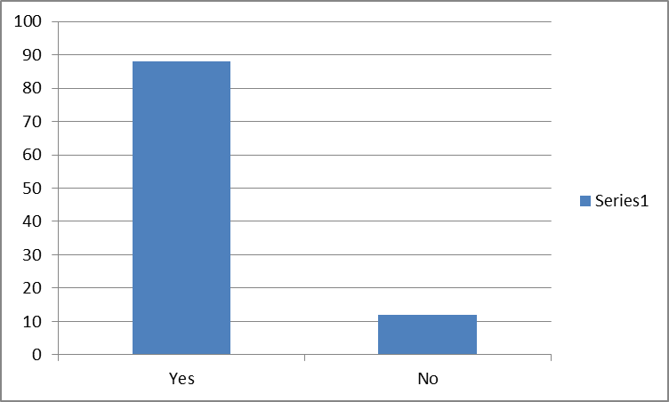
Inference:

The above table shows that 88% of the employees stated that the training is necessary and 12% of the employees are stated that they don’t need training for their jobs.
Table No 6.2:- the WILLINGNESS of THE employees TOWARDS THE training programs.

Dimensions | Respondents | Percentage %
Yes | 90 | 90
No | 10 | 10
Total | 100 | 100
(Source-Questionnaire and oral interview)
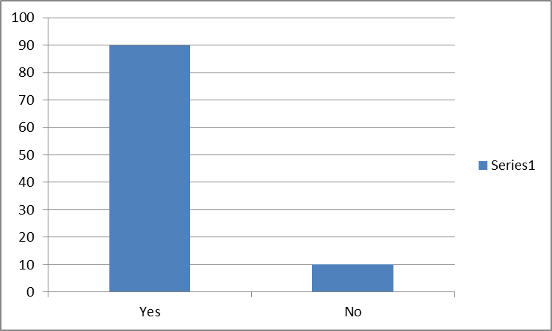
INFERENCE:

The above table shows that 90 percent of the employees in the organization had taken training. 10 percent of the employees are seniors and training personnel.

Table No 6.3:- the number of Training Programs attended by the employee’s.
Dimensions | Respondents | Percentage %
One | 16 | 16
Two | 34 | 34
Three | 24 | 24
Four & More | 26 | 26
Total | 100 | 100
(Source-Questionnaire and oral interview)
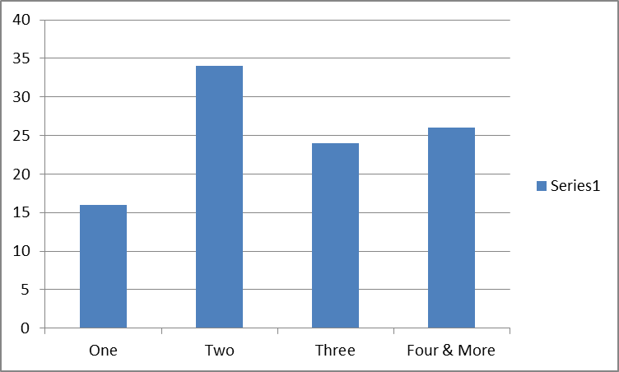
INFERENCE:
The above table shows that most of the employees in the organization are interested to attend two training programs only.

Table No 6.4:- the satisfaction level of the Training Programs.
Dimensions | Respondents | Percentage
Great Extent | 40 | 40
Some Extent | 30 | 30
Little Extent | 30 | 30
Total | 100 | 100
(Source-Questionnaire and oral interview)
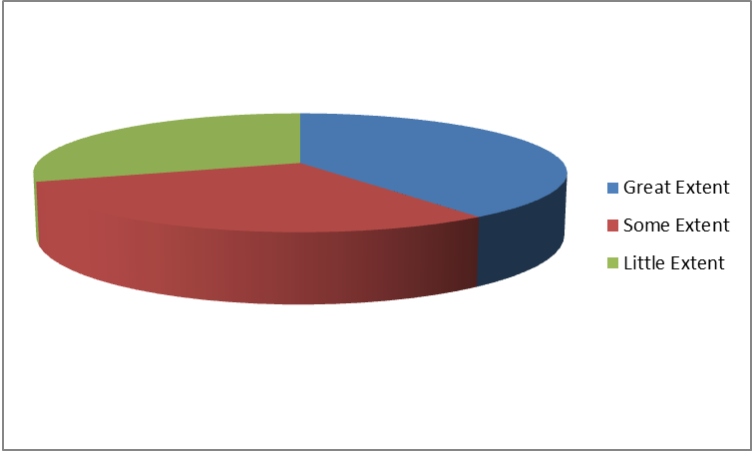
INFERENCE:

The above table shows that most of the employees are satisfied up to great extent to the number of training programs attended in the organization.

Table No 6.5:- the employees expected benefits from Training and Development

Benefits | High | Medium | Low | Rank
Aware of Company Policies | 20 | 18 | 02 | I
Aware of Work / job | 25 | 10 | 04 | II
Improve in skills, knowledge, & attitude | 26 | 12 | 02 | I
Motivation | 20 | 20 | - | I
To face new technology | 22 | 18 | - | I
Idea generation | 22 | 14 | 02 | III
Problem solving | 29 | 08 | - | IV
Aware of other dept’s work | 10 | 15 | 08 | V
(Source-Questionnaire and oral interview)

INFERENCE:

The above table shows that, most of the employees expect good benefits from the Training & Development like aware of Company policies, improve in skills, knowledge & attitude, motivation and to face new technology etc.

Table No 6.6:- the method of Training received by the employees

Dimensions | Respondents | Percentage
On the Job | 32 | 32
Off the Job | 40 | 40
Both | 24 | 24
Non Respondents | 4 | 4
Total | 100 | 100
(Source-Questionnaire and oral interview)
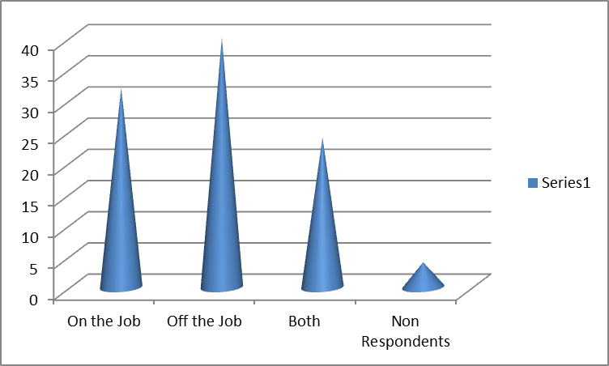
INFERENCE:
The above table tells us that 40% of the employees received off the job training 12% received both the methods of training and 32% received on the job training.

Table No 6.7:- the training received by the employees
Dimensions | Respondents | Percentage
Inside the company | 88 | 88
Outside the company | 04 | 04
Both | 08 | 08
Total | 100 | 100
(Source-Questionnaire and oral interview)
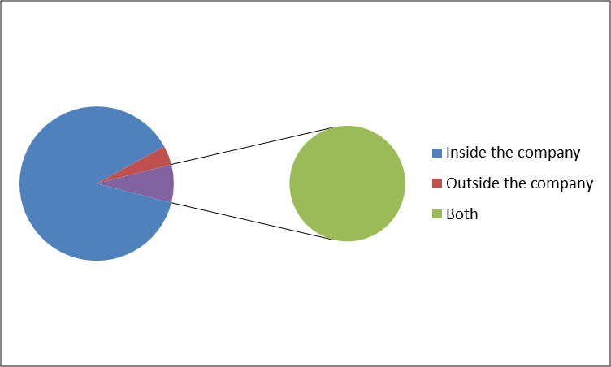
INFERENCE:
The above table shows that most of the employees received training inside and fewer employees are trained in out side of the Organization.

Table No 6.8:- from whom the training has received
Dimensions | Respondents | Percentage
Superiors | 40 | 40
Consultants | 40 | 40
Institutions | 04 | 04
Others | 08 | 08
Non Respondents | 08 | 08
Total | 100 | 100
(Source-Questionnaire and oral interview)
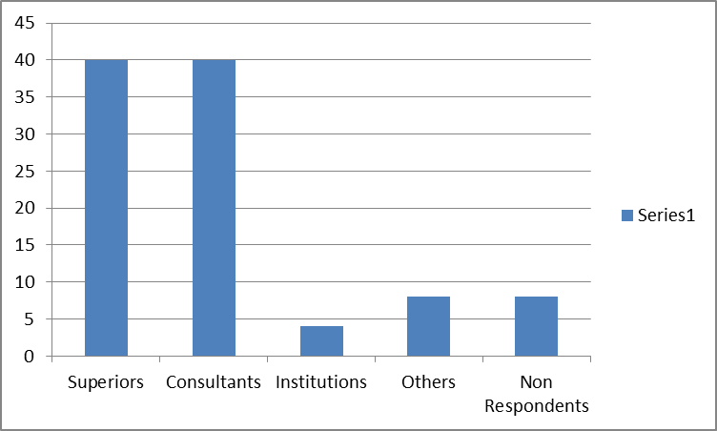
INFERENCE:
The above table enables us that most of the employees received training from superiors and Consultants.

Table No 6.9:- the type of training received by the employees
Dimensions | Respondents | Rank
Induction | 16 | IV
Updating | 20 | II
Competence Development | 32 | I
All the above | 26 | II
(Source-Questionnaire and oral interview)
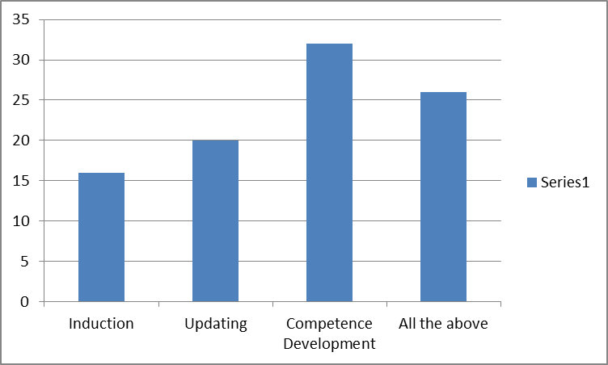
INFERENCE:
The above table shows that most of the employees ranked to the Competence Development. Out of 50 samples 26 employees received all the trainings.

Table No 6.10:- the developed area after training
Dimensions | Respondents | Rank
Skills, Knowledge & Attitude | 48 | I
Motivated | 14 | IV
Social Behavior | 24 | II
Face new technology | 12 | III
Non Respondents | 02 | -
(Source-Questionnaire and oral interview)
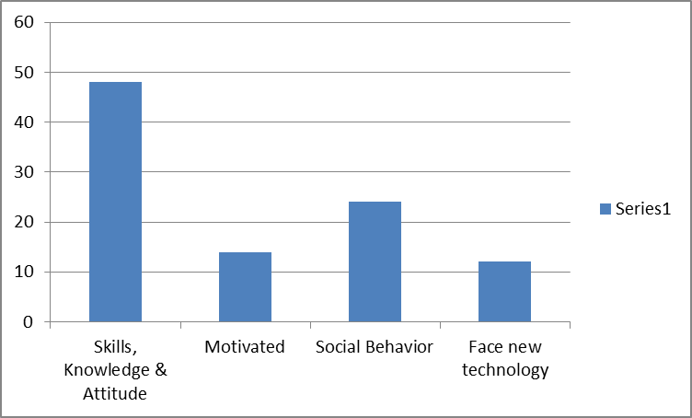
INFERENCE:
The above table enable us most of the employees developed skills and knowledge. Twelve employees developed in the area of social behavior.

Analysis of workers response
Kajaria Ceramics Limited basically provides three tupes of trtaining to workers. These trainings are:

- Skill Ehancement
- Personlaity Development
- Information Technology related

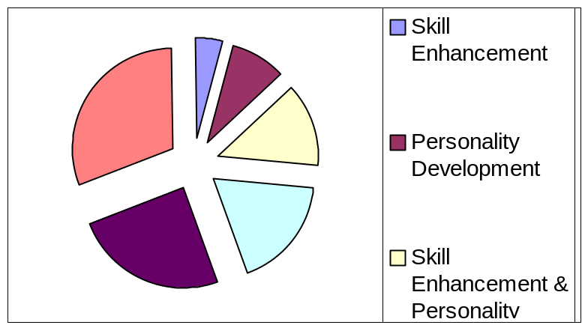
Total 45 workers have gone through these training programs. 2 out of them got the skill enhancement training, 4 got personality development, and 6 got skill enhancement & personality development program. Out of 45 workers 8 got skill enhancement & IT related training, 11 got personality development & IT related training and rest 14 got all three, skill enhancement, personality development & IT related training.

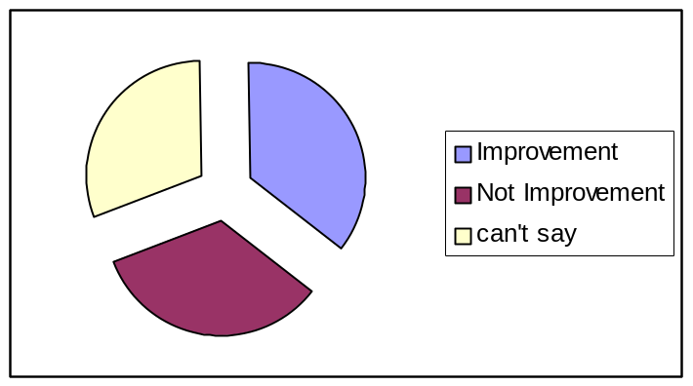
To read the development after applying development programs questions are asked to the workers. Responding to the questions 16 out of 45 workers say that they go t improvement after the training program, 15 told that they didn’t get any improvement and rest 14 are not able to say any thing.
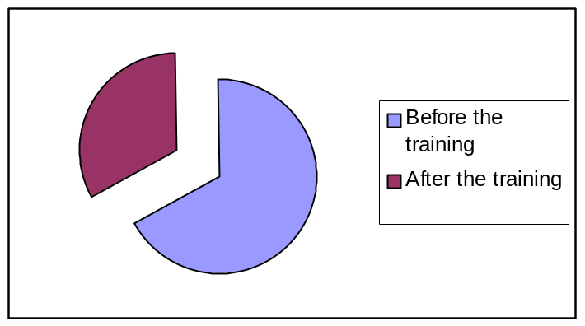
In any training program the material plays an important role. So it should be provided. But the question is that, "when should be the materials be given, before the training or after the training.” In the responses of such
Question, 30 out of 45 workers say that materials should be given before the training and 15 says that it should be given after the training.
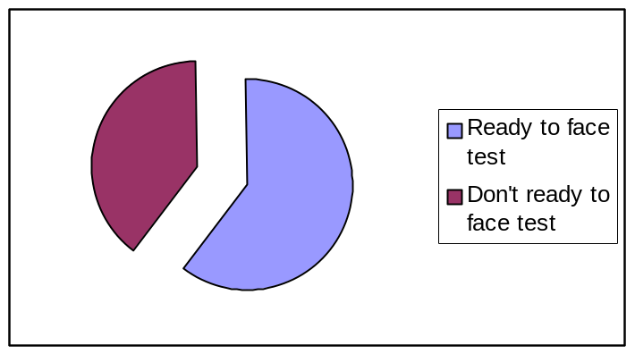
A good trainee is essential for the successful completion of any training program. A good trainee can be selected by the test. So a test is required for selecting appropriate trainees. Responding this 27 out of 45 workers tell that they don’t want to go through any test and rest 18 want to go through such test process.
The evolution of any program is very much require for the future. It can be done by asking the trainees.

Skill Enhancement:

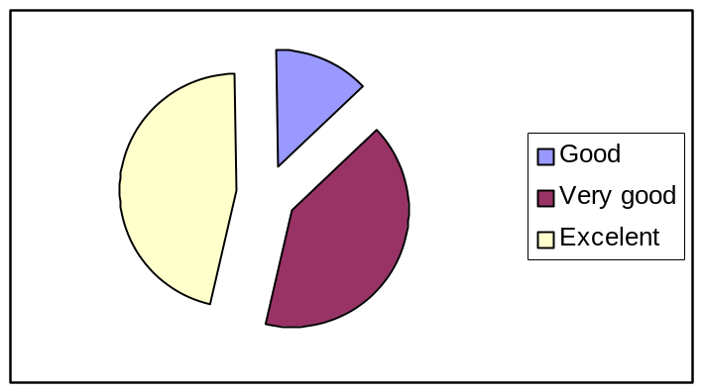

Responding to skill enhancement programs, 11 out of 45 workers say that the training program was good, 20 say that it ways very good and rest 14 trainees opine that training program was very helpful to enhance their skills and perform their job in batter manner.

Personality Enhancement:

Responding to the personality development questions there are different views of the trainees, 6 out of 45 workers say that the program was good, 18 say that it was very good and 21 workers say that program was excellent.
FINDINGS & ANALYSIS
The Quality of Work Life of the workmen is analyzed on the basis of various parameters concerning monetary benefits, health and safety, welfare facilities, management worker relationship, work environment and growth and development opportunities. The analysis reveals satisfaction among a majority of 50.87 % of the workers, somewhat satisfactory response from 15.1% of the workers and not satisfactory response from 29.34% of the workers. The remaining 4.69% of the respondents were not sure about their responses.
Hence we can conclude that the overall Quality of Work Life of the workmen in the Coca Cola Dasna plant is satisfactory.
It has been seen that pay and benefits has been rated as the most important need by as many as 40% of the workers. Also an analysis of the responses relating to the factors that contribute the most towards improvement of the workers performance reveals highest preference for pay and benefits by as many as 32.5% of the workers.
This correlation of pay and benefits as being the most important need and its highest contribution for improvement of the workers performance clearly indicates that pay and benefits are an important motivational factor for the workers.
However analysis on the satisfaction level of the workers with regards to monetary benefits indicates high level of dissatisfaction among the workers with negative response from as many as 40% of the workers.

Pay and benefits being identified as the major performance booster, there was a need to identify the basis on which pay and benefits should be given to the workers.
Responses sought on the factor to which pay and benefits should be linked revealed that as many as 42.5% of the workers wanted pay and benefits to be linked to individual’s performance. However an analysis of the respondents feedback to how far pay is linked with performance revealed dissatisfaction among a majority of 67.5% of the workers which indicated that there is hardly any practice of linking pay of the workers with performance in Coca Cola Company.
Other important factors identified for improvement of the workers performance is the amount of responsibility that is being assigned to the workers and timely feedback on performance. As many as 30% of the workers responded positively to amount of responsibility assigned to them and 25% to timely feedback on performance as the most important factor that improves performance. Hence we can conclude that amount of responsibility and feedback on performance also acts as important motivational factors.
The welfare facility which is identified as the most important source of motivation for the workers is the education facility provided to the workers and their wards. As many as 60% of the workers felt the need for education facility in the form of reimbursement of tuition fees or scholarships to deserving students. However there was high criticism by as many as 75% of the workers about the education facility provided to them by Coca Cola Company.
LIMITATIONS OF THE STUDY
It is a brief conducted during short span of time. In order to know the depth one requires a lot of information, money and involvement of manpower. As is the case with every research effort, this study also leaves a lot of room for further improvements. The major Limitations of this study are given below.
⇒ Due to non- corporate nature of some of the organizations, project could not be undertaken at the external level.
⇒ Biases in the responses cannot be ruled out as the questionnaires were only filled by the managers and workers of the sample taken.
⇒ Sudden changes in the programme of some of the participants at the time of interviews led to the problem in getting data.
CONCLUSION

TRAINING PROGRAMME AT COCA COLA

RESPONSIBILITY
HR Manager is overall responsible for effectiveness of training program.

DESCRIPTION
This program details about the training methodology applicable to each and every company employee. This program includes SOP on skill set identification HR-SOP-112.6.1 and SOP of conducting training HR-SOP-112.6.2. The applied methodology is outlined below.
QUALIFICATION CRITERIA: For hiring permanent employees the qualification requirements for individuals are described in the below stated matrix.

JOB DESCRIPTION | ESSENTIAL QUALIFICATION | DESIRABLE QUALIFICATION | EXPERIENCE LEVEL
Plant Manager | Graduate in Science & Engineering | Mechanical or electrical graduate engineer | 10 years in a manufacturing facility or process industry.
Sales/Marketing Manger | Graduate in any discipline | Degree/diploma in marketing & sales Management | 5 years in a market or food products or FMCG
Quality Assurance Manager | Graduate in Chemistry or Food Technology. | Post graduate in Food Science & Technology | 8 years quality assurance/ quality control of a food industry.
Maintenance Incharge/ Maintenance Executive | Diploma/Graduate in Engineering in Mechanical or electrical | Engineering graduate in mechanical or electrical | 5 years in maintenance/engineering function of process industry.
Production Manager/ Production In charge | Graduate in any discipline | Diploma in Engineering in (Mechanical or electrical) | 5 years in a production or maintenance function in related industry
Material Manager/Stores Incharge | Graduate in any discipline | Commerce graduate with Diploma in material management | 6 years in a stores facility in related industry
Logistics Manager | Graduate in any discipline | Commerce graduate | 6 years in a distribution facility
Personnel & HRD Manager | Graduate in any discipline | Degree or diploma in management with specialization in personnel & HRD | 6 yr. in personnel and HRD area.
Finance Manger | Commerce graduate | CA/ICWA | 10 years in an accounts division.
QA Executive | Graduate in Science. | Degree or diploma in Chemical or Food Technology | 5 years quality control /assurance function of a food or related industry.
Maintenance supervisor | 10+2 with ITI certificate | Degree in Engineering (mechanical or electrical) | 2 years in a production or maintenance function in related industry
Quality Assurance Officer | Graduate in Science. | Degree or diploma in Chemical or Food Technology | 3 years quality control /assurance function of a food or related industry.
General Duty Supervisor | 10+2 pass | Graduate | 2 years in a related industry.
Marketing Executive | Graduate in any discipline | Diploma in Marketing Management | 2 years in a similar capacity.
Fitter | 10+2 with ITI Fitter certificate | - | 2 years in a related industry.
Turner | 10+2 with ITI Turner certificate | - | 2 years in a related industry.
Electrician | 10+2 with ITI Electrician certificate | - | 2 years in a related industry.
Boiler operator | ‘B’ certificate holder for boiler proficiency | ‘A’ certificate holder for boiler proficiency | 2 years in a similar capacity.
Utilities operator | 10+2 in Science with respective certificate | - | 2 years in a similar capacity.
Operator (General) | 10+2 in Science | Graduate in Science | 2 years in a similar capacity.
Bottle Inspector | Literate with sound eyesight | 10+ 2 in Science | -
Helper | Literate | - | -
Accountant | Commerce graduate | CA/ICWA | 4 years in a similar capacity.
Drivers | Literate with valid driving licenses | - | 2 years of driving experience
Labour | Unskilled one | - | -

SKILL SET IDENTIFICATION: Identify the skills and levels of competency necessary to perform the jobs on individual basis. The desired skill set matrix for each individual in defined below which had been worked out based on importance and urgency.

RECOMMENDATION
SAFETY
Eye glasses, hand gloves and masks to be provided to electricians/DG Operators/Line operators to avoid major loss during accidents. Wearing of the above safety equipments must be made mandatory.

MEDICAL FACILITY AND EMERGENCY CARE
24 hrs Ambulance facility with doctor.
A Doctor to be appointed for night shift.

ABSENTEEISM
Proper check on attendance record keeping through a card based attendance monitoring system which can be linked to a software system for generating salaries automatically. This will improve efficiency, reduce absenteeism, ensure faster salary calculation and avoid any unnecessary delays and mistakes in salary generation.
TEMPERATURE, HUMIDITY AND NOISE LEVEL IN THE PLANT:
67.5% of the workers expressed dissatisfaction related to temperature, humidity and noise level in the plant.Due to noise pollution in the plant there is ill affect in the health of the workers. Therefore there should be arrangements for a proper rest room for the workers. The workers should be instructed to be in the rest room when not working. This will in turn help the supervisors to easily track the workers during emergencies. More water coolers/drinking water facility in the plant. Coolers, fans and proper seating arrangements for the workers at the shop floors.

GROWTH AND DEVELOPMENT OF WORKERS:
Pay and benefits being identified as the major performance booster,there should be more incentives and awards for workers annually. Work recognition through salary increments can prove to be a better performance booster apart from gift and certificates Publicize workers achievements. Frequent use of notice boards.

Special attention need to be focused on performance appraisal system of the workers as there was considerable criticism and was viewed to be a de-motivator. Efforts should be made to avoid any kind of discrimination.
There should be proper check to provide equal opportunity for all workers and to avoid any kind of partiality.

TOWARDS INCREASING SENSE OF BELONGINGNESS:
Annual day to be celebrated annually
Announcement of birthdays on Shop-Floors
Celebration of religious function to create oneness

OTHER SUGGESTIONS:
- Inspection team to be formed and instructed to produce monthly inspection report. Inspection team would be responsible for activities such as Check of mould safety guards. Ensure that they are repaired on time.
- Check of fire extinguishing cylinders. Ensure that they are refilled on time.
- Ensure that all water coolers, fans, air coolers, AC’s in the shop floor are functioning properly.
- Proper maintenance of godowns, floors etc.
- To ensure immediate clearance of Hospitalization claim on FIFO basis. Pending claims to be addressed immediately.
- Ensure that quality of food is maintained during night shift.
- Scholarship for deserving children of workers. Reimbursement of tuition fees.
- Payment of salary through cash/ ATM facility within or somewhere near around the campus if possible.
- The workers employed as the next of kind of retired or deceased workers should be made permanent in the stipulated time period.
- Post retirement benefits to be paid on time.
- Educate the workers regarding income tax deduction and details.
- Appointment of more relievers to avoid work load.
- Special suggestion system to encourage workers to express their problems and thus contribute their way towards improvement of QWL.

ANNEXURE
Name …………………………………………………
Department ………………………………………
Designation ………………………………………

QUESTIONNAIRE
A STUDY ON EMPLOYEES PERCEPTION ON TRAINING & DEVELOPMENT IN TITAN INDUSTRIES
Name:
Designation:
Sex:

- Are there any Training programs conduced in your organization?

Yes [ ] No [ ]
- If ‘ Yes’, have you taken training?

Yes [ ] NO [ ]
- IS the training is necessary training ?
Yes [ ] no [ ]
- What benefits you expected from the training & development ?

SL. | Benefits | High | Medium | Low
1. | Aware of company policies
2. | Aware of work/job
3. | Improve in skills ,knowledge & attitude
4. | Motivation
5. | To face new Technology
6. | idea generation
7. | problem solving
8. | Aware of other dept’s work

- How many programs were attended by you?

a) One b) Two c) Three d) Four & More

- To what extent have you satisfied with the respective training?

a) Great extent b) Some extent c) little extent

- What method of training have you received?

a) On the job b) Off the job c) Both

- Where you have received the training?

  - Inside the Company
  - Outside the Company
  - Both
- From whom the training is received
a) Superiors b) Institutions c) Consultants d) Others

- What method of training you received

a) Induction b) Competence Development
c) Updating Knowledge d) Preparing for future assignments
e) All the above
BIBLIOGRAPHY
- Hindustan Coca Cola Beverages Pvt. Ltd. Intranet Services.
- VSP RAO (TEXT BOOK)
- BUSINESS TODAY (MAGAZINE)
- www.hradvice.com
- www.human-resources.careerbuilding.com

