**CONTENTS**

**CHAPTER: I**

INTRODUCTION

INDUSTRY PROFILE

CHAPTER SCHEME

**CHAPTER: II**

COMPANEY PROFILE

**CHAPTER: III**

NEED FOR STUDY

REASARCH METHODOLOGY

LIMITATIONS

**CHAPTER: IV**

DATA ANALYSIS &

INTERPRETATION

**CHAPTER: V**

FINDINGS

SUGGETIONS

BIBILOGRAPHY

ANNEXURE

**CHAPTER: I**

**Introduction**

**Industry profile**

Chapter scheme

INTRODUCTION

Marketing is the art of creating, satisfying customers by meeting the needs of customers and by creating value satisfaction for them. As Peter Ducker says “the essence of marketing is that the entire business has to be seen from the point given of the customer”. However, customers face a vast array of product and brand choices prices, supplies and to understand the needs and preferences of the customers it becomes imperative for us to carry out research together information.

We believe that customers estimate which offer will deliver the most value to them and which will deliver and maximize value, within the bounds of research costs and limited knowledge, mobility, and income they form an expectation of value and act on it. Whether or not the offer lives up to the value expectation affects both purchase and repurchase probability.

The purpose of any Marketing research is to provide information at a specific time on customer, trade, competition and the future brands, so as to enable marketers to formulate successful strategies in their quest for customers mind share and market share.

The research helps the marketers to find out the attributes and variable that influence the customers behavior towards a given product offering and it shapes the attitudes of the customers favorably towards a specific product, thus by analyzing these undertones the researcher can find out the levels of customer satisfaction, and the results of the marketing research can help the marketers to analyze the weak spots in their marketing strategies and can reformulate their strategies so that they can satisfy their customers and maximize their brand loyalty and profitability.

**MARKENTING**

The practice of management, Peter Ducker wrote that “Because the purpose of business is to create a customer, the Business enterprise has two –and only two-basic functions: marketing and innovation. Marketing and innovation produce results; all the rest cost. Marketing is the distinguishing, unique function of the business.” if Marketing is the distinguishing function of the business, then what is the Marketing and how is it achieved?

1. “An organizational function and a set of process for creating, communicating, and delivering value to customers and for managing customer relationships in ways that benefit the organization and its stakeholders.”
2. “Human activity directed at satisfying needs and wants through exchange processes.” Philip Kotler
3. The Ongoing process of moving people closer to making a decision to purchase, use, follow, upload, download, obey, reject, conform, become co placement to someone else’s products, services, or values.Simply,if it doesn’t facilitate a “sale” then it’s not Marketing.”
4. The thing process of anticipating, identifying and satisfying Customer requirements profitably” Chartered Institute of Marketing.
5. Find a limited market and seek to dominate it totally. Bill Good Marketing.

In general satisfaction is a person’s of pleasure or disappointment resulting from comparing a products perceived performance in relations to his or her expectations. If the performance falls short of expectations, the customer is satisfied.

If the performance exceeds expectations, the customer is highly satisfied or delighted.

If the company increases customer satisfaction by lowering its price of increasing its Services, the results may be lower profits. The company might able to increase its profitability by means other than increased satisfaction.

When customer rate their satisfaction with an element of the company’s performance say, delivery-the company needs to recognize that customer vary in how they define good delivery. It could mean that early delivery on-time delivery is so on.

Companies need to be especially concerned today with their customer satisfaction level because the internet provides and tool for customer to spread bad word of mouth as well as good word of mouth-to the rest of the world.

**Accountable marketing**

The sales person phone to customer to check whether the product is meeting expectation or not. The sales people also ask the customer for any product or service improvement suggestions and any specific disappointments.

**Partnership Marketing**

The company works continuously with its large customers to help improve their performance. The motto of the company is to provide the best to its customers their by providing total customer satisfaction.

**Proacting Marketing**

The sales person contacts the customers from to time with suggestion about improved products uses or new products.

**The core business process includes the fallowing concepts:-**

**The Marketing sensing process**

All the activities involved in gathering market intelligence, disseminating it with the organization and acting of information.

**The new offering Realization process**

All the activities involved in researching, developing and launching new high-quality offering quickly and within the budget.

**The customer relationship management**

All the activities involved in building deeper understanding relationships and offerings to individual customers.

**The Fulfillment management process**

All the activities involved in receiving and approving orders, shipping the goods on time and collecting payment.

**Business Definition for: After-sales Service**

* Customer support following the purchase of a product or service. In some cases, after-sales service can be almost as important as the initial purchase. The manufacturer, retailer, or service provider determines what is included in any warranty (or guarantee) package. This will include the duration of the warranty traditionally one year from the date of purchase, but increasingly two or more year’s maintenance and/or replacement policy, items included/excluded, labor costs, and speed of response. In the case of a service provider, after-sales service might include additional training or helpdesk availability. Of equal importance is the customer's perception of the degree of willingness with which a supplier deals with a question or complaint, speed of response, and action taken.

**Customer Satisfaction**

**Definition of Customer Satisfaction**

**Kotler** (1997) defines customer satisfaction as follows:

Satisfaction is a person's feelings of pleasure or disappointment resulting from comparing a Product’s perceived performance (or outcome) in relation to his or her expectations.

**Brown** (1992) defines customer satisfaction as:

The state in which customer needs, wants and expectations throughout the product or service's life are met or exceeded resulting in repeat purchase, loyalty and favorable worth-of mouth.

According to **Jones and Sesser** (1995), four basic elements affect customer satisfaction.

They are: The basic elements of the product or service, basic support services, a recovery process for counteracting bad experiences, and extraordinary service. There are many definitions of the key elements of the services, but this one is considered appropriate in the context of care or after sales services.

Satisfaction is a function of perceived performance and expectation. If the performance matches the expectations the customer is satisfied. If the performance exceeds the expectation the customer is highly satisfied and delighted. If the performance does not match the expectations the customer is dissatisfied. Satisfaction is a person’s feelings of pleasure of disappointment resulting for comparing a products perceived performance (out-come) in relation t his/her expectation. The link between customer satisfaction and customer loyalty is proportional. Suppose customer satisfaction is rated on a scale from 1 – 5. At a very low levels of customer satisfaction.

.Level-1, customers are likely to abandon.

Level-2 to 4, customers are fairly satisfied but still find tit easy to switch when a better offer comes along.

Level-5, the customer is very likely to repurchase an even spread good word of mouth about the company.

|  |
| --- |
| **Customers are very likely to repurchase LEVEL5**  **Customers are fairly satisfied LEVEL 2-4**  **Low level of customer satisfaction LEVEL 1** |

The key to generating high customer loyalty is to deliver high customer value. A company’s value proposition is much more than it’s positioning on a single attribute. Most of the successful companies are raising expectations and delivering performances to match. These companies are aiming for TCS – Total Customer Satisfaction. Customer satisfaction is both a goal and a marketing tool. Companies that achieve high customer satisfaction ratings make sure that their target market is known.

After sales support management system is a part of ERP *Enterprise Resource Planning* solution dealing with the support module after the sales of product. It creates an advanced environment to the organization, which are in to technical support after sales e.g. Companies offering electronic goods and motor vehicles etc.

**Measuring customer satisfaction**

Organizations need to retain existing customers while targeting non-customers;. Measuring customer satisfaction provides an indication of how successful the organization is at providing products and/or services to the marketplace.

Customer satisfaction is an abstract concept and the actual manifestation of the state of satisfaction will vary from person to person and product/service to product/service. The state of satisfaction depends on a number of both psychological and physical variables which correlate with satisfaction behaviors such as return and recommend rate. The level of satisfaction can also vary depending on other factors the customer, such as other products against which the customer can compare the organization's products.

Work done by Parasuraman, Zenithal and Berry (Leonard L) between 1985 and 1988 delivered SERVQUAL which provides the basis for the measurement of customer satisfaction with a service by using the gap between the customer's expectation of performance and their perceived experience of performance. This provides the researcher with a satisfaction "gap" which is semi-quantitative in nature. Cronin and Taylor extended the disconfirmation theory by combining the "gap" described by Parasuraman, Zenithal and Berry as two different measures (perception and expectation) into a single measurement of performance relative to expectation.

**Improving Customer Satisfaction**

Published standards exist to help organizations develop their current levels of customer satisfaction. [The International Customer Service Institute](http://en.wikipedia.org/wiki/The_International_Customer_Service_Institute) (TICSI) has released The International Customer Service Standard (TICSS). TICSS enables organizations to focus their attention on delivering excellence in the management of customer service, whilst at the same time providing recognition of success through a 3rd Party registration scheme. TICSS focuses an organization’s attention on delivering increased customer satisfaction by helping the organization through a Service Quality Model.

TICSS Service Quality Model uses the 5 P's - Policy, Processes, People, Premises, Product/Services, as well as performance [measurement](http://en.wikipedia.org/wiki/Measurement). The implementation of a customer service standard should lead to higher levels of customer satisfaction, which in turn influences [customer retention](http://en.wikipedia.org/wiki/Customer_retention) and [customer loyalty](http://en.wikipedia.org/wiki/Customer_loyalty).

**The functional features include:**

* Customer complaints tracking
* Service engineers information tracking
* Job scheduling for the complaints
* Spares management
* Online support
* Reports

**Customer complaints tracking**

Complaint is the start point of any technical support system. Without a client request the technical support is not initiated. Complaint tracking is done as follows:

* Client may come down or make a phone call or complaint online
* The client is validated. The client may have an annual maintenance contract or may have a product in warranty or of warranty.
* The intensity of the complaint is to be estimated to allocate resources.

**Service Engineers information tracking:**

Information about the engineers is inevitable in job scheduling. Information about the engineers has to be added, deleted or modified in the database. It may contain the following: the name, id of the engineer; the skill set of the manager; the status of the engineer.

**Job scheduling for the complaints**:

Job scheduling means sequencing the request to its intensity, assignment of a service engineer and creating a job card. It is done to optimize the technical resources and to render the best service to the customer. Minor problem are processed by technicians requests are handled by the expert team.

**The job card includes the following:**

The compliant id, the assigned engineer id, the data and time of service, the spare details, no. of man hours required etc.

* The spare part name and serial number
* The available quantity of each spare part
* The prize, warranty and other specifications
* The supplier information.

**Online support:**

The service is done online also. The client may visit the website to obtain basic support information about the product and FAQ. He can chat with the service engineer on phone or online.

**Report:**

The report reflects the current status of the system. The reports that can be generated are as follows:

* Customer request report status of the system. The reports that can be requests.
* Service engineer report provides the information about the skills and strengths of the support team.
* Job scheduling report states the allotment of engineers to jobs.
* Spares report discloses the availability of all the shapes in the system.
* Receipts and payments report gives information about the cash flow in the system.
* Bills generation.

**Customer satisfaction tracking:**

Customer satisfaction is the key concept to dictate the future of the organization. In order to maximize the customer satisfaction along with quick response and efficient service some other activities are to be performed.

**They may be as follows:**

* Reception of the customer with hospitality.
* Entertaining environment to the customer.
* Providing guidance about the usage and maintenance of the product.
* Offering gift and discounts.

**Operationalisation of Customer Satisfaction**

As customer needs and expectations are changing all the time, this will lead to a situation whereby customers keep setting ever higher standards, and therefore to achieve perfection is impossible. Markets should be seen as a group of individual companies, and each of them must be treated individually with different requirements, experiences, commitments, and relationships.

Customer needs can be determined through marketing research, customer interviews, reading customer concerns, or involving customers in the design of services and service deliveries. In order to decide if the service can be provided at a profit, it is necessary to link value equation to the strategic service vision. Working together with both supplier and customer can increase profitability by expanding margin potential.

A customer satisfaction study should begin by asking about the factors affecting customer satisfaction, how important those factors are for the whole, and the level of customer satisfaction. A problem with customer satisfaction surveys (Neumann, 1994) is that a poor customer satisfaction programmed yields vague data and raises customer expectations. If customer expectations are raised and a company's performance remains the same, the customer's overall satisfaction will decrease.

**After Sales Excellence**

After Sales Excellence is a key driver for customer satisfaction and loyalty but also a very important source of revenues and profits throughout a vehicle lifecycle. Our after sales experts support our clients in all relevant areas of after sales service to improve the internal cost base, the retail attractiveness as well as customer satisfaction. Our results are measurable - significant improvements on key indicators such as warranty costs, service quality, and fixed first visit rate.

**Supply Chain Excellence**

Our Supply Chain Excellence service enables you to realize substantial improvements in your supply chain performance in terms of cost, efficiency, lead times, demand management, customer service and working capital requirements. We measure, improve and qualify supply chain organizations and processes and support our clients by identifying and rapidly implementing cost and efficiency savings in the entire supply chain. This can be achieved with the comprehensive, cross-functional redesign of all logistics processes leveraging the entire supply chain including customers and suppliers. With our proven Integrated Supply Chain Excellence Audit we quickly identify gaps to proven best practices and benchmarks within, and beyond, the Automotive Industry.

**Value Chain Design**

Constantly reviewing the companies’ value chain in a rapidly evolving environment; deriving required core competencies and partnerships is a key management responsibility. We help our clients design their value chain in terms of a global engineering footprint, production and service network, thereby improving efficiency and customer satisfaction in alignment with corporate strategy.

**Customer Contacts and Relationships**

In all cases, the supplier had been involved with the customer since the beginning of the network building. It is difficult to distinguish whether some of the changes in customer-supplier relationship were due to the duration of the relationship between the two parties and whether some of the changes were caused by changes in the customer's needs resulting from the customer's new position in the network life cycle curve. For the results of this research, that question in terms of the underlying factors has not addressed, but for future studies, it would be relevant to clarify which of these two factors is the more significant or in fact, whether they can be distinguished.

**Relation of the Care to Customer Satisfaction**

Innes and La Lined (1994) discovered that several customer satisfaction variables significantly affect a customer's total customer satisfaction. Customer service attributes received high ratings for the importance of customer satisfaction. Attributes for physical distribution of customer service were rated higher than many marketing attributes.

**Most Important Services**

Barky (1995) proposed that what is important for one customer may not be important for another. Barky proposes this in the area of priority marketing, and the idea was applied to different services in general. When a buyer considers closer integration with a supplier, they may consider that it will most likely limit the number of potential suppliers and fear that the partner may take advantage of this by increasing prices or delivering poorer quality or poorer service. Interlocking with the supplier can limit the opportunity to acquire innovations if the supplier lacks the capability of being a leading-edge supplier. Research has shown that there are frequently differences between the views of the supplier's management on customer value and the customers' views on what they say they value. This was studied in the present study as well.

1. **HISTORY OF INDIAN FOODS INDUSTRY**

Retailing is one of the pillars of the economy in [India](http://en.wikipedia.org/wiki/India) and accounts for 35% of GDP.

The retail [industry](http://en.wikipedia.org/wiki/Industry) is divided into organized and unorganized sectors. Over 12 million outlets operate in the country and only 4% of them being larger than 500 sq ft (46 m2) in size. Organized retailing refers to trading activities undertaken by licensed retailers, that is, those who are registered for sales tax, income tax, etc. These include the corporate-backed [hypermarkets](http://en.wikipedia.org/wiki/Hypermarkets) and retail chains, and also the privately owned large retail businesses. Unorganized retailing, on the other hand, refers to the traditional formats of low-cost retailing, for example, the local [kirana](http://en.wikipedia.org/wiki/Kirana) shops, owner manned general stores, [pan](http://en.wikipedia.org/wiki/Paan)/beady shops, convenience stores, hand cart and pavement vendors, etc.

Most Indian shopping takes place in open markets and millions of independent grocery shops called Kirana. Organized retail such supermarkets accounts for just 4% of the market as of 2008. Regulations prevent most foreign investment in retailing. Moreover, over thirty regulations such as "signboard licenses" and "anti-hoarding measures" may have to be complied before a store can open doors. There are taxes for moving goods to states, from states, and even within states.

**Growth**

An increasing number of people in India are turning to the services sector for employment due to the relative low compensation offered by the traditional agriculture and manufacturing sectors. The organized retail market is growing at 35 percent annually while growth of unorganized retail sector is pegged at 6 percent.

The Retail Business in India is currently at the point of inflection. Rapid change with investments to the tune of US $ 25 billion is being planned by several Indian and [multinational companies](http://en.wikipedia.org/wiki/Multinational_company) in the next 5 years. It is a huge industry in terms of size and according to management consulting firm [Techno Park Advisors Pvt. Ltd.](http://en.wikipedia.org/w/index.php?title=Technopak_Advisors_Pvt._Ltd.&action=edit&redlink=1), it is valued at about US $ 350 billion. Organized retail is expected to garner about 16-18 percent of the total retail market (US $ 65-75 billion) in the next 5 years.

India has topped the [A.T. Kearney](http://en.wikipedia.org/wiki/A.T._Kearney)’s annual Global Retail Development Index (GRDI) for the third consecutive year, maintaining its position as the most attractive market for retail investment. The Indian economy has registered a growth of 8% for 2007. The predictions for 2008 are 7.9%. The enormous growth of the retail industry has created a huge demand for real estate. Property developers are creating retail real estate at an aggressive pace and by 2010, 300 malls are estimated to be operational in the country.

With over 1,000 [hypermarkets](http://en.wikipedia.org/wiki/Hypermarket) and 3,000 [supermarkets](http://en.wikipedia.org/wiki/Supermarket) projected to come up by 2011, India will need additional retail space of 700,000,000 sq ft (65,000,000 m2) as compared to today. Current projections on construction point to a supply of just 200,000,000 sq ft (19,000,000 m2), leaving a gap of 500,000,000 sq ft (46,000,000 m2) that needs to be filled, at a cost of US$15–18 billion.

According to the Icier report, the retail business in India is estimated to grow at 13% from $322 billion in 2006-07 to $590 billion in 2011-12. The unorganized retail sector is expected to grow at about 10% per annum with sales expected to rise from $ 309 billion in 2006-07 to $ 496 billion in 2011-12.

**The Indian Retail Market**

Indian market has high complexities in terms of a wide geographic spread and distinct consumer preferences varying by each region necessitating a need for localization even within the geographic zones. India has highest number of outlets per person (7 per thousand) Indian retail space per capita at 2 sq ft (0.19 m2)/ person is lowest in the world Indian retail density of 6 percent is highest in the world. 1.8 million Households in India have an annual income of over 45 [lakes](http://en.wikipedia.org/wiki/Lakh)

Delving further into consumer buying habits, purchase decisions can be separated into two categories: status-oriented and indulgence-oriented. CTVs/[LCDs](http://en.wikipedia.org/wiki/LCD), [refrigerators](http://en.wikipedia.org/wiki/Refrigerators), washing machines, dishwashers, [microwave](http://en.wikipedia.org/wiki/Microwave) ovens and DVD players fall in the status category. Indulgence-oriented products include plasma TVs, state-of-the-art home theatre systems, iPods, high-end digital cameras, camcorders, and gaming consoles. Consumers in the status category buy because they need to maintain a position in their social group. Indulgence-oriented buying happens with those who want to enjoy life better with products that meet their requirements. When it comes to the festival shopping season, it is primarily the status-oriented segment that contributes largely to the retailer’s cash register.

While India presents a large market opportunity given the number and increasing purchasing power of consumers, there are significant challenges as well given that over 90% of trade is conducted through independent local stores. Challenges include: Geographically dispersed population, small ticket sizes, complex distribution network, and little use of IT systems, limitations of mass media and existence of counterfeit goods.

**Major Indian Retailers**

Indian apparel retailers are increasing their brand presence overseas, particularly in developed markets. While most have identified a gap in countries in West Asia and [Africa](http://en.wikipedia.org/wiki/Africa), some majors are also looking at the [US](http://en.wikipedia.org/wiki/US) and [Europe](http://en.wikipedia.org/wiki/Europe). Arvind Brands, Madura Garments, Spykar Lifestyle and Royal Classic Polo are busy chalking out foreign expansion plans through the distribution route and standalone stores as well. Another denim wear brand, Spykar, which is now moving towards becoming a casualwear lifestyle brand, has launched its store in Melbourne recently. It plans to open three stores in London by 2008-end.

The low-intensity entry of the diversified Mahindra Group into retail is unique because it plans to focus on lifestyle products. The [Mahindra Group](http://en.wikipedia.org/wiki/Mahindra_Group) is the fourth large Indian business group to enter the business of retail after [Reliance Industries Ltd](http://en.wikipedia.org/wiki/Reliance_Industries_Ltd), the [Aditya Birla Group](http://en.wikipedia.org/wiki/Aditya_Birla_Group), and [Bharti Enterprises](http://en.wikipedia.org/wiki/Bharti_Enterprises) Ltd. The other three groups are focusing either on perishables and groceries, or a range of products, or both.

* Vivek Limited Retail Formats: Viveks, Jainsons, Viveks Service Centre, Viveks Safe Deposit Lockers
* PGC Retail -T-Mart IndiaSwitcher , Respect India , Grand India Bazaar ,etc.,
* REI AGRO LTD Retail-Formats:6TEN Hyper & 6TEN Super
* RPG Retail-Formats: Music World, Books & Beyond, Spencer’s Hyper, Spencer’s Super, Daily & Fresh
* Pantaloon Retail-Formats: Big Bazaar, Food Bazaar, Pantaloons, Central, Fashion Station, Brand Factory, Depot, aLL, E-Zone etc.
* The Tata Group-Formats: Westside, Star India Bazaar, Steeljunction, Landmark, and Titan Industries with World of Titans showrooms, Tanishq outlets, Chroma.
* K Raheja Corp Group-Formats: [Shoppers Stop](http://en.wikipedia.org/wiki/Shoppers_Stop), Crossword, Hyper City, Inorbit
* Lifestyle International-Lifestyle, Home Centre, Max, Fun City and International Franchise brand stores.
* Pyramid Retail-Formats: Pyramid Megastore, TruMart
* Nilgiri’s-Formats: Nilgiris’ supermarket chain
* Subhiksha-Formats: Subhiksha supermarket pharmacy and telecom discount chain.
* Trinethra- Formats: Fabmall supermarket chain and Fabcity hypermarket chain
* Vishal Retail Group-Formats: Vishal Mega Mart
* BPCL-Formats: In & Out
* Reliance Retail-Formats: Reliance Fresh
* Reliance ADAG Retail-Format: [Reliance World](http://en.wikipedia.org/wiki/Reliance_World)
* German Metro Cash & Carry
* Shoprite Holdings-Formats: Shoprite Hyper
* Paritala stores bazar: honey shine stores
* Aditya Birla Group - more Outlets
* Kapas- Cotton garment outlets

**FOOD PRODUCT PROCESS IN INDIA**

**India has a major agribusiness sector which has achieved remarkable successes over the last three and a half decades. Unprocessed foods are susceptible to spoilage by biochemical processes, microbial attack and infestation. The right post harvest practices such as good processing techniques, and proper packaging, transportation and storage (of even processed foods) can play a significant role in reducing spoilage and extending shelf life. The industry consists of segments like processed fruits and vegetables, cereal based products, dairy products, meat, poultry and fishery products, beverages and confectionary. The global processed food market is estimated at $3.2 trillion. The Indian food market is estimated at $182 billion. Food processing industry in India is growing at 14% annum.The total food production in India is likely to double in the next ten years and there is an opportunity for large investments in food and food processing technologies especially in areas of canning, dairy and food processing, specialty processing, packaging, frozen food or refrigeration and thermo Processing. Fruits & vegetables, fisheries, milk & milk products, meat & poultry, packaged or convenience foods, alcoholic beverages & soft drinks and grains are important sub-sectors of the food processing industry. Health food and health food supplements are another rapidly rising segment of this industry which is gaining vast popularity amongst the health conscious. Coming to the snack food sector, application of modern technology has helped in enriching the quality of produce. It has tremendous growth opportunities in the country. Growing population, rapid urbanization, changing consumer preferences etc are expected to keep the demand increasing in future too. With a well-integrated supply chain and a good marketing strategy, a tremendous opportunity lies for snack food industry in India.**

**India's food processing industry is expected to benefit from this and grow to around $260-billion from the present USD 200-billion in the next 6-years, according to industry expert. It is estimated that potential for processed foods is estimated to reach from Rs 8,200-billion in 2009-10 to Rs13, 500-billion by 2014-15. India produces 41% of the world's mangoes, 30% of cauliflowers, 28 per cent of tea, 23% of cashews, 36 per cent of green peas and 10% of onions.The Indian diary sector is around $ 62 b and will grow to $108 b. The Indian food production is estimated at 500 million tonnes and food processing industry has immense potential.India is a large and growing market for food products as it is growing at about 1.6%annum. On the global food sector, the food products industry is expected to reach $3,137.2-billion by 2011.**

**In India, only 6% of total agro output of India is currently processed as against 80% in some developed countries leaving a large potential to be tapped in this sector.**

**The Indian government has formulated a Vision 2015, to triple the size of the food processing industry, from the current $ 70 b to around $ 210 b, enhancing her global share to 3%, increasing value addition to 35%, from the current 20% and raising the level of processing of perishables to 20%.The most promising sub-sectors includes -Soft-drink bottling, Confectionery manufacture, Fishing, aquaculture, Grain-milling and grain-based products, Meat and poultry processing, Alcoholic beverages, Milk processing, Tomato paste, Fast-food, Ready-to-eat breakfast cereals, Food additives, flavors etc.**

**INDIAN FOOD INDUSTRY**

India is the world's second largest producer of food next to China, and has the potential of being the biggest with the food and agricultural sector. The total food production in India is likely to double in the next ten years and there is an opportunity for large investments in food and food processing technologies, skills and equipment, especially in areas of Canning, Dairy and Food Processing, Specialty Processing, Packaging, Frozen Food/Refrigeration and Thermo Processing. Fruits & Vegetables, Fisheries, Milk & Milk Products, Meat & Poultry, Packaged/Convenience Foods, Alcoholic Beverages & Soft Drinks and Grains are important sub-sectors of the food processing industry. Health food and health food supplements are another rapidly rising segment of this industry which is gaining vast popularity amongst the health conscious.   
  
India is one of the world’s major food producers but accounts for less than 1.5 per cent of international food trade. This indicates vast scope for both investors and exporters.

Food exports in 1998 stood at US $5.8 billion whereas the world total was US $438 billion. The Indian food industries sales turnover is Rs 140,000 crore (1 crore = 10 million) annually as at the start of year 2000. The industry has the highest number of plants approved by the US Food and Drug Administration (FDA) outside the USA.   
  
India's food processing sector covers fruit and vegetables; meat and poultry; milk and milk products, alcoholic beverages, fisheries, plantation, grain processing and other consumer product groups like confectionery, chocolates and cocoa products, Soya-based products, mineral water, high protein foods etc. We cover an exhaustive database of an array of suppliers, manufacturers, exporters and importers widely dealing in sectors like the -Food Industry, Dairy processing, Indian beverage industry etc. We also cover sectors like dairy plants, canning, bottling plants, packaging industries, process machinery etc.   
  
The most promising sub-sectors includes -Soft-drink bottling, Confectionery manufacture, Fishing, aquaculture, Grain-milling and grain-based products, Meat and poultry processing,

Alcoholic beverages, Milk processing, Tomato paste, Fast-food, Ready-to-eat breakfast cereals, Food additives, flavors etc.

**Chapter scheme**

**Chapter I:** - Chapter I consists of Introduction about Marketing and Customer satisfaction and Food Industry profile.

**Chapter II** Chapter II consists of profile of the company. This Company Profile consists of

Information about the Super Agri Seeds Forms.

**Chapter III** Chapter III consists of Need and Importance of the Study, Methodology, and

Scope of the Study and Limitation of the Study.

**Chapter IV** Chapter IV consists of Data Analysis & Interpretation. This Method consists of

Preparing the Data Analysis & Interpretation on the Base of Questionnaire Method.

**Chapter V** Chapter V consists of Findings, Suggestions, Bibliography, and Annexure.

**CHAPTER: II**

**Company profile**

**Company Profile**

Super Agri Seeds offers superior quality seeds and price value to the customers by developing, producing and marketing Hybrid and Improved varieties of seeds for both Vegetable and Field Crops.  
The company was founded in 1998 by a team of young agricultural professionals with specialization in Seed Technology and related Agricultural Sciences, adhering to strong Research and Development, and a commitment to supply the highest quality seeds to the farming community

**Quality through innovation**

Super seeds specializes in breeding, product development, evaluation and selling of both vegetable and field crops, with utmost care and innovative techniques. The company supplies a wide range of high quality seeds on a wide range of geographical locations across India and South Asia.  
The company has been built with a strong base of Knowledge, Experience and Indelible commitment. It expanded its activities by selecting, breeding and producing seeds of superior quality. Now the company is one of India's best quality seed producing and marketing house with a wide range of products.

|  |
| --- |
| **Backbone of the Organization**  The company is involved in research and development by closely following market signals and consumer preferences, which differ strongly across the regions. It produces varieties/hybrids in both vegetable and field crops which have the required adaptability, resistance, yielding abilities and quality standards. This allows for different modes of cultivation and climatic conditions with specific characteristics such as test weight, colour, size and taste. |

**Strong focus**

F1/Certified seed production is the heart of any seed production programme. To assure superior quality standards, super Agri Seeds takes up the hybrid/certified seed production with in the holds at its own production locations. This production system involves the participation of a team of experienced crop specialists, field managers and trained technical supervisors as well as the application of crop specific seed production techniques and rigorous inspections with dedication. Seed extraction at all the locations is supervised with utmost care by the team.

**Best technology**

This process includes cleaning, sizing, grading, treating and packing. Super Agri Seeds made its core investments and established the best machinery to process the field produced seeds into desired grades of highest standards which is then marketed. The company has a trained technical team of engineering and agri professionals who supervise the whole process meticulously. The company has developed relevant research based techniques which are used right from seed cleaning to packing to assure uniform sized seed with best standards.

|  |
| --- |
| **Committed Team**  The team at Super Agri Seeds comprises of well qualified people in the field of agriculture with vast experience in various disciplines such as Research & Development, Production, Processing and Marketing.  The company management comprises of technocrats who place a great deal of emphasis on the area of research and new product development. |

**Innovative screening systems**

The company comprises of a dynamic team of professionals to test the adaptability of newly bred varieties/hybrids across different geographical regions in the country. New types are being evaluated with specially formulated data base. The Company also conducts the Market Acceptability Test (MAT), and evaluates the result which is a novel approach where farmers and consumers are involved in screening for the suitability of the crop for a given area after preliminary screening in Multi Locational Trial (MLT). The professional team right from the senior management is closely involved in identifying the suitable hybrid/variety specific to a particular region or situation with all desirable traits viz., yield, resistance and quality.

## Super Agri Seeds

* 1. Bhendi
  2. Tomato
  3. Chilli
  4. Brinjal
  5. Cucumbers
  6. Gourds
  7. Watermelon
  8. Beans
  9. Bajra
  10. Maize
  11. Cotton
  12. Sunflower
  13. Cole Crops
  14. Cucurbits
  15. Root Crops
  16. Leafy Vegetables
  17. Sweet Pepper
  18. Melons
  19. Paddy

|  |
| --- |
| hendi (Okra) |
| Bhendi (Okra) |
| |  | | --- | |  | | |  |  |  |  | | --- | --- | --- | --- | | |  | | --- | | [Bhendi](http://www.superagriseeds.com/bhendi_seeds.html) | | |  | | --- | | Hybrid | | | Super Arun - 36 SS BHE-02 | | Early duration, prolific bearer | | Fruit: 10-12 cm, uniform dark green | | High tolerance to YMV | | Excellent cooking quality | | First Harvest: 38-40 DAS | | |  | | |  |  |  |  | | --- | --- | --- | --- | | |  | | --- | | [Bhendi](http://www.superagriseeds.com/bhendi_seeds.html) | | |  | | --- | | Hybrid | | | Super Arun - 36 SS BHE-02 | | Early duration, prolific bearer | | Fruit: 10-12 cm, uniform dark green | | High tolerance to YMV | | Excellent cooking quality | | First Harvest: 38-40 DAS | | |  | | |  |  |  |  | | --- | --- | --- | --- | | |  | | --- | | [Bhendi](http://www.superagriseeds.com/bhendi_seeds.html) | | |  | | --- | | Varieties | | | Vijay SS BHE-01 | | Early duration, goog yielder | | Fruit: 10-12 cm, attractive uniform green | |  | |  | |  | | |  | | |  |  |  |  | | --- | --- | --- | --- | | |  | | --- | |  | | |  | | --- | | Notified | | | Arka Anamika | | |

**CHAPTER: III**

**Need for the study**

**Research Methodology of the study**

**Limitations of the study**

**NEED AND IMPORTANCE OF THE STUDY**

From the days of industrial revolution when goods & services were produced to the present day, the emphasis has shifted from the producers to the consumer and his needs, and with the consumer becoming more involved, in the marketing process there is greater need for information regarding the consumer needs. Preferences and making them satisfied of the products & services, has led to a constant but increasing need to conduct marketing research.

This research is an insight into the mind of the consumer, with the help of which the organizations will become aware of their pitfalls and in turn can also make improvements in the product regarding the level of satisfaction of the consumers towards their offerings in the market place.

The basic need of this project is to know the”Satisfaction” amongst the respondents, with regard to “SUPER AGRI SEEDS” services and its products.

Surely, the Indian Customers have a variety of choice that seems to be growing. The advantage of these goods & services has made the job of the Product market more difficult and challenging than ever before.The first task in from of this, is to clear the confusion on the face of the Indian Customer and motive him to the purchage action of the Brand Markets. Slights complacency on his Product would tantamount to losing a potencial customer.

Therefore, the Food product marketers are making every effort to woe the potential Food product

Buyers in maintaining Showrooms, Disributions thems with efficient Service centers, stocking and adequate quantity of genuine spares, customer care, and finance discount.

Schemes, mobile services and what not on the other hand, it is the buyer’s market now and therefore for one “Customer is the King”.

**RESEARCH OBJECTIVES**

1. To study the “Customer Satisfaction” amongst the users of “SUPER AGRI SEEDS” products.
2. To study the ‘satisfaction’ levels of SUPER AGRI SEEDS” retail customers.
3. To study the ‘Satisfaction’ level of “SUPER AGRI SEEDS”” customers with regard to other products and services offered by SUPER AGRI SEEDS”.
4. To make suggestions for improvement of their products & their services from the customer’s point of view based on this research to fulfill customer’s needs.
5. To know the customers feed back towards the redressed of grievances by SUPER AGRI SEEDS”.
6. To ascertain the role of media in promoting and creating awareness towards the diversified portfolio of SUPER AGRI SEEDS” products.
7. To find out the quality of service in terms of transmission coverage, clarity in the reception and connectivity of the various services that are being offered by SUPER AGRI SEEDS”.
8. To study the satisfaction levels of SUPER AGRI SEEDS”.

**RESEARCH METHODOLOGY**

Research in common pursuance refers to a search for knowledge in a scientific and systematic way for pursuant information on a specified topic.

Once the objective is identified that next step is to collect the data which is relevance to the problem identified and analyze the collected data in order to find out the hidden reasons for the problem. There are two types of data namely.

1. Primary Data
2. Secondary Data

**1. PRIMARY DATA**

Primary data is to be collected by the concerned project researcher with relevance to his problem. So the primary data is original in nature and is collected first hand.

**Collection of primary data**

There are several methods of collecting primary data particularly in surveys and descriptive researches. Important ones are as follows:

1. Observation Method
2. Interview Method
3. Questionnaire
4. Schedules and
5. Other methods which include

* Warranty needs
* Distributor audits
* Pantry audits
* Consumer panels
* Using mechanical devices
* Through projective techniques
* In depth interviews and
  1. **OBSERVATION METHOD:**

It is the most commonly used methods especially in studies relating to behavioral sciences. This method implies the collection of information by way of investigators own observation, without interviewing the respondents. The information obtained relates to what is currently happening and is not complicated by either the past behavior or future intentions or attitudes of respondents.

* 1. **INTERVIEW METHOD**

The interview method of collecting data involves presentation of oral, verbal stimuli and reply in terms of oral-verbal responses. This method can be used through personal interview and, if possible, through telephone interview.

**Personal Interview**

The method of collecting information through personal interview is usually carried out in a structured way. As such we call this interview as structured interviews. Such interviews involve the use of a set of predetermined questions and of highly standardized techniques of recording. Thus, the interviewer in a structured interview follows a rigid procedure laid down, asking questions in a given format and the order prescribed. As against it, the unstructured interviews are characterized by flexibility of approach to questioning. Unstructured interviews do not follow a system of pre-determined questions and standardized techniques of recording information.

**3) QUESTIONNAIRE**

The researcher and the respondents do come in contact with each other if this method of survey is adopted. Questionnaires are mailed to the respondents with a request to return after completing the same. It is the most extensively used method in various economic and business surveys & research. Questionnaire to be used must be prepared very carefully so that it may prove to be effective in collecting the relevant information.

**Structured questionnaire**

Using structured questionnaire method, which contains close-ended questions, collected the primary data with respect the problem chosen. The questions have some options, from which the respondents have to choose a choice. As the answers lie within a specified range they are called close-ended questions.

Open-ended questions are those questions where no choices are given to respondents and respondents are free to express their choice or answer.

The following sampling method was used.

**Sample size:**

The sample was taken from the universe on random sampling basis in Hyderabad. The sample size designed for this project is 100 keeping in mind the paucity of time and also the customer base of the organization in the research area.

**Research Methodology**

A structured questionnaire was prepared and presented to the respondents and related questions were asked. Questionnaires mainly contained close-ended questions and a few open ended questions, to identify the reasons for customer’s satisfaction & their dissatisfaction.

**Secondary data**

It is the data already existing, which has gone through some standard analysis. Under the secondary data, the company’s annual reports, broachers, pamphlets, newspapers, journals and internet were taken into consideration.

**SCOPE OF THE STUDY**

* The scope of project work is to get the opinions from respondents on the issues mentioned earlier.
* It is limited to the twin cities of Vijayawada and is confined to the urban areas as the respondents are the subscribers of SUPER AGRI SEEDS services is one form or the other.
* it is know and analyze the degree of customer satisfaction for the brand SUPER AGRI SEEDS services
* it is the main aim of to identify the target customers.
* The scope of project work is to estimate the extent of loyalty of customers.
* This work is to know the brand awareness of the SUPER AGRI SEEDS among customers.
* To know the and analyze the drawbacks if any present in the SUPER AGRI SEEDS products.
* This study is give suggestions by understanding the customer relationship of the SUPER AGRI SEEDS and customers.

**LIMITATION OF THE STUDY**

* The present research is restricted to the twin cities of Hyderabad city only.
* The sample size taken is only 100 and as such is very small as compared to the universe, this is due to the constraints of time and effort, and as such may not be enough to generalize to the entire population, however it is presumed that the sample represents the universe.
* Respondents might have responded with the actual feelings of facts while giving responses to the questionnaire.
* Time being a limiting factor was not sufficient to gather opinions from majority of the respondents, who form part of the universal sample.
* While every care as been taken to eliminate perceptual bias from the side of the researcher and the respondents however certain element of bias might have set in to the research inadverantly.
* Since this study concentrated on customer satisfaction towards HERITAGE no attempt was made to study other activities of the organization. Such as finance, human resource management etc.,

**CHAPTER: IV**

**Data Analysis**

**&**

**Interpretation**

1. **How did you come to know about** “SUPER AGRI SEEDS” **products?**

|  |  |  |
| --- | --- | --- |
|  | **No. of respondents** | **Percentage** |
| Electronic media | 22 | 22% |
| Print media | 28 | 28% |
| Road shows | 20 | 20% |
| Hoardings | 30 | 30% |
| **Total** | **100** | **100%** |

**Knowing about the product:**

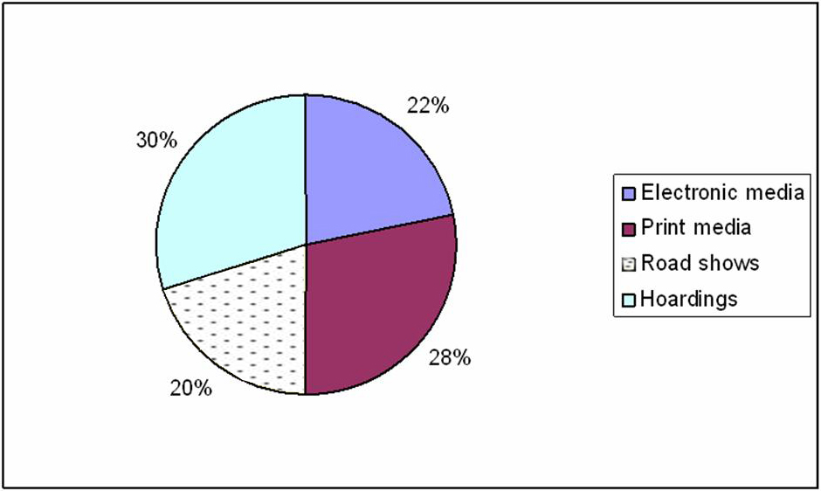

**Interpretation:**

30% of the respondents came to know about SUPER AGRI SEEDS products from hoardings while 28% of the respondents came to know from print media and electronic media was assumed by 22% of the respondents. A small significant 20% of the respondents replied that road shows have helped them in understanding SUPER AGRI SEEDS products.

1. **Since how many months have you been using this service?**

|  |  |  |
| --- | --- | --- |
|  | **No. of respondents** | **Percentage** |
| 0-6 months | 23 | 23% |
| 6-12 months | 37 | 37% |
| 1-2 years | 36 | 36% |
| More than 2 years | 04 | 04% |
| **Total** | **100** | **100%** |

**Using of the service (in months):**

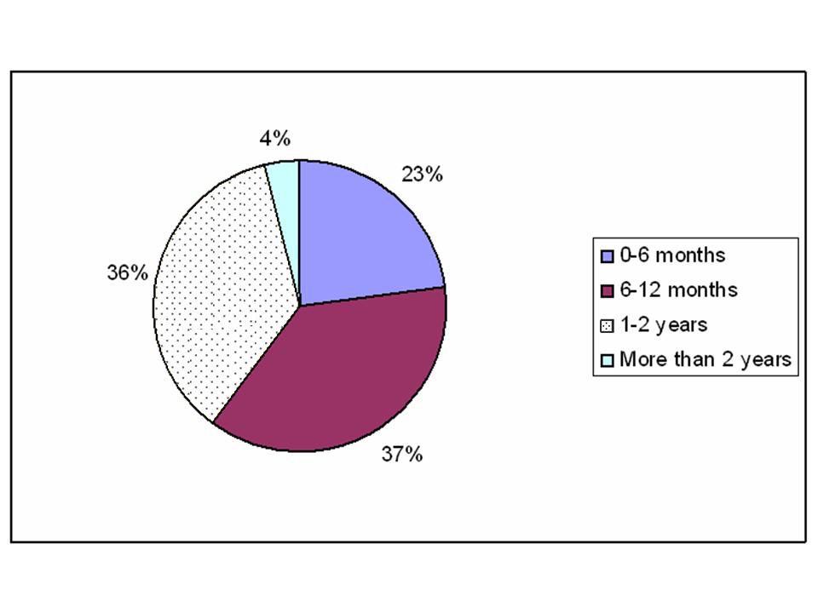

**Interpretation:**

From the above table it is seen that 37% of the respondents have been using SUPER AGRI SEEDS products for past one year. While 36% have been using it for more than 1 year, and a significant 23% of respondents have been using the service for less than six months. Only 4% of the respondents have been using SUPER AGRI SEEDS products for more than 2 –years.

**3) Which Kind of service are you using? Please mention?**

|  |  |  |
| --- | --- | --- |
| **Type of service** | **No. of respondents** | **Percentage** |
| Wholesale | 40 | 40% |
| Retail | 60 | 60% |
| **Total** | **100** | **100%** |

## Kind of service

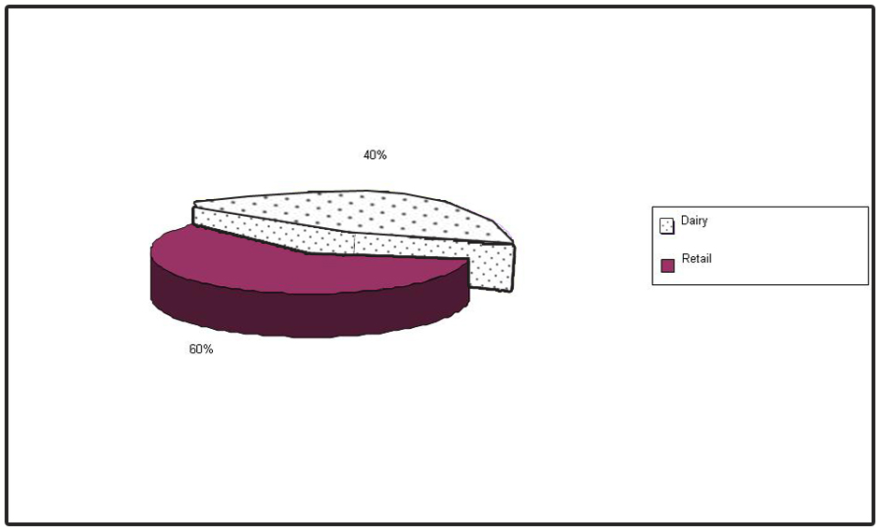

**Interpretation**

From the above table it can be seen that 60% of them are using retail services, while 27% are using Dairy services, and the remaining 13% are using Agri services.

**4) What is the reason for choosing this service?**

|  |  |  |
| --- | --- | --- |
|  | **No. of respondents** | **Percentage** |
| Less price | 20 | 20% |
| Quality service | 56 | 56% |
| Brand image | 24 | 24% |
| **Total** | **100** | **100%** |

**Reason for choosing the service**:



**Interpretation**

From the above table it is shown that 56% of the respondents are citing quality of service as the factor. While 24% cited brand image as the reason for choosing the service. As far as price is concerned only 20% of the respondents have quoted it as the reason for choosing this service.

**5) Why do you prefer for this service?**

|  |  |  |
| --- | --- | --- |
|  | **No. of respondents** | **Percentage** |
| Convenience | 53 | 53% |
| Economical | 30 | 30% |
| Security | 04 | 04% |
| Features | 13 | 13% |
| **Total** | **100** | **100%** |

**Preferring for this service**:

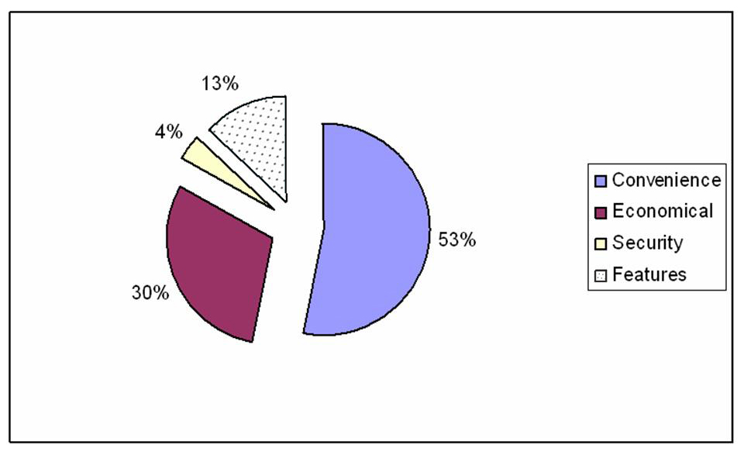

**Interpretation**

In today’s busy world convenience seems to be the most overriding factor while preferring a cellular service. It is clear that 53% of the respondents have preferred this service due to easy & hands free availability, making it convenient to use it. On the other hand 30% have said economy of the service, while 13% of the respondents have given features as their choice. While a meager 4% of the said security as the reason for preferring the service.

**6) Are you satisfied with the quality of service being provided?**

|  |  |  |
| --- | --- | --- |
|  | **No. of respondents** | **Percentage** |
| Yes | 85 | 85% |
| No | 5 | 5% |
| To some extent | 0 | 0% |
| Can’t say | 10 | 10% |
| **Total** | **100** | **100%** |

**Satisfaction l with the quality of service:**



**Interpretation:**

From the above table it is clear that 85% of the respondents are satisfied with the quality of service while a significant number i.e., 10% of the respondents couldn’t say anything and 5% of the respondents replied they are not satisfied with the quality of service.

**7) Have you faced any problem at the time of Purchase & usage?**

|  |  |  |
| --- | --- | --- |
|  | **No. of respondents** | **percentage** |
| Yes | 10 | 10% |
| No | 90 | 90% |
| **Total** | **100** | **100%** |
|  |  |  |

**Facing of problems:**

10

90

0

10

20

30

40

50

60

70

80

90

100

Yes

No

**Interpretation:**

The above table indicates that at the time of activation only 10% of the respondents have faced problem with company, and 90% of the respondents have not face any problem.

**8) While buying SUPER AGRI SEEDS product that has influenced your purchase**

**Decision?**

|  |  |  |
| --- | --- | --- |
|  | **No. of respondents** | **Percentage** |
| Colleagues | 25 | 25% |
| Friends | 60 | 60% |
| Family members | 15 | 15% |
| Others | 0 | 0% |
| **Total** | **100** | **100%** |

**Influence on purchase decision:**



**Interpretation:**

From the above table it is shown that 60% of the respondents were influenced by their friends, 25% by their colleagues and 15% by others.

**9) Did you know the customer awareness program for every month ?**

|  |  |  |
| --- | --- | --- |
|  | **No. Of respondents** | **Percentage** |
| Yes | 40 | 40% |
| No | 60 | 60% |
| Total | 100 | 100% |

**Including of activation charges:**



**Interpretation:**

The above table is indicating that, from the total respondents of the survey 40% respondents are aware of the customer program , and the remaining 60% respondents are completely unaware of this statement, due to lack of communication from the company.

**10) Where do you pay your bills?**

|  |  |  |
| --- | --- | --- |
| **Periods** | **No. of respondents** | **percentage** |
| At showrooms | 100 | 100% |
| On delivery | 00 | 00% |
| **Total** | **100** | **100%** |

### Place of paying Bills:

100

100%

0

0%

0

20

40

60

80

100

120

1

2

At showrooms

On delivery

**Interpretation:**

It is clear from the above analysis that the respondents have to pay their post paid bills at the True-Paid shops only. So 100% of the respondents pay at their dealer outlets only.

**11) Do you prefer online-billing counters for your bill payment like counters of ATM’s?**

|  |  |  |
| --- | --- | --- |
| **Type of service** | **No. of respondents** | **percentage** |
| Yes | 99 | 99 |
| No | 01 | 01% |
| **Total** | **100** | **100%** |

**Preferring of online bills:**



**Interpretation:**

Of the 100 respondents surveyed 99% of them prefer online counters for their bills payments as it saves their time & effort, and only 1% of the respondents are not willing to have the online payment facility.

**12) How do you feel about the pricing of SUPER AGRI SEEDS services as compared with other?**

|  |  |  |
| --- | --- | --- |
|  | **No. Of respondents** | **Percentage** |
| Expensive | 00 | 00% |
| Competitive | 96 | 96% |
| Can’t say | 04 | 04% |
| **Total** | **100** | **100%** |

**Pricing of SUPER AGRI SEEDS services:**



**Interpretation:**

The feelings of customers of SUPER AGRI SEEDS about the pricing of the services is, 96% of them are satisfied and feel the prices are comparable with others and 4% of them are not satisfied with the pricing of the company as they feel the prices are not competitive enough.

**13) Are you satisfied with the payment of your bills?**

|  |  |  |
| --- | --- | --- |
|  | **No. of respondents** | **Percentage** |
| Yes | 10 | 10% |
| No | 00 | 00% |
| To some extent | 90 | 90% |
| **Total** | **100** | **100%** |

**Satisfaction with payment:**



**Interpretation:**

With the above analysis, from the 100 respondents, only 10% are satisfied with the time given to them for payment of bills, and the remaining 90% of respondents are not fully satisfied.

**14) What is your Opinion on the service availability of Retail?**

|  |  |  |
| --- | --- | --- |
|  | **No. of respondents** | **Percentage** |
| Easily available | 100 | 100% |
| Not available | 00 | 00% |

**Service availability of retail:**

100

100%

0

0%

0

20

40

60

80

100

120

1

2

Easily available

Can’t say

**Interpretation:**

The above table indicates that the SUPER AGRI SEEDS services of retail services are easily available in urban areas; this is clarified from 100 respondents surveyed.

**15) Is home delivery facility providing by the services is sufficient & convenient to you?**

|  |  |  |
| --- | --- | --- |
|  | **No. of respondents** | **Percentage** |
| Yes | 100 | 100% |
| No | 00 | 00% |
| **Total** | **100** | **100%** |

**Opinion about home delivery facility:**



**Interpretation:**

From the above analysis it is clear that 100% of the respondents are feeling happy and feel the home delivery facility is sufficient and convenient to them.

**16) Do you feel that the instruments being provided along with the services is ok or you want a change (as per choice)?**

|  |  |  |
| --- | --- | --- |
|  | **No. of respondents** | **Percentage** |
| Yes, we want change | 10 | 10% |
| No, it is OK | 90 | 90% |
| **Total** | **100** | **100%** |

**Instruments provided with service are ok or not:**



**Interpretation:**

From the above table it is clear that 90% of the total 100 respondents don’t want any change in the instruments being provided by the company, they want as it is. But the remaining 10% of the respondents are willing to have change in that at some choice, in terms of certain features as compared with the competitors.

**17) Do you recommend these services to your friends, Colleagues & Family?**

|  |  |  |
| --- | --- | --- |
|  | **No. of respondents** | **Percentage** |
| Yes | 63 | 63% |
| No | 37 | 37% |
| Can’t say | 00 | 00% |
| **Total** | **100** | **100%** |

**Recommendation of the service**:



**Interpretation:**

It is clear that 63% of the respondents would recommend the service, while a significant 37% of the respondents do not want to recommend the service to their friends, colleagues & family.

**18) Do you want any additional features to be included to you service in future?**

|  |  |  |
| --- | --- | --- |
|  | **No. of respondents** | **Percentage** |
| Yes | 67 | 67% |
| No | 23 | 23% |
| **Total** | **100** | **100%** |

**Any additional features:**



**Interpretation:**

From the above table it is clear that 67% of the total respondents are desirous of having some new features like call waiting, GPRS, MMS etc., to be included in this service in future, and the remaining 23% respondents do not want any changes as far as the additional features are concerned.

**CHAPTER: V**

**Findings**

**Suggestions**

**Bibliography**

**Annexure**

**FINDINGS**

1. The coverage is limited to only urban areas hence effort should be made to increase the coverage in semi urban and rural areas as it increases the number of subscribers

2. SUPER AGRI SEEDS should create awareness amongst its customers regarding various services that are being offered by it by increasing its sales promotion reach.

1. Special promotional schemes to be launched especially to target youth segment who take up the new product by having special packages
2. SUPER AGRI SEEDS try to focus on the after sales customer support as this is perceived to be a weak spot, by the consumes and should have responsive call centers to address the needs of its customers.
3. From the study it was found that mostly SUPER AGRI SEEDS products was preferred by Household people.
4. It was found that 82% of the respondents are satisfied with the delivery of the SUPER AGRI SEEDS products.
5. From the study it was found that 53% of the respondents are satisfied with the service provided by the SUPER AGRI SEEDS Company.
6. The overall service of the dealership is average.
7. Most of the respondents purchased the SUPER AGRI SEEDS products for the hose purpose.
8. It was also found that the performance of the sales executive while approaching the customers is also average.

**SUGGESTIONS**

* SUPER AGRI SEEDS should increase the coverage of its all services i.e. dairy and agri and retail also, services by installing more at strategic points.
* The quality of the retail service needs to be improved in terms of clarity and connectivity.
* SUPER AGRI SEEDS should vigorously promote its retail services as compared with the competition and should concentrate on individual customers and non-commercial customers.
* SUPER AGRI SEEDS should aggressively promote its offerings in various media and should concentrate on hoardings and road shows and electronic media.
* Attractive schemes for owning the retail instruments should be launched to attract more customers.

# BIBLIOGRAPHY

1. MARKETING MANAGEMENT

- Philip Kotler

2. PRINCIPLE OF MARKETING

- Philip Kotler & Gray Armstrong

3. MARKETING MANAGEMENT

- Stanton

4. BUSINESS RESEARCH METHODOLOGY

- C.R. Kothari

5. [www.Agrifoods](http://www.Agrifoods)yahoo.co.in

7. Www. Customer psychology.com

8. [www.Indian](http://www.Indian) mart.com

**ANNEXURE –I**

**QUESTIONNAIRE**

Name of the respondent :

Age :

Gender :

Address :

Signature

1) How do you come to know that About SUPER AGRI SEEDS products?

a) Electronic Media b) Print media

b) Road shows c) Hoardings

2) Since how many months have you been using this?

a) 0-6 months b) 6-12 months

c) 1-2 years d) more than 2 years

3) Which kind of service is you using please mention?

a) Wholesale b) Retail

4) What is the reason for choosing this service?

a) Less price b) Quality service

b) Brand image

5) Why do you prefer this service?

a) Convenience b) Economical

c) Security e) Features

6) Are you satisfied with the quality of service being provided?

a) Yes b) No

c) To some extent d) can’t say

7) Have you faced any problem at the time of purchase & usage?

a) Yes b) No

8) Who has influenced you, in purchase decision towards SUPER AGRI SEEDS Product?

a) Colleagues b) Friends

c) Family members d) others

9) Do you know customer awareness program for every month?

a) yes b) No

10) Where do you pay your bills?

a) At showrooms b) on delivery

11) Do you prefer online billing counters for your bill payment like ATM’s?

a) Yes b) No

12) How do you feel about the pricing of SUPER AGRI SEEDS Services as compared with other?

a) Expensive b) Competitive

c) Can’t say

13) Are you satisfied with the payment of your bills?

a) Yes b) No

c) To some extent

14) What is your opinion on the serviced availability of Retail?

a) Easily available b) Not available

c) To some extent d) can’t say

15) Is home delivery facility providing by the service is sufficient & convenient to you?

a) Yes b) No

16) Do you feel that the instruments being provided along with the services is OK or you want any change? (As per your choice)

a) Yes, we want change b) No, it is ok

17) Do you recommend this service to your friends, colleagues & family?

a) Yes b) No

18) Do you want any additional features to be included to your services in future?

a) Yes b) No

19) What are the common problems, which you face while using this service:_____________________________________________

_____________________________________________

Thank you

# 

# 