1. **INTRODUCTION**
   1. **Market Segmentation - An Overview**

**INTRODUCTION**

**Market segmention** is a group of people or organizations sharing one or more characteristics that cause them to have similar product and/or service needs. A true market segment meets all of the following criteria: it is distinct from other segments (different segments have different needs), it is homogeneous within the segment (exhibits common needs); it responds similarly to a market stimulus, and it can be reached by a market intervention. The term is also used when consumers with identical product and/or service needs are divided up into groups so they can be charged different amounts. These can broadly be viewed as 'positive' and 'negative' applications of the same idea, splitting up the market into smaller groups.

**DEFINITION BY PHILIP KOTLER**

Market segmentation is subdividing into homogeneous sub set of customer, where any subset may conceivably be selected as market target to be reached with distinct marketing mix.

Market segmenting is the process that a company divides the market into distinct groups who have distinct needs, wants, behavior or who might want different products & services Broadly, markets can be divided according to a number of general criteria, such as by industry or public versus private although industrial market segmentation is quite different from consumer market segmentation, both have similar objectives. All of these methods of segmentation are merely proxies for true segments, which don't always fit into convenient demographic boundaries. Consumer-based market segmentation can be performed on a *product specific* basis, to provide a close match between specific products and individuals.

The process of segmentation is distinct from targeting (choosing which segments to address) and positioning (designing an appropriate marketing mix for each segment). The overall intent is to identify groups of similar customers and potential customers; to prioritize the groups to address; to understand their behavior; and to respond with appropriate marketing strategies that satisfy the different preferences of each chosen segment. Revenues are thus improved. Improved segmentation can lead to significantly improved marketing effectiveness. Distinct segments can have different industry structures and thus have higher or lower attractiveness. With the right segmentation, the right lists can be purchased, advertising results can be improved and customer satisfaction can be increased leading to better reputation.

Successful segmentation requires the following :

* Homogeneity within the segment
* heterogeneity between segments
* Segments are measurable and substantial
* Segments are differentiable
* Segments are accessible and actionable
* Target segment is large enough to be profitable

**Effective market segmentation**

* Improves understanding of the customer base
* Provides a clear classification of the customers
* Enables the generation of a targeted product portfolio that responds to the needs of market place
* Helps gauge a company's market position relative to the competition
* Leads to the effective fine tuning of marketing strategies

**Reasons for Market Segmentation**

As already stated, segmentation is the basis for developing targeted and effective marketing plans. Furthermore, analysis of market segments enables decisions about intensity of marketing activities in particular segments. A segment-orientated marketing approach generally offers a range of advantages for both, businesses and customers.

Better serving customers needs and wants :

It is possible to satisfy a variety of customer needs with a limited product range by using different forms, bundles, incentives and promotional activities. The computer manufacturer Dell, for instance, does not organize its website by product groups (desktops, notebooks, servers, printers etc), but by customer groups (privates, small businesses, large businesses, public/state organizations). They offer the same products to all customer groups. Nevertheless, they suggest product bundles and supporting services that are individually tailored for the needs of each particular group. As an example, Dell offers to take on all IT-administration for companies. This service provides a huge potential for savings for corporate customers. However, it would be absolutely useless for private customers. Thus, segment-specific product bundles increase chances for cross selling.

Higher Profits :

It is often difficult to increase prices for the whole market. Nevertheless, it is possible to develop premium segments in which customers accept a higher price level. Such segments could be distinguished from the mass market by features like additional services, exclusive points of sale, product variations and the like. A typical segment-based price variation is by region. The generally higher price level in big cities is evidence for this.

When differentiating prices by segments, organizations have to take care that there is no chance for cannibalization between high-priced products with high margins and budget offers in different segments. This risk is the higher, the less distinguished the segments are.

**REQUIREMENTS OF MARKET SEGMENTATION**

**Philip Kotler** mentioned five criteria for an effective segmentation which states that Segmentation should be: -

* **Measurable:** - it should be possible to determine the values of the variable used for the segmentation.
* **Relevant:** - it should justify the expected profits and the growth potential.
* **Accessible: -** the target customers must be reachable and servable for the organization.
* **Distinguishable:** - the target audiences must be diverse and able to show different reactions to different marketing mix.
* **Feasible: -** the firm must have an ability to draw an effective marketing program for its customers.

**1.2 Market Segmentation with reference to Automobile Industry:**

In today’s times, the automobile sector is robust with growth and more and more players are entering the automobile industry. The meaning of market segmentation was discussed in the last post and here an attempt has been made to get an overview of the market segmentation of automobiles.

* **Geographic segmentation**

Geographical segmentation is one of the most important basis of segmentation of the automobile sector, especially in large sized countries like India, where the conditions in different regions.

Taking the segmentation in India itself, we find that manufactures of tractors would focus only on those areas where agriculture is of prime importance and would target those agriculturists who have sizeable land holdings and have the resources to buy a tractor.

On the other hand, commercial vehicle companies would segment the market on the basis of concentration of industries in different regions.

Luxury car makers would definitely target the metropolitan regions for the sale of their cars, whereas small car makers would also take into account developing cities and townships into account during the process of segmentation of their products.

* **Demographic segmentation**

An other important basis for segmentation of the automobile sector is demographic segmentation. Demographic segmentation provides a base marketing of products according to the income, status, age, etc.

Manufactures of small cars like Nano would primarily focus on the segment of the people belonging to the middle class and here comes lies the demographic segmentation. On the other hand, luxury car manufacturers would focus more on the high income segment.

Similarly, demographic segmentation plays an important role in the two wheeler market. Bike manufacturers generally target young to middle aged people. More and more manufactures are coming with automobiles for women, which have special features and are easy to use.

According to the age of the target market group, automobile manufacturers would come up with different colour variants, for instance bright and flashy colours for the young and vice versa.

* **Psychological segmentation**

Based on psychological segmentation, automobile manufacturers come up with different variant of the models of their products. This has been largely seen in the case of cars, where companies generally come up with two or three variants of the same model, and it has been observed by industry analysts that the variant of the medium variant of the model sells the most.

Tag-lines such as “Men are Back” (used by Maruti Suzuki for the launch of a new car) and “Definitely Male” (used by Bajaj for a popular bike) target a particular category of individuals and help to increase sales and popularity in that segment.

Manufacturers of luxury cars like Ferrari, Porsche, etc target the section of the society with a large disposable income and high status, and this can be achieved by psychological segmentation.

* **Behavioural  segmentation**

As mentioned earlier, behavioural segmentation is done on the basis of the benefits sought, loyalty status, etc.

This is another important means for segmentation in the automobile sector, and taking yet again the example of a car, Daimler, the manufacturer of luxury car Maybach, customises the cars according to the needs and requirements of the products.

Thus, through some examples, we have seen how the market for automobiles is segmented.

**1.3 Market Segmentation in Maruti Udyog Limited(MUL):**

The Maruti Udyog Limited(MUL) is undertaken various aspects of Marketing and International Business in automobile industry especially throws light on strategies of Maruti Udyog Limited and also draws comparative analysis of various products of MUL with its competitors. Marketing in automobile industry is a lot about providing services before the competitors settle down with cheap & even better alternatives and also before the consumer perceives your product lack desired features. After tracing the history of small car concept in India briefly, the project reveals the significance, performance of Maruti Udyog Limited and the revolution brought about by it in the Indian car market. The competing rival’s product, positioning, strategy and prospects in the market are evaluated and then compared. This evaluation and comparison along with study of consumer buying behavior and purchase drivers and implication of price war launched by MUL, profitability technology upgradation and new product development, marketing mix, market share. Along with this the likely marketing strategy of MUL to tackle the competition is also evaluated. The company annually exports more than 50,000 cars and has an extremely large domestic market in India selling over 730,000 cars annually. Maruti 800, till 2004, was the India's largest selling compact car ever since it was launched in 1983. More than a million units of this car have been sold worldwide so far.

Due to the large number of Maruti 800s sold in the Indian market, the term "Maruti" is commonly used to refer to this compact car model. Till recently the term "Maruti", in popular Indian culture, was associated to the Maruti 800 model. Maruti Suzuki India Limited, a subsidiary of Suzuki Motor Corporation of Japan, has been the leader of the Indian car market for over two decades.

It’s manufacturing facilities are located at two facilities Gurgaon and Manesar south of New Delhi. Maruti’s Gurgaon facility has an installed capacity of 350,000 units per annum. The Manesar facilities, launched in February 2007 comprise a vehicle assembly plant with a capacity of 100,000 units per year and a Diesel Engine plant with an annual capacity of 100,000 engines and transmissions. Manesar and Gurgaon facilities have a combined capability to produce over 700,000 units annually. More than half the cars sold in India are Maruti cars. The company is a subsidiary of Suzuki Motor Corporation, Japan, which owns 54.2 per cent of Maruti. The rest is owned by the public and financial institutions. It is listed on the Bombay Stock Exchange and National Stock Exchange in India. During 2007-08, Maruti Suzuki sold 764,842 cars, of which 53,024 were exported. In all, over six million Maruti cars are on Indian roads since the first car was rolled out on December 14,983. There was a possibility that export sales continue to suffer, unless MUL's parent company, Suzuki, comes up with a plan to export different models from India, as the decline in international demand due to this economic recession.

Indian automobile is of Rs. 46,500 crore and its 86% share is captured by small size car which are offered by Maruti Udyog Limited, Hyundai Motors, Telco GM.

Company should not comprise on technology of cars in make cheaper if a company does so, it will find itself out of the game. Referee 'the car customer will announce you not fit for the game.

Very few companies or better to say there is only one company in the Indian market is using the safety or security as its USP. This concern is hardly exploited in India and should be looked into.

Price of the product in not only factor which can make a company winner in Indian passenger car market. A judicious mix of comfort, luxury, space, design, looks and technology at a reasonable price. Should e made so as to offer value for money concept to customers.

Proper segmentation has to be done according to the Indian/International Markets. Eg. in Europe, Opel Astra and Mitsubishi Lancer would be classified as 'small family cars' in India they have been clubbed along with Honda city as top and premium cars in segment C, because they all fall in 8-10 lacs price range.

Today, the Indian market and industry are confronting a change never experience before. The market in getting re-segmented not only on price, physical, technological and psychographic description but also on behavioral, sociological and economic patterns influencing consumer thinking and attitude. The buying behavior is changing dramatically and today's new evolving customer is free from past experience and prejudices and is a lot more exposed to free market philosophy, international products and global media. All these customer changes must be kept in mind for achieving success.

Today, in India there are only 6 cars among 1000 people so there is a huge market to exploit. Maruti should show consistency in its pricing policy otherwise customers feel cheated who purchased the car just before the price fall. Upgrade the existing models time to time with innovative technology, interiors, design and value added features and accessories. It should expand its dealership and service network especially in eastern Indian region.

Thus Maruti should train their technical staff to deal with customer who is in the workshop to get their cars serviced/repaired. No doubt it is hard to manage and handle such a big network but the company has to handle it properly to satisfy its customers. We should always remember that loyal and satisfied customer gives a chain of new customers.

Maruti is providing just 33% of the total industry and having the 50% of market share but this is a quite impossible to job retains 50% of market share with just 33% production capacities so any how Maruti should try to increase its production capacities to retain its market share in near future.

Maruti should launch the CNG(Compressed Natural Gas**)** variant of its models used for public transport. It should improve the interiors of the cars. A survey should that 67% of the people favored this decision. The above article was extracted from dissertations in Marketing, Finance, Human Resources, Strategy, Information Systems by the students from Skyline College

**2. Profile Of The Industry**

**2.1 Industry Profile-An Overview**

The Four-Wheeler Industry in India has not quite matched up to the performance of its counterparts in other parts of the world. The primary reason for this has been the all-pervasive regulatory atmosphere prevailing till the opening up of the industry in the mid-1990s. Thevarious layers of legislative Acts sheltered the industry from external competition for a long time. Moreover, the industry was considered low-priority as cars were thought of as unaffordable luxury". Post Liberalization, the car market in India have been in a burgeoning stage with all types of cars flooding the market in order to meet the demands of Indian customers who are increasingly exposed to state of the world automobiles and want the best when it comes to purchasing a car.

It is expected that by 2030, the Indian car market will be the 3rd largest car market across the globe. The main encouraging factors for the success story of the car market in India are the increase in the opportunity for new investments, the rise in the GDP rate, the growing per capita income, massive population, and high ownership capacity. The liberalization policies followed by the Indian government had been inviting foreign players to participate in the car market in India. The recent trend within the new generation to get work in the software based sector has led to the rise in the income level and change in the lifestyle significantly, which has further led to the increase in the demand for luxurious cars among them.

The car Market in India is crowded with all varieties of car models like the small cars, mid-size cars, luxury cars, super luxury cars, and sports utility vehicles. Initially the most popular car model dominating the Car Market in India was the Ambassador, which however today gave way

to numerous new models like Hyundai, Honda, Mercedes-Benz, BMW, Bentley and many others. Moreover, there are many other models of cars in the pipeline, to be launched in the car market in India. Some of the leading brands dominating the car market in India at present are Hindustan Motors, Reva Electric Car Co., Fiat India Private Ltd., Daimler Chrysler India Private Ltd, Ford India Ltd., Honda Siel Cars India Ltd., General Motors India, Hyundai Motors India Ltd., Skoda Auto India Private Ltd., and Toyota Kirloskar Motor Ltd. Since the demand for foreign cars are increasing with time, big brands like Mercedes Benz, Volkswagen, Aston Martin, Ferrari, and Rolls-Royce have long since made a foray into the Indian car market.

**Facts about Indian Car Market:**

Although the Indian automobile industry has come a long way since the deregulation in 1993, India does not rank well among its global peers in many respects, viz., the contribution of the sector to industrial output, number of cars per person, employment by the sector as a percentage of industrial employment, number of months' income required to purchase a car, and penetration of cars.

**Figure:-**Passenger vehicle stock per 100 people

India is far behind from other countries with just 6.9 cars per 100 persons, while Unites States has 76.9 cars on per 100 persons. Among developing countries, Russia also stands ahead than India and China with 16.3 cars per 100 persons.

Fig 2.1

Two things that stunted growth of the Indian automobile industry in the past have been low demand and lack of vision on the part of the original equipment manufacturers (OEMs). However, the demand has picked up after the liberalization of the regulatory environment, and

global OEMs who enjoy scale economies both in terms of manufacturing and research and development (R&D) entered the Indian market. This has resulted in a significant shift in the way business is conducted by suppliers, assemblers and marketers.

**MARKET SCENERIO**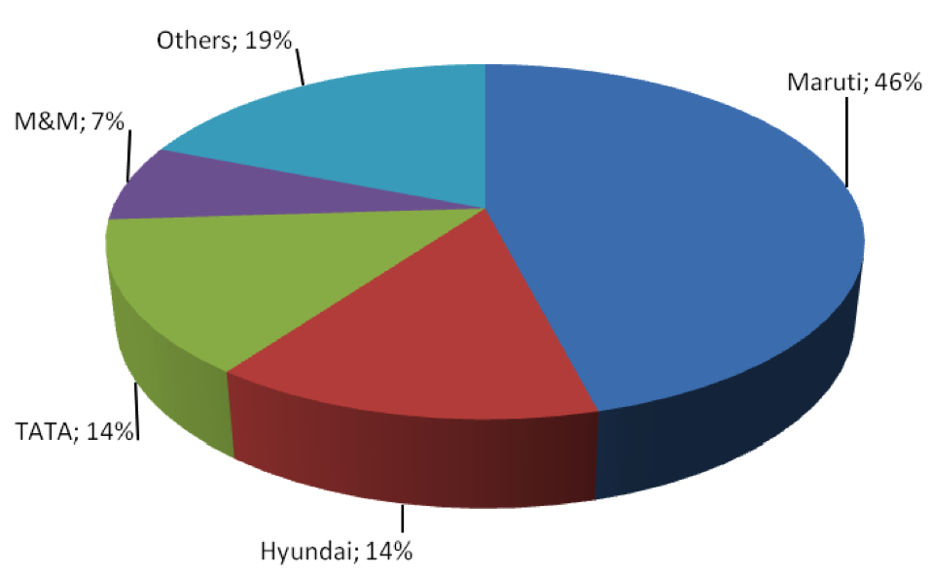

Fig 2.2

**2.2 Profile Of The Organizations**

Maruti Udyog Limited (MUL) was established in Feb 1981 through an Act of Parliament, to meet the growing demand of a personal mode of transport caused by the lack of an efficient public transport system. It was established with the objectives of - modernizing the Indian automobile industry, producing fuel efficient vehicles to conserve scarce resources and producing indigenous utility cars for the growing needs of the Indian population. A license and a Joint Venture agreement were signed with the Suzuki Motor Company of Japan in Oct 1983, by which Suzuki acquired 26% of the equity and agreed to provide the latest technology as well as Japanese management practices. Suzuki was preferred for the joint venture because of its track record in manufacturing and selling small cars all over the world. There was an option in the agreement to raise Suzuki’s equity to 40%, which it exercised in 1987. Five years later, in 1992, Suzuki further increased its equity to 50% turning Maruti into a non-government organization managed on the lines of Japanese management practices.

Maruti created history by going into production in a record 13 months. Maruti is the highest volume car manufacturer in Asia, outside Japan and Korea, having produced over 5 million vehicles by May 2005. Maruti is one of the most successful automobile joint ventures, and has made profits every year since inception till 2000-01. In 2000-01, although Maruti generated operating profits on an income of Rs 92.5 billion, high depreciation on new model launches resulted in a book loss.

COMPANY HISTORY AND BACKGROUND

The Evolution

Maruti’s history of evolution can be examined in four phases: two phases during pre-liberalization period (1983-86, 1986-1992) and two phases during post-liberalization period (1992-97, 1997-2002), followed by the full privatization of Maruti in June 2003 with the launch of an initial public offering (IPO).The first phase started when Maruti rolled out its first car in December 1983. During the initial years Maruti had 883 employees, a capital of Rs. 607 mn and profit of Rs.17 mn without any tax obligation. From such a modest start the company in just about a decade (beginning of second phase in 1992) had turned itself into an automobile giant capturing about 80% of the market share in India. Employees grew to 2000 (end of first phase 1986), 3900 (end of second phase 1992) and 5700 in 1999. The profit after tax increased from Rs 18.67 mn in 1984 to Rs. 6854.54 mn in 1998 but started declining during 1997-2001.

During the pre-liberalization period (1983-1992) a major source of Maruti’s strength was the wholehearted willingness of the Government of India to subscribe to Suzuki’s technology and the principles and practices of Japanese management. Large number of Indian managers, supervisors and workers were regularly sent to the Suzuki plants in Japan for training. Batches of Japanese personnel came over to Maruti to train, supervise and manage. Maruti’s style of management was essentially to follow Japanese management practices.

The Path to Success for Maruti was as follows:

(a) teamwork and recognition that each employee’s future growth and prosperity is totally dependent on the company’s growth and prosperity

(b) strict work discipline for individuals and the organization

(c) constant efforts to increase the productivity of labor and capital

(d) steady improvements in quality and reduction in costs

(e) customer orientation

(f) long-term objectives and policies with the confidence to realize the goals

(g) respect of law, ethics and human beings. The “path to success” translated into practices that Maruti’s culture approximated from the Japanese management practices.

## SERVICES OFFERED

The following products are offered by Maruti Suzuki:-

1. Maruti 800: Launched 1983. Largest selling car in India, until 2004. Cheapest car in India. 3 Face-Lifts.(P)
2. Maruti Omni: Launched 1984. 2 Face-Lifts.(P)
3. Maruti Gypsy: Launched 1985.(P)
4. Maruti Wagon-R:Launched 1999, 2 Face-Lifts.(P)
5. Maruti Alto: Launched 2000. Currently the largest selling car in India. 1 Face-Lift.({{Tooltip|P|Petrol
6. Maruti Versa(2003-) (P)
7. [Maruti Zen Estilo](http://en.wikipedia.org/wiki/Maruti_Zen_Estilo)(2005-) (P)
8. [Maruti Suzuki Swift](http://en.wikipedia.org/wiki/Maruti_Suzuki_Swift) 1 very small face-lift(2006- ) (P & D)
9. [Maruti Suzuki SX4](http://en.wikipedia.org/wiki/Maruti_Suzuki_SX4) (May 2007- ) (P & D)
10. [Maruti Grand Vitara](http://en.wikipedia.org/wiki/Maruti_Grand_Vitara) Sports Utility Vehicle Launched in (July 2007- ). Imported(P)
11. [Maruti DZiRE](http://en.wikipedia.org/wiki/Maruti_DZiRE) Sedan Version of swift launched in (March 2008- ) (P)

Upcoming models in 2008

1. Suzuki Splash
2. Suzuki A-Star

Future Maruti Suzuki Plans

1. Maruti Omni Face-Lift in 2009
2. New Mini-SUV in 2010 Likely to be a four-door Jimny.
3. New Luxury Sedan in 2010 Likely to be a production version of the Kizashi.
4. New Swift in 2011
5. New Alto

**(Price wise product segmentation by Maruti Suzuki)**

**GENERAL DISCRIPTION OF MODELS**

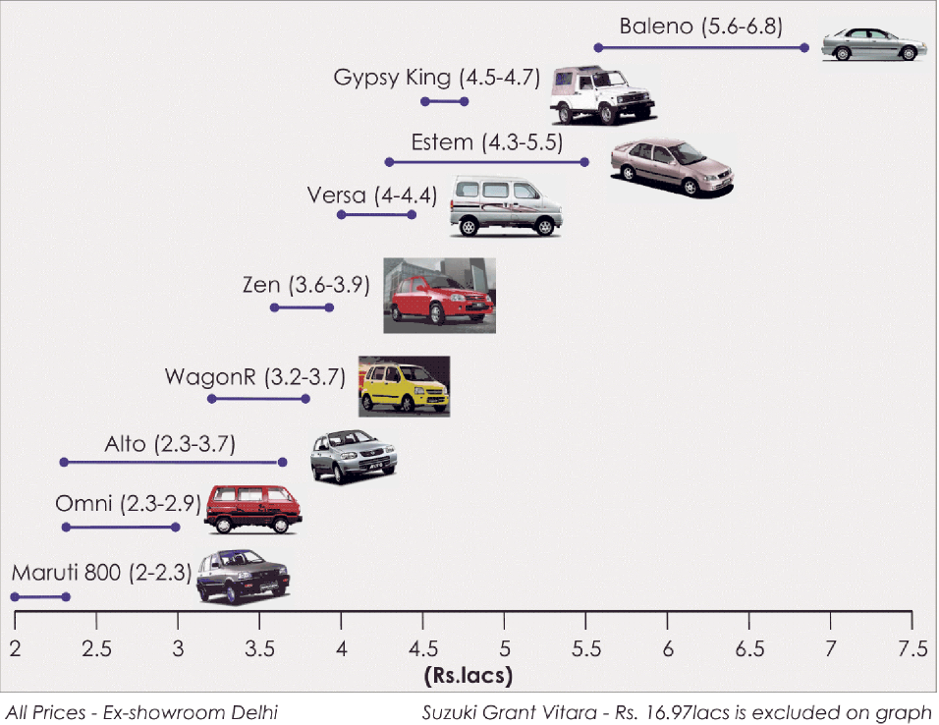

Fig 2.3

**MARUTI 800:-**

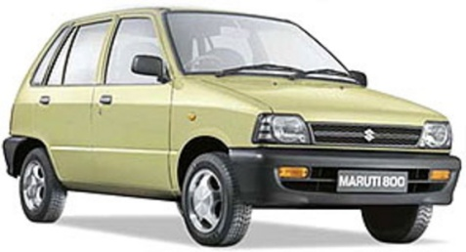**Maruti 800** is a city car manufactured by [Maruti Udyog](http://en.wikipedia.org/wiki/Maruti_Udyog) in India .It used to be the largest selling car in India until the Maruti Alto recently took that title. It is also exported to a number of countries in southeastern Asia including Bangladesh and Sri Lanka, and to some South American markets (as Chile, sold as Suzuki Maruti), and was available in selected European markets between 1988 and 1992, sold as the Suzuki Maruti. In Morocco it is currently sold as Suzuki Maruti (as of March 2008). The car comes in different versions including one with air conditioning and one without. It was launched in December 1984 with almost 100% imported components.

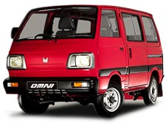**MARUTI OMNI :**

The **Maruti Omni** is a [microvan](http://en.wikipedia.org/wiki/Microvan) manufactured by Indian automaker Maruti Udyog Limited. The first version of Maruti Omni had the same 796 cc engine as the [Maruti 800](http://en.wikipedia.org/wiki/Maruti_800) [city car](http://en.wikipedia.org/wiki/City_car). This was the second vehicle to be launched by Maruti, one year after the 800, in 1984. Later version of the Omni includes the

* Omni (E), released in 1996, 796 cc engine, 8 seater capacity vehicle
* Omni XL - 1999, same engine, modified with a higher roof.
* Omni Cargo LPG - 2004, created to answer the growing popularity of this car being used as an inter-city cargo vehicle.

Omni LPG - 2003, same 796 cc engine, added with a factory fitted LPG Kit, authorised by the Indian RTOs (Regional Transport Offices). This makes it the most economic 4 wheeler in India, as far as the driving costs are concerned

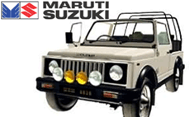**MARUTI GYPSY**

The [**Maruti**](http://en.wikipedia.org/wiki/Maruti) **Gypsy** is a four wheel drive SUV based on the Suzuki SJ long wheel base.Produced in India, it is also a common sight in Chile and Kenya. Within Europe, it is most often found in Malta and Hungary. In contrast to the Suzuki, the Maruti is available with 4 seats and a sizeable trunk. The Maruti Gypsy is available as a "soft top", "hard top " and as an "ambulance car". In India, it is widely used by the police and defense forces. In civilian use, the Gypsy is a popular choice as a low-cost SUV and is a common sight at rally events.

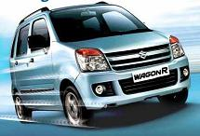**MARUTI WAGON-R**

The [**Maruti**](http://en.wikipedia.org/wiki/Maruti_Udyog) **Wagon-R** is a made for India version of Suzuki Wagon R. The Wagon-R was born out of Japanese kei-jido-sha restrictions which dictated a limited length and engine size. This boxy, tall-boy design has now completed five years of presence on Indian roads. Now the car has found a market for itself, especially among young Indian urban professionals who don't mind its boxy slab-sided looks, but value its Maruti lineage. The car is currently among India's top five best-selling cars.

**MARUTI ALTO**

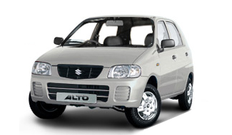The **Maruti Alto** is a city car manufactured by [Maruti Udyog](http://en.wikipedia.org/wiki/Maruti_Udyog) in India. It is the best-selling car in India.It is India's largest selling car and has recently crossed the 1 million production figure.It is exported to a number of countries including Bangladesh and Sri Lanka, and to Chile. Alto has crossed the 150,000 export target. The popularity of the Alto has increased over the past few years, mainly due to the reduction in prices. This reduction in prices has mainly come in due to the reduction in excise duty over time. It has now become the first choice of young car buyers intending to upgrade from a 2 wheeler. Some of its appeal is from stylish looks, attractive features, and impressive fuel economy at very affordable prices compared to the other cars in the Indian market.

**MARUTI VERSA**

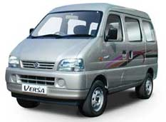The **Maruti Versa** is a micro van produced by Maruti Udyog Limited and sold in India since October 2001. The Versa is a clone of the now discontinued Suzuki Carry. It is the second van released by Maruti Udyog since the Maruti Omni was released in 1984. There are two basic versions of this car in production; the two 8-seater **DX**/**DX2** versions, and the 5-seater **STD** version. The DX2 version of the Versa is equipped with twin air conditioners for front and rear.

**MARUTI SUZUKI SWIFT**

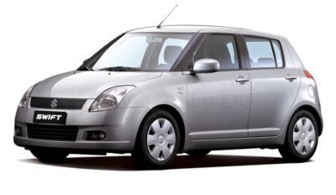The MARUTI **Suzuki Swift** is name plate marketed by Suzuki carried by vehicles of three distinct derivations:

* **Generations I, II, III:** a [super mini](http://en.wikipedia.org/wiki/Supermini) that began as an export nameplate of the [Japanese domestic market](http://en.wikipedia.org/wiki/Japanese_domestic_market) of suzuki .
* **Generation IV:** the current JDM, Europe and Oceana generation, a significant departure from the previous models, marketed solely under the nameplate "Swift". (this article)

**Canadian Swift+:** the current Canada-only generation marketed under the Suzuki swift.

Currently this varient is hot seller in India in the mini car segment.

**MARUTI SUZUKI SX4**

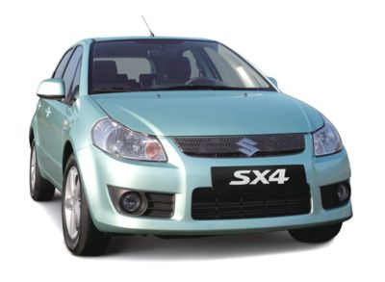In an attempt to strengthen its position in the of Sedan cars market, [Maruti Udyog Ltd.](http://www.surfindia.com/automobile/maruti-udyog-ltd.html) has launched its premium model bearing name SX4. After Maruti Suzuki Swift, SX4 is the second international model being launched in India. Suzuki SX4, is an A3 segment sedan car, with a perfect combination of style, performance, safety and comfort. There are two versions of Suzuki SX4: Vxi and Zxi that gets power from latest and efficient 1.6-litre M-Series engine delivering impressive 102 BHP of power. Having the price tag of between Rs. 6-6.5 Lacs, Maruti Suzuki SX4 will provide tough competition to its rivalry models like Ford Fiesta, Hyundai Verna, Honda City, and Indigo XL.

**MARUTI SUZUKI DZIRE**

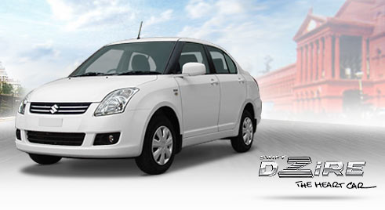**Maruti Swift Dzire** is the new entry level sedan from Indian automaker Maruti Suzuki. Launched on March 26 2008, Maruti DZiRE is based on the popular Maruti Swift platform. The DZire replaces Maruti Suzuki’s popular entry level sedan, Maruti Suzuki Esteem, production of which was discontinued in late 2007. Maruti Suzuki has introduced DZire only in the Indian market. The car is pitted against the other entry level sedans in the Indian market, such as the Mahindra Renault Logan and the Tata Indigo.

**MARUTI SUZUKI ESTEEM**

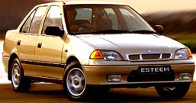Sophisticated big structured Maruti Suzuki esteem is one of the old car of the Maruti Udyog group. To run this huge car its engine is made of lightweight all-aluminum. This contemporary engine has capacity of 65 bhp at 6000 rpm . According to *Mileage (Auto India , Nov 2005), Esteem holds the topmost position on mileage among the other category of cars including the small cars. The Esteem was introduced in the global market in 1995 as Suzuki's first attempt in the compact segment, at the time dominated by European cars such as the Volkswagen Bora/Jetta and Opel Astra, and Japanese models such as the Nissan Sunny/Sentra and Toyota Corolla. As a North American replacement for the Suzuki Swift sedan (the 3-door hatchback remained after it was redesigned in 1995), it was built on a slightly stretched Suzuki Cultus platform for improved cabin room, but otherwise sharing most of internal components with the smaller model — and marketed as a distinct model

**MARUTI SUZUKI BALENO**

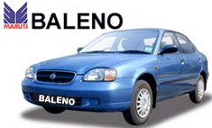The Baleno has the looks and feel of a winner. This was Maruti Udyog's first D-segment car launched in India to compete with the Mitsubishi Lancer and the Honda City. This is also Suzuki's biggest passenger car and in Japan and other markets. The Baleno is called the Cultus in Japan. Suzuki restyled the Baleno in 1999. The car was given a new front end, with a rounder grille and new headlights, and the engine lineup was expanded.

**MARUTI SUZUKI GRAND VITARA**

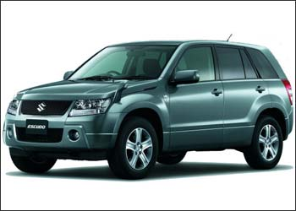The **Suzuki Grand Vitara** is a compact SUV, namely a long-wheelbase version of the Vitara, produced by the Japanese automaker Suzuki since 1999. It was face lifted in 2002 and 2004, and redesigned in 2006. A rebadged version was sold in North America by General Motors as the **Chevrolet Tracker.** The Tracker is sold in Latin America, but Mexico, as Chevrolet Grand Vitara. In Mexico, Grand Vitara and Tracker are different vehicles, sold by Suzuki and Chevrolet respectively The 2006 model has had a structural redesign with a new ladder-boxed chassis integrated into a unibody construction. In India, it is sold as a Maruti.

**MARUTI SUZUKI ZEN-ESTILO**

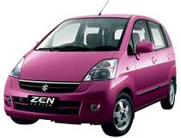Estilo has got Wagon R's engine and chassis and Suzuki MR Wagon's shape. Whatever remains is taken from Zen, well does anything remain actually? This is the mixture of zen and wagon -R . 'Zen Estilo'. In essence its stylish Wagon R, Japan's MR Wagon, combination of the two or anything but Zen. It seems Maruti wants to exploit Zen brand-image hence named this car after Zen. With this model MSL has given it’s B segment a new variant by which it may compete with the models of other company.

**3. REVIEW OF LITERATURE & DESIGN OF THE STUDY**

**3.1 Introduction**

**Market segmention** is a group of people or organizations sharing one or more characteristics that cause them to have similar product and/or service needs. A true market segment meets all of the following criteria: it is distinct from other segments (different segments have different needs), it is homogeneous within the segment (exhibits common needs); it responds similarly to a market stimulus, and it can be reached by a market intervention. The term is also used when consumers with identical product and/or service needs are divided up into groups so they can be charged different amounts. These can broadly be viewed as 'positive' and 'negative' applications of the same idea, splitting up the market into smaller groups.

**3.2 Review of Literature :**

Today where the world is being recognized as global village marketing has become vital ingredient for every business success. It is almost become difficult to every competitor to survive in market for a prolonged period because competition is cut to throat. Change or die is the core faith of marketing. That is

why development of right marketing strategy over time is required. Right marketing Strategy is something that helps companies achieves marketing objectives. Marketing objectives help achieve corporate objectives and corporate objectives aim to achieve a competitive advantage over rival organizations. Effective marketing strategies or marketing campaigns often consist of a combination of several marketing tactics that work together in a synergistic way to establish your brand, reduce sales resistance, and create interest and desire for your product or service. Today marketing is every where, formally or informally, people and organization engage in vast number of activity that we call as marketing. But still there is one constraint before all companies that they can not connect to all customers in large, broad or diverse market Every company want to focus on customers within there capacity and with customers intimacy . For this market is to divide into groups of consumers or segments with distinct needs and wants. This strategy of dividing the market in homogenous group is known as segmentation. Even companies, who have mass marketing phenomena, are now adopting this new world’s strategy i.e. segmentation. The purpose of segmentation is the concentration of marketing energy and force on subdividing to gain a competitive advantage within the segment. It’s analogous to the military principle of concentration of force to overwhelm energy. Concentration of marketing energy is the essence of all marketing strategies and market segmentation is the conceptual tool to help in achieving this focus.

The marketer must try to understand the target market’s needs, wants, and demands. Need can be described as basic human requirements. People need food, air, water, clothing, and entertainment. These needs become wants when they are directed to specific objects that might satisfy the need. An American needs food but wants hamburger, French fries and a soft drink. Wants are shaped by one’s society (Kotler, 2000). Cartwright (2002) is of the opinion that need is something that people cannot do without; a want is the method by which people would like the need to be satisfied. Demands are wants for specific products backed by an ability to pay (Kotler, 2000). Market segmentation was first put forward in the middle of 1950s by Wendell.R.Smith, an American professor of marketing. “Market segmentation is to divide a market into smaller groups of buyers with distinct needs, characteristics, or behaviors who might require separate products or marketing mixes.” (Charles W. Lamb 2003). Segmentation is the process of dividing the market into groups of customers or consumers with similar needs. The more closely the needs match up, the smaller the segment tends to be, but the higher the premium customers are likely to be prepared to pay to have a product that more exactly meets their needs (Blythe, 2003). Segmentation allows marketers to identify distinct groups of customers whose behaviours significantly differ from others. This allows firms to adjust their marketing mix, to cater to particular needs of different market segments. Four segmentation bases have emerged as the most popular in segmentation studies (Kotler, Armstrong, Saunders, & Wong, 2002): geographic segmentation (i.e. markets segmented by geographic region, population density or climate); demographic segmentation (i.e. markets segmented by age, sex, size and family type, etc.); psychographic segmentation (i.e. markets segmented by life-style variables); and behavioural segmentation (i.e. markets segmented by purchase occasion, benefits sought, user status). The segmentation base chosen to subdivide a market will depend on many factors such as “the type of product, the nature of demand, the method of distribution, the media available for market communication, and the motivation of the buyers” (Chisnall 1985).

Segment congruence analysis usually progresses in the following manner:

1. Traditional dimension-reducing techniques such as factor and cluster analysis are used to identify a number of segmentation bases (batteries of variables).

2. These segmentation bases can then serve as categorical variables and a multidimensional, contingency table is formed.

3. Various categorical data analysis tests are carried out on the multi-way table to assess the nature and extent of associations among its dimensions.

4. A segmentation base is identified as the distinguished base and a model is developed for predicting this base from other (possibly external) variables.

The present paper highlights the definition and major basis of market segmentation. This research paper is broadly divided in to four parts. First part deals with the steps of market segmentation and its basis. Second part deals with the benefits of market segmentation. Third part includes the theoretical and empirical evidences in favor of market segmentation. Fourth and the last part discuss about the conclusion.

**3.3 Statement of the Problem :**

There a few reasons why businesses may use market segmentation. These reasons can include increasing market share, to identify new ways to market a product, to assist/improve new product development and to extend products into new markets.

Businesses can seek to identify and target a market segment that they have not yet reached. To target this segment effectively they will have to adapt their products and marketing strategy to become established within the segment. Doing this correctly serves to increase the businesses market share.

**3.4 Scope Of Market Segmentation:**

As already stated, segmentation is the basis for developing targeted and effective marketing plans. Furthermore, analysis of market segments enables decisions about intensity of marketing activities in particular segments. A segment-orientated marketing approach generally offers a range of advantages for both, businesses and customers.

Better serving customers needs and wants :

It is possible to satisfy a variety of customer needs with a limited product range by using different forms, bundles, incentives and promotional activities. The computer manufacturer Dell, for instance, does not organize its website by product groups (desktops, notebooks, servers, printers etc), but by customer groups (privates, small businesses, large businesses, public/state organizations). They offer the same products to all customer groups. Nevertheless, they suggest product bundles and supporting services that are individually tailored for the needs of each particular group. As an example, Dell offers to take on all IT-administration for companies. This service provides a huge potential for savings for corporate customers. However, it would be absolutely useless for private customers. Thus, segment-specific product bundles increase chances for cross selling.

Higher Profits :

It is often difficult to increase prices for the whole market. Nevertheless, it is possible to develop premium segments in which customers accept a higher price level. Such segments could be distinguished from the mass market by features like additional services, exclusive points of sale, product variations and the like. A typical segment-based price variation is by region. The generally higher price level in big cities is evidence for this.

When differentiating prices by segments, organizations have to take care that there is no chance for cannibalization between high-priced products with high margins and budget offers in different segments. This risk is the higher, the less distinguished the segments are.

**3.5 Objectives of the study :**

1. Find out the marketing strategies of MARUTI UDYOG Ltd.
2. To know the way Maruti has segmented its cars
3. To know the areas in which the dealers satisfy their customer and the areas that they do not satisfy.
4. To come out with the conclusion and recommendations based on the analysis and interpretation.
5. To check out the Marketing mix strategies of MARUTI.
6. Exporting strategies.
7. Find out the BCG matrix for maruti udyog ltd.
8. Find out the key success factor of maruti udyog and overall business strategies of MARUTI UDYOG Ltd

**3.6 Operational Definitions of Market segmentation :**

Market segmentation is subdividing into homogeneous sub set of customer, where any subset may conceivably be selected as market target to be reached with distinct marketing mix.

Market segmenting is the process that a company divides the market into distinct groups who have distinct needs, wants, behavior or who might want different products & services Broadly, markets can be divided according to a number of general criteria, such as by industry or public versus private although industrial market segmentation is quite different from consumer market segmentation, both have similar objectives. All of these methods of segmentation are merely proxies for true segments, which don't always fit into convenient demographic boundaries. Consumer-based market segmentation can be performed on a *product specific* basis, to provide a close match between specific products and individuals.

The process of segmentation is distinct from targeting (choosing which segments to address) and positioning (designing an appropriate marketing mix for each segment). The overall intent is to identify groups of similar customers and potential customers; to prioritize the groups to address; to understand their behavior; and to respond with appropriate marketing strategies that satisfy the different preferences of each chosen segment. Revenues are thus improved. Improved segmentation can lead to significantly improved marketing effectiveness. Distinct segments can have different industry structures and thus have higher or lower attractiveness. With the right segmentation, the right lists can be purchased, advertising results can be improved and customer satisfaction can be increased leading to better reputation.

# 3.7 METHODOLOGY :

# In our market research process we had followed different steps of marketing research, such as :-

There are six steps involve in effective marketing research process:

**Step 1:-**

Define the problem and research objectives It is extremely important to define the problem very clearly. The Objectives of the research have to be very clearly defined. No amount of Vagueness is acceptable here. More specifically defined the objectives would be to find out the kind of accounts being closed down and the objective would be stated as “To study the reasons for closure of savings accounts in urban and metro areas”.

**Step 2:-**

Develop the research plan The second stage of marketing research calls for developing the most efficient plan For gathering the needed information. The marketing manager needs to know the Cost of the research plan before approving it. Designing a research plan calls for Decisions on the data sources, research approaches, research instruments, Sampling plan, and contact methods.

**Data sources: -** The researcher can gather secondary data, primary data, or both. Secondary data are data that were collected for another purpose and already exist somewhere. Primary data are data freshly gathered for a specific research Project.

**Research approaches: -** Primary data can be collected in five main ways: through Observation, focus groups, surveys, behavioral data, and experiments.

**Research instruments:-** Marketing researchers have a choice of three main research Instruments in collecting primary data:

1. **Questionnaires: -** A questionnaire consists of questions presented to respondents for their answers. Because of its flexibility, the questionnaire is by far the most common Instrument used to collect primary data. Questions can be open-ended or closed-Ended.
2. **Qualitative measures: -** Some marketers prefer more qualitative methods for gauging consumer opinion because consumer actions do not always match their answers to survey questions. Qualitative research techniques are relatively unstructured measurement approaches that permit a range of possible responses, and they are a creative means of ascertaining consumer perceptions that may other-Wise be difficult to uncover.
3. **Mechanical devices: -**Mechanical devices are occasionally used in marketing research .Mechanical devices like galvanometers measure the respondent’s interest or emotions aroused by exposure to a specific ad or picture.

**Sampling plan: -** After deciding on the research approach and instruments, the marketing researcher must design a sampling plan. This calls for three decisions:

1. **Sampling unit: -** Who is to be surveyed? The marketing researcher must define the target population that will be sampled.
2. **Sample size:** - How many people should be surveyed? Large samples give more reliable results than small samples. However, it is not necessary to sample the entire target population or even a substantial portion to achieve reliable results
3. **Sampling procedure: -** How should the respondents be chosen? To obtain a representative sample of the population should be drawn. Probability sampling allows the calculation of confidence limits for sampling error. Some marketing researchers feel that no probability samples are very useful in many circumstances, even though they do not allow sampling error to be measured.

**Contact methods:-** Once the sampling plan has been determined, the marketing researcher must decide how the subject should be contact:

1. **Mail questionnaire: -** The mail questionnaire is the best way to reach people who would not give personal interviews or whose responses might be biased or distorted by the interviewers. Mail questionnaires require simple and clearly worded questions.
2. **Telephone interview: -** Telephone interviewing is the best method for gathering information quickly; the interviewer is also able to clarify questions if respondents do not understand them. The response rate is typically higher than in the case of mailed questionnaires.
3. **Personal interview: -** Personal interviewing is the most versatile method. The interviewer can ask more questions and record additional observations about the respondent, such as dress and body language. Personal interviewing takes two forms. In arranged interviews, respondents are contacted for an appointment, and often a small payment or incentive is offered. Intercept interviews involve stopping people at a shopping mall or busy street corner and requesting an interview.
4. **Online interviews: -** There is increased use of online methods. There are so many ways to use the Net to do research. In this method, researcher can include a questionnaire on its Web site and offer a people to answer the questionnaire.

**Step 3:-Collect the information**

The data collection phase of marketing research is generally the most expensive and the most prone to error. In this case of surveys, four major problems arise. Some respondents will not be at home and must be contacted again or replaced. Other respondents will refuse to cooperate. Still others will give biased or dishonest answers. Finally, some interviewers will be biased or dishonest. Getting the right respondents is critical. It is important to recognize that not everyone in the sample population will be online.

**Step 4:-Analyze the information**

The next-to-last step in the process is to extract findings from the collected data. The researcher tabulates the data and develops frequency distributions. Averages and measures of dispersion are computed for the major variables. The researcher will also apply some advanced statistical techniques and decision models in the hope of discovering additional findings.

**Step 5:-Present the findings**

As the last step in marketing research, the researcher presents his or her findings to the relevant parties. The researcher should not overwhelm management with lots of numbers and fancy statistical techniques, but rather should present major findings that are pertinent to the major marketing decisions facing management.

**Step 6:-make the decision**

The managers who commissioned the research need to weigh the evidence. If their confidence in the findings is low, they may decide against introducing the in-flight internet service. If they are predisposed to launching the service, the findings support their inclination. They may even decide to study the issues further and do more research. The decision is theirs, but hopefully the research provided them with insight into the problem.

# Along with this there may be 3 type of research methodology these are :-

# Exploratory Research

# Descriptive Research

# Casual Research

# Our research is based on the exploratory research.

# Exploratory Research

# “ the objective of this research is to gather preliminary information that will help us to define the problem and to suggest any hypothesis.” Which means first we have to define the problem and research objective . then we have to develop the research plan for collecting information. Now after collection data we have to interpret those data for any suggestion.

**3.8 LIMITATIONS :**

* 1. Company don’t want to disclose their core strategies, so the survey was restricted to the dealer’s only
  2. Due to time and money constraint, some study was restricted to web only.
  3. Data collection method was secondary and web based only
  4. Secondary data is not sufficient to find out the overall plan and marketing strategies of any of the company

**4. RESULTS, ANALYSES & DISCUSSIONS**

**CAR MARKET CLASSIFICATION**

It is necessary to understand the Indian car market classification and the segments in which MUL operates.

There are two principal systems of classification in the Indian passenger car industry:

**A. Price Based Classification**

Price based classification is the widely accepted classification basis in the Indian passenger car industry.

The different price segments used by Maruti were as follows:

1.  Segment A – cars priced lower than Rs. 300,000

2.  Segment B – cars priced between Rs. 300,000 and Rs. 500,000

3.  Segment C – cars priced between Rs. 500,000 and Rs. 1,000,000

4.  Segment D – cars priced between Rs. 1,000,000 and Rs. 2,500,000

5. Segment E – cars priced above Rs. 2,500,000

**B. Length & weight Based Classification:**

In April 2002, SIAM introduced a new segmentation of cars on the basis of the length of the cars, in order to establish a uniform industry standard. The new segmentation of passenger vehicles is as follows:

**1. Passenger cars**

• Segment A1 (Mini) – cars having a length up to 3,400mm

• Segment A2 (Compact) – cars having a length of 3,401- 4,000mm

• Segment A3 (Mid-size) – cars having a length of 4,001- 4,500mm

• Segment A4 (Executive)– cars having a length of 4,501- 4,700mm

• Segment A5 (Premium) – cars having a length of 4,701- 5,000mm

• Segment A6 (Luxury) – cars having a length of more than 5,000mm

1. **Utility vehicles**

• Weight up to 3.5 tonnes

a) Seating capacity not exceeding 7 (including driver)

b) Seating capacity between 7 and 9 (including driver)

• Weight up to 5 tonnes

a) Seating capacity not exceeding 13 (including driver)

• Multi-purpose vehicles (Weight up to 3.5 tonnes).

**SECTOR OUTLOOK**

Between fiscal 2002 and fiscal 2007, the entire Indian passenger car market had a growth of approximately 9.5%, largely as a result of increasing demand for segment B cars .

**Segment A**

This is the entry-level and the most price sensitive segment. Maruti is the sole manufacturer in this segment since fiscal 2000. Models like Maruti 800 are the ruler in this segment anybody who is economic wants to buy this model so during the period of 2000-05 this was the hot selling product from Maruti.

**Segment B**

This segment is shining with a growth of approximately 57.6% of the Indian passenger car market. Due to the present low per capita income in India, the price and cost of ownership of cars are significant factors that affect demand for cars in this segment. Alto, Zen , Swift, Wagon-R , Gypsy etc are the models that anyone can find them in any corner of this country. This segment comprise of 69% from the whole sale of Maruti Suzuki. This segment is always focused by Maruti and it is still improving this segment.

**Segment C, D, and E**

There are 11 manufacturers with approximately 20 models in these segments. These segments typically have low sales volumes; therefore, high growth rates of 11%, 19% and 35%, respectively . But in this segment Maruti has lesser number of product . SX4 , Dzire and Grand Vitara is the few models in this segment. New model launches, growth in per capita income levels, high aspirations and status associated with larger cars, are the key factors affecting demand for cars in these segments. Maruti has to improve this segment to fight with others.

**THE PRE-OWNED CAR MARKET**

The size of the pre-owned car market in India has been estimated to be more then the size of the new car market. The A and B segments account for between 70 and 80% of the total sales volumes in the pre-owned passenger car market in India. The proportion of pre-owned cars from segment B is increasing and is expected to form the largest portion of the pre owned passenger car market. Mid-size and large cars are less popular in the pre-owned passenger car market. Here also Maruti Suzuki started its own market known as TRUE VALUE. Here the company sell all kind of cars without altering their specification.

**COMPETITION MODELS**

Table 4.1

|  |  |  |
| --- | --- | --- |
| Segment | **Maruti** | **Competition** |
| A1 (Mini - Hatchback) | M800 |  |
| A2 (Compact - Hatchback) | Zen, WagonR, Alto, Swift | Hyundai - Santro& Getz; Tata - Indica&Palio; GM - Spark & Beat |
| A3 (Mid Size) | Esteem, SX4 | Hyundai - Accent; Tata - Indigo & Petra; Honda - City; GM - Corsa, Optra, &Aveo; Ford - Ikon, Fusion, & Fiesta |
| A4/A5/A6 (Exec./Prem./Luxury) |  | Hyundai - Elantra& Sonata; Honda - Accord; GM - Vectra; Ford - Mondeo; Skoda - Octavia & Superb; Toyota - Corolla & Camry; Daimler Chrysler - C,E, & S Class; |
| C (Van Type) | Omni, Versa |  |

## MATRIX Of MARUTI SUZUKI

## 

## Fig 4.1

## STAR: The Company has long run opportunity for growth and profitability. They have high relative market share and high Growth rate. SWIFT, SWIFT DESIRE AND ZEN ESTILO is the fast growing and has potential to gain substantial profit in the market.

## QUESTION MARK: there are also called as wild cats that are new products with potential for success but there cash needs are high And cash generation is low. In auto industry of MARUTI SX4, GRAND VITARA, ASTAR there has been improve the organization reputation. As they want successful not only in Indian market but as well as in global market.

## CASH COW: It has high relative market share but compete in low growth rate as they generate cash in excess of their needs.

## MARUTI 800, ALTO AND WAGNOR have fallen to ladder 3 & 4 due to introduction of ZEN ESTALIO and   A STAR.

## DOG: The dogs have no market share and do not have potential to bring in much cash.BALENO, OMINI, VERSA There business have liquidated and trim down thus The strategies adopted are that are harvest, divest and drop.

## BCG matrix can serves as a simple tool for viewing a corporation’s business portfolio at a glance , and may serves as a starting point for discussing resource allocation among strategic business units.

## 

Fig 4.2

**2011- 2012 Market Share Segment A2:**

2011- 2012 Market Share Segment A2

Fig 4.3

Showing Market Share in A2 Segment

Description

Maruti 59%

Tata 20%

Hyundai 21%

Refrence :- Auto India (Automobile Magzine), March 2012

**Market Share in A3 Segment:**

2011 – 2012 Market share Segment A3

Fig 4.4

Showing Market Share in A3 Segment

Description

Tata 20%

Ford 14%

GM 6%

Honda 20%

Maruti 17%

Hyundai 16%

Others 7%

Refrence :- Auto India (Automobile Magzine), March2012

**2011 -2012 Market Share Passenger Car:**

2011 -2012 Market Share Passenger Car

Fig 4.5

Showing Market Share of passenger cars

Description

Hyundai 17%

Maruti 55%

Tata 16%

Honda 4%

GM 3%

Toyota 10%

Others 3%

Refrence :- Auto India ( Automobile Magzine), March 2012

**MARKETING STRATEGY OF MARUTI SUZUKI**

Maruti’s marketing objective is to continually offer the customer new products and services that:

* reduce the customer’s cost of ownership of cars; and
* Anticipate and address the customer’s needs and preferences in all aspects and stages of car ownership, to provide what Maruti Suzuki refer to as the “360 degree customer experience.”

Maruti Suzuki has been aggressively cutting prices of its models since the beginning of the year. It began the year by slashing the price of Esteem's diesel version followed by a by the reduction on the premium segment Baleno. Then the mid sized Versa's price was slashed, Alto's price tag was then pruned putting its base variant at par with the AC version of M800.

The rationale behind the price cuts is the focus on offering new upgraded vehicles at a low price.

**Warranty and Extended Warranty Program**

Maruti Suzuki offers a two-year warranty on all the vehicles at the time of sale. The dealers are required to address any claim made by a customer, in accordance with practices and procedures prescribed by Maruti Suzuki, under the provisions of the warranty in force at that time. The dealers subsequently claim the warranty cost from Maruti Suzuki. Maruti Suzuki analyze warranty claims from dealers and either claim the cost from the vendors, in the case of defective components, or bear the cost ourselves, in the case of manufacturing defects.

Maruti Suzuki also offers an extended paid-warranty program marketed under the brand, “Forever Yours” for the third and fourth year after purchase. The extended warranty program is intended to maintain the dealer’s contact with the customer and increase the revenue generated from sale of spares, accessories and automobile-related services. An effort is made during the period of the extended warranty to encourage the customer to exchange his existing Maruti car for a new Maruti car, or upgrade to a new Maruti car.

# DATA COLLECTION

# For the data collection regarding our project we are using questionnaire method. We had pre pared a set of question which are being asked from different dealers present in Bangalore and Shimoga. And according to there answer we are tiring to analyze the segmentation and sales trend of Maruti Suzuki.

# For the data we visited the following dealers of Maruti Suzuki in Bangalore city and Shimoga city and based on their view and talk we try to interpret on our own. So the primary data is collected in the form of questionnaire and their data analysis and interpretation is given afterward.

# DELEARS OF MARUTI SUZUKI

|  |  |
| --- | --- |
| **NAME OF THE DEALER** | **ADDRESS** |
| SHRUTHI MOTORS | SHANKARMUTT ROAD, SHIMOGA |
| BIMAL AUTO AGENCY | WHITEFIELD ROAD BANGALORE |
| BIMAL AUTO AGENCY | OLD AIRPORT ROAD, BANGALORE |
| BIMAL AUTO AGENCY | YELAHANKA, BANGALORE |
| GARUDA AUTOCRAFT PVT. LTD | SANKEY ROAD BANGALORE |
| GARUDA AUTOCRAFT PVT. LTD | LALBAGH ROAD, BANGALORE |
| KALYANI MOTORS PVT. LTD | BANNERGHATTA ROAD, BANGALORE |
| KALYANI MOTORS PVT. LTD | MYSORE ROAD BANGALORE |
| LEO MOTORS PVT. LTD. | INDIRANAGAR, BANGALORE |
| MANDOVI MOTORS PVT. LTD. | W.O.C ROAD, BANGALORE |
| MANDOVI MOTORS PVT. LTD. | LAVELLE ROAD, BANGALORE |
| MANDOVI MOTORS PVT. LTD. | COX TOWN, BANGALORE |
| PRATHAM MOTORS PVT. LTD. | QUEENS ROAD, BANGALORE |
| PRATHAM MOTORS PVT. LTD. | BELLANDUR BANGALORE |
| PRATHAM MOTORS PVT. LTD. | HSR LAYOUT, BANGALORE |
| RNS MOTORS | YESHWANTPUR, BANGALORE |
| RNS MOTORS | BOMANAHALLI, BANGALORE |
| SAGAR AUTOMOBILES | BANNERGHATTA ROAD, BANGALORE |
| SURAKSHAA CAR CARE PVT LTD | ELECTRONIC CITY BANGALORE |
| NEW CAR SALES SHOWROOM | SARJAPUR, BANGALORE |

Table 4.2

* Dealers selling Maruti Suzuki cars.

# Fig 4.6

# DATA ANALYSIS:

# From the above table it is clear that the most of dealers i.e 55% of them are having more than 5 years experience , 30 % of them are having more than 10 years experience and only 15% have more than 2 years of experience with them.

# DATA INTERPRETATION:

# So the above query clears that all the dealers are experienced enough to understand the trend of sales and segmentation of Maruti Suzuki . And they can also add valuable suggestion to us for the recommendation part.

* segments of cars which, Dealers are selling more

# Fig 4.7

# DATA ANALYSIS:

# From the table we can conclude that 30% of sale is from Segment B, segment A is 25%, segment C is 20% , Segment D is 20% and segment E is only 5 %.

# DATA INTERPRETATION

# Here we see that Maruti Suzuki’s market leader in B-segment car , So the models Like Wagon –R, Alto, Zen Estilo, Swift are the hot selling product of It. However, it is lacking in the segments like C, D and E. Cars like Dzire , SX4, Kizashi. and Grand Vitara should be improved in accordance with the customer’s need.

# customer is price sensitive

Fig 4.8

# DATA ANALYSIS:

# The above data table shows that 75% of customers are price sensitive and rest 25% are not price sensitive.

# DATA INTERPRITATION:-

We can conclude that most of Maruti’s customer is price sensitive. They buy its cars care fully in accordance of their budget. And they also like some discount or festive offers. But the rest people are not price sensitive. They buy the models like SX4, Dzire, Kizashi and grand Vitara , they buy according their choice and specification.

* competitive advantage of Maruti Suzuki over other cars companies.

Fig 4.9

# DATA ANALYSIS:

# The above table shows that according to the dealers the 45% of customers are buying the Maruti Suzuki product for its Quality, 30% think that after sale service is beautifully provided by Maruti. 15% of customers are buying the Maruti Suzuki product for its price. And 10% people buy them due to other reasons like style , look etc.

# DATA INTERPRETATION:

# We can conclude that most of the people think that Maruti Suzuki Quality is good so they are loyal to his brand. While other people give emphasis to the after sale service , Price and other features are also a trait for the buyers.

* version of the models which is mostly demanded by the customer

Fig 4.10

# DATA ANALYSIS:

# From the above table we can conclude that according to the dealers 40% of the customer ask for the Petrol variants while 35% support the Diesel variants and 25% wants the LPG variants of different models.

# DATA INTERPRETATION:

# The demand for the Petrol variant is more for most of the models so the firm has number of the models having Petrol variants. The customers are also looking for the gas models which will suitable for LPG and CNG. So the firm should think for the diesel and gas variants.

* sales position of Maruti Suzuki

Fig 4.11

**DATA ANALYSIS:**

The above table shows that 65% of the dealers told that Maruti Suzuki’s sales position is going up while 10% of the dealers said that it is going down and 25% of dealers said that the sales position is remaining the same.

**DATA INTERPRITATIONS:**

Here we can conclude that the sales position of Maruti Suzuki is going up and up . So Maruti Suzuki should always maintain this. But the reason why it is lacking behind than its competitors should be corrected. In this way MSL can maintain its growth rate.

* Price of Maruti Suzuki is

Fig 4.12

# DATA ANALYSIS:

# The above table shows that according to the dealers the 45% of the Maruti Suzuki products are Reasonable, 30% think that it is Expensive. 20% of dealers think the Maruti Suzuki products are less expensive.

# DATA INTERPRETATION:

We can conclude that most of the people think that Maruti Suzuki Products are Reasonable and it is also true by comparing other car company. But some dealers thing that the products of MSL are Expensive because the mind of people are price sensitive. And some dealers thing that the products of MSL are Less because by comparing other car company.

* sources that Dealers give awareness to customer

Fig 4.13

# DATA ANALYSIS:

# The above table shows that the main source of Advertisement to give awareness to customer by dealers is by Newspaper Advertisement and TV Advertisement that is 30%. And 20% of dealers use Events & promotion and Online source for Advertisement.

# DATA INTERPRETATION:

# We can conclude that the main way of Advertising the Maruti Suzuki Products is by Newspaper Advertisement and TV Advertisement because it is effective media of Advertisement. And some dealers thing Events & promotion and Online source of Advertisement is more effective way of Advertisement in there area.

* celebrity endorsements influence to customer buying decision

Fig 4.14

# DATA ANALYSIS:

The above table shows that how celebrity endorsements influence your customer buying decision and it is clear that it is High Influenced that is 35%, 25% of them says Normal Influenced, 15% say Netural and Less Influenced and 10% says Not Influenced.

# DATA INTERPRETATION:

We can conclude that the celebrity endorsements is very much influence for the customer buying decision because the current trend is more influence by celebrity most of the customer buy the product by seeing the celebrity in the advertisement and buy the product. And some may not influenced by the celebrity endorsements because they don’t like that celebrity or for them it is not a important one.

* Maruti Suzuki has the most fuel efficiency

Fig 4.15

# DATA ANALYSIS:

# The above data table shows that 80% says that Maruti Suzuki has fuel efficiency and 20% says it has not fuel efficiency

# DATA INTERPRETATION:

We can conclude that the Maruti Suzuki has fuel efficiency car. Because Maruti Suzuki, a name which is celebrated for the best mileage cars, is said to be working on its most fuel-efficient car known as 'A Star Eco', with an expected fuel efficiency of 33 kilometres per litre.

**5. SUMMARY OF FINDINGS, CONCLUSIONS & SUGGESTIONS**

* **FINDINGS**

After the study of the project , we have got several information and real facts about Maruti Suzuki :-

* It was the idea of Sanjay Gandhi, son of Indian Prime Minister Indira Gandhi to provide cheap and low maintenance cars to Indiansand for this purpose Maruti limited was established but after his death Maruti limited went into collaboration with the Suzuki Motors of Japan.
* Maruti Suzuki focuses on overall segment of market and the strategied adopted by Marutis are very appealing and interacting for the customers.
* Initially it focused on providing cheap cars to the customers but after Globalisation of the Indian economy (1990s) many foreign companies started to enter the Indian market then to stand in the market Maruti Suzuki also started to manufacture luxury cars also.
* Along with manufacturing of cars Maruti also started another operations like :- Maruti finance, Maruti Insurance, Maruti genuine parts, After sale service, Maruti True value, Maruti Driving school etc..

**Some other findings about Maruti Suzuki**

**A Buying Experience Like No Other**

Maruti Suzuki has a sales network of 307 state-of -the-art showrooms across 189 cities, with a workforce of over 6000 trained sales personnel to guide our customers in finding the right car.

**Quality Service Across 1036 Cities**

Maruti Suzuki scored the highest across all 7 parameters: least problems experienced with vehicle serviced, highest service quality, best in-service experience, best service delivery, best service advisor experience, most user-friendly service and best service initiation experience.

92% of Maruti Suzuki owners feel that work gets done right the first time during service. 97% of Maruti Suzuki owners would probably recommend the same make of vehicle, while 90% owners would probably repurchase the same make of vehicle.

**One Stop Shop**

At Maruti Suzuki, you will find all your car related needs met under one roof. Whether it is easy finance, insurance, fleet management services, exchange- Maruti Suzuki is set to provide a single-window solution for all your car related needs.

**The Low Cost Maintenance Advantage**

The acquisition cost is unfortunately not only the cost we face buying a car. Although a car may be afforded to buy , it may not necessarily be afforded to maintain as some of its regularly used spare partsmay be priced quite steeply. Not so in the case of Maruti Suzuki. It is in the economy segment thatb the affordability of spares is most competitive and it is here where Maruti Suzuki shines. In the Maruti Suzuki Stable, the Omni has the lowest aggregate cost of the spares followed by the Maruti 800. The Maruti 800 has the cheapest spares of any Indian car. In the lower Mid Size segment as well price consciousness is very high , Where the cars have to be not only affordable on purchase price but alsoneed to combine quality and have comfortable interiors. In this segment the Maruti Suzuki Versa had scored particularly well with the lowest cost of spares in the segment. In the upper Mid Size Segment the Maruti Suzuki Baleno had the segment lowest price on a majority of spares.

**Lowest Cost of Ownership**

To be really happy with the car one owns, it should be easy on the pocket to buy and to run-which is why the cost of ownership is so important. It is clear that a Maruti Suzuki delights you even when you run it for years. The 6 highest satisfaction ratings with regard to cost of ownership among all models are all Maruti Suzuki vehicles: Zen, Wagon R, Esteem, Maruti 800, Alto and Omni. They are proud to have the lowest cost of operation / km (among petrol vehicles) - the top 5 models are all Maruti Suzuki models: Maruti 800, Alto, Zen, Omni and Wagon R.

* **CONCLUSION**

The research work was successfully identifying the different segmentation of Maruti Suzuki and also the sales trend. The conclusion can be drawn from this study may be:-

* Maruti Suzuki is India’s one of the leading auto mobile manufactures and also the leader of the market both in terms of volume and revenue generated.
* MSL (Maruti Suzuki Limited) has segmented the market in to A, B, C, D and Eon the basis of price and length and weight. Between fiscal year 2002 and 2007 the market of automobile grew at rate of 9.5%.
* In segment A price always plays a vital role MSL was the sole manufacture till 2000, Maruti 800 was the hot seller till 2005.
* In segment B growth of automobile was 57.6% where Maruti captures a share of 69%. Its products like alto and Zen are two role models with these segments.
* In C,D and E segment Maruti has number of competitors and has a less growth . In this segment also MSL lack of more models than other company.
* MSL has also captured 51.4% of passenger car segment while the total share of this segment is 78%. It also captures 89% of multi –purpose vehicles. And 1.6 % in sports utility vehicle segments. So in every segment Maruti Suzuki has shown its presence.
* Hence Maruti Suzuki Limited has captured over all share of 46% in the Indian car market.
* **SUGGESTIONS**
* Initially Maruti was operating in the market which was a part of closed economy but with opening of market, the scenario has changed dramatically and at an international juncture where both challenges and opportunity are immense.
* With such immense growth Indian auto mobile sector attracts the global players, who want to make their name a house hold name in Indian auto mobile sectors.
* Hence Maruti has a tough competition from the companies like Hyundai, GM, Honda, Telco, ford etc.
* So Maruti should improve its segments like :-
  1. Segment B whose maximum market share is captured by Maruti Suzuki is facing a tough competition from players like Hyundai; it lunched its SANTRO Xing and I10 to give more excitement in this segment. So Maruti should improve this segment by lunching newer models with better facilities.
  2. Almost 18 years the 800 is on its last stage. So Maruti should think a replacement of this model or should improve this model, otherwise it will face a tough competition from the TATA NANO.
  3. Over the years MSL brand value had begun to erode as it is known as the market leader of small car segments but as the market is open now and the purchase power of people is increased MSL should look in the segments such as D and E. In this segment players like Honda, Toyota and Ford has more models than Maruti. So Maruti should lunch more vehicles in this segment.
  4. A industry where the models are given numbers of features every year Maruti is still lacking of the features in its models such as Maruti Zen did not changed o from its date of lunch . So Maruti should renew its models.
  5. Maruti is still has problems in its mid size variants as the products like Esteem, Versa and Baleno is no more a favorite by the customers. So MSL should think to re lunch these products with higher features.
  6. Maruti is offering the diesel variant in a less numbers of models. As this variant is more demanded by the customer MSL should look into this matter. It should also offer the CNG enable models to take newer market share.
  7. By taking these recommendations MSL should improve its image and market share.