C O N T E N T S

Chapter – I
Introduction
Need of the Study
Objectives of the study
Scope of the study
Limitations
Design & Methodology
1 - 10
Chapter – II
Industry Profile 11 – 47
Company Profile
  - Toyota Motor Corporation
  - Toyota in India
  - About Dobra Toyota
Toyota Products
Chapter –III 48 – 60
Literature Review
Chapter – IV 61 -- 71
- Data Analysis & Interpretation
Chapter – V 72 – 75
- Findings
- Conclusion
- Suggestions
Bibliography

Questionnaire 76 --80

INTRODUCTION
A Brand is a name, sign, symbol, slogan or anything that is used to identify and distinguish a specific product, service, or business. A legally protected brand name is called a proprietary name.
Brand is the image of the product in the market. Some people distinguish the psychological aspect of a brand from the experiential aspect. The experiential aspect consists of the sum of all points of contact with the brand and is known as the brand experience. The psychological aspect, sometimes referred to as the brand image, is a symbolic construct created within the minds of people and consists of all the information and expectations associated with a product or service.
People engaged in branding seek to develop or align the expectations behind the brand experience, creating the impression that a brand associated with a product or service has certain qualities or characteristics that make it special or unique. A brand is therefore one of the most valuable elements in an advertising theme, as it demonstrates what the brand owner is able to offer in the marketplace. The art of creating and maintaining a brand is called brand management. Orientation of the whole organization towards its brand is called brand orientation.
Careful brand management seeks to make the product or services relevant to the target audience. Therefore cleverly crafted advertising campaigns, can be highly successful in convincing consumers to pay remarkably high prices for products which are inherently extremely cheap to make. This concept, known as creating value, essentially consists of manipulating the projected image of the product so that the consumer sees the product as being worth the amount that the advertiser wants him/her to see, rather than a more logical valuation that comprises an aggregate of the cost of raw materials, plus the cost of manufacture, plus the cost of distribution. Modern value-creation branding-and-advertising campaigns are highly successful at inducing consumers to pay, for example, 50 dollars for a T-shirt that cost a mere 50 cents to make, or 5 dollars for a box of breakfast cereal that contains a few cents' worth of wheat.
Brands should be seen as more than the difference between the actual cost of a product and its selling price - they represent the sum of all valuable qualities of a product to the consumer. There are many intangibles involved in business, intangibles left wholly from the income statement and balance sheet which determine how a business is perceived. The learned skill of a knowledge worker, the type of metal working, the type of stitch: all may be without an 'accounting cost' but for those who truly know the product, for it is these people the company should wish to find and keep, the difference is incomparable. Failing to recognize these assets that a business, any business, can create and maintain will set an enterprise at a serious disadvantage.
A brand which is widely known in the marketplace acquires brand recognition. When brand recognition builds up to a point where a brand enjoys a critical mass of positive sentiment in the marketplace, it is said to have achieved brand franchise. One goal in brand recognition is the identification of a brand without the name of the company present. For example, Disney has been successful at branding with their particular script font (originally created for Walt Disney's "signature" logo)
Consumers may look on branding as an important value added aspect of products or services, as it often serves to denote a certain attractive quality or characteristic (see also brand promise). From the perspective of brand owners, branded products or services also command higher prices. Where two products resemble each other, but one of the products has no associated branding (such as a generic, store-branded product), people may often select the more expensive branded product on the basis of the quality of the brand or the reputation of the brand owner.

NEED OF THE PROJECT

The basic need of the project is to understand the service of TOYOTA products and identify what are the gaps in service. The idea behind the projects is to identify what is the brand and service range of TOYOTA products in Hyderabad market.

Company wants to know whether service process working properly or not? And are retailers satisfied with the service practice? Company also wants to distinguish the availability of TOYOTA products and visibility in market through promotional materials.

The need of project arises from company to improve its service practice in order to have better market placement in Hyderabad market. So, for that they needed in-depth analysis of the problems which would also generate some fresh ideas for the improvement.

SCOPE OF PROJECT
The study is conducted within Hyderabad town and its various parts. Hyderabad was divided in two regions which are one town and two Town. The survey is conducted in Automobile shops situated in all regions which are exclusive in sales of TOYOTA.

LIMITATIONS

- As the time given for the completion of the project was limited.

- The survey was restricted to Hyderabad and Secunderabad only.

- They may be few opinions which might have been missed out.

RESEARCH METHODOLOGY
Definition:

Research methodology is the specification of the method of acquiring the information needed to the structure or to solve the problem at hand.

It is the pattern of the framework of the project that stipulates what information is to be collected, from which source and by what method.

Primary Source Data:

A questionnaire was prepared helped in gaining an insight view of the factors effecting the customer needs and related issues. The addresses of various customers were given and with the help of the questionnaire prepared, I need to find out the first hand information regarding the share of the Toyota in every segment in the market and the satisfaction level of each customer. Further I need to find out the future plans of the customer regarding the purchase of the Toyota products.
Each day I met 5 customers for 4 weeks the sample size of 100 respondents was decided upon. Any problem and issues were noted and were informed to out guide later.
Secondary Data:
Secondary data is the annual report of the company and the official.

Research Objective:

- To study about the four wheelers.

- To study about the TOYOTA products.

- To know about the brand image of TOYOTA.

- To know about the valuable attributes of four wheeler.

- To know the performance level of TOYOTA products.

- To know about why the customer like this car.

- Are they happy with the service?

- To know about what customer needs and what the company is providing.

SAMPLING
Sampling Procedure:

The sampling technique use here was Quota Sampling, which is one of the most commonly used non-probability sample design.

Sampling Unit:

The target population from which the sample is chosen is owners of all brands of cars.

Sample Size:
The sample of 100 from the target population was chosen.

Analysis Used:

The data collected in form of questionnaires was tabulated and analyzed using basic statistical method percentages.

Marketing Mix (4 Ps):

Marketing mix includes the set of controllable, tactical marketing tools in the target market.
- Product means the goods and services combination the company offer to the target market. Ex: Nuts & Bolts, Spark plugs, Pens & Pencils etc.

- Price is the amount of money customers have to pay to obtain the product.

- Place includes company activities that make the product available to target consumers
- Promotion means activities that communicate the merits of the product and persuade target customers to buy it. Ford spends money each year for advertising to tell consumer about the company and its product.

Product
Product variety
Quality & Design
Features
Brand name
Packaging & Services
Warranties & Returns
Price
List price
Discounts
Allowances
Payment period
Credit terms

Place
Channels
Coverage & Locations
Assortments
Inventory
Transportations
Logistics

Promotion
Advertising
Personal selling
Sales promotion
Public relations

Target
Customers

BRAND IMAGE

Branding helps buyers in many ways. Brand names help consumers identify products that might benefit them. Brands also tell the buyer something about product quality. Buyers who always buy the same brand know that they will get the same features, benefits, And quality each time they buy. Branding also gives the seller several advantages; the brand name becomes the basis on which a whole story can be built about a product special qualities.
Building and managing bands is perhaps the marketer most important task. Will discuss branding strategy in more details I the below.

Definition Of Brand:
A name, term, sign, symbol or design or a combination of this intended to identify the goods are services of one seller or group of sellers and to differentiate them from those of competitors.

Branding Strategy:
Some analysts see brands as the major enduring asset of a company, outlasting the company’s specific products and facilities.

John Stewart, co founder of Quaker oats, once said, “If this business were spilt up , I would give you the land and bricks and mortar, and I would keep the brands and trade marks, and I would fare better than you.

Brands are more than just names and symbols, brands represents consumers perceptions and feeling about a product and its performance-- everything that the product or service means to consumers. As one branding expert suggests, “Ultimately, brands reside in the minds of consumers”.
A powerful brand as high brand equity. Brand equity is the positive differential affects that knowing the brand name as on consumer response to the product or service. A measure of a brand’s equity is the extent to which customers are willing to pay more for

the brand. A brand with strong brand equity is a very valuable asset. Brand valuation is the process of estimating the total financial value of brand.
High brand equity provides a many competitive advantages. A powerful brand enjoys a high level of consumer brand awareness and loyalty. Because consumers expect stores top carry the brand, the company has more leverage in bargaining with resellers.

Building Strong Brands:

Building poses challenging decisions to the marketer. Figures shows that the major brand stagy decisions involve brand positioning, brand name selection, brand sponsorship and brand development.
Brand name selection

Selection
Protection
Brand sponsorship

Manufacture’s Brand
Private Brand
Licensing
Co branding
Brand Positioning

Attributes
Benefits
Beliefs and values
Brand development

Line Extensions
Brand Extensions Multi Brands
New Brands

Managing Brands:

Companies must carefully manage their brands. First, the brands positioning must be continuously communicated to consumers. Major brand marketers often spend huge amounts on advertising to create brand awareness and to build preference and loyalty.

CHAPTER – II

&

Automobile industry in India
The automobile industry in India is the ninth largest in the world with an annual production of over 2.3 million units in 2008 In 2009, India emerged as Asia's fourth largest exporter of automobiles, behind Japan, South Korea and Thailand.
Following economic liberalization in India in 1991, the Indian automotive industry has demonstrated sustained growth as a result of increased competitiveness and relaxed restrictions. Several Indian automobile manufacturers such as Tata Motors, Maruti Suzuki and Mahindra and Mahindra, expanded their domestic and international operations. India's robust economic growth led to the further expansion of its domestic automobile market which attracted significant India-specific investment by multinational automobile manufacturers. In February 2009, monthly sales of passenger cars in India exceeded 100,000 units.
bryonic automotive industry emerged in India in the 1940s. Following the independence, in 1947, the Government of India and the private sector launched efforts to create an automotive component manufacturing industry to supply to the automobile industry. However, the growth was relatively slow in the 1950s and 1960s due to nationalization and the license raj which hampered the Indian private sector. After 1970, the automotive industry started to grow, but the growth was mainly driven by tractors, commercial vehicles and scooters. Cars were still a major luxury. Japanese manufacturers entered the Indian market ultimately leading to the establishment of Maruti Udyog. A number of foreign firms initiated joint ventures with Indian companies.
In the 1980s, a number of Japanese manufacturers launched joint-ventures for building motorcycles and light commercial-vehicles. It was at this time that the Indian government chose Suzuki for its joint-venture to manufacture small cars. Following the economic liberalization in 1991 and the gradual weakening of the license raj, a number of Indian and multi-national car companies launched operations. Since then, automotive component and automobile manufacturing growth has accelerated to meet domestic and export demands.

Exports
India has emerged as one of the world's largest manufacturers of small cars. According to New York Times, India's strong engineering base and expertise in the manufacturing of low-cost, fuel-efficient cars has resulted in the expansion of manufacturing facilities of several automobile companies like Hyundai Motors, Nissan, Toyota, Volkswagen and Suzuki.
In 2008, Hyundai Motors alone exported 240,000 cars made in India. Nissan Motors plans to export 250,000 vehicles manufactured in its India plant by 2011. Similarly, General Motors announced its plans to export about 50,000 cars manufactured in India by 2011.
In September 2009, Ford Motors announced its plans to setup a plant in India with an annual capacity of 250,000 cars for US$500 million. The cars will be manufactured both for the Indian market and for export. The company said that the plant was a part of its plan to make India the hub for its global production business. Fiat Motors also announced that it would source more than US$1 billion worth auto components from India.
According to Bloomberg L.P., in 2009 India surpassed China as Asia's fourth largest exporter of cars.

Indian automobile companies

Notable Indian automobile manufacturers
- Ashok Leyland
- Chinkara Motors: Beachster, Hammer, Roadster 1.8S, Rockster, Jeepster, Sailster.
- Force Motors
- Hindustan Motors: Ambassador.
- Mahindra: Major, Xylo, Scorpio.
- Maruti Suzuki: 800, Alto, WagonR, Estilo, AStar, Ritz, Swift, Swift DZire, SX4, Omni, Versa, Gypsy
- Premier: Sigma, Roadster, RiO.
- San Motors: Storm
- Tata Motors: Nano, Indica, Indigo, Sumo, Safari, TL.Aria

Electric car companies in India
- Ajanta Group
- Mahindra
- Hero Electric REVA
- Tara International
- Tata Motors

Notable Multi-national automobile manufacturers

Locally manufactured Automobiles of Multi-national Companies
- Audi: A4, A6.
- BMW: 3 Series, 5 Series.
- Chevrolet: Spark, Beat, Aveo U-VA, Aveo, Optra, Cruze, Tavera.
- Fiat: Palio, Grande Punto, Linea.
- Ford: Ikon, Fiesta, Fusion, Endeavour, Figo
- Honda: Jazz, City, Civic, Accord.
- Hyundai: Santro, i10, Getz, i20, Accent, Verna, Hyundai , Sonata.
- Mercedes-Benz: C-Class, E-Class
- Mitsubishi: Lancer, Lancer Cedia.
- Nissan: Micra
- Renault: Logan
- Škoda: Fabia, Octavia, Laura.
- Toyota: Corolla, Innova, Fortuner
- Volkswagen: Jetta, Passat, Polo.

Cars sold in India as CBU (Completely Built Units)
- Audi: A8, TT, R8, Q5, Q7.
- Bentley: Arnage, Azure, Brooklands, Continental GT, Continental Flying Spur, Mulsanne.
- BMW: 6 Series, 7 Series, X3, X5, X6, M3, M5, M6 and Z4.
- Chevrolet: Captiva
- Fiat: Nuova 500.
- Honda: Civic Hybrid, CR-V.
- Hyundai: Santa Fe.
- Jaguar: XF, XJ, XK.
- Lamborghini: Gallardo, Murciélago.
- Land Rover: Range Rover, Range Rover Sport, Discovery 4, Freelander 2.
- Maybach: 57 and 62.
- Mercedes-Benz: CL-Class, CLS-Class, S-Class, SL-Class, SLK-Class, M-Class, Viano.
- Mitsubishi: Pajero, Montero, Outlander.
- Nissan: Teana, X-Trail, 307Z.
- Porsche: 911, Boxter, Panamera, Cayman, Cayenne.
- Rolls Royce: Ghost, Phantom, Phantom Coupé, Phantom Drophead Coupé.
- Škoda: Superb.
- Suzuki: Grand Vitara.
- Toyota: Camry, Land Cruiser, Land Cruiser Prado, Prius.
- Volkswagen: Beetle, Touareg.
- Volvo: S80, XC90.

COMPANY PROFILE
TOYOTA MOTOR CORPORATION

Toyota is a Japanese multinational corporation and the world's second largest automaker making automobiles, trucks, buses, robots and providing financial services through its division Toyota Financial Services. Based in Toyota, Aichi, Japan, the company boasted a total vehicle production of 9.018 million vehicles in 2006. It is the world's eighth largest company by revenue of $179 billion as of 2006. Toyota is the world's most profitable automaker with net income of $11 billion on year 2006. The company is part of Toyota Group and is it’s largest. Toyota encompasses Toyota, Lexus, Scion, and parts of Daihatsu brands, divisions and companies
The company was founded in 1933 by Kiichiro Toyoda as a spin off from his father's company Toyota Industries to create automobiles. It created its first product Type A engine in 1934 and its first passenger car in 1936.
Many analysts believe Toyota will become the world's largest auto maker in the 2007 calendar-year by total vehicle production and thus overtaking the current leader General Motors Corporation, with a stated goal of producing 9.4 million vehicles in 2007. Its vehicle production increased by 1.7 million vehicles to little over 9 million in 2006 calendar-year
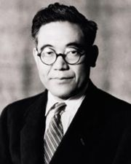
The Toyota Motor Corporation was founded in September
1933 when Toyoda Automatic Loom created a new division
devoted to the production of automobiles under the direction
of the founder's son, Kiichiro Toyoda. Soon thereafter, the
division produced its first Type A Engine in 1934, which
was used in the first Model A1 passenger car in May 1935
and the G1 truck in August 1935. Production of the Model
Founder:
Kiichiro Toyoda
AA passenger car started in 1936. Early vehicles bear a
striking resemblance to the Dodge Power Wagon and
Chevrolet, with some parts actually interchanging with their American originals.

Although the Toyota Group is best known today for its cars, it is still in the textile business and still makes automatic looms, which are now fully computerized, and electric sewing machines which are available worldwide.
Toyota Motor Co. was established as an independent company in 1937. Although the founding family name is Toyoda, the company name was changed in order to signify the separation of the founders' work life from home life, to simplify the pronunciation, and to give the company a happy beginning. Toyota is considered luckier than Toyoda in Japan, where eight is regarded as a lucky number, and eight is the number of strokes it takes to write Toyota in Katakana. In Chinese, the company and its vehicles are still referred to by the equivalent characters (Traditional Chinese: Simplified Chinese: with Chinese reading. Both transliterations are correct.
During the Pacific War (World War II) the company was dedicated to truck production for the Imperial Japanese Army. Because of severe shortages in Japan, military trucks were kept as simple as possible. For example, the trucks had only one headlight on the center of the hood. The war ended shortly before a scheduled Allied bombing run on the Toyota factories in Aichi.

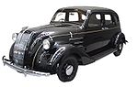

Replica of the Toyota Model AA, the first production model of Toyota in 1936

After the war, commercial passenger car production started in 1947 with the model SA. The quality and production principles on which Toyota is based originated in an education program from the United States Army in the post war era.^{[6]} In 1950 a separate sales company, Toyota Motor Sales Co., was established (which lasted until July 1982). In April 1956 the Toyopet dealer chain was established.

The following year, the Toyota Crown became the first Japanese car to be exported to the United States and Toyota's American and Brazilian divisions, Toyota Motor Sales Inc. and Toyota do Brazil S.A., were also established. Toyota began to expand in the 1960s with a new research and development facility, a presence in Thailand was established, the 10 millionth model was produced, a Deming Prize and partnerships with Hino Motors and Daihatsu were also established. By the end of the decade, Toyota had established a worldwide presence, as the company had exported its one-millionth unit.

History and Management:
The company was awarded its first Japanese Quality Control Award at the start 1970s and began participating in a wide variety of Motorsports. Due to the 1973 oil crisis consumers in the lucrative U.S. market began turning to small cars with better fuel economy. American car manufacturers had considered small economy cars to be an "entry level" product, and their small vehicles were not made to a high level of quality in order to keep the price low. Japanese customers, however, had a long-standing tradition of demanding small fuel-efficient cars that were manufactured to a high level of quality. Because of this companies like Toyota, Honda, and Nissan established a strong and growing presence in North America in the 1970s.

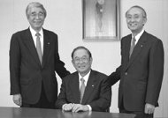

Fuji Cho(left), Katsuhiro Nakagawa (centre), Katsuaki Watanabe (right)

In 1982, the Toyota Motor Company and Toyota Motor Sales merged into one company, the Toyota Motor Corporation. Two years later, Toyota joined NUMMI, the New United Motor Manufacturing, Inc. Toyota then started to establish new brands at the end of the 1980s, with the launch of their luxury division Lexus in 1989.
In the 1990s Toyota began to branch out from producing mostly compact cars by adding many larger and more luxurious vehicles to its lineup, including a full sized pickup, the T100 (and later the Toyota Tundra), several lines of SUVs, a sport version of the Camry, known as the Camry Solar, and the Scion brand, a group of several affordable, yet sporty, automobiles targeted specifically to young adults. Toyota also began production of the world's best selling hybrid car, the Toyota Prius, in 1997.
With a major presence with Europe, due to the success of Toyota Team Europe, the corporation decided to set up TMME, Toyota Motor Europe Marketing & Engineering, to help market vehicles in the continent. Two years later, Toyota set up a base in the United Kingdom, TMUK, as the company's cars had become very popular among British drivers. Bases in Indiana, Virginia and Tianjin were also set up. In 1999, the company decided to list itself on the New York and London Stock Exchange.
In 2001, Toyota's Toyo Trust and Banking merged to form the UFJ, United Financials of Japan, which was accused of corruption by the government for making bad loans to the Yakuza crime syndicates. The UFJ became one of the most money-losing corporations in the world, with Toyota's chairman serving as a director. At the time, the UFJ was one of the largest shareholders of Toyota. As a result of Japan's banking crisis, the UFJ was merged again to become Mitsubishi UFJ Financial Group.
In 2002, Toyota managed to enter a Formula One works team and establish joint ventures with French motoring companies Citroën and Peugeot, a year after Toyota started producing cars in France.
On December 7, 2004, a U.S. press release was issued stating that Toyota would be offering Sirius Satellite Radios. However, as late as Jan. 27, 2007, Sirius Satellite Radio and XM Satellite radio kits were not available for Toyota factory radios. While the

press release enumerated nine models, only limited availability existed at the dealer level in the U.S. Major Lexus dealerships have been offering satellite radio kits for Lexus vehicles since 2005, in addition to factory-equipped satellite radio models.
In 2007, Toyota released an update of its full size truck, the Toyota Tundra, produced in two American factories, one in Texas and one in Indiana, and "Motor Trend" named the 2007 Toyota Camry "Car of the Year" for 2007. It also began the construction of a new factory to build the Toyota Highlander in Mississippi.
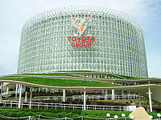

Toyota Pavilion at the Expo in Aichi.
The headquarters of Toyota are located in Toyota, Aichi, Japan. Its subsidiary, Toyota Financial Services sells financing and participates in other lines of business. Toyota brands include Scion and Lexus and the corporation is part of the Toyota Group. Toyota also owns majority stakes in Daihatsu and Hino, and 8.7% of Fuji Heavy Industries, which manufactures Subaru vehicles. They also acquired 5.9% of Isuzu Motors Ltd. on November 7, 2006 and will be introducing Isuzu diesel technology into their products.
In 2005, Toyota, combined with its half-owned subsidiary Daihatsu Motor Company, produced 8.54 million vehicles, about 500,000 fewer than the number produced by GM that year. In some months in 2006, Toyota passed Ford in selling cars. Toyota has a large market share in the United States, Europe and Africa and is the market leader in Australia. It has significant market shares in several fast-growing Southeast Asian countries.

In the Fortune Global 500, Toyota Motor is the 8th largest company in the world outpacing Ford Motor Company in all listings in terms of revenue and growth and in the 2006 Forbes Global 2000 it is the 12th largest company in the world. It has been consistently gaining market share in the United States.
The company was founded in 1933 by Kiichiro Toyoda as an offshoot of Toyoda Automatic Loom Company, under the encouragement of the Japanese government, which needed domestic vehicle production partly due to the worldwide money shortage and partly due to the war with China. Toyota has introduced new technologies including the first hybrid gas-electric vehicle, Advanced Parking Guidance System (automatic parking), a four-speed electronically controlled automatic with buttons for power and economy shifting, and an eight-speed automatic transmission. Toyota, and Toyota-produced Lexus and Scion automobiles, consistently rank at the top in quality and reliability surveys, including J.D. Power and Consumer Reports, among others.

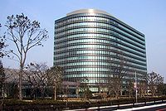

The headquarters of Toyota in Toyota City, Japan

Toyota has factories all over the world, manufacturing or assembling vehicles for local markets, including the Corolla. Toyota has manufacturing or assembly plants in the United States, Japan, Australia, Canada, Indonesia, Poland, South Africa, Turkey, the United Kingdom, France, Brazil, and more recently Pakistan, India, Argentina, Czech Republic, Mexico, Malaysia, Thailand, China, Vietnam, Venezuela, and the Philippines.
The first Toyota built outside of Japan was a Land Cruiser FJ-251, built in São Paulo, Brazil in May 1959.

Toyota invests a great amount of research into cleaner-burning vehicles such as the Toyota Prius, based on technology such as the Hybrid Synergy Drive. In 2002, Toyota successfully road-tested a new version of the RAV4 which ran on a Hydrogen fuel cell. Scientific American called the company its Business Leader of the Year in 2003 for commercializing an affordable hybrid car.

Toyota Motor North America:

Main articles: Toyota Motor Engineering & Manufacturing North America and Toyota Motor North America
Toyota has large presence in the United States with five major assembly plants in Huntsville, Alabama, Georgetown, Kentucky, Princeton, Indiana, San Antonio, Texas and Buffalo, West Virginia and its north American headquarters in New York and/or California. North America is a major automobile market for Toyota. In these assembly plants Toyota Camry and the 2007 Toyota Tundra among others are manufactured. It uses number of catchphrases and/or slogan in its American TV commercials such as It's time to move forward, Smart way to keep moving forward, or Moving forward. Toyota and its brand Lexus vehicles consistently rank well in terms of performance and quality in North American automobile magazines, awards and tests.

Products and brands:



The first Toyota brand was the eponymous Toyota, which remains the best selling of Toyota's brands. Sales of Toyota branded vehicles have given Toyota Motor Corporation a 45% domestic market share in Japan, higher than any other manufacturer. In North America, Toyota has achieved success with a full line up of cars, trucks, SUVs, and other vehicles. In particular, the Toyota Camry has been America's best-selling car

for the past five years, and is assembled in Kentucky; the Toyota Corolla has been the second best-selling car for 2006. These vehicles have helped drive sales of the Toyota brand in the United States.^{[11]} Total U.S. sales reached 2,220,090 units in 2006, making the brand third overall in U.S. sales for the first time in history.



Lexus is Toyota's brand name for its luxury vehicle division. In 1989, Lexus was launched in the U.S., the culmination of a clandestine seven-year initiative to build world-class luxury vehicles. The luxury division expanded to Europe and Oceania in 1990. Lexus was launched with two vehicles, the LS 400 flagship and the ES sedan, and has grown into a full line up of models ranging from the convertible SC to sport utility vehicles such as the bestselling RX Series. Today, Lexus is the best selling luxury marquee in North America, and the fourth largest luxury marquee in the world by volume. Lexus is now sold in over forty countries around the world, and launched in Japan in 2005, becoming the first luxury marquee of a Japanese manufacturer to enter the Japan Domestic Market. Lexus also produces hybrid vehicles under the name Lexus Hybrid Drive
Since its debut, Lexus has developed a reputation for reliability and quality customer service. Consumer ratings firm J.D. Power and Associates has named Lexus the most reliable automotive brand for twelve consecutive years. Consumer Reports in 2006 also named Lexus the most reliable brand in its survey of over one million vehicles, and Lexus customers frequently give their dealerships high ratings for customer service. Although Lexus' financial results are not publicly reported, analysts suggest that the Lexus division is the most profitable business unit of the Toyota Motor Corporation. In 2005, Lexus was organizationally separated from Toyota, gaining its own board of directors and dedicated design, engineering, and manufacturing centers.

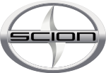

Scion is a United States, Guam, and Puerto Rico-only division of Toyota founded in 2003. In 2003, Toyota brought two of its popular cars from Japan (including the bB) to America, and created a new badge, called Scion, meaning a descendant or heir. The xA (known in Japan as the Toyota ist) and xB (known in Japan as the Toyota bB) are powered by a 1.5L DOHC I4 engine. A third model, the Scion tC, was introduced in 2004 and uses a 2.4 litre engine; it was designed for the North American market as a Toyota Celica replacement, using the four-cylinder engine and transmissions from the Toyota Camry, and the basic platform of the European Toyota Aventis.

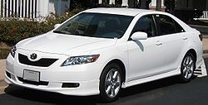

Hybrid Technology:



Main article: Hybrid Synergy Drive

The Prius has become the top selling hybrid car in America. Toyota now has three hybrid vehicles in its line up (Prius, Highlander, & Camry). The popular minivan Toyota Sienna is supposed to join the hybrid line up by 2010, and by 2030 Toyota plans to have its entire line up of cars, trucks, and SUVs to have a Hybrid Synergy Drive option. Lexus also has their own hybrid line up, consisting of the GS 450h, RX 400h, and soon in 2007, the LS 600h L.

Guiding Principles at Toyota:
1. Honour the language and spirit of the law of every nation and Under take open and fair corporate activities to be a good corporate citizen of the world.
2. Respect the culture and customs of every nation and contribute to Economic and social
development through corporate activities in the communities.
3. Dedicate ourselves to providing clean and safe products and to enhancing the quality of
life everywhere through all our activities.
4. Create and develop advanced technologies and provide outstanding products and
services that fulfil the needs of customers worldwide.
5. Foster a corporate culture that enhances individual creativity and teamwork value,
while honouring mutual trust and respect between labour and management.
6. Pursue growth in harmony with the global community through innovative management.
7. Work with business partners in research and creation to achieve stable, long-term
growth and mutual benefits, while keeping ourselves open to new partnerships.

The Toyota Production System:

Main article: Toyota Production System
Toyota has long been recognized as an industry leader in manufacturing and production. Three stories of its origin have been found, one that they studied Piggly-Wiggly's just-in-time distribution system, one that they followed the writings of W. Edwards Deming, and one that they were given the principles from an Army training program (see above reference). Regardless of the origin, the principles, described in Jeffrey Liker’s the Toyota way, are as follows.

1. Base your management decisions on a long-term philosophy, even at the expense of
Short-term goals.

2. Create continuous process flow to bring problems to surface.
3. Use “pulls” systems to avoid overproduction.
4. Level out the workload.
5. Build a culture of stopping to fix problems, to get quality right the first Time.

6. Standardized tasks are the foundation for continuous improvement and employee empowerment.
7. Use visual control so no problems are hidden.
8. Use only reliable, thoroughly tested technology that serves your people and processes.

9. Grow leaders who thoroughly understand the work, live the philosophy, and teach it to others.

10. Develop exceptional people and teams who follow your company’s Philosophy.
11. Respect your extended network of partners and suppliers by challenging them and helping them improve.
12. Go and see for you to thoroughly understand the situation (genchigenbutsu).
13. Make decisions slowly by consensus, thoroughly considering all options; implement decisions rapidly.
14. Become a learning organization through relentless reflection and continuous improvement.

Non-automotive activities:

Higher education:

Toyota established the Toyota Technological Institute in 1981, as Sakichi Toyoda had planned to establish a university as soon as he and Toyota became successful. Toyota Technological Institute founded the Toyota Technological Institute at Chicago in 2003.

Robotics:

Toyota has been developing multitask robots destined for elderly care,
manufacturing, and entertainment.

Finance:

Toyota Financial Services Corporation provides financing to Toyota customers.

Agricultural biotechnology:

Toyota invests in several small start-up businesses and partnerships in biotechnology, including:

P.T. Toyota Bio Indonesia in Lampung, Indonesia
Australian Afforestation Pty. Ltd. in Western Australia and Southern Australia

Toyota Floristic Co., Ltd. in Rokkasho-Mura, Kamikita District, Aomori Prefecture
Sichuan Toyota Nitan Development Co., Ltd. in Sichuan, China
Toyota Roof Garden Corporation in Miyoshi-Cho, Aichi Prefecture

TOYOTA IN INDIA

Toyota Kirloskar Motor Pvt. LTD:

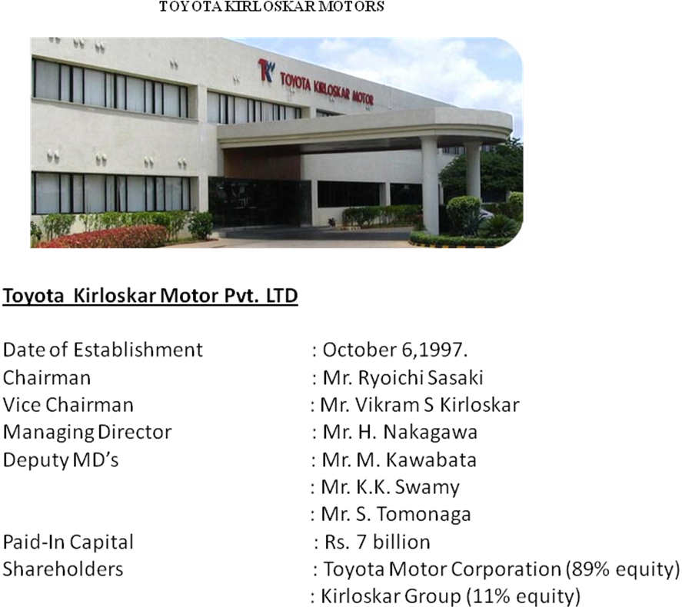

TKM’s growth since its inception can be attributed to one simple, yet important aspect of its business philosophy – “Putting Customer First” While managing growth, TKM has maintained its commitment to provide quality products at a reasonable price and has made every effort to meet changes customer needs. TKM firmly believes that the

success of this venture depends on providing high quality products and services to all valued customers through the efforts of its team members.

TKM along with its dedicated dealers and suppliers has adopted the “Growing Together” philosophy of its parent company TMC to create long-term business growth. In this way, TKM aims to further contribute to progress in the Indian automotive industry, realize greater employment opportunities for local citizens, improve the quality of life of the e\team members and promote robust economic activity in India.

Non-Automotive Activities:

Local Community Development:

At TKM every effort is made to contribute to society. A residential school at Bidai, reconstructed by Toyota, now houses 75 students, mainly belonging to backward communities. In the aftermath of the tragic earthquake in Gujarat, TKM and its dealers played a major role in distributing food, clothing and relief in remote affected area. TKM also takes a lead role in contributing to the community, distributing books and bags in local school, etc.

Environmental Care:

Automobile Manufacturing Industry causes a certainly environmental impact by its all operational fields. With the aiming to create a new image of TOYOTA as the globally leading company in terms of environmental protection, TOYOTA as the globally leading company in terms of environmental protection, Toyota Motor Corporation (TMC) has committed itself to a course of action to achieve the goal. After “Toyota Earth Charter” announcement, TMC reaffirms the importance of environment protection b y establishing “Toyota Environmental Committee” – directly chaired by Mr. Fuji Cho – TMC President.

The committee’s function is reaffirms the importance of carrying out top-level environmental action in all countries and regions at the development and design, production, sale and disposal stages of a vehicle’s life cycle.

In addition, as part of our dedication to environmental preservation, TMV leads and supports its dealers and TASS to protect environment in common activities as well as developed strong partnerships with organizations like hazardous waste recovery companies; the Ministry of Resources and Environment and industrial group.

Higher Education:
Toyota established the Toyota Technological Institute in 1981, as Sakichi Toyoda had planned to establish a university as soon as he and Toyota became successful. Toyota Technological Institute founded the Toyota Technological Institute at Chicago in 2003.

DOBRO TOYOTA

[Toyota Kirloskar Motors Dealer in Hyderabad City]

Dobro Toyota was established in the year 2000. Dobro Toyota is authorized by Toyota Kirloskar Motors Pvt. Ltd. Its head office is at Basheerbagh, Doshi Chambers & its work-station is at Uppal where more than 150 cars can be parked & repaired at the same time. They are 76 attendants in this service station. They put all their efforts to service and repair the cars up to the customer’s expectations. One of the significant factors about the success of the Dobro Toyota is of course its service centre. Six years of time have witnessed tremendous growth of the centre, manned dedicated and highly professional team, which knows every need of its customers. An excellent customer relation maintained by Dobro Toyota is another factor that attracts more and more people to the showroom and service centre.

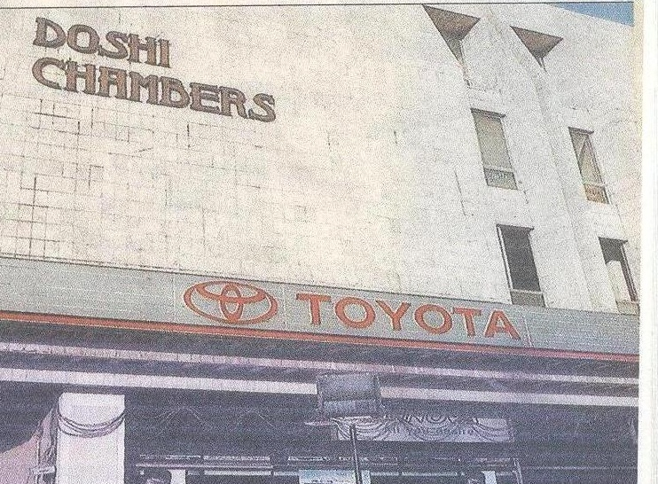

Management Of Dobro Toyota
Dobro Toyota, the first dealer of Toyota Kirloskar Motor Private Ltd in Andhra Pradesh provides a “single sort of commutation solutions” to the customer. It includes finance, insurance, registration and servicing.
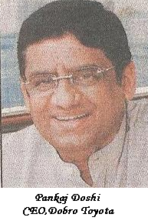
Dobro Toyota the brainchild of Pankaj Doshi is located at the heart of the city built in three acres with a capacity to service 100 vehicles per day.
.“Leadership to excellence is not only our slogan, but also our Working philosophy. In the pursuit of excellence, our greatest asset philosophy. In the pursuit of excellence, our greatest asset

Is our Manpower. I am the happiest person on earth Pankaj Doshi every one of my Customers is happy with our CEO, Dobro Toyota dobra services” says Mr. Pankaj Doshi. In order to provide uninterrupted service, Dobro Toyota and services Centre is open on Sundays and Public Holidays.
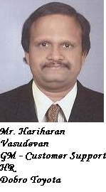
On the 14th February, 2007 the Dobro Toyota is going to celebrate its 7th successful anniversary in a very short span of time in the industry like automobiles is no mean task. Working towards the customer’s benefit has resulted in Dobro Toyota becoming one of the top three Toyota Dealers in India. Well qualified staff members who are experts in technical, commercial and financial aspects of vehicle provide clear solutions for all customer needs.
Mr. Hariharan Vasudevan, a Post Graduate in Business Management with an experience more than 22 years currently the General Manager, Training & Customer Relations is willing to give opportunities to the deserving youth to become the part of Dobro Global Era.

Hariharan Vasudevan
General Manager
Training & Customer Relations

Our Vision
The vision of Toyota Kirloskar Motor is to
- Delight our customers through innovative products, by utilising advanced technologies and services.
- Ensure growth to become a major player in the Indian auto industry and contribute to the Indian economy by involving all stakeholders.
- Become the most admired and respected company in India by following the Toyota Way.
- Be a core company in global Toyota operations.

Our Mission:
- Practice ethics and transparency in all our business operations.
- Touch the heart of our customers by providing products and services of superior quality at a competitive price.
- Cultivate a lean and flexible business model throughout the value chain by continuous improvement.
- Lead the Toyota global operations for the emerging mass market.
- Create a challenging workplace which promotes sense of pride, ownership, mutual trust and teamwork.
- Create an eco-friendly company in harmony with nature and society.

SERVICE STATION OF DOBRO TOYOTA

Dobro Toyota is authorized by Toyota Kirloskar Motors Pvt. Ltd. Its Head Office is at Basheerbagh, Doshi Chambers and its work-station is at Uppal where more than 150 cars can be parked and repaired at the same time. They are 76 attendants in this service station. They put all their efforts to service and repair the cars up to the customer’s expectations.

Daily more than 50% of the customers come for the delivery process for which service station have maintained some standards to make customer satisfied with the delivery Process and various Customer Service Program which are ultimately offered for the customer’s benefit
TOYOTA PRODUCTS IN INDIA

INNOVA:
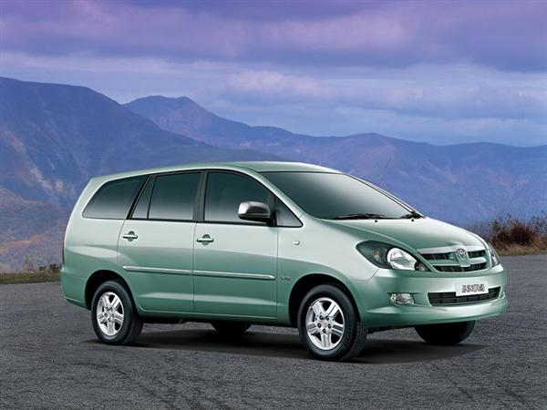

- The Innova has not just changed perceptions but rocked the very foundations to give the competition a rude jolt.

- And our Innova with her excellent interior space, ride comfort and equally commendable highway munching abilities, has as usual been the choice of wheels for all our outings.

- Engine response is instantaneous and smooth on both diesel and petrol with none of the jerkiness associated with high powered cars.

- The Innova is a large car, and that it swallowed six people and their totes and bags besides the laptop and VBOX, stands testimony to the same.

- The interiors are where the Innova sparkles. Light and airy, creamy upholstery covering every inch is soothing.

- The Innova goes down in our books as the most comfortable, spacious, practical, refined and well finished and now an extremely safe vehicle.

- From 0-60 kmph in 5.36 seconds, 0-100 kmph in 13.0 seconds and with a top speed of 180 kmph read like a car’s figures.

One can safely say that it exhibits all those qualities that have made the Toyota name what it is today – revered for extremely good build quality and reliability.

I firmly believe there isn’t a better vehicle to haul four or more individuals and their luggage in such comfort, especially given the condition of our roads post monsoons.
The Innova, with so much torque, which is beautifully spread across the rev range, made climbing through the hilly section child’s play. All we ever needed was fourth gear throughout.
Moreover, the Innova has left a great impression on my wife; and she wants one as our first car.
The Innova goes down in our books as the most comfortable, spacious, practical, refined and well finished and now an extremely safe vehicle.

SPECIFICATIONS:

Engine & transmission

Engine Type/Model : 2.5 liter,4-cylinder , 16 valve , DOHC, Turbo
Displacement : 2494 cc
Valve Mechanism : DOHC
Fuel system : Common rail
Valves Per Cylinder : 4-valve
Number of cylinders : 4-Cylinders
Gears/ speed : 5 Gears
Transmission type : manual
Drive : FWD
Power : 102 PS @ 5600 rpm
Torque (Nm @ rpm) : 200 @ 3400

Fuel Economy

City (kpl) : 14.4
Highway (kpl) : 10.6
Overall (kpl) : 11.4

Performance

Maximum speed (kmph) : 151
0 – 100 kph (sec) : 17.6
¼ mile (sec) : 20.5
100 kmph -0 (breaking) : 43.2 meters
80 kmph -0 (breaking) : 29.7meters

Brakes, Steering, Suspension & Tyres

Brakes – front : Ventilated discs
Brakes – rear : leading-trailing drum
Steering type : Rack and pinion
Min. turning radius (m) : 5.4
Power assisted : N/A
Suspension – front : Independent, coil spring, Double Wishbone, with stabilizer
Suspension – rear : 4-Link, coil springs
Tyres : 205/65 R15 Tubeless
Wheel Size : 15 inch

Dimensions, Weight & Capacity

Seating capacity : 8
Fuel capacity (litters) : 55
Ground clearance (mm) : 176
Gross Vehicle Weight (kg) : 2240
No. Of Doors : 5
Kerb weight (kg) : 1545
Length (mm) : 4555
Width (mm) : 1770
Height (mm) : 1755
Wheelbase (mm) : 2750

COROLLA:

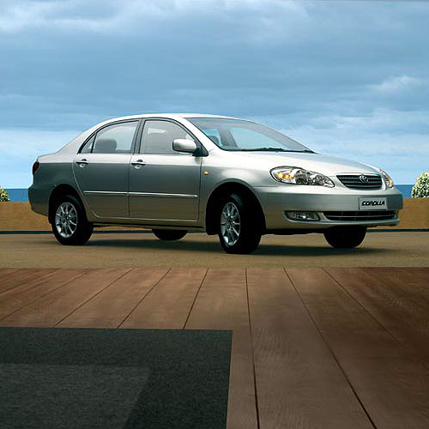

Toyota Corolla offers an unparalleled motoring experience. Engineered to precision and styled with flamboyance, Toyota Corolla has stretched the limits of excellence.
Powered by 1.8-litre DOHC VVT-i engine, Toyota Corolla delivers a staggering power of 125 PS. The VVT-i technology allows for extra smooth acceleration, and ensures enhanced fuel efficiency and reduced emissions.
Toyota Corolla has a host of advanced safety features. The GOA (Global Outstanding Assessment) body makes for a high integrity cabin with front and rear crumple zones to absorb impact energy in a collision. Disc brakes on all four wheels, ventilated in the front and solid in the rear, provide assured braking. In addition other enhanced safety features include Anti-lock Braking System, collapsible steering column and side door impact beams.
One look and you will understand why the Toyota Corolla is the best-selling car in Japan. Drive it and you’ll know why it has been for 32 years in a row. With over 30 million cars sold worldwide. The Corolla comes with high expectations. Adapted for

Indian conditions. It brings you the style and performance of a world-class sedan, backed by Toyota’s legendary reliability.

Exterior:

Cool and Sleek Style
The advanced sleek Corolla design CD .0.30, the aerodynamic performance equals that of a sports car.
Corolla’s dimensions create a new sedan category in India.

Interior:
That indulges Two-tone colour scheme, leather upholstery, chrome highlights… the interiors of the Corolla hold nothing back. One of the roomier cars in its class, space is never at a premium in the Corolla is surprisingly quiet, with almost no road or wind noise intruding into the cabin. The leather upholstery, wood-grain central console and chrome highlights radiate luxury.

Safety:
The Toyota Corolla comes packed with safety features. Disc brakes on all four wheels ensure that the power of the Corolla also comes with adequate stopping power. Seat belts on all seats and SRS airbags for the driver and passenger make the Corolla one of the safest cars in its class.

History:
The first generation Corolla blossomed way back in 1966 in Japan as a Toyota dream to produce a people’s car. This rear wheel drive Toyota Corolla was an instant hit – an outstanding compact car that coupled striking appeal with the highest standards of performance.

Power Features:

Power Steering Standard
Power Window Standard
One touch Up/Down Standard Drive side (with Jam protection).

SPECIFICATIONS:
Engine & transmission 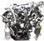
Engine : Petrol, Inline-4 Cyl, 1794 cc.
Born (mm) x stroke (mm) : 79 x 91.5
Compression ratio : 10.0:1
Valves per cylinder : 4
Valvegear operation : DOHC
Fuel system : MPFi
Aspiration : Naturally-aspirated
Gears : 5-speed manual
Drive : FWD
Power (bhp @ rpm) : 125 @6000
Power to weight (bhp/ton) : 108
Torque (Nm @ rpm) : 157.88@ 4200
Torque to weight (Nm/ton) : 136
Fuel Economy 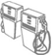

Fuel : Petrol
City (kpl) : 8.2
Highway (kpl) : 13.6
Overall (kpl) : 9

Performance 

0 – 60 kph (sec) : 4.78
0 – 100 kph (sec) : 9.97
20 – 80 kph in 3rd gear (sec) : 12
40 – 100 kph in 4th gear (sec) : 16.55
Brakes, Steering, Suspension & Tyres 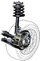

Brakes – front : Ventilated discs
Brakes – rear : Solid discs
Steering type : Rack and pinion, power assist
Min. turning radius (m) : 5.1
Suspension – front : Macpherson strut type with stabilizer.
Suspension – rear : Beam type suspension with toe control torsion beam
and coil spring
Tyres : 195/60 R15

Interior Dimensions 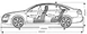

Seating capacity : 5
Rear seat legroom-min (cm) : 63
Rear seat legroom-max (cm) : 87
Headroom (cm) : 91
Width (cm) : 136
Boot (litres) : 620
Fuel capacity (litres) : 87

Exterior Dimensions
Kerb weight (kg) : 1160
Length (mm) : 4530
Width (mm) : 1705
Height (mm) : 1490
Track – front (mm) : 1480
Track – rear (mm) : 1460
Wheelbase (mm) : 2600
Corolla Propels Toyota Sales:

Toyota Kirloskar Motor (TKM) has posted a record breaking performance in March 2007, crossing sales of 6,600 units in a month for the first time.
The Corolla has come back with a strong performance in March attracting customers across segments. TKM has also put to rest all rumours of a new Corolla being launched.
“The surge in Corolla sales is an indication that customers are seeing value in ride comfort and long term reliability of the Corolla,” said A Toyoshima, managing director, TKM.
TKM sold 1,083 units of the Corolla, 5,411 units of Innova, and 197 units of the imported vehicles Camry and Prado Land cruiser. TKM said there are no plans to launch a new Corolla in India this year.
The Corolla is expected to sell 8,000 units this year in India. The Toyota Corolla has attracted customers from the personal and corporate segments across India. “The customers have noticed that the
Corolla offers the most luxurious passenger seats and the best performance through the VVTi engine.
The Corolla owner also enjoys peace of mind through the 3 year or one lakh kilometre warranty, which is not available in its competitors,” added Toyoshima.
The Corolla, which debuted in 1966 in Japan, is a best-seller in over 140 countries and regions, and has created automobile history with worldwide sales crossing 32 million.
TKM has sold a record 51,346 vehicles in 2006-07. It also registered a growth of 26 percent in the January-March 2007 quarter, compared to the same period last year.

CAMRY:

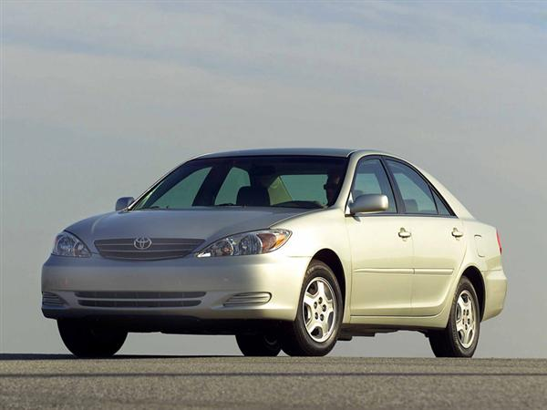

The all new Camry - Beyond Excellence.

Fresh and inspiring, the Camry shapes a new global quality standard in the premium luxury segment. Its dynamic physical presence and exhilarating performance
stimulates your desire to drive. Your pleasure is heightened by the subtle appeal of
contemporary comfort and relaxing atmosphere that speaks directly to your soul.
Sleek and strong, the eye-catching design and dramatic stance exudes a vital
Life force. Vibrant and poised, the bold flowing lines hint at superb aerodynamics,
immediately raising spirits.

SPECIFICATIONS:
Engine & transmission

Engine : Petrol, V-6 cyl, 3956 cc
Born (mm) x stroke (mm) : 94 x 95
Compression ratio : 10.0:1
Valves per cylinder : 4
Valvegear operation : DOHC
Fuel system : MPFi
Aspiration : Naturally-aspirated
Gears : 5-speed automatic
Drive : 4WD
Power (bhp @ rpm) : 235 @ 5200
Power to weight (bhp/ton) : 124
Torque (Nm @ rpm) : 361.85 @ 3800
Torque to weight (Nm/ton) : 190
Fuel Economy

Fuel : Petrol
City (kpl) : 5
Highway (kpl) : 6.9
Overall (kpl) : 5

Performance

0 – 60 kph (sec) : 4.19
0 – 100 kph (sec) : 9.45
Top speed (kph) : 186
20 – 80 kph in 3rd gear (sec) : 5.68
40 – 100 kph in 4th gear (sec) : 7.34
Brakes, Steering, Suspension & Tyres

Brakes – front : Ventilated discs
Brakes – rear : Ventilated discs
Steering type : Rack and pinion, power assist
Min. turning radius (m) : 5.7
Suspension – front : Double wishbone with coil springs, air filled dampers
Suspension – rear : Four – link with air springs, stabilizer bar with air
Filled dampers
Tyres : 265/65 R17

Interior Dimensions

Seating capacity : 7
Boot : 620
Fuel capacity (litres) : 87

Exterior Dimensions

Kerb weight (kg) : 1900
Length (mm) : 4715
Height (mm) : 1905
Track – front (mm) : 1575
Track – rear (mm) : 1575
Wheelbase (mm) : 2790

CHAPTER - III

LITERATURE REVIEW

History
The word "brand" is derived from the Old Norse brandr, meaning "to burn." It refers to the practice of producers burning their mark (or brand) onto their products.
Although connected with the history of trademarks and including earlier examples which could be deemed "protobrands" (such as the marketing puns of the "Vesuvinum" wine jars found at Pompeii), brands in the field of mass-marketing originated in the 19th century with the advent of packaged goods. Industrialization moved the production of many household items, such as soap, from local communities to centralized factories. When shipping their items, the factories would literally brand their logo or insignia on the barrels used, extending the meaning of "brand" to that of trademark.
Bass & Company, the British brewery, claims their red triangle brand was the world's first trademark. Lyle’s Golden Syrup makes a similar claim, having been named as Britain's oldest brand, with its green and gold packaging having remained almost unchanged since 1885.
Cattle were branded long before this; the term "maverick", originally meaning an unbranded calf, comes from Texas rancher Samuel Augustus Maverick who, following the American Civil War, decided that since all other cattle were branded, his would be identified by having no markings at all. Even the signatures on paintings of famous artists like Leonardo Da Vinci can be viewed as an early branding tool.
Factories established during the Industrial Revolution introduced mass-produced goods and needed to sell their products to a wider market, to customers previously familiar only with locally-produced goods. It quickly became apparent that a generic package of soap had difficulty competing with familiar, local products. The packaged goods manufacturers needed to convince the market that the public could place just as much trust in the non-local product. Campbell soup, Coca-Cola, Juicy Fruit gum, Aunt Jemima, and Quaker Oats were among the first products to be 'branded', in an effort to increase the consumer's familiarity with their products. Many brands of that era, such as Uncle Ben's rice and Kellogg's breakfast cereal furnish illustrations of the problem.
Around 1900, James Walter Thompson published a house ad explaining trademark advertising. This was an early commercial explanation of what we now know as branding. Companies soon adopted slogans, mascots, and jingles that began to appear on radio and early television. By the 1940s, manufacturers began to recognize the way in which consumers were developing relationships with their brands in a social/psychological/anthropological sense.
From there, manufacturers quickly learned to build their brand's identity and personality (see brand identity and brand personality), such as youthfulness, fun or luxury. This began the practice we now know as "branding" today, where the consumers buy "the brand" instead of the product. This trend continued to the 1980s, and is now quantified in concepts such as brand value and brand equity. Naomi Klein has described this development as "brand equity mania". In 1988, for example, Philip Morris purchased Kraft for six times what the company was worth on paper; it was felt that what they really purchased was its brand name.
Marlboro Friday: April 2, 1993 - marked by some as the death of the brand - the day Philip Morris declared that they were to cut the price of Marlboro cigarettes by 20%, in order to compete with bargain cigarettes. Marlboro cigarettes were notorious at the time for their heavy advertising campaigns, and well-nuanced brand image. In response to the announcement Wall street stocks nose-dived for a large number of 'branded' companies: Heinz, Coca Cola, Quaker Oats, PepsiCo. Many thought the event signalled the beginning of a trend towards "brand blindness" (Klein 13), questioning the power of "brand value".
How do customers remember?
The tendency of a brand to be thought of in a buying situation is known as “brand salience”. Brand salience is “the propensity for a brand to be noticed and/or thought of in buying situations” and the higher the brand salience the higher it’s market penetration and therefore its market share. Salience refers not to what customers think about brands but to which ones they think about.
Brands which come to mind on an unaided basis are likely to be the brands in a customer’s consideration set and thus have a higher probability of being purchased. Advertising weight and brand salience are cues to customers indicating which brands are popular, and customers have a tendency to buy popular brands. Also, an increase in the salience of one brand can actually inhibit recall of other brands, including brands that otherwise would be candidates for purchase.
It is widely acknowledged that buyer’s do not see their brand as being any different from other brands that are available. They buy a particular brand because they are more aware of it, not because it is more distinctive, or has a point of difference. We now know that all decisions made by humans involve memory processes to a greater or lesser extent. Incoming information from the external environment travels by the sensory memory into the short-term (or working) memory (STM) but if it is not acted upon in a very short time the brain simply discards it.
But salient information that is important and received on a regular basis through different channels is passed to the long-term memory (LTM) where it can be stored for many years. Memories are stored or filed via connections between new and existing memories in the different parts of the memory. They are laid down in a framework making some memories easier to access than others. Recall is the process by which an individual reconstructs the stimulus itself from memory, removed from the physicality’s of that reality.

Global Brand
A global brand is one which is perceived to reflect the same set of values around the world.Global brands transcend their origins and creates strong, enduring relationships with consumers across countries and cultures.
Global Brands are brands which sold to international markets. Examples of Global Brands include Coca-Cola, McDonald's, Marlboro, Levi's etc.. These brands are used to sell the same product across multiple markets, and could be considered successful to the extent that the associated products are easily recognizable by the diverse set of consumers.

Benefits of Global Branding
In addition to taking advantage of the outstanding growth opportunities, the following drives the increasing interest in taking brands global:
•economies of scale (production and distribution)
•lower marketing costs
•laying the groundwork for future extensions worldwide
•maintaining consistent brand imagery
•quicker identification and integration of innovations (discovered worldwide)
•preempting international competitors from entering domestic markets or locking you out of other geographic markets
•increasing international media reach (especially with the explosion of the Internet) is an enabler
•increases in international business and tourism are also enablers

Global Brand Variables
The following elements may differ from country to country: •corporate slogan
•products and services
•product names
•product features
•positionings
•marketing mixes (including pricing, distribution, media and advertising execution)
These differences will depend upon:
•language differences
•different styles of communication
•other cultural differences
•differences in category and brand development
•different consumption patterns
•different competitive sets and marketplace conditions
•different legal and regulatory environments
•different national approaches to marketing (media, pricing, distribution, etc.)

Local Brand
A brand that is sold and marketed (distributed and promoted) in a relatively small and restricted geographical area. A local brand is a brand that can be found in only one country or region. It may be called a regional brand if the area encompasses more than one metropolitan market. It may also be a brand that is developed for a specific national market, however an interesting thing about local brand is that the local branding is mostly done by consumers then by the producers. Examples of Local Brands in Sweden are Stomatol, Mijerierna etc..

Brand name
The brand name is quite often used interchangeably within "brand", although it is more correctly used to specifically denote written or spoken linguistic elements of any product. In this context a "brand name" constitutes a type of trademark, if the brand name exclusively identifies the brand owner as the commercial source of products or services. A brand owner may seek to protect proprietary rights in relation to a brand name through trademark registration. Advertising spokespersons have also become part of some brands, for example: Mr. Whipple of Charmin toilet tissue and Tony the Tiger of Kellogg's. Local Baranding is usually done by the consumers rather then the producers.

Types of brand names
Brand names come in many stylesA few include:
Acronym: A name made of initials such as UPS or IBM
Descriptive: Names that describe a product benefit or function like Whole Foods or Airbus
Alliteration and rhyme: Names that are fun to say and stick in the mind like Reese's Pieces or Dunkin' Donuts
Evocative: Names that evoke a relevant vivid image like Amazon or Crest
Neologisms: Completely made-up words like Wii or Kodak
Foreign word: Adoption of a word from another language like Volvo or Samsung
Founders' names: Using the names of real people like Hewlett-Packard or Disney
Geography: Many brands are named for regions and landmarks like Cisco and Fuji Film
Personification: Many brands take their names from myth like Nike or from the minds of ad execs like Betty Crocker
The act of associating a product or service with a brand has become part of pop culture. Most products have some kind of brand identity, from common table salt to designer jeans. A brandnomer is a brand name that has colloquially become a generic term for a product or service, such as Band-Aid or Kleenex, which are often used to describe any kind of adhesive bandage or any kind of facial tissue respectively.

Brand identity
A product identity, or brand image are typically the attributes one associates with a brand, how the brand owner wants the consumer to perceive the brand - and by extension the branded company, organization, product or service. The brand owner will seek to bridge the gap between the brand image and the brand identity. Effective brand names build a connection between the brand personality as it is perceived by the target audience and the actual product/service. The brand name should be conceptually on target with the product/service (what the company stands for). Furthermore, the brand name should be on target with the brand demographic Typically, sustainable brand names are easy to remember, transcend trends and have positive connotations. Brand identity is fundamental to consumer recognition and symbolizes the brand's differentiation from competitors.
Brand identity is what the owner wants to communicate to its potential consumers. However, over time, a products brand identity may acquire (evolve), gaining new attributes from consumer perspective but not necessarily from the marketing communications an owner percolates to targeted consumers. Therefore, brand associations become handy to check the consumer's perception of the brand.
Brand identity needs to focus on authentic qualities - real characteristics of the value and brand promise being provided and sustained by organisational and/or production characteristics

Visual Brand Identity

The visual brand identity manual for Mobil Oil (developed by Chermayeff & Geismar), one of the first visual identities to integrate logotype, icon, alphabet, color palette, and station architecture to create a comprehensive consumer brand experience.
The recognition and perception of a brand is highly influenced by its visual presentation. A brand’s visual identity is the overall look of its communications. Effective visual brand identity is achieved by the consistent use of particular visual elements to create distinction, such as specific fonts, colors, and graphic elements. At the core of every brand identity is a brand mark, or logo. In the United States, brand identity and logo design naturally grew out of the Modernist movement in the 1950’s and greatly drew on the principals of that movement – simplicity (Mies van der Rohe’s principle of "Less is more") and geometric abstraction. These principles can be observed in the work of the pioneers of the practice of visual brand identity design, such as Paul Rand, Chermayeff & Geismar and Saul Bass.

Company name
Often, especially in the industrial sector, it is just the company's name which is promoted (leading to one of the most powerful statements of "branding"; the saying, before the company's downgrading, "No one ever got fired for buying IBM").
In this case a very strong brand name (or company name) is made the vehicle for a range of products (for example, Mercedes-Benz or Black & Decker) or even a range of subsidiary brands (such as Cadbury Dairy Milk, Cadbury Flake or Cadbury Fingers in the United States).

Individual branding
Each brand has a separate name (such as Seven-Up, Kool-Aid or Nivea Sun (Beiersdorf)), which may even compete against other brands from the same company (for example, Persil, Omo, Surf and Lynx are all owned by Unilever).

Attitude branding and Iconic brands
Attitude branding is the choice to represent a larger feeling, which is not necessarily connected with the product or consumption of the product at all. Marketing labeled as attitude branding include that of Nike, Starbucks, The Body Shop, Safeway, and Apple Inc.. In the 2000 book No Logo,^{[12]} Naomi Klein describes attitude branding as a "fetish strategy".
"A great brand raises the bar -- it adds a greater sense of purpose to the experience, whether it's the challenge to do your best in sports and fitness, or the affirmation that the cup of coffee you're drinking really matters." - Howard Schultz (president, CEO, and chairman of Starbucks)
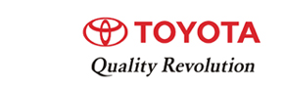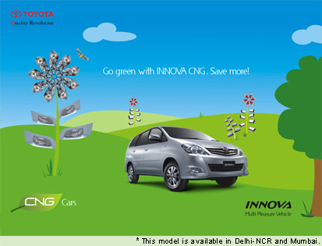

Iconic brands are defined as having aspects that contribute to consumer's self-expression and personal identity. Brands whose value to consumers comes primarily from having identity value comes are said to be "identity brands". Some of these brands have such a strong identity that they become more or less "cultural icons" which makes them iconic brands. Examples of iconic brands are: Apple Inc., Nike and Harley Davidson. Many iconic brands include almost ritual-like behaviour when buying and consuming the products.
There are four key elements to creating iconic brands (Holt 2004):
- "Necessary conditions" - The performance of the product must at least be ok preferably with a reputation of having good quality.
- "Myth-making" - A meaningful story-telling fabricated by cultural "insiders". These must be seen as legitimate and respected by consumers for stories to be accepted.
- "Cultural contradictions" - Some kind of mismatch between prevailing ideology and emergent undercurrents in society. In other words a difference with the way consumers are and how they some times wish they were.
- "The cultural brand management process" - Actively engaging in the myth-making process making sure the brand maintains its position as an icon.

"No-brand" branding
Recently a number of companies have successfully pursued "No-Brand" strategies by creating packaging that imitates generic brand simplicity. Examples include the Japanese company Muji, which means "No label" in English (from 無印良品 – "Mujirushi Ryohin" – literally, "No brand quality goods"), and the Florida company No-Ad Sunscreen. Although there is a distinct Muji brand, Muji products are not branded. This no-brand strategy means that little is spent on advertisement or classical marketing and Muji's success is attributed to the word-of-mouth, a simple shopping experience and the anti-brand movement. "No brand" branding may be construed as a type of branding as the product is made conspicuous through the absence of a brand name.

Derived brands
In this case the supplier of a key component, used by a number of suppliers of the end-product, may wish to guarantee its own position by promoting that component as a brand in its own right. The most frequently quoted example is Intel, which secures its position in the PC market with the slogan "Intel Inside".

Brand extension
The existing strong brand name can be used as a vehicle for new or modified products; for example, many fashion and designer companies extended brands into fragrances, shoes and accessories, home textile, home decor, luggage, (sun-) glasses, furniture, hotels, etc.
Mars extended its brand to ice cream, Caterpillar to shoes and watches, Michelin to a restaurant guide, Adidas and Puma to personal hygiene. Dunlop extended its brand from tires to other rubber products such as shoes, golf balls, tennis racquets and adhesives.
There is a difference between brand extension and line extension. A line extension is when a current brand name is used to enter a new market segment in the existing product class, with new varieties or flavors or sizes. When Coca-Cola launched "Diet Coke" and "Cherry Coke" they stayed within the originating product category: non-alcoholic carbonated beverages. Procter & Gamble (P&G) did likewise extending its strong lines (such as Fairy Soap) into neighboring products (Fairy Liquid and Fairy Automatic) within the same category, dish washing detergents.

Multi-brands
Alternatively, in a market that is fragmented amongst a number of brands a supplier can choose deliberately to launch totally new brands in apparent competition with its own existing strong brand (and often with identical product characteristics); simply to soak up some of the share of the market which will in any case go to minor brands. The rationale is that having 3 out of 12 brands in such a market will give a greater overall share than having 1 out of 10 (even if much of the share of these new brands is taken from the existing one). In its most extreme manifestation, a supplier pioneering a new market which it believes will be particularly attractive may choose immediately to launch a second brand in competition with its first, in order to pre-empt others entering the market.
Individual brand names naturally allow greater flexibility by permitting a variety of different products, of differing quality, to be sold without confusing the consumer's perception of what business the company is in or diluting higher quality products.
Once again, Procter & Gamble is a leading exponent of this philosophy, running as many as ten detergent brands in the US market. This also increases the total number of "facings" it receives on supermarket shelves. Sara Lee, on the other hand, uses it to keep the very different parts of the business separate — from Sara Lee cakes through Kiwi polishes to L'Eggs pantyhose. In the hotel business, Marriott uses the name Fairfield Inns for its budget chain (and Ramada uses Rodeway for its own cheaper hotels).
Cannibalization is a particular problem of a "multibrand" approach, in which the new brand takes business away from an established one which the organization also owns. This may be acceptable (indeed to be expected) if there is a net gain overall. Alternatively, it may be the price the organization is willing to pay for shifting its position in the market; the new product being one stage in this process.

Private labels
With the emergence of strong retailers, private label brands, also called own brands, or store brands, also emerged as a major factor in the marketplace. Where the retailer has a particularly strong identity (such as Marks & Spencer in the UK clothing sector) this "own brand" may be able to compete against even the strongest brand leaders, and may outperform those products that are not otherwise strongly branded.

Individual and Organizational Brands
There are kinds of branding that treat individuals and organizations as the "products" to be branded. Personal branding treats persons and their careers as brands. The term is thought to have been first used in a 1997 article by Tom Peters. Faith branding treats religious figures and organizations as brands. Religious media expert Phil Cooke has written that faith branding handles the question of how to express faith in a media-dominated culture. Nation branding works with the perception and reputation of countries as brands.

CHAPTER - IV

- Do you own a car?

Options | Percentage of Respondents
YES | 100%
No | 0%

Interpretation:
From above pie chart it can be stated that 100% people having their own cars.

2. Which brand of car do you own?

 |  |  |  | Brand namePercentage of Respondents
 | Toyota | 50%
Honda
10% | Hyundai | 12%
 | Maruthi Suzuki | 13%
 | Others | 15%

Interpretation:

From above it can be stated that 50% of people having Toyota cars,10% of people having Honda cars , 12% of people having Hyundai cars , 13% of people having Maruthi Suzuki cars , 15% of people having other cars .

3. What are the valuable attributes you normally look while purchasing a Four Wheeler?

Attributes | Percentage of preference of attribute
Design | 10
Quality | 15
Price | 8
Brand Name | 40
Comfort | 12
Service | 10
Performance | 5

Interpretation:
From above pie chart it can be stated that people give preference 40% to brand name,15% to quality,8% to price,10% to design, 12% to comfort,10% to service,5% to performance.

4. Which model of Toyota do you have?

Model | No of people | percentage
Quails | 10 | 20
Innova | 30 | 60
Corolla | 12 | 24
Camry | 3 | 6

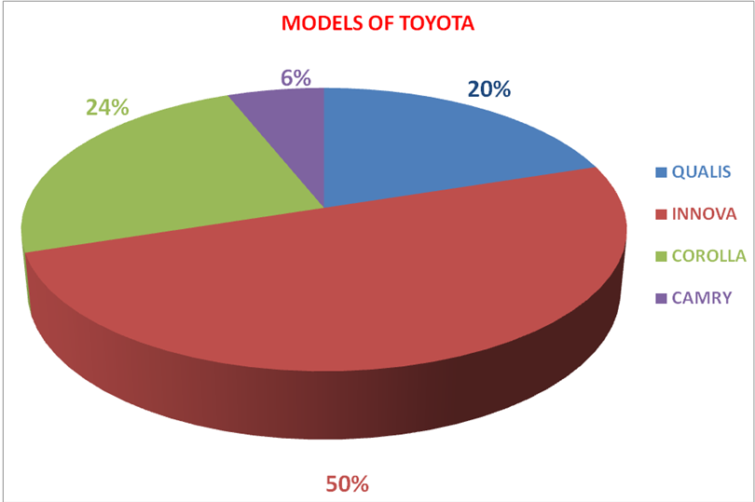

Interpretation:

From above pie chart it can be stated that out of the people who having Toyota ,60% of people having Innova, 24% of people having Corolla, 20% of people having Qualis,6% of people having Camry.

5. You heard about the Toyota vehicle through?

source | percentage
Friends | 40
Advertisements | 24
Tele call | 6
Event | 20
Consultant | 10

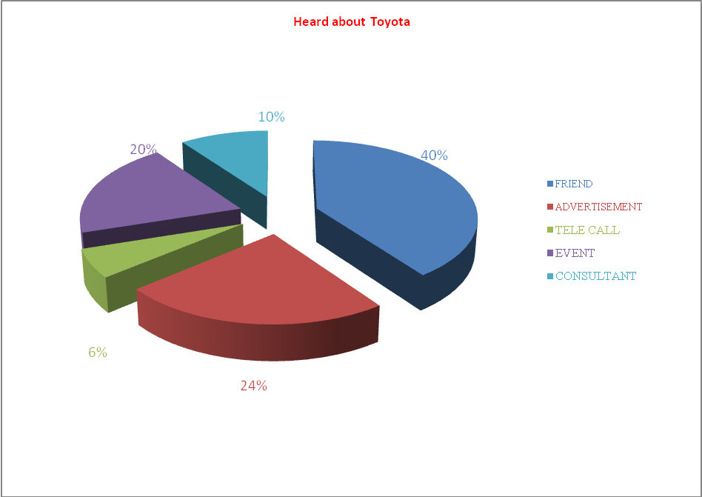

Interpretation:
From the above we can state that 40% people heard about the Toyota vehicle through friends, 24% through advertisements, 6% through tele call, 20% through event and 10% through consultant.

6. Why are you chosen Toyota vehicle?

Attributes | Percentage of preference to attribute
Features | 30
Better Mileage | 20
Brand name | 40
All the above | 10

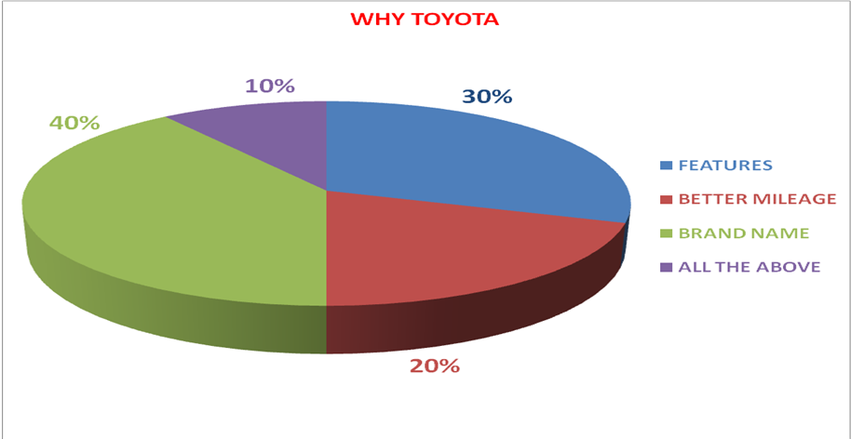

Interpretation:

From above pie chart it can be stated that people give preference 40% to brand name, 30% to features, 20% to better mileage, 10% to all the above attributes.

7. Where did you purchase Toyota car in A.P.?

Show room name of Toyota | Percentage of people
Dobro | 50
Harsha | 46
other | 4

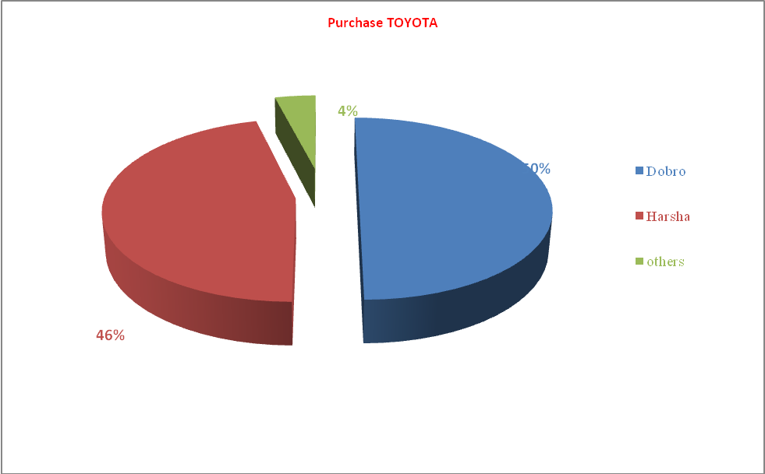

Interpretation:
From above pie chart it can be stated that 50% of people purchase Toyota vehicles at Dobro, 46% at Harsha and 4% at other show room.

8. Which show room is providing better service in A.P.?

Show rooms | % of people got better service
Dobro | 50
Harsha | 40
other | 10

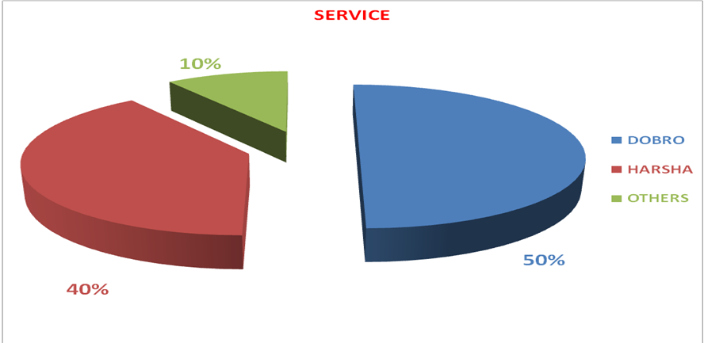

Interpretation:

From above pie chart it can be stated that 50% of people get satisfied with the service provided at Dobro, 40% at Harhsa and 10% at other show room.

9. Receiveness of staff with the customers at showrooms?

Receiveness at show room | percentage
Excellent | 60
Very good | 20
Good | 10
Average | 10
Poor | 0

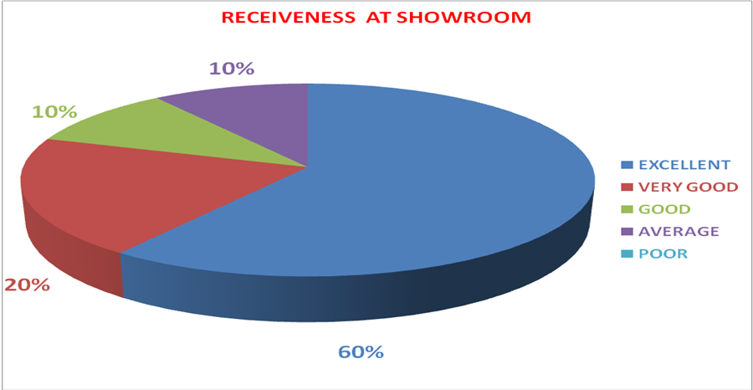

Interpretation:

From above pie chart it can be stated that the receiveness with customers at show room is 60% excellent, 20% very good, 10% good and 10% average.

10. When did you intend to purchase your next car in Toyota?

Duration | Percentage of people
6 months | 30
1 year | 40
1-2 years | 20
No plan | 10

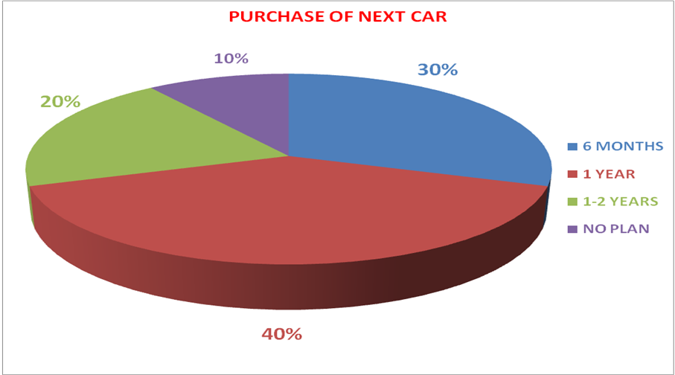

Interpretation:

From above pie chart it can be stated that the percentage of people who are planned to purchase their next car in Toyota with in 6 months is 30%, with in one year is 40%, with in one or two years is 20%. And 10% of people not yet planned.

CHAPTER - V

FINDINGS

- From the survey about the people who have own cars I found that 50% of the people having Toyota cars,10% of the people having Honda cars,12% of the people having Hyundai,13% of the people having Maruthi Suzuki and 15 % of the people having other cars. Hence, we can say that most of the people having Toyota cars.
- From the survey I found that most of the people giving preference to brand name of the company then they look for quality and service. And giving least preference to price.
- From the survey about the people who having Toyota cars, most of the people having Innova because it can be used for multi purposes. Then Qualis and Corolla. But less people having Camry cars.
- From the survey I found that most of the people heard about the Toyota through friends (who having Toyota cars) and by ads. The people less heard about the Toyota through telesales, events and consultants.
- From the survey I found that to purchase Toyota car 50% of the people interested at Dobro show room because it is well established and also providing better services, 46% of the people interested at Harsha showroom.
- From the survey about the behaviour of the staff with customers, most of the people well satisfied.
- From the survey I found that most of the people interested to buy new Toyota with in one year. Because Toyota car having best quality and providing better services.

CONCLUSION

This project concludes that the Toyota motor should provide lowest price of cars for the sake of increasing sales & increasing Toyota motor market. In Andrapradesh, there are two types of Toyota showrooms in Hyderabad. These are Dobro Toyota & Harsha Toyota. Compare to Dobro showroom Harsha Toyota provide special offers to the customers to increase their market position in the competitive world. Toyota Kirloskar motor company ready give another dealership in Hyderabad. That’s why Dobro Toyota showroom tries to attract new customer to give new offers & better discounts to them. Dobro Toyota gives advertisements using electronic media& print media to increase their sales. And also provide new events & better after sales service to the existing customers. Already Dobro Toyota is having well brand image in the automobile market.

SUGGESTIONS

- The company should maintain their market position and try to increase their customers.

- Enough spare parts for the latest models should be stocked, so as to meet sudden break down calls.

- To enable the customers to get in touch with the service personal more easily, the number of direct phones should be increase or provide the toll free number.

- Periodically, review meetings with the customers in different areas should be convinced, to have a general consensus regarding problems being faced by them.

- To increase sales of the cars, the company should concentrate on advertisements and try to provide special offers.

- If the company reduce the price of the cars then sales will be increased dramatically.

CHAPTER - VI

BIBLIOGRAPHY

- PHILIP KOTLER 2000/e - MARKETING MANAGEMENT

- PHILIP KOTLER &
GARY ARMSTRONG - PRINCIPLES OF MARKETING

- G.C. BERI - MARKETING RESEARCH

- www.google.com

- www.toyotaindia.com

- www.dobrotoyota.com

QUESTIONNAIRE

Name of Respondent : _____________________________________
Designation : ________________________ Age : _______
Income :___________________________
Address : ______________________________________
______________________________________
Phone No._________________ Email id:___________________________

Introduction & purpose:

Good ___________________. I’m __________________ from Toyota customer satisfaction cell as part of curriculum. Iam doing this survey for the award of Master of Business Administration. Kindly, co-operate, the information given by you will be used for academic purpose only.

1. Do you own a car? (Yes / No)

2. Which brand do you own?
Toyota |  | Maruthi Suzuki
Honda |  | Other’s( please specify)
Hyundai

3. What are the value attributes you normally look while purchasing a Four Wheeler?
(Please rank)
Design |  | Quality
Price |  | Brand Image
Comfort |  | Service
Performance |  | Other’s (please specify)

4. Are you aware of TOYOTA? (Yes / No)

5. Which model do you have?
Quails |  | Innova
Corolla |  | Camry
Prado

6. Where did you purchase your Toyota vehicle? ( )
A. Dobro B. Harsha C. Other

7. You heard about Toyota vehicle through? ( )
A. A Friend B. Add C.Tele call D. Event E.Consultent

8. Why are you chosen Toyota? ( )
A. Features B. Better mileage C. Brand Image D. All the above

9. When do you intend to purchase your next car?
6 months ( ) 1 year ( ) 1-2 years ( ) No plan ( )

10. When would you like to be test drive Toyota vehicle?
Date : ____________ Time : ______________________.

11. In your opinion, which show room providing better service? ( )
A. Dobro B. Harsha C. Other

12. Receiveness of staff with the customers at showrooms? ( )
A. Excellent B. Very good C. Good D. Average E.Poor

13. Why are you chosen___________ show room?
Reason: _______________________________________________.

14. Do you know any person in that show room (YES/NO)
If know please tell me details: _______________________________
________________________________.

15. Mention your valuable suggestions
___________________________________________________________________________________________________________________.

THANK YOU.

