Where is Phoenix Speedskating Club located (“PSSC”)?
We don't have a storefront, office, or clubhouse. You could say our office is the rink during practice times. IceDen Chandler, AZ

How much does it cost?
IceDen basic drop-in rate is $15/session, $15 fee to PSSC/session, plus $7 for skate rental.

Do I have to be a member?
Membership in Phoenix Speedskating Club is really for everybody, but we give newcomers the opportunity to explore the sport before committing. Skate up to five drop-in sessions with us to see if this is something you want to tackle. Seasonal membership fees will be required. Membership is the key to getting the best ice time rates.

Beyond PSSC membership, USS membership is also required in order for you to be covered under our liability policy. First Year USS membership is only $30/year. Returning skater memberships are $55/year for the Club Competitor/Recreational level, and $95/year for the National Competitor level.

Become a US Speedkating member here.
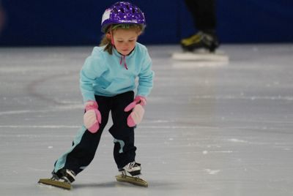

Do I need to know how to skate?
It's best if you have basic, rudimentary skating skills, but it's not mandatory. For context, the Learn to Skate USA curriculum, used in many skating classes, requires successful completion of the Basic Skills 3 class before you can take the Learn to Speedskate 1 class.

We don't have such a requirement, but you'll have more fun if you come to us with some amount of experience on hockey or figure skates. You should be well past clinging to the side boards--that's the least safe place to be during practice. You should be able to get from the ice entrance to the middle of the rink under your own power quickly enough to not be a hazard to the skaters who are "on track."

Also keep in mind that speedskates are quite different from hockey and figure skates, so they present unique challenges. They don't really make the best skates for total beginners.

How old do I need to be?
Skaters of all ages are welcome. You should see our smallest rental skates (child size 12--totally adorable). Basic ability is more important than age.

What should I wear?
Without getting fancy, you should at least wear long sleeves, long pants, full-fingered gloves, and most importantly, a helmet. A bike, hockey, or ski helmet will do. We can't let you on the ice without one. Knee pads are also recommended.

The next step up would be cycling gear, as in tights and jackets. At this point, you may want to also consider skating-specific cut proof gloves and a neck guard. You could also add in some shin guards--check out the soccer equipment aisle at the sporting goods store.

If you really want to look the part, go for the skin suit. Some skin suits provide cut-proof fabric in strategic areas. Nowadays, though, full cut-proof undersuits are required at the national level (elite as well as age group).
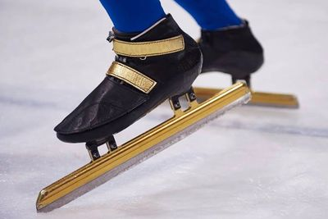

What are my options for skates?
Rent from us
We have a fleet of rental skates. Most are Bont club skates and they're good for getting a beginning speedskater on the ice. They're a little like loaner balls at the bowling alley--fine for having fun and getting into it, but not necessarily for advancing in the sport. They're available for rent on a per-session basis ($7).

Buy your own
Let's cut to the chase. You want to know what they cost, don't you? A decent pair of short track skates will cost about $350-$400 new. You can spend less, but you'll be happier on something other than the bare minimum. This would get you into the ever-popular Bont Patriot C boot and a MapleZ Premium PB blade, a pretty decent setup. The "C" stands for carbon, and it's the more heat moldable variation of the Patriot models. More heat moldability means a more customizable fit. And fit is everything.

There’s a newcomer in the entry-level boot category. It’s the Vision MV1 from MapleZ (formerly Maple) and it runs about $50 more than the Patriot C. It’s designed with help from US Olympian Kip Carpenter. People in the know say the degree of heat moldability is better than anything there’s ever been in this price range. Remember--fit is everything.

There are not a lot of speedskating retail outlets in the US. Below are the folks we've worked with the most. Tell them we sent you.

The Skate Now Shop, Salt Lake City, UT
Special Equipment Company, Pittsfield, MA
Cascade Speedskates, Taylorsville, UT

Take the plunge
There may come a time when you might consider custom-made boots. You don't have to wait until you're vying for the national team. Many recreational skaters in our club have done it. Of course, custom boots don't automatically make you faster. But they can help you get better sooner. The perfect fit helps your feet relax, and you can focus more on your technique rather than worrying over foot discomfort and fatigue. Can't say it enough--fit is everything.

At this level, heat moldability isn't as much of a concern. Plaster casts are formed around your feet. From the casts, replicas of your feet are produced, and boots are then constructed around those. Be warned: this comes at a price--around $2,000. Is it worth it? We know of no one that has regretted it. There are plenty of people who will spend three to five times that amount on a bicycle. The custom boots will do more for your skating than the boutique bicycle will for your riding. (Yes, we know. Those are fighting words to the wheelnerds.)

SS Boots, Bruce Kohen, Jefferson City , MO
Simmons Racing, David Simmons, Cape Coral, FL
Marchese Racing, Paul Marchese, W. Coxsackie, NY

Any other gear I should have?
If you're skating regularly, you'll want to learn to sharpen your blades and get your own sharpening equipment. This includes a jig to hold your skates, sharpening stones of various grits, and a burr stone or some deburring gadget. We're happy to teach you how to sharpen. We're also happy to accept gifts of food and/or drink.

What are practices like?
All practice sessions have the same basic protocol. Look to the club regulars for what to do and when. They’ll help you get into the swing of things.

Rink setup
Around 20 to 30 minutes prior to our actual ice time, there's a flurry of activity to get the rink ready. The sooner we get this done, the sooner we can be skating. Some people are working on getting our crash pads out of storage and on the ice (parents--this is a great way to help out). Others are on the ice putting pads in place (skaters--watch and learn which pads go where). We also have to get supplies out of our storage shed (buckets, squeegees, track blocks), fill the water barrel back in the Zamboni garage, and set out the blocks (the little black rubber cones) on the ice.

Suiting up
After setting up the rink, it's time to put on all your stuff: skates, skin suit, safety gear… whatever you have. Some skaters do this first so that they can be putting pads in place and setting up the track while on skates. This can be the faster way to go once you know what you're doing.

Warm-up & practice
There will be a number of skaters working their way onto the ice while others skate slow to medium-speed warm-up laps. Watch for these skaters as you enter the ice. We’re almost always going counter-clockwise, so skaters will be approaching from your left. If you’re new to speedskating, work your way to center ice. We’ll meet you there. If you’re experienced, dive in with some warm-up laps.

The coach will call everyone to center ice. The coach runs the session and is the primary traffic cop, so please listen and pay attention. We usually start with a group warm-up, move on to some balance and technique drills, skate sets of laps that focus on the drills we just covered, and usually, we conclude with a relay set (often the funnest part of the session).

At the beginning of the season (September), the focus is more on drills and technique rather than pure speed. Toward the end of the season (March), practices are more workout-like, i.e., lots of sets of lots of laps.

Cleanup
Roughly five to 10 minutes before the session is scheduled to end, somebody yells "PADS!" All skating stops and we start picking up. That means everybody. Club regulars know how the pads are collected and stowed. Again, watch and learn. There’s a method to the madness, and we’d rather have you observe how it’s done instead of randomly dragging pads around. We’re usually in a hurry, so don’t be offended by the shouting. It’s imperative that we stay in good favor with rink management, so if the session is over at 7:00am or 5:15pm, that means everybody and everything is off the ice at 7:00am or 5:15pm.
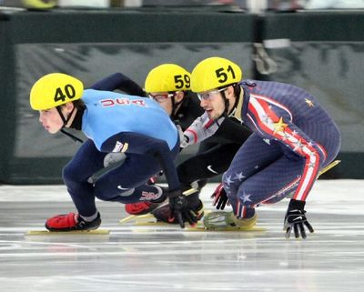

I want MORE! What can I do?
Go Racing!
Our club will host races in the future. However if you're willing to travel, there are numerous opportunities to compete at the local, regional, and national level. Check out the EVENTS section of the US Speedskating website.

Dryland
Dryland refers to off-ice strength and conditioning training that is specific to the demands of speedskating. Swimmers use the same term. Maybe curlers do dryland as well, but probably at a bar. Dryland exercises include holding basic skating position for cruel amounts of time, working on the 1-2-3 skating motion while nice and low, slideboard exercises, stair drills, balance exercises, and much more.

When there are enough people interested, we have been known to organize regular dryland sessions. If you're game, let us know.

Inline Skating
Often referred to as "Rollerblading," inlining has a lot in common with ice speedskating. Much of the technique is the same, but much is also different. Wheels on pavement behave in a different manner than blades on ice.

Other Cross-Training
Many of us favor cycling as a cross-training activity. During the off season, you'll find most of us on our bikes. Short track events play out over just a couple of minutes, while bike rides often go for hours. Strength training and dryland will address your fitness during a single race event, while cycling will help you with recovery between races and throughout a competition. A good cycling regimen will also make you the Energizer Bunny of any skate practice.

Where else can I skate?
Lots of places. Take your speedskates to a public session at your local rink--but PLEASE, be a good ambassador for the sport and avoid skating truly fast. Public sessions, especially lightly-attended ones at odd times of the day, are ideal for practicing the drills that confounded you at practice. It really pays to get good at those. There's a saying in speedskating: if you can't do it slow, you can't do it fast. Public sessions are the time to keep it slow.

