MEASUREMENTS (in centimeters)
1.Neck Circumference
2.Chest (Bust)
3.Waist
4.Hip
5.Biceps
6.Forearm
7.Arm length from shoulder to thumb(extend arm 45 degree)
8.Armpit to wrist
9.Wrist Circumference
10.Inseam (Crotch to Knee)
11.Inseam (Crotch to floor)
12.Thigh Circumference
13.Knee Circumference
14.Calf Circumference
15.Ankle Circumference
16.Height
17.Weight in kg
*
Name and Gender

*See picture below(Next Page)
Measure over bare skin

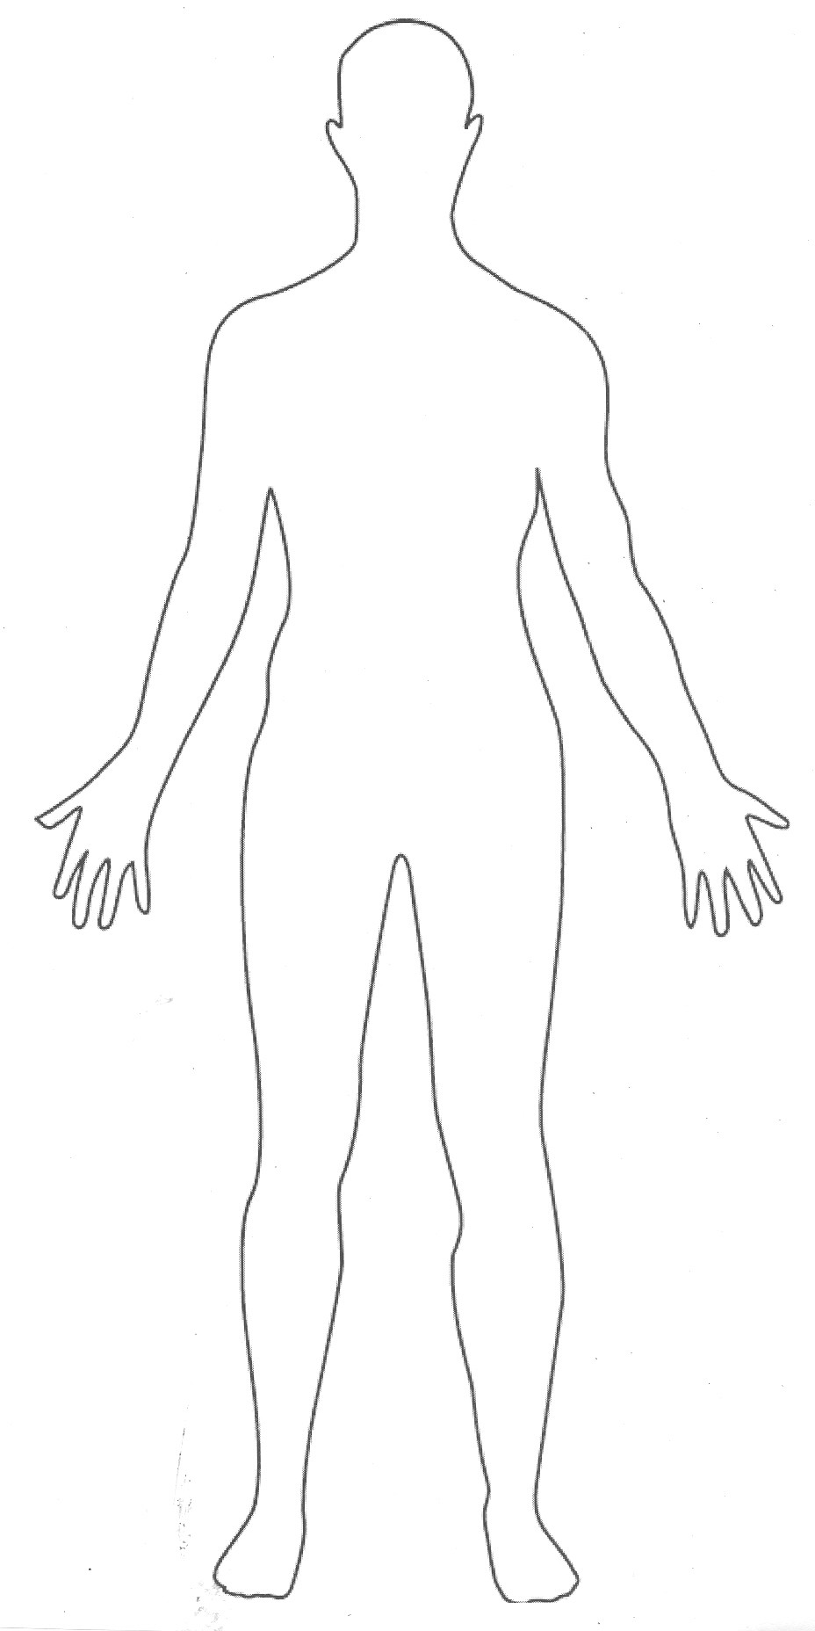
1: Neck circumference
2. Chest (bust)
3: Waist
4: Hip
5: Bicep
6: Forearm
7: Arm length from shoulder to thumb (blue)
8: Armpit to wrist (red)
9: Wrist circumference
(green)
10: Inseam: crotch to knee
11: inseam, crotch to bottom of heel
15: Ankle circumference
13: Knee circumference
12: Thigh circumference
14: Calf circumference

**Weight in kg.
**Height: Measure from top of head to the floor (cm) to get height.

Note: Everything is in centimeters

