**Autumn 1**

**All about me!/ My family/My home**

**Who am I?**

(Visit to the park)

Upcoming events:

Autumn

Black history month

Harvest

Halloween (Dress up day)

All about families, Spot goes to nursery, Room on the broom

**Autumn 2**

**On the farm/Celebrations**

**How do we celebrate?**

(Visit to the church)

Upcoming events:

Bonfire Night

Remembrance Day

Diwali

Nursery Rhyme week (Trip to Discover centre)

Christmas

Peppa’s Diwali, Kipper’s birthday, Cookies Christmas invention

The nativity

Poems

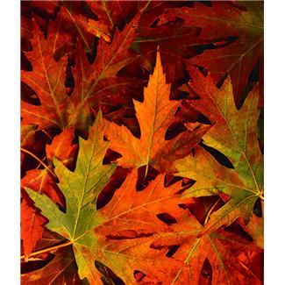

Term Topics 2024/25

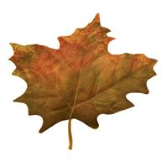

**Summer 2**

**Under the sea/ Traditional tales**

**Who is afraid of the big bad wolf?**

Upcoming events:

Healthy eating week

Father’s Day

Friendship day

Graduation

Summer party

We’re going on a bear hunt, Three little pigs, The tiger who came for tea, Three Billy goats gruff

**Summer 1**

**Transport/ People who help us**

**What adventure should we go on today?**

Upcoming events:

Earth Day

Mental health awareness week

The very hungry caterpillar, We all go travelling by, Spot goes to the beach

**Spring 1**

**Land animals/ Seasons**

**What do seasons bring?**

(Visit to the library)

Upcoming events:

New Year

National story telling week

Lunar New Year

Valentines’ day

Big cats: happy new year, my first Ramadan, I love my mummy

**Spring 2**

**Mini beasts/Growth and change**

**How do things grow?**

Upcoming events:

World book day

Mother’s day

Ramadan

St Patrick’s day

Eid Ul Fitr/Adha

Easter (visit to church)

Watch me grow, Mr Men-happy Eid, Jack and the beanstalk, The enormous turnip





