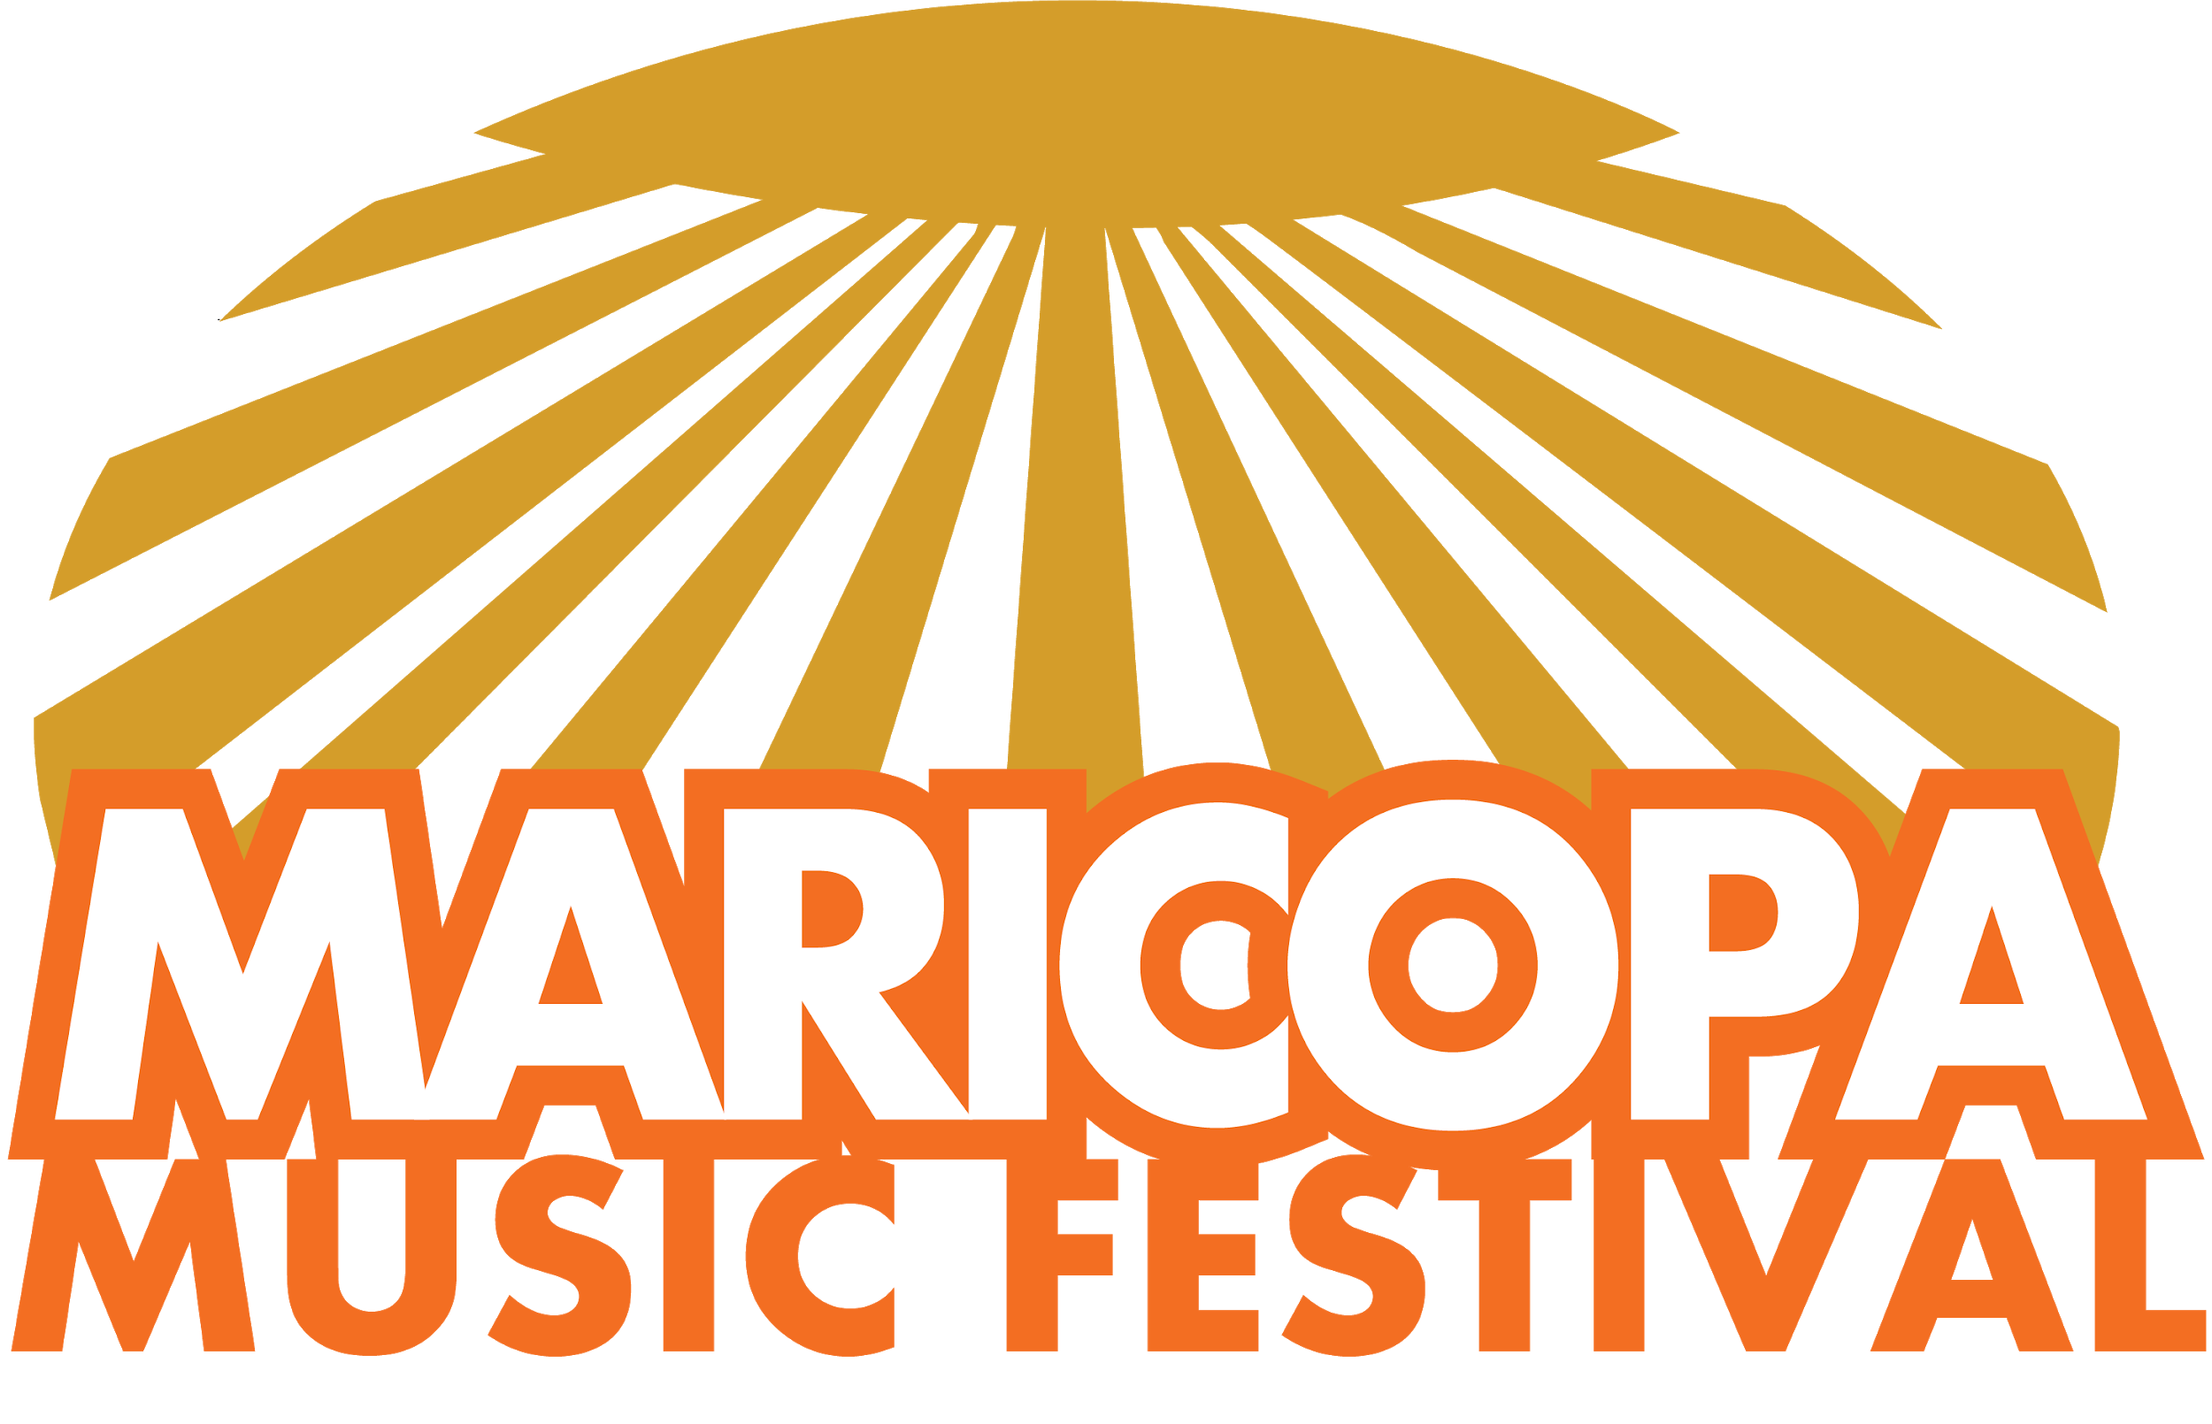
Presents The Maricopa Battle of the Bands / Free Event / Benefits Youth Initiatives/ Fosters Good Will

Press Release / Event Location Update

The Maricopa Battle of The Bands & Skateboard Demo with Game Trucks Onsite is now slated for Oct 25, 2019 in Maricopa, AZ.

It’s FREE to the community and will be held at The Copper Sky Recreation Multigenerational Center. https://www.maricopa-az.gov/web/memberships. The Copper Sky Multigenerational Center is a 52,000 sq. ft. where people of all ages and interests can come.

Sponsor fees please confirm now.

The City of Maricopa is a small town of 55k+ but isl experiencing a growth spurt. With this growth comes youth and young adults who will need activities that keep them out of potential trouble.

The event Producers have chosen this event to benefit three local initiatives with a goal $500 each:

1. The city of Maricopa youth scholarship program: http://www.maricopa-az.gov/web/sports-recreation/1242-scholarships-available,

2.The Streets Don’t Love You Back Program - http://www.thestreetsdontloveyouback.com

3. Be Awesome Youth Coalition - https://beawesomeyouth.life/be-awesome

We are all responsible for keeping our youth & young adults busy and out of trouble. It takes a community, a village. It takes US! Thus, we are inviting to you be a sponsor in this endeavour.

About Our Team
Since 2014 my team and I have been bringing small music events targeted to Families, the Youth and our Veterans here in Maricopa - This includes past Nationwide events. We’ve added John M. the author of “Performance Matters” who will act as a Judge and provide a short seminar: https://www.amazon.com/Performance-Matters-John-M/dp/1718078617.

This Event Target & Details:
17-25 Males/Females - Music Genres: All

The event goal is to include Sponsor Interactive Activation Tents for the selling and promotion of sponsor product and services. We are expecting 2-4k+ and it's FREE to the public.

Bands with large followings will compete with each other from:
Maricopa, Casa Grande, Tucson, Chandler, Phoenix, Mesa, Awhatukee Including the local Native American Bands. Winners get a cash prize of $1,000.

Arizona bands will be chosen in-house and invited to compete. Once chosen their youtube videos will be introduced to the public.

A half time skateboard show of local talent will be presented with Game Trucks on site.

The benefits of sponsorships include:
Increase in Sales in the AZ Region
Growth of Brand Awareness
Development of Customer Loyalty
Lead Generation from event promotions Fostering of Community Goodwill

Event Sponsor: $5,000 (Sponsor / Pop Up Tent Instructions emailed in August 1)
- Signage placement at all Festival stages
- Logo included in all marketing materials (including website, social media, emails, and program cover)
- Opportunity to distribute collateral material (10x10 Tent)
- Live acknowledgment as Festival Sponsor from select performances at all concert stages
- Color full page ad in the program (5” x 8” vertical)
- 4 VIP passes to the Festival
- 6 Invitations to reception with Festival Artists
- Radio

Lead Sponsor: $10,000
- Premium signage placement at all Festival stages
- Name and logo in premium position for all marketing materials (including website, social media, emails, and program cover)
- Opportunity to distribute collateral material and run the marketing campaign of your choice (10x10 or 20x10 Tent)
- Live acknowledgment as Lead Sponsor from select performances at all concert stages
- Color full page ad on the inside cover of the program (5” x 8” vertical)
- 10 VIP passes to the Festival
- 10 Invitations to reception with Festival Artists
- Radio
- Print News

Game Truck Vendors $500
Related Business Vendors: $100 (Youth & Young Adult Driven)

Please let us know that you are "IN" as an event sponsor - Event audience data will be provided.

Sincerely,

Chrystal Allen-O'Jon (AZ) www.maricopamusicfest.us / Battle of the Bands Tab
C 615.569.9138, Chrysallenojon@aol.com
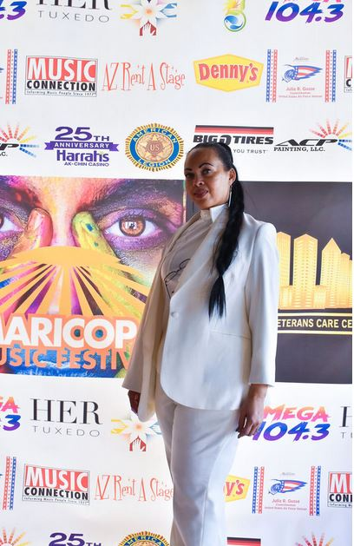

Sponsor Interest Form
Please fill out form below and we’ll email a confirmation asap. Your logo and link of choice will be populated to event site and monthly updates will be sent to your organization representative.

First Name *

Last Name *

Company *

Title *

Phone *

Email *

Website *

Address *

City *

State/Province *

Zip *

Sponsor Level Commitment - please check

Event Sponsor: $5,000: * _____
Event Sponsor: $10,000: *_____
Game Truck Vendor $500 *____
Youth Industry Vendor $200*___ (non food)
Food Truck Vendor $100 *_____ (5% of food/drink sales go to Maricopa Youth Initiatives)
Organization Rep Name: ________________________________________ (printed please)

Date: ________________

Signature: _____________________________________

Remit Payment To:
Maricopa Music Fest / c.o. B.O.B. - P.O. Box 622 Maricopa, AZ 85138

Bands will be chosen in-house this year - via Artist Relations Director, Antonia Hickman, atmybest104@gmail.com.

