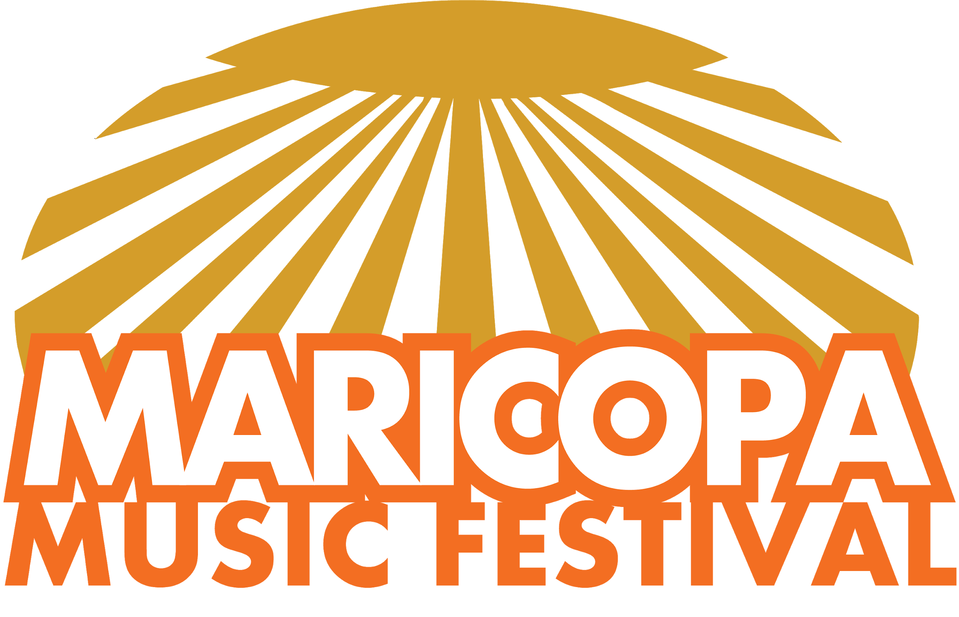

FREE FAMILY FUN EVENT

Maricopa Lip Sync Battle & Skateboard Demo with Game Trucks Onsite

Saturday, October 26, 2019
The Copper Sky Recreation Multigenerational Center
44345 M.L.K. Jr. Blvd, Maricopa, AZ 85138
1-7PM
Skateboarders Age Range 12-16 & 17-25
Lip Sync Singers: Open to all ages 1-101

Maricopa Music Fest, LLC - Founder, Chrystal Allen-O'Jon
Co-Founder of 5014c Maricopa Veterans Care Center Project
Co-Owner of URE LLC, O'Jon Property Management & Investments & Co-Owner of Next Great Drummer Nationwide Search Show (being pitched).
______________________________________________________________
This community event is FREE and will be held at The Copper Sky Recreation Multigenerational Center. The Copper Sky Multigenerational Center is a 52,000 sq. ft. where people of all ages and interests can come.
https://www.maricopa-az.gov/web/memberships.

The City of Maricopa is a small town of 55k+ and is experiencing a growth spurt. With this growth comes youth and young adults who will need activities that keep them out of potential trouble.

The event Producers have chosen this event to benefit local Maricopa organizations: Our Goal is to award $500 to each of the following local organizations.

1. The city of Maricopa Youth Scholarship Program: http://www.maricopa-az.gov/web/sports-recreation/1242-scholarships-available;

2.The Streets Don’t Love You Back Program - http://www.thestreetsdontloveyouback.com.
The Streets Don't Love You back organization is committed to helping youth
reach their highest potential through a variety of life-transforming programs.
They educate against gangs, drugs, violence, and abuse. focusing on empowerment, education and teaching the life skills needed to make changes in their life.

3. Be Awesome Youth Coalition - https://beawesomeyouth.life/be-awesome
“Be Awesome is a team of people with the boldness to believe that we can impact our world by developing confident, connected, and successful youth by offering community focused programs and services.”

4) Zonta international, Maricopa Chapter, Youth Scholarship.

In celebration of Maricopa Youth Initiatives, The Zonta Club of Maricopa will be having a 100 Women Walk to raise money for this events youth scholarships.

Zonta's mission is to empower women through service and advocacy. Their slogan is “We say No to abuse against women, bullying and childhood marriage”. https://www.facebook.com/ZontaMaricopa/.

About Our Team
Since 2014, my team and I have been bringing small music events targeted to Families, the Youth and our Veterans here in Maricopa - This includes past Nationwide events. Our Artist Relations Director is Antonio Hickman. All interested bands should submit their performance videos to: atmybest104@gmail.com. We’ve also added John M. the author of “Performance Matters” who will act as a Judge and provide a short seminar: https://www.amazon.com/Performance-Matters-John-M/dp/1718078617.

Event Demo Target:
- Families of All Ages
- Skateboarders 12-16 & 17-25 (Win $500 - Sponsor This)

Sponsor Interactive Activation Tents for the selling and promotion of products and services will be made available.

Lip Sync Contestants are invited from:
Maricopa, Casa Grande, Tucson, Chandler, Phoenix, Mesa, Awhatukee Including the local Native American Bands.

This year local bands will be hand chosen picked and invited to compete. Once chosen their YouTube videos will be introduced to the public. Next year the competition will start online with final winners to compete live.

A half time skateboard show of local talent will be presented with Game Trucks on site.

The benefits of sponsorship include:
Increase in Sales in the AZ Region
Growth of Brand Awareness
Development of Customer Loyalty
Lead Generation from event promotions Fostering of Community Goodwill

The Zonta 100 Women March - will be onsite to raise money via their march
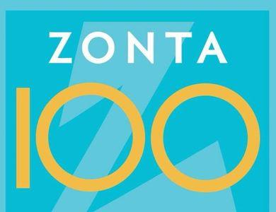

Zonta International
100 Years Strong - Provides Local & Int'l Scholarships

SPONSOR OPTIONS

Lead Sponsor: $5,000
- Premium signage placement at all Festival stages
- Name and logo in premium position for all marketing materials (including website, social media, emails, and program cover)
- Opportunity to distribute collateral material and run the marketing campaign of your choice (10x10 or 20x10 Tent)
- Live acknowledgment as Lead Sponsor from select performances at all concert stages
- Color full page ad on the inside cover of the program (5” x 8” vertical)
- 10 VIP passes to the Festival

Event Sponsor: $1,000 (Sponsor / Pop Up Tent )
- Signage placement at main stage
- Logo included in all marketing materials (including website, social media, emails, and program cover)
- Opportunity to distribute collateral material
- (10x10 Tent)
- Live acknowledgment as Festival Sponsor from select performances at all concert stages
- 6 VIP passes to the Festival

Game Truck Vendors FREE Space - Pay to play option

Related Business Vendors: & Pop Up Shops $100 - $500 (Youth & Young Adult Driven)
Scholarships can be sponsored for $500 (Cross-Promo Inclusion)

Please let us know that you are "IN" as an event sponsor - Event audience data will be provided to major sponsors.

Sincerely,

Chrystal Allen-O'Jon (AZ) www.maricopamusicfest.us / Battle of the Bands Tab
C 615.569.9138, Chrysallenojon@aol.com
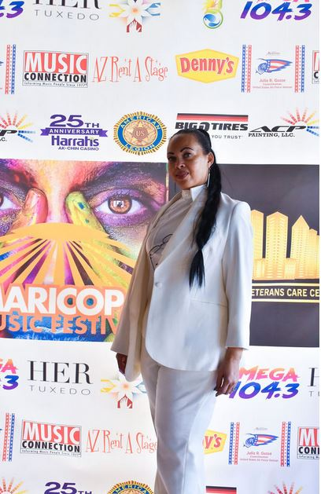

Sponsor or Vendor Application
Please fill out the form below and we’ll email a confirmation asap. Your logo and link of choice will be populated to event site and monthly updates will be sent to your organization representative.

First Name *

Last Name *

Company *

Title *

Phone *

Email *

Website *

Address *

City *

State/Province *

Zip *

Sponsor or Vendor Level Commitment - please check

Main Event Sponsor: $5,000: *_____
Event Sponsor: $1,000: * _____
Game Truck Vendor *____
Business Vendor $50*___ 5013c or Craft Vendor $25*___
Food Truck Vendor $100 *_____ (5% of food/drink sales go to Maricopa Youth Initiatives)

Organization Rep Name: ________________________________________ (printed please)

Date: ________________

Signature: _____________________________________

Remit Payment To:
Maricopa Music Fest / c.o. B.O.B. - P.O. Box 622 Maricopa, AZ 85138 or pay on event website

https://maricopamusicfest.us/battle-of-the-bands-info?olsPage=products

Lip Sync Contestants will be chosen in-house this year - via Artist Relations Director, Antonia Hickman, atmybest104@gmail.com.

