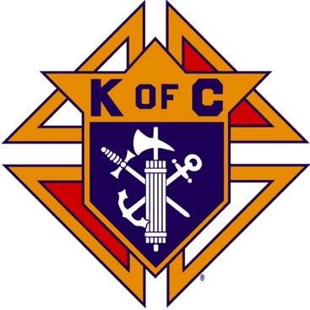
Saugus Knights of Columbus
Council #1829

57 Appleton Street
Saugus, MA 01906

Council Newsletter

Volume 22, Issue 11 www.sauguskofc1829.org November 2025

Grand Knight’s Message
Hello, my Worthy Brothers.
Greetings from sunny and warm Florida. The weather here is absolutely perfect. Karen and I are lounging by the pool almost every day. We have had rain only three times since we have been here, but the locals call it liquid sunshine. Perfect!!!!
I will be back on Thursday, November 13th. Our usual Saturday morning breakfast will definitely be held on November 15th. The social dinner will be held on November 18th at 6:00 pm. The LRC game will be played immediately after.
From what I can see from the bar schedule we will have a busy December this year. That is a welcoming. We can certainly use the revenue.
When I return, I will be looking for volunteers to help with the parking lot cleanup. Last year we paid the landscaper $400.00, and he was there for only1 hour. With us volunteering our time we can save the money and use it elsewhere.
As you all know Thanksgiving is on Thursday, November 27th. We have so much to be thankful for, our families, our health, our friends, our homes, and the great in which we live. Please take a moment to think if there may be an elderly person or someone you know who will not have a dinner to eat, or someone to say "Happy Thanksgiving" to them. Kindness goes a long way. Maybe a plated meal dropped off to them would be the highlight of their year.
I would like to thank Brothers Richard Aiello, Steve Gerome, Phil Barbanti, and Bob Northrup for covering for me in my absence. My sincere thank you!
See you all soon,
John Coburn
Grand Knight,
Saugus Council 1829

Eastern Poker Tour

Every Wednesday night, 6:30-10:30 P.M.

The Weekly Attendance Pool

The Weekly Attendance Pool is up to $132.

October 07 116 James O’Brien
October 14 206 James Petras
October 21 101 Glen McCoy
October 28 191 William McKenna

BA1829 Club Numbers
October 07 – 99
October 14 – 32
October 21 – 76
October 28 – 13

Rent Our Function Hall

Saturday Morning Breakfast
Breakfast is served from 8:30-9:00 A.M. every Saturday morning.
All are welcome. The fare is only $7.00

Menu:
November 01 – Bacon, egg & cheese omelets
November 08 – Canadian bacon, eggs, cheese on a bagel
November 15 – John is back!!!

Upcoming Events
Eastern Poker Tour every Wednesday 6:30 – 10:30
Social Meeting Dinner/ LRC game Tuesday, November 18, 6:30 P.M.
Menu: Calzone, stuffed mushrooms, assorted hors d’oeuvres, finger food.
Deceased Brothers’ Mass Sunday, November 9, 11:00 mass
Fourth Degree Exemplification November 16
Christmas Party December 5, 6:00-10:00 P.M.

November Birthdays
Happy Birthday to the following Brothers

01st – John O’Connell 02nd – Steven Duplisea
04th – Robert Favuzza 06th – Rev. Danial McCoy
09th – Stephen Gerome 13th – Kevin O’Neill
18th – Stephen Socci 20th – James Hogan
20th – Alfred Sabella 21st – Henry Leno
23rd – Lawrence Donovan 26th – Paul Arinello
27th – Vincent Zinna 30th – James Boyle
30th – Kevin Ring

If your name is listed above, you are invited to stop by the lounge for a complimentary beverage of your choice on Tuesday of your birthday week

JFK Assembly Meeting

The Fourth Degree meets on the second and fourth Tuesdays at 7:00.

All Worthy Knights are encouraged to attend.

Meeting Schedule
Saugus Council #1829

First Tuesday – Social meeting only - Pizza Night
Second Tuesday – Business meeting
Third Tuesday – Dinner meeting only. The cost for dinner is $10/$12.
Fourth Tuesday – Business meeting
Fifth Tuesday (when applicable) – Social meeting only

Monthly Newsletters
The monthly newsletter files have been added to the Council web site at https://sauguskofc1829.org/newsletters.

You can download a Microsoft Word copy of the file
to your computer/smart phone/tablet any time you wish.

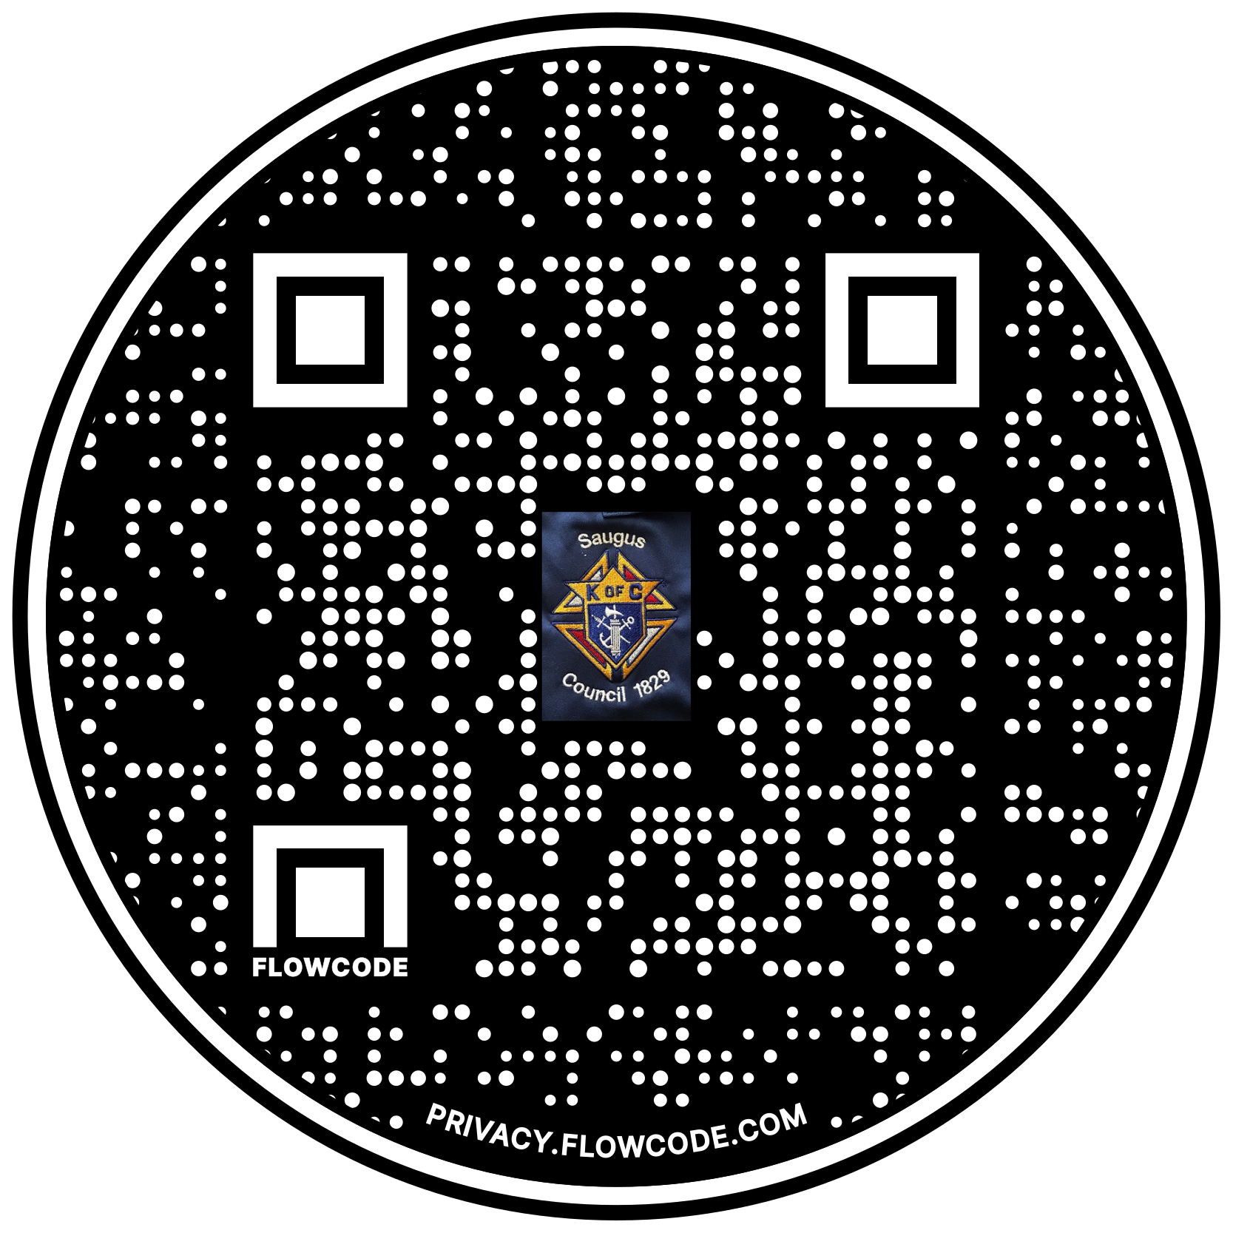

Scan the Code to view the Council Web site!

