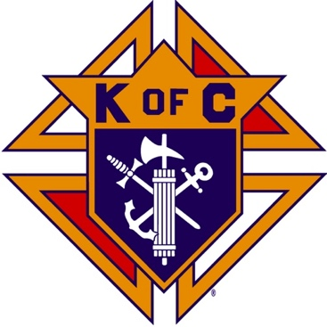
Saugus Knights of Columbus
Council #1829

57 Appleton Street
Saugus, MA 01906

Council Newsletter

Volume 22, Issue 3 www.sauguskofc1829.org March 2025

Grand Knight’s Message

Good morning my worthy Brothers.
Well the month of March has arrived. The good weather is very close. As the saying goes, "March comes in like a lion and goes out like a lamb". I will say the weather here in Florida is pretty good. it's at night, it's during the day.
This month has been a fairly busy one for the council. We have had several functions, Saturday breakfasts, and weekly meetings. I would like to whole heartedly thank all the Brothers for stepping up to cover for Steve, Henry, and I while we are away. I want you all to know we truly appreciate it. Also, my personal thanks to Bob and Dawn Northrup for keeping the Saturday breakfast going during the past month.
I will be returning home on March 6th. As soon as I get home, I will get the wheels of the corned beef and cabbage dinner going. I'm planning the dinner for the Tuesday night of March 18th. I will put out a sign-up sheet the day I get home. Because of the short notice I will also make calls, so everyone is made aware of the dinner.
There isn't much more to write about now. I will see everyone soon. Please be safe. Remember you are all in my thoughts and prayers.
Lord Jesus, please keep us all happy and safe. Bless our families and friends, especially our departed brothers whom you have given eternal life. 🙏 🙏 🙏

John Coburn
Grand Knight

District Deputy’s Message

Greetings to all brothers.
All councils are being reviewed to see if they are Safe Environment Compliant. Your GK’s and FS’s are going to start getting called about this. We are at 21.1% in the State. Many councils still haven’t submitted 365’s.
There are several incentives to increase membership
  - if a DD’s region brings in 4 new members they will get a $50 gift card for each month of the 3rd quarter.
  - March Madness is running in March, who will bring in the highest percentage of new members each week!
  - Gold pen for the #1 Recruiter in 2024/2025 by percentage.
  - Delta Church drives, with prospect cards proof will get a gift card to raffle at council exemplification. All DD’s should have 1 Drive in their district per month!
  - All councils that have reached safe environment have a chance to be in a drawing to use funds for Charity. Encourage more of your councils to get into this raffle to help meet these goals:
Upcoming Dates:
Town Hall Meetings: All DD’s are expected to attend. As many officers in your councils as possible! All starting at 7 PM:
  - Week of March 24th. Still waiting on some:
    - Central: Monday March 24^{th,} Joseph P Keating Council 99, 165 Electric Avenue, Fitchburg, MA 01420
    - North/Boston North: Tuesday March 25^{th,} Sacred Heart Parish Hall, 311 River Street, Waltham, MA 02453
    - West: Wednesday March 26^{th,} the Castle of Knights, 1599 Memorial Drive, Chicopee, MA 01020
    - South and Boston South March 27th Our Lady of Sorrows Parish, 59 Cottage Street, Sharon, MA 02067
April 21st is the Lantern Award dinner in Framingham, MA, at the Sheraton. All DD’s should be attending with tables of 10. The Honoree is Pope St. John XXIII Seminary and accepting the award will be Very Reverend Brian R. Kiely, Rector.
The State Convention will be held May 16th -18th at the Emerald Resort, Hyannis, MA.

Upcoming Events
St. Patrick’s Day Dinner Tuesday, March 18, 6:30 P.M.
Meager Meals Friday night, April 4, 5:30 P.M.

Saturday Morning Breakfast
John is back!!
Breakfast is served from 8:30-9:00 A.M. every Saturday morning.
All are welcome. The fare is only $5.00

The Weekly Attendance Pool

The Weekly Attendance Pool is up to $171. Come to the council, sign the logbook, and put $1 in the pool each week. The weekly number will be drawn on Tuesday after the meeting. If your number is drawn and you have signed in that day you win all that is in the pool. It continues to grow until someone wins. Don’t miss out! The numbers for the past month:

February 04 – 139
February 11 – 143
February 18 – 149
February 25 – 004

BA1829 Club Numbers

February
February 04 – 54
February 11 – 11
February 18 – 45
February 25 – 02

March Birthdays
Happy Birthday to the following Brothers

01st – Avery Sprague 03rd – John Sullivan
05th – Thomas Sheehan 05th – Sal Russo
05th – Kenneth Lanzilli 06th – Richard Doucette
07th – Michael Adams 07th – Peter Giunta
15th – William Leuci 15th – James Petrillo
15th – David Tomolillo 16th – Stephen Spinelli
17th – Paul Cook 19th – Warren Scott
20th – Joseph Dauenhauer 21st – Philip Barbanti
21st – Nicholas Melanchook 22nd – Deacon Francis Gaffney
23rd – Anthony LaRosa 27th – David Cromwick
29th – Rev. Timothy Kelleher 29th – Ernest Buonopane

Members are invited to stop by the lounge for a complimentary beverage of their choice on Tuesday of their birthday week. If your name is listed above, just stop by the Council on Tuesday of that week and present your membership card to the bartender to claim it.

Meeting Schedule
Saugus Council #1829

First Tuesday – Social meeting only - Pizza Night
Second Tuesday – Business meeting
Third Tuesday – Dinner meeting only. The cost for dinner is $10.00.
Fourth Tuesday – Business meeting
Fifth Tuesday (when applicable) – Social meeting only

JFK Assembly Meeting

The Fourth Degree meets on the second and fourth Tuesdays at 7:00.

All Worthy Knights are encouraged to attend.

Thanks to Ron Keohan for submitting a word search for the monthly newsletter. (Solution will appear in next month’s newsletter).

3. LAWS OF HOLINESS

J | W | F | O | R | G | I | V | E | N | E | S | S | F | Z | L | V | J | M | Z | O | O
O | I | B | R | N | N | P | N | Q | H | D | E | C | R | E | E | S | D | H | C | S | R
R | M | T | U | W | I | X | S | C | T | E | C | N | A | N | I | D | R | O | R | J | F
D | P | C | O | R | S | L | F | I | U | T | R | E | S | P | A | S | S | H | N | M | M
I | U | O | D | E | N | M | S | A | N | S | S | E | N | I | L | N | A | E | L | C | J
N | R | N | R | G | A | T | Q | E | H | S | S | T | A | T | U | T | E | S | K | H | A
A | I | S | S | Z | E | W | B | U | N | N | T | A | K | Q | N | V | W | U | O | N | N
N | T | E | T | A | L | U | N | R | Y | I | E | R | H | S | O | E | V | L | P | T | Y
C | Y | C | V | S | C | T | W | A | N | R | L | P | U | K | N | J | Y | R | Q | A | S
E | I | R | O | T | Z | J | I | X | E | N | A | E | D | C | R | L | F | R | C | G | O
S | W | A | I | P | K | R | K | S | C | L | S | U | D | H | T | U | A | G | W | M | R
W | N | T | P | E | S | A | C | R | E | D | C | O | T | I | Q | I | L | U | J | Z | P
U | E | I | E | C | H | G | T | B | S | T | O | N | N | C | U | L | O | E | T | S | E
I | G | O | A | E | E | T | Z | J | F | L | A | W | U | X | N | G | S | N | S | I | L
U | C | N | C | R | S | I | N | H | B | B | T | D | A | D | C | A | F | S | S | X | R
E | P | B | E | P | B | L | Y | T | I | R | U | P | N | M | P | K | S | Z | C | G | E
S | N | O | I | T | A | L | U | G | E | R | R | G | R | A | I | N | S | U | Q | A | C
B | V | C | O | V | E | N | A | N | T | O | N | N | H | M | M | T | G | R | F | T | O

Blood Holy Purity
Burnt Impurity Regulations
Cleanliness Instructions Ritual
Cleansing Lap Rules
Consecration Leprosy Sacred
Covenant Mandates Sanctuary
Decrees Ordinance Sin
Forgiveness Ordinances Statutes
Grain Peace Trespass
Guidelines Precepts Unclean

Last Month’s Solution

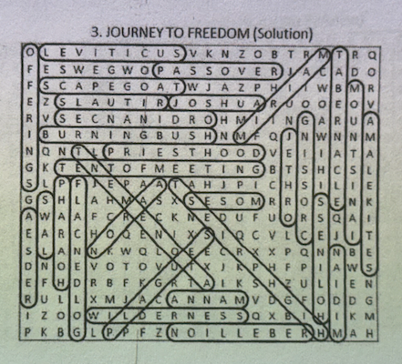

Monthly Newsletters
The monthly newsletter files have been added to the Council web site at https://sauguskofc1829.org/newsletters.

You can download a Microsoft Word copy of the file
to your computer/smart phone/tablet any time you wish.

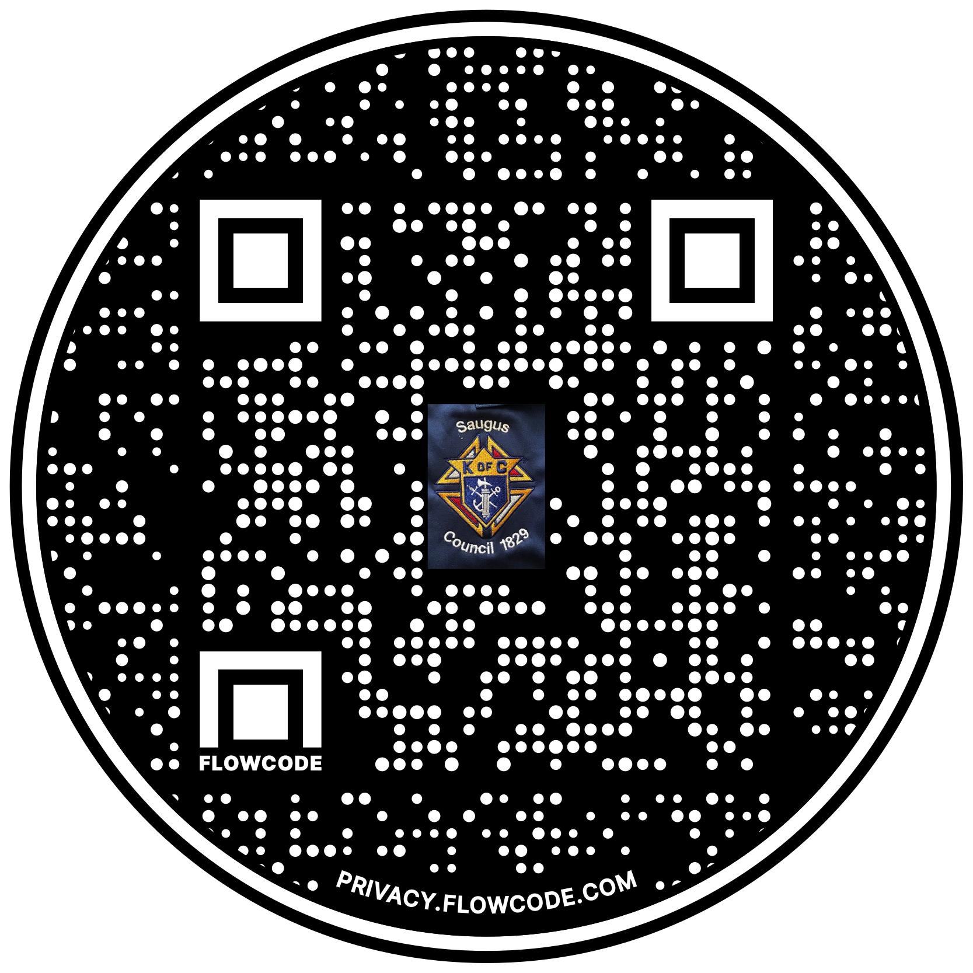

Scan the Code to view the Council Web site!

