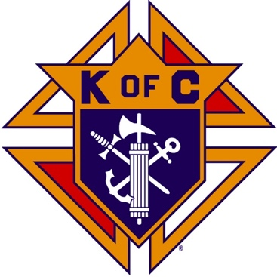
Saugus Knights of Columbus
Council #1829

57 Appleton Street
Saugus, MA 01906

Council Newsletter

Volume 23, Issue 03 www.sauguskofc1829.org March 2026

Grand Knight’s Message

Greetings, my Worthy Brothers.
I am back from Florida. It was a much-needed vacation for my physical and mental health. Florida was awesome but it was time to come home. Believe it or not I missed the council and all of you guys. Karen missed the ladies and the events.
I always thought my heart issues were a fluke thing, and I would get over them, but I guess not. I must modify my eating, exercise, and general life behaviors so I will live to be 100 years old.
I would like to thank all the members who stepped up and handled the everyday events. On a personal note, I would like to thank WDGK Richard Aiello for covering for me. Even down in Florida the word was he was doing a fantastic job. Ya, no kidding. It was on both Fox and CNN news. Thanks Richie.
During the Lenten season we have our Meager Meals event coming up on March 13th. I will coordinate with all our volunteers on Tuesday evening. I’m assuming we will be making the grilled cheese sandwiches and the soup for our meal.
Spring is almost upon us. When the snow clears, we will need help with the upkeep of the grounds and the painting of the function room. Although we haven’t finalized the plans, we need to get a count of the volunteers who will help with painting. We will have to get the work done quickly so we won’t interfere with our functions. We desperately need fresh paint on the walls and especially the smoke-stained ceilings.
The Ladies of the Knights are meeting Tuesday night to plan a meatless dinner on our social night. Not definite, but I heard Linguini and clam sauce, Italian bread, beverages, and dessert.
I will see you all Tuesday night at our regular business meeting. Until then, my thoughts and prayers are with each one of you. Whether you believe it or not we are all family. Most importantly we are all God’s children and He loves us unconditionally.
Vivat Jesus,
Love to all,
John Coburn
Grand Knight

INCLEMENT WEATHER POLICY

Saugus Council #1829 and The John F. Kennedy Assembly #409 of the Knights of Columbus will follow the policy of the Saugus Public School System with regard to weather related decisions. These decisions could be made the day before, or the day of, an impending weather occurrence.

If Saugus Public Schools are closed, the evening meeting or event of both the Council and the JFK Assembly will be cancelled.

If the Saugus Public School System announces an early closing or the cancellation of afternoon or evening programs, due to inclement weather, the evening meeting or event of the Saugus Council 1829 and the JFK Assembly will be cancelled.

If the Saugus Public School System has not issued weather related announcement, then both the Council and the JFK Assembly will evaluate conditions and may cancel the evening meeting or event.

In any circumstance, err on the side of caution when travelling back and forth to a meeting or event in inclement weather.

Monthly Social Dinner

The social dinner will be held on March17, 2026; 6:30 pm – 9:30 pm.
Left-Right-Center will follow the dinner.
Menu TBD.

The Weekly Attendance Pool

The Weekly Attendance Pool is up to $46.00

February 03 193 Sal Messina
February 10 149 Rich Salerno
February 17 148 Alfred Sabella
February 24 No meeting

BA1829 Club Numbers
February 03 – 80
February 10 – 08
February 17 – 60
February 24 – 24

Rent Our Function Hall

Eastern Poker Tour

Every Wednesday night, 6:30-10:30 P.M.

Meeting Schedule
Saugus Council #1829

First Tuesday – Social meeting only - Pizza Night
Second Tuesday – Business meeting
Third Tuesday – Dinner meeting only. The cost for dinner is $10/$12.
Fourth Tuesday – Business meeting
Fifth Tuesday (when applicable) – Social meeting only

Saturday Morning Breakfast

John is back. Breakfasts are back.
The fare is only $7.00

Upcoming Events
Eastern Poker Tour every Wednesday, 6:30 – 10:30
Friday Nights at Members’ Lounge every Friday evening, 6:00 – 11:00
Meager Meals Friday, March 13, 6:00-7:00
Social Meeting Dinner/ LRC game March17, 6:30 pm – 9:30

JFK Assembly Meeting

The Fourth Degree meets on the second and fourth Tuesdays at 7:00.

All Worthy Knights are encouraged to attend.

March Birthdays
Happy Birthday to the following Brothers

01st – Avery Sprague 03rd – John Sullivan
05th – Sal Russo 05th – Kenneth Lanzilli
06th – Richard Doucette 07th – Michael Adams
07th – Peter Giunta 15th – William Leuci
15th – James Petrillo 16th – Stephen Spinelli
17th – Paul Cook 19th – Warren Scott
20th – Joseph Dauenhauer 21st – Philip Barbanti
22nd – Deacon Francis Gaffney 23rd – Anthony LaRosa
27th – David Cromwick 29th – Rev. Timothy Kelleher 29th – Ernest Buonopane

If your name is listed above, you are invited to stop by the lounge for a complimentary beverage of your choice on Tuesday of your birthday week

Monthly Newsletters
The monthly newsletter files have been added to the Council web site at https://sauguskofc1829.org/newsletters.

You can download a Microsoft Word copy of the file
to your computer/smart phone/tablet any time you wish.

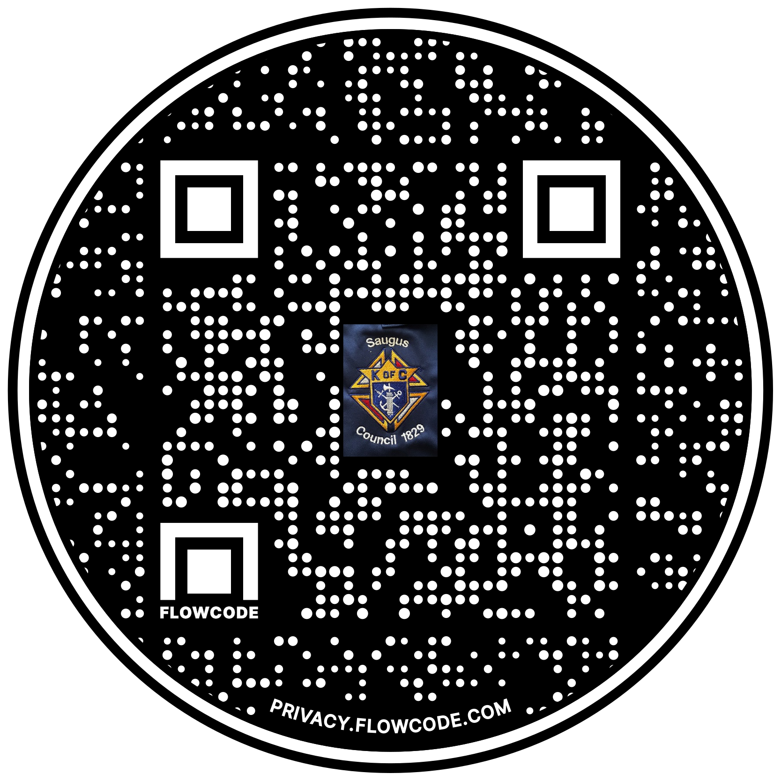

Scan the Code to view the Council Web site!

