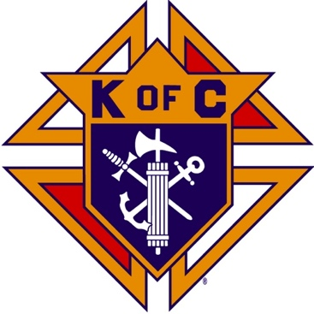
Saugus Knights of Columbus
Council #1829

57 Appleton Street
Saugus, MA 01906

Council Newsletter

Volume 22, Issue 1 www.sauguskofc1829.org January 2025

Grand Knight’s Message

Greetings my Worthy Brothers.
Another holiday season has passed. I truly hope that you all enjoyed Christmas and New Years. I hope you all were blessed with family and friends. For me, I had company all day and into the early evening. It was a humbling experience to have dinner with my entire family. I sat in my dining room chair and just looked at everyone and thought about how blessed I am.
I must honestly say I was a little disappointed in the turnout for our annual Christmas party. I expected more members and their families to attend. I do not know if the weather was a factor or what else it could have been. Hopefully, our next dinner together will be different.
The month of December has been a bit slow for us. Our weekly meetings have been cut in half because of the holidays. We will resume them starting on January 7th.
If anyone has any information, they want to get out to the members send me an email and I will include it in my monthly newsletter.
On a different note, while we are all freezing our butts off here, Steve and Henry are basking in the sun in Florida. Oh, I forgot, I am heading there on February 1st. Never mind. Lol!! Just a reminder, there will be no breakfast during the month of February.
In closing I would like all of us to keep each other in our thoughts and prayers. I would also like to remind everyone to check on each other on the freezing snowy days and nights. Maybe our grandchildren could help shovel out our members who need a hand. Just a thought.
Take care my brothers, see you on Tuesday.
Vivat Jesus,
John Coburn
Worthy Grand Knight

Upcoming Events
Annual Christmas Party Thursday, December 5, 6-10
RSVP to info@sauguskofc1829.org to purchase tickets - $25 pp.
Breakfast w/ Santa December 14, 9-12

Saturday Morning Breakfast
Breakfast is served from 8:30-9:00 A.M. every Saturday morning.
All are welcome. The fare is only $5.00

The Weekly Attendance Pool

The Weekly Attendance Pool is now in full swing. Come to the council, sign the logbook, and put $1 in the pool each week. The weekly number will be drawn on Tuesday after the meeting. If your number is drawn and you have signed in that day you win all that is in the pool. It continues to grow until someone wins. Don’t miss out!

December 03 – 064 – Larry Gallant
December 10 – 122 – Craig Orlando
December 17 – 086 – Henry Leno
December 24 – 160 – Michael Sicuranza
December 31 – 160 – Michael Sicuranza

BA1829 Club Numbers

November
December 03 – 58
December 10 – 36
December 17 – 55
December 24 – 62
December 31 - ??

January Birthdays
Happy Birthday to the following Brothers

01st – Anthony Ciaccarelli 02nd – Richard D. Salerno
04th – John Dolan 04th – Paul Pantano
08th – Paul Giannetta 12th – David Ceruolo
15th – Thomas Finnegan 17th – Edward DiGirolamo
24th – Ronald DellaGrotte 27th – John Hunt
28th – Patrick Verderico 30th – Peter Morris
31st – Anthony DePlacido 31st – Kenneth Hanlon Jr.
Members are invited to stop by the lounge for a complimentary beverage of their choice on Tuesday of their birthday week. If your name is listed above, just stop by the Council on Tuesday of that week and present your membership card to the bartender to claim it.

JFK Assembly Meeting

The Fourth Degree meets on the second and fourth Tuesdays at 7:00.

All Worthy Knights are encouraged to attend.

Meeting Schedule
Saugus Council #1829

First Tuesday – Social meeting only - Pizza Night
Second Tuesday – Business meeting
Third Tuesday – Dinner meeting only. The cost for dinner is $10.00.
Fourth Tuesday – Business meeting
Fifth Tuesday (when applicable) – Social meeting only

Thanks to Ron Keohan for submitting a word search for the monthly newsletter. (Solution will appear in next month’s newsletter).

2. THE DIVINE ACT OF CREATION UNFOLDS

T | E | O | H | D | E | R | E | H | T | A | G | T | M | E | K | B | H | Z | A | N | A
G | C | E | F | X | O | O | I | B | P | S | X | K | S | A | F | E | G | J | D | S | E
U | V | C | E | M | Z | K | S | N | V | E | R | Z | D | E | B | G | M | S | K | C | J
L | Q | B | N | T | Y | B | P | E | C | S | D | K | E | G | I | I | U | R | R | H | I
S | I | A | P | A | I | E | C | M | R | W | A | F | E | K | R | N | L | E | X | V | H
J | I | G | D | E | B | M | R | L | E | U | H | F | S | F | D | N | P | W | J | N | J
H | C | P | H | O | E | Z | K | J | S | L | T | M | W | R | S | I | I | A | B | T | S
E | G | M | C | T | G | D | A | H | F | B | T | A | E | M | S | N | P | W | J | N | J
A | B | B | R | U | H | X | D | O | F | X | G | T | E | A | B | G | L | A | H | E | X
V | T | U | O | M | C | R | R | K | M | K | R | F | A | R | F | S | Y | S | S | M | Z
E | H | F | W | U | Y | M | T | X | D | I | D | T | C | C | C | D | O | E | I | A | E
N | A | O | I | F | Z | I | Q | D | B | E | X | H | K | M | N | I | J | X | F | M | T
S | E | A | R | T | H | G | E | N | T | Z | R | G | O | B | E | V | D | K | U | R | I
U | X | U | Q | B | N | V | W | A | O | E | H | I | O | B | Q | I | J | H | M | I | R
X | I | V | D | R | O | B | E | L | M | K | R | N | S | E | R | D | S | Z | O | F | I
T | E | N | U | I | L | R | X | S | A | E | S | D | M | O | V | E | D | U | C | V | P
E | E | A | D | I | C | I | X | V | E | G | E | T | A | T | I | O | N | I | Q | X | S
X | C | F | G | B | D | A | R | K | N | E | S | S | Z | C | I | T | J | K | U | Q | T

Beginning Dry Moved
Birds Earth Multiply
Cattle Firmament Night
Created Fish Seas
Creatures Form Seed
Darkness Fruit Spirit
Day Gathered Tree
Deep Heaven Vegetation
Divide Land Void
Dog Light Waters

Last Month’s Solution

Monthly Newsletters
The monthly newsletter files have been added to the Council web site at https://sauguskofc1829.org/newsletters.

You can download a Microsoft Word copy of the file
to your computer/smart phone/tablet any time you wish.

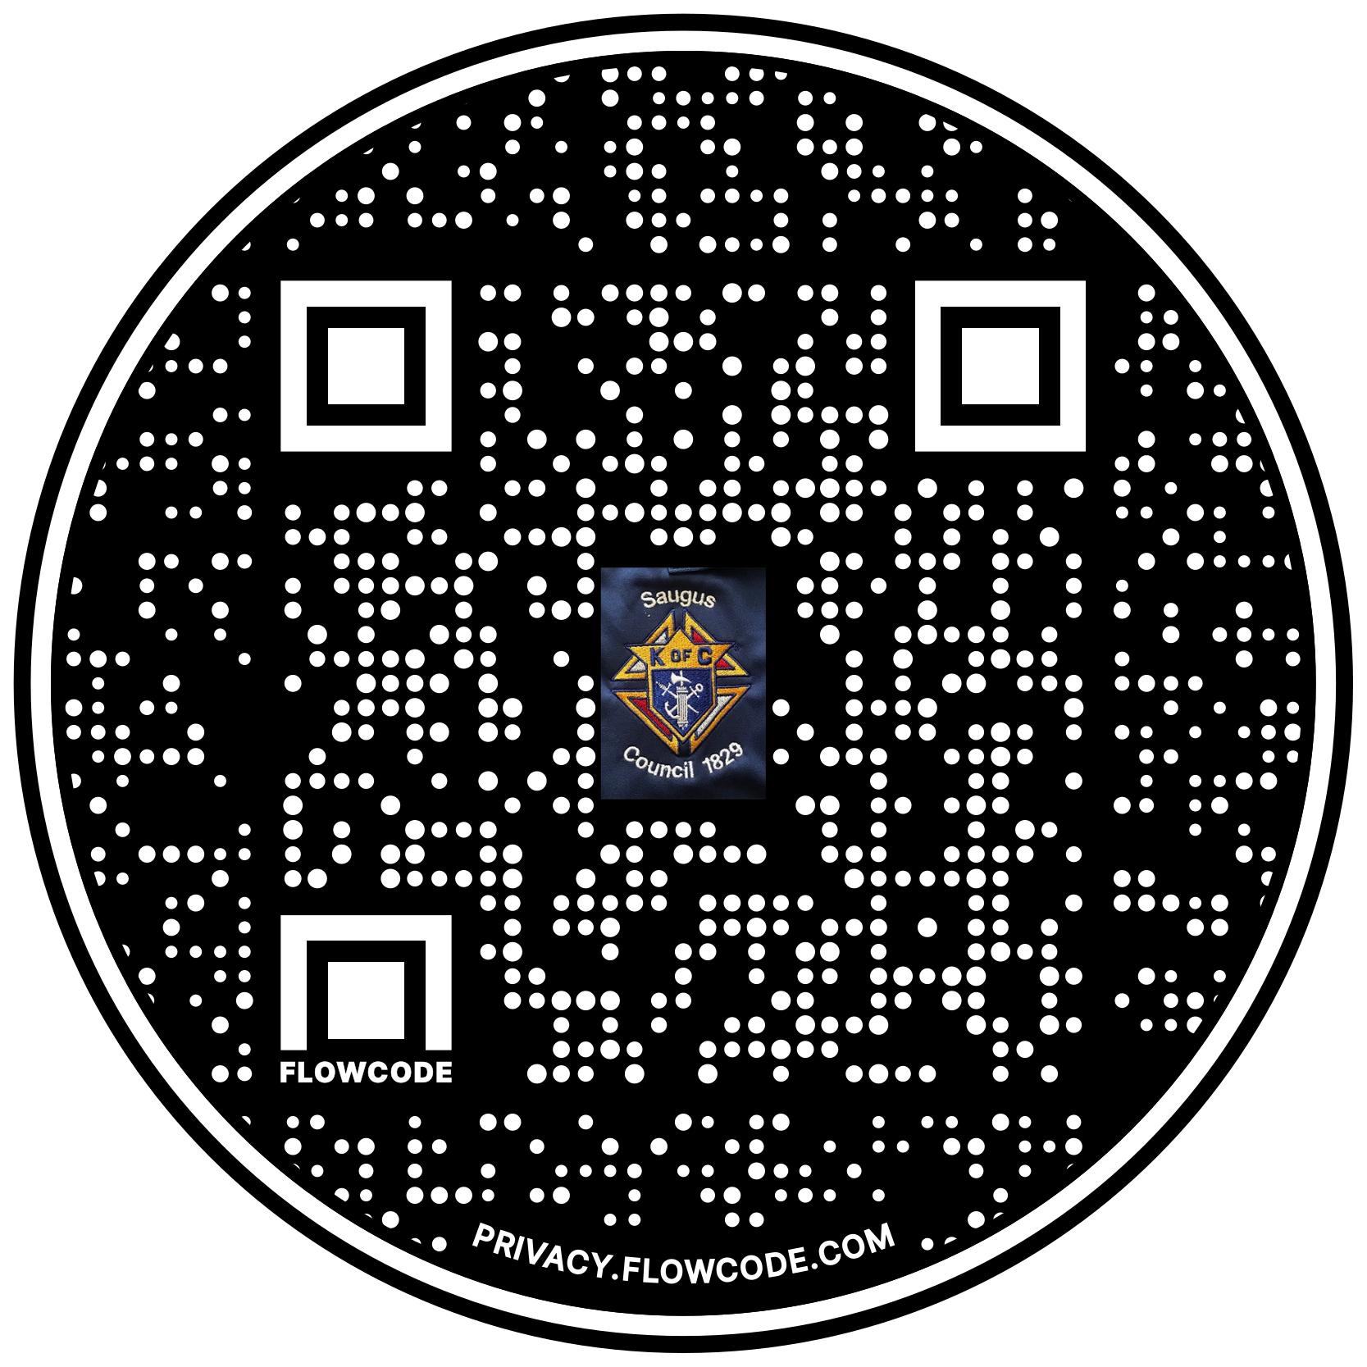

Scan the Code to view the Council Web site!

