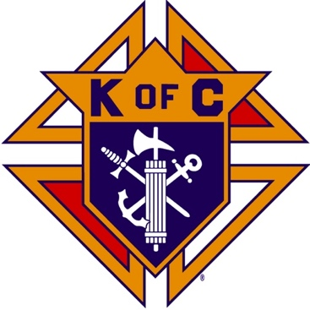
Saugus Knights of Columbus
Council #1829

57 Appleton Street
Saugus, MA 01906

Council Newsletter

Volume 21, Issue 1 www.sauguskofc1829.org December 2024

Grand Knight’s Message
Greetings my brothers.
Another holiday season is upon us. One thing I notice is that people are still saying “happy holidays.” I, for one, still say “Happy Thanksgiving” and “Merry Christmas.” It really bothers me when people write on a card “Merry Xmas.” I was brought up to write the full “Merry Christmas.” This was taught to me by my parents, out of respect for our Lord Jesus Christ. I don't know if this is a lazy person or a person who just doesn't get the full meaning of what Christmas is truly about. I know that our fraternal brothers will say Merry Christmas.
We have a somewhat busy schedule coming up. The council Christmas dinner is on December 5th at 6:00 PM. The menu is ziti, meatballs, sausage-peppers-potatoes, salad and dessert. The meal will be catered by Anthony’s of Malden. See the announcement below. Next up is “Breakfast with Santa” at the Blessed Sacrament church hall on December 14th from 9:00-12:00. This has become, in my opinion, an annual spectacular event. It is a very successful event mainly because we have caring groups of volunteers, such as you brothers, the Woman's Guild, and our very own wives. Thank you for all your time and commitment.
I would like to thank our very own “Ladies of the Knights” for taking time out of their busy lives to set up both Christmas trees. They look beautiful. Karen says they haven't finished decorating the hall yet. I'm sure it will be beautiful when they are done.
A special thanks to those who helped put on the dinner last week, a delicious old-fashioned franks and beans dinner. I forgot how delicious they could be. Also, thanks to the folks who brought the desserts. A quick reminder - breakfast is served every Saturday morning from 8:30 until 9:30. Ask anyone who attends - the meal can't be beat.
I want to wish all my brothers and sisters a very Merry Christmas and a Happy New Year. Please take time to pray for, remember, and thank all of our law enforcement, firefighters, EMS, and military forces during the Christmas season.
God bless you all my brother's
Vivat Jesus
Grand Knight
John Coburn
Upcoming Events
Annual Christmas Party Thursday, December 5, 6-10
RSVP to info@sauguskofc1829.org to purchase tickets - $25 pp.
Breakfast w/ Santa December 14, 9-12
Blessed Sacrament Church Hall

Saturday Morning Breakfast
Breakfast is served from 8:30-9:00 A.M. every Saturday morning.
All are welcome. The fare is only $5.00
John is back. Menu is open.

The Weekly Attendance Pool

The Weekly Attendance Pool is now in full swing. Come to the council, sign the logbook, and put $1 in the pool each week. The weekly number will be drawn on Tuesday after the meeting. If your number is drawn and you have signed in that day you win all that is in the pool. It continues to grow until someone wins. Don’t miss out!

November 05 – 064 – Larry Gallant
November 12 – 122 – Craig Orlando
November 19 – 086 – Henry Leno
November 26 – 160 – Michael Sicuranza

BA1829 Club Numbers

November
November 05 – 17
November 12 – 52
November 19 – 59
November 26 – 76

December Birthdays
Happy Birthday to the following Brothers

02nd – Francis Manning 02nd – Joseph Koslouski
02nd – John Pellegrini 07th – William Breining
10th – Thomas Losco 10th – Gianni Pagliocco
11th – George Egan 13th – James O’Brien
20th – Joseph Mazzone 21st – James Doyle
23rd – Roland DelSapio 28th – Joseph Gould
28th – Joseph Markowski
Members are invited to stop by the lounge for a complimentary beverage of their choice on Tuesday of their birthday week. If your name is listed above, just stop by the Council on Tuesday of that week and present your membership card to the bartender to claim it.

JFK Assembly Meeting

The Fourth Degree meets on the second and fourth Tuesdays at 7:00.

All Worthy Knights are encouraged to attend.

Meeting Schedule
Saugus Council #1829

First Tuesday – Social meeting only - Pizza Night
Second Tuesday – Business meeting
Third Tuesday – Dinner meeting only. The cost for dinner is $10.00.
Fourth Tuesday – Business meeting
Fifth Tuesday (when applicable) – Social meeting only

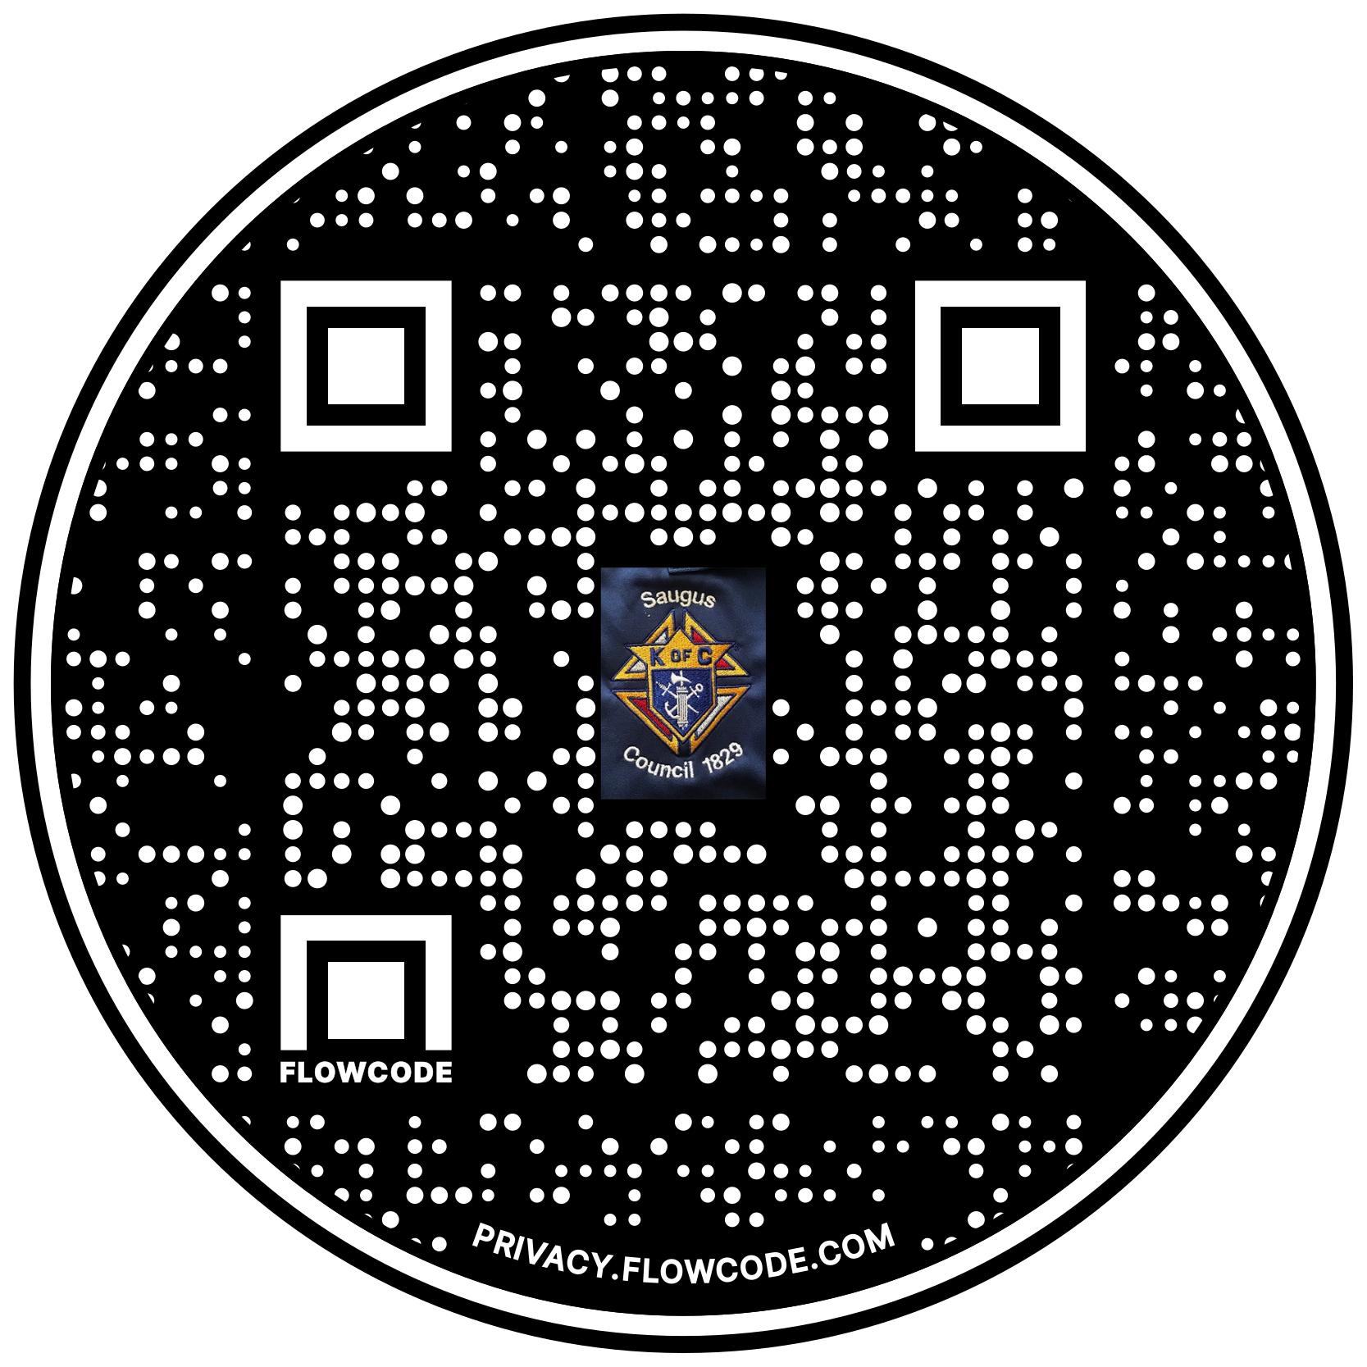

Scan the Code to view the Council Web site!

