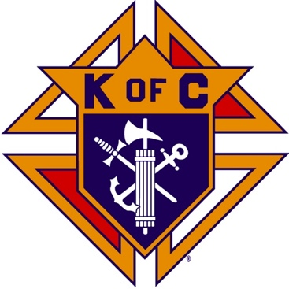
Saugus Knights of Columbus
Council #1829

57 Appleton Street
Saugus, MA 01906

Council Newsletter

Volume 23, Issue 05 www.sauguskofc1829.org May 2026

Grand Knight’s Message
Greetings, my Worthy Brothers.
We made it through another cold and snowy winter. I am totally done with the winter season in Massachusetts. (I say that every year.) This year was extremely harsh and stormy. The good Lord was looking upon us all and gave us the strength to get through it.
March and April were quiet for us in the function room, but the poker tables and the Keno machine have been steady. Chris, Richie, Ronnie, Stevie and Mike Fernandez, thank you for your continued volunteerism at these two events. WE NEED MORE VOLUNTEERS if these events are to continue to flourish.
The Ladies of the Knights have graciously picked up the annual craft fair for us. As you know Paul has handled the craft fair for the past three years. He has decided to step back but he has offered to work with the girls and get them up to speed to continue this successful event. Karen has been in contact with Brother Gerome, Brother Gianetta, several vendors, several local businesses, and the rest of the Ladies Aux and started the process of getting the craft fair in motion. It will be held in the upstairs function room and the downstairs lounge onAugust 8th, 2026. The start time is 8:00 am and will end at 3:00 pm. Karen and the Ladies are looking for VOLUNTEERS!!!! Please help them out. A sign-up sheet will be made available shortly.
A thank you goes out to Brother Ernie and to Brother Jeff for the spectacular haddock dinner. May’s dinner will be held on the 19th. The sign-up sheet is posted.
As most of you Brothers have heard by now, PDD, PGK, and FN Chris Luongo is leaving the council. He and his wife Louise are relocating to Texas. Chris has been an integral part of the Knights of Columbus, and our own Council. Both Chris and Louise have always given us their full support and their volunteer hours are uncountable. As your current Grand Knight, I can honestly say “I’ve learned from the best”. Thank you Chris, you will be missed.
I will be out of the state from May 2nd to May 11th. In my absence, please call Brother Richie or Brother Stephen for any council business. See you shortly.
Vivat Jesus,
Love to all,
John Coburn, Grand Knight
Monthly Social Dinner

The social dinner will be held on May 19, 2026; 6:30 pm – 9:30 pm.
It will be pot roast, oven roasted potatoes, veggies, rolls, dessert, and beverages. The cost is 12.00 per person. LRC and 3 card bingo will follow the dinner.

The Weekly Attendance Pool

The Weekly Attendance Pool is up to $46.00

April 07 083 Tony LaRosa
April 14 105 Nick Melanchook
April 21 173 James Vining
April 28 153 William Schultz

BA1829 Club Numbers
April 07 – 38
April 14 – 48
April 21 – 56
April 28 – 29

Rent Our Function Hall

Eastern Poker Tour

Every Wednesday night, 6:30-10:30 P.M.

Meeting Schedule
Saugus Council #1829

First Tuesday – Social meeting only - Pizza Night
Second Tuesday – Business meeting
Third Tuesday – Dinner meeting only. The cost for dinner is $10/$12.
Fourth Tuesday – Business meeting
Fifth Tuesday (when applicable) – Social meeting only

Saturday Morning Breakfast

John is back. Breakfasts are back.
The fare is only $7.00

Upcoming Events
Eastern Poker Tour every Wednesday, 6:30 – 10:30
Friday Nights at Members’ Lounge every Friday evening, 6:00 – 11:00
Social Meeting Dinner/ LRC game May 19, 6:30 pm – 9:30

May Birthdays
Happy Birthday to the following Brothers

03rd – Thomas Cunningham 09th – Dennis Roy
11th – Charles Naso 11th – John Donovan
13th – Paul Seaman 16th – Michael Boudreau
16th – Ryan Amara 16th – John Meaney
18th – Andrea Paci 19th – Robert Petrillo
19th – Roberto Petrillo 20th – Daniel Prezioso
25th – Roel Benavides 25th – Robert Palleschi
29th – William Petrillo

If your name is listed above, you are invited to stop by the lounge for a complimentary beverage of your choice on Tuesday of your birthday week

Monthly Newsletters
The monthly newsletter files have been added to the Council web site at https://sauguskofc1829.org/newsletters.

You can download a Microsoft Word copy of the file
to your computer/smart phone/tablet any time you wish.

JFK Assembly Meeting

The Fourth Degree meets on the second and fourth Tuesdays at 7:00.

All Worthy Knights are encouraged to attend.

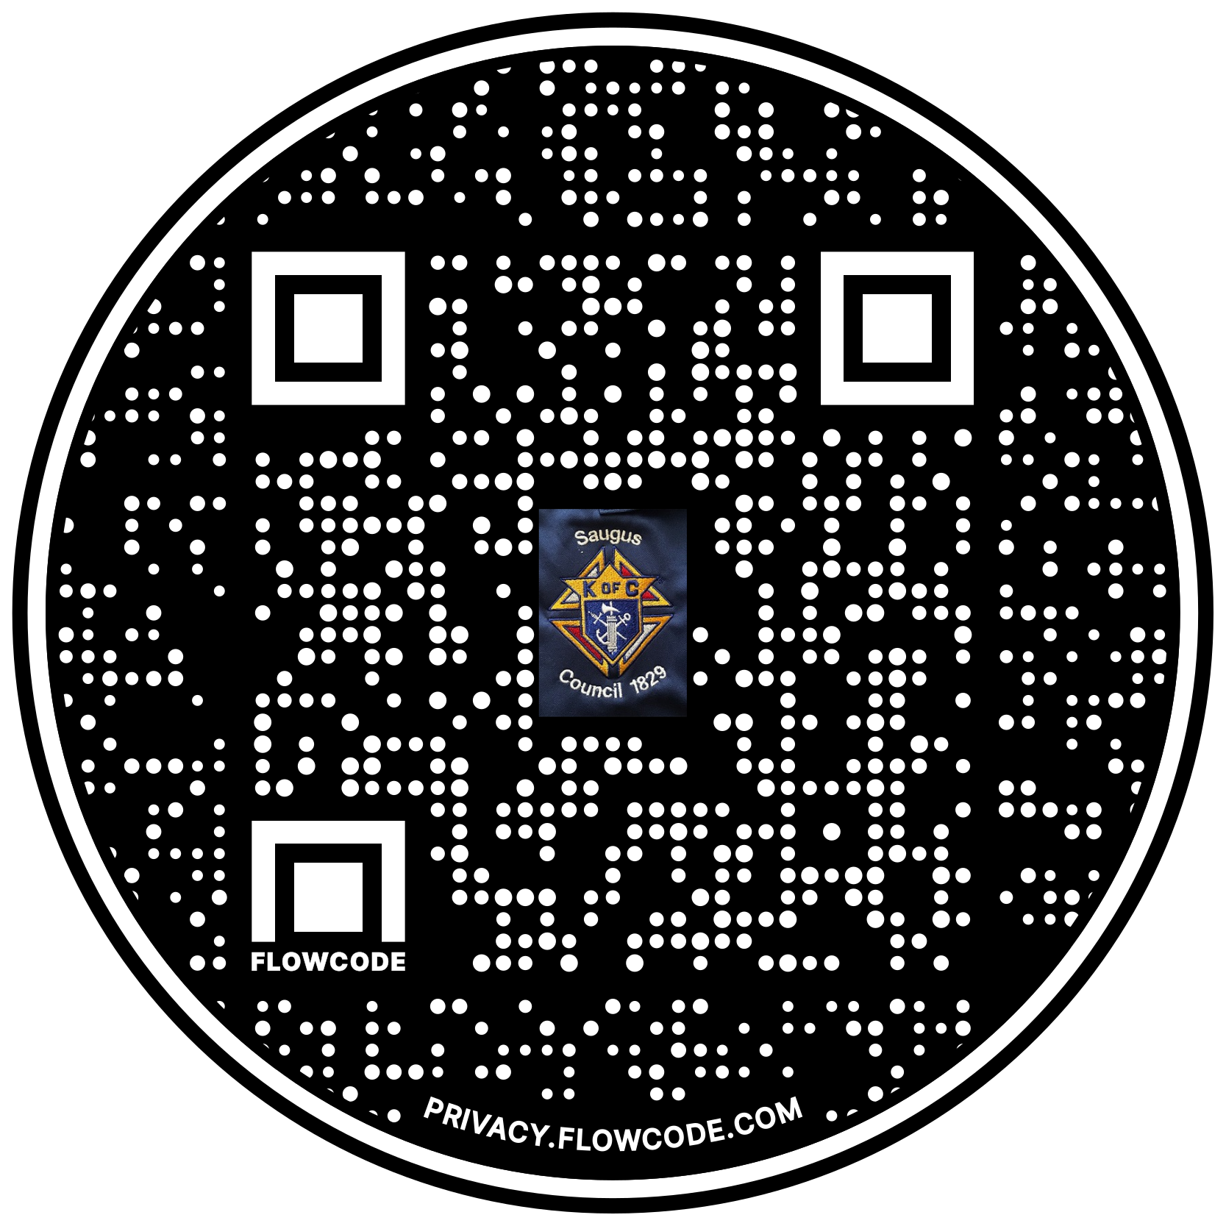

Scan the Code to view the Council Web site!

