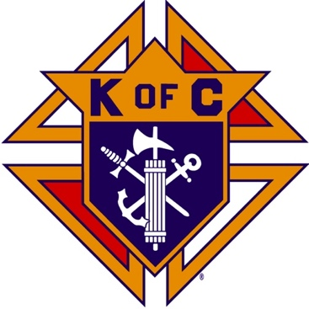
Saugus Knights of Columbus
Council #1829

57 Appleton Street
Saugus, MA 01906

Council Newsletter

Volume 21, Issue 11 www.sauguskofc1829.org November 2024

Grand Knight’s Message
Greetings my Brother Knights,
I would like to thank all of the members who took the time to contact me to make sure Karen and I were safe during and after the recent hurricane we experienced down here in Florida. I will say it definitely was an experience that will stay in my mind for quite a while. Luckily my home was somewhat spared from the devastation other Floridians experienced. I had some minor damages to my roof and carport. Fortunately, I was able to repair the damage within two days.
As I'm sitting here on my lanai writing this letter, I cannot wonder what these other Floridians are going through after having experienced two major hurricanes within three years, Hurricane Ian and Hurricane Milton. I ask myself; how can they recover both financially and mentally. I asked several people, " how do you folks do it?" They all told me that "God only gives them what they can handle," and "God will never abandon them". Now that my brothers is true faith in our Lord. All I can say to them is, " God bless you".
I would like to thank Deputy Grand Knight Rich Aiello for filling in for me during my absence. I really appreciate it. (But don't get comfortable. lol) You really helped me out.
I was told that the annual yard sale was awesome as usual. We made some monies that will come in handy during the year. Brother Paul Gianetta did his usual great job planning and executing his plan. Thank you all for your help and volunteering.
We have a busy holiday schedule coming up. When I get back on November 5th I will get right to work and get us in motion for all of our Holiday events. Again, we will need volunteers. Let's get everyone involved and enjoy ourselves while doing our best for the kids.
Like I stated previously, I will be back on November 5th. I will see you all that night. Also, I will be giving Brother Steve a well-deserved break in the kitchen on Saturdays. "Thank you, Steve,".
Vivat Jesus
Grand Knight
John Coburn

Upcoming Events
Deceased Brother’s Mass November 3; 11:00 am
Blessed Sacrament Church
Annual Christmas Party TBD
Breakfast w/ Santa December 14, 9:00
Blessed Sacrament Church Hall

The Weekly Attendance Pool

The Weekly Attendance Pool is now in full swing. Come to the council, sign the logbook, and put $1 in the pool each week. The weekly number will be drawn on Tuesday after the meeting. If your number is drawn and you have signed in that day you win all that is in the pool. It continues to grow until someone wins. Don’t miss out!

October 01 – 156 – Paul Seaman
October 08 – 087 – Steve Lentini
October 15 – 037 – Joseph Dauenhauer
October 22 – 111 – Peter Morris
October 29 – 042 – Joseph DiBella

BA1829 Club Numbers

October
October 01 – 33
October 08 – 18
October 15 – 68
October 22 – 43
October 29 – 90

November Birthdays
Happy Birthday to the following Brothers

01st – John O’Connell 02nd – Steven Duplisea
04th – Robert Favuzza 06th – Rev. Daniel McCoy
09th – Stephen Gerome 13th – Kevin O’Neill
17th – Vincent Sclafani 18th – Stephen Socci
20th – James Hogan 20th – Alfred Sabella
21st – Henry Leno 23rd – Lawrence Donovan
26th – Paul Arinello 27th – Vincent Zinna
30th – Kevin Ring
Members are invited to stop by the lounge for a complimentary beverage of their choice on Tuesday of their birthday week. If your name is listed above, just stop by the Council on Tuesday of that week and present your membership card to the bartender to claim it.

Saturday Morning Breakfast
Breakfast is served from 8:30-9:00 A.M. every Saturday morning.
All are welcome. The fare is only $5.00
Menu:
November 02 – Pancakes and sausage patties
November 09 – 29
John is back. Menu is open.

JFK Assembly Meeting

The Fourth Degree meets on the second and fourth Tuesdays at 7:00.

All Worthy Knights are encouraged to attend.

Meeting Schedule
Saugus Council #1829

First Tuesday – Social meeting only - Pizza Night
Second Tuesday – Business meeting
Third Tuesday – Dinner meeting only. The cost for dinner is $10.00.
Fourth Tuesday – Business meeting
Fifth Tuesday (when applicable) – Social meeting only

Friday Night Socials
The downstairs hall is open every Friday night.
7:00 – 10:00 p.m.
Come socialize with your brother knights and their guests.

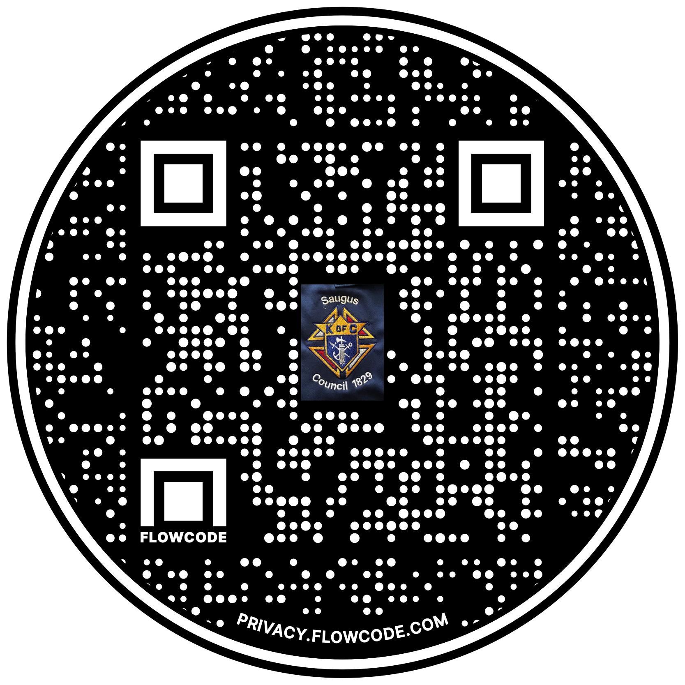

Scan the Code to view the Council Web site!

