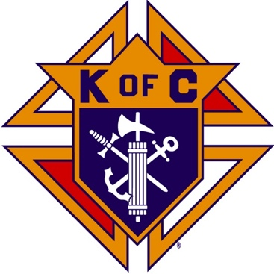
Saugus Knights of Columbus
Council #1829

57 Appleton Street
Saugus, MA 01906

Council Newsletter

Volume 23, Issue 06 www.sauguskofc1829.org June 2026

Grand Knight’s Message
Greetings, my Worthy Brothers.
My Worthy Brothers, summer is almost here. Pretty soon we will have 80- and 90-degree days, and nice enjoyable evenings. Right now, we must get by this rainy and cool weather we have now.
Our function hall schedule for the month of June is packed solid. Most weekends have Saturday and Sunday booked. One weekend is Friday, Saturday, and Sunday. Make sure you all recommend our function hall to all your friends.
It looks like our remodel job is starting to get off the ground. DGK Rich has already lined up a painter for the foyer and the function hall. We are still trying to figure out what to do about the ceiling tiles. We already have new sconces for the walls and most importantly Brother Frank has graciously informed me that he will pay for the paint. Thank you Frank.
Our annual Family Day BBQ will be on June 28th. Brother Andrea, and Brother Henry will be the master chefs. We are still seeking volunteers to assist in setting up, serving, and cleaning. We are also asking for donations from the members to buy the food, that way we will not have to take money from the treasury. So far, the donations of both money and food have been super.
On a different note, but on the same subject, Karen and I would like to host the Family Day BBQ at our home. We have several large canopies, a built-in pool, plenty of parking, and a huge yard for the kids to play in. I personally would love to have you all bring your children, or grandchildren. Let me know.
Don’t forget council elections are this month. A sample ballot is on the white board. The elections will be held on the 9th of June at our regular business meeting.
Brother Chris Luongo moved to Texas this past Saturday morning. He has, in my opinion, been the glue that has held this council together during his time here. Chris, on personal note, and I think I will speak for the entire council, thank you. Good luck to both you and Louise and may Jesus always have your backs.
Vivat Jesus.
John Coburn, Grand Knight
Saugus Council 1829
Elections

Both Assembly and Council elections will be held at the first
monthly meeting on Tuesday, June 9, 2026.

Contact the Election Committee if you want to be a
candidate for an officer position.

Be sure to attend to make your vote count.

Monthly Social Dinner

The social dinner will be held on June 16, 2026; 5:30 pm – 9:30 pm.
The dinner will be homemade Italian subs, with salad, dessert, and beverages. The cost is 10.00 per person. LRC and 3 card bingo will follow the dinner.

The Weekly Attendance Pool

The Weekly Attendance Pool is up to $92.00

May 05 153 William Schultz
May 12 125 Giani Pagliocco
May 19 153 William Schultz
May 26 028 Alexander Cody

BA1829 Club Numbers
May 05 – 48
May 12 – 96
May 19 – 05
May 26 –29

Rent Our Function Hall

Eastern Poker Tour

Every Wednesday night, 6:30-10:30 P.M.

Saturday Morning Breakfast

John is back. Breakfasts are back.
The fare is only $7.00

Meeting Schedule
Saugus Council #1829

First Tuesday – Social meeting only - Pizza Night
Second Tuesday – Business meeting
Third Tuesday – Dinner meeting only. The cost for dinner is $10/$12.
Fourth Tuesday – Business meeting
Fifth Tuesday (when applicable) – Social meeting only

Upcoming Events

Council/Assembly Elections June 9, at the weekly meeting
Social Meeting Dinner/ Card games June 16, 6:30 pm – 9:30
Family Day BBQ June 28, 12:00 – 3:00
Eastern Poker Tour every Wednesday, 6:30 – 10:30
Friday Nights at Members’ Lounge every Friday evening, 6:00 – 11:00

June Birthdays
Happy Birthday to the following Brothers

01st – Harold Doucette 01st – Michael Blandini
08th – Charles Leone 10th – Raymond O’Neill Jr.
13th – Michael Ragucci 14th – Francis McKinnon
15th – Peter Blais 15th – Stephen Lentini
17th – Arthur Perham 24th – Deacon Jorge Patino
26th – Edward Wawrzynowicz 30th – Joseph DiBella

If your name is listed above, you are invited to stop by the lounge for a complimentary beverage of your choice on Tuesday of your birthday week

Monthly Newsletters
The monthly newsletter files have been added to the Council web site at https://sauguskofc1829.org/newsletters.

You can download a Microsoft Word copy of the file
to your computer/smart phone/tablet any time you wish.

JFK Assembly Meeting

The Fourth Degree meets on the second and fourth Tuesdays at 7:00.

All Worthy Knights are encouraged to attend.

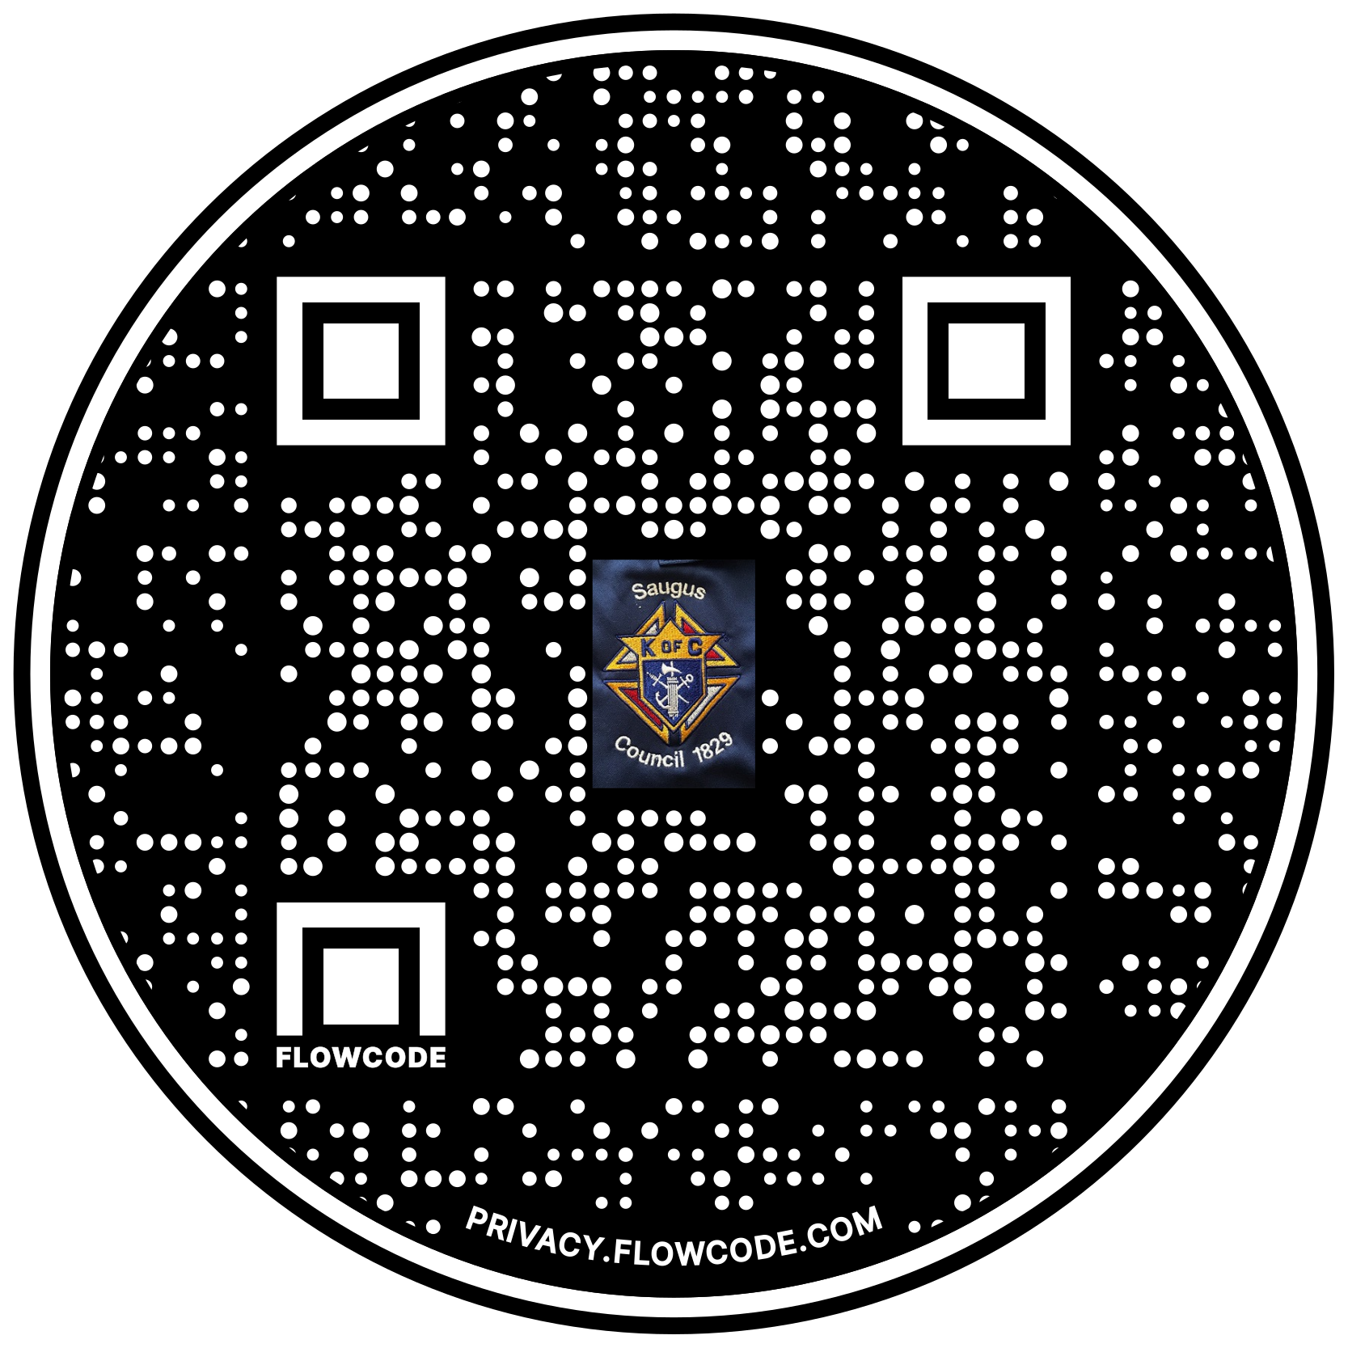

Scan the Code to view the Council Web site!

