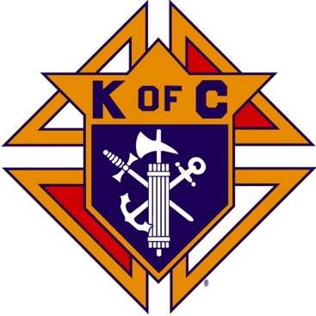
Saugus Knights of Columbus
Council #1829

57 Appleton Street
Saugus, MA 01906

Council Newsletter

Volume 22, Issue 9 www.sauguskofc1829.org September 2025

Grand Knight’s Message
My Worthy Brothers,
Summer has passed by. It went by like a blink of the eye. It seems like Memorial Day was yesterday. We did, however, have a somewhat busy time at the council. We had several functions happen, like our weekly Saturday breakfasts, our monthly social dinners, our after-dinner left-right-center games, and our weekly Council meetings. We have several important functions coming up. We have the Founders Day table on September 13th, our very own indoor flea market on September 27th, and the Mass on the Grass at the Blessed Sacrament Church on September 21st.
I would like to form a committee to explore ways to inform our community residents about our hall rentals. We need to explore ways to get our function hall availability out to our residents. I am surprised that we had only one graduation party this summer. Brothers, we need hall rentals to help with our council expenses. Winter is coming and so are the heating bills and plowing bills. We are posting on FB but that doesn’t seem to be working. We have several hall decorators that mention us to their prospective clients, but not enough bookings have come our way. Several members have suggested updating the hall, but that takes money. To that part I am saying that we are working on it.
Our next social dinner is on September 16, 2025. The dinner on that evening will be sausage and/or meatball subs, salad, and soda. The cost is 10.00 per person. The sign-up sheet will be posted on the whiteboard. If you do not sign, then you will not be guaranteed a meal.
That’s it for now. My editor/publisher says my letters are too long and wordy, See you all Tuesday night.
Vivat Jesus,
John Coburn, Grand Knight
Saugus Council 1829.

Saturday Morning Breakfast
Breakfast is served from 8:30-9:00 A.M. every Saturday morning.
All are welcome. The fare is only $7.00

Upcoming Events
Founder’s Day September 13, 8:00 – 3:00
Social Meeting Dinner Tuesday, September 16, 6:30 P.M.
See the flyer later in this newsletter for menu and details.
Indoor Craft Fair/Flea Market September 27, 8:00 – 3:00
Deceased Brothers’ Mass Sunday, November 9, 11:00 mass

BA1829 Club Numbers

August 05 – 50
August 12 – 15
August 19 – 35
August 26 – 86

The Weekly Attendance Pool

The Weekly Attendance Pool is up to $132.

August 05 181 Domenic Amara
August 12 201 Richard Salerno
August 19 112 Anthony Moscaritolo
August 26 123 Andrea Paci

September Birthdays
Happy Birthday to the following Brothers

01st – Gerald Page 04th – John Millar
04th – Steven Fernandez 10th – Christopher Rich
12th – John Coburn 16th – Derek Cipriano
22nd – Steven Johnson 22nd – Jason Vining
27th – Chris Luongo 30th – Frank Sanfilippo

If your name is listed above, you are invited to stop by the lounge for a complimentary beverage of your choice on Tuesday of your birthday week

JFK Assembly Meeting

The Fourth Degree meets on the second and fourth Tuesdays at 7:00.

All Worthy Knights are encouraged to attend.

Meeting Schedule
Saugus Council #1829

First Tuesday – Social meeting only - Pizza Night
Second Tuesday – Business meeting
Third Tuesday – Dinner meeting only. The cost for dinner is $10/$12.
Fourth Tuesday – Business meeting
Fifth Tuesday (when applicable) – Social meeting only

Word Search

10. RISE OF THE MONARCHY

G | O | O | P | H | T | A | I | L | O | G | G | V | O | E | D | P | G | R | C | A | B
I | R | H | A | N | N | A | H | X | P | E | T | U | I | M | P | I | X | G | P | I | B
D | P | I | H | S | G | N | I | K | J | D | M | B | V | C | H | B | V | T | C | E | S
C | K | N | M | J | I | N | H | P | O | H | V | Q | X | S | X | C | V | A | T | W | A
A | K | E | L | A | B | A | N | U | V | S | T | K | E | A | G | X | O | H | D | R | U
B | E | T | R | A | Y | A | L | L | E | T | T | F | E | U | D | T | L | R | F | O | L
E | L | E | U | M | A | S | A | H | E | N | I | H | P | L | H | E | W | H | B | D | S
W | E | H | N | E | R | K | F | L | T | A | F | P | F | I | H | G | L | E | A | N | R
Z | O | N | Z | A | W | M | P | A | I | A | W | S | X | E | R | B | L | U | T | E | E
L | C | A | H | L | I | A | G | I | B | A | E | T | M | I | P | I | W | O | T | F | I
P | I | H | S | D | N | E | I | R | F | N | J | F | E | L | V | L | Q | J | L | O | G
R | V | T | T | R | J | E | S | S | E | S | E | F | E | J | A | F | A | P | E | H | N
M | K | A | S | L | S | D | R | Z | S | H | A | R | S | D | O | N | G | H | N | C | R
G | E | N | R | Q | W | D | T | N | A | N | E | V | O | C | B | Q | E | M | C | T | R
A | K | O | X | I | P | Z | V | P | H | I | L | I | S | T | I | N | E | S | Z | I | N
S | M | J | G | N | I | T | N | I | O | N | A | J | N | P | W | C | X | F | K | W | M
N | O | I | S | S | E | C | C | U | S | E | E | S | I | R | S | D | I | V | A | D | V
V | I | C | T | O | R | Y | V | U | L | O | Y | A | L | T | Y | B | D | G | O | Q | T

Abigail Eli Loyalty
Abner Friendship Michal
Anointing Goliath Philistines
Battle Grief Phinehas
Bethlehem Hannah Samuel
Betrayal Horni Saul
Covenant Jesse Sauls Reign
David Jonathan Succession
Davids Rise Kingship Victory
Defeat Laban Witch of Endor

Last Month’s Solution
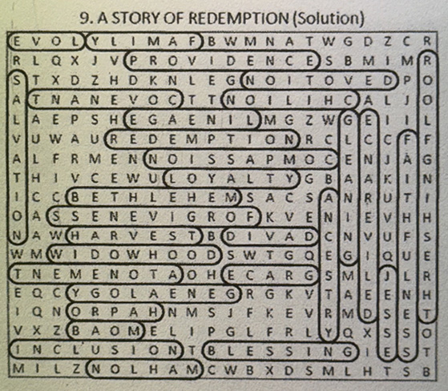

Monthly Newsletters
The monthly newsletter files have been added to the Council web site at https://sauguskofc1829.org/newsletters.

You can download a Microsoft Word copy of the file
to your computer/smart phone/tablet any time you wish.

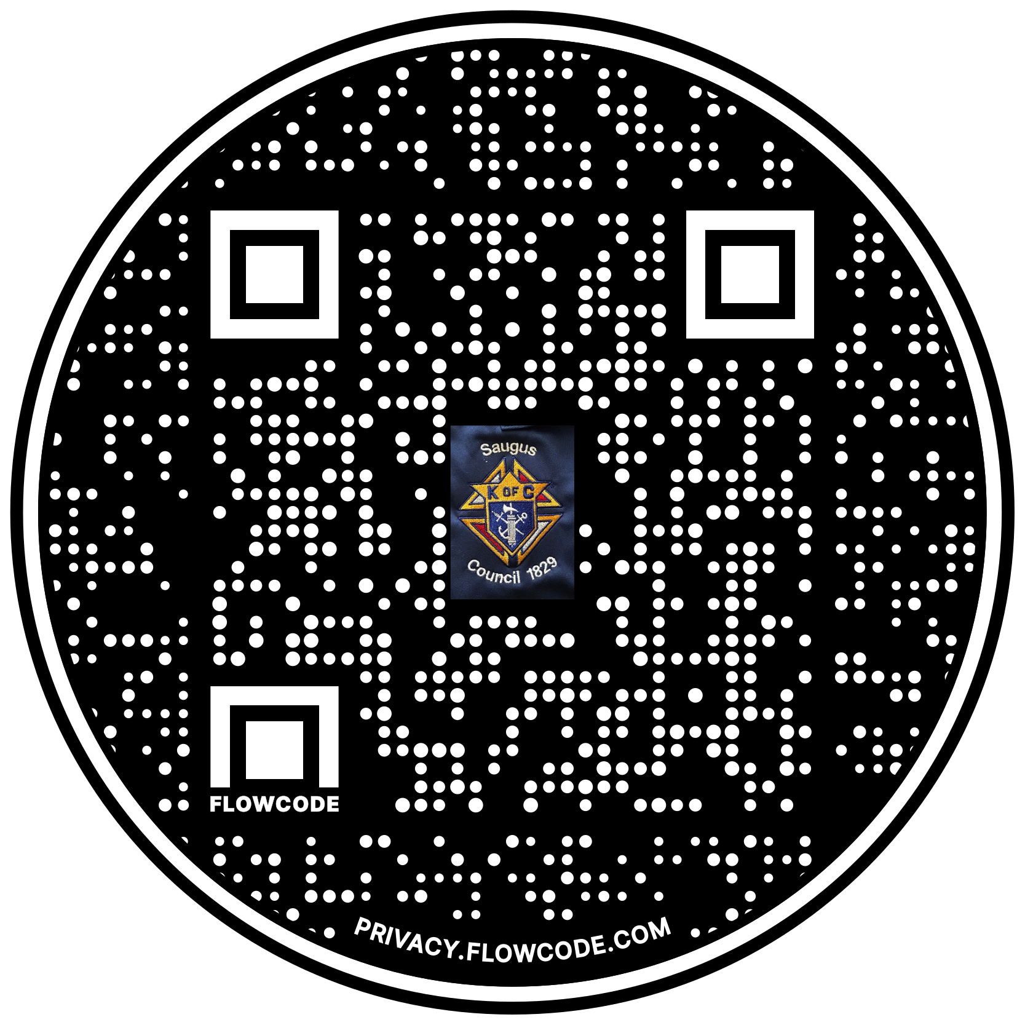

Scan the Code to view the Council Web site!

