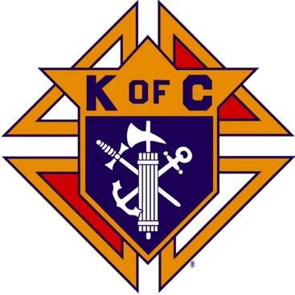
Saugus Knights of Columbus
Council #1829

57 Appleton Street
Saugus, MA 01906

Council Newsletter

Volume 22, Issue 6 www.sauguskofc1829.org June 2025

Grand Knight’s Message
Hello, Worthy Brothers,
The month of May has come and gone already. The summer has arrived and with it comes the great weather. We have several things planned for the upcoming summer. See the schedule later in this newsletter.
I need to put together a crew to clean up the upstairs closet where we store the tables and chairs. It can probably be done in about two hours. Also, the furnace room needs to be cleaned as well. Also, the outside lighting and kitchen electrical issues downstairs are being addressed. Our own member Al is currently putting together a stock list, and he will be taking care of this matter.
We will be electing new officers this month. Please consider running for a position. New blood is always welcomed and appreciated. Keep in mind we still desperately need a recording secretary.
Karen has volunteered to cook again for our June social dinner. The cost will be 10.00 per person. Due to the number of wasted meals from no-shows at the last dinner, payment will be collected at the business meeting before the social dinner. So sorry. On a personal note, I would like to thank all the ladies who help out with our dinners. Karen also sends her thanks. Without your help there would be no social dinners.
I would ask all members to recommend our function hall to whomever is looking for a hall for birthday parties, graduations, wedding and baby showers, or funeral collations. We have had many inquiries from our members about redoing the function over. An undertaking of that size requires money, volunteers, and planning. Let’s do it!!
Saturday morning breakfasts have been going great. There are 12 to 18 diners every week. Come down and enjoy the fine cuisine Chef Steve and Chef John offer between 8:30 and 9:30.
In ending I would like to thank God the Almighty and his son Jesus Christ for making our lives worth living. I ask us all to remember the sacrifices our veterans have made in giving us a free country. I ask the good Lord to watch over us all and keep us safe. Amen.
Vivat Jesus
John F. Coburn,
Grand Knight
District Deputy’s Message

Worthy Council Officers, I bring you greetings from Supreme Knight Patrick Kelly and State Deputy Bob Schwarz.
- This is the last month of 2025 to reach our goals. Is your council meeting STAR requirements? Planning on a STAR lunch this year?
- Councils have been doing great moving members from the Prospect tabs into councils. Thank you for having these members in your councils allowing your council to stay relevant.
- All Councils should be submitting their Columbian Award Form SP7.
- All Councils should start submitting 185 and 365 for years 2025-2026, copy your DD and send to Supreme.
- State Incentives for Membership:
  - Councils get $100 for coming off the “Zero Members List” from the State!
  - Gold pen for the #1 Recruiter in 2024/2025 by percentage.
  - Delta Church drives, with prospect cards proof will get a gift card to raffle at council exemplification.
  - Supreme Contest March 31/June 30 have 125% membership get a council banner.
- 4th Degree needs new members for the June 22nd Exemplification (125 new members goal) If you have men interested, please get information to a 4th degree assembly or Master Stan Ciukaj (email: stanley@waretv.org).
- Upcoming State Dates:
  - June 26th - Past State Officers Dinner. EnVision Hotel, Mansfield, MA.
  - June 27th - State Golf Outing
  - June 28th - State Training for GK, FS, DD’s. EnVision Hotel, Mansfield, MA.

Saturday Morning Breakfast
John is back!!
Breakfast is served from 8:30-9:00 A.M. every Saturday morning.
All are welcome. The fare is only $7.00

Elections

Both Assembly and Council elections will be held at the first
monthly meeting on Tuesday, June 10, 2025.

Contact GK John Coburn if you want to be a
candidate for an officer position.

Be sure to attend to make your vote count.

Upcoming Events
Council Elections Tuesday, June 10
Social Meeting Dinner Tuesday, June 17, 6:30 P.M.
We will be serving American chop suey, Italian bread, salad, and dessert. The price is $10.00 per person. As usual, all are welcome to bring their wives and girlfriends. The sign-up sheet is posted in the downstairs meeting hall near the kitchen. After the meal we plan to have a Left-Right-Center game.
Family Day BBQ Sunday, June 29, 2025, 12:00-4:00
Indoor Craft Fair/Flea Market October 19, 8:00 – 3:00
Deceased Brothers’ Mass Sunday, November 9, 11:00 mass

BA1829 Club Numbers

May 06 – 47
May 13 – 27
May 20 – 83
May 27 – 79

The Weekly Attendance Pool

The Weekly Attendance Pool is up to $132. Come to the council, sign the logbook, and put $1 in the pool each week. The weekly number will be drawn on Tuesday after the meeting. If your number is drawn and you have signed in that day you win all that is in the pool. It continues to grow until someone wins. Don’t miss out! The numbers for the past month:

May 06 191 Robert McHugh
May 13 024 Darid Cerulo
May 20 104 Vinnie Zinna
May 27 128 Paul Pantano

June Birthdays
Happy Birthday to the following Brothers

01st – Harold Doucette 01st – Michael Blandini
08th – Charles Leone 10th – Raymond O’Neill Jr.
13th – Michael Ragucci 14th – Francis McKinnon
15th – Peter Blais 15th – Stephen Lentini
17th – Arthur Perham 24th – Deacon Jorge Patino
26th – Edward Wawrzynowicz 30th – Joseph DiBella

If your name is listed above you are invited to stop by the lounge for a complimentary beverage of your choice on Tuesday of your birthday week

JFK Assembly Meeting

The Fourth Degree meets on the second and fourth Tuesdays at 7:00.

All Worthy Knights are encouraged to attend.

Meeting Schedule
Saugus Council #1829

First Tuesday – Social meeting only - Pizza Night
Second Tuesday – Business meeting
Third Tuesday – Dinner meeting only. The cost for dinner is $10.00.
Fourth Tuesday – Business meeting
Fifth Tuesday (when applicable) – Social meeting only

Word Search

7. CONQUEST OF CANAAN

Y | R | O | T | C | I | V | C | S | P | R | O | M | I | S | E | D | L | A | N | D | J
R | K | K | C | H | O | C | I | K | V | S | R | E | L | C | A | N | R | E | B | A | T
M | U | L | A | L | A | T | T | S | W | E | C | B | W | M | I | A | T | X | V | F | P
O | Q | G | G | L | M | D | I | X | S | T | C | R | O | S | S | I | N | G | E | X | E
U | J | V | E | I | M | N | E | S | P | I | C | U | H | J | J | L | K | G | E | L | G
N | W | B | V | T | E | O | S | E | U | V | C | M | C | H | O | Q | D | G | A | U | Z
T | M | F | U | S | H | E | O | I | C | E | H | L | I | A | P | P | A | Q | H | R | A
G | E | P | W | D | C | B | F | P | H | L | T | E | R | H | H | R | K | Z | A | A | C
E | M | Y | Z | N | E | I | R | S | I | J | I | H | E | V | U | D | A | O | E | Z | O
R | O | S | L | A | H | G | E | N | U | M | A | N | J | O | E | C | H | Z | C | A | N
I | R | A | W | T | S | D | F | X | T | N | F | B | C | H | Q | P | R | R | M | E | Q
Z | I | T | R | S | M | T | U | E | L | T | T | A | B | I | G | R | S | N | G | L | U
I | A | S | P | N | K | J | G | O | U | V | G | R | B | A | H | A | R | A | K | E | E
M | L | O | W | U | H | U | E | W | O | G | G | W | T | O | A | L | T | A | R | V | S
Z | S | P | J | S | C | J | R | E | V | I | R | N | A | D | R | O | J | F | X | W | T
N | A | A | S | N | L | S | E | S | O | M | F | O | W | A | L | A | E | B | A | L | F
H | I | G | H | P | R | I | E | S | T | W | E | L | V | E | T | R | I | B | E | S | W
D | F | G | I | L | G | A | L | L | Z | O | R | Y | R | T | A | L | O | D | I | R | P

Ai Ebal Memorials
Altar Eleazar Mount Gerizim
Apostasy Faith Promised Land
Battle Gibeon Rahab
Caleb Gilgal Shechem
Cities of Refuge High Priest Spies
Conquest Idolatry Sun Stand Still
Courage Jericho Tabernacle
Crossing Jordan River Twelve Tribes
Law of Moses Levites Victory

Last Month’s Solution

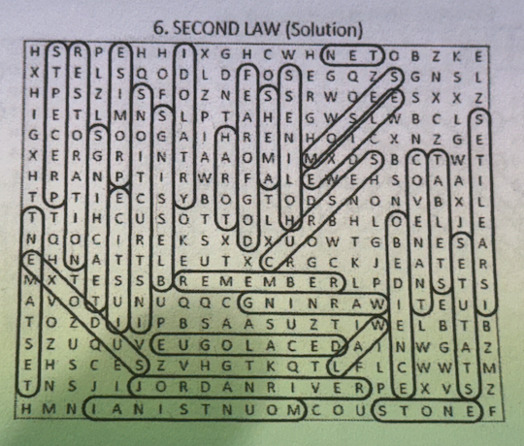

Monthly Newsletters
The monthly newsletter files have been added to the Council web site at https://sauguskofc1829.org/newsletters.

You can download a Microsoft Word copy of the file
to your computer/smart phone/tablet any time you wish.

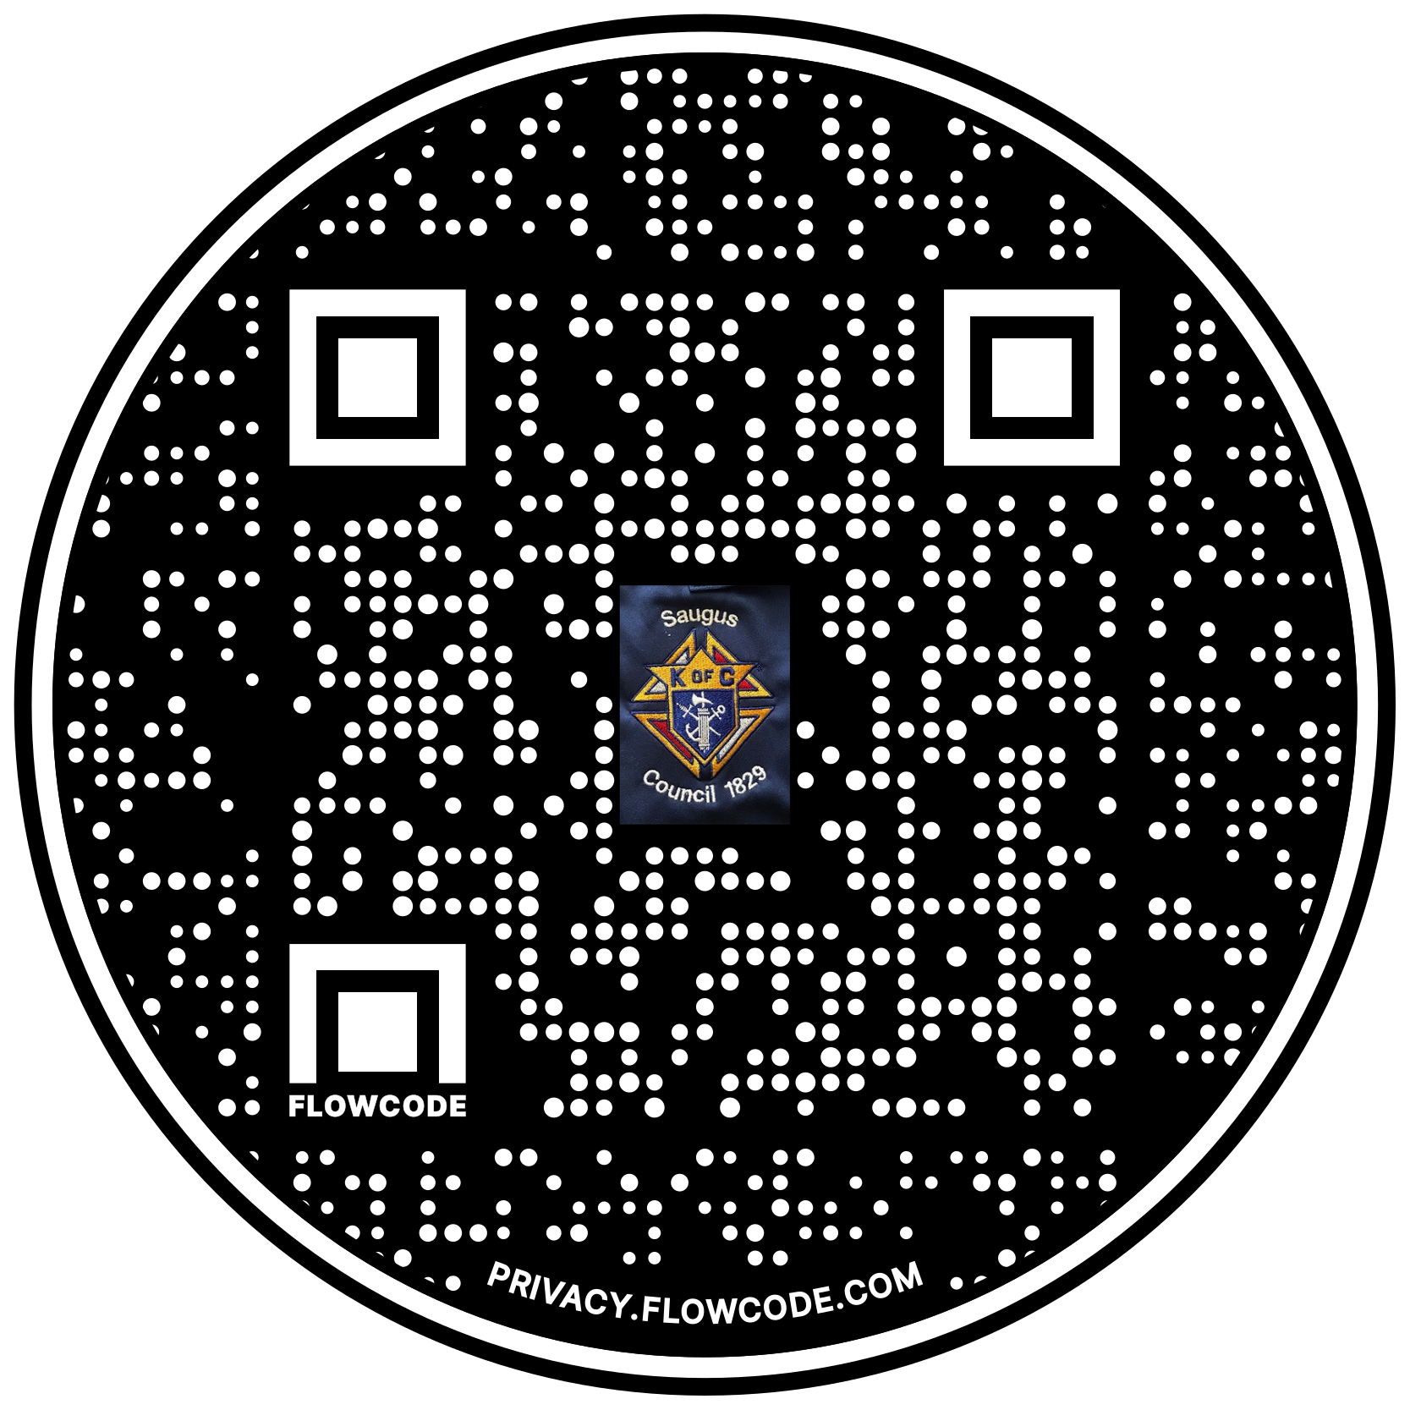

Scan the Code to view the Council Web site!

