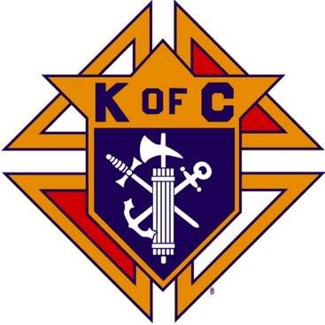
Saugus Knights of Columbus
Council #1829

57 Appleton Street
Saugus, MA 01906

Council Newsletter

Volume 22, Issue 12 www.sauguskofc1829.org December 2025

Grand Knight’s Message
Hello, my Worthy Brothers.
December will be an extremely busy month for our council. We have functions every weekend. Several are both Saturday and Sunday, and some are during the week as well.
We have several events coming up that should interest us all. Our annual Christmas party is being held on December 5th in our function hall. Prince Pizza will cater our meal. See the information later in this newsletter.
Breakfast with Santa is being held on December 13th at the Blessed Sacrament Church from 9am to 12pm. It is free to all. We need volunteers to make it work. Gerry Laney, who usually sets up the hall for the church, is recovering from surgery. I will need two or three council members to assist me in putting out the tables and chairs. Let me know if you can help.
Our monthly social dinner is being held on December 16th in the members lounge. The menu is salad, stuffed shells, meatballs, sausage, scali bread, beverage, and dessert. The cost is 12.00 per person.
I, along with several other members have expressed interest in having a New Years Eve get together in the 1829 Club on December 31st from 4pm until 8pm. That way we can all be in bed after the 11pm news, like we always are. The fare will be pot luck, so we can all bring whatever you want. The bar will be open for service and we will raffle off a door prize as well. Please get back to me by December 16th.
On a personal note, it has been my pleasure to serve as your Grand Knight for the year 2025. We have made many strides within the Council. Our attendance is up, we now have Keno, we have a weekly poker event, our Saturday morning breakfast club is thriving, our monthly social dinner is growing every month, we have a very active ladies auxiliary, and it only possible because Saugus Knights of Columbus, Council 1829, is a TEAM. Made up of US. If I don't see any of you before Christmas, MERRY CHRISTMAS!!
John Coburn
Grand Knight,
Saugus Council 1829

Christmas Party

Friday night, December 5, 6:30-10:30 P.M.

Menu: Antipasto; Lasagna w/ beef; chicken parmigiana;
meatballs; chicken, broccoli, penne; eggplant rollatini; dessert.

The Weekly Attendance Pool

The Weekly Attendance Pool is up to $149.

November 04 133 James Petrillo
November 11 No meeting
November 18 182 Ryan Amara
November 25 032 Paul Corsino

BA1829 Club Numbers
November 04 – 39
November 11 – 76
November 18 – 78
November 25 – 29

Rent Our Function Hall

Eastern Poker Tour

Every Wednesday night, 6:30-10:30 P.M.

Saturday Morning Breakfast
Breakfast is served from 8:30-9:00 A.M. every Saturday morning.
All are welcome. The fare is only $7.00

Upcoming Events
Eastern Poker Tour every Wednesday 6:30 – 10:30
Social Meeting Dinner/ LRC game Tuesday, December 16, 6:30 P.M.
Menu: Salad, stuffed shells, meatballs, sausages, dessert.
Christmas Party December 5, 6:30-10:00 P.M.
Breakfast with Santa December 13, 9:00-12:00

JFK Assembly Meeting

The Fourth Degree meets on the second and fourth Tuesdays at 7:00.

All Worthy Knights are encouraged to attend.

December Birthdays
Happy Birthday to the following Brothers

02nd – Francis Manning 02nd – Joseph Koslouski
02nd – John Pellegrini 07th – William Breining
10th – Thomas Losco 10th – Gianni Pagliocco
11th – George Egan 13th – James O’Brien
20th – Joseph Mazzone 21st – James Doyle
23rd – Roland Del Sapio 28th – Joseph Gould
28th – Joseph Markowski

If your name is listed above, you are invited to stop by the lounge for a complimentary beverage of your choice on Tuesday of your birthday week

Meeting Schedule
Saugus Council #1829

First Tuesday – Social meeting only - Pizza Night
Second Tuesday – Business meeting
Third Tuesday – Dinner meeting only. The cost for dinner is $10/$12.
Fourth Tuesday – Business meeting
Fifth Tuesday (when applicable) – Social meeting only

Monthly Newsletters
The monthly newsletter files have been added to the Council web site at https://sauguskofc1829.org/newsletters.

You can download a Microsoft Word copy of the file
to your computer/smart phone/tablet any time you wish.

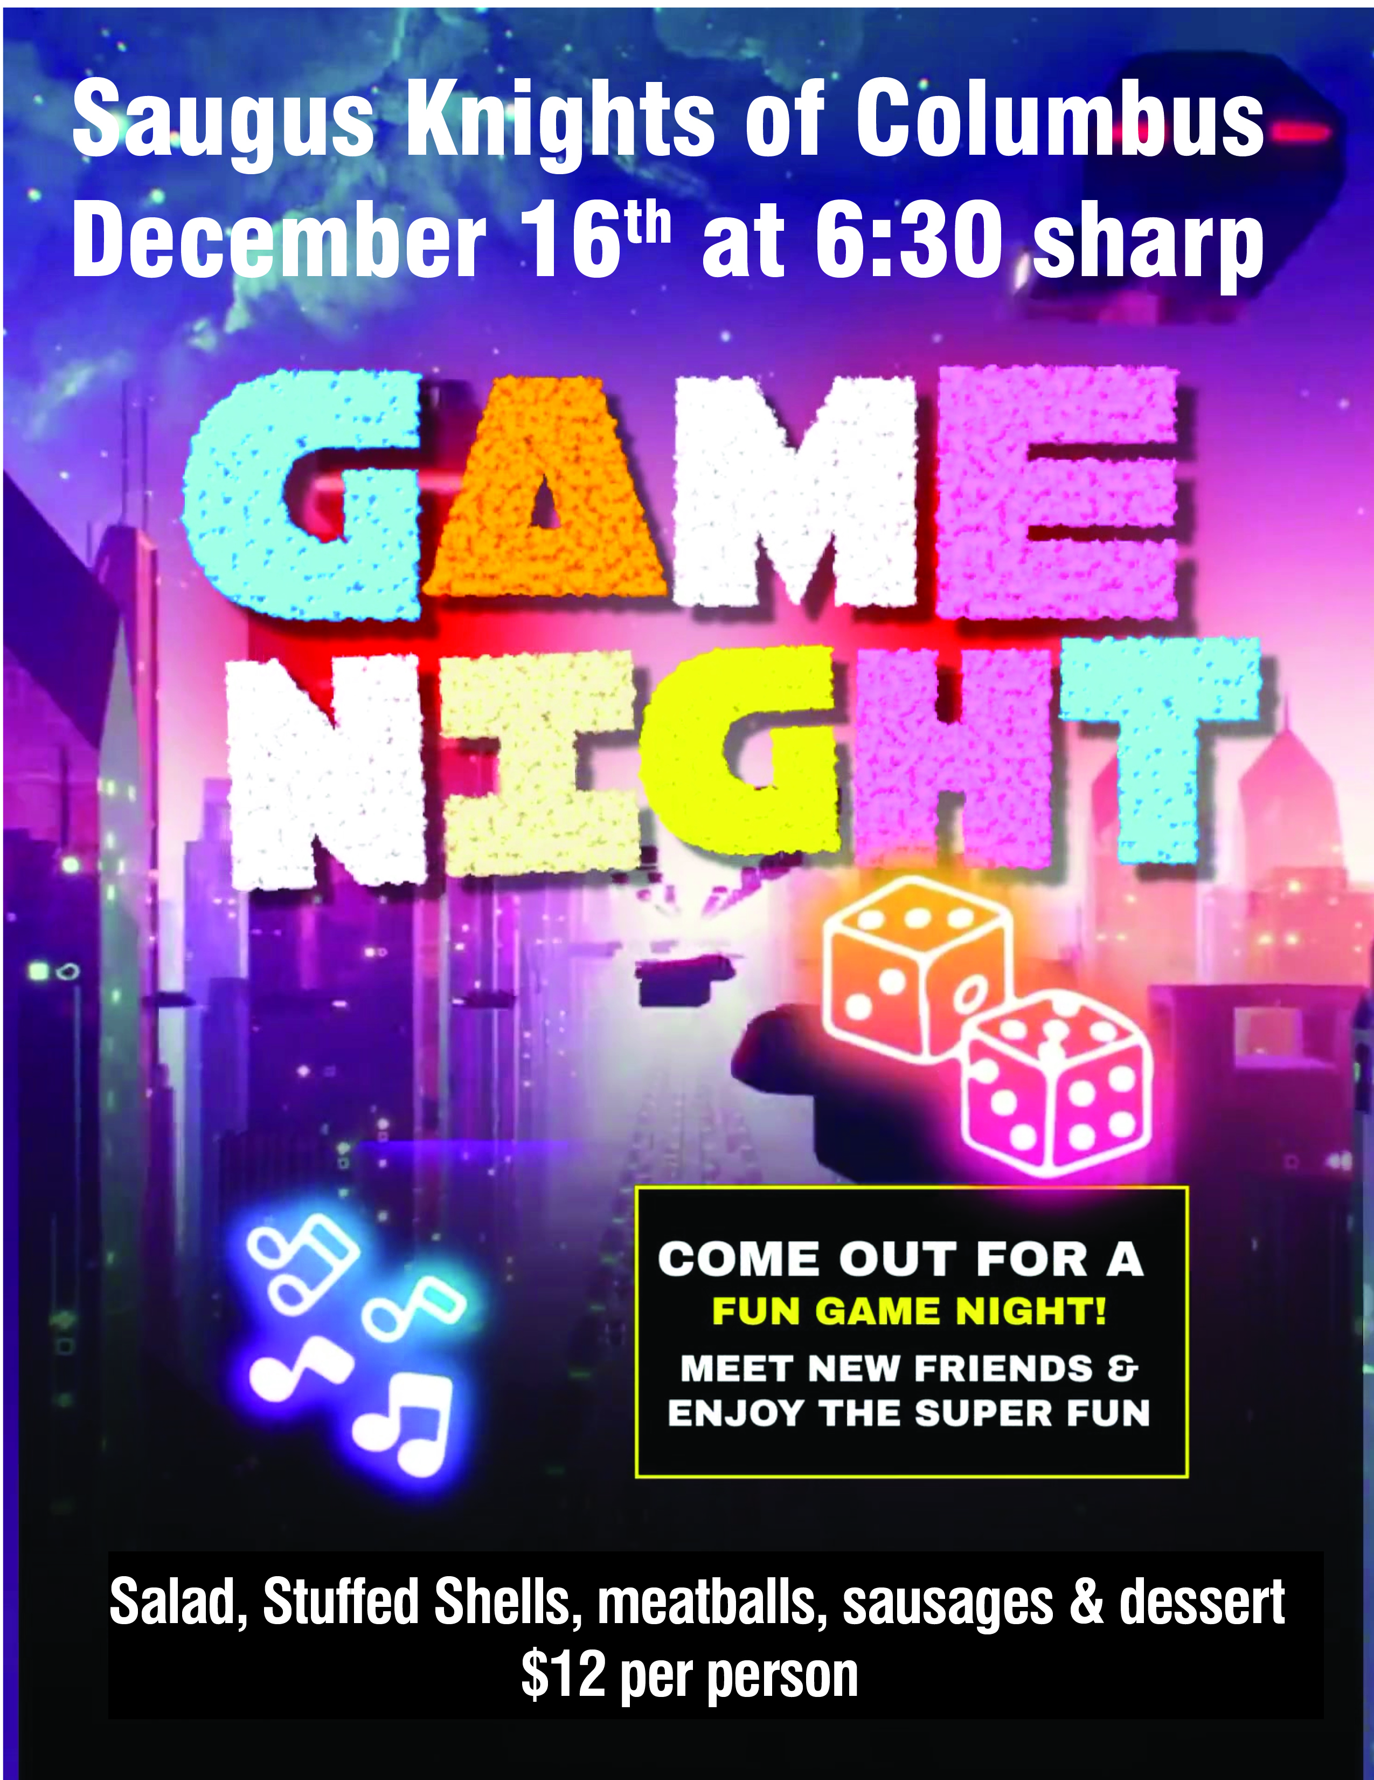

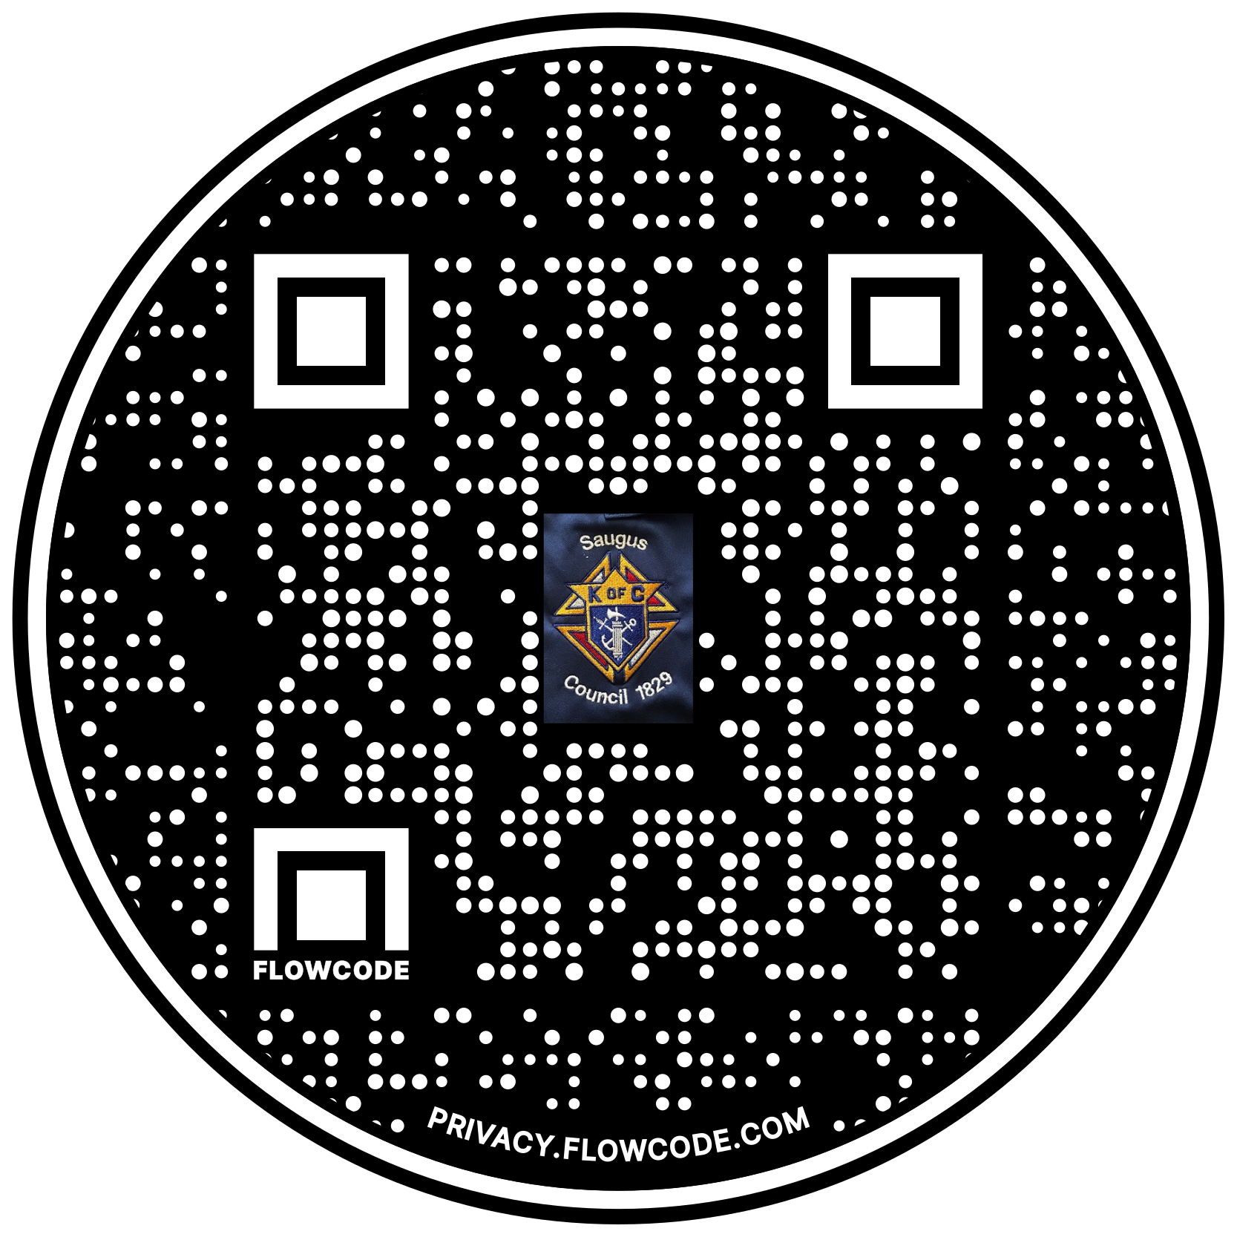

Scan the Code to view the Council Web site!

