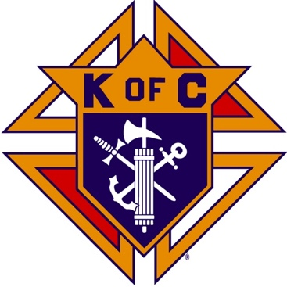
Saugus Knights of Columbus
Council #1829

57 Appleton Street
Saugus, MA 01906

Council Newsletter

Volume 23, Issue 01 www.sauguskofc1829.org January 2026

Grand Knight’s Message

Greetings my Worthy Brothers.
It has been a crazy past month for me. My health, without notice, has punched me in the face. One week in the hospital for heart artery blockage, come home and in the hospital again for another three days with chest pains. One artery cleaned out and another one with two stents. I think what I need is a couple of months in the warm sunshine of Fort Myers, Florida. Oh ya, that is where I am going. I want to thank everyone who called, texted, and reached out to Karen and I offering their prayers and anything we may have needed. I will always remember you for remembering me. Thanks so much.
The month of December was a busy month for us. Our annual Christmas party was an enormous success, our Breakfast with Santa was amazing, and most of all we were all able to spend Jesus’s birthday with our loved ones. We had a busy month with the function hall. According to brothers Chris Luongo and Richard Aiello, our poker nights on Wednesday evenings hold their own and the Mass Lottery in the members lounge is beginning to pick up. The council is heading in the right financial direction. Thank you to all the volunteers for your help.
As most of you know by now Brother Steve Gerome is in Florida and I will be in Florida on Friday. In our absence Brothers Luongo, Aiello, and Barbanti will be able to assist any brothers with any questions concerning the council.
Our usual social dinners on the third Tuesday of the month will pause until March, and our Saturday morning breakfast club will also pause until I get back. I will be returning home on February 27th.
As always, Brother Steve Gerome and I are available by telephone anytime. Please do not hesitate to call us. I will see you all in two months. Remember, I pray for all of us and I am honored to be your Grand Knight.
Vivat Jesus,
John Coburn
Worthy Grand Knight

Monthly Social Dinner

There will be no social dinners until March.

The Weekly Attendance Pool

The Weekly Attendance Pool is up to $210 .

December 02 107 Ralph Meola
December 09 032 Paul Corsino
December 16 081 Nysam Korkpor
December 23 196 Robert Petrillo
December 30 XX No meeting

BA1829 Club Numbers
December 02– 61
December 09 – 49
December 16 – 24
December 23 – 46
December 30 – 80

Rent Our Function Hall

Eastern Poker Tour

Every Wednesday night, 6:30-10:30 P.M.

Saturday Morning Breakfast

John and Steve are both away. Bob may be cooking
breakfast occasionally. Check with him about what weeks
he will be cooking. The fare is only $7.00

Upcoming Events
Eastern Poker Tour every Wednesday 6:30 – 10:30
Social Meeting Dinner/ LRC game March17, 2026; 6:30 pm – 9:30 pm..

JFK Assembly Meeting

The Fourth Degree meets on the second and fourth Tuesdays at 7:00.

All Worthy Knights are encouraged to attend.

January Birthdays
Happy Birthday to the following Brothers

01st – Anthony Ciaccarelli 02nd – Richard D. Salerno
04th – John Dolan 04th – Paul Pantano
08th – Paul Giannetta 12th – David Ceruolo
15th – Thomas Finnegan 17th – Edward DiGirolamo
24th – Ronald DellaGrotte 27th – John Hunt
28th – Patrick Verderico 30th – Peter Morris
31st – Anthony DePlacido 31st – Kenneth Hanlon Jr.

If your name is listed above, you are invited to stop by the lounge for a complimentary beverage of your choice on Tuesday of your birthday week

Meeting Schedule
Saugus Council #1829

First Tuesday – Social meeting only - Pizza Night
Second Tuesday – Business meeting
Third Tuesday – Dinner meeting only. The cost for dinner is $10/$12.
Fourth Tuesday – Business meeting
Fifth Tuesday (when applicable) – Social meeting only

Monthly Newsletters
The monthly newsletter files have been added to the Council web site at https://sauguskofc1829.org/newsletters.

You can download a Microsoft Word copy of the file
to your computer/smart phone/tablet any time you wish.

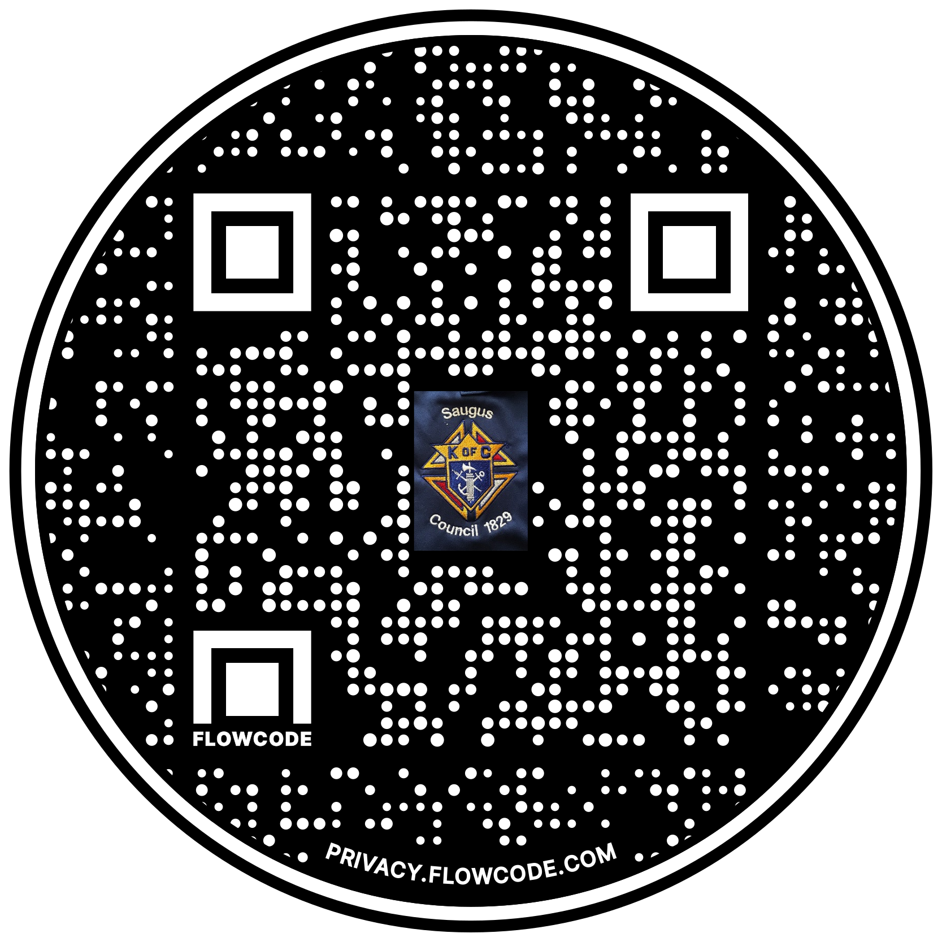

Scan the Code to view the Council Web site!

