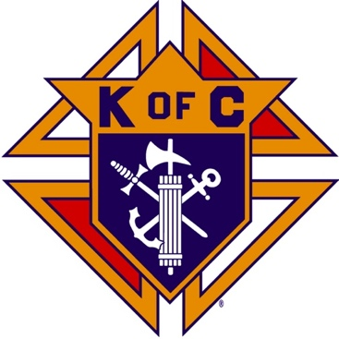
Saugus Knights of Columbus
Council #1829

57 Appleton Street
Saugus, MA 01906

Council Newsletter

Volume 22, Issue 5 www.sauguskofc1829.org May 2025

Grand Knight’s Message
Hello, my Worthy Brothers,
The month of May, along with the good weather has finally arrived. We have many good things planned for the next few months. I'll get to that in a minute.
April was a good month for us. First, we had the Meager Meals. It was a great success. We served over sixty people. We could have only achieved the success because of the many Knights who volunteered their time. My personal thanks to you all. Second, our members dinner on April 15 was fantastic. We had a great dinner of meatball/sausage submarine sandwiches, salad, and dessert. My personal thanks to Karen, Chris, Dawn, Paul and Kevin Ring. You all make me look good. (But then again, I always look good). lol. To all the LRC players, I hope you had fun. Next dinner is on May 20th. Individual HOME-MADE chicken pies, veggies, salad, and dessert. Price is $12.00 per person. LRC immediately after dinner.
We need to put a cleanup committee together. Our property is starting to look shabby. In the past we had Arcadio Landscaping do a courtesy semi cleanup for us. He basically just blew away the leaves. We need more than that. I will post a sign up sheet. I think four hours on a Saturday would take care of what we need done.
On a different note, welcome back Steve and Henry. We missed you guys.
On a personal note, Karen would like to thank everyone who called her, sent her cards and notes, and said prayers for her. She has suffered with her back injury for the past three years and hopefully the surgery has corrected the problem. Chris Luongo, our District Deputy has just undergone the same surgery.
Vivat Jesus
John F. Coburn
Grand Knight

District Deputy’s Message

Worthy Council Officers, I bring you greetings from Supreme Knight Patrick Kelly and State Deputy Bob Schwarz
- 2 months of 2025 left to reach our goals, is your council meeting STAR requirements?
- Councils have been doing great moving members from the Prospect tabs into councils. Thank you for having these members in your councils allowing your council to stay relevant.
- I been reviewing all councils that are not Safe Environment Compliant. GK’s and FS’s are going to start getting called if not compliant.
- Supreme has sent all Jurisdictions request to have a pass the hat for ASAP at all the State Conventions. We are doing this also, please bring checks from your councils or Cash when we pass the hat. If you can’t make it to the convention, give a check to your DD to bring to the Convention on your behalf.
- State Incentives for Membership:
  - Gold pen for the #1 recruiter in 2024/2025 by percentage.
  - Delta Church drives, with prospect cards proof will get a gift card to raffle at council exemplification.
  - Supreme Contest March 31/June 30 have 125% membership get a council banner.
- 4th Degree needs new members. June 22nd Exemplification
- Upcoming State Dates:
  - May 16th - 18th - State Convention. Emerald Resort, Hyannis MA. Two delegates from each council, all members are invited. (Form on Website) Remember Donation for Ladies Lunch Centerpieces ($25). Donations to be in Convention Booklet Ad’s.
  - June 26th - Past State Officers Dinner. EnVision Hotel, Mansfield, MA.
  - June 27th - State Golf Outing.
  - June 28th - State Training for GK, FS, DD’s. EnVision Hotel, Mansfield
  - July 18th - WooSox

Upcoming Events
Social meeting Dinner Tuesday, May 20, 6:30 P.M.
We will be serving individual home-made chicken pies, veggies, salad, and dessert. The price is $12.00 per person. As usual, all are welcome to bring their wives and girlfriends. The sign-up sheet is posted in the downstairs meeting hall near the kitchen. After the meal we plan to have a Left-Right-Center game.
Deceased Brothers’ Mass Sunday, November 9, 11:00 mass

Saturday Morning Breakfast
John is back!!
Breakfast is served from 8:30-9:00 A.M. every Saturday morning.
All are welcome. The fare is only $5.00

The Weekly Attendance Pool

The Weekly Attendance Pool is up to $60. Come to the council, sign the logbook, and put $1 in the pool each week. The weekly number will be drawn on Tuesday after the meeting. If your number is drawn and you have signed in that day you win all that is in the pool. It continues to grow until someone wins. Don’t miss out! The numbers for the past month:

April 01 135 Mike Piazza
April 08 066 Paul Giannetta
April 15 003 Rich Aiello
April 22 082 Joseph Koslowski
April 29 164 Stephen Spinelli

BA1829 Club Numbers

April 01 – 13
April 08 – 53
April 15 – 66
April 22 – 67
April 29 - 64

May Birthdays
Happy Birthday to the following Brothers

03rd – Thomas Cunningham 09th – Dennis Roy
11th – Charles Naso 11th – John Donovan
13th – Paul Seaman 16th – Michael Boudreau
16th – Ryan Amara 16th – John Meaney
18th – Andrea Paci 19th – Robert Petrillo
19th – Roberto Petrillo 20th – Daniel Prezioso
25th – Roel Benavides 25th – Robert Palleschi
26th – Michael Sicuranza 29th – William Petrillo

If your name is listed above you are invited to stop by the lounge for a complimentary beverage of your choice on Tuesday of your birthday week

Meeting Schedule
Saugus Council #1829

First Tuesday – Social meeting only - Pizza Night
Second Tuesday – Business meeting
Third Tuesday – Dinner meeting only. The cost for dinner is $10.00.
Fourth Tuesday – Business meeting
Fifth Tuesday (when applicable) – Social meeting only

JFK Assembly Meeting

The Fourth Degree meets on the second and fourth Tuesdays at 7:00.

All Worthy Knights are encouraged to attend.

Thanks to Ron Keohan for submitting a word search for the monthly newsletter. (Solution will appear in next month’s newsletter).

6. SECOND LAW

H | S | R | P | E | H | H | I | X | G | H | C | W | H | N | E | T | O | B | Z | K | E
X | T | E | L | S | Q | O | D | L | D | F | O | S | E | G | Q | Z | S | G | N | S | L
H | P | S | Z | I | S | F | O | Z | N | E | S | S | R | Q | O | E | E | S | X | X | Z
I | E | T | L | M | N | S | L | P | T | A | H | E | G | W | S | L | W | B | C | L | S
G | C | O | S | O | O | G | A | I | H | R | E | N | H | O | I | C | X | N | Z | G | E
X | E | R | G | R | I | N | T | A | A | O | M | I | M | X | D | S | B | C | T | W | T
H | R | A | N | P | T | I | R | W | R | F | A | L | E | W | E | H | S | O | A | A | I
T | P | T | I | E | C | S | Y | B | O | G | T | O | D | S | N | O | N | V | B | X | L
T | T | I | H | C | U | S | O | T | T | O | L | H | R | B | H | L | O | E | L | J | E
N | Q | O | C | I | R | E | K | S | X | D | X | U | O | W | T | G | B | N | E | S | A
E | H | N | A | T | T | L | E | U | T | K | C | R | G | C | K | J | E | A | T | E | R
M | X | T | E | S | S | B | R | E | M | E | M | B | E | R | L | P | D | N | S | T | S
A | V | O | T | U | N | U | Q | Q | C | G | N | I | N | R | A | W | I | T | E | U | I
T | O | Z | D | J | I | P | B | S | A | A | S | U | Z | T | L | W | E | L | B | T | B
S | Z | U | Q | U | V | E | U | G | O | L | A | C | E | D | A | I | N | W | G | A | Z
E | H | S | C | E | S | Z | V | H | G | T | K | Q | T | L | F | L | C | W | W | T | M
T | N | S | J | I | J | O | R | D | A | N | R | I | V | E | R | P | E | X | V | S | Z
H | M | N | I | A | N | I | S | T | N | U | O | M | C | O | U | S | T | O | N | E | F

Blessings Israelites Remember
Covenant Jordan River Restoration
Curses Justice Shema
Decalogue Law Statutes
Fear of God Moses Stone
Exile Mount Sinai Tablets
Exodus Net Teachings
Holiness Obedience Testament
Idolatry Precepts Torah
Instructions Promise Warning
Last Month’s Solution

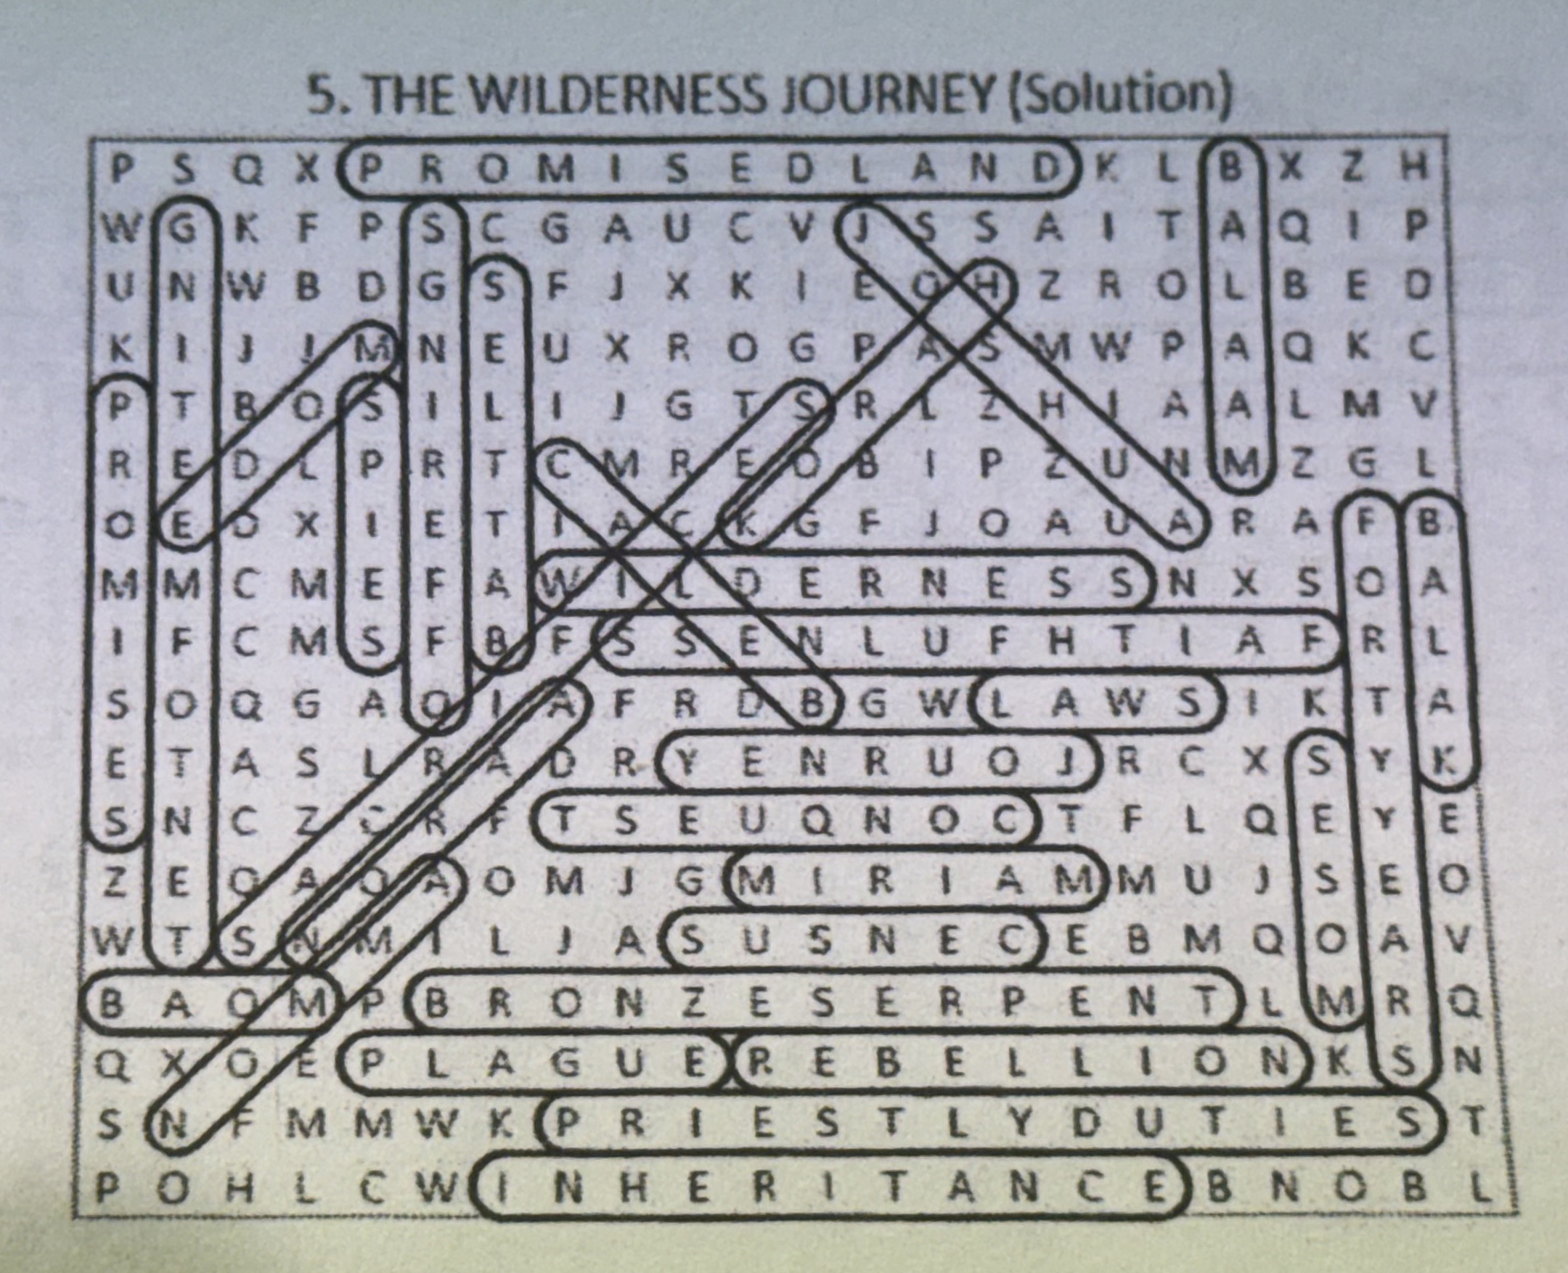

Monthly Newsletters
The monthly newsletter files have been added to the Council web site at https://sauguskofc1829.org/newsletters.

You can download a Microsoft Word copy of the file
to your computer/smart phone/tablet any time you wish.

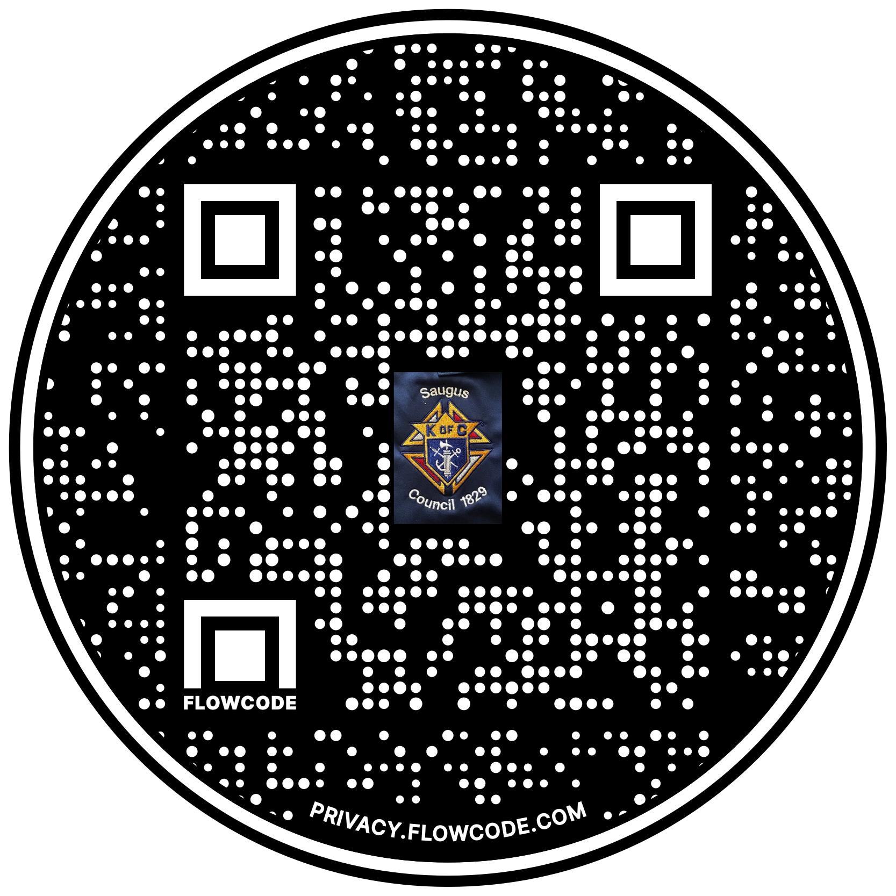

Scan the Code to view the Council Web site!

