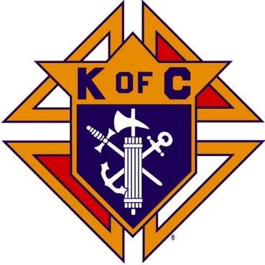
Saugus Knights of Columbus
Council #1829

57 Appleton Street
Saugus, MA 01906

Council Newsletter

Volume 22, Issue 7 www.sauguskofc1829.org July 2025

Grand Knight’s Message
Good day my Worthy Brothers,
It is July already! Where is the time going? There isn’t much to say in this newsletter, so I’ll keep it brief.
June was a kind of quiet month. Outside of our usual monthly meetings, we had a wonderful social dinner. We had over 30 people come for the meal and then play an awesome game of LRC. Congrats to the winner, Vinny Zinna. Thanks again to all our volunteers for making it happen. Thank you, Karen, for the delicious meal. This month the dinner be held on July 15th, at 630pm. The menu will be Chicken Cutlets, mashed potatoes, corn on the cob, rolls, and dessert. The cost is 12.00.
Last week I had the pleasure of presenting the annual Knight of the Year Award. Andrea Pace was this year’s winner. I thought about each member of the council before I decided on Andy. Andy, my personal thanks to you for making my job as a Grand Knight a bit easier. You are always there for our council.
Our annual Family Day BBQ was an unbelievable success. There were so many members present. It was awesome to see everyone laughing and having a grand time. A special thanks to Henry and Sylvanna Leno for the great job of cooking and presenting the meal A special thanks from me to all who helped during the cleanup. The expression “many hands make light work” certainly came into play.
On a different note, breakfast on Saturday July 5th is cancelled so we all can enjoy the holiday. We will resume the following Saturday.
That’s it for now, I will see you all on Tuesday night.
Vivat Jesus,
John Coburn, Grand Knight
Saugus Council 1829.

Saturday Morning Breakfast
Breakfast is served from 8:30-9:00 A.M. every Saturday morning.
All are welcome. The fare is only $7.00

Upcoming Events
Social Meeting Dinner Tuesday, July 15, 6:30 P.M.
We will be serving chicken cutlet, mashed potato, vegetables, and dessert. The price is $12.00 per person. As usual, all are welcome to bring their wives and girlfriends. The sign-up sheet is posted in the downstairs meeting hall near the kitchen. After the meal we plan to have a Left-Right-Center game.
Indoor Craft Fair/Flea Market September 27, 8:00 – 3:00
Deceased Brothers’ Mass Sunday, November 9, 11:00 mass

BA1829 Club Numbers

June 03 – 94
May 10 – 59
May 17 – 62
May 24 – 06

The Weekly Attendance Pool

The Weekly Attendance Pool is up to $132.

June 03 177 Vinnie Zinna
May 10 087 Stephen Lentini
May 17 084 Fred Landry
May 24 002 Michael Adams

July Birthdays
Happy Birthday to the following Brothers

01st – William Schultz 05th – Rich Aiello
07th – Chester Sayles 07th – Craig Orlando
08th – Glen McKay 15th – Robert Petrillo
17th – Ralph Meola 18th – Richard Camuso
23rd – Robert Randazzo 24th – Dante Floccher
25th – Thomas O’Neill 26th – Patrick Rooney
26th – Charles Reid 26th – Michael Piazza
27th – John Stanasek 28th – Ronald Keohan

If your name is listed above you are invited to stop by the lounge for a complimentary beverage of your choice on Tuesday of your birthday week

JFK Assembly Meeting

The Fourth Degree meets on the second and fourth Tuesdays at 7:00.

All Worthy Knights are encouraged to attend.

Meeting Schedule
Saugus Council #1829

First Tuesday – Social meeting only - Pizza Night
Second Tuesday – Business meeting
Third Tuesday – Dinner meeting only. The cost for dinner is $10.00.
Fourth Tuesday – Business meeting
Fifth Tuesday (when applicable) – Social meeting only

Word Search

8. CYCLE OF REBELLION

U | V | G | R | H | A | J | O | H | H | D | J | U | H | A | H | T | H | P | E | J | Q
G | F | X | M | U | A | U | C | A | E | U | R | K | A | W | B | A | J | W | M | E | W
E | O | S | A | D | N | C | N | L | D | X | I | F | I | L | B | R | C | U | R | E | X
F | T | A | R | H | V | A | I | G | P | K | A | Q | O | I | U | X | N | O | D | B | A
A | H | H | E | K | Z | L | E | M | N | S | J | A | M | T | A | N | V | I | H | K | L
T | N | E | S | B | A | S | P | G | Q | L | H | E | H | S | G | I | D | E | O | N | E
K | I | N | I | H | U | J | V | E | Q | S | L | A | H | A | Z | B | P | U | P | P | V
J | E | I | S | I | N | O | L | P | E | E | P | E | M | G | R | O | A | B | R | J | I
F | L | H | I | Z | L | I | P | I | C | K | R | S | C | G | G | A | L | M | S | O | T
H | T | P | D | I | M | E | D | H | A | A | A | W | R | S | A | Z | O | P | S | U | E
F | G | A | O | E | W | U | U | L | H | K | W | R | A | N | I | R | T | O | G | Q | K
M | P | O | L | Q | E | H | U | D | M | L | J | B | A | W | Q | N | L | E | C | U | U
B | B | E | A | R | W | O | X | F | B | A | P | K | D | B | C | B | H | J | R | P | P
F | C | L | T | W | V | E | H | Q | I | G | M | D | A | E | X | S | E | P | X | E | J
H | V | P | R | L | J | J | J | T | K | P | S | A | G | O | B | O | J | S | O | T | P
H | Z | T | Y | N | A | O | M | I | L | J | L | C | N | Q | T | O | F | L | B | H | J
K | B | A | J | Q | X | V | B | X | D | S | A | I | R | A | M | A | S | T | S | X | C
H | A | R | O | B | E | D | B | X | F | I | S | A | M | S | O | N | U | G | N | X | B

Abdon Elimelech Micah
Abimelech Gideon Naomi
Asherah Hophni Obed
Baal Ibzan Othniel
Barak Idolatry Phineas
Boaz Jair Ruth
Deborah Jephthah Samaria
Delilah Judges Samson
Ehud Levite Shamgar
Eli Lota Sisera

Last Month’s Solution
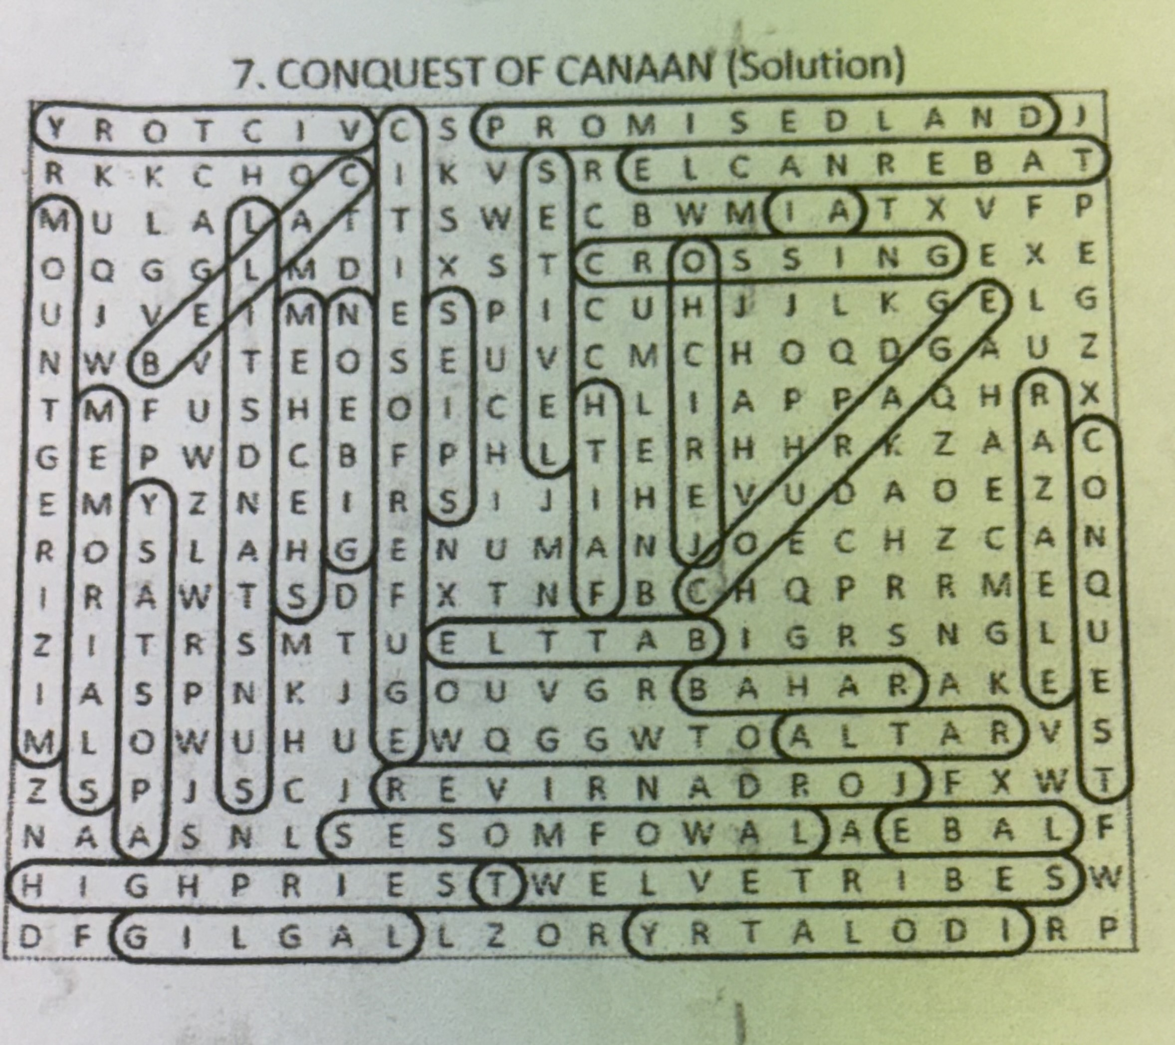

Monthly Newsletters
The monthly newsletter files have been added to the Council web site at https://sauguskofc1829.org/newsletters.

You can download a Microsoft Word copy of the file
to your computer/smart phone/tablet any time you wish.

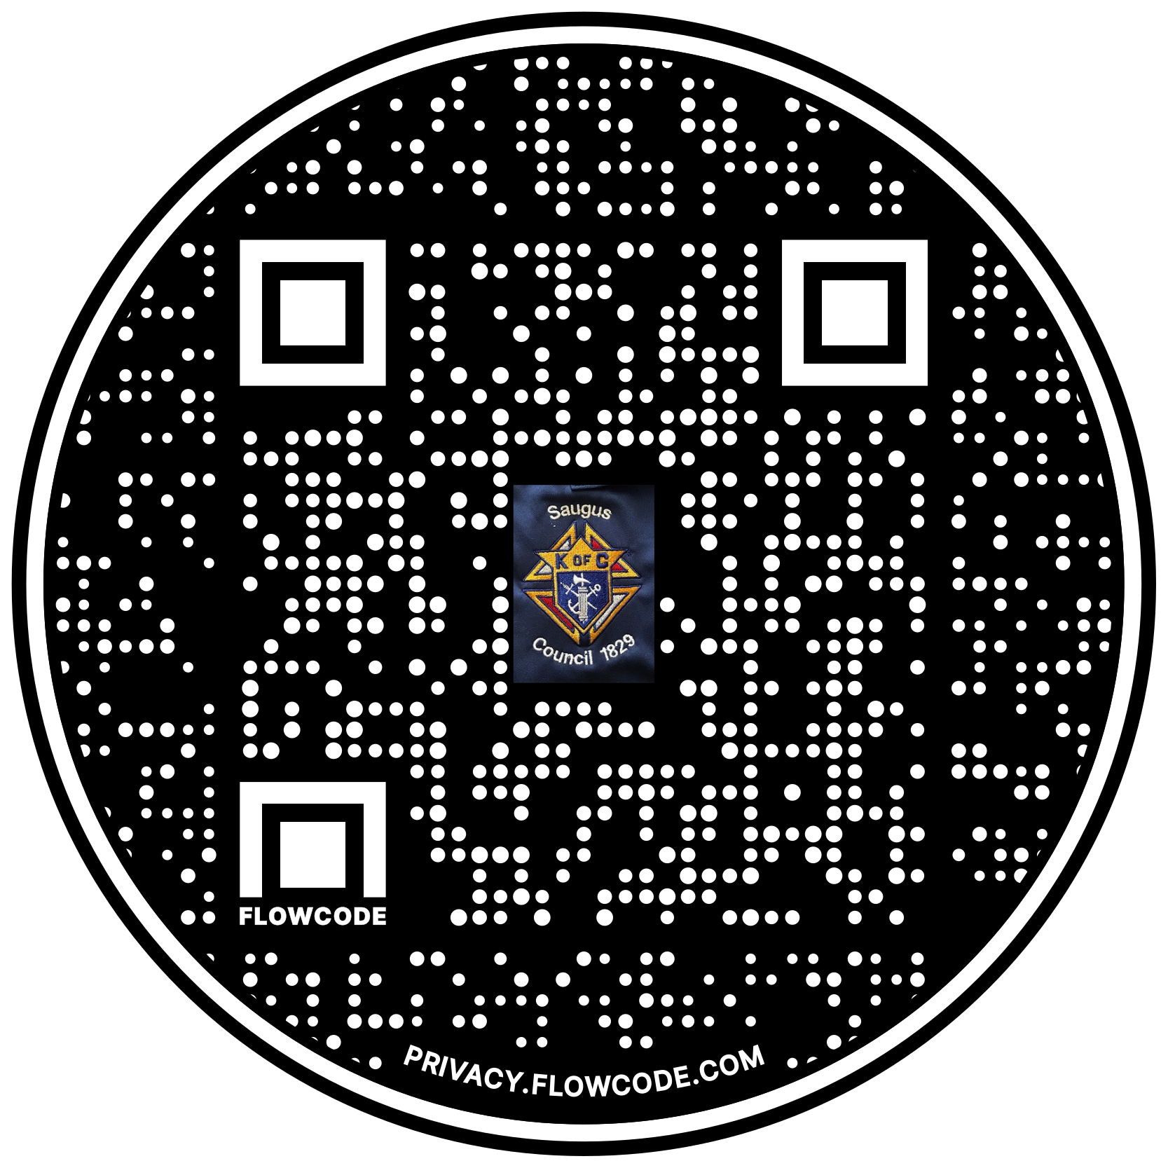

Scan the Code to view the Council Web site!

