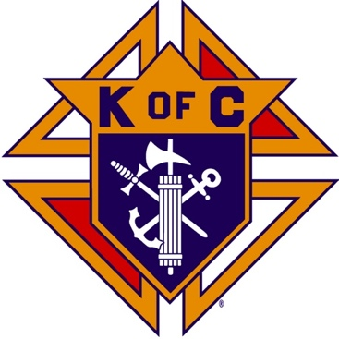
Saugus Knights of Columbus
Council #1829

57 Appleton Street
Saugus, MA 01906

Council Newsletter

Volume 23, Issue 07 www.sauguskofc1829.org July 2026

Grand Knight’s Message
Greetings, my Worthy Brothers.
June was a busy month for us. Our function hall was occupied every weekend, sometimes Friday and Saturday evenings. The Saturday morning breakfast club has also been busy and will continue throughout the summer, except this Saturday, July 4th. The Wednesday night poker games are on a pace to sell out the entire summer. The past three weeks the poker night has had over 40 card players. The gentleman running the games told us that we are getting the same numbers of players that the other venues are getting so yes we are definitely holding our own. The keynote sales are working well also.
The Family Day BBQ was fabulous. I am so proud to be the grand knight of the best group of guys I have ever met. The overall generosity of the food donations, the help that was given in the setup, serving, and clean up was unbelievable. It all came together like clockwork. The amount of food donated by our members was incredible. Everyone had plenty to eat and drink. My special thanks goes out to our very own Ladies of the Knights. You ladies make things happen for us. Thank you all so much. I would like to pass on a $50 donation to your group to use for your raffle baskets This donation is courtesy of the Saturday morning breakfast club.
Thank you, brother Robert Northrop for making up the craft fair banners and signs. Bob was gracious enough to donate 2 banners from his company and gave us an outstanding discount on the flyers and rotary signs. Another thanks to Rhonda Coombs for the flyers she made for distribution. According to Karen, 34 tables have been sold and paid for. Don't forget we need volunteers for the craft fair which is being held on August 8th
On a personal note, from me to all you brothers, thank you for allowing me to serve another term as your grand knight. I honestly believe we have the best team in the entire district. Richie, thank you.
I wish to extend my personal thanks and gratitude to you all for your prayers, thoughts, emails and phone calls to my wife Karen. They are certainly helped in her healing. On a final note, as stated in the last regular business meeting the lost veal cutlet has been found.
Vivat Jesus.
John Coburn, Grand Knight
Saugus Council 1829

Monthly Social Dinner

The social dinner will be held on July 21, 2026; 5:30 pm – 9:30 pm.
The dinner will be homemade corn chowder, ham, carrots, dessert, and beverages. The cost is 12.00 per person. LRC and 3 card bingo will follow the dinner.

The Weekly Attendance Pool
The Weekly Attendance Pool is up to $13.00

June 02 003 Rich Aiello
June 09 192 John Meaney
June 16 No drawing
June 23 083 Anthony LaRosa
June 30 007 Phil Antonelli

BA1829 Club Numbers
June 02 – 85
June 09 – 42
June 16 – 45
June 23 – 95
June 30 – 95

Rent Our Function Hall

Eastern Poker Tour

Every Wednesday night, 6:30-10:30 P.M.

Saturday Morning Breakfast

Saturday morning breakfasts are served from 8:00 – 9:00.
Menu changes every week.
The fare is only $7.00

Meeting Schedule
Saugus Council #1829

First Tuesday – Social meeting only - Pizza Night
Second Tuesday – Business meeting
Third Tuesday – Dinner meeting only. The cost for dinner is $10/$12.
Fourth Tuesday – Business meeting
Fifth Tuesday (when applicable) – Social meeting only

Upcoming Events

Social Meeting Dinner/ Card games July 21, 6:30 pm – 9:30
Eastern Poker Tour every Wednesday, 6:30 – 10:30
Friday Nights at Members’ Lounge every Friday evening, 6:00 – 11:00
Craft Fair August 8, 8:00 – 3:00

July Birthdays
Happy Birthday to the following Brothers

01st – William Schultz 02nd – Joseph Silipini
05th – Rich Aiello 07th – Chester Sayles
07th – Craig Orlando 08th – Glen McKay
14th – John Donegan 17th – Ralph Meola
18th – Richard Camuso 23rd – Robert Randazzo
24th – Dante Floccher 25th – Thomas O’Neill
26th – Patrick Rooney 26th – Charles Reid
26th – Michael Piazza 27th – John Stanasek
28th – Ronald Keohan

If your name is listed above, you are invited to stop by the lounge for a complimentary beverage of your choice on Tuesday of your birthday week

Monthly Newsletters
The monthly newsletter files have been added to the Council web site at https://sauguskofc1829.org/newsletters.

You can download a Microsoft Word copy of the file
to your computer/smart phone/tablet any time you wish.

JFK Assembly Meeting

The Fourth Degree meets on the second and fourth Tuesdays at 7:00.

All Worthy Knights are encouraged to attend.

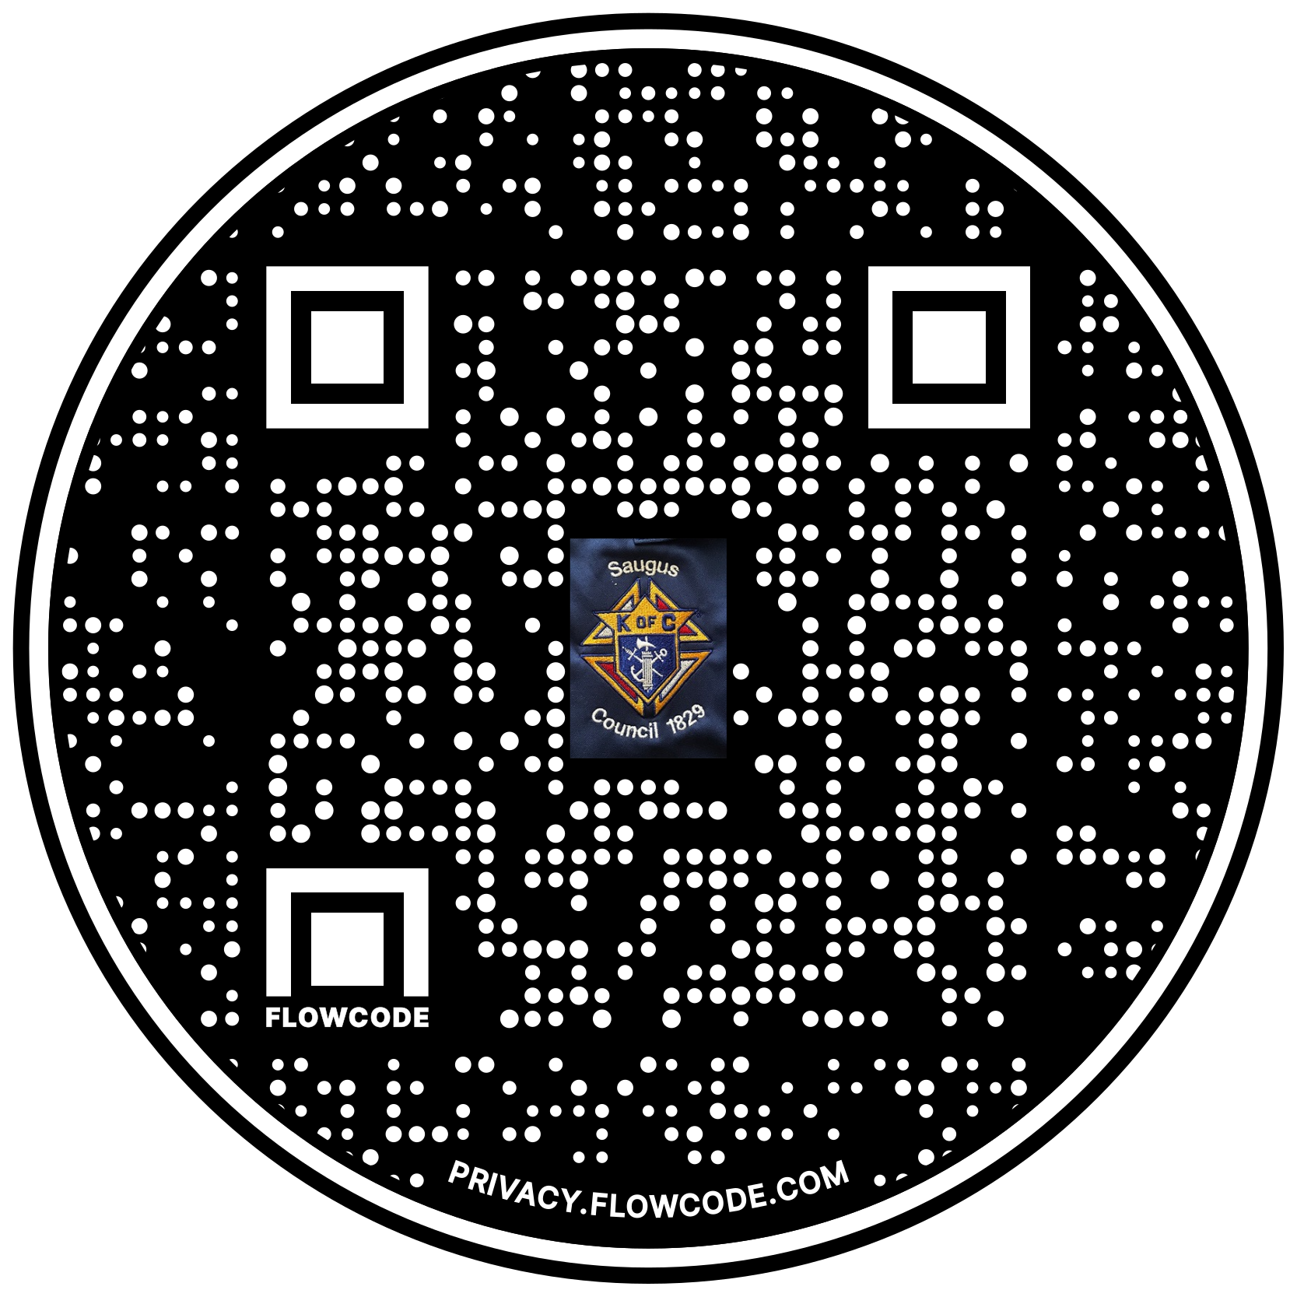

Scan the Code to view the Council Web site!

