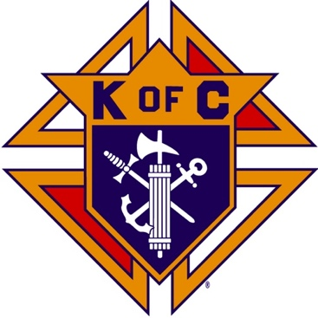
Saugus Knights of Columbus
Council #1829

57 Appleton Street
Saugus, MA 01906

Council Newsletter

Volume 21, Issue 08 www.sauguskofc1829.org August 2024

Grand Knight’s Message
Worthy Brothers,
I am just completing my first month of being your Grand Knight. It was a busy month. We just had a very successful annual family BBQ. I would like to thank everyone who participated in the cooking and the setup of the hall. Special thanks to Henry and Sam who did an outstanding job in the actual barbecuing I will tell you it was quite proud to look out at our members and see everyone talking and laughing and enjoying the time together. It will only get better.
To everyone involved in cleaning out the game room, thank you. We have waited a long time to get the new floor installed. It is finally happening. Thanks to Chris and Rich for the fantastic job of painting the room. The room will be a showplace when it's done.
Karen Coburn and Louise Luongo will be starting a Women's Auxiliary for our council. As you all know our wives and ladies are an integral part of our council. My hope is that with their help we can continue growing and expanding both our membership and the beautification of our function hall. They are also putting together ideas and thoughts to renovate the hall and foyer. Stay tuned for further updates.
Brother Ron Keohane is putting together a daily and weekly lottery game. Please see the description later in this newsletter. It sounds like to me a win-win for the members
In closing, please remember to keep our family members, friends, and dearly departed members in our prayers.
John Coburn, Grand Knight
(781) 854-6116
coachcoby@comcast.net
The Weekly Attendance Pool.

We are instituting a new pool – The Weekly Attendance Pool. Members who wish to participate put $1 in the pool each week he attends a meeting at the Council and signs the Pool Logbook in the Member’s lounge. You must sign the log to be eligible to win. The weekly number will be drawn on Tuesday after the meeting. If your number is drawn and you have signed in that day you win all that is in the pool. It continues to grow until someone wins. Don’t miss out!

Happy Birthday to the following Brothers

01st – Donald Cook 02nd – Roger Worthley
03rd – Louis Melillo 04th – William Magarian
09th – Lorenzo Grasso 13th – John Barrett
15th – Michael Fernandez 17th – Gregory Natalucci
22nd – Oscar Desjardins 27th – Philip Antonelli
27th – Pasquale Alfe 28th – John Messina
30th – Mario Trafficante

NEW - Members are invited to stop by the lounge for a complimentary beverage of their choice on Tuesday of their birthday week. If your name is listed above, just stop by the Council on Tuesday of that week and present your membership card to the bartender to claim it.

Installation of Officers
Tuesday, August 20, 2024, 6:30 – 7:00
Dinner to follow.
All brothers and families are invited.
RSVP to info@sauguskofc1829.org if you will be attending.

BA1829 Club Numbers

July
July 02 – 51
July 09 – 27
July 16 – 73
July 23– 27
July 30 - 38

Saturday Morning Breakfast
Breakfast is served from 8:30-9:00 A.M. every Saturday morning.
All are welcome. The fare is only $5.00
Menu:
August 03 – French Toast and sausage links
August 10 – No Breakfast
August 17 –Ham and cheese omelets
August 24 – Pancakes and sausage link
August 31 - Sausage, egg and cheese on a bagel

Meeting Schedule
Saugus Council #1829

First Tuesday – Social meeting only - Pizza Night
Second Tuesday – Business meeting
Third Tuesday – Dinner meeting only. The cost for dinner is $10.00.
Fourth Tuesday – Business meeting
Fifth Tuesday (when applicable) – Social meeting only

Upcoming Events
Installation of Officers August 20, 7:30 – 8:30
PGK Banquet September 27, 6:00 – 10:00
Indoor Craft Fair/Flea Market October 19, 8:00 – 3:00
Life-Line Screening October 21, 8:00 – 4:00
Annual BA Meeting October 22, after regular meeting.
Deceased Brother’s Mass November 3; 11:00 am

Congratulations to all the Brothers and Sir Knights
who were elected for the upcoming year.

We thank those who served last year for their service.

Council Election Results – 2024 - 2025
GRAND KNIGHT John Coburn
DEPUTY GRAND KNIGHT Richard Aiello
CHANCELLOR Henry Leno
WARDEN Steve Fernandez
RECORDING SECRETARY Vincent Zinna
FINANCIAL SECRETARY Phillip Barbanti
TREASURER Stephen Gerome
INSIDE GUARD Andrea Paci
OUTSIDE GUARD Michael Fernandez
ADVOCATE Mark Panetta
TRUSTEES Anthony LaRosa
Edward Wawrzynowicz
Greg Nadalucci

Assembly Election Results – 2024 - 2025
FAITHFUL NAVIGATOR Chris Luongo
FAITHFUL CAPTAIN Mark Panetta
FAITHFUL ADMIRAL Anthony LaRosa
FAITHFUL PILOT Rich Aiello
FAITHFUL COMPTROLLER Stephen Gerome
FAITHFUL SCRIBE Vincent Zinna
FAITHFUL PURSER Henry Leno
FAITHFUL INNER SENTINEL John Coburn
FAITHFUL OUTER SENTINEL Ed Wawrzynowicz
TRUSTEES John Dolan
Ron Keohan
Ernest Buonopane

JFK Assembly Meeting

The Fourth Degree meets on the second and fourth Tuesdays at 7:00.

All Worthy Knights are encouraged to attend.

Friday Night Socials
The downstairs hall is open every Friday night.
7:00 – 10:00 p.m.
Come socialize with your brother knights and their guests.

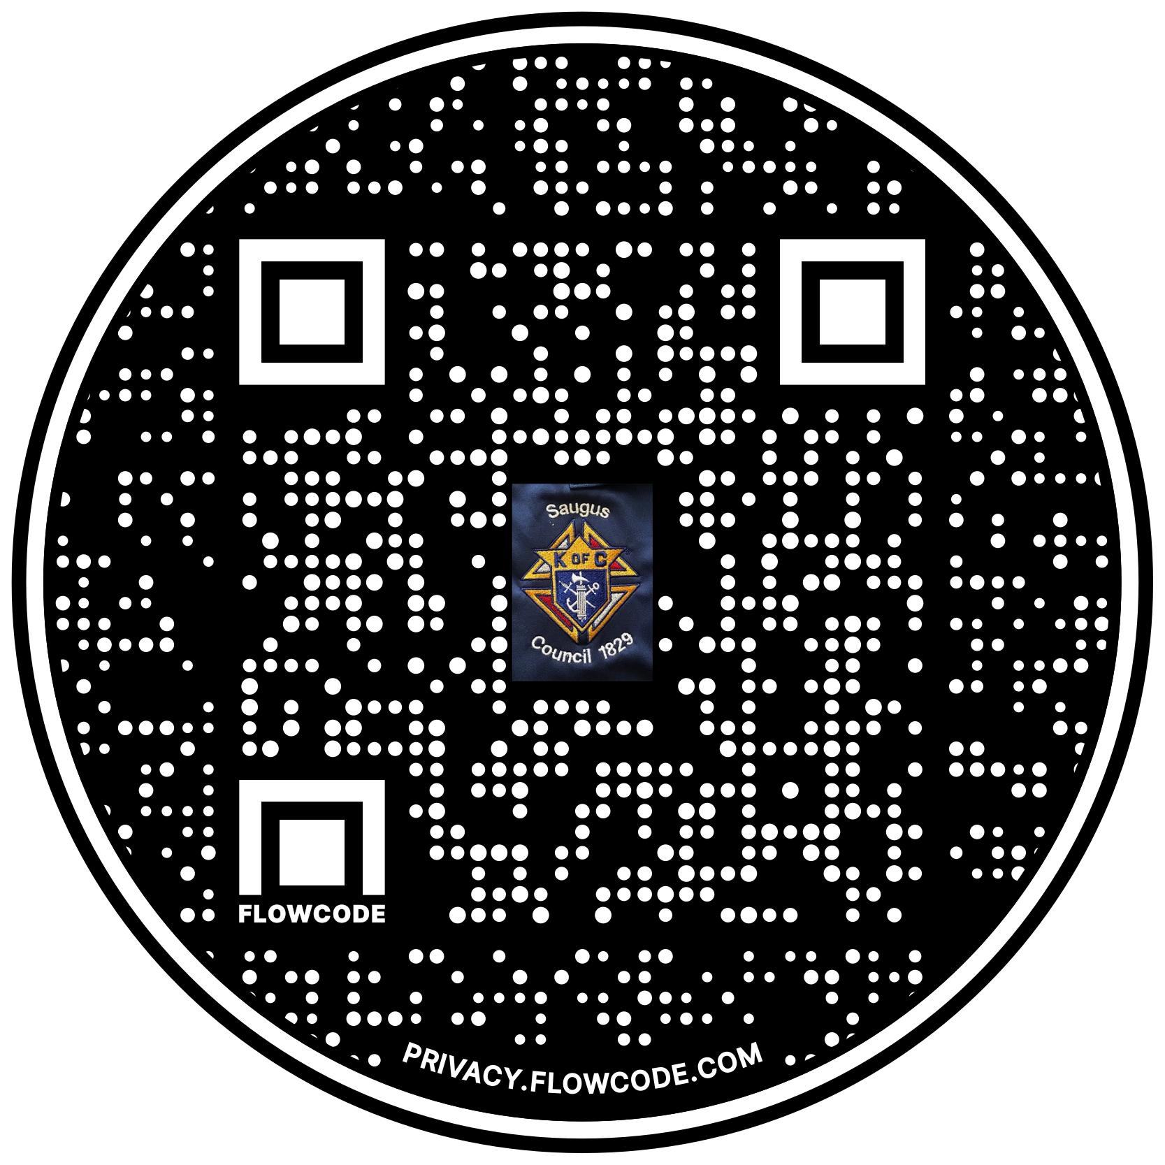

Scan the Code to view the Council Web site!

