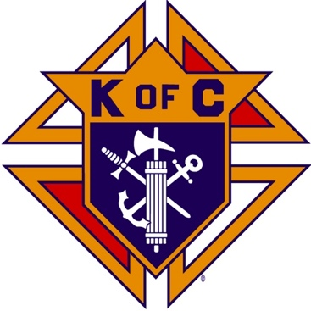
Saugus Knights of Columbus
Council #1829

57 Appleton Street
Saugus, MA 01906

Council Newsletter

Volume 23, Issue 04 www.sauguskofc1829.org April 2026

Grand Knight’s Message

Good evening my Worthy Brothers,
Well, it appears as though we survived another winter season. Even though I was gone for several months I have felt your pain. There is nothing good about snow or freezing temperatures. I will let you all in on a secret, “PILATESî” is the word of the day. When you see our Warden Steve, just tell him “PILATES” and he will get the message.
It appears our only two-wheeler has become lost or borrowed. We need to get this back ASAP. I use it to carry in 15 cases of beer and water. I know my cardiologist won’t like it one bit. Please, if someone borrowed it, please return it.
For those of us who work at the bar we need to keep the bar clean and vacuumed, the glasses put away after they are washed, and most importantly the beer chest needs to be restocked. I know it is not the most comfortable position to sit on the floor while restocking, but it is the only way we can do it. I hear your arguments about sitting on the floor, but it is what it is. If you cannot fill the beer chest, and take out the trash, then let me know and I will find someone else to work with. It simply is not fair to leave it for the next guy. Please reread the rules that are posted in the bar area.
In the downstairs kitchen I put a jar out for coffee money. Twice already the money in the jar has been misplaced. We voted to put the jar out to help pay for the coffee we all drink. If anyone has borrowed the money, please let me know.
Again, I will ask for volunteers to help blow out the leaves from the council parking lot and front entrance. I have several leaf blowers we can use. We don’t have to pick up the leaves as we can blow them into the woods. Come down and give the council four hours of our time on a Saturday after breakfast.
During the month of March, we had our annual Meager Meals. I would like to thank all the members who volunteered their time to cook and serve the Saugus community. We had plenty of food and beverages and plenty of help. When we volunteer our council looks very good.
I would like to give a very special shout out to our Ladies of the Knights. The social dinners are all planned, cooked and served by them. They clean up after we are finished. When the work is all done, they put together LRC games and now the 3 card Bingo. Please give them a mention of gratitude when you see them.
As you all know, Easter is next Sunday. Let’s enjoy our day with the family but lets also remember our Lord Jesus Christ made the ultimate sacrifice for us and our sins. Let’s pay homage to Him by attending Mass and thanking him and the entire Holy Family. Jesus will never abandon us, and He will never leave any of us behind.
See you all soon,

Vivat Jesus,
Love to all,
John Coburn
Grand Knight

INCLEMENT WEATHER POLICY

Saugus Council #1829 and The John F. Kennedy Assembly #409 of the Knights of Columbus will follow the policy of the Saugus Public School System with regard to weather related decisions. These decisions could be made the day before, or the day of, an impending weather occurrence.

If Saugus Public Schools are closed, the evening meeting or event of both the Council and the JFK Assembly will be cancelled.

If the Saugus Public School System announces an early closing or the cancellation of afternoon or evening programs, due to inclement weather, the evening meeting or event of the Saugus Council 1829 and the JFK Assembly will be cancelled.

If the Saugus Public School System has not issued weather related announcement, then both the Council and the JFK Assembly will evaluate conditions and may cancel the evening meeting or event.

In any circumstance, err on the side of caution when travelling back and forth to a meeting or event in inclement weather.

Monthly Social Dinner

The social dinner will be held on April 21, 2026; 6:30 pm – 9:30 pm. Brothers Ernie and Jeff will be cooking this month. The menu is baked haddock, mashed potatoes, veggies, and dessert. The price is 15.00 per person. The sign-up sheet is in the kitchen. Any questions see Ernie or Jeff. As always LRC and 3 card Bingo will be played after dinner.

The Weekly Attendance Pool

The Weekly Attendance Pool is up to $46.00

March 03 No drawing
March 10 098 Robert McHugh
March 17 112 Anthony Moscaritolo
March 24 No meeting
March 31 029 William Cole

BA1829 Club Numbers
March 03 – 85
March 10 – 61
March 17 – 43
March 24 – 18
March 31 - 54

Eastern Poker Tour

Every Wednesday night, 6:30-10:30 P.M.

Rent Our Function Hall

Meeting Schedule
Saugus Council #1829

First Tuesday – Social meeting only - Pizza Night
Second Tuesday – Business meeting
Third Tuesday – Dinner meeting only. The cost for dinner is $10/$12.
Fourth Tuesday – Business meeting
Fifth Tuesday (when applicable) – Social meeting only

Upcoming Events
Eastern Poker Tour every Wednesday, 6:30 – 10:30
Friday Nights at Members’ Lounge every Friday evening, 6:00 – 11:00
Social Meeting Dinner/ LRC game April 21, 6:30 pm – 9:30

Saturday Morning Breakfast

John is back. Breakfasts are back.
The fare is only $7.00

JFK Assembly Meeting

The Fourth Degree meets on the second and fourth Tuesdays at 7:00.

All Worthy Knights are encouraged to attend.

April Birthdays
Happy Birthday to the following Brothers

04th – James Petras 06th – Ryan Cooney
09th – James Vining 09th – Bart Simonelli
11th – Dennis DiNitto 12th – Frank Andreottola
12th – Thomas Raiche 12th – Kevin O’Brien
16th – Allen Capone 16th – Robert Losco
16th – Steven Sgroi 17th – Andrew Cipriani
19th – Albert Nicholls 20th – David Rizzo
21st – Sean Cummings 21st – Ernest Felice
23rd – Robert McHugh 25th – Peter Aversa
29th – Michael Harris 30th – Michael Furbush

If your name is listed above, you are invited to stop by the lounge for a complimentary beverage of your choice on Tuesday of your birthday week

Monthly Newsletters
The monthly newsletter files have been added to the Council web site at https://sauguskofc1829.org/newsletters.

You can download a Microsoft Word copy of the file
to your computer/smart phone/tablet any time you wish.

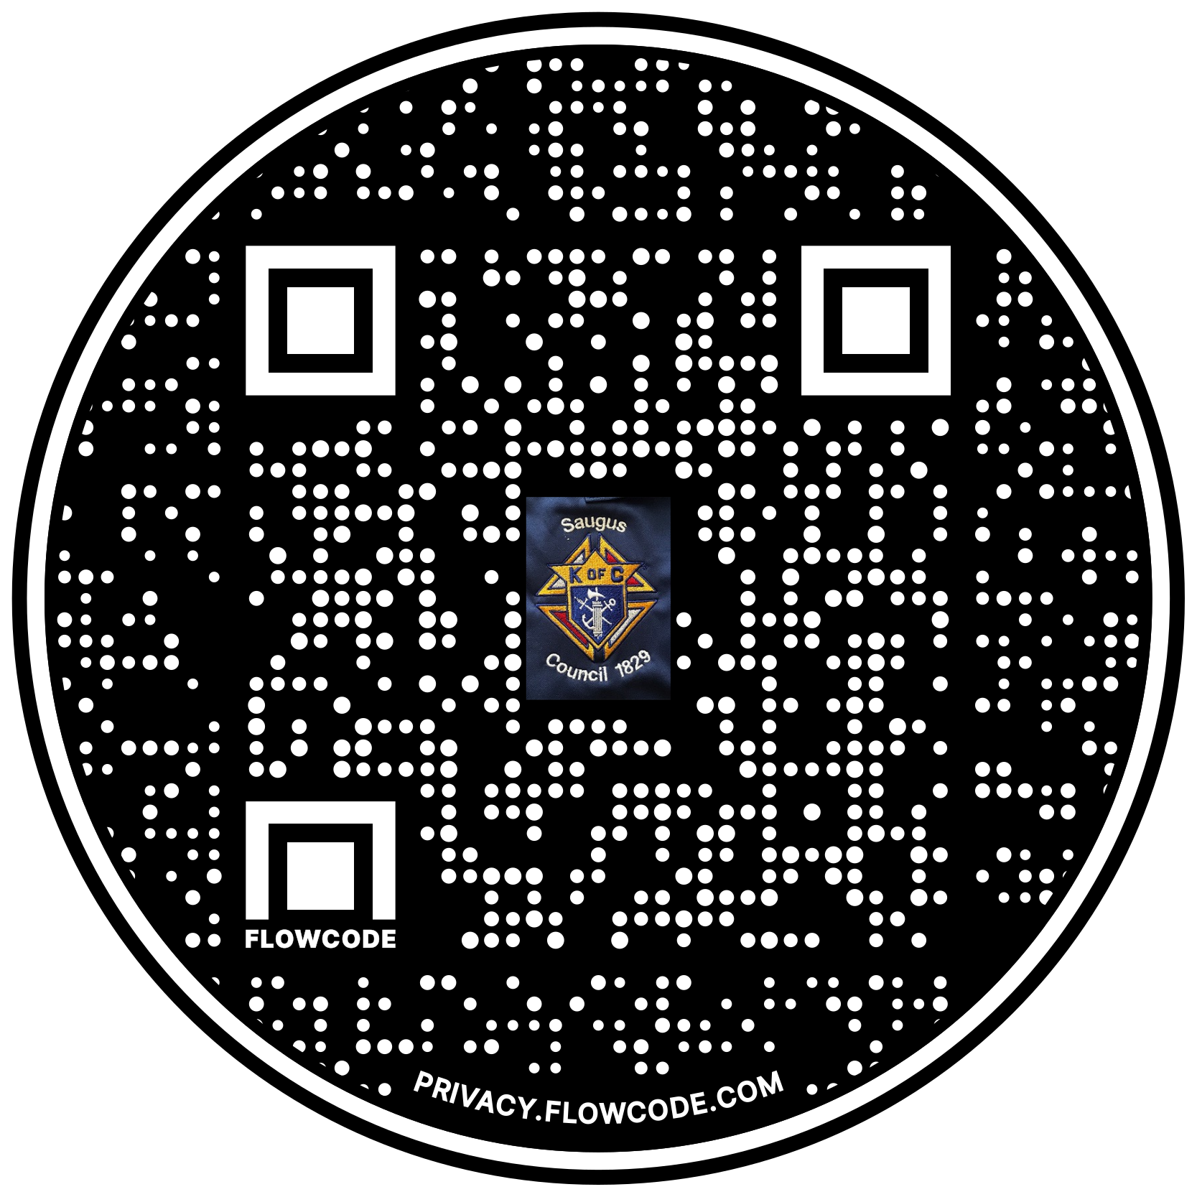

Scan the Code to view the Council Web site!

