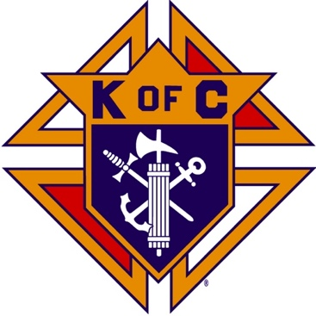
Saugus Knights of Columbus
Council #1829

57 Appleton Street
Saugus, MA 01906

Council Newsletter

Volume 21, Issue 10 www.sauguskofc1829.org October 2024

Grand Knight’s Message
Worthy Brothers,
I would like to start off by saying “thank you” to our Brother Steve Gerome for the outstanding meal and ceremony he put together for PGK Mark Panetta. It was a fantastic meal. I could tell Mark was thrilled and extremely proud.
We have some very exciting news regarding our function room. Our recently established Ladies Auxiliary is moving fast towards modernizing the room with new lighting, fresh paint, and new wall hangings. I believe an updated function room will bring more business and our tenant, Weight Watchers, will be even happier than they already are. When the painting starts, we will need volunteer painters and laborers to help get the project going.
We have several very important events coming our way very fast. We have the annual Tootsie Roll Drive coming up this month. I will provide more info on that during our next business meeting. In November we have the Deceased Brothers Mass. I would like to have as many of our current members as possible at the service to show our Brothers that they are not forgotten and to show their families that we will always remember them and keep them in our prayers. We also have the annual Breakfast with Santa coming up in December. I know we will need volunteers for this as well. This breakfast is one of our biggest events. It has become in my opinion our showcase of events. It involves many families from our two parishes and gives our community a look at the many good things we do. Remember Brothers, we can only do these events with your help. These events only take up a couple of hours of our time. LET’S ALL GET INVOLVED.
As most of you know I will be away for the entire month of October. I will return on November 5th. In my absence Deputy Grand Knight Richard Aiello will fill in for me.
One final notice, Tony LaRosa is home now from the hospital, and he is looking forward to seeing us all. I know he would appreciate a phone call. Another Brother of ours has suffered a terrible fall and has become bedridden. Jimmy Sclafani, a long time Knight from our Council and our former bartender would like to hear from our members. Jimmy is 93 years old and truly one of the good guys.
Vivat Jesus
John Coburn, Grand Knight
(781) 854-6116

District Deputy’s Message
Worthy Council Officers, I bring you greetings from Supreme Knight Patrick Kelly and State Deputy Bob Schwarz
- Thank you for the hard work done by you the DD’s and Councils. We have meet the 20% recruitment goal for the first quarter of 2024/25.
- Still look for members to help each of our councils do the charitable and faith filled works that they perform. I will now be doing a big push to get active councils Safe Environment Compliant.
- Plan Delta Church Drives, councils that were off, get them working on programs and membership, keep this up September was a Great Month, use all opportunities of council activities to have a membership drive.
- Councils should start to plan for Wreaths across America donations $17/wreath for veteran cemeteries.
- State Incentives for Membership:
  - Gold pen for the #1 Recruiter in 2024/2025 by percentage.
  - Delta Church drives, with prospect cards proof will get a gift card to raffle at council exemplification. (Need a picture of the prospect cards)
  - 100% of Membership/2 FBN’s Done/Safe Environment Complete by 12/31/24 get into drawing for State Convention (Room for 2 and all events covered by state). One for DD of the councils and one for the Councils.
- Upcoming Dates:
- Oct 19 Charity Ball in Milford at the Double Tree, start promoting, each DD should attend. This is when councils had over checks for the State Charity Fund from Tootsie Roll proceeds.
- Nov 10th at 12:30 in Norwood K of C hall, Star Award Banquet for 2023/2024 Star council Grand Knights and DD’s (No charge)
- 4th Degree Exemplification 24th of November in Chicopee, Castle of Knights. Encourage 3rd degree knights to join the Patriotic Degree and register. 125th year of 4th degree oncoming!
- Saturday December 14th Wreaths Across America at both National Cemeteries in the state, Bourne and Agawam.
- Pro-Life Mass Schedule:
10/6/24 10:00am @ St. Paul’s Cathedral, Worcester
10/20/24 10:30am @ St. Mary’s Cathedral, Fall River
11/17/24 10:00am @ St. Michael’s Cathedral, Springfield
- Reginal Meetings –Wednesday 10/2 North Regional Meeting, Tewksbury Council, 2068 Main St, Tewksbury MA 01876
- Get out there and live as a Catholic Man and Families, “Together in Faith”.

The Weekly Attendance Pool

The Weekly Attendance Pool is now in full swing. Come to the council, sign the logbook, and put $1 in the pool each week. The weekly number will be drawn on Tuesday after the meeting. If your number is drawn and you have signed in that day you win all that is in the pool. It continues to grow until someone wins. Don’t miss out!

October Birthdays
Happy Birthday to the following Brothers

01st – Paul Corsino 05th – Anthony Amara
07th – William Pray 08th – Michael Moscaritolo
09th – Richard Salerno 17th – Phillip Sinatra
18th – James Doyle 20th – Frederick Verro
22nd – Domenic Amara 23rd – John Hastings
24th – Thomas Gillespie 25th – Andrew Sarno
25th – William McKinnon 26th – Frederic Landry
27th – Sam Korkpor
Members are invited to stop by the lounge for a complimentary beverage of their choice on Tuesday of their birthday week. If your name is listed above, just stop by the Council on Tuesday of that week and present your membership card to the bartender to claim it.

BA1829 Club Numbers

July
September 03 – 36
September 10 – 65
September 17 – 58
September 24– 08

Saturday Morning Breakfast
Breakfast is served from 8:30-9:00 A.M. every Saturday morning.
All are welcome. The fare is only $5.00
Menu:
October 05 – Sausage, egg and cheese on a bagel
October 12 – French toast and ham
October 19 – No Breakfast – Steve out of town.
October 26 – Ham and cheese omelets

Meeting Schedule
Saugus Council #1829

First Tuesday – Social meeting only - Pizza Night
Second Tuesday – Business meeting
Third Tuesday – Dinner meeting only. The cost for dinner is $10.00.
Fourth Tuesday – Business meeting
Fifth Tuesday (when applicable) – Social meeting only

Upcoming Events
Indoor Craft Fair/Flea Market October 19, 8:00 – 3:00
Life-Line Screening October 21, 8:00 – 4:00
Annual BA Meeting October 22, after regular meeting.
Deceased Brother’s Mass November 3; 11:00 am

JFK Assembly Meeting

The Fourth Degree meets on the second and fourth Tuesdays at 7:00.

All Worthy Knights are encouraged to attend.

Friday Night Socials
The downstairs hall is open every Friday night.
7:00 – 10:00 p.m.
Come socialize with your brother knights and their guests.

Past Grand Knights’ Banquet
Great dinner. Fun was had by all who attended.
Here’s what you missed!!

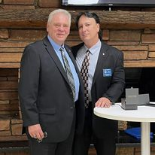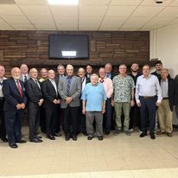

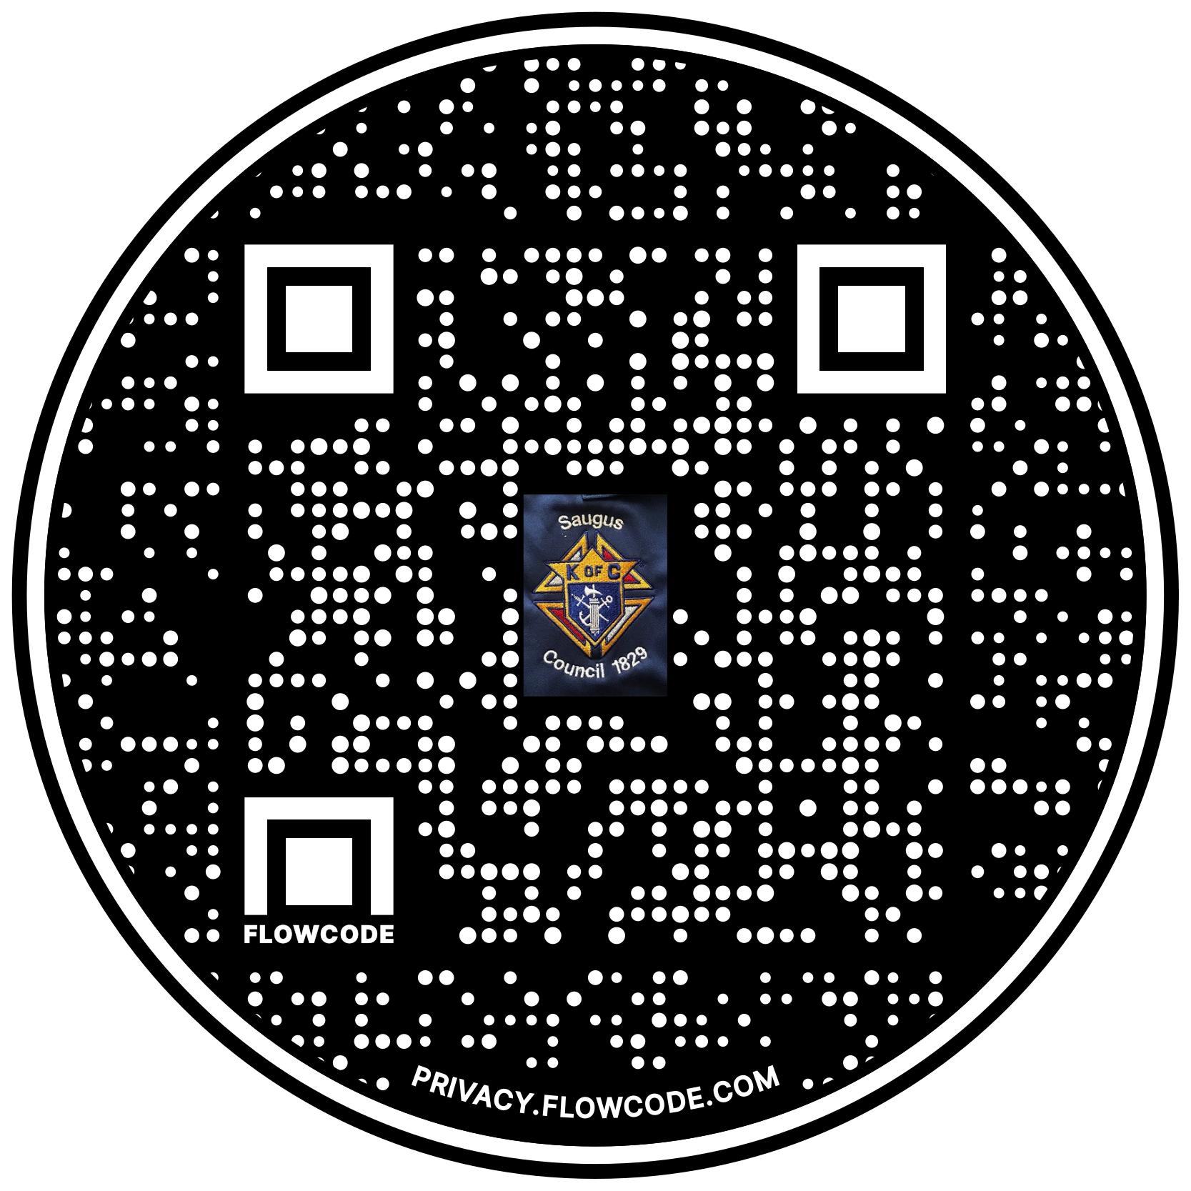

Scan the Code to view the Council Web site!

