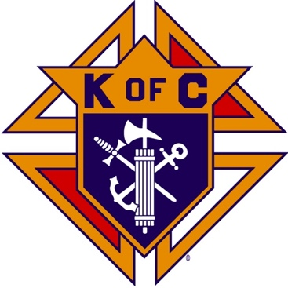
Saugus Knights of Columbus
Council #1829

57 Appleton Street
Saugus, MA 01906

Council Newsletter

Volume 23, Issue 08 www.sauguskofc1829.org August 2026

Grand Knight’s Message
Greetings, my Worthy Brothers.
It appears our summer is moving along quite rapidly. The weather will be changing before we know it. We were very busy in June and July. In the function hall we also had and are continuing to have a very schedule. On Wednesday nights with the poker games and the keno machine. So far, so good.
As you all know by now, we scored big on buying ceiling tiles for the foyer. We spent $300.00 for 340 new tiles. I would like to thank all the men who helped unload the two vehicles containing the tiles.
The annual craft fair will be held on August 8, 2026. The women from the Ladies of the Knights have been tirelessly working - putting raffle baskets together, hanging advertisement signs throughout the town, and gathering donations. Without their help we would still be at square one. I have to thank Brother Paul for his expertise and Treasurer Steve Gerome for his guidance. The donations from the local businesses and the generous donations from our own membership are incredible. The volunteer sign-up sheet is on the whiteboard.
The Saturday breakfast club will suspend operations during the month of Augus. I have several family commitments, and to be honest, I could use a break. I have my own summer projects at the house. I hope you all understand. Breakfast will resume on the 1st Saturday of September.
On a different note, brother Tony is doing well. He is rehabbing at home. DGK Richie's mother is doing OK, but she still needs our prayers, as does Warden Steve and Inner Guard Mike's mother. Whether you believe it or not the power of prayer works. I strongly believe in prayer. My prayers are very often answered. Just try it and see.
Dear Lord Jesus, watch over all of us and our families. We are all good people and we all hold you dearest and nearest in our hearts. We love you Jesus and we love the blessed Mary.
Vivat Jesus.
John Coburn, Grand Knight
Saugus Council 1829

Monthly Social Dinner

The August social dinner will be held on Tuesday, August 18th. The menu is meatloaf, mashed potatoes, veggie s, salad, dessert and beverages.
The cost is $12.00 per person. The sign-up sheet is near the kitchen window.
LRC and 3 card bingo will follow the dinner.

The Weekly Attendance Pool
The Weekly Attendance Pool is up to $13.00

August 07 027 John Coburn
August 14 079 Francis Manning
August 21 116 William Petrillo
August 28 032 David Cookwick

BA1829 Club Numbers
August 07 – 20
August 14 – 46
August 21 – 99
August 28 – 28

Rent Our Function Hall

Eastern Poker Tour

Every Wednesday night, 6:30-10:30 P.M.

Saturday Morning Breakfast

There will be no Saturday Morning Breakfast Club during the month of August.

Meeting Schedule
Saugus Council #1829

First Tuesday – Social meeting only - Pizza Night
Second Tuesday – Business meeting
Third Tuesday – Dinner meeting only. The cost for dinner is $10/$12.
Fourth Tuesday – Business meeting
Fifth Tuesday (when applicable) – Social meeting only

Upcoming Events
Craft Fair August 8th, 8:00 – 3:00
Social Meeting Dinner/ Card games August 18th, 6:30 pm – 9:30
Eastern Poker Tour every Wednesday, 6:30 – 10:30
Friday Nights at Members’ Lounge every Friday evening, 6:00 – 11:00

August Birthdays
Happy Birthday to the following Brothers

01st – Donald Cook 02nd – Roger Worthley
03rd – Louis Melillo 04th – William Magarian
09th – Lorenzo Grasso 13th – John Barrett
15th – Michael Fernandez 17th – Gregory Natalucci
22nd – Oscar Desjardins 27th – Philip Antonelli
27th – Pasquale Alfe 28th – John Messina
30th – Mario Trafficante
If your name is listed above, you are invited to stop by the lounge for a complimentary beverage of your choice on Tuesday of your birthday week

Monthly Newsletters
The monthly newsletter files have been added to the Council web site at https://sauguskofc1829.org/newsletters.

You can download a Microsoft Word copy of the file
to your computer/smart phone/tablet any time you wish.

JFK Assembly Meeting
The Fourth Degree meets on the second and fourth Tuesdays at 7:00.
All Worthy Knights are encouraged to attend.

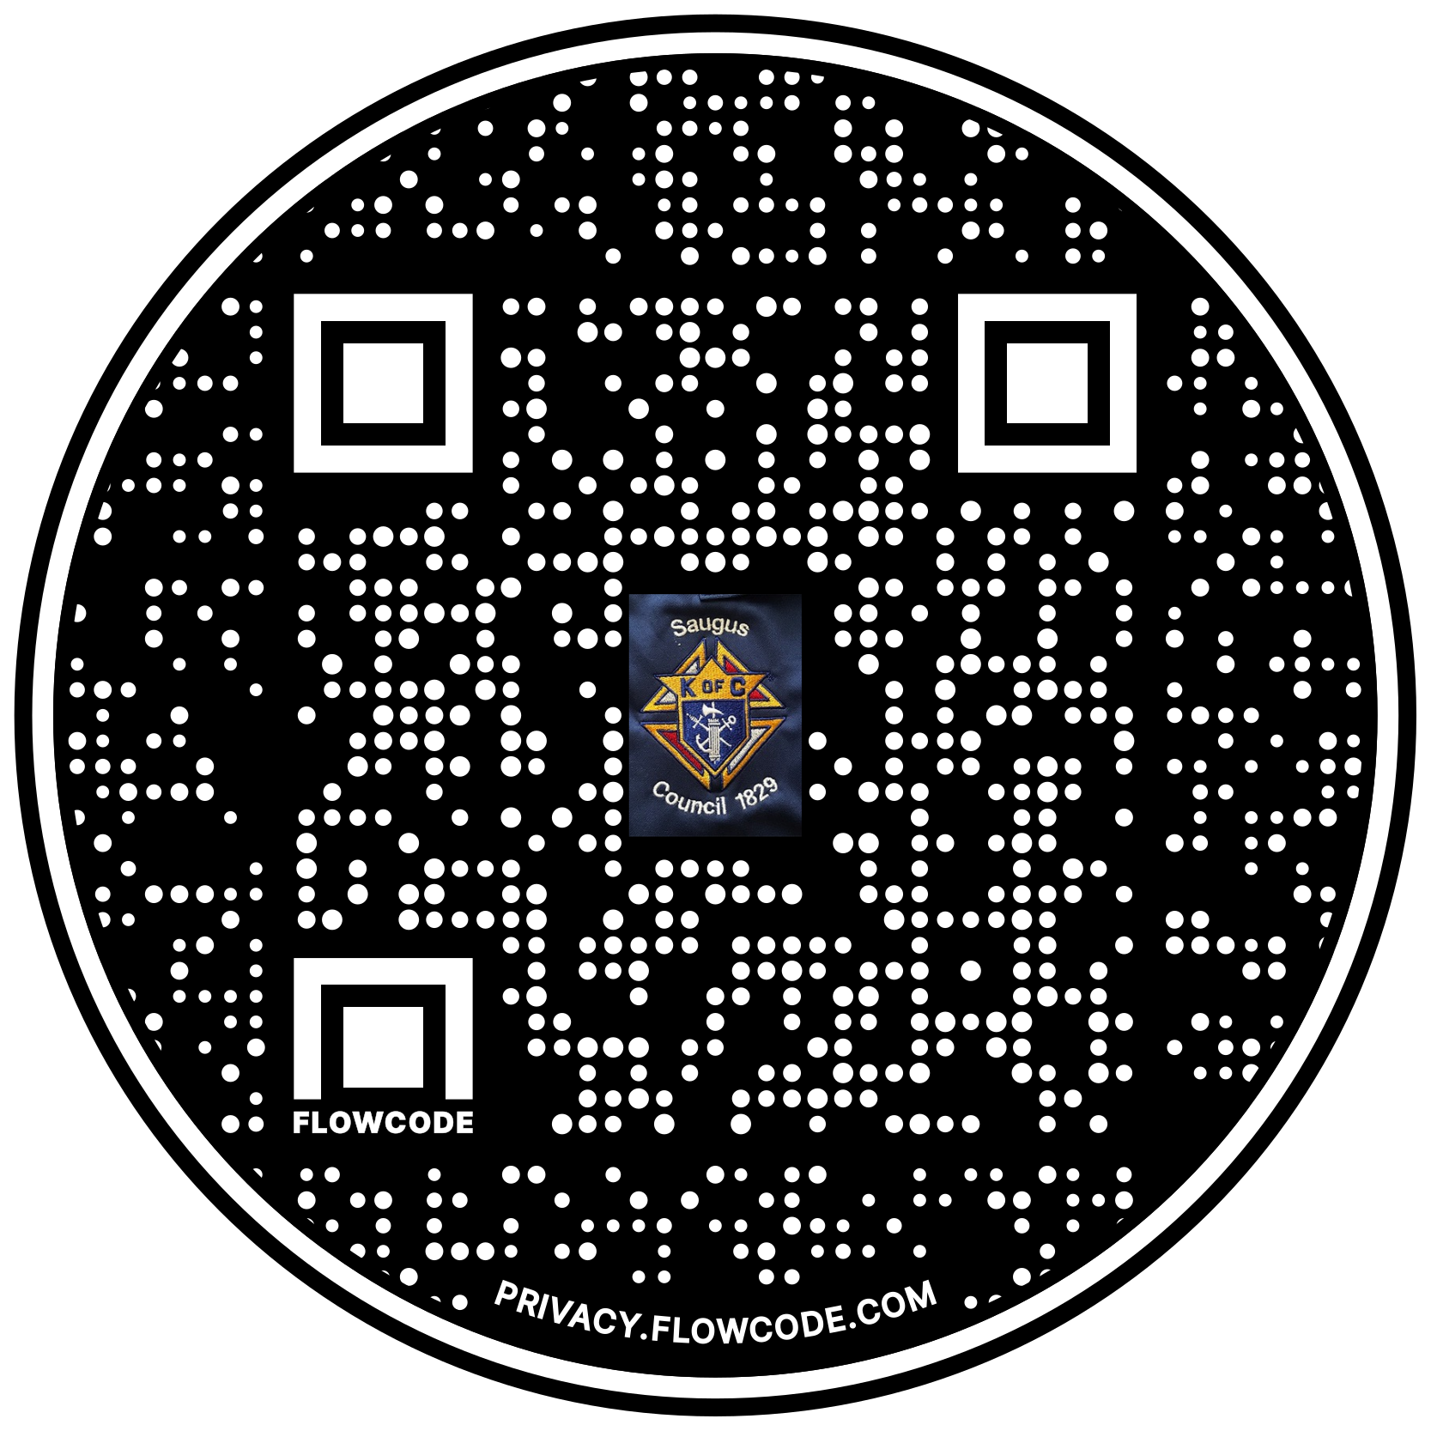

Scan the Code to view the Council Web site!

