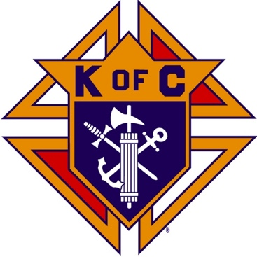
Saugus Knights of Columbus
Council #1829

57 Appleton Street
Saugus, MA 01906

Council Newsletter

Volume 23, Issue 02 www.sauguskofc1829.org February 2026

Grand Knight’s Message

Greetings my Worthy Brothers.
I am still here in not so sunny southern Florida. The weather has been extremely cold. The past two weeks have been the worst. The average temperature at 8:00 has been around 45*, and 65* in the midafternoon. I could have stayed home and cooked breakfast, dinners, and tended bar for all you guys, NAH. I'm good!
Seriously, how are you guys? Life here is good even on a bad day. I have met up with Steve, and Henry, along with his lovely Silvanna. Stevie, Karen and I have had lunch at an incredible Chinese food buffet. The waiter kept yelling at us to leave, he kept saying "you been here 4 hour! You all leave now!!" lol. Karen, Silvanna, Henry, and I went to the Seminole Casino several different days. Glad to say we all walked away able to make our mortgage payments a little easier. The casino is about 45 minutes away and it is a straight drive for us. Very profitable indeed!
At the risk of sounding sappy I just want to say I miss you all. Karen and I are looking forward to returning home next month and continuing our council duties. I receive text messages and phone calls daily from our members. They really make a difference in keeping up to date with local happenings. Karen says she is really looking forward to the social dinners and the LRC games.
Thank you to Chris, Louise, Richie, Phil, Bobby, Big Ed, Earl, Jimmy, and Michael for stepping up and taking care of business in my absence. I truly appreciate it. This is an awesome definition of brotherhood. I may have missed some names, but I truly mean you all.
I have to go now but you are all in my thoughts and prayers. Thank you for watching out for each other and taking care of your families and neighbors. We are all family!!

Vivat Jesus,
Love to all,
John Coburn
Grand Knight,
Saugus Council 1829

Monthly Social Dinner

There will be no social dinners until March.

The Weekly Attendance Pool

The Weekly Attendance Pool is up to $8.00

January 06 135 Mike Piazza
January 13 183 John Buonopane
January 20 002 Rich Aiello
January 27 149 Rich Salerno

BA1829 Club Numbers
January 06 – 51
January 13 – 51
January 20 – 08
January 27 – 35

Rent Our Function Hall

Eastern Poker Tour

Every Wednesday night, 6:30-10:30 P.M.

Meeting Schedule
Saugus Council #1829

First Tuesday – Social meeting only - Pizza Night
Second Tuesday – Business meeting
Third Tuesday – Dinner meeting only. The cost for dinner is $10/$12.
Fourth Tuesday – Business meeting
Fifth Tuesday (when applicable) – Social meeting only

Saturday Morning Breakfast

John and Steve are both away. Bob may be cooking
breakfast occasionally. Check with him about what weeks
he will be cooking. The fare is only $7.00

Upcoming Events
Eastern Poker Tour every Wednesday 6:30 – 10:30
Friday Nights at Members’ Lounge every Friday evening 6:00 – 11:00
Social Meeting Dinner/ LRC game March17, 2026; 6:30 pm – 9:30 pm.

JFK Assembly Meeting

The Fourth Degree meets on the second and fourth Tuesdays at 7:00.

All Worthy Knights are encouraged to attend.

February Birthdays
Happy Birthday to the following Brothers

01st – Scott Campbell 03rd – Anthony Moscaritolo
03rd – Earl Zibell 05th – Robert Batchelder
07th – Mark Panetta 08th – Salvatore Messina
09th – Jeffrey Short 09th – Paul Ring
10th – Albert Dinardo 15th – Simeon Korkpor
22nd – Joseph Marfione 24th – Nicholas V. Melanchook
24th – Matthew Demas 24th – Michael Faysa
24th – John Buonophane 24th – Jason Markos
26th – Daniel Marfione 27th – Robert McDonald
28th – Peter Frontiera 28th – Alexander Cody

If your name is listed above, you are invited to stop by the lounge for a complimentary beverage of your choice on Tuesday of your birthday week

Monthly Newsletters
The monthly newsletter files have been added to the Council web site at https://sauguskofc1829.org/newsletters.

You can download a Microsoft Word copy of the file
to your computer/smart phone/tablet any time you wish.

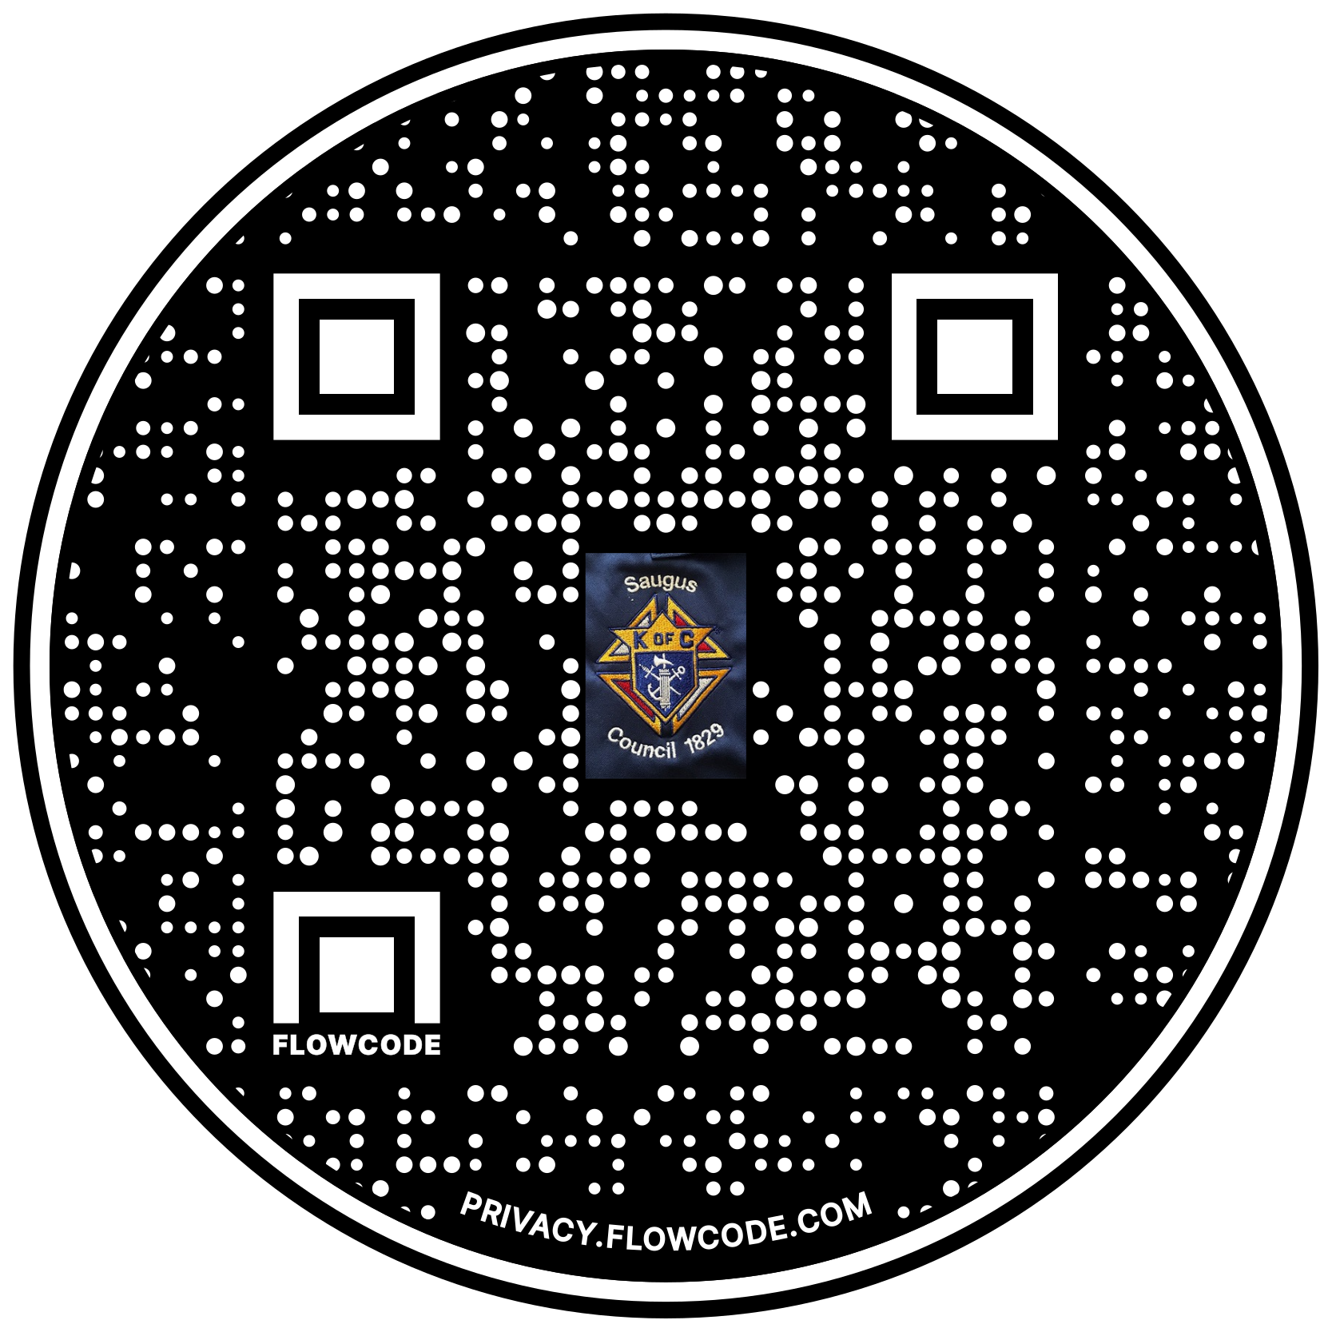

Scan the Code to view the Council Web site!

