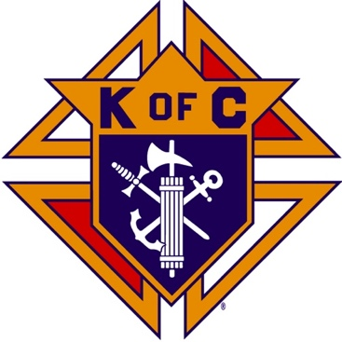
Saugus Knights of Columbus
Council #1829

57 Appleton Street
Saugus, MA 01906

Council Newsletter

Volume 22, Issue 4 www.sauguskofc1829.org April 2025

Grand Knight’s Message

Hello, my Worthy Brothers.
Spring is here. I want to say hello to all our brothers. Our membership attendance on Tuesday evenings has been growing every week. It is great to see.
The Saturday morning breakfast club is growing every week also. As most of you have heard, the price of breakfast has increased to $7.00. The price was increased to $10.00 per vote of the Saturday morning attendees, but after two weeks, the increase was reduced to $7.00 after the price of eggs and bacon came down. You cannot beat the meal you get for $7.00!
For those who have asked, a Building Association meeting is going to be held on April 8th, after our regularly scheduled meeting. It was decided to hold the BA meeting after our regular meeting so as to not rush the meeting.
A reminder to all members. We still have not had anyone step up and show any interest in becoming our council recording secretary. As you know Vinny Zinna is retiring from the position. I asked him if he would continue to serve, but he stated his health wouldn’t allow it.
As most of you have heard, another member, Peter Frontiera, is in ill health and hospitalized. We all hope he has a speedy recovery. Also, Tony LaRosa’s wife is in the hospital after having surgery. Marie, we all wish you a speedy recovery as well.
I hope you all have a wonderful Easter and enjoy all the blessings our Lord Jesus has to offer. See you all soon. In God’s Holy name we all pray that we stay healthy and well.
John F. Coburn
Grand Knight

District Deputy’s Message

Greetings to all brothers.
All councils are being reviewed to see if they are Safe Environment Compliant. Your GK’s and FS’s are going to start getting called about this.
There are several incentives to increase membership
  - Gold pen for the #1 Recruiter in 2024/2025 by percentage.
  - Delta Church drives, with prospect cards proof will get a gift card to raffle at council exemplification. All DD’s should have 1 Drive in their district per month!
  - All councils that have reached safe environment have a chance to be in a drawing to use funds for Charity. Encourage more of your councils to get into this raffle to help meet these goals:
    - 20% total state wide, 3 drawn councils get $100 finished 23.3% 3 councils get $100 each
  - Supreme Contest March 31/June 30 have 125% membership get a council banner.
4th Degree needs new members. June 22nd Exemplification (125 new members goal).
Upcoming State Dates:
  - April 21st is the Lantern Award in Framingham MA at the Sheraton. All councils and officers are invited. Info is on MassKofC.org. The Honoree is Pope St. John XXIII Seminary and accepting the award will be Very Reverend Brian R. Kiely, Rector. (Form on Website)
  - State Convention is May 16th -18th at the Emerald Resort, Hyannis, MA. Two delegates from each council, all members are invited. (Form on Website) Remember Donation for Ladies Lunch - Centerpieces ($25). Donations to be in Convention Booklet Ad’s.
  - Past State Officers Dinner is June 26 in Mansfield, MA. At the EnVision Hotel, Mansfield.
  - June 27th is the State Golf Outing

Upcoming Events
Meager Meals Friday night, April 4, 5:30 P.M.
Blessed Sacrament Church Hall
All volunteers are to report to the Church at 5pm. Hot tomato soup and grilled cheese sandwiches are being served. According to last year’s attendance we expect between 70 and 80 people.
Social meeting Dinner Tuesday, April 15, 6:30 P.M.
We will be serving hot meatball and sausage submarine sandwiches, along with salad and dessert. The price is $10.00 per person. As usual all are welcome to bring their wives and girlfriends. The sign-up sheet is posted in the downstairs meeting hall near the kitchen. After the meal we plan to have a Left-Right-Center game.

Saturday Morning Breakfast
John is back!!
Breakfast is served from 8:30-9:00 A.M. every Saturday morning.
All are welcome. The fare is only $5.00

The Weekly Attendance Pool

The Weekly Attendance Pool is up to $171. Come to the council, sign the logbook, and put $1 in the pool each week. The weekly number will be drawn on Tuesday after the meeting. If your number is drawn and you have signed in that day you win all that is in the pool. It continues to grow until someone wins. Don’t miss out! The numbers for the past month:

March 04 – 139
March 11 – 143
March 18 – 149
March 25 – 004

BA1829 Club Numbers

March 04 – 96
March 11 – 56
March 18 – 47
March 25 – 94

April Birthdays
Happy Birthday to the following Brothers

04th – Demetrios Petras 06th – Ryan Cooney
09th – James Vining 09th – Bart Simonelli
11th – Dennis DiNitto 12th – Frank Andreottola
12th – Thomas Raiche 12th – Kevin O’Brien
16th – Allen Capone 16th – Robert Losco
19th – Albert Nicholls 21st – Sean Cummings
21st – Ernest Felice 23rd – Robert McHugh
25th – Peter Aversa 30th – Michael Furbush

If your name is listed above you are invited to stop by the lounge for a complimentary beverage of your choice on Tuesday of your birthday week

Meeting Schedule
Saugus Council #1829

First Tuesday – Social meeting only - Pizza Night
Second Tuesday – Business meeting
Third Tuesday – Dinner meeting only. The cost for dinner is $10.00.
Fourth Tuesday – Business meeting
Fifth Tuesday (when applicable) – Social meeting only

JFK Assembly Meeting

The Fourth Degree meets on the second and fourth Tuesdays at 7:00.

All Worthy Knights are encouraged to attend.

Thanks to Ron Keohan for submitting a word search for the monthly newsletter. (Solution will appear in next month’s newsletter).

5. THE WILDERNESS JOURNEY

P | S | Q | X | P | R | O | M | I | S | E | D | L | A | N | D | K | L | B | X | Z | H
W | G | K | F | P | S | C | G | A | U | C | V | J | S | S | A | I | T | A | Q | I | P
U | N | W | B | D | G | S | F | J | X | K | I | E | O | H | Z | A | O | L | B | E | D
K | I | J | I | M | N | E | U | X | R | O | G | P | A | S | M | W | P | A | Q | K | C
P | T | B | O | S | I | L | I | J | G | T | S | R | L | Z | H | J | A | A | L | M | V
R | E | D | L | P | R | T | C | M | R | E | O | B | I | P | Z | U | N | M | Z | G | L
O | E | O | X | I | E | T | I | A | C | K | G | F | J | O | A | U | A | R | A | F | B
M | M | C | M | E | F | A | W | I | L | D | E | R | N | E | S | S | N | X | S | O | A
I | F | C | M | S | F | B | F | S | S | E | N | L | U | F | H | T | I | A | F | R | L
S | O | Q | G | A | O | I | A | F | R | D | B | G | W | L | A | W | S | I | K | T | A
E | T | A | S | L | R | A | D | R | Y | E | N | R | U | O | J | R | C | X | S | Y | K
S | N | C | Z | C | R | F | T | S | E | U | Q | N | O | C | T | F | L | Q | O | A | V
Z | E | O | A | O | A | O | M | J | G | M | I | R | I | A | M | M | U | J | S | E | O
W | T | S | N | M | I | L | J | A | S | U | S | N | E | C | E | B | M | Q | O | A | V
B | A | O | M | P | B | R | O | N | Z | E | S | E | R | P | E | N | T | L | M | R | Q
Q | X | O | E | P | L | A | G | U | E | R | E | B | E | L | L | I | O | N | K | S | N
S | N | F | M | M | W | K | P | R | I | E | S | T | L | Y | D | U | T | I | E | S | T
P | O | H | L | C | W | I | N | H | E | R | I | T | A | N | C | E | B | N | O | B | L

Aaron Forty Years Offerings
Ammon Inheritance Plague
Balaam Joshua Priestly Duties
Balak Journey Promised Land
Battles Korah Promises
Bronze Serpent Laws Rebellion
Caleb Miriam Sacrifices
Census Moab Spies
Conquest Mode Tent of Meeting
Faithfulness Moses Wilderness

Last Month’s Solution

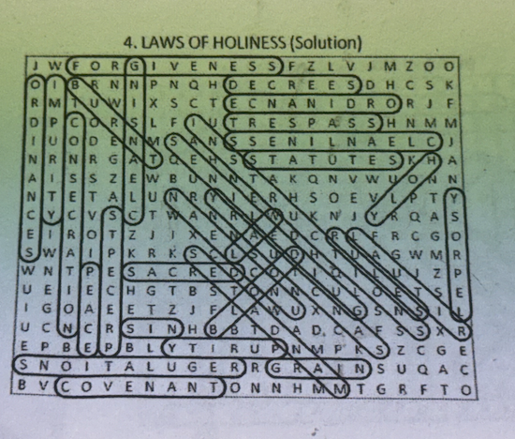

Monthly Newsletters
The monthly newsletter files have been added to the Council web site at https://sauguskofc1829.org/newsletters.

You can download a Microsoft Word copy of the file
to your computer/smart phone/tablet any time you wish.

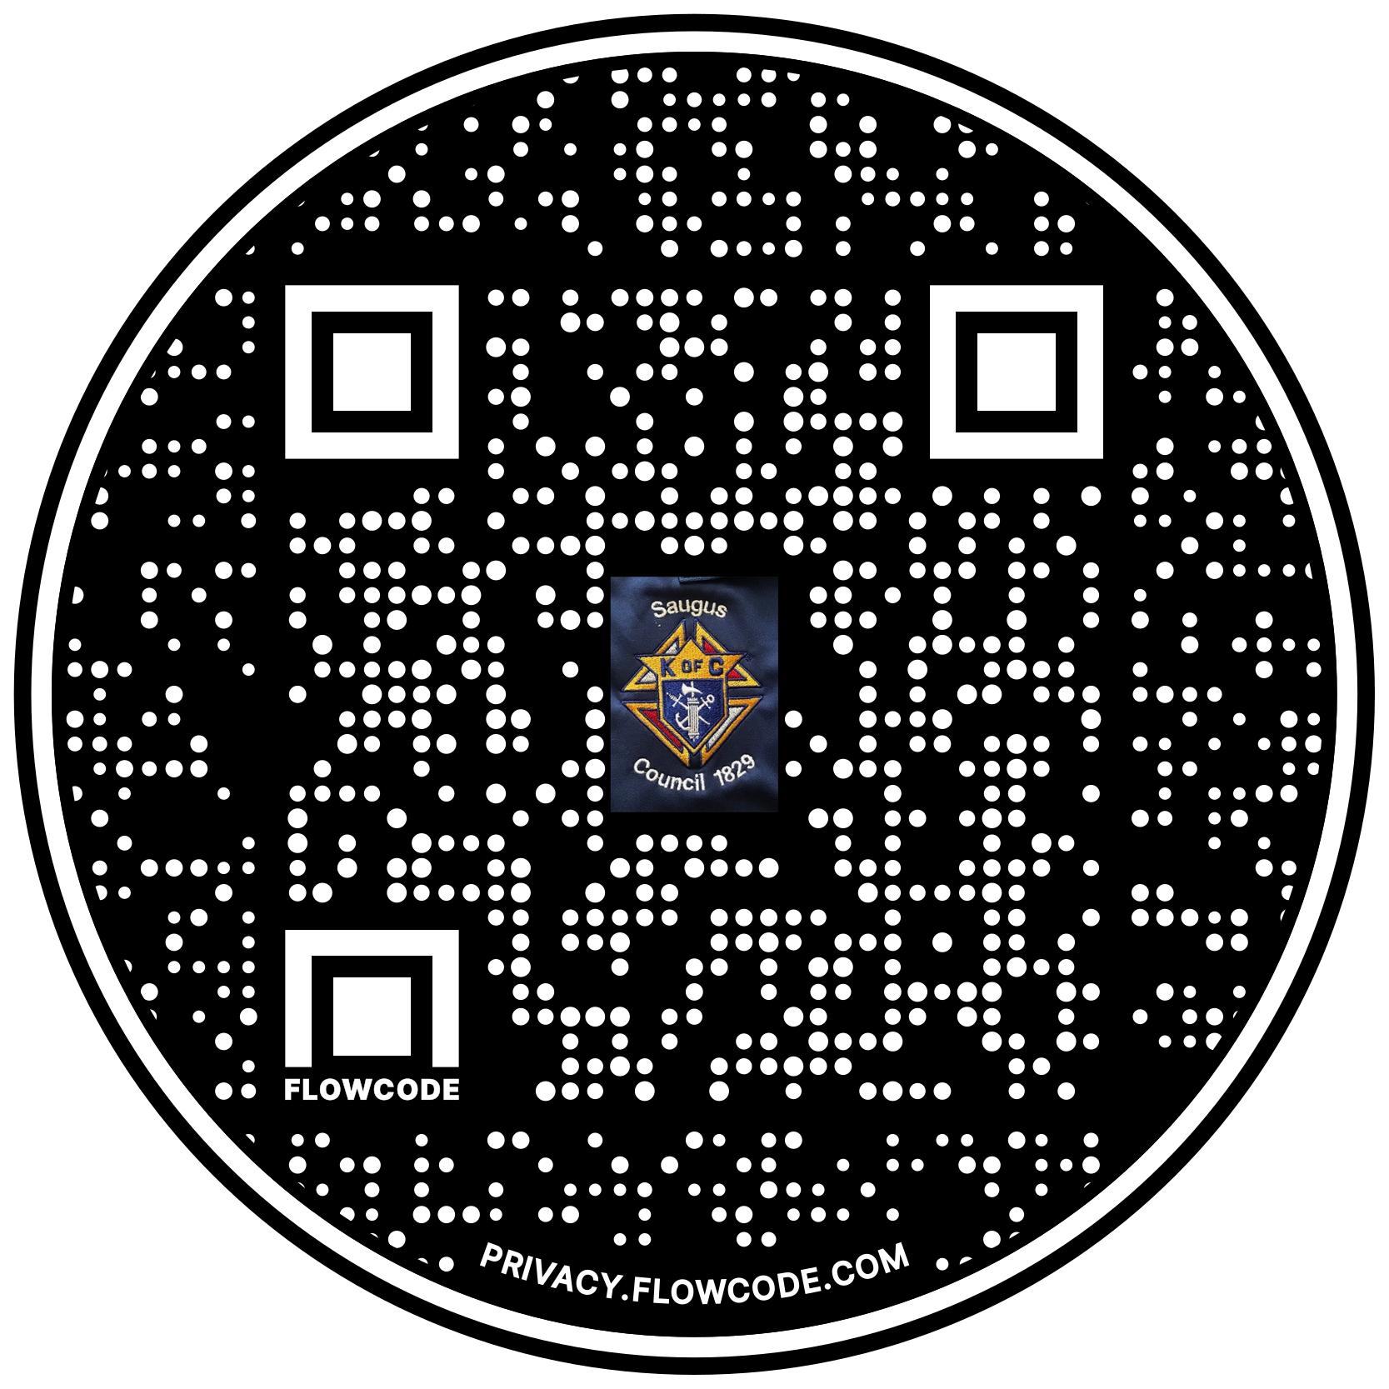

Scan the Code to view the Council Web site!

