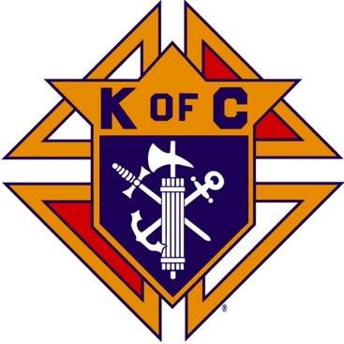
Saugus Knights of Columbus
Council #1829

57 Appleton Street
Saugus, MA 01906

Council Newsletter

Volume 22, Issue 10 www.sauguskofc1829.org October 2025

Grand Knight’s Message
Good day my brothers.
We are into the start of Autumn. The leaves are turning color, and the grass stops growing. The weather is getting colder and soon we will be turning on the heat. I hope everyone had a great summer.
Speaking of turning on the heat, we will be doing the same thing at the council. We all must try to control the heat in the building by turning down the thermostats when we leave the building. Last year we spent an average of $800.00 a month on heating. Along with controlling the heat, we must make sure all the lights are turned off, especially the back parking lot lights. These lights are too often left on.
We had a busy and extremely successful month this past September. We had the Mass on the Grass, our monthly social dinner, and our annual Flea Market. All were done perfectly thanks to all the volunteers. Without all of you we could not have done it. Thank you from the Council leadership. Also, a huge thank you to our newly formed “Ladies of the Knights.” My personal thanks to Paul Gianetta for setting up the flea market agenda and signing up all the vendors.
As most of you know, I will be gone starting October 2^{nd,} and I will be returning on November 13th. In my absence, DGK Richie Aiello will be taking my place. The monthly social dinner will still take place October 21st and the LRC game with be right after dinner. The Saturday morning breakfast club will continue as always.
Well, that’s it for now. If I don’t see you at the September 30th meeting, I’ll see you when I get back.
Vivat Jesus,
John Coburn, Grand Knight
Saugus Council 1829.

Annual BA Meeting

The annual BA meeting will be held after the regular
October 28, 2025

All Knights are encouraged to attend.

Eastern Poker Tour

Starting October 1, 2025
Every Wednesday night, 6:30-10:30 P.M.

BA1829 Club Numbers
September 02 – 52
September 09 – 46
September 16 – 87
September 23 – 61
September 30 – 75

Rent Our Function Hall

Saturday Morning Breakfast
Breakfast is served from 8:30-9:00 A.M. every Saturday morning.
All are welcome. The fare is only $7.00

John is on vacation. Steve is back!!

Menu:
October 07 – Ham, egg & cheese omelets
October 14 – Pancakes & sausage links
October 21 – No breakfast (Steve is away)
October 28 – Canadian bacon, eggs, cheese on a bagel

The Weekly Attendance Pool

The Weekly Attendance Pool is up to $132.

September 02 204 Terry Murphy
September 09 163 Steven Socci
September 16 199 Paul Ring (won)
September 23 131 John Pellegrini
September 30 077 Steven Johnson

Upcoming Events
Eastern Poker Tour every Wednesday starting October 1, 6:30 – 10:30
Social Meeting Dinner/ LRC game Tuesday, October 21, 6:30 P.M.
Menu: Spaghetti, meatballs, salad, dessert.
Annual BA Meeting Tuesday, October 28, 8:00P.M.
Deceased Brothers’ Mass Sunday, November 9, 11:00 mass
Fourth Degree Exemplification November 16
Christmas Party December 5 or 6 TBD 6:00-10:00 P.M.

October Birthdays
Happy Birthday to the following Brothers

01st – Paul Corsino 05th – Anthony Amara
07th – William Pray 08th – Michael Moscaritolo
09th – Richard Salerno 17th – Phillip Sinatra
18th – James Doyle 20th – Frederick Verro
22nd – Domenic Amara 23rd – John Hastings
24th – Thomas Gillespie 25th – Andrew Sarno
25th – William McKinnon 26th – Frederic Landry
27th – Sam Korkpor

If your name is listed above, you are invited to stop by the lounge for a complimentary beverage of your choice on Tuesday of your birthday week

JFK Assembly Meeting

The Fourth Degree meets on the second and fourth Tuesdays at 7:00.

All Worthy Knights are encouraged to attend.

Meeting Schedule
Saugus Council #1829

First Tuesday – Social meeting only - Pizza Night
Second Tuesday – Business meeting
Third Tuesday – Dinner meeting only. The cost for dinner is $10/$12.
Fourth Tuesday – Business meeting
Fifth Tuesday (when applicable) – Social meeting only

Monthly Newsletters
The monthly newsletter files have been added to the Council web site at https://sauguskofc1829.org/newsletters.

You can download a Microsoft Word copy of the file
to your computer/smart phone/tablet any time you wish.

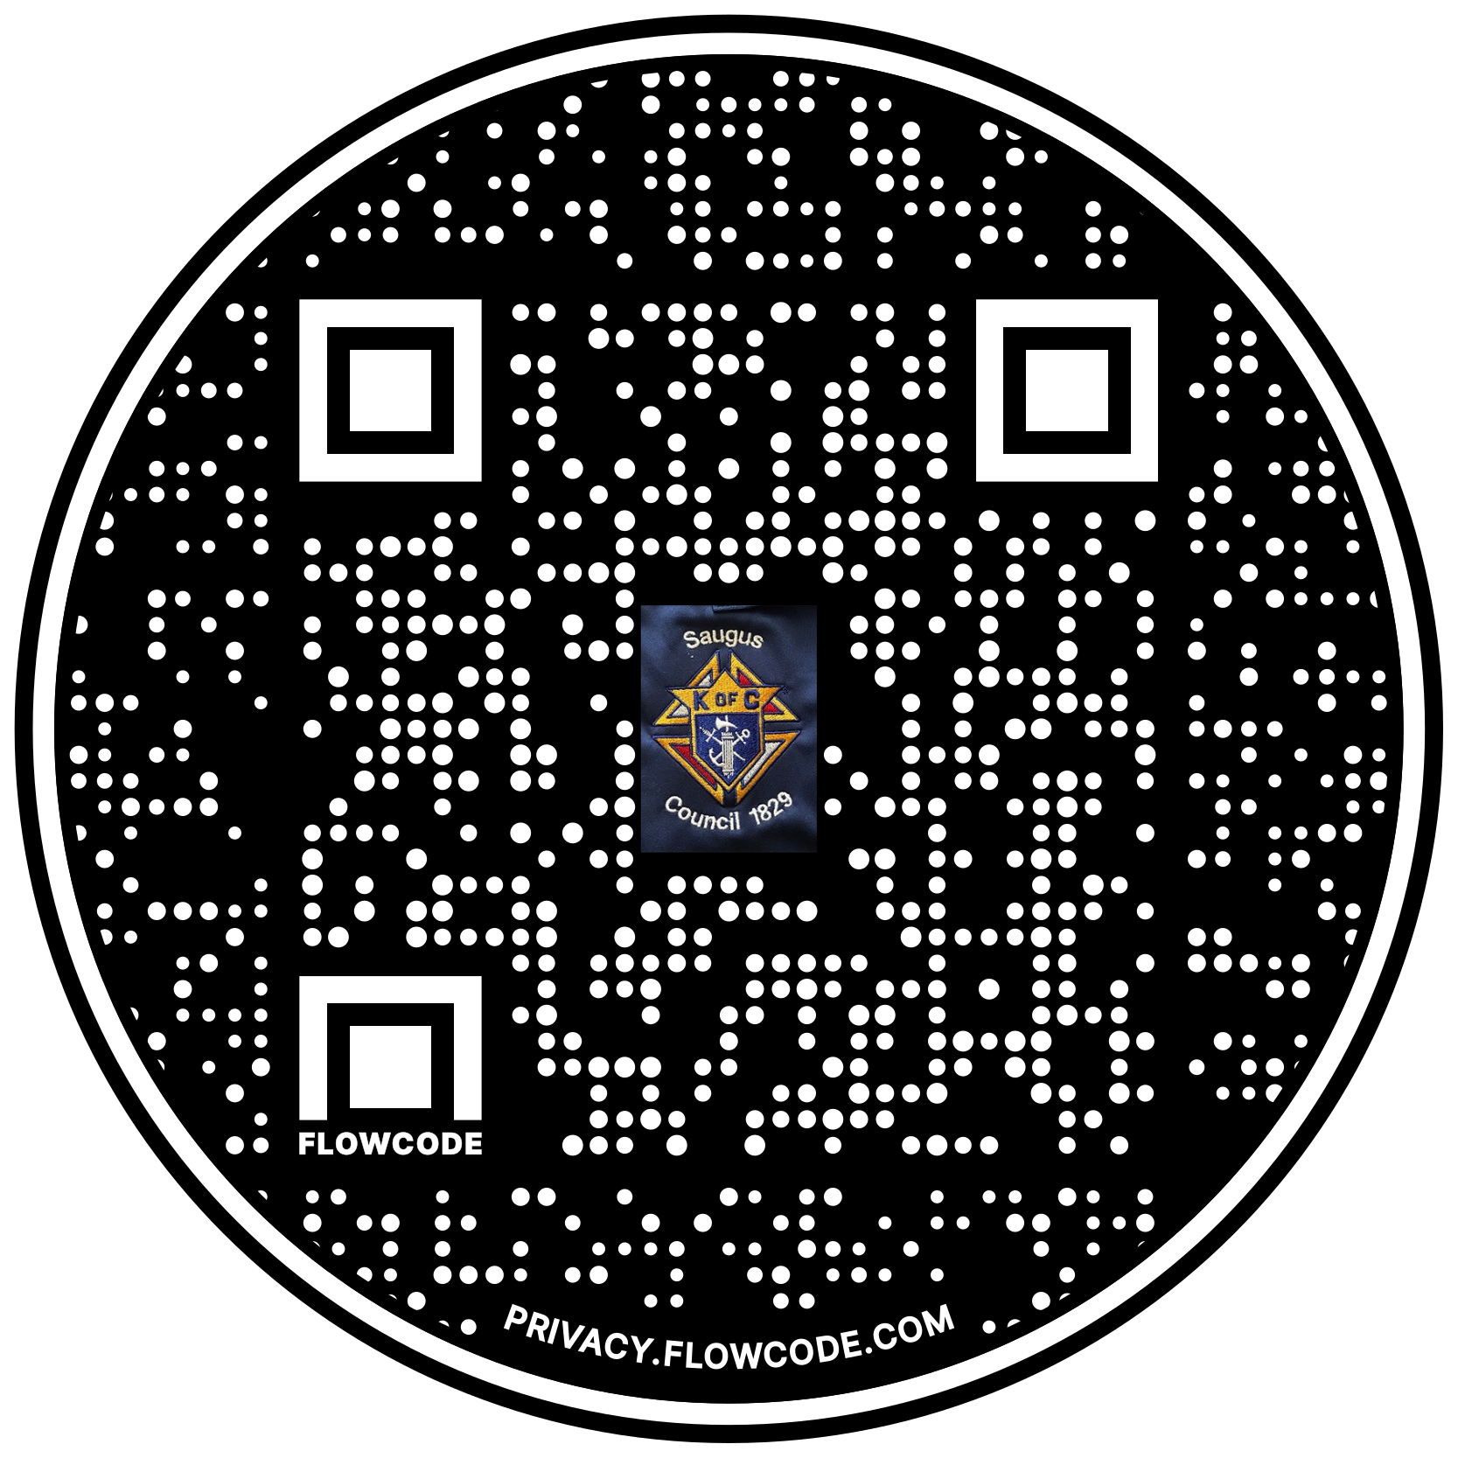

Scan the Code to view the Council Web site!

