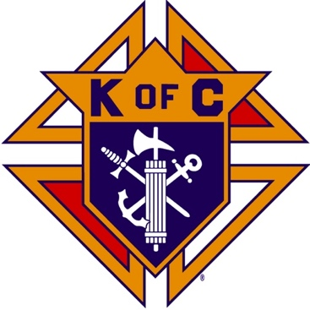
Saugus Knights of Columbus
Council #1829

57 Appleton Street
Saugus, MA 01906

Council Newsletter

Volume 21, Issue 09 www.sauguskofc1829.org September 2024

Grand Knight’s Message
Worthy Brothers,
Another summer has passed us by. I hope everyone enjoyed the summer months and had time for fun in the sun and an opportunity to spend quality time with their families. For me it seems that the older I get the faster the summer goes by.
We had a very productive summer council-wise. Several major improvements were made. The game room has been renovated; two new ice machines were installed (replacing those that were purchased and installed in the early 1980s), a new beer cooler was installed in the member’s bar. The function room floor was stripped, sealed and waxed with three coats of high sheen wax. The carpet in the member’s lounge was steamed cleaned. I would like to thank the members that gave their time moving furniture so these projects could be done.
There are several events scheduled for which we will need volunteers. See the schedule listed later in this newsletter. There are sign-up sheets in the member’s lounge. Remember, these events will only succeed with your help. One event that I'm looking forward to is the home cooked dinner on September 17th. Back by popular demand is the stuffed pork chops, roasted potatoes, corn-on-the-cob, vegetables and dessert. The cost of the meal is $10. The sign-up sheet is on the downstairs lounge near the kitchen. Gourmet chef Karen Coburn will do the cooking. (I have to say that or I'm in trouble).
We have several new members that I am honored to introduce. They are brothers Earl Zibel III and Demetrius Petras. They were both introduced by brother Ernie Buonopane. I welcome them both to our council. This is proof that our council is alive and well and thriving. I would like to thank our District Deputy Christopher Luongo and our Treasure Stephen Gerome for the awesome ceremony and amazing dinner honoring our newly installed 2024 council officers. On a personal note, I would like to thank all my brothers who have reached out to me and offered to give me help if I need it during my tenure as your Grand Knight.
John Coburn, Grand Knight
(781) 854-6116
coachcoby@comcast.net

District Deputy’s Message
Worthy Brothers,

Sept 2024 Worthy Council Officers, Bring you greetings from Supreme Knight Patrick Kelly and State Deputy Bob Schwarz
- Plan your year, are you going to continue being STAR council or join the councils who made it this year, get your Safe Environment done, earlier the better, plan your activities and delta church drives. Councils need to start off on the right foot
- Get a date for your councils first membership drive of the year, get this date to your district deputy so he can get this to the regional membership team and Rodolfo. (Rodolfopanizales@gmail.com)
- State Incentives for Membership:
  - Gold pen for the #1 Recruiter in 2024/2025 by percentage.
  - Delta Church drives, with prospect cards proof will get a gift card to raffle at council exemplification.
  - 50% of membership goal by 9/30 - council will get $100 to use for their charitable giving.
  - 50% of membership goal by 9/30 - council will be eligible for entry into a raffle for free night at hotel and entry for 2 to charity ball.
- Upcoming Dates:
- Sept 8th Turn Over of Silver Rose 10 AM at Saint Joseph Church, 1200 Mendon Rd, Woonsocket, RI
- Oct 19th Charity Ball in Milford at the Double Tree. This is when councils hand over checks for the State Charity Fund from Tootsie Roll proceeds.
- Nov 10th at 12:30 in Norwood K of C hall, Star Award Banquet for 2023/2024 Star council Grand Knights and DD’s
- Pro-Life Mass Schedule:
9/22/24 11:30am @ Cathedral of the Holy Cross, Boston
10/6/24 10:00am @ St. Paul’s Cathedral, Worcester
10/20/24 10:30am @ St. Mary’s Cathedral, Fall River
11/17/24 10:00am @ St. Michael’s Cathedral, Springfield

- Reginal Meetings –Councils officers are invited, hopefully all GK’s can attend
Tuesday 9/25 Boston Regional Meeting, St Francis Xavior Council Hall, 25 Chauncy St. South Weymouth MA 02191, 7PM
Tuesday 10/1 Worchester Regional Meeting, Adelphi council, 206 S. Quinsigamond Ave, Shrewsbury, MA 01545
Wednesday 10/2 North Regional Meeting, Tewksbury Council, 2068 Main St, Tewksbury MA 01876

- Get out there and live as a Catholic Man and Families, “Together in Faith”.
Past Grand Knights’ Banquet
Friday, September 27, 2024, 6:00 – 10:00
Tickets are $30
All brothers, families, guests, friends are invited
Email info@sauguskofc1829.org for tickets

Mass on the Grass
Sunday, September 29, 2024, 11:00 Mass
Brothers are needed to help set up chairs at 9:00 AM
and cleaning up at 1:30 PM.
Email info@sauguskofc1829.org to volunteer to help.

The Weekly Attendance Pool

The Weekly Attendance Pool is now in full swing. Come to the council, sign the logbook, and put $1 in the pool each week. The weekly number will be drawn on Tuesday after the meeting. If your number is drawn and you have signed in that day you win all that is in the pool. It continues to grow until someone wins. Don’t miss out!

BA1829 Club Numbers

August
August 06 – 11
August 13 – 59
August 20 – 85
August 27– 73

Happy Birthday to the following Brothers

01st – Gerald Page 04th – John Millar
04th – Steven Fernandez 10th – Christopher Rich
12th – John Coburn 16th – Derek Cipriano
22nd – Steven Johnson 22nd – Jason Vining
27th – Chris Luongo 30th – Frank Sanfilippo

If your name is listed above, you are invited to stop by the lounge for a complimentary beverage of your choice on the Tuesday of your birthday week. Present your membership card to the bartender to claim it.

Saturday Morning Breakfast
Breakfast is served from 8:30-9:00 A.M. every Saturday morning.
All are welcome. The fare is only $5.00
Menu:
September 03 – French Toast and ham steak
September 10 –Ham and cheese omelets
September 17 – Pancakes and sausage link
September 24 – Canadian bacon, egg and cheese on English

Meeting Schedule
Saugus Council #1829

First Tuesday – Social meeting only - Pizza Night
Second Tuesday – Business meeting
Third Tuesday – Dinner meeting only. The cost is $10.00.
Fourth Tuesday – Business meeting
Fifth Tuesday – Social meeting only (when applicable)

Upcoming Events
Mass on the Grass September 14, 11:00 A.M. Mass
PGK Banquet September 27, 6:00 – 10:00
Indoor Craft Fair/Flea Market October 19, 8:00 – 3:00
Life-Line Screening October 21, 8:00 – 4:00
Annual BA Meeting October 22, after regular meeting.
Deceased Brother’s Mass November 3; 11:00 A.M. Mass

JFK Assembly Meeting

The Fourth Degree meets on the second and fourth Tuesdays at 7:00.

All Worthy Knights are encouraged to attend.

Friday Night Socials
The downstairs hall is open every Friday night.
7:00 – 10:00 p.m.
Come socialize with your brother knights and their guests.

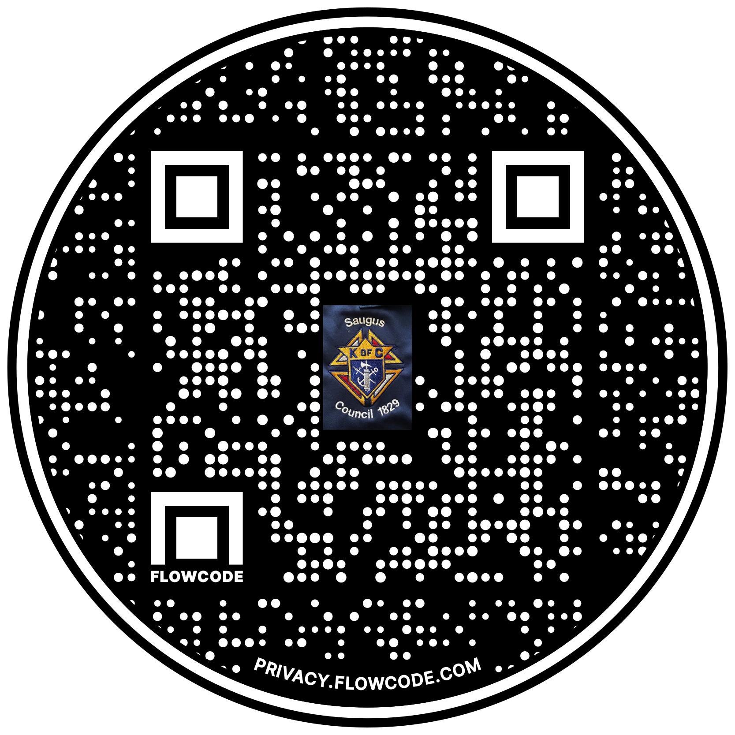

Scan the Code to view the Council Web site!

Life-Line Screening

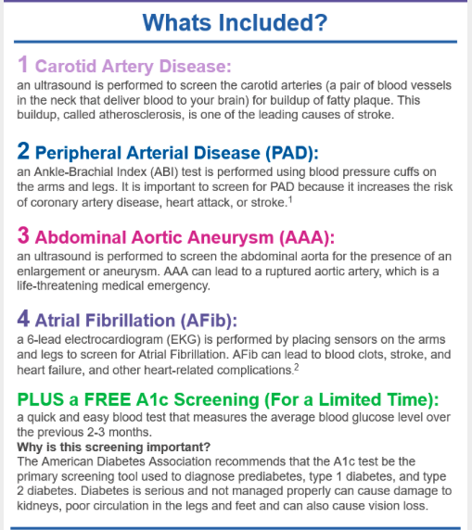

To register – Copy this link into your browser:

https://ecom.lifelinescreening.com/Locations-short?sourcecd=LW4D001&tid=102926372abed2d8f1ad525b125ab9&screeningID=485897&screeningDate=10/21/2024

