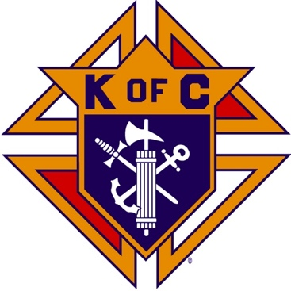
Saugus Knights of Columbus
Council #1829

57 Appleton Street
Saugus, MA 01906

Council Newsletter

Volume 23, Issue 08 www.sauguskofc1829.org September 2026

Grand Knight’s Message
Greetings, my Worthy Brothers.
It appears as though our summer season is rapidly ending. Pretty soon we will be worrying about snowstorms and cold weather. I for one am not looking forward to it. Fortunately, I will be down in Florida for some of it.
The Blessed Sacrament Church is looking for volunteers for the annual Mass on the Grass. The mass will be on September 27th at 11:00 AM. I know several of our knights have volunteered their time already, but we can certainly use more help. Please let me know if you can help.
Henry's Catering of Malden has been booked for the annual Christmas party scheduled for December 4th. The social hour will start at 6:00 and the meal will be served promptly at 7:00. The cost will be approximately $30 to $32 per person. Waitress service will be provided. We must have a fifty-person minimum in order for this event to pan out. Please let me know as soon as possible if you plan to attend. Also, we are planning a Yankee swap at the dinner. The mystery gifts are not to exceed $25. We would like to have a DJ so we may relax and dance. If anyone knows of one that we can afford, let me know.
Our annual breakfast with Santa is in the planning stage as we speak. The sign-up sheet is on the white board. This annual event always makes our council shine. Many of the Saugus children look forward to seeing Santa and having breakfast with us. I will coordinate the date with the staff at Blessed Sacrament. We are looking at December 12th. I will let everyone know.
Our council rehab has started deputy Ricci has started replacing the ceiling tiles in the foyer and the painter will come be coming this week. Remember many hands make light work. See Richie to get on the volunteer list.
Brothers Mike and Ronnie have scheduled our annual car show for October 25th from 12:00 PM to 4:00 PM. They will certainly need help. See them to volunteer.
dear Jesus please shine your everlasting light on all of our brothers both present or past please keep us in good health and assist us all in being good loving people thank you
Vivat Jesus.
John Coburn, Grand Knight
Saugus Council 1829

Founders’ Day

Founders’ Day will be held on September 12, from 9:00 am-3:00 pm.
Several brothers are needed to load up on Friday night, setup on Saturday
from 7:00 – 9:00, work the tables, and clean up after.
Signup sheets are on the white board in the member’s lounge.

Mass on the Grass

The Mass on the Grass will be held on September 27, at the 11:00 mass
at the Blessed Sacrament church.
Several brothers are needed to setup the chairs, man the tables,
and help store the chairs after the cookout.
Signup sheets are on the white board in the member’s lounge.

Monthly Social Dinner

The September social dinner will be held on Tuesday, September 15th.
The dinner will be pot luck. No charge for dinner.
LRC and 3-card bingo will follow the dinner.

The Weekly Attendance Pool
The Weekly Attendance Pool is up to $95.00.

August 04 No drawing
August 11 103 John O’Connell
August 18 042 Larry Donovan
August 25 037 Joseph DiBella

BA1829 Club Numbers
August 04 – 92
August 11 – 42
August 18 – 15
August 25 – 15

Rent Our Function Hall

Eastern Poker Tour

Every Wednesday night, 6:30-10:30 P.M.

Saturday Morning Breakfast

Saturday Morning Breakfast Club will resume on September 5th.

Meeting Schedule
Saugus Council #1829

First Tuesday – Social meeting only - Pizza Night
Second Tuesday – Business meeting
Third Tuesday – Dinner meeting only. The cost for dinner is $10/$12.
Fourth Tuesday – Business meeting
Fifth Tuesday (when applicable) – Social meeting only

Upcoming Events
Founders’ Day September 12, 9:00 am-3:00 pm
Social Meeting Dinner/ Card games September 15th, 6:30 pm – 9:30
Mass on the Grass September 27, 11:00 mass
Eastern Poker Tour every Wednesday, 6:30 – 10:30
Friday Nights at Members’ Lounge every Friday evening, 6:00 – 11:00

JFK Assembly Meeting
The Fourth Degree meets on the second and fourth Tuesdays at 7:00.
All Worthy Knights are encouraged to attend.

September Birthdays
Happy Birthday to the following Brothers

01st – Gerald Page 04th – John Millar
04th – Steven Fernandez 10th – Christopher Rich
12th – John Coburn 16th – Derek Cipriano
22nd – Steven Johnson 22nd – Jason Vining
27th – Chris Luongo 30th – Frank Sanfilippo

If your name is listed above, you are invited to stop by the lounge for a complimentary beverage of your choice on Tuesday of your birthday week
If your name is listed above, you are invited to stop by the lounge for a complimentary beverage of your choice on Tuesday of your birthday week

Monthly Newsletters
The monthly newsletter files have been added to the Council web site at https://sauguskofc1829.org/newsletters.

You can download a Microsoft Word copy of the file
to your computer/smart phone/tablet any time you wish.

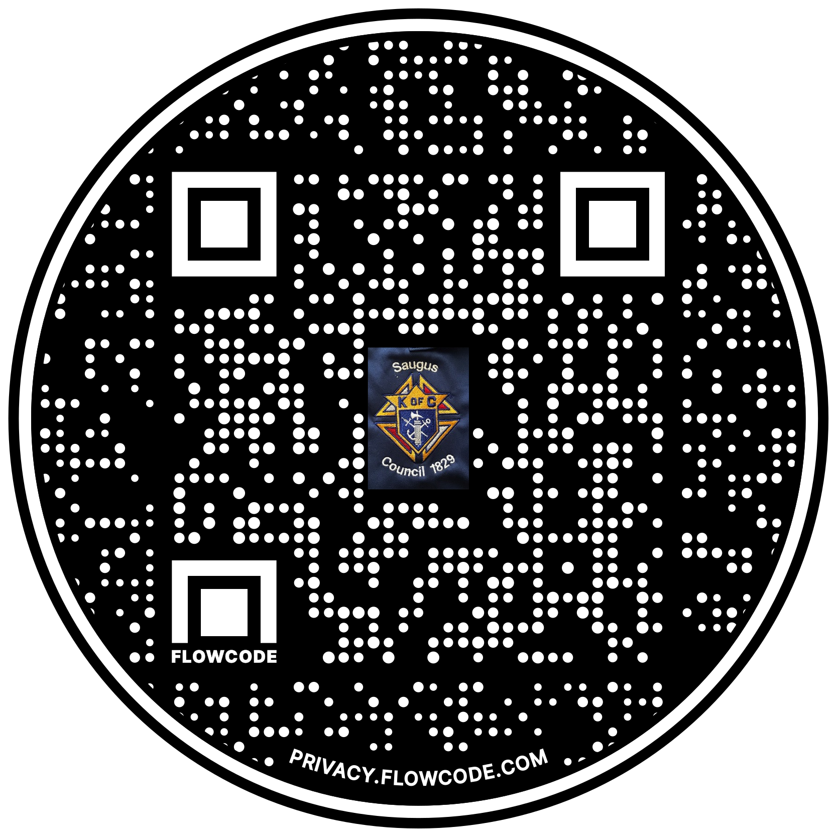

Scan the Code to view the Council Web site!

