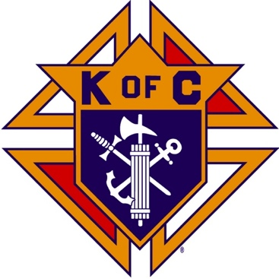
Saugus Knights of Columbus
Council #1829

57 Appleton Street
Saugus, MA 01906

Council Newsletter

Volume 22, Issue 8 www.sauguskofc1829.org August 2025

Grand Knight’s Message
Hello, my worthy Brothers.
Our summer is in full swing. Our annual family BBQ was a great success, our social dinners have been outstanding, our meeting attendance has been remarkable, and our overall council “heartbeat” is fantastic.
I personally want to thank several people for their help in keeping our building beautiful and maintained. Thank you so much to Al Silvestri for the unbelievable electrical work he did in our kitchen. It was first class and the money he saved the council was sufficient. I also want to thank a friend of mine, David Harrison. Dave owns his own trucking company in Saugus. He is a regular at our Saturday morning breakfasts. He noticed the rear parking lot was in bad shape with five enormous potholes. He came by last Saturday and filled the holes with asphalt. The total cost for our council was coffee, muffins and 4 bottles of water.
For those of you who don't know, we have a new ladies auxiliary. They call themselves “The Ladies of the Knights.” They are just starting to get events lined up. A mother-son dance, a father-daughter dance, a Halloween party and several other events are in the planning stages. These ladies are always there for us, so let's make sure we are there for them.
Lastly, our social dinner this month is on August 19th. The menu will consist of stuffed pork chops, baked potato, vegetables, rolls, dessert. The cost is $12.
In closing, I want to thank all our members for their commitment to God, the Almighty Jesus Christ our savior, our Mary mother, and to our council.
Vivat Jesus,
John Coburn, Grand Knight
Saugus Council 1829.

Saturday Morning Breakfast
Breakfast is served from 8:30-9:00 A.M. every Saturday morning.
All are welcome. The fare is only $7.00

Upcoming Events
Social Meeting Dinner Tuesday, August 19, 6:30 P.M.
See the flyer later in this newsletter for menu and details.
Founder’s Day September 13, 8:00 – 3:00
Indoor Craft Fair/Flea Market September 27, 8:00 – 3:00
Deceased Brothers’ Mass Sunday, November 9, 11:00 mass

BA1829 Club Numbers

July 01 – 73
July 08 – 36
July 15 – 20
July 22 – 12
July 29 – 47

The Weekly Attendance Pool

The Weekly Attendance Pool is up to $132.

July 01 180 Steve Fernandez
July 08 089 William Leuci
July 15 095 Dan Marfione
July 22 025 Anthony Ciccarelli
July 29 127 Mark Panetta

August Birthdays
Happy Birthday to the following Brothers

01st – Donald Cook 02nd – Roger Worthley
03rd – Louis Melillo 04th – William Magarian
09th – Lorenzo Grasso 13th – John Barrett
15th – Michael Fernandez 17th – Gregory Natalucci
22nd – Oscar Desjardins 27th – Philip Antonelli
27th – Pasquale Alfe 28th – John Messina
30th – Mario Trafficante

If your name is listed above you are invited to stop by the lounge for a complimentary beverage of your choice on Tuesday of your birthday week

JFK Assembly Meeting

The Fourth Degree meets on the second and fourth Tuesdays at 7:00.

All Worthy Knights are encouraged to attend.

Meeting Schedule
Saugus Council #1829

First Tuesday – Social meeting only - Pizza Night
Second Tuesday – Business meeting
Third Tuesday – Dinner meeting only. The cost for dinner is $10.00.
Fourth Tuesday – Business meeting
Fifth Tuesday (when applicable) – Social meeting only

Word Search

9. A STORY OF REDEMPTION

E | V | O | L | Y | L | I | M | A | F | B | W | M | N | A | T | W | G | D | Z | C | R
R | L | Q | X | J | V | P | R | O | V | I | D | E | N | C | E | S | B | M | I | M | R
S | T | X | D | Z | H | D | K | N | L | E | G | N | O | I | T | O | V | E | D | P | O
A | T | N | A | N | E | V | O | C | T | T | N | O | I | L | I | H | C | A | L | J | O
L | A | E | P | S | H | E | G | A | E | N | I | L | M | G | Z | W | G | E | I | I | L
V | U | W | A | U | R | E | D | E | M | P | T | I | O | N | R | C | L | C | C | F | F
A | L | F | R | M | E | N | N | O | I | S | S | A | P | M | O | C | E | N | J | A | G
T | H | I | V | C | E | W | U | L | O | Y | A | L | T | Y | G | B | A | A | K | I | N
I | C | C | B | E | T | H | L | E | H | E | M | S | A | C | S | A | N | R | U | T | I
O | A | S | S | E | N | E | V | I | G | R | O | F | K | V | E | N | I | E | V | H | H
N | A | W | H | A | R | V | E | S | T | B | D | I | V | A | D | C | N | V | U | F | S
W | M | W | I | D | O | W | H | O | O | D | S | W | T | G | Q | E | G | I | Q | U | E
T | N | E | M | E | N | O | T | A | O | H | E | C | A | R | G | S | M | L | J | L | R
E | Q | C | Y | G | O | L | A | E | N | E | G | R | G | K | V | T | A | E | E | N | H
I | Q | N | O | R | P | A | H | N | M | S | J | F | K | E | V | R | M | D | S | E | T
V | X | Z | B | A | O | M | E | L | I | P | G | L | F | R | L | Y | Q | X | S | S | O
I | N | C | L | U | S | I | O | N | T | B | L | E | S | S | I | N | G | I | E | S | T
M | I | L | Z | N | O | L | H | A | M | C | W | B | X | D | S | M | L | H | T | S | B

Ancestry Forgiveness Love
Atonement Family Loyalty
Bethlehem Forgiveness Mahlon
Blessing Genealogy Moab
Chilion Gleaning Orpah
Compassion Grace Providence
Covenant Harvest Redemption
David Inclusion Salvation
Deliverance Jesse Threshing Floor
Devotion Lineage Widowhood

Last Month’s Solution
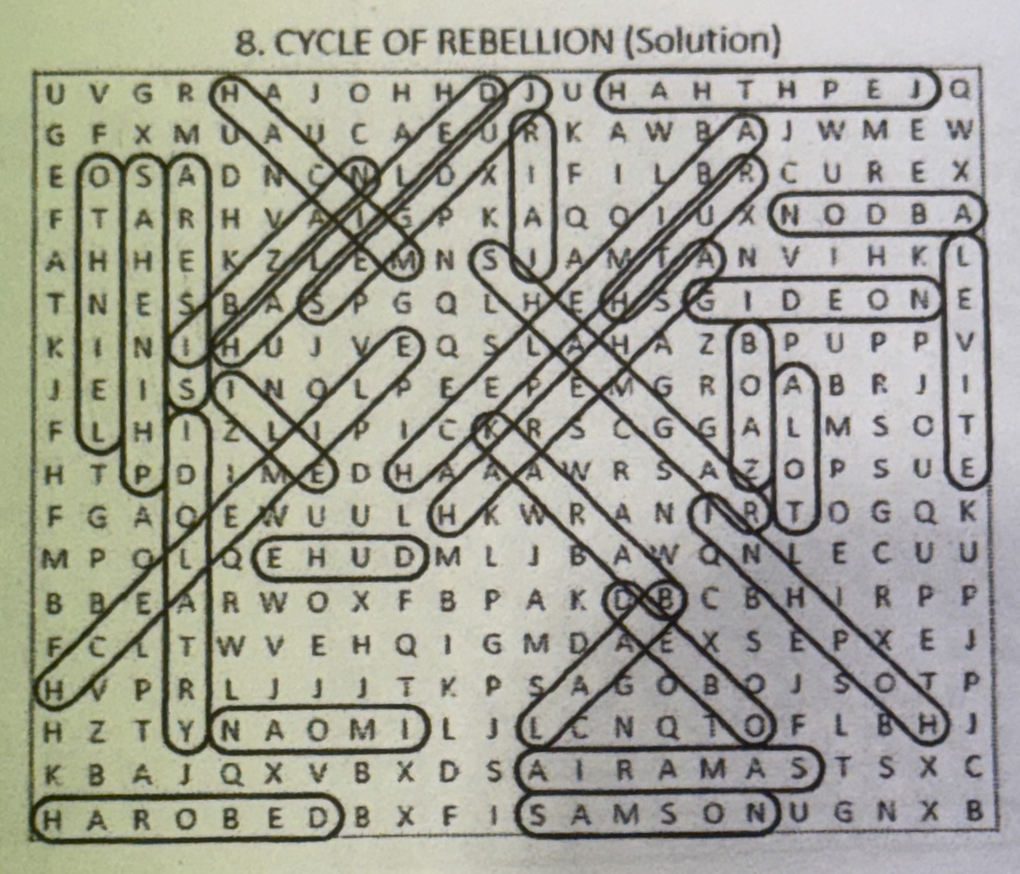



Monthly Newsletters
The monthly newsletter files have been added to the Council web site at https://sauguskofc1829.org/newsletters.

You can download a Microsoft Word copy of the file
to your computer/smart phone/tablet any time you wish.

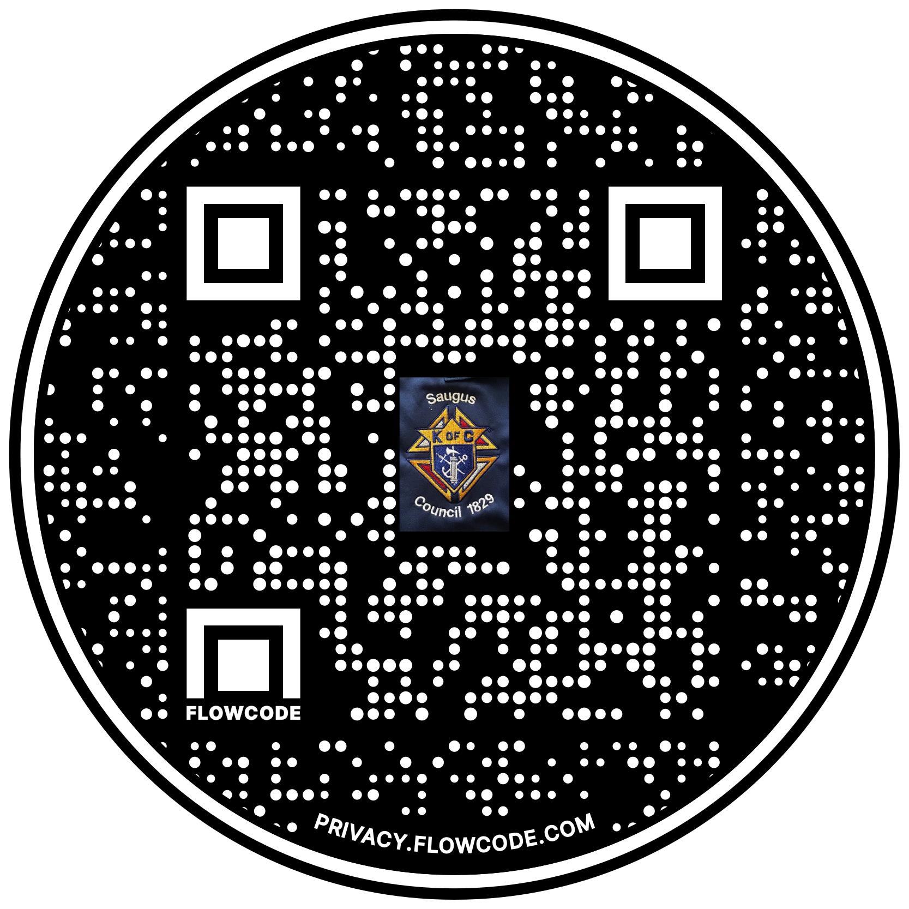

Scan the Code to view the Council Web site!

