Right to Life of Michigan Educational Fund
2023 High School Oratory Contest

Contest Application Form
(Please print legibly)

Contestant Name:
Address/City/ZIP:
Phone: Birthdate:
Email Address: Parent email address:
School Name:
School Address/City/ZIP:
School Phone: Grade (2022-2023 school year):

Prolife issue you will be speaking on (choose one):
Abortion Embryonic Stem Cell Research (or Cloning) Euthanasia Infanticide

*Student Signature

*Parent Signature

*By signing, you agree to allow Right to Life of Michigan to publicize contest results including your information (name, grade and hometown), speech, contest photos and videos, as well as provide your contact information to any news media interested in stories about contest winners.

Return this form by the entry deadline to your local coordinator:

Local Contest: Plymouth Right to Life

Local Coordinator: Mary Ann Verderbar Phone: 734.347.8473

EMAIL: prtloratorycontest@gmail.com

Entry Deadline: March 22, 2023 Local Contest Date: March 25, 2023

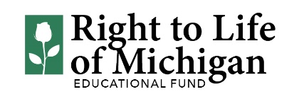

2340 Porter St. SW • PO Box 901, Grand Rapids, MI 49509 • 616.532.2300 • RTL.org

