PAMELA SWORDS,  PRESIDENT  MEMBER SINCE 2003  CONTACT  PHONE:  201-913-6028  EMAIL:  Pswords101@gmail.com  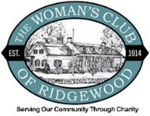 |  | WOMAN’S CLUB OF RIDGEWOOD  MARCH 2024 KEY DATES  - March 13th at Noon – Luncheon @ TBD  - March 19th at 6PM – Movie Night @ Clubhouse  - April 16 – Federated Meeting at Indian Trail, Franklin Lakes  - April 24 – 6:30PM Women’s Club of Allendale Fashion Show @ Seasons  CLUB NEWS & ANNOUNCEMENTS  Happy birthday to our sole March birthday member, Gretta O’Brien!  Gretta O’Brien 3/17  We hope you have a very happy birthday/St. Patrick’s Day Gretta!  Our Clubhouse renovations in 2023 made for an eventful year and we look forward now to enjoying our space thanks to the generous gift from the Bolger Foundation and all those listed in the Directory who helped improve the Clubhouse.  With much of the Clubhouse Updates behind us, and increased support from our rentals, we can now personalize our efforts to help our local charities listed in our bulletin, and we encourage you to learn more about the groups we support. Let us know if you have interest in being a designated representative for one of the charities that we support.  LUNCHEONS  Our February luncheon overlapped with movie night, so we opted to combine the two and order pizza for the Barbie movie viewing instead of having the separate luncheon. This month we will return to our usual mode with the March luncheon taking place Wednesday, March 13.  All are welcome to join our monthly luncheons which are scheduled to take place the second Wednesday of each month. Please mark your calendars and look for a separate email with location and guest speaker information closer to the date of each one.  FUNDRAISING  Our biggest fundraiser of the year, the annual WCOR Garage Sale, took place last week and was a terrific success!  Many, many thanks to Kristen Plumley for organizing this important event, as well as those who donated, and all the volunteers who worked tirelessly to help out.  Altogether we were able to raise $4,000 for our charities. Well done ladies!  COLLECTIONS/FEDERATION NEWS  The big Federated meeting at Indian Trail in Franklin Lakes is coming up April 16th. Please contact Pam for details.  Besides filing our paperwork with Federated as required, we’ve also entered into informal agreements with other women’s clubs in the area (Ramsey, Paramus, Allendale) to promote and attend each other’s events for greater reach and impact.  To that end, please consider supporting the Woman’s Club of Allendale Fashion Show fundraiser. See flyer below and check out their website here: https://allendalewomans.club/fashion-show  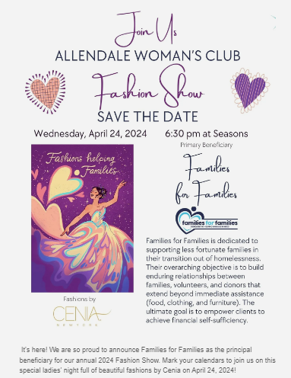  BOOK CLUB  Due to difficulty obtaining the highly sought after book we were planning to read, The Heaven and Earth Grocery Store by James McBride, we will need to find another title and reschedule our previously planned book group meeting date of March 19 to sometime in April. More info to come….  MOVIE NIGHT  Since Book Club will be postponed, we will make March 19 movie night this month. Please join us at the clubhouse to watch My Big Fat Greek Wedding 3!  Please bring a light snack to share and BYOB. See you there!  SCHOLARSHIP TRUST  Our Scholarship Trust Fund/Group is led by Samantha Bajraktari and members Mary Alice Coti, Andrea Rademacher, Heather Vimba, and Treasurer Leila Kamal.  Our Scholarship Trust supports 20 exceptional students with scholarship gifts each year. Unlike other clubs, this is not a loan, but a GIFT from our generous benefactors, donations, and monies from Clubhouse sales. We are committed to helping this program grow as it is why our club was originally started.  If you would like to donate in any amount, please send a check made payable to the Scholarship Trust Fund and mail it to The Woman’s Club of Ridgewood, 215 W. Ridgewood Ave., Ridgewood, NJ 07450.  Or tap the following link that you can copy and share; https://womansclubofridgewood.com/scholarship-trust/  Thank you in advance for your support.  UPCOMING EVENTS  Mark your Calendars for the following:  - March 13, 12 PM noon March Luncheon TBD  - March 19 5:30 PM @ Clubhouse – Movie Night  - April 16 – Federated Meeting at Indian Trail, Franklin Lakes  - April 24 – Allendale Woman’s Club Fashion Show  CLUBHOUSE BUSINESS  Our Club house rental income helps us pay our bills, and additional income can go towards the local charities, and to expand the scholarship trust program. Our invaluable staff who are on site to make sure its events run smoothly and that our fixtures and technology are secure and safe and not removed from the premises. Thank you, Tina Anderson, Hana Rojecki, Virtudes Lantigua and Sal Volpe for such excellent care and attention to our Clubhouse.  When we all work together to carry out our mission of charity, we can do great things. I look forward to members getting more involved in learning about the charities we support and connecting with them on a regular basis.  Once again, a very special thank you to Kristen Plumley for the amazing Garage Sale!  Thank you, Cathy Cooke, for your continued dedication to the Meals on Wheels program. If anyone is interested in Being involved, please contact Cathy at 201-327-4939 or Director Penny Schildraut 917-714-9656.  Special thanks to Virginia Harper, our Secretary, for the continued review of our insurance and contracts.  Thank you Ron Straining for improving our website that can be found here https://womansclubofridgewood.com/ and on our blog post https://womansclubofridgewood.com/blog/  Thank you, Cheryl Sarno, for helping with Membership, Please note that Club Directories were mailed out in November. Please let us know if you did not receive yours.  Thank you, Monica Fennell, for our Book Group.  Thank you, Kathleen Duggan, for helping with the bulletin,  Thank you all for your continued interest and support.  Respectfully,  Pamela Swords  President; The Woman’s Club of Ridgewood  Please CLICK HERE to see our Instagram page for updated videos and information.

