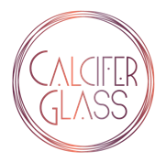

Calcifer Glass, LLC 1080 SE Pioneer Way Oak Harbor, WA 98277
Water Pipe Order Sheet 206-919-0588 admin@calciferglass.com
*Minimum of 10 units per order

COLOR / DESIGN | QUANTITY (NO WRAP)  $27.50 per unit | QUANTITY (WITH WRAP) $29.50 per unit | COST
Red / Solid
Red / Netted
Red / Optic
Orange / Solid
Orange / Netted
Orange / Optic
Yellow / Solid
Yellow / Netted
Yellow / Optic
Green / Solid
Green / Netted
Green / Optic
Blue / Solid
Blue / Netted
Blue / Optic
Purple / Solid
Purple / Netted
Purple / Optic
Pink / Solid
Pink / Netted
Pink / Optic
Black / Solid
Black / Bubbled
Crystal Clear

TOTALS: _________ _________ $

