4 SEASONS TOUR

August 4th-11th, 2018

TRIP SHEETS

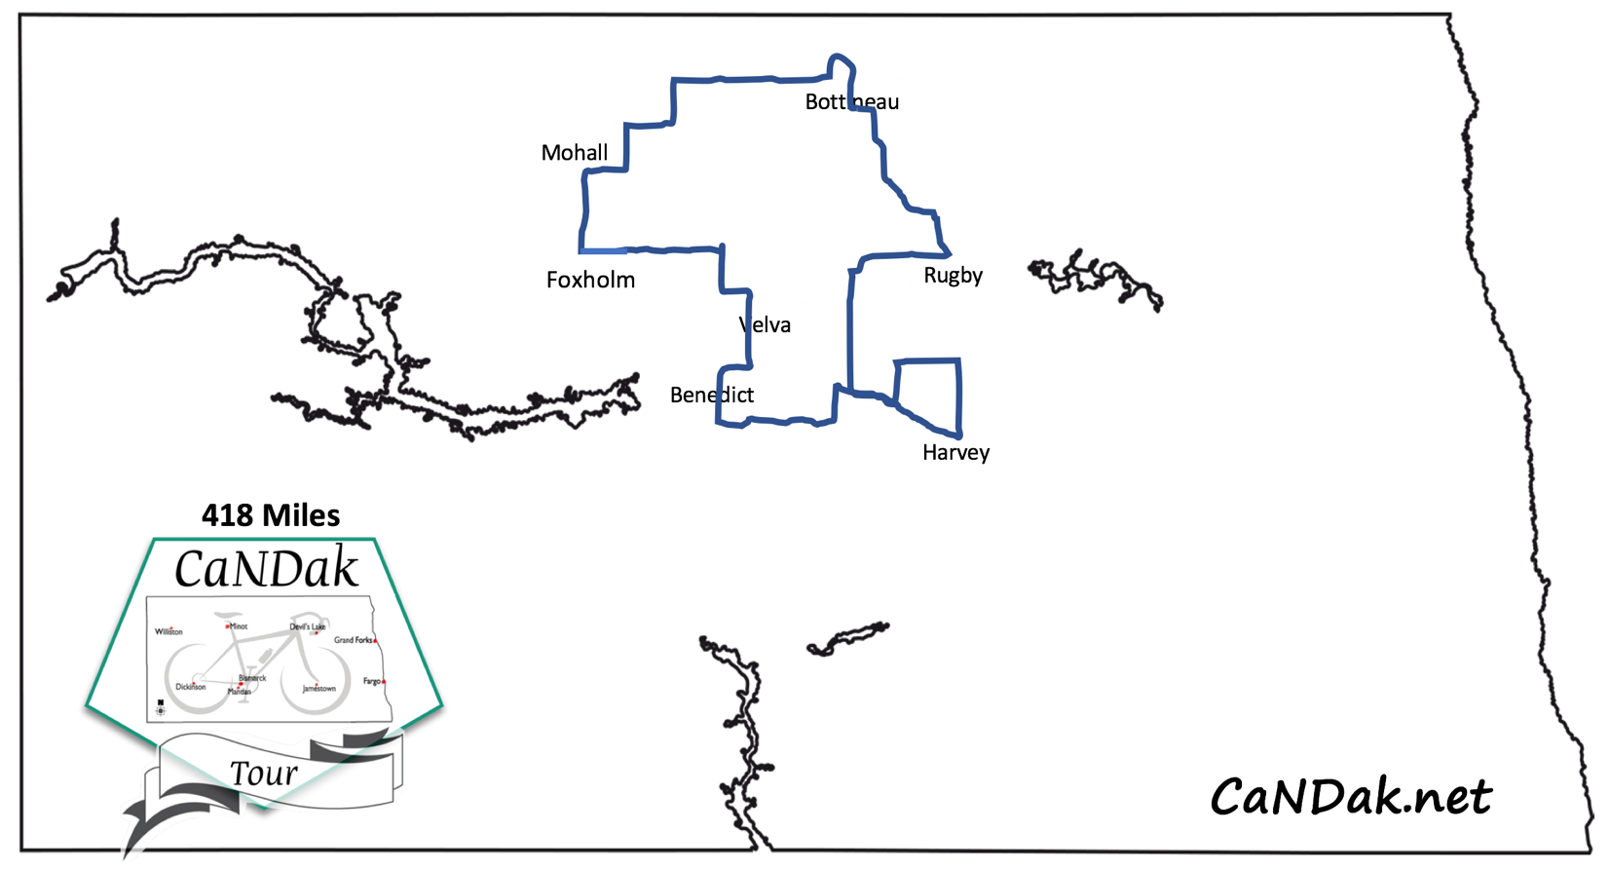

Welcome to

CaNDak

Cycling Around North Dakota

**Greetings CaNDak Cyclists!**

Welcome to CaNDAK 2018- we are thrilled to have you joining us on our very first tour! Our new group is excited to be offering the experience that many of you cherish and look forward to all year long. The scenery and uniqueness of North Dakota are truly one of a kind and this tour will give you the opportunity to see the beauty of North Dakota first hand on two wheels.  North Dakota’s small- town hospitality has made a lasting impression for many tourists and we hope you get that experience as well!

Our new group consists of high school wrestling teams from around the area. Minot High School, Velva High School, and Bishop Ryan High School has come together to offer this amazing event in hopes to offer a great ride and to help fund their teams for the upcoming season. We have been working tirelessly with members of the original CANDISC ride to ensure that we keep the traditions of the past alive while adding in our own identity as well. We have been working with the area communities and have put together what we hope will be an experience that you will seek out again and again.

Enjoy yourselves as we deliver what North Dakota has to offer!

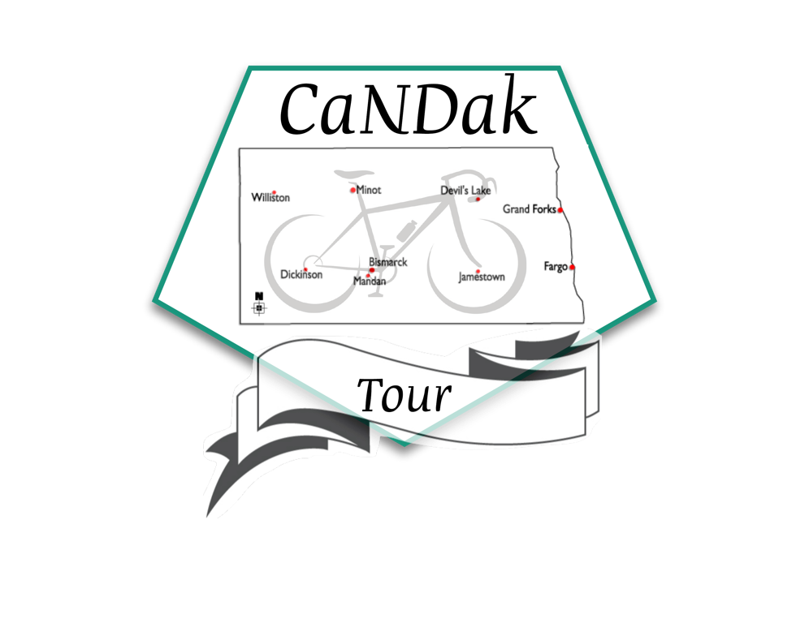

**WELCOME TO CaNDak!!**

**CaNDAK TOUR 2018 ITINERARY**

**“4 SEASONS TOUR”**

August 4th-11th, 2018

**DATE LOCATION MILES**

Saturday, August 4 Velva, Registration Day

Sunday, August 5 Velva to Foxholm 57 miles

Monday, August 6 Foxholm to Mohall 54 miles

Tuesday, August 7 Mohall to Bottineau 70 miles

Wednesday, August 8 Bottineau to Rugby 47 miles

Thursday, August 9 Rugby to Harvey 77 miles

Friday, August 10 Harvey to Benedict 91 miles

Saturday, August 11 Benedict to Velva 23 miles

**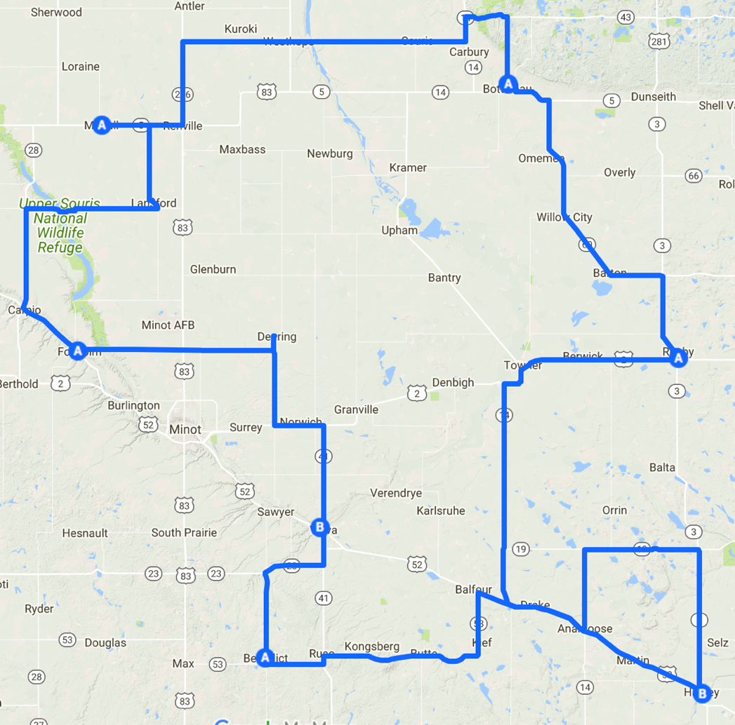***End of Tour Celebration in Velva!!* 418 miles

GENERAL INFORMATION

**Route Marking**

Right Turn Straight Left Turn Wrong Way

These signs will be printed on the right side of the roads as you approach the intersection.

Rough Crossing Ahead (Railroads, rumble strips). Go very slowly.

**Emergency Number: 1-800-472-2121 or 911**

**Baggage Loading and Hauling**

5:00 am to 8:00 am – ***Baggage Truck will leave at 8:00 am sharp.***

**SAG Wagons**

Thumbs down signal if you want help: water, first aid, energy snacks, etc.

Transportation to next rest stop or overnight stop.

*If the riders spread out too far within the day’s route, CANDAK Officials have the discretion to mandate that riders sag to the next rest stop or to a safe stopping point closer to the rider group. This is due to safety concerns of CANDAK Officials having to sag many miles along each day’s route in order to ensure full patrol for the entire rider group.*

**CaNDak Wristband**

Wristbands must be worn at all times during the ride.

Wristbands will be used to identify pre-paid meal plan purchasers.

***Green: No Meal Plan, Red: Full Meal Plan, Blue: Supper Only Plan, Yellow: Breakfast Only Plan***

**MEALS**

Must have a meal plan wristband. Individual meals may be sold at the discretion of the host community if they have an adequate amount of food left, but will not be sold or served until after 7:00pm/7:00am. This is not guaranteed.

**Minor Waiver-** Waiver must be carried at all times by cyclists under 18.

**Information Van**

Weather information, trip sheets, emergency numbers, lost and found, etc. can be found in the information van. If you have any questions, please visit the info van.

**Staff Vehicles**

CANDAK Staff Vehicles are all marked with signage on the sides.

**CaNDak Day Riders/Late registrations-** Available at the Information Van.

***WEAR YOUR HELMET!!! Riding permitted only during daylight hours.***

**HOW TO RIDE CaNDak SAFELY**

1. **OBEY TRAFFIC LAWS**: In North Dakota, bicyclists enjoy the same rights as motorists. In accepting those rights, bicyclists also assume the responsibilities for riding in a safe and legal manner by:

\*\*\*\*Stopping completely at stop signs, obeying yield signs, not crossing yellow lines in your lane, riding to the right, signaling for turns, not cutting corners, and riding in a respectful manner.

1. **STOP OFF THE ROAD SURFACE**: When stopping along the CaNDak route please signal to let those behind know your intentions. Stop at the right edge of the roadway and immediately move to the shoulder. Stay clear of the roadway. Stopping is especially dangerous at the crest of a hill or on a curve.
2. **BE CONSIDERATE**: The bicycling skills of those participating in CaNDak cover the full range of the spectrum. Each rider must look out for everyone else, as well as themselves. These tips will help:

\*\*\*\*Don’t weave. Make sure no bicyclists or motor vehicles are immediately behind you when you stop. Signal turns and stops. Sound off when passing. Use phrases such as “On your left,” “On your right,” or “Coming through the middle.” Ride to the right, leaving room to pass on your left. Keep your bicycle in good condition. Turn left from the center of the roadway. Park completely off the roadway. Be courteous to passing vehicles and other bicyclists. Instead of riding several abreast, go single file and let those behind you pass. Use a rear view mirror.

1. **WEAR A HELMET**: It is estimated that 85% of bicycling accidents result in injury to face or head. Wear a good protective helmet!
2. **CROSS RAILROAD TRACKS AT RIGHT ANGLES.**
3. **BEWARE OF LOOSE GRAVEL:** Especially at intersections, on curves and going down hills.
4. **DON’T DRAFT:** Drafting in crowds is dangerous. There is no place for it on CaNDak. Drafting vehicles is also dangerous and will not be tolerated.
5. **DON’T RIDE AT NIGHT:** North Dakota offers 16 hours of daylight; riders will not be allowed to ride before sunrise or after dark.
6. **BE IN CONDITION:** You should be in good shape and be capable of riding the distances each day before you come on the ride.
7. **PACE YOURSELF:** CaNDak is not a race; it is a touring bicycle ride in the state of N.D. All riders do not travel at the same speed, so don’t try to keep up with someone who rides too fast for you. Riding too fast or in too high a gear is tough on your knees, heart and lungs.
8. **EAT AND DRINK FREQUENTLY:** Rather than loading up once in the middle of the day, stop frequently for fluid and food and also carry water with you.
9. **COOPERATE WITH CaNDak OFFICIALS:** State Troopers, Deputy Sheriffs, and other law enforcement personnel will be patrolling the route. Obey their signals. Please stay on the marked route. (Services are not available to you if you are off the route.)
10. **CONTROL YOUR SPEED WHEN GOING DOWN HILLS:** Don’t ride your brakes and be very careful on down hill curves.
11. **REMOVE BIKING GLOVES AND WASH HANDS AS OFTEN AS POSSIBLE BEFORE EATING:** Remove biking gloves when using toilet facilities.

CAMPGROUND ETIQUETTE

sl00637_

**Everywhere we CaNDakers go, we want to be welcomed guests, so please treat our hosts with courtesy and respect.**

1. **DO NOT LITTER**. Pick up your own trash in the campground and along the route.

2. **RESPECT THE PROPERTY OF OTHERS**. Leave the campground in better condition than you found it. If the meal is inside, please respect that property by taking off your cleats

before walking onto the floor.

3**. KEEP THE CAMPGROUND QUIET**. Most riders want to get a good night’s rest. Quiet hours will begin at 9:30 PM. When you get up in the mornings, please be quiet and respect

that others might still be sleeping.

4. **CAMP ONLY WHERE DIRECTED.** Local communities go through a great deal of work to set up the campground. Please be respectful.

5. **NO CLEATS ON GYMNASIUM FLOORS**

5. **NO SMOKING OR ALCOHOL ON SCHOOL GROUNDS**

**ENJOY CaNDak AND ENJOY NORTH DAKOTA!!**

*We hope you make great friends and memories to last a lifetime on CaNDak.*

***PRE-RIDE DAY***

**SATURDAY, AUGUST 4th, 2017**

**Velva Park**

**Registration starts at 3 p.m.**

-----------------------------------------------------------------------------------------------

***-CAMPING-***

Tent Camping is available in the park.

***-SUPPER MEAL-***

5:00-8:00pm at the North Shelter in the park.

Hamburgers, chips, macaroni salad, potato salad, veggie tray, water, juice.

***-SHOWERS-***

Showers are located at the Velva Pool just South of the park.

***-BREAKFAST MEAL-***

5:00-8:00 a.m. at the North Shelter in the park.

Breakfast Burritoes, Fruit, Juice, Coffee

***-ENTERTAINMENT-***

Pre-Ride Information Meeting 8:00pm North Shelter Parking lot

***We recommend all riders & support vehicles attend this meeting. Very Important!!***

***New riders REQUIRED to attend.***

**SEVERE WEATHER SHELTER--** Velva High School Gymnasium

**ATM—**North Star Credit Union ATM on Main Street & Cenex on Highway 52

**MAP to Velva Park**

**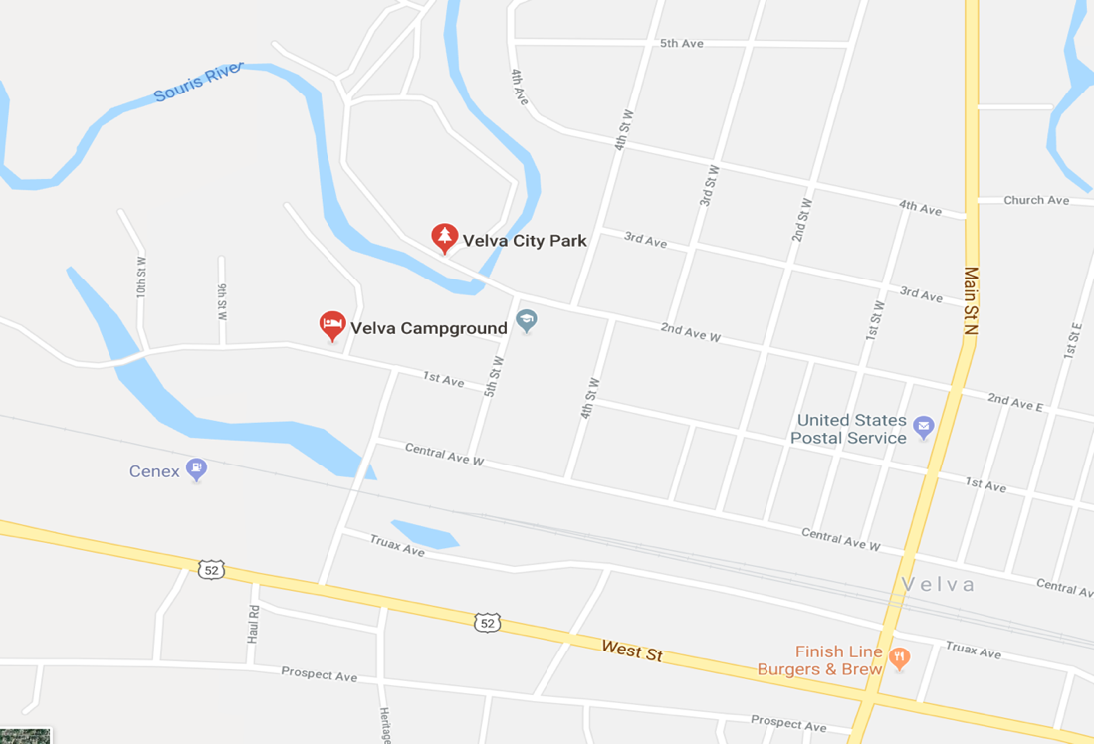**

This blank page is left for you to start making memories & meeting friends!

***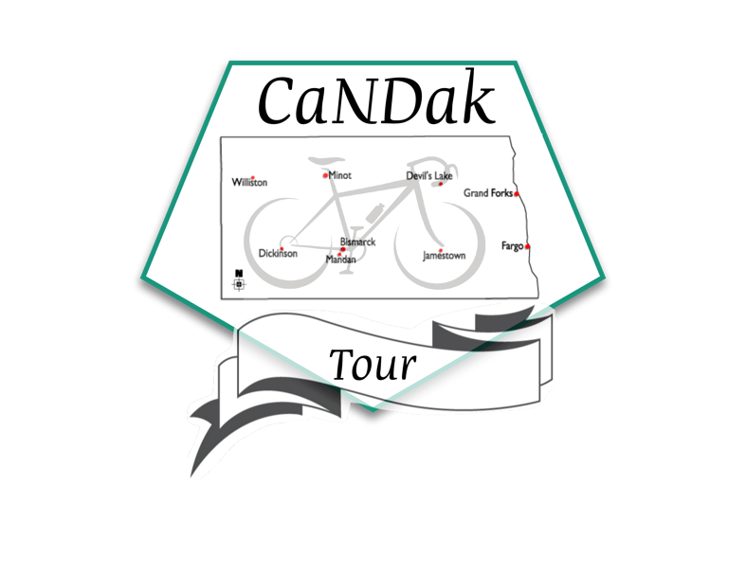***

***DAY 1***

**SUNDAY, AUGUST 5th, 2018**

**VELVA TO FOXHOLM**

**56 MILES**

-----------------------------------------------------------------------------------------------

***-REST STOPS-- (Check map)-***

**MILES--**

12.9 Velva to Highway 2 Water & Toilet(Porta)

17.1 Highway 2 to Deering Café and Store Drink, Toilet, & Food

13 Deering to Ruthville Convenient Store Drink, Toilet, & Food

12.7 Ruthville to Foxholm FINAL DESTINATION

***-POINTS OF INTEREST-***

***-CAMPING-***

Tent Camping is available at the St. Mary’s Church.

***-SUPPER MEAL-***

**5:00-8:00pm at St. Mary’s Church**

Spaghetti dinner, garlic bread, glorified rice, green salad, veggies, desserts, and drinks

***-SHOWERS-***

The “Great North Dakota Water Shed.”

***-BREAKFAST MEAL-***

**5:00-8:00am at Fox Den**

Pancakes, eggs, sausage, juice, and coffee.

***-ENTERTAINMENT-***

*Corn Hole and ladder ball available for use free of charge.*

**INTERNET ACCESS** --None

**LAUNDROMAT**—None

**ATM**—Fox Den

**SEVERE WEATHER LOCATION—** St. Mary’s Church

***C:\Documents and Settings\Hilary\Local Settings\Temporary Internet Files\Content.IE5\Z6GBJXW1\MCj02390150000[1].wmfDAY 1***

**SUNDAY, AUGUST 5th, 2018**

**VELVA TO FOXHOLM**

**56 MILES**

**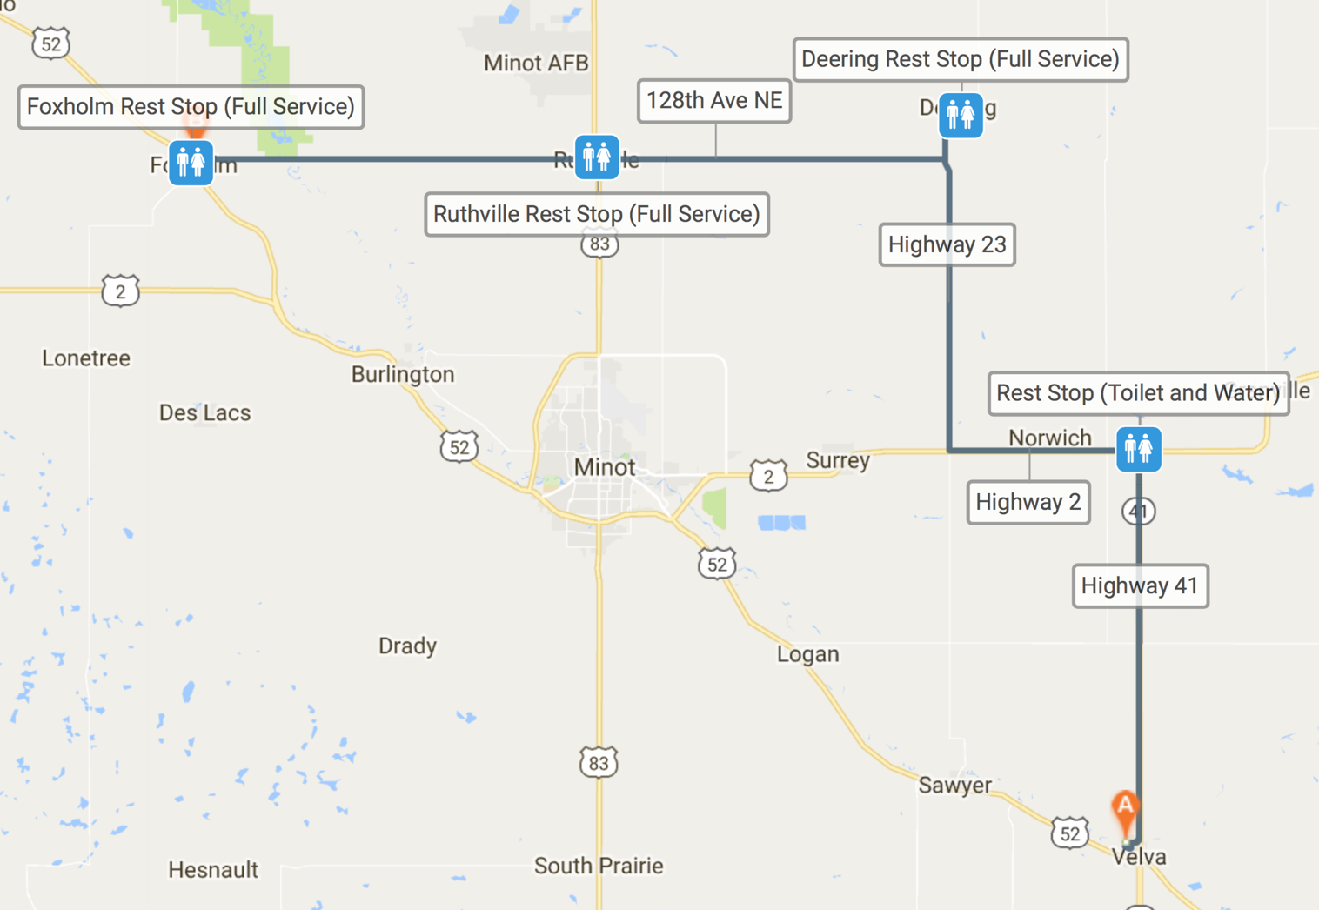**

***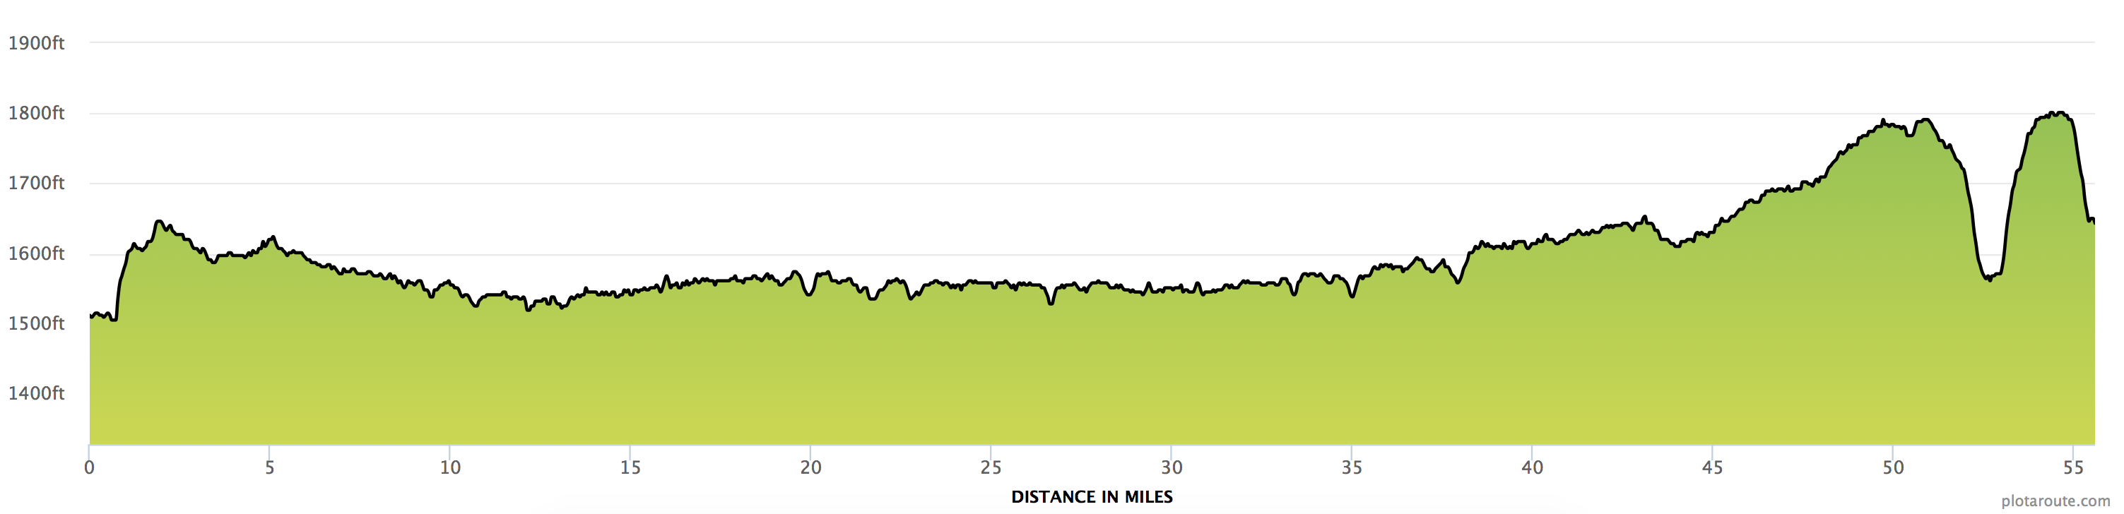***

***DAY 2***

**MONDAY, AUGUST 6th, 2018**

**FOXHOLM TO MOHALL**

**54 MILES**

-----------------------------------------------------------------------------------------------

***-REST STOPS-- (Check map)-***

**MILES—**

8.8 Foxholm to Carpio Cenex Water, Food, & Toilet

18.2 Carpio to Grano Fireside Lounge Water, Food, & Toilet

11.2 Grano to Lansford Cafe Water, Food, & Toilet

16.2 Lansford to Mohall FINAL DESTINATION

***-POINTS OF INTEREST-***

Mohall Country Clubs, The Naked Moose, Rustic Ronnie’s, The Prairie Bistro.

***-CAMPING-***

Tent camping in Mohall Fairgrounds. RV hookups for personal charge.

***-SUPPER MEAL-***

**5:00-8:00pm at Renville County Fairgrounds (1 mile west of Mohall)**

Pasta buffet with 2 sauces, Garlic Bread, coleslaw, bars, water, and lemonade

***-SHOWERS-***

Mohall Fairgrounds and the “Great North Dakota Water Shed.”

***-BREAKFAST MEAL-***

**5:00-8:00am at Paragon Cafe**

French Toast, sausage and bacon, water Tea, Coffee

***-ENTERTAINMENT-***

8:00-9:45 Karaoke or Outdoor Movie Mohall City Park

**INTERNET ACCESS**—N/A

**LAUNDROMAT**— 505 2nd Ave NE, Mohall

**ATM**—Multiple banks in town

**SEVERE WEATHER LOCATION—** MLS School

***C:\Documents and Settings\Hilary\Local Settings\Temporary Internet Files\Content.IE5\Z6GBJXW1\MCj02390150000[1].wmfDAY 2***

**MONDAY, AUGUST 6th, 2018**

**FOXHOLM TO MOHALL**

**57 MILES**

**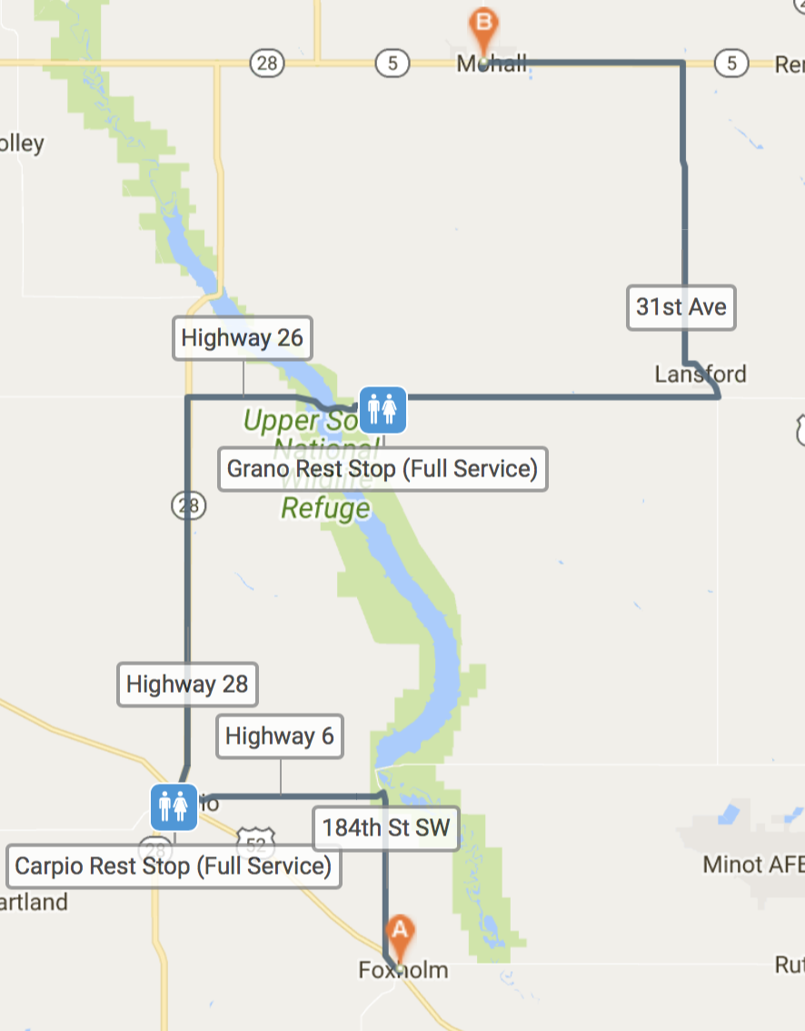**

***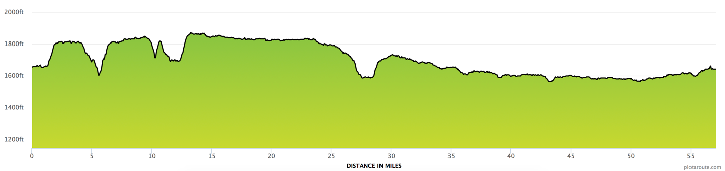***

***DAY 3***

**TUESDAY, AUGUST 7th, 2018**

**MOHALL TO BOTTINEAU**

**88 MILES**

-----------------------------------------------------------------------------------------------

***-REST STOPS-- (Check map)-***

**MILES--**

9.7 Mohall to Renville Corner Toilet & Water (Porta)

22.9 Renville to Westhope- Cenex, Jason Super Foods Food, Drink, & Toilet

15.5 Westhope to Souris Toilet & Water (Porta)

10.1 Souris to Mystical Horizons Toilet & Water

11.9 Mystical Horizons to Bottineau FINAL DESTINATION

***-POINTS OF INTEREST-***

*Historic Site on Hwy 14; monument with plaque to show the original site of the Turtle Mountain Lutheran Church, congregation organized in 1890 and log church built in 1892, moved to its current location in 1897, Turtle Mountain Church sign seen farther up Hwy 14*

*Beginning of Scenic Byway Hwy 43; a deer and turtle rebar statue welcome you to the Turtle Mountains, pull out available to stop for pictures, Belcourt artist Bennett Brien brought to life a turtle representing the Turtle Mountains, while the deer represents the most recognized animal in the plateau*

*Twisted Oaks Equestrian Campground; REST STOP! Short, packed-gravel road to vaulted toilets, camping, shared trails, and equestrian corrals*

*Mystical Horizons; Scenic Byway Hwy 43, 21 st century Stonehenge, an equinox and solstice structure, pillars and elongated stones to view the sun, great views of the prairie that expand into Canada*

*Strawberry Lake Recreation Area; camping, boat ramp, beach, fishing dock, wildlife viewing and shared trails, vaulted toilets but they are much farther inside the campgrounds*

*Annie’s House and Hiking Trails; Bottineau Winter Park on Scenic Byway Hwy 43, Annie’s House is named for Ann Nicole Nelson who was the only North Dakotan (Stanley, ND) to perish in the 9/11 attack on the World Trade Center. Ann was working as a bond trader on the 104 th floor of the WTC when the towers collapsed. Her unfinished “bucket list” inspired many on a collaborative effort to build Annie’s House which provides an array of life-changing opportunities to veterans with disabilities. Thunder Mountain Speedway; home track of legendary #2strong Robbie Conway (Westhope, ND), Bombers, Enduro, IMCA Sportmod and Hobby Stock classes, last two races of the season August 10 & 17*

***-CAMPING-***

Tent Camping is available at the Bottineau County Fairgrounds. RV Hookups available for charge.

***-SUPPER MEAL-***

**5:00-8:00pm**

Beef or no Beef Lasagna, Bread sticks, ice cream, water, kool-aid and coffee.

***-SHOWERS-***

Showers are located at the fairgrounds or The “Great North Dakota Water Shed.”

***-BREAKFAST MEAL-***

**5:00-8:00am Command Officers Quarters**

Eggs and pancakes, Country Style Sausage, Coffee, orange drink, and Milk

***-ENTERTAINMENT-***

2:00-5:00 – Two (2) massage therapists will be located under the Fairgrounds Shelter, east of the restrooms for

mini massages (15 minutes @ $20)

7-9:30- Live Music at the fairgrounds

**INTERNET ACCESS**—1 st Lutheran Church Stand, and the Fairgrounds Exhibit Hall,

**LAUNDROMAT—** Mr. B’s Laundromat, 313 Main Street, change machine

**ATM—** Many in town (See info sheet)

**SEVERE WEATHER LOCATION—** Fairgrounds Exhibit Hall

***C:\Documents and Settings\Hilary\Local Settings\Temporary Internet Files\Content.IE5\Z6GBJXW1\MCj02390150000[1].wmfDAY 3***

**TUESDAY, AUGUST 7th, 2018**

**MOHALL TO BOTTINEAU**

**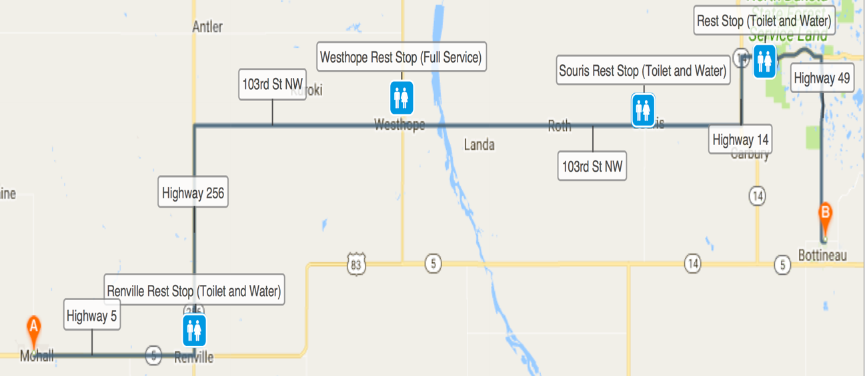70 MILES**

**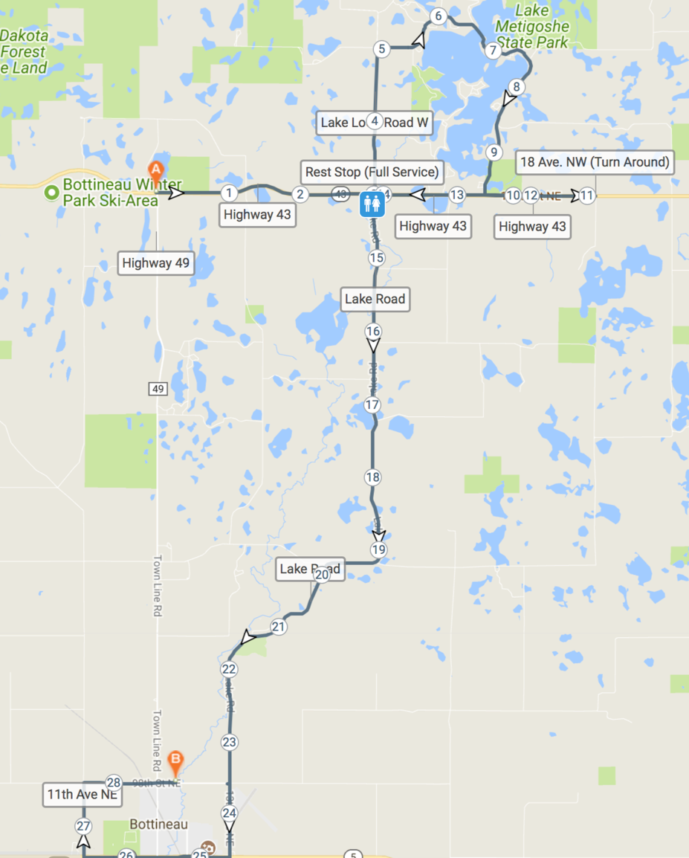**

**Scenic Option (30 miles)**

This route will take you around beautiful Lake Metigoshe. Instead of turning on Highway 49, just keep going! This route has many restaurants and scenery to offer. The lake road is a very wooded section to make for seeing a lot of wildlife. We hope you enjoy it!

**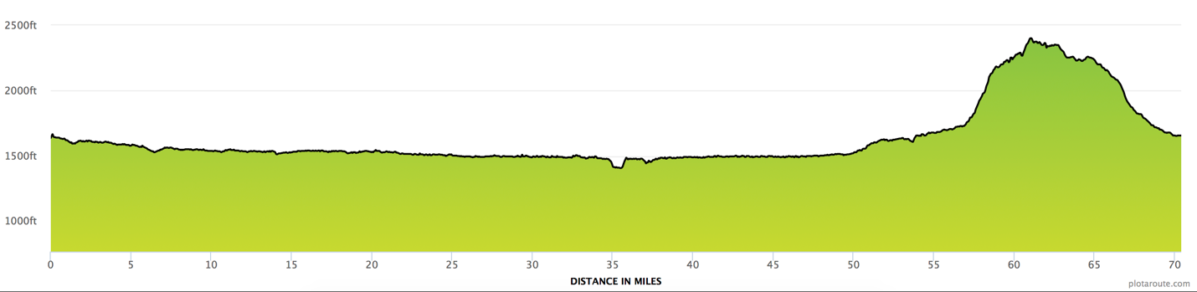**

***DAY 4***

**WEDNESDAY, AUGUST 8th, 2018**

**BOTTINEAU TO RUGBY**

**47 MILES**

-----------------------------------------------------------------------------------------------

***-REST STOPS-- (Check map)-***

**MILES--**

20.6 Bottineau to Willow City- Cenex/ Backwoods Café Drink, Food, & Toilet

15.1 Willow City to Barton Rest Stop Water & Toilet(Porta)

9.8 Rest Stop to Rugby- Fair Grounds FINAL DESTINATION

***-POINTS OF INTEREST-***

*Geographical Center of North America – SE corner of HWY’s 2&3.*

*Northern Lights Tower & Interpretive Center – SE side of HWY 2 in front of Prairie Village Museum Prairie Village Museum – 102 Hwy 2 SE Victorian Dress Museum – 312 2 nd Ave SW Niewoehner Bell Tower – 213 2 nd Ave SW The Historic Pierce County Courthouse – 240 2 nd St SE*

***-CAMPING-***

Tent Camping is available at Ellery Park and Rugby Recreation Complex

***-SUPPER MEAL-***

**5:00-8:00pm at the Ellery Park**

Hamburgers, Pasta Salad, Baked Beans, Ice Cream, Lemonade, and Water

***-SHOWERS-***

Showers are located at the Rugby Armory, Rugby Swimming pool or The “Great North Dakota Water Shed.”

***-BREAKFAST MEAL-***

**5:00-8:00am at the Fair Grounds**

Texas Style French Toast, Apples, Bananas, peaches, Juice, Milk, and Coffee.

***-ENTERTAINMENT-***

Ellery Park – 600 3 rd St SW - Art in the Park & Classic Car Show at 5PM, Rugby Lions Music in the Park with music by The Rock Princesses at 7PM (same place/time as supper)

*Massage Services offered by Rising Lotus Massage for additional cost.*

**INTERNET ACCESS**—Rugby Chamber of Commerce & CVB Office – 102 Hwy 2 SE – Guest password: centerguest

**LAUNDROMAT—** Mack Plaza Laundromat – 107 Hwy 2 SW

**ATM—** Cenex C-Store, Jct Hwy 2 & 3; Merchants Bank Lobby, 210 S Main Ave; Hi-Way MVP Tesoro – 209 ND-3 (Closes at 12AM); 1 st International Bank & Trust, NE Corner of Hwy’s 2&3, Lobby & Drive through ATM

**SEVERE WEATHER LOCATION—** Rugby Memorial Hall – 100 3 rd St SE

***C:\Documents and Settings\Hilary\Local Settings\Temporary Internet Files\Content.IE5\Z6GBJXW1\MCj02390150000[1].wmfDAY 4***

**WEDNESDAY, AUGUST 8th, 2019**

**BOTTINEAU TO RUGBY**

**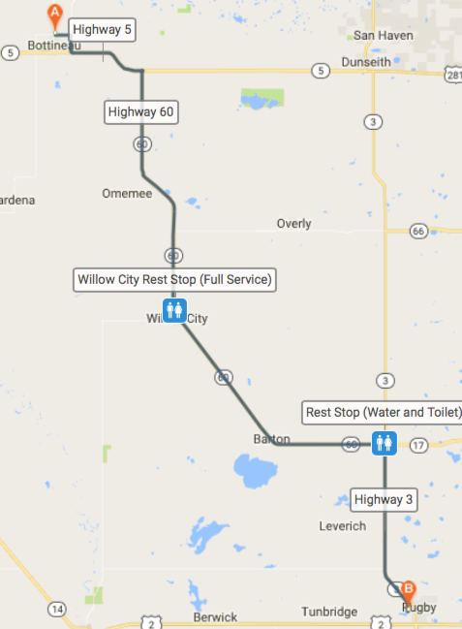47 MILES**

***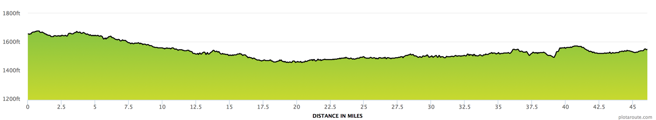***

***DAY 5***

**THURSDAY, AUGUST 9th, 2018**

**RUGBY TO HARVEY**

**77 MILES**

-----------------------------------------------------------------------------------------------

***-REST STOPS-- (Check map)-***

**MILES--**

20.6 Rugby to Towner- Food, Drink, & Toilet

15.6 Towner to CaNDak Rest Stop Water & Toilet(Porta)

18.7 CaNDak Rest Stop to Drake Cenex Food, Drink, & Toilet

7.6 Drake to Anamoose Bakery and café Food, Drink, & toilet

16.7 Anamoose to Harvey FINAL DESTINATION

***-POINTS OF INTEREST-***

Sheyenne River runs through the east side of the town.

***-CAMPING-***

Tent camping is available. RV hookups for personal charge.

***-SUPPER MEAL-***

**5:00-8:00pm at Senior Center (905 Lincoln Ave.**

Turkey and Dressing, Mashed Potatoes/gravy, Corn, pumpkin pie, ice cream, brownies, milk, coffee, lemonade, and water.

***-SHOWERS-***

Harvey Pool and The “Great North Dakota Water Shed.”

***-BREAKFAST MEAL-***

**5:00-8:00am at City Hall (Shuttle Provided)**

Pancakes, Sausage, Fresh Fruit, Juice, Coffee, water, and Milk.

***-ENTERTAINMENT-***

Free swimming and movie at 7:00 and 9:00 p.m.

**INTERNET ACCESS**— Chamber on Main Street

**LAUNDROMAT—**Downtown

**ATM—** 3 different banks in town

**SEVERE WEATHER LOCATION—**112 8th St. Armory

***C:\Documents and Settings\Hilary\Local Settings\Temporary Internet Files\Content.IE5\Z6GBJXW1\MCj02390150000[1].wmfDAY 5***

**THURSDAY, AUGUST 9th, 2018**

**RUGBY TO HARVEY**

**77 MILES**

**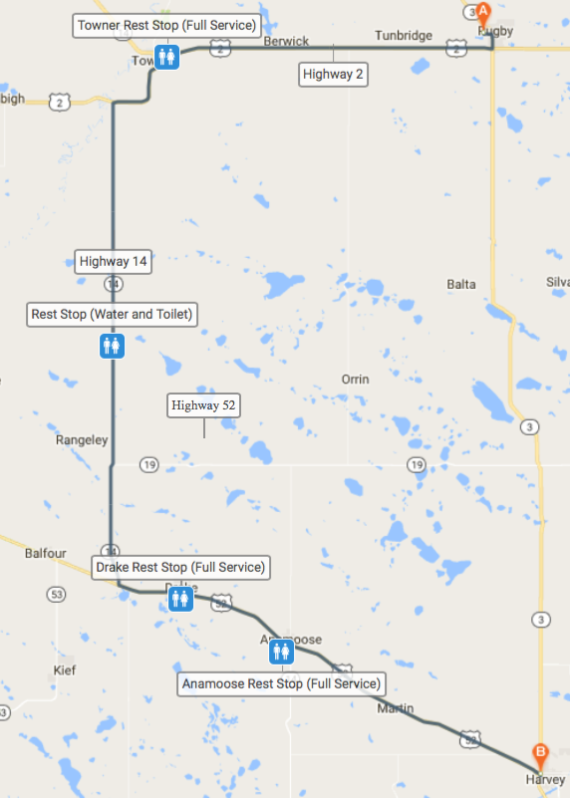**

***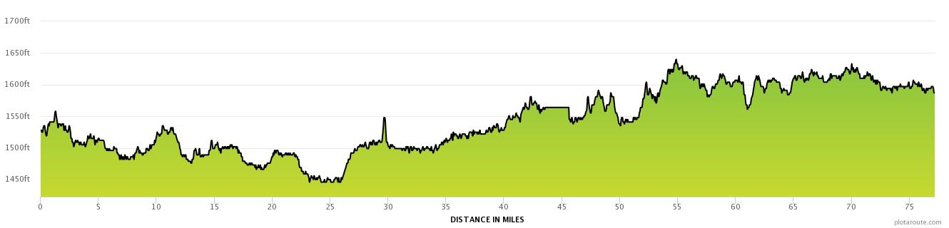***

***DAY 6***

**FRIDAY, AUGUST 10th, 2018**

**HARVEY TO BENEDICT**

**91 MILES**

-----------------------------------------------------------------------------------------------

***-REST STOPS-- (Check map)-***

**MILES--**

21 Harvey to CaNDak Rest stop Water and Toilet

20 CaNDak Rest Stop to Anamoose Food, Drink, & Toilet

7.6 Anamoose Bakery and Café to Drake Cenex Food, Drink, & Toilet

22.8 Drake to Butte Hunter’s Lounge Food, Drink, & Toilet

21.6 Butte to Benedict FINAL DESTINATION

***-POINTS OF INTEREST-***

Lake Gertie ½ mile south of town and the old Benedict Jail

***-CAMPING-***

Tent camping is available in the City Park.

***-SUPPER MEAL-***

**5:00-8:00pm at City Hall**

Smoked Ribs, potato, vegetable, bread, juice, water

***-SHOWERS-***

The “Great North Dakota Water Shed”

will be located at City Hall

***-BREAKFAST MEAL-***

**5:00-8:00am at City Hall**

Ham, scrambled eggs, pancakes, fruit, granola, coffee, water, juice

***-ENTERTAINMENT-***

Outdoor Movie at sunset and guitar music in the park

**INTERNET ACCESS**—None

**LAUNDROMAT—**None

**ATM—** Hitchin’ Post Bar

**SEVERE WEATHER LOCATION—**Concordia Lutheran Church Basement

***C:\Documents and Settings\Hilary\Local Settings\Temporary Internet Files\Content.IE5\Z6GBJXW1\MCj02390150000[1].wmfDAY 6***

**FRIDAY, AUGUST 10th, 2018**

**HARVEY TO BENEDICT**

**91 MILES**

**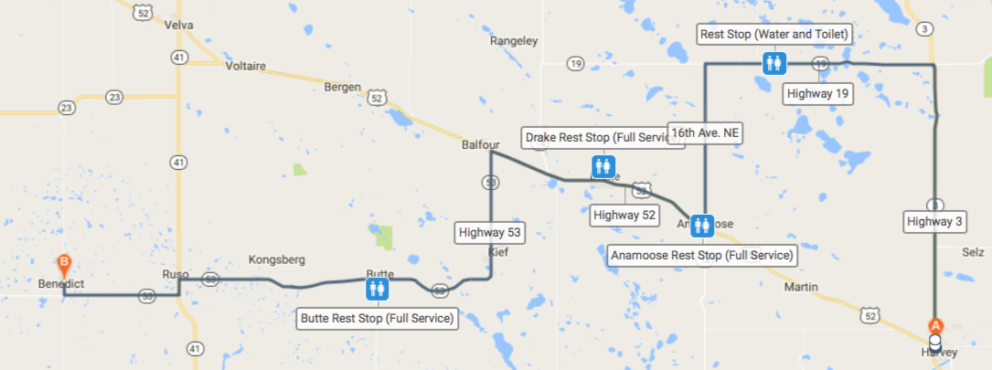**

**Century Option**

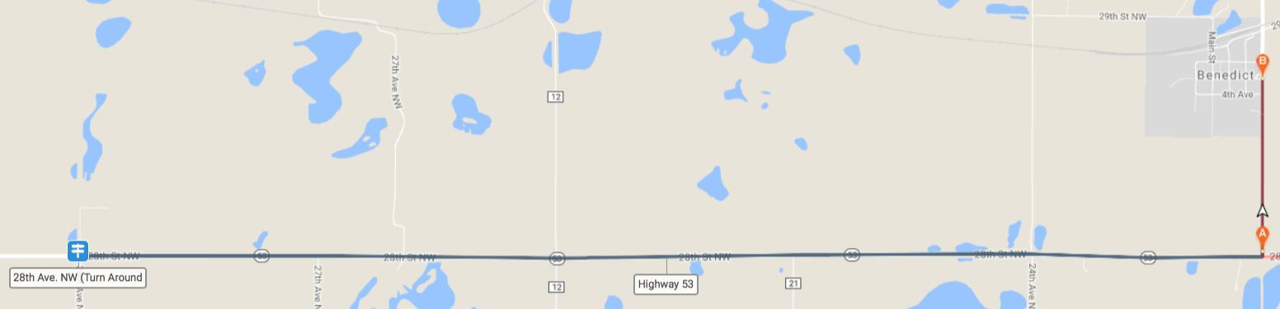If riders would like to achieve 100 miles in one day, your in luck! We have the century option! If you continue on Highway 53 instead of turning into benedict, we have added the need 10 more miles to get to 100. You simply need to ride until you reacht the 28th Ave. NW and turn around and go back to our Benedict host town. We will have a sign at the end of the road to tell you when its time to turn around. Enjoy!!

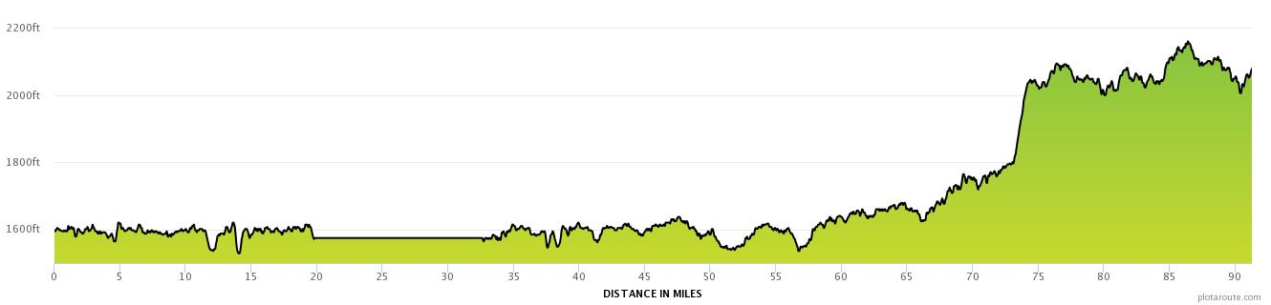

***DAY 7***

**SATURDAY, AUGUST 11th, 2018**

**BENEDICT TO VELVA**

**23 MILES**

-----------------------------------------------------------------------------------------------

***-REST STOPS-- (Check map)-***

**MILES—**

10.7 Benedict to CaNdak Rest Stop Water & Toilet

12.4 CaNDak Rest Stop to Velva FINAL DESTINATION

**CANDAK TOUR WRAP-UP CELEBRATION!!!**

**Velva City Park** –

Cross the finish line and get your picture taken!

enjoy some fruit and vegetable trays.

**Luggage Pick Up –**

In the Velva City Park

**Showers --**

Available at the Velva Pool or the “Great American Water Shed”

***BE SURE TO VOTE FOR THE BEST REST STOP AND OVERNIGHT HOST!!!!***

***(Ballot available at the Return Celebration)***

***C:\Documents and Settings\Hilary\Local Settings\Temporary Internet Files\Content.IE5\Z6GBJXW1\MCj02390150000[1].wmfDAY 7***

**SATURDAY, AUGUST 11th, 2018**

**BENEDICT TO VELVA**

**23 MILES**

**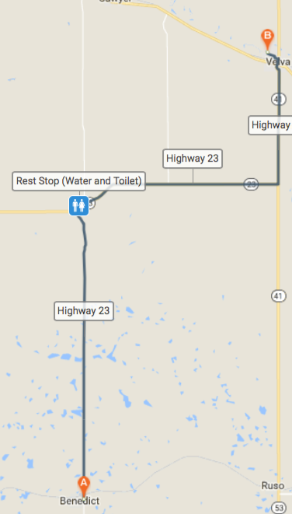**

**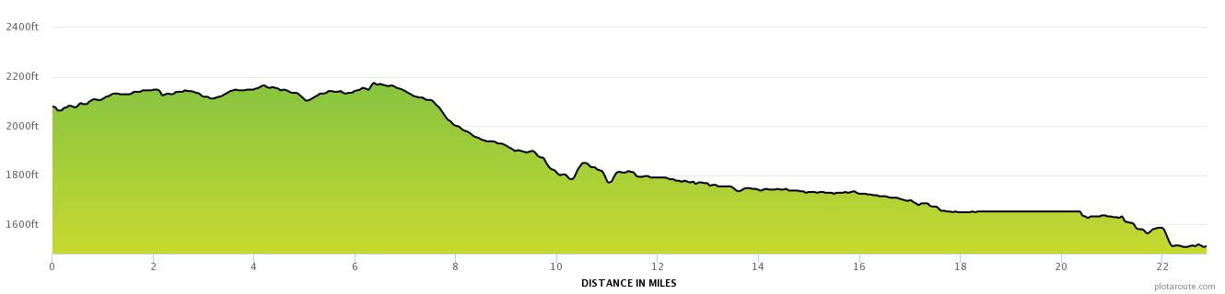**

****

**REMEMBER TO VOTE!**

*During the tour, please keep in mind the following questions:*

**1. BEST OVERNIGHT HOST COMMUNITY**

**2. FAVORITE SUPPER MEAL**

**3. FAVORITE BREAKFAST MEAL**

***The 2018 CaNDak Ballots will be available at the End of Ride Celebration near the luggage truck. A Ballot box will also be available here to turn in your ballot. If you choose to complete your ballot later, please mail to 503 4th St W. Velva, ND 58790***