**Monetary Stabilisation Policy**

***Data: Inflation Rates China and USA***

1. Price Controls in Capitalism and Communism, USA and China

***Data: National Debt and GDP***

1. Debt by Country, the United States and its Debt Crisis, A Case Study of the United States, Greece, and Japan

***Data: Exchange Rates, Interest Rates, Inflation Rates***

1. Impact of Monetary Stabilization Policy on National Debt

***Data: Interest Rates and Inflation Rates***

1. Rising Interest Rates and Demand-Pull Inflation

<https://commodity.com/data/russia/debt-clock/>

<https://www.visualcapitalist.com/charted-heres-who-owns-u-s-debt/>

<https://www.visualcapitalist.com/ranked-the-worlds-20-largest-economies-by-gdp-ppp/>

Inflation rates in U.S. and China, for different baskets of goods, time period analysis

Government spending as a % of GDP, IMF

Reduce taxes, reduce business regulations

Why does the central bank always think that increasing interest rates will bring down demand-pull inflation? Conversely, it is good to stimulate the economy with more spending. When people spend more to buy more products, the suppliers then produce more products to meet demand. All increasing interest rates does is increase the cost of debt for individuals and businesses. The objective should be to get suppliers to produce more goods through legislation and tax breaks, not to get consumers to stop spending money and stimulating the economy. Perhaps a communist government form with state-owned enterprises could force suppliers to produce more.

Thus, how does monetary policy affect inflation rates, exchange rates, interest rates, employment rates, poverty rates, and output. A further study examines how fixed interest rates along with a monetary rule may influence these variables, and even further how exchange rates may better be understood through better calculation.

**Price Controls in Capitalism and Communism, USA and China**

The interests of the ruling elite always have and always will dominate governmental regulations, and consequently the society as a whole. However, it is still widely accpeted that even if perfect information dispersion to the ignorant masses were possible, our human nature can still intercede and render the effort null. Even if this perfect information were able to be communicated to the society at large, what guarantee do we have that fixed-interest rates and a basic monetary growth rule would in fact work to stabilise the economy by limiting growth and therefore recession?

And even if fixed-interest rates and a monetary rule do stabilise the economy, some will still benefit; to whom is it to decide who should prosper and who should fail? What happens when one of the other many macroeconomic variables or natural disasters or whatever else decides to rear its head, that fixed-interest rates or incremental monetary growth would still work; there are simply too many unknowns in the world of economics to be sure about any economic theory. However, an important issue arises. If interest-rates are fixed, what happens when inflation strikes. The answer is that inflation should never strike. Inflation is a consequence of seigniorage, and thus should never be cited as a solution or a cause.

Microeconomic game theory can enlighten the foundation of the monetary game. Domestic and international monetary policy can be seen as a game in which participants, the individuals and the government, make strategic decisions that take into account each other's actions and responses. There is no optimal or dominant strategy in the domestic or international economy, as money remains an elusive issue that will never be fully understood. However, the domestic money game is a sort of Nash equilibrium whereby each participant uses a set of strategies such that all players are doing their best given the strategies of of other players, thereby relying on the rationality of each participant. Conversely, the international monetary system can certainly be characterised as a non cooperative game, whereby negotiation and enforcement of binding contracts between players (governments) is not possible, resulting in price wars. We do have trade treaties and exchange rate agreements, but since they are all international in nature there is no way for a country to legally enforce the contracts on other countries (short of a military invasion).

The money game is also an example of a sequential game, whereby different governments at times wait and see what their neighbors are doing with their stabilisation policy before executing theirs.

Threats, commitments, and credibility are relevant concerns, but there is not a lot of entry deterence or bargaining strategy. Further, the nature of money dictates that domestic inflation and international exchange rate policies many times are one and the same issue.

Monetary stabilisation policy can even be seen as a sort of a maximin strategy, where the government, in a choice between 2 products, waits and sees what a competitor, the other nations, does before doing theirs. There is no pure strategy where there is a specific choice to make or action to take, but rather a mixed strategy in which the government (the player) makes a random choice among 2 or more alternatives, based on a set of chosen probabilities (outcomes for the economy). Monetary stabilisation policy would certainly be categorised as a repeated game with infinite repetition, in that the expected gains from cooperating outweigh those from undercutting; similar to when firms face pricing decisions every period. This concept emphasises that cooperation is best for everyone when the game is infinite, but when the game is finite undercutting can produce benefits. As money will last as long as organised society, it is therefore to all's advantage to cooperate with each other with regard to both domestic and international monetary stabilisation policy.

**Communism v. Democracy**

This leads us to an interesting question. Is central bank policy different in communism than in democracy? Efremov (2012) writes that the Soviet system of price controls prevented inflation, but it also resulted in shortages of food and consumer goods. This is counterintuitive, as a communist government is more efficient in supplying goods and services. As for China, He (2023) writes that China is in a deflationary period, with inflation at 0.7%, while America was 5%, the European Union was 8.3%, and the United Kingdom was 10.1%. The evidence is clear, one way to reduce inflation is to adopt a communist government form with strict price controls.

**Democratic Monetary Policy and Inflation**

The government can control the interest rates, not the inflation rate, though does this necessarily mean that interest rates can be used to combat inflation? The typical democratic government attempts to maintain a 2% annual rate of inflation. Inflation can be classified as either demand-pull inflation or cost-pull inflation.

**Price Controls in America**

Even in capitalism there are price controls set by the government for some products, resulting in government intervention in market prices, such as in the United States price floors for agricultural products and price ceilings for rental properties.

In some markets, however, governments have been called on by groups of citizens to intervene to keep prices of certain items higher or lower than what would result from the market finding its own equilibrium price.

agricultural markets and apartment rental markets—two markets that have often been subject to price controls.

the effects of controlling prices

reasons why governments have chosen to control prices in these markets and the consequences of these policies

In agriculture, price floors have created persistent surpluses of a wide range of agricultural commodities. Governments typically purchase the amount of the surplus or impose production restrictions in an attempt to reduce the surplus.

model of demand and supply to explain what happens when the government imposes price floors or price ceilings.

governments sometimes choose to control prices and the consequences of price control policies.

Prices and quantities converge to equilibrium in capitalistic markets, with prices adjusting to equate quantity demanded with quantity supplied, resulting in surpluses and shortages of goods being short-lived.

**U.S. Price Floors for Agricultural Products**

Governments often seek to assist farmers by setting price floors in agricultural markets. A minimum allowable price set above the equilibrium price is a price floor. With a price floor, the government forbids a price below the minimum. (Notice that, if the price floor were for whatever reason set below the equilibrium price, it would be irrelevant to the determination of the price in the market since nothing would prohibit the price from rising to equilibrium.) A price floor that is set above the equilibrium price creates a surplus.

Figure 4.8 “Price Floors in Wheat Markets” shows the market for wheat. Suppose the government sets the price of wheat at PF. Notice that PF is above the equilibrium price of PE. At PF, we read over to the demand curve to find that the quantity of wheat that buyers will be willing and able to purchase is W1 bushels. Reading over to the supply curve, we find that sellers will offer W2 bushels of wheat at the price floor of PF. Because PF is above the equilibrium price, there is a surplus of wheat equal to (W2 − W1) bushels. The surplus persists because the government does not allow the price to fall.

Figure 4.8 Price Floors in Wheat Markets

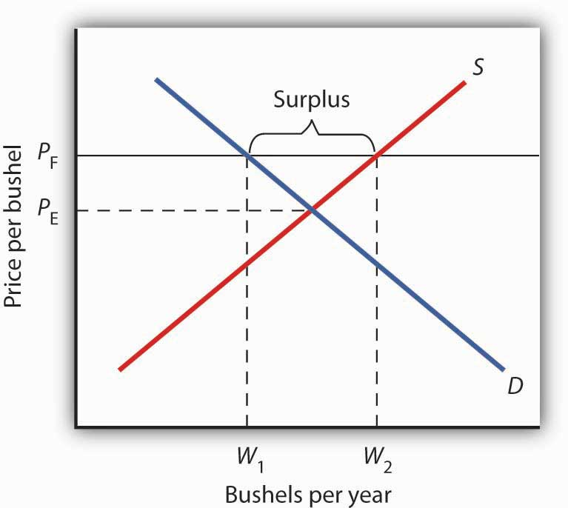

Price Floors in Wheat Markets

A price floor for wheat creates a surplus of wheat equal to (W2 – W1) bushels.

Why have many governments around the world set price floors in agricultural markets? Farming has changed dramatically over the past two centuries. Technological improvements in the form of new equipment, fertilizers, pesticides, and new varieties of crops have led to dramatic increases in crop output per acre. Worldwide production capacity has expanded markedly. As we have learned, technological improvements cause the supply curve to shift to the right, reducing the price of food. While such price reductions have been celebrated in computer markets, farmers have successfully lobbied for government programs aimed at keeping their prices from falling.

While the supply curve for agricultural goods has shifted to the right, the demand has increased with rising population and with rising income. But as incomes rise, people spend a smaller and smaller fraction of their incomes on food. While the demand for food has increased, that increase has not been nearly as great as the increase in supply. Figure 4.9 “Supply and Demand Shifts for Agricultural Products” shows that the supply curve has shifted much farther to the right, from S1 to S2, than the demand curve has, from D1 to D2. As a result, equilibrium quantity has risen dramatically, from Q1 to Q2, and equilibrium price has fallen, from P1 to P2.

On top of this long-term historical trend in agriculture, agricultural prices are subject to wide swings over shorter periods. Droughts or freezes can sharply reduce supplies of particular crops, causing sudden increases in prices. Demand for agricultural goods of one country can suddenly dry up if the government of another country imposes trade restrictions against its products, and prices can fall. Such dramatic shifts in prices and quantities make incomes of farmers unstable.

Figure 4.9 Supply and Demand Shifts for Agricultural Products

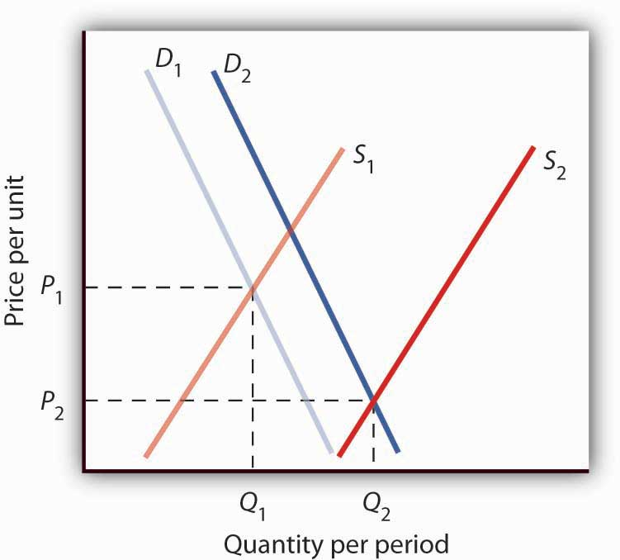

Supply and Demand Shifts for Agricultural Products

A relatively large increase in the supply of agricultural products, accompanied by a relatively small increase in demand, has reduced the price received by farmers and increased the quantity of agricultural goods.

The Great Depression of the 1930s led to a major federal role in agriculture. The Depression affected the entire economy, but it hit farmers particularly hard. Prices received by farmers plunged nearly two-thirds from 1930 to 1933. Many farmers had a tough time keeping up mortgage payments. By 1932, more than half of all farm loans were in default.

Farm legislation passed during the Great Depression has been modified many times, but the federal government has continued its direct involvement in agricultural markets. This has meant a variety of government programs that guarantee a minimum price for some types of agricultural products. These programs have been accompanied by government purchases of any surplus, by requirements to restrict acreage in order to limit those surpluses, by crop or production restrictions, and the like.

To see how such policies work, look back at Figure 4.8 “Price Floors in Wheat Markets”. At PF, W2 bushels of wheat will be supplied. With that much wheat on the market, there is market pressure on the price of wheat to fall. To prevent price from falling, the government buys the surplus of (W2 – W1) bushels of wheat, so that only W1 bushels are actually available to private consumers for purchase on the market. The government can store the surpluses or find special uses for them. For example, surpluses generated in the United States have been shipped to developing countries as grants-in-aid or distributed to local school lunch programs. As a variation on this program, the government can require farmers who want to participate in the price support program to reduce acreage in order to limit the size of the surpluses.

After 1973, the government stopped buying the surpluses (with some exceptions) and simply guaranteed farmers a “target price.” If the average market price for a crop fell below the crop’s target price, the government paid the difference. If, for example, a crop had a market price of $3 per unit and a target price of $4 per unit, the government would give farmers a payment of $1 for each unit sold. Farmers would thus receive the market price of $3 plus a government payment of $1 per unit. For farmers to receive these payments, they had to agree to remove acres from production and to comply with certain conservation provisions. These restrictions sought to reduce the size of the surplus generated by the target price, which acted as a kind of price floor.

What are the effects of such farm support programs? The intention is to boost and stabilize farm incomes. But, with price floors, consumers pay more for food than they would otherwise, and governments spend heavily to finance the programs. With the target price approach, consumers pay less, but government financing of the program continues. U.S. federal spending for agriculture averaged well over $22 billion per year between 2003 and 2007, roughly $70 per person.

Help to farmers has sometimes been justified on the grounds that it boosts incomes of “small” farmers. However, since farm aid has generally been allotted on the basis of how much farms produce rather than on a per-farm basis, most federal farm support has gone to the largest farms. If the goal is to eliminate poverty among farmers, farm aid could be redesigned to supplement the incomes of small or poor farmers rather than to undermine the functioning of agricultural markets.

In 1996, the U.S. Congress passed the Federal Agriculture Improvement and Reform Act of 1996, or FAIR. The thrust of the new legislation was to do away with the various programs of price support for most crops and hence provide incentives for farmers to respond to market price signals. To protect farmers through a transition period, the act provided for continued payments that were scheduled to decline over a seven-year period. However, with prices for many crops falling in 1998, the U.S. Congress passed an emergency aid package that increased payments to farmers. In 2008, as farm prices reached record highs, Congress passed a farm bill that increased subsidy payments to $40 billion. It did, however, for the first time limit payments to the wealthiest farmers. Individual farmers whose farm incomes exceed $750,000 (or $1.5 million for couples) would be ineligible for some subsidy programs.

**U.S. Price Ceilings for Rental Properties**

The purpose of rent control is to make rental units cheaper for tenants than they would otherwise be. Unlike agricultural price controls, rent control in the United States has been largely a local phenomenon, although there were national rent controls in effect during World War II. Currently, about 200 cities and counties have some type of rent control provisions, and about 10% of rental units in the United States are now subject to price controls. New York City’s rent control program, which began in 1943, is among the oldest in the country. Many other cities in the United States adopted some form of rent control in the 1970s. Rent controls have been pervasive in Europe since World War I, and many large cities in poorer countries have also adopted rent controls.

Rent controls in different cities differ in terms of their flexibility. Some cities allow rent increases for specified reasons, such as to make improvements in apartments or to allow rents to keep pace with price increases elsewhere in the economy. Often, rental housing constructed after the imposition of the rent control ordinances is exempted. Apartments that are vacated may also be decontrolled. For simplicity, the model presented here assumes that apartment rents are controlled at a price that does not change.

Figure 4.10 Effect of a Price Ceiling on the Market for Apartments

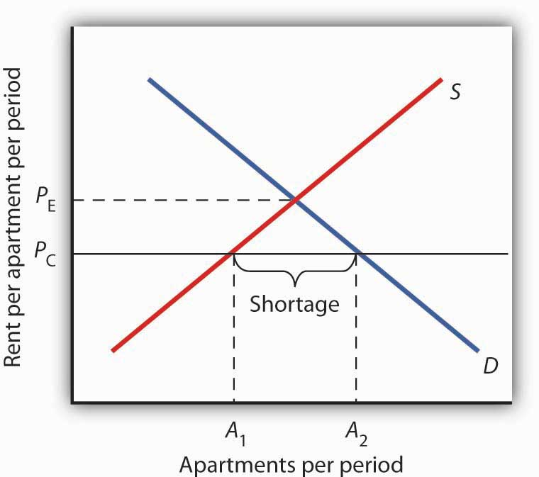

Effect of a Price Ceiling on the Market for Apartments

A price ceiling on apartment rents that is set below the equilibrium rent creates a shortage of apartments equal to (A2 − A1) apartments.

Figure 4.10 “Effect of a Price Ceiling on the Market for Apartments” shows the market for rental apartments. Notice that the demand and supply curves are drawn to look like all the other demand and supply curves you have encountered so far in this text: the demand curve is downward-sloping and the supply curve is upward-sloping.

The demand curve shows that a higher price (rent) reduces the quantity of apartments demanded. For example, with higher rents, more young people will choose to live at home with their parents. With lower rents, more will choose to live in apartments. Higher rents may encourage more apartment sharing; lower rents would induce more people to live alone.

The supply curve is drawn to show that as rent increases, property owners will be encouraged to offer more apartments to rent. Even though an aerial photograph of a city would show apartments to be fixed at a point in time, owners of those properties will decide how many to rent depending on the amount of rent they anticipate. Higher rents may also induce some homeowners to rent out apartment space. In addition, renting out apartments implies a certain level of service to renters, so that low rents may lead some property owners to keep some apartments vacant.

Rent control is an example of a price ceiling, a maximum allowable price. With a price ceiling, the government forbids a price above the maximum. A price ceiling that is set below the equilibrium price creates a shortage that will persist.

Suppose the government sets the price of an apartment at PC in Figure 4.10 “Effect of a Price Ceiling on the Market for Apartments”. Notice that PC is below the equilibrium price of PE. At PC, we read over to the supply curve to find that sellers are willing to offer A1 apartments. Reading over to the demand curve, we find that consumers would like to rent A2 apartments at the price ceiling of PC. Because PC is below the equilibrium price, there is a shortage of apartments equal to (A2 – A1). (Notice that if the price ceiling were set above the equilibrium price it would have no effect on the market since the law would not prohibit the price from settling at an equilibrium price that is lower than the price ceiling.)

Figure 4.11 The Unintended Consequences of Rent Control

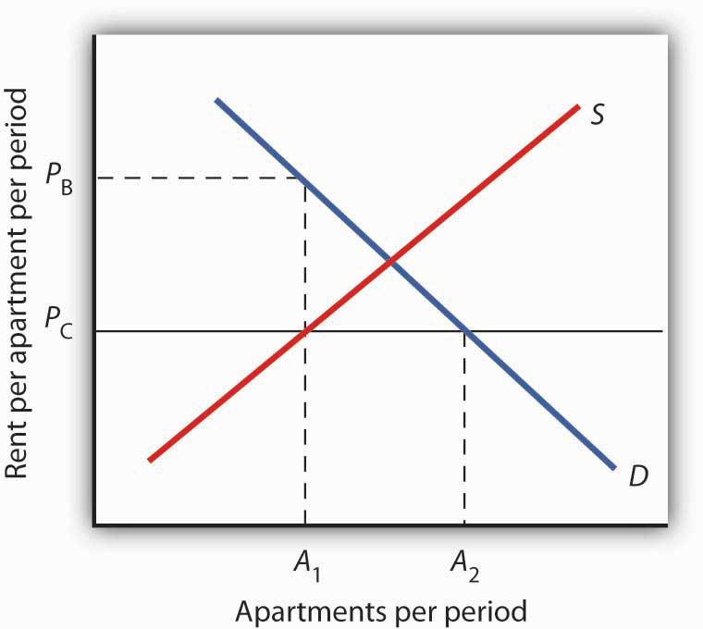

The Unintended Consequences of Rent Control

Controlling apartment rents at PC creates a shortage of (A2 − A1) apartments. For A1 apartments, consumers are willing and able to pay PB, which leads to various “backdoor” payments to apartment owners.

If rent control creates a shortage of apartments, why do some citizens nonetheless clamor for rent control and why do governments often give in to the demands? The reason generally given for rent control is to keep apartments affordable for low- and middle-income tenants.

But the reduced quantity of apartments supplied must be rationed in some way, since, at the price ceiling, the quantity demanded would exceed the quantity supplied. Current occupants may be reluctant to leave their dwellings because finding other apartments will be difficult. As apartments do become available, there will be a line of potential renters waiting to fill them, any of whom is willing to pay the controlled price of PC or more. In fact, reading up to the demand curve in Figure 4.11 “The Unintended Consequences of Rent Control” from A1 apartments, the quantity available at PC, you can see that for A1 apartments, there are potential renters willing and able to pay PB. This often leads to various “backdoor” payments to apartment owners, such as large security deposits, payments for things renters may not want (such as furniture), so-called “key” payments (“The monthly rent is $500 and the key price is $3,000”), or simple bribes.

In the end, rent controls and other price ceilings often end up hurting some of the people they are intended to help. Many people will have trouble finding apartments to rent. Ironically, some of those who do find apartments may actually end up paying more than they would have paid in the absence of rent control. And many of the people that the rent controls do help (primarily current occupants, regardless of their income, and those lucky enough to find apartments) are not those they are intended to help (the poor). There are also costs in government administration and enforcement.

Because New York City has the longest history of rent controls of any city in the United States, its program has been widely studied. There is general agreement that the rent control program has reduced tenant mobility, led to a substantial gap between rents on controlled and uncontrolled units, and favored long-term residents at the expense of newcomers to the city (Arnott, R., 1995). These distortions have grown over time, another frequent consequence of price controls.

A more direct means of helping poor tenants, one that would avoid interfering with the functioning of the market, would be to subsidize their incomes. As with price floors, interfering with the market mechanism may solve one problem, but it creates many others at the same time.

Government support for corn dates back to the Agricultural Act of 1938 and, in one form or another, has been part of agricultural legislation ever since. Types of supports have ranged from government purchases of surpluses to target pricing, land set asides, and loan guarantees. According to one estimate, the U.S. government spent nearly $42 billion to support corn between 1995 and 2004.

Then, during the period of rising oil prices of the late 1970s and mounting concerns about dependence on foreign oil from volatile regions in the world, support for corn, not as a food, but rather as an input into the production of ethanol—an alternative to oil-based fuel—began. Ethanol tax credits were part of the Energy Act of 1978. Since 1980, a tariff of 50¢ per gallon against imported ethanol, even higher today, has served to protect domestic corn-based ethanol from imported ethanol, in particular from sugar-cane-based ethanol from Brazil.

The Energy Policy Act of 2005 was another milestone in ethanol legislation. Through loan guarantees, support for research and development, and tax credits, it mandated that 4 billion gallons of ethanol be used by 2006 and 7.5 billion gallons by 2012. Ethanol production had already reached 6.5 billion gallons by 2007, so new legislation in 2007 upped the ante to 15 billion gallons by 2015.

Beyond the increased amount the government is spending to support corn and corn-based ethanol, criticism of the policy has three major prongs:

1. Corn-based ethanol does little to reduce U.S. dependence on foreign oil because the energy required to produce a gallon of corn-based ethanol is quite high. A 2006 National Academy of Sciences paper estimated that one gallon of ethanol is needed to bring 1.25 gallons of it to market. Other studies show an even less favorable ratio.
2. Biofuels, such as corn-based ethanol, are having detrimental effects on the environment, with increased deforestation, stemming from more land being used to grow fuel inputs, contributing to global warming.
3. The diversion of corn and other crops from food to fuel is contributing to rising food prices and an increase in world hunger. C. Ford Runge and Benjamin Senauer wrote in *Foreign Affairs* that even small increases in prices of food staples have severe consequences on the very poor of the world, and “Filling the 25-gallon tank of an SUV with pure ethanol requires over 450 pounds of corn—which contains enough calories to feed one person for a year.”

Some of these criticisms may be contested as exaggerated: Will the ratio of energy-in to energy-out improve as new technologies emerge for producing ethanol? Did not other factors, such as weather and rising food demand worldwide, contribute to higher grain prices? Nonetheless, it is clear that corn-based ethanol is no free lunch. It is also clear that the end of government support for corn is nowhere to be seen.

Sources: Alexei Barrionuevo, “Mountains of Corn and a Sea of Farm Subsidies,” *New York Times*, November 9, 2005, online version; David Freddoso, “Children of the Corn,” National Review Online, May 6, 2008; C. Ford Runge and Benjamin Senauer, “How Biofuels Could Starve the Poor,” *Foreign Affairs*, May/June 2007, online version; Michael Grunwald, “The Clean Energy Scam,” *Time* 171:14 (April 7, 2008): 40–45.

Arnott, R., “Time for Revisionism on Rent Control,” *Journal of Economic Perspectives* 9(1) (Winter, 1995): 99–120.

[Principles of Economics](https://open.lib.umn.edu/principleseconomics) Copyright © 2016 by University of Minnesota is licensed under a [Creative Commons Attribution-NonCommercial-ShareAlike 4.0 International License](https://creativecommons.org/licenses/by-nc-sa/4.0/), except where otherwise noted.

**Difference Between Large-Ticket Items and Small-Ticket Items**

There is no extra room at the grocery store. The grocery store is fully stocked. The same amount of food is available no matter the inflation rate. Raising interest rates does not lead to people spending less money at the grocery store, nor does raising interest rates lead to more food being stocked on the shelves. Inflation may lead to people dining out at restaurants more, though not buying less food at the grocery store.

The premise behind raising interest rates is to reduce purchases of large-ticket items like cars, real estate, and electronics, not small-ticket items like food. The cost of borrowing increases, thereby increasing the cost of large-ticket items. However, people don’t borrow to purchase food, so rising interest rates should not increase the price of food.

Instead of large-ticket and small-ticket, we could say luxury and necessity items. Luxury items are those you have to borrow to purchase, and necessity items are those you do not have to borrow to purchase, like food. There is a hole in this theory, however, as cars are necessity items, and real estate can be, even though you usually have to borrow to purchase cars and real estate. Electronics and jewelry are luxury items that you may borrow to purchase, though most people are able to purchase jewelry and electronics without borrowing. So we raise interest rates on borrowing for necessity items like cars and real estate. This is counterintuitive.

If raising interest rates increases credit card rates, how does this help the economy and inflation? Credit cards can be for luxury or necessity purchases, though are for luxury purchases for most people, like electronics and jewelry. However, for people who have recently lost their jobs, credit cards can be for necessity purchases like food. Raising credit card rates via increasing the federal funds rate does not help consumers who are paying for food with credit cards. This is counterintuitive.

This brings us to another question. Do the prices of luxury goods affect the prices of necessity items? Most people would say that the price of cars has no effect on the price of food. Tractors use car parts, and tractors are used to make food. Tractor trailers use car parts, and tractor trailers are used to transport food. Though does the price of cars really affect the price of food, and thus can raising the interest rates on cars really bring down the price of food? Or, is raising the interest rates on cars not helping the price of food, and possibly even exacerbating the problem?

**Role of Fiscal Policy and Legislation in Combating Inflation**

The impact of energy prices on inflation cannot be discounted.

**Role of Interest Rates on Corporate Activity**

Higher interest rates increase borrowing costs for companies for both short-term and long-term debt. This means less money available to invest in long-term growth, which decreases GDP. This also means less money available for short-term daily operating expenses, which could affect the going concern assumption of the company. When interest rates rise, short-term financing options, like lines of credit and business credit cards, become harder to qualify for, because you need a higher credit score, and if you do qualify, the financing rates will be higher.

Revenue and sales will also drop for a company due to rising interest rates, as consumers preserve their limited funds to pay their interest charges on student loans, cars, and mortgages. This could affect customer retention and acquisition rates for companies and their consumers. When interest rates rise, and the business has variable-rate loans, it becomes harder to plan for the future because interest charges become more unknown and unpredictable.

**References**

Efremov, S. (2012). The Role of Inflation in Soviet History: Prices, Living Standards, and Political Change. East Tennessee State University, Electronic Theses and Dissertations.

<https://dc.etsu.edu/cgi/viewcontent.cgi?article=2667&context=etd>

He, L. CNN. (2023). China has an inflation problem. It’s way too low. <https://www.cnn.com/2023/04/24/economy/china-deflation-economy-intl-hnk/index.html>

**Debt by Country, the United States and its Debt Crisis, A Case Study of the United States, Greece, and Japan**

What is the impact of Treasury measures to prevent a debt default of national debt.

What is the process for reducing inflation, and raising interest rates.

Debt by country is an effective way to measure a country’s exposure to macroeconomic events globally. As of 2022, the countries with debt to GDP ratios greater than 90% include Japan at 240%, Greece at 157%, Lebanon at 131%, the United States at 124%, Italy at 122%, Singapore at 120%, Cabo Verde at 117%, Portugal at 106%, Canada at 101%, France at 99%, Spain at 98%, Bahrain at 96%, Sudan at 94%, and Belgium at 91%.

One of the first questions that jumps out from analyzing this data is why did Greece have an epic national debt meltdown when Japan has nearly 100% more debt than Greece? One reason is that much of Japan’s debt is internally held by its banks, including 45% by the Bank of Japan.[1] Japan is the only industrialized nation to have more debt than the United States, though a majority of Japan’s debt, from 45%-70%, is held by the Bank of Japan. Japan also holds over $1 trillion in U.S. debt, and China also holds over $1 trillion.

Greece can be differentiated from Japan and the United States in that only Greece has defaulted on their debt. One of the contributing factors to Greece’s economic implosion is that Greece had less flexibility in their monetary policy due to their inclusion in the Eurozone currency union. This fact suggests that Japan and the United States have more leverage to manage their substantial debts than Greece did, through the use of monetary stabilization policy.

**United States Debt Crisis**

The United States ranks fourth on the list of countries with the highest debt per GDP ratio. Debt levels in the U.S. have recently risen to levels not seen since World War II, due to increased spending during the Covid pandemic. A distinguishing characteristic about the United States is that it is the world’s reserve currency, thus allowing it to carry debt more cheaply than other nations, such as Japan or Greece. The eternal question in the United States among experts is whether the U.S. will eventually have to face consequences due to its high level of debt, or whether it can maintain its debt leadership position. Central to the U.S.’s debt leadership strategy is maintaining effective control over the Earth reserve currency, as the U.S. dollar. Other countries, such as China and even the European Union, however, have other plans when it comes to replacing the U.S. dollar as the world reserve currency. How long can the U.S. dollar hold out? Will the Chinese yuan or European euro replace or compete with the U.S. dollar. What does the reserve currency have to ddo with the global language, English? Will petro dollars come into play? Saudi Arabia and OPEC register transactions in U.S. dollars, per a decades old agreement, though China has been known to be intent on replacing the U.S. dollar as the petro currency of choice.

To qualify for reserve currency status, several aspects must be met by a country. It has to be a developed country with a big economy with relatively free capital flows; it has to have a banking system able to handle being a creditor, and; it has to have export clout.[2] Drawbacks to the Chinese yuan being held as a reserve currency are two-fold. One, China tends to artificially hold down the yuan’s value to boost exports. Two, foreigners are limited in how much Chinese bonds they can hold, and reserve currencies are typically held as government bonds rather than hard currency.[3] An alternative to a national reserve currency system is the International Monetary Fund unit of Special Drawing Rights, or SDRs, whose value is calculated from a weighted basket of major currencies, including the U.S. dollar, the euro, Japanese yen, Chinese yuan, and the British pound.

Having a reserve currency reduces transaction costs, since both sides of the transaction involve the same currency and one is yours. Exchange rate risk is also reduced, since commodities, which are often quoted and settled in dollars. Being the reserve currency allows the United States to pay less in interest rates, as steady demand from foreign central banks keeps demand high and thus rates low. Higher demand for the reserve currency to process international transactions means lower borrowing costs for the reserve country through depressed bond yields, and most reserves are held as government bonds. Since other countries want to hold a currency and use it for transactions, there is higher demand for the reserve currency. This ability to borrow in your home currency means the country is less worried about propping up their currencies to avoid default.A drawback to having a reserve currency is that low borrowing costs due to reserve currency status may prompt loose spending by both the public and private sectors, which may result in asset bubbles and ballooning government debt.[4]

In the United States, debt as a percentage of GDP topped out in 1946 at 100%. It then fell to 24% by 1974. Spending then started increasing starting in the 1980s, and has continued until present day. Some estimates suggest that the U.S. debt could double by 2029, coming close to the size of the entire United States economy, and twice the size of the economy by 2050, due to growth in entitlements and higher interest rates. In the United States, 61% of the budget goes to mandatory spending, which includes Social Security, Medicare, and Medicaid; 30% goes to discretionary spending, which includes defense spending; and 9% goes to interest payments. Some forecasts estimate that spending on health programs and interest payments will increase, while defense spending will decrease. China and Japan each hold more than $1 trillion in U.S. debt, and Britain holds more than $500 million (McBride and Siripurapu, 2021).

**Japan Debt Crisis**

Around 70% of Japanese government bonds are purchased by the Bank of Japan, and much of the remainder is purchased by Japanese banks and trust funds, which largely insulates the prices and yields of such bonds from the effects of the global bond market and reduces their sensitivity to credit rating changes (Grimes, 2011). Betting against Japanese government bonds has become known as the "widowmaker trade" due to their price resilience even if fundamental analysis indicates the contrary should be true.

Grimes (2011) writes that a downgrade in Japan’s credit rating would likely have little on the country’s ability to borrow. This is because the bulk of Japanese government debt is held domestically by public entities, including the Bank of Japan (BOJ) and government trust funds; financial institutions (banks, insurance companies, and securities firms); and households. Foreign financial institutions are more sensitive to credit ratings than domestic entities.

The monetary policy of quantitative easing suggests buying national debt, and this is Japan’s current monetary policy. Reasons for the Bank of Japan (BOJ) to stop buying government bonds would be to maintain the integrity of its balance sheet, or to due to the limitations of the “Banknote Rule,” which limits BOJ holdings of Japanese Government Bonds (JGBs) to the amount of currency in circulation. These are debatable measures, however, as balance sheet quality is self-defined and the Banknote Rule is not legally binding, and was abandoned in practice in fall 2010. Adverse reactions from political leaders is a major factor in the BOJ choosing not to increase its credibility by taking these measures. Why don’t Japanese banks stop buying as much government debt? In Japan, there is an environment of low corporate credit demand and growing deposits. The price of debt in Japan will remain stable and foreigners will have no incentive to reduce their holdings unless they expect a significant depreciation of the yen, as long as domestic investors are not leaving the JGB market (Grimes, 2011).

With national debt at 200% of GDP and annual deficits at 8%, Japan cannot significantly reduce debt without causing a recession. Even if they reduce debt, the numerator in the debt-to-gdp ratio, this action may also cause GDP to drop, thereby eliminating gains. Debt reduction is always a long term process. One way to look at debt reduction is to try to reduce the primary deficit, i.e. not including debt repayment, to allow surpluses to eventually reduce the debt. Economic growth is another way to reduce debt, though analysts forecast only a 1-1.5% growth rate in Japan, due to an aging population and shrinking labor force.

One effort suggested in Japan to reduce debt is the raising of the consumption tax to 15%, though this will be met by political resistance from politicians and the voting populace alike. A consumption tax is easy to administer and reduces volatility in tax collection, in contrast to taxes on corporate profits. Most importantly, in Japan’s aging society, To ensure that the entire tax burden does not fall onto the nation’s dwindling workforce, a consumption tax considers the aging population of Japan. The lesson of 1997 was that taxing consumption when it is already weak raises the likelihood of further declines. A way to phase in the consumption tax would be 1% increases a year for 10 years.

Japan has a high level of veto points in its political system, such as the Diet, the political parties, and the bureaucracy. In times of high growth, the rapid growth of the economy and tax revenues meant that through compensation politics political losers could be compensated through transfers, public works spending, and subsidized lending through policy banks (including financial institutions oriented toward farmers, housing, small- and medium-sized enterprises, and depressed regions)(Grimes, 2011). In periods of slow growth, like Japan is currently experiencing, this compensation politics becomes less beneficial.

**Greece Debt Crisis**

Greece’s debt crisis became evident after the damage of the 2007-2008 worldwide debt crisis. Greece can also be differentiated from Japan and the United States in that they have actually defaulted on their debt. The Greek economy suffered the longest recession of any advanced mixed economy to date, and as a result, the Greek political system was upended, social exclusion increased, and hundreds of thousands of well-educated Greeks left the country.[5] Starting in 2009, the Greek economy contracted, triggered by the turmoil of the world-wide Great Recession, structural weaknesses in the Greek economy, and lack of monetary policy flexibility as a member of the Eurozone.

The Greek government developed a habit for underreporting government debt levels and deficits. The official forecast for the 2009 budget deficit was less than half the final value as calculated in 2010, while after revisions according to Eurostat methodology, the 2009 government debt was finally raised from $269.3bn to $299.7bn, i.e. about 11% higher than previously reported.[6] Greece experienced a widening of bond yield spreads and rising cost of risk insurance on credit default swaps. 12 rounds of tax increases, spending cuts, and reforms ensued from 2010 to 2016. Greece required bailout loans in 2010, 2012, and 2015 from the International Monetary Fund, Eurogroup, and the European Central Bank, and negotiated a 50% reduction on debt owed to private banks in 2011, which amounted to a €100bn debt relief (a value effectively reduced due to bank recapitalisation and other resulting needs).[7]

On 30 June 2015, Greece became the first developed country to fail to make an IMF loan repayment on time, after the payment was made with a 20-day delay. At the time of late payment, debt levels stood at €323bn or some €30,000 per capita, which was not much different from the beginning of the crisis and at a per capita value below the OECD average, but high as a percentage of the respective GDP. Between 2009 and 2017, Greek government debt rose only from €300bn to €318bn, though during the same period the Greek debt-to-GDP ratio rose up from 127% to 179% due to the severe GDP drop during the handling of the crisis.[8]

**2007-2009 Worldwide Debt Crisis, The Great Recession**

The 2007-2009 worldwide debt crisis was the most significant downturn since the Great Depression. The term "Great Recession" applies to both the U.S. recession, officially lasting from December 2007 to June 2009, and the ensuing global recession in 2009. The downturn resulted from the U.S. housing market going bust, and large amounts of mortgage-backed securities (MBS) and derivatives lost value. This event can be differentiated from the Great Depression of the 1930s in the United States, where GDP declined by 10% and the unemployment rate reached 25%. During the Great Recession, U.S. GDP declined by 0.3% in 2008 and 2.8% in 2009, while unemployment briefly reached 10%.

***Avoidable Causes of the Great Recession***

1. Failure of the government to regulate the financial industry, including mortgage lending.
2. The shadow banking system failed, which affected the flow of credit to consumers and businesses. There were too many financial firms taking on too much risk. The investment firms of the shadow banking system grew to rival the depository banking sector, but was not under the same regulation or scrutiny.
3. Excessive borrowing by consumers and corporations.
4. Lawmakers who were not able to fully understand the collapsing financial system

These factors created asset bubbles, including in the housing market as mortgages were extended at low interest rates to unqualified borrowers who could not repay them. The asset bubbles caused housing prices to fall and left many other homeowners underwater, which impacted the market for mortgage-backed securities (MBS) held by banks and other institutional investors. Low interest rates through mid-2004 and federal policy to encourage homeownership, helped spark a boom in real estate and financial markets and an expansion of the volume of total mortgage debt. New types of subprime and adjustable mortgages allowed unqualified borrowers to obtain home loans based on expectations that interest rates would remain low and home prices would continue to rise indefinitely. Then from 2004 to 2006 the Fed raised interest rates to moderate inflation, resulting in borrowers with adjustable rate mortgages found themselves in danger of default, and a housing bubble ensued. In the US, real GDP bottomed out in the second quarter of 2009 and regained its pre-recession peak in the second quarter of 2011, three and a half years after the initial onset of the official recession.[9]

The Dow Jones Industrial Average (DJIA) lost over half its value from its August 2007 peak, began to recover in March 2009 and, four years later, in March 2013, broke its 2007 high. Unemployment was at 5% at the end of 2007, reached a high of 10% in October 2009, and did not recover to 5% until 2015, nearly eight years after the beginning of the recession. Real median household income did not surpass its pre-recession level until 2016. Critics of the liquidity creation and deficit spending which accompanied the recovery led to institutions that should have failed being propped up, and resources being diverted from industries that more appropriately needed the money.

The Great Recession lasted 18 months, per data from the Federal Reserve, from December 2007 to June 2009. On October 9, 2007, the Dow Jones Industrial Average hit its pre-recession high and closed at 14,164.53. By March 5, 2009, the index had fallen by more than 50% to 6,594.44. On September 29, 2008. The Dow Jones fell by nearly 778 points intraday.

Bear Stearns was the first bank to fall in March 2008. The banks were overleveraged from marketing mortgage-backed securities and sophisticated derivative products, and when the real estate market collapsed in 2007, these securities declined in value. The credit markets that had financed the housing bubble, quickly followed housing prices into a downturn as a credit crisis unfolded in 2007. Lehman Brothers went bankrupt in September 2008, and the financial contagion quickly spread to Europe, with the Royal Bank of Scotland going under in October 2008. RBS was bailed out by the British government. The Great Recession’s official end date was June 2009. The morning of October 8, 2008, the British Treasury announced it was making £25 billion of capital available to the banks, £20 billion of which would turn out to be for RBS. Following a second bailout in December 2009, taking the total to £46 billion, the public found itself owning 84% of RBS.[10]

It is argued that the aggressive monetary policies undertaken by the US Federal Reserve and other central banks not only helped to moderate the effects of the economic downturn, though also may have extended the time it took the overall economy to recover and laid the groundwork for later recessions. This monetary policy represented a doubling down of the aggressive policies of the 2000s that led the housing bubble in the first place. These monetary and fiscal policies prevented the liquidation of major financial institutions, though also kept the same structures in place that created the crisis.

***Monetary Policy***

1. Lowered a key interest rate to nearly zero to promote liquidity.
2. Quantitative Easing (QE), provided banks with a staggering $7.7 trillion of emergency loans.

***Fiscal Policy***

1. According to the Congressional Budget Office, $787 billion in deficit spending under the American Recovery and Reinvestment Act.

***Federal Legislation***

1. **Glass-Steagall Act;** The repeal of this act led the mergers of US financial institutions and the creation of larger banks.
2. **Dodd-Frank Act;** President Obama enacted the Dodd-Frank Act enacted in 2010, which gave the government control of failing financial institutions and the ability to establish consumer protections against predatory lending.

The COVID-19 coronavirus pandemic has increased the budget deficit and public debt of the United States and EU countries to a record high and made it impossible to reduce them traditionally without economic and social problems. The purpose of this study is to systematize tactical budgetary decisions to prevent a decline in GDP and a debt crisis that are not related to structural policy. The research methodology is a comparative analysis of the main budget documents of the United States, the European Union, Germany, Canada, as well as publications on the budget policy of the IMF and the OECD. The results of the study show: (1) declarative balance of budgets in the medium term and postponing the solution of the problem of deficits from year to year; (2) PR for small development spending and comparing it over 5–10 years to huge annual budget deficits; (3) emphasis on net and market public debt, i.e. net of reserves and debt to central banks; (4) shifting part of the state debt to state corporations and off-budget funds; (5) accelerating inflation and maintaining low rates on government bonds, inflation of GDP and tax revenues; (6) freezing or slow indexation of budget expenditures against the backdrop of a rise in inflation. Thus, systematized budget decisions on the manipulation of key budget indicators will give a delay of several years to develop and start implementing structural reforms that have yet to be detailed and implemented. (5) accelerating inflation and maintaining low rates on government bonds, inflation of GDP and tax revenues; (6) freezing or slow indexation of budget expenditures against the backdrop of a rise in inflation. Thus, systematized budget decisions on the manipulation of key budget indicators will give a delay of several years to develop and start implementing structural reforms that have yet to be detailed and implemented. (5) accelerating inflation and maintaining low rates on government bonds, inflation of GDP and tax revenues; (6) freezing or slow indexation of budget expenditures against the backdrop of a rise in inflation. Thus, systematized budget decisions on the manipulation of key budget indicators will give a delay of several years to develop and start implementing structural reforms that have yet to be detailed and implemented.

Anureev S.V. Avoiding a public debt crisis in the US and the Eurozone through creative changes in key budget indicators and inflation. Outlines of Global Transformations: Politics, Economics, Law . 2022;15(1):224-244. <https://doi.org/10.31249/kgt/2022.01.11>

Simitis, Costas. (2012). The European Debt Crisis: The Greek Case. Manchester University Press.

**Failure of Silicon Valley Bank and Signature Bank**

SVB was home to many deposits for tech companies from Silicon Valley, so the failure of this bank will have ripple effects throughout the tech industry. SVB was the 16th largest bank in the country, with 200 billion in deposits. When SVB was acquired by First Citizens, depositors were made whole, and the only ones who lost money were equity investors in the stock market. SVB played a critical role in the tech start-up industry going back to 1983, and it remains to be seen if First Citizens Bank will show the same affinity for tech start-ups in Silicon Valley.

What brought SVB down was an old fashioned bank run, precipitated by events in 2021. The problem was that in 2021 the stock market was booming and interest rates were low, near zero, and money flooded into the tech sector. As many start-ups deposited their cash at SVB, the bank took that money and invested it in government bonds. When interest rates rose these investments became riskier, and as tech investment slowed many of these companies pulled their money out of the bank to pay expenses, the bank had to sell their investments at a loss to satisfy obligations. As the economy soured many companies shelved plans to go public and began conserving cash.

This really wasn’t a bad investing decision, it was bad monetary policy by the Federal Reserve spurred by bad fiscal policy by the president. Interest rates had been near zero for some time, and it is always a good investment to buy government bonds. This is a safe investment. The problem was inflation and rising interest rates. Then when Silicon Valley Bank tried to explain to its investors what had happened, many depositors got spooked and started a bank run. THis was a classic bank run, not bad financial management by the bank. Any bank would be in trouble if there were a bank run. All banks invest funds to make a profit, that is, excess funds over a safe amount for deposits withdrawals.

Nevertheless, even though this was not a bad investment decision by the management of the bank, maybe they could have foreseen the nature of the depositors it had. Since it has tech start-ups as depositors, whose funding ability was vulnerable to rising interest rates, maybe they should not have invested so much in long-term government bonds. If you know that your depositors will be withdrawing cash soon, then don’t invest that cash. You have to keep in that bank to fund their withdrawals.

Another lesson learned from the SVB collapse is that their problems may have also been from their online clientele, in addition to their tech start-up clientele. Online clientele and tech start-ups in liberal SIlicon Valley tend to be sensitive, like democrats, and overly scrutinize company filings, or at least overly react to the news of the day. Most normal people in middle America would not have thought twice that the bank had to sell assets to raise funds. This happens all the time at banks, and is normal. SVB had a board of democratic donors, and these people are liberal crybabies, who complain and do bank runs for no reason. The only reason for this bank run at SVB was so First Citizens Bank could buy it. There were no financial problems at SVB. This is 2023, all deposits are insured at US banks. That is the strength of the US dollar as the world reserve currency, all deposits at domestic banks have to be insured. At regular banks that is. INvestment banks for rich people should not be FDIC insured, like Lehman Brothers and Bear Stearns. But commercial banks that hold people’s deposits and checking and savings accounts should all be insured, per the exchange rate. If the deposits are not all insured at the national banks, then the exchange rate will drop and the currency will depreciate and inflation will happen in the country too.[11]

**Lessons Learned from SVB Collapse**

1. Online clientele is sensitive to normal people
2. Tech start-ups are sensitive to interest rate rises
3. Panicked customers, bank runs
4. US banking regulation worked, FDIC made full
5. Opportunity for First CItizens Bank to buy a Liberal Democrat Bank; mark against California from North Carolina
6. Strengthen the US Dollar as the world reserve currency, all deposits made full at commercial banks
7. Regional banks should stock to their region, SVB had branches in California and New York. It bought a Boston bank for $900 million to manage money for wealthy clients on the East Coast.
8. Donations to social movements is not a good idea for banks or companies
9. Keep a healthy mix of long-term and short-term debt, SVB bet too much on long-term debt with higher interest rates, a suspicious investment
10. More Regulation or More Rigorous Regulatory Oversight: The big debate among policy makers is whether more regulation is needed over medium and small banks, or whether the Federal Reserve needed to adjust its stress tests to address the impact of higher interest rates on the health of the banks and whether it missed clear warnings of problems at SVB.[12]
11. Regulator Reviews: Federal Reserve supervision is under review, with proposals for an independent investigator general as well as restrictions that would prohibit bank executives from serving on regional Fed boards. It would also bar Fed employees from investing in institutions under its jurisdiction.[13]

SVB announced a $1.8 billion loss from selling $21 billion in debt and then put together a plan to raise $2.25 billion in fresh capital from stock issuances. This news spooked the bank’s depositors and investors so much that its stock plummeted roughly 60 percent and clients pulled out $42 billion of their money. The next day the bank was dead, and the following week stocks of small and mid-sized banks took a tumble on the US stock exchanges. By the end of 2021, the bank held $189.2 billion in deposits up from $102 billion in 2020 and $49 billion in 2018. Its stock price roughly tripled from 2018 to 2021. As of Dec. 31, 2022, SVB classified most of its debt portfolio, or roughly $95 billion, as “held to maturity.” Because of an accounting loophole, the bank didn’t have to show fluctuations in the value of those bonds on its balance sheet. According to Janney Montgomery Scott, on average, banks with at least $1 billion in assets classified only 6 percent of their debt in this category at the end 2022. But Silicon Valley Bank put 75 percent of its debt as held to maturity.[14]

It would have sell the long-term debt at low interest rates for a discount, or loss, since the newer bonds were paying higher interest rates. The bank had a tanking bond portfolio and underwater securities.

The FDIC agreed to sell the deposits, loans, and branches of Silicon Valley Bridge Bank (SVB) to First Citizens Bank & Trust Company. Raleigh-based First Citizens Bank was the 30th largest US lender at the end of 2022 and assumed roughly $56 billion in deposits, $72 billion in loans, and 17 branches at a discount of $16.5 billion. According to the FDIC, $90 billion of securities and other assets will remain in receivership and the total loss from SVB’s collapse to the Deposit Insurance Fund is estimated at $20 billion. As part of the deal, the FDIC also offered First Citizens a $70 billion line of credit to boost liquidity, allowed the bank to complete the purchase by issuing a $35 billion bank note to the agency, and agreed to cover losses in excess of $5 billion over the next 5 years on the commercial loans it assumed. Regarding shareholders, all shares of Silicon Valley Bank are owned by its holding company SVB Financial Group, which was not included in the closing of the bank or resulting receivership. Upon the closing of the bank, the FDIC directed all shareholders to not contact the Receiver or file a claim but instead to contact the holding company directly.[15]

The news comes one week after the FDIC struck a similar arrangement for Signature Bank to be assumed by New York Community Bancorp and its Flagstar Bank subsidiary—estimated to cost the FDIC $2.5 billion. While the exact costs will be determined at the conclusion of FDIC receivership, the roughly $23 billion in losses incurred from the two bank collapses will pull from the $128 billion Deposit Insurance Fund and be recouped through special assessment fees on banks.[16]

**References**

1. Grimes, William. (2011). Japan’s Debt Challenge, <https://www.nbr.org/publication/japans-debt-challenge/#.Ustug9IW1_0>
2. McBride, J. and Siripurapu, A. (2021). The National Debt Dilemma, Council on Foreign Relations, <https://www.cfr.org/backgrounder/national-debt-dilemma>

Lutthi, Ben. (2023). ​​What’s the national debt by president?, <https://www.usatoday.com/money/blueprint/banking/national-debt-by-president/>

| **PRESIDENT** | **YEARS SERVED** | **NATIONAL DEBT CONTRIBUTION** | **PERCENTAGE INCREASE** |
| --- | --- | --- | --- |
| Joe Biden | 2021 – present | $1.84 trillion | 6.33% |
| Donald Trump | 2017 – 2021 | $8.2 trillion | 40.43% |
| Barack Obama | 2009 – 2017 | $8.34 trillion | 69.98% |
| George W. Bush | 2001 – 2009 | $6.1 trillion | 105.08% |
| Bill Clinton | 1993 – 2001 | $1.4 trillion | 31.64% |
| George H.W. Bush | 1989 – 1993 | $1.55 trillion | 54.39% |
| Ronald Reagan | 1981 – 1989 | $1.86 trillion | 186.36% |
| Jimmy Carter | 1977 – 1981 | $299 billion | 42.79% |
| Gerald Ford | 1974 – 1977 | $223.8 billion | 47.11% |
| Richard Nixon | 1969 – 1974 | $121.3 billion | 34.30% |
| Lyndon B. Johnson | 1963 – 1969 | $42 billion | 13.48% |
| John F. Kennedy | 1961 – 1963 | $22.7 billion | 7.87% |
| Dwight D. Eisenhower | 1953 – 1961 | $22.9 billion | 8.61% |
| Harry S. Truman | 1945 – 1953 | $7.4 billion | 2.86% |
| Franklin D. Roosevelt | 1933 – 1945 | $236.1 billion | 1047.73% |
| Herbert Hoover | 1929 – 1933 | $5.6 billion | 33.12% |
| Calvin Coolidge | 1923 – 1929 | -$5.42 billion | -24.24% |
| Warren G. Harding | 1921 – 1923 | -$1.63 billion | -6.79% |
| Woodrow Wilson | 1913 – 1921 | $21 billion | 722.21% |
| William H. Taft | 1909 – 1913 | $276.7 million | 10.48% |
| Theodore Roosevelt | 1901 – 1909 | $502.6 million | 23.52% |

1. Wikipedia, retrieved September 28, 2022, <https://en.wikipedia.org/wiki/National_debt_of_Japan>
2. Investopedia, retrieved September 29, 2022, <https://www.investopedia.com/articles/economics/13/reserve-currencies.asp>
3. Investopedia, retrieved September 29, 2022, <https://www.investopedia.com/articles/economics/13/reserve-currencies.asp>
4. Investopedia, retrieved September 29, 2022, <https://www.investopedia.com/articles/economics/13/reserve-currencies.asp>
5. Wikipedia, retrieved November 7, 2022, <https://en.wikipedia.org/wiki/Greek_government-debt_crisis>
6. ["Acropolis now"](http://www.economist.com/node/16009099). *The Economist*. 29 April 2010. Retrieved November 7, 2022.
7. ["Greek/German bond yield spread more than 1,000 bps"](https://reuters.com/article/markets-bonds-greece/greek-german-bond-yield-spread-more-than-1000-bps-idUSLDE63R0WU20100428). Reuters.com. 28 April 2010. Retrieved November 7, 2022.
8. ["IMF Greece makes overdue payments, no longer in default"](https://www.eubusiness.com/news-eu/greece-politics.13i2/). *EUBusiness*. 20 July 2015. Retrieved November 7, 2022.
9. Investopedia, retrieved November 7, 2022, <https://www.investopedia.com/terms/g/great-recession.asp#:~:text=The%20Great%20Recession%20was%20the,ensuing%20global%20recession%20in%202009>.
10. UK Parliament, House of Commons Library, retrieved November 7, 2022, <https://commonslibrary.parliament.uk/royal-bank-of-scotland-bailout-10-years-and-counting/#:~:text=The%20fall,lost%2087%25%20of%20their%20value.&text=The%20most%20eventful%20day%20for%20RBS%20that%20year%20was%207%20October>.
11. The New York Times (n.d.). 3 Lessons From Silicon Valley Bank’s Failure, <https://www.nytimes.com/2023/03/11/technology/silicon-valley-bank-failure-lessons.html>
12. The Conference Board. (2023). The Silicon Valley Bank (SVB) Collapse and Implications for Business, <https://www.conference-board.org/topics/recession/Silicon-Valley-Bank-SVB-Collapse-Implications-for-Business>
13. The Conference Board. (2023). The Silicon Valley Bank (SVB) Collapse and Implications for Business, <https://www.conference-board.org/topics/recession/Silicon-Valley-Bank-SVB-Collapse-Implications-for-Business>
14. Ferrell, Maureen. (2023. Inside the Collapse of Silicon Valley Bank, <https://www.nytimes.com/2023/03/14/business/silicon-valley-bank-gregory-becker.html>
15. The Conference Board. (2023). The Silicon Valley Bank (SVB) Collapse and Implications for Business, <https://www.conference-board.org/topics/recession/Silicon-Valley-Bank-SVB-Collapse-Implications-for-Business>
16. The Conference Board. (2023). The Silicon Valley Bank (SVB) Collapse and Implications for Business, <https://www.conference-board.org/topics/recession/Silicon-Valley-Bank-SVB-Collapse-Implications-for-Business>