**Advanced Solar Cell Technologies**

1. PERC Solar Cells Technology
2. PERT Solar Cells Technology
3. TOPCON Solar Cells Technology
4. HJT Solar Cells Technology
5. Back-Contact Micrometric Photovoltaic Cells
6. Dye-sensitized Solar Cells (DSSC)
7. Multijunction III-IV Technology
8. Bifacial Solar Cells
9. Ultrathin Solar Cells
10. Transition Metal Dichalcogenide (TMD) Solar Cells

**Photovoltaic Precursors, Cell Absorbers**

1. Crystalline Silicon
2. Cadmium Telluride
3. Copper Indium Gallium Diselenide
4. Gallium-Arsenide-Nitrogen-Bismuth
5. Organic
6. Kesterite
7. Perovskite

**Solar Cell Precursors**   
Silicon is the most prevalent solar cell precursor material, with other precursors including cadmium telluride (CdTe), copper indium gallium selenide (CIGS), gallium arsenide (GaAs), perovskite materials (like methylammonium lead halide), and organic materials.

Silicon is an established technology and has relatively low cost, but can be less efficient than newer options. Cadmium Telluride (CdTe) has high efficiency and low production costs.

Copper Indium Gallium Selenide (CIGS) is a thin-film material with good efficiency and potential for flexible applications. Gallium Arsenide (GaAs) has high efficiency, but also has a complex manufacturing process, so is more expensive. Perovskite has seen efficiency gains, but has stability issues, and is commonly made with toxic compounds, such as lead, methylammonium cations (${CH}_{3}{NH}_{3}^{+}$), and dimethylformamide (DMF). Organic Materials are lightweight and flexible, but generally have lower efficiency compared to inorganic materials.

<https://www.energy.gov/eere/solar/photovoltaics>

<https://solarquarter.com/2023/10/13/explained-topcon-vs-hjt-what-are-the-fundamental-differences-in-the-solar-technologies/>

***Accelerated Aging Tests Check that Silicon Modules are Robust***

1. Sealing modules inside humid, sauna-like conditions for about four months
2. Exposing them to bright simulated sunlight
3. Bombarding them with artificial hailstones

"No matter how hard you try, with whatever method you choose to make them, solar cells will always contain some defects thanks to entropy. By using a heterojunction structure, with carefully designed emitter properties, you can minimize the adverse impact of these defects on efficiency, even though you haven't done anything to reduce their concentration," said Kevin Schulte, a scientist in NREL's High-Efficiency Crystalline Photovoltaics group and lead author of the paper on III-IV solar cells published in the journal *Cell Reports Physical Science* (Hicks, 2023). Perovskite is the most abundant mineral on the planet, making up 38 per cent of the mass of the Earth. The biggest challenge to commercial perovskite production is improving reliability, as efficiency gains over silicone cells have already been achieved. Perovskite panels could be 50 per cent cheaper and 50 per cent more efficient than traditional silicon cells. The theoretical efficiency limit of silicon-perovskite tandem solar cells is 43 per cent, however this level is unlikely to ever be realized on a commercial scale (Cuthbertson, 2023B).

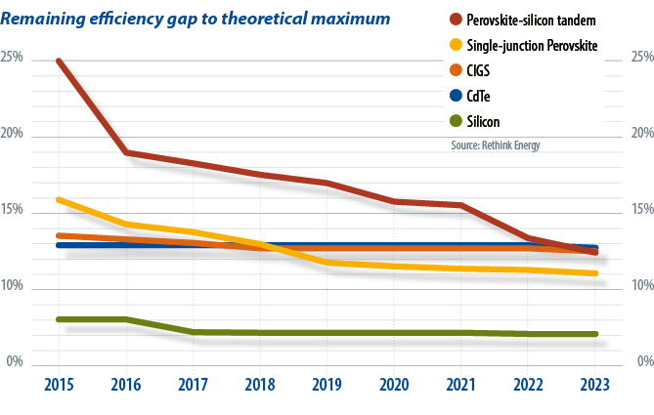

*Image: PV Magazine,* [*https://www.pv-magazine.com/2023/10/31/commercial-perovskites-imminent/*](https://www.pv-magazine.com/2023/10/31/commercial-perovskites-imminent/)

**PERC Solar Cells Technology**

PERC stands for passivated rear emitter contact solar cell, and in this cell both the front and rear surfaces of the device are passivated by dielectrics. Small pockets of the rear dielectric layer are opened (etched away) with laser so that metal can be contacted to the rear surface of the device. Compared to a conventional Si solar cell, PERC is able to improve the efficiency of Si solar cells mainly due to the additional passivating dielectric layer on the rear side. Rear side passivation prevents minority carriers (current generated from light absorption) from recombining (eliminated) at the rear surface. Also, the extra rear dielectric layer reflects long wavelength photons from the rear surface back to the device for more light absorption and current generation.

Figure 1, The solar cell is based on p-type Si wafer. The front surface (emitter) is passivated by dielectrics such as SiNx, which also act as an antireflection layer. The rear surface of the Si wafer, however, is not passivated by any dielectric. Aluminium (Al) is being doped into Si to form a back surface field (BSF) during metal co-firing process to act as a high-low junction that prevent minority carriers from recombining at the rear surface.

**Figure 1: A conventional Si solar cell**

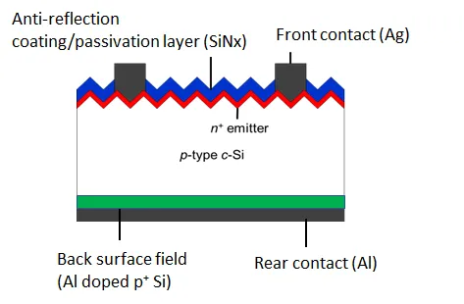

*Image: Keng Siew Chan (2019)* [*https://medium.com/@kengsiewchan/perc-solar-cells-3eb275804ded*](https://medium.com/@kengsiewchan/perc-solar-cells-3eb275804ded)

**Figure 2: A typical PERC solar cell**

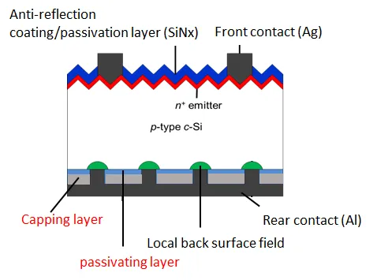

*Image: Keng Siew Chan (2019)* [*https://medium.com/@kengsiewchan/perc-solar-cells-3eb275804ded*](https://medium.com/@kengsiewchan/perc-solar-cells-3eb275804ded)

**PERT Solar Cells Technology**

The PERT solar cell, like the PERC solar cell, is also based on crystalline Si wafers. PERT stands for passivated emitter rear totally diffused. PERC (passivated emitter restructure has a localised back surface field(BSF). The BSF is created from the doping of Al into Si during metal co-firing processes. BSF helps to improve the solar cell efficiency by forming a high-low junction with the p-type Si base wafer. This junction repels minority carriers and prevent them from recombining at the rear surface of the Si wafer. On the other hand, for PERT structure, the rear surface is “totally diffused” with either boron (p-type) or phosphorus (n-type). Usually PERT technology is implemented on n-type Si solar cells. This is to take full advantage of n-type Si wafers’ higher tolerance to metallic impurities, lower temperature coefficient and lower light induced degradation than p-type Si wafers. The light induced degradation is lower in n-type Si, possibly due to lower boron-oxygen pairs, as the bulk in n-type wafer is doped with phosphorus. Nevertheless, the “totally diffused” BSF requires additional novel processes, such as high temperature POCL and BBr3 diffusion. As a result, PERT is more expensive to manufacture than PERC. Nonetheless, the full area BSF in PERT solar cells may provide more effective high-low junction passivation effect, than the localised, coarser Al based BSF in PERC. In addition, n-type PERT also allows the integration of the so-called tunnel oxide passivated contact (TOPCON) structure.

**Figure 1 shows the difference between a p-type PERC and a n-type PERT structure**

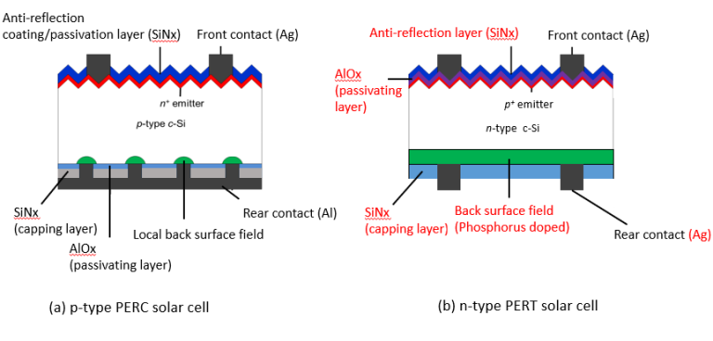

*Image: Keng Siew Chan (2019)* [*https://www.kschan.com/what-is-a-pert-solar-cell/*](https://www.kschan.com/what-is-a-pert-solar-cell/)

**TOPCON Solar Cells Technology**

TOPCON stands for “Tunnel Oxide Passivated Contact”. TOPCON (also known as passivated contact) solar cell, is the next generation of solar cell technology after PERC, and TOPCON can be upgraded from the current PERC or PERT line. To upgrade an n-PERT solar cell to a n-TOPCON solar cell, only an additional ultra thin ${SiO}_{2}$ layer and a doped poly-Si layer are required. The ultrathin ${SiO}_{2}$ acts as a surface passivation layer between the rear Si surface and the rear contact, the poly-Si layer. In addition, the ${SiO}_{2}$ layer also needs to be thin enough so that current can tunnel through it quantum mechanically. The poly-Si layer is highly doped to produce a high conductivity layer. This high conductivity layer will then acts as a contact for current collection. Additionally, in a n-type TOPCON, the poly-Si layer is typically doped with phosphorus to provide field passivation (back surface field). This is similar to the phosphorus doped rear surface of n-PERT.

TOPCon cells can be used to provide inference into the grid’s transparency, as due to the long minority carrier diffusion length of the emitter, TOPCon cells are ideally suited as an electrically active detector. Ag NW networks have superior optoelectronic and mechanical properties compared to indium tin oxide (ITO) for cell electrodes, and these Ag NW wires will be particularly useful in thin film-based solar cells, where light trapping is more challenging and carrier diffusion lengths are smaller. A TOPCon cell was developed by Bleiji et al. (2025) that utilizes silver nanowire (Ag NW) grids, grown by nanoimprint lithography and room-temperature light-driven electrochemical deposition as opposed to indium tin oxide, as transparent electrodes (Bleiji et al., 2025; Bellini, 2024B).

1 µm copper (Cu) plating layers on the front silver grid of screen-printed tunnel oxide passivated contact (TOPCon) solar cells can create a protective barrier that reduces corrosion susceptibility and produces less contaminant-induced degradation. This method enhances the reliability and durability of TOPCon cells under damp heat (DH) and field-like conditions, and also results in reduced silver consumption and a lower levelized cost of electricity (LCOE). Plated-Cu contacts capped with silver (Ag) or tin (Sn) are used to prevent contaminants from infiltrating the contacts themselves and causing oxidation, as well as to improve the soldering process in TOPCon cells. Furthermore, scanning electron microscopy (SEM) and energy-dispersive X-ray spectroscopy (EDS) analysis confirmed that Cu plating filled voids in the silver contact, creating a denser, more robust interface that prevents contaminant penetration and reduced parasitic recombination (Wang et al., 2025A; Bellini, 2025N).

Research on PID testing and the prediction of power degradation in modules under illuminated conditions remains limited. Field degradation can be predicted from potential induced degradation (PID) and light exposure for tunnel oxide passivated contacts (TOPCon) double-glass module configuration with double ethylene vinyl acetate (EVA) as an encapsulant. This new methodology is based on the Arrhenius equation, which is an empirical equation that describes the effect of temperature on the velocity of a chemical reaction, which is the basis of all predictive expressions used for calculating reaction-rate constants. The equation can be used to fit the power degradation in terms of PID date from a steady-state test chamber under illumination (Li et al., 2025; Bellini, 2025P).

Tong et al. (2025) suggests that the silicon nitride (SiNx) layers used in TOPCon cell rear-side are particularly prone to chemical degradation from sodium (Na) contaminants, or sodium-induced degradation under damp-heat exposure, which can lead to significant open-circuit voltage losses and reduced cell efficiency. Tests showed that two sodium contaminants, CH3COONa and sodium chloride (NaCl), were responsible for significant performance losses. A fix to address the analyzed degradation mechanisms is introducing on the cell front side a 10 nm aluminum oxide (AlOx) barrier layer, deposited via atomic layer deposition (ALD), to protect against contaminant diffusion (Tong et al., 2025; Bellini, 2025U)

A tunnel oxide passivated contact (TOPCon) solar based on aluminum (Al) contacts placed on the rear side has been built with an aluminum contact manufacturing process that reportedly does not compromise the surface passivation quality of underlying silicon oxide layers, that is aimed at replacing expensive silver (Ag) pastes used for cell contacts with low-cost aluminum, which can be seamlessly integrated into the existing industrial screen-printing infrastructure and is already well-established in solar cell manufacturing. Al pastes cost approximately $3–7/kg, which is more than 100 times cheaper than silver (Ag) pastes and significantly cheaper than emerging copper (Cu) pastes. Al contacts were prepared with a laser contact opening (LCO) tool and were then screen-printed with a conventional Al paste. Although the laser ablation step involves additional capex (capital expenditure) and opex (operational expenditure), many manufacturers already operate laser contact opening (LCO) tools for PERC cell production. The process was implemented without compromising the surface passivation quality of underlying silicon oxide (poly-Si/SiOx) layers and with the Al fingers being printed and fired with the aluminum paste on the rear surface of the cells. Although the Al particles penetrated deeply into the poly-Si layer, they did not reach the poly-Si/SiO2 interface, preserving the surface passivation (Cheng et al., 2025; Bellini, 2025V).

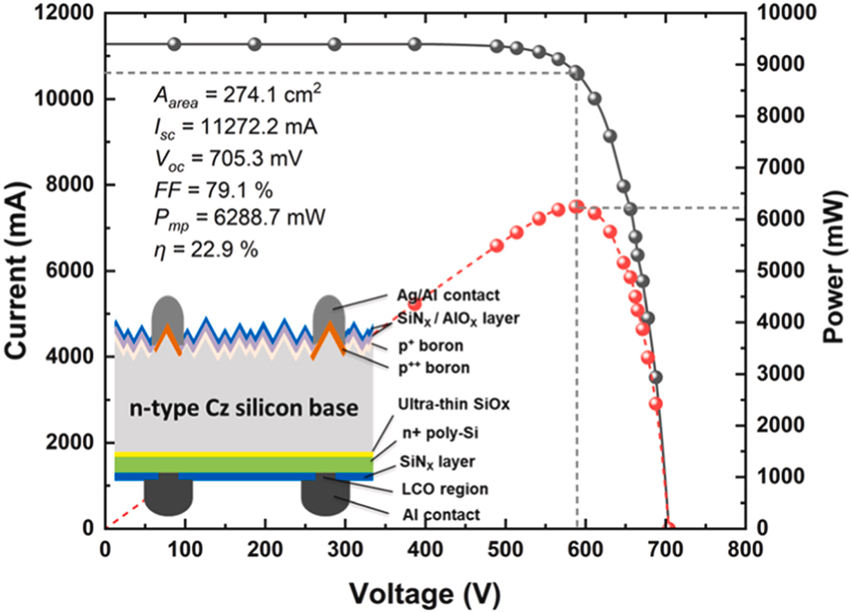

Cheng, Y., Zhang, Y., Xu, Y., et al. (2025) Integration of aluminum contacts in TOPCon solar cells: A pathway to reduce silver usage, Solar Energy Materials and Solar Cells, Volume 285, 113559, <https://doi.org/10.1016/j.solmat.2025.113559>

**Figure 1. n-PERT compared to n-TOPCON solar cell architectures**

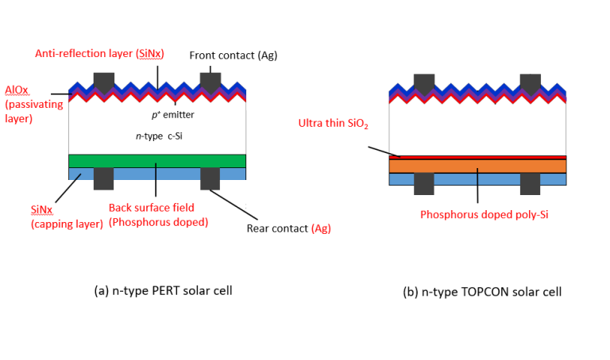

*Image: Keng Siew Chan (2019)* [*https://www.kschan.com/what-is-a-topcon-solar-cell/*](https://www.kschan.com/what-is-a-topcon-solar-cell/)

**HJT Solar Cells Technology**

HJT stands for hetero-junction solar cells, and due to HJT’s fewer number of cell processing steps, and a much lower cell processing temperatures, this architecture has the potential to simplify the current solar cell manufacturing lines that are currently heavily based on PERC technology. HJT cells are also known as Silicon heterojunctions (SHJ) or Heterojunction with Intrinsic Thin Layer (HIT). HJT is very different from the conventional PERC structure, and as a result, HJT requires significant capital investment in new equipment to start mass production. HJT demonstrates high solar cell efficiency thanks to the high quality hydrogenated intrinsic amorphous Si (a-Si:H) that can provide impressive defect passivation to both the front and rear surface of Si wafers (both n-type and p-type polarity). The use of ITO as transparent contacts also improves current flows, while also acting the anti-reflection layer to provide optimal light capturing. Moreover, ITO can also be deposited via sputtering at low temperature, thus avoiding the re-crystallisation of the amorphous layer that will impact the passivation quality of the materials on the bulk Si surface. HJT combines thin film with traditional silicon technology, and HJT cells are made of three layers of photovoltaic material. The top layer is amorphous silicon, which catches sunlight before it hits the crystalline layer. The middle layer is monocrystalline silicon, which turns most of the sunlight into electricity. The bottom layer is another amorphous silicon layer, which captures any remaining photons. HJT cells possess a superior temperature coefficient, as HJT cells are less affected by changes in temperature, and they have a high bifacial rate, as they can absorb sunlight from both the front and back sides.

In investigating the impact of sodium(Na)-induced moisture degradation in heterojunction (HJT), or silicon heterojunction (SHJ), solar cells under accelerated damp-heat testing, three different types of sodium salts, sodium bicarbonate (NaHCO₃), sodium chloride (NaCl), and sodium nitrate (NaNO₃) were used, to study Na-induced degradation and its interactions with environmental anions and material compositions, such as transparent conductive oxide (TCO) layers and metal contacts, to identify recombination issues and other degradation pathways (Wu et al., 2025A; Bellini, 2025A).

In an experiment conducted on bifacial half-cut n-type silicon HJT solar cells, solar modules with glass-backsheet configurations, researchers identified four failure modes in the silicon heterojunction glass-backsheet (Sen et al., 2023; Bellini, 2023G). To build heterojunction (HJT) solar cells built with ultrathin wafers, a direct gas-to-wafer process could be a full replacement for conventional Czochralski (CZ) wafers, eliminating the saw damage etching process step in cell production, with the oxygen content of these wafers being 20 times lower than conventional CZ wafers, which enables thermal stability and helps improve cell performance (Bellini, 2024D). N-type fully passivated HJT solar cells can be made using a phosphorous-doped CZ-type silicon wafer substrate, thin-film backside full passivation technology, ultra-fine line printing technology, and multi-frequency radio frequency processes, to optimize the doped microcrystal system (Foley, 2024A).

Direct wire bonding (DWB) can be used to reduce silver consumption in heterojunction solar cells, as a low-temperature method for interconnecting finger-free heterojunction (HJT) solar cells on the front side using low-cost, highly conductive copper (Cu) wires, whereby low-cost copper wires on HJT solar cells are utilized as electrodes with conductive paste applied in discrete pads to replace the traditional metallization and interconnection process. In this process, the paste is cured at low temperatures during the lamination process, making it suitable for heterojunction and perovskite-silicon tandem solar cells. Despite the slightly lower efficiency, the proposed cell configuration offers considerable advantages in terms of paste consumption, comparable to that of modules with the lowest usage 0BB solution. DWB offers superior cost savings by eliminating the need for interconnect material (Liu et al., 2025A; Bellini, 2025C).

In terms of the impact of soldering flux on heterojunction solar cells, the composition of this component is key to prevent major cracks and significant peeling. HJT solar cells are sensitive to soldering flux-induced degradation, particularly in metallization and the ITO layer. According to Wang et al. (2025B), pre-existing pores, or holes, in the silver metallization layer allow flux penetration, which leads to chemical reactions that degrade contact integrity and subsequent power losses in HJT cells. Also, the indium tin oxide (ITO) layer in HJT cells is highly susceptible to damage from soldering flux, with degradation leading to an increase in contact resistivity on both the front and rear surfaces and damage/corrosion to the ITO layers and metal contacts, resulting in a pronounced rise in series resistance, along with peeling in some ITO regions and cracking in the metal electrodes. Pre-existing pores or holes in the metal electrode likely allowed the soldering flux to penetrate and chemically react with Ag particles and binder resin, exacerbating the cracking after dry heat exposure (Wang et al., 2025B; Bellini, 2025M).

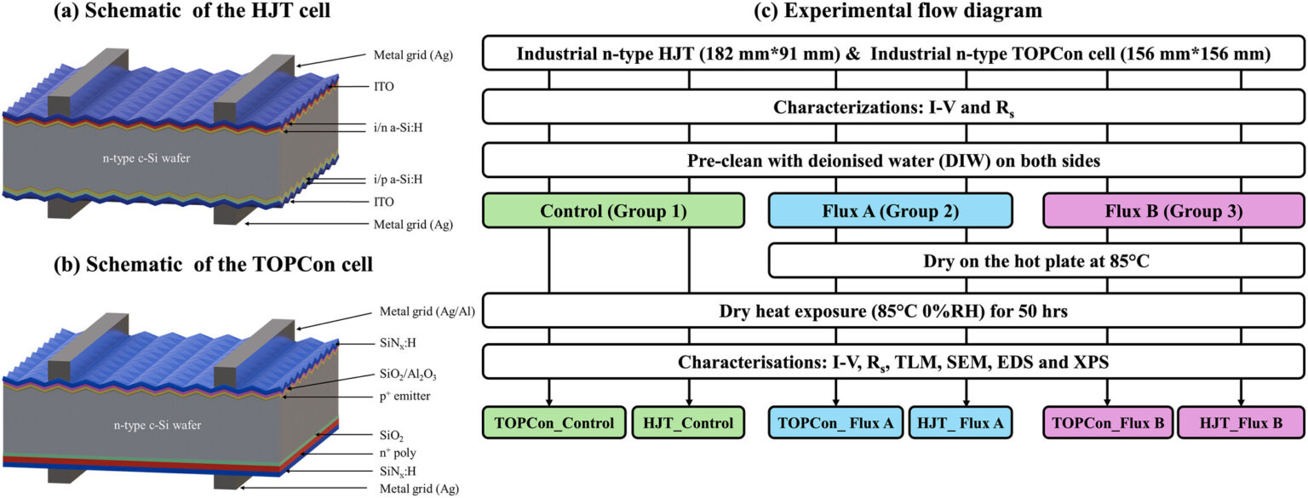

*Image: UNSW, Progress in Photovoltaics, CC BY 4.0*

*Wang, H., Sen, C., Fu, J., Khan, M., Song, H., Lv, R., Conibeer, G. and Hoex, B. (2025B), The Influence of Soldering Flux on Stability of Heterojunction and TOPCon Solar Cells, Progress in Photovoltaics: Research and Applications,* [*https://doi.org/10.1002/pip.3896*](https://doi.org/10.1002/pip.3896)

HJT cells, with their unique structural advantages, are considered the ultimate choice among single p/n junction technologies for future solar cell development, including in the realm of perovskite-silicon tandem cells. Heterojunction cells use indium tin oxide (ITO) as a transparent conductive layer, while other cells like BC, TOPCon, and PERC rely on insulating layers. This design allows for easier integration of tandem cells, enhancing overall performance, which also claims that other silicon-based cells, which lack ITO films, require entirely new structural designs for tandem technology, increasing both costs and complexity (Shaw, 2025).

**Figure 1: p-type PERC vs n-type HJT solar cell**

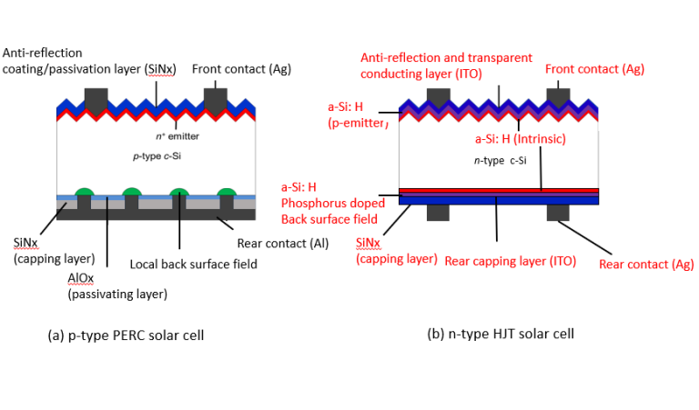

*Image: Keng Siew Chan (2019)* [*https://www.kschan.com/what-is-a-hjt-solar-cell/*](https://www.kschan.com/what-is-a-hjt-solar-cell/)

**Heterojunction v. Multijunction**

Ji, R., Zhang, Z., Hofstetter, Y.J. et al. Perovskite phase heterojunction solar cells. Nature Energy 7, 1170–1179 (2022). <https://doi.org/10.1038/s41560-022-01154-y>

Heterojunction refers to a junction formed between two different semiconductor materials with different bandgaps, while a multijunction describes a solar cell made up of multiple junctions, often stacked on top of each other, and "tandem" is essentially another term for a multijunction cell, particularly when referring to a two-junction configuration where different layers absorb different wavelengths of light to maximize efficiency. A heterojunction is about the interface between two different semiconductors, while multijunction/tandem is about the overall structure of a solar cell with multiple junctions made from different materials. Heterojunction focuses on the contact point between two different semiconductor materials, creating a unique electrical behavior due to their different bandgaps. Multijunction describes a solar cell with multiple p-n junctions, meaning multiple layers of different semiconductor materials stacked together to absorb a broader range of light wavelengths. Tandem is often used interchangeably with "multijunction," but specifically refers to a two-junction configuration where the stacked layers are designed to absorb different light energies, maximizing efficiency. For example, a solar cell could utilize a heterojunction between a wide bandgap material like gallium arsenide and a narrower bandgap material like indium phosphide to create a multijunction/tandem cell, where the different layers absorb different portions of the light spectrum.

**Heterojunction Perovskite**

Heterojunction perovskite solar cells (PSCs) are photovoltaic devices that use a combination of semiconductor layers to generate, separate, and transport photocarriers. In graded heterojunction cells, the electron-accepting material is distributed in the perovskite layer to improve photoelectron collection. In facet heterojunction cells, two films with distinct crystal facets are integrated to create junctions that enhance device performance. The introduction of phase heterojunctions can improve the stability and efficiency of PSCs. Heterojunctions improve PSCs by reducing defects in the reduction of the formation of crystal interface defects. Heterojunctions can improve and tune energy levels into perovskites. Heterojunctions can improve the power conversion efficiency (PCE) of PSCs. Perovskite-silicon tandem solar cells use a bottom cell based on a heterojunction design. Facet heterojunction solar cells combine the advantages of (001) and (111) facet orientations of perovskite. Bilayer heterojunction (BLH) cells reconstruct the perovskite surface into a BLH structure to minimize voltage losses. Bulk heterojunction PSCs are made with thin films that combine 2D and 3D perovskites.

**Back-Contact Micrometric Photovoltaic Cells**

Back-contact micrometric photovoltaic cells have a size twice the thickness of a strand of hair, have significant advantages over conventional solar technologies, reducing electrode-induced shadowing by 95% and potentially lowering energy production costs by up to three times (de Lafontaine et al., 2023; Rizk, 2023).

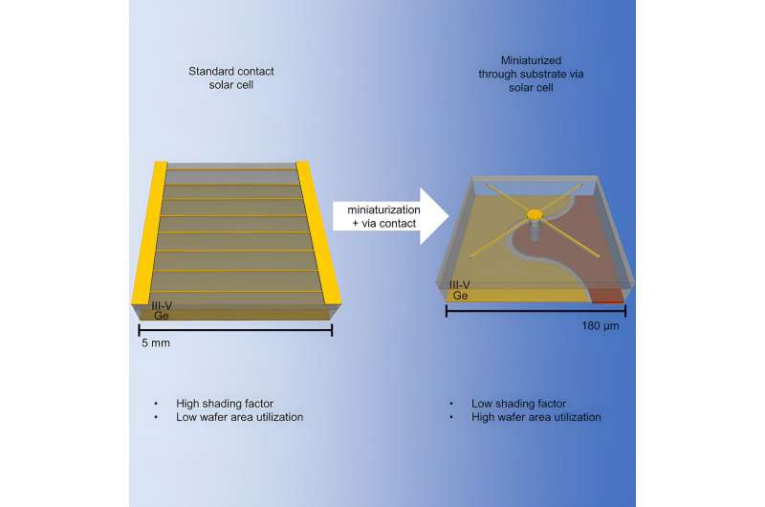

*Image: Rizk, B. Cell Reports Physical Science (2023). DOI: 10.1016/j.xcrp.2023.101701*

<https://techxplore.com/news/2023-11-back-contact-micrometric-photovoltaic-cells.html>

**Dye-sensitized Solar Cells (DSSC)**

Dye-sensitized solar cells (DSSC) are the thin-film solar cells also known as Grätzel cells, which convert light into electricity through photosensitizers. The DSSC dye compounds absorb light and inject electrons into an array of oxide nanocrystals, which are then collected as electric current. The photosensitizers are attached to the surface of nanocrystalline mesoporous titanium dioxide films, which are saturated with redox-active electrolytes or a solid charge-transport material. The entire design aims to generate electric current by moving electrons from the photosensitizer to an electrical output such as a device or storage unit. Dye concentrators can improve PV cell field, with one such device utilizing a tinted and luminescent acrylic glass known as polymethyl methacrylate (PMMA) to increase power generation by 1.21% (Brągoszewska et al., 2024; Bellini, 2024E).

**III-IV Solar Cells**

The III-V cells derive their name from where the materials used to make them are positioned on the periodic table of elements and are widely used to power space-faring technologies. D-HVPE offers the potential to be a lower-cost method of synthesizing these cells compared to incumbent techniques. Solar cells manufactured from GaAs and gallium indium phosphide (GaInP) have long yielded some of the highest conversion efficiencies of any technology. The challenge with these cells is bringing down production costs to make them viable for mainstream solar applications (Schulte et al., 2023; Bellini, 2023B).

Scientists at the U.S. Department of Energy's National Renewable Energy Laboratory (NREL) grew a gallium arsenide (GaAs) heterojunction solar cell using dynamic hydride vapor phase epitaxy (D-HVPE) with a certified efficiency of 27%, the highest efficiency ever reported for a single-junction GaAs cell grown using this technique, published in *Cell Reports Physical Science*. To synthesize the solar cell, they used dynamic hydride vapor phase epitaxy (D-HVPE) as an alternative lower-cost solution to metal organic vapor phase epitaxy (MOVPE). HVPE uses low-cost elemental group III precursors with high utilization efficiency and very high growth rates. The study aims to improve the performance of solar cells via optimization of the doping and bandgap of a device layer called the "emitter" to minimize the impact of defects on device efficiency. The results are theoretically applicable to materials beyond III-Vs that use heterojunctions such as silicon, cadmium telluride, or perovskites (Schulte et al., 2023; Bellini, 2023B).

Along with the GaAs base layer, the solar cell relied on an emitter layer of gallium indium arsenide phosphide (GaInAsP). Together the two different layers make up the heterojunction. Researchers modeled the effect of varying the zinc doping density and bandgap of the emitter layer, which is realized by varying the relative concentrations of gallium, indium, arsenic, and phosphorus during layer growth, on cell efficiency. The modeling identified optimal choices for these two parameters that maximize device efficiency. The rear heterojunction solar cell that served as a baseline used an emitter comprised of GaInP and had a reported efficiency of 26%. By reducing the doping in the emitter and changing its composition from GaInP to the lower bandgap GaInAsP, the efficiency increased to 27% even though the rest of the device was exactly the same (Hicks, 2023). For processing, a reflective Au metal contact was electroplated onto the AlGaAs contact layer, and then samples were inverted onto a Si handle, and the substrate was etched away followed by the etch stop (Schulte et al., 2023; Bellini, 2023B).

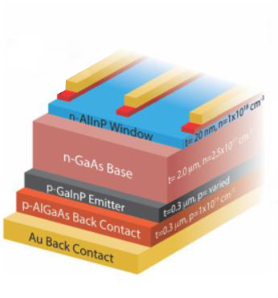

*Image: PV Magazine,* [*https://www.pv-magazine.com/2023/11/10/nrel-presents-new-gaas-solar-cell-concept-with-27-efficiency/*](https://www.pv-magazine.com/2023/11/10/nrel-presents-new-gaas-solar-cell-concept-with-27-efficiency/)

**Bifacial Solar Cells**

Dutch researchers researched the effect rear irradiance has on the optimal bandgap energy and thickness of the perovskite cell in a bifacial two-terminal perovskite-silicon tandem module. Their findings show that bifacial tandems have over a 25% gain in energy yield compared to bifacial single junction modules and up to 5% gain compared to monofacial tandem modules. The research group used a reference 32.5%-efficient perovskite-silicon tandem cell developed by German research center Helmholtz-Zentrum Berlin (HZB) to optimize the design of a perovskite cell in a bifacial monolithic 2T tandem module under various conditions. The reference cell was adjusted by reducing the wafer thickness and adding glass and encapsulation, and the bifacial modules were created by removing the silver layer and adding a second encapsulant layer. The simulations were conducted via the PVMD Toolbox, which is a comprehensive modeling software to simulate building-integrated and tandem PV systems. The Advanced Semiconductor Analysis (ASA) was used to calculate the electrical properties of the cells and the calibrated lumped element method (CLEM) was utilized for energy yield simulations (Blom et al., 2025; Bellini, 2025F).

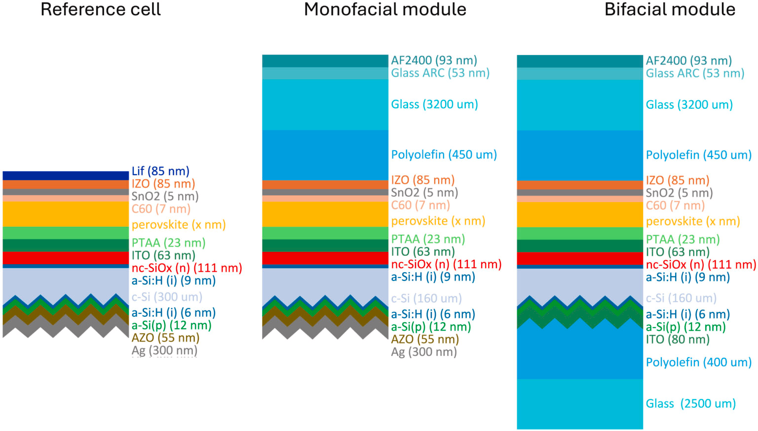

The bifacial perovskite/silicon cell structure used in the simulations

*Image: TU Delft, Solar Energy Materials and Solar Cells, CC BY 4.0*

*Blom, Y., Vogt, M.R., Isabella, O., and Santbergen, R. (2025) Optimization of the perovskite cell in a bifacial two-terminal perovskite/silicon tandem module, Solar Energy Materials and Solar Cells, Volume 282, 113431,* [*https://doi.org/10.1016/j.solmat.2025.113431*](https://doi.org/10.1016/j.solmat.2025.113431)

To construct a transparent electrode for bifacial solar cells, Rani et al. (2025) employed a technique called low-energy physical vapor deposition, where materials are vaporized in a vacuum chamber and then condensed onto a surface, forming thin, uniform layers (Rani et al., 2025).

BPvSC (bifacial perovskite solar cell), bifacial solar cells, solar cells with two faces, can capture more sunlight than ever and they can even be put on transparent glass windows. However, bifacial solar cells are not widely used because they require transparent electrodes to conduct electricity while allowing light to pass through. This transparent electrode material needs to be durable, stable, efficient, and affordable. Bifacial solar cells could be used in industrial and agricultural setups, such as they can be integrated into greenhouses and transparent windows of houses and large buildings. The performance of the device begins to decline after 2 weeks, which is typical with PvSCs (Rani et al., 2025; Brahambhatt, 2025). One such transparent electrode is made of two layers of nickel oxide (NiO) and one layer of silver (Ag), to form a three-layer Nio/Ag/Nio (NAN) structure, resulting in an electrode less than 40 nanometers thick. A 40 nanometers thick design could be used in building materials and combined with other types of solar cells. Previous transparent electrode designs for bifacial solar cells have used materials such as indium tin oxide (ITO) that are expensive and fragile, and require special treatment to become durable and flexible. NAN has no such requirements and is comparatively cheaper (Rani et al., 2025; Brahambhatt, 2025).

According to Indian researchers, bifacial perovskite solar cells, for applications in either tandem or single-junction PV devices, can achieve a 2% higher power conversion efficiency with a tilt angle of 20 degrees. They conducted a quantitative analysis of optimal values for albedo and tilt angle in bifacial perovskite solar cells and have found that enhancing the rear-side albedo to 0.5 and using a tilt angle of 20 degrees results in the highest efficiency levels, using Lambertian reflection effects through tilt angle arrangements and bottom albedo illuminations. The core component of their bifacial solar cells is the transparent back contact made of indium zinc oxide (IZO), which they claim has excellent conductivity, high mobility, and optimum transparency. The bifacial perovskite cell was designed to have a transparent fluorine-doped tin oxide (FTO) substrate, an electron transport layer (ETL) made of tin oxide (SnO2), a perovskite absorber, a hole transport layer (HTL) relying on spiro-OMeTAD and molybdenum oxide (MoOx), the IZO layer, a molybdenum oxide (MoOx) (Paul et al., 2024; Bellini, 2024U).

**Ultrathin Cells**

An ultrathin perovskite solar cell was developed by Chinese researchers that uses a back mirror based on silver, a Gires-Tournois resonator, to improve light harvesting and absorption, by optimizing light capture and utilization while improving light absorption capacity. Gires-Tournois resonators are optical standing-wave resonators designed for generating chromatic dispersion, and are based on a reflective metal mirror and are primarily used in chirping applications such as pulse compression. Ultrathin perovskite cells, which reduce manufacturing costs and lead content, require the use of vacuum deposition techniques to achieve the desired efficiency levels in commercial production. The cell achieves an average absorptivity of approximately 85%, due to an increase in light absorption in the wavelength range of 400-800 nm, which would result in a significant enhancement in the incident photon current efficiency (IPCE) attributable to pronounced light-matter interference effects between the perovskite absorber and the metal mirror, with a conversion efficiency of ultra-thin perovskite solar cells can even reach about 27% (Dou et al., 2024; Bellini, 2024Q).

**Transition Metal Dichalcogenide (TMD) Solar Cells**

Transition metal dichalcogenide (TMD) solar cells can be used for light harvesting in indoor environments to power internet of things (IoT) devices and sensors. TMDs are two-dimensional layered materials, like WSe2 and MoS2, with good semiconducting properties and high optical absorption coefficients, suitable for the production of semi-transparent and flexible solar cells with potential applications in aerospace, architecture, electric vehicles, and wearable electronics, where light weight, a high power-per-weight ratio, and flexibility are very desirable (Nitta et al., 2025; Bellini, 2025W).

**Crystalline Silicon Solar Cells**

<https://www.solar-eng.com/silicon-solar-cells> electrodes

Monocrystalline, made from a single crystal of silicon, which gives it a uniform dark appearance and rounded edges, is the most efficient and popular type of solar cell and was first invented in 1955. Polycrystalline is made from many silicon crystals melted together, giving it a grainy texture and bluish hue, and is less efficient than monocrystalline, but more affordable, and entered the market in 1981. Thin film silicon cells can be made from a variety of materials, including amorphous silicon, cadmium telluride, and copper indium gallium selenide, were originally developed for space applications because of their power-to-weight ratio, and are more versatile than other types of solar cells because of their flexibility. Amorphous silicon requires less silicon than conventional solar panels and doesn't require as many toxic materials to build.

For mainstream solar power generation, technologies that cannot operate for more than two decades are unlikely to succeed, regardless of other benefits. For commercial, grid-level electricity production, SETO is targeting an operational lifetime of at least 20 years, and preferably more than 30 years. Crystalline silicon PV cells are the most common solar cells used in commercially available solar panels, representing more than 85% of world PV cell market sales in 2011. Crystalline silicon PV cells have laboratory energy conversion efficiencies over 25% for single-crystal cells and over 20% for multicrystalline cells. However, industrially produced solar modules currently achieve efficiencies ranging from 18%–22% under standard test conditions. Current research efforts focus on innovative ways to reduce costs. Research and development is being done to reduce raw material requirements, including pioneering ultra-thin crystalline silicon absorber layers, developing kerf-free wafer production techniques (kerf is silicon dust that is wasted when silicon ingots are cut into thin wafers), and optimizing growth processes. Commercial silicon cells are typically larger than an A5 sheet of paper, and these are assembled into 2-meter-long modules, the building blocks of larger panels and arrays, that have an efficiency of around 22–24%. The modules typically come with a warranty that guarantees at least 80% of their original performance after 25 years — that is, a loss of less than 1% efficiency per year (Peplow, 2023).

Conventional silicon solar panel manufacturing begins with the mining and refinement of raw polysilicon. The polysilicon is then made into polysilicon ingots, which are then sliced into thin photovoltaic wafers. These wafers are then manufactured as cells and integrated into a frame as a final solar panel (known as a module).

For both multicrystalline and monocrystalline silicon photovoltaic applications, oxygen is a key impurity issue. For example, it can cause silicon oxide formation, which increases the hardness of crystals, which can complicate downstream processing (Dezfoli, 2025; Thompson, 2024K).

A light upconversion system, consisting of a multiband near-infrared (NIR) upconversion (UC) system to enhance light harvesting in silicon solar cells (SSCs), has been developed that can reportedly improve crystalline silicon solar cell efficiency by up to 0.87%, which consists of multilayer lanthanide (Lb) and ytterbium (Yb) doped upconversion nanoparticles (UCNPs), which can capture NIR energy in a broad range of 1,100 to 2,200 nm, that act as near-infrared absorbers across different spectral ranges by converting low-energy photons in the infrared range into higher-energy photons in visible light. This device collects more of the NIR energy in sunlight by SSCs by integrating multiband NIR responsive core-shell UCNPs. The system also contains holmium ion (Ho³⁺), erbium ion (Er³⁺), and thulium ion (Tm³⁺), which are all Ln activator ions. Using a solvothermal method, they were all synthesized to create core-shell-shell-shell (CSSS) nanocrystals. Yb³ was introduced to all layers of the CSSS, and the team found it to “serve as a highly efficient electron pump, in synergistic action with the long-wavelength excitation NIR light, and simultaneously acts as a two-photon UC emitter (Wang et al., 2024B; Kahana, 2024).

**Oxygen Impurities**

Taiwanese researchers have developed a heater design in the Czochralski silicon crystal growth process that can control and decrease oxygen concentration without incurring the costs associated with other methods, such as installing magnets or using alternative crucible materials. As certain oxygen defects reduce the bulk lifetime and enhance recombination activity at dislocations, the team focused on controlling, mainly reducing, the oxygen impurity by modifying the heater design in the Czochralski (CZ) puller, as an oxygen reduction of 6 Ppm atoms could be achieved by “simply altering” the heater design configuration (Dezfoli, 2025; Thompson, 2024K).

Researchers used a lifetime-equivalent defect density standard known ΔNleq to quantify the impact of observed defect kinetics during light and elevated temperature induced degradation (LeTID). In investigating the impact of gettering on impurity concentrations on light- and elevated temperature-induced degradation (LeTID) in industrial recharged Czochralski-grown silicon (RCz-Si) gallium-doped p-type silicon ingots, researchers have found that defect density depends on impurity concentrations in the melt, which are observed in the case of interstitial iron concentrations. Gettering is a technique used in the PV manufacturing industry during crystal growth to remove containments and other forms of defects in wafers, and involves three steps. In gettering, the impurities are initially released into a solid solution, then undergo diffusion through the silicon, and then they are trapped in an area away from the active circuit regions of the wafer. Gettering is embedded in most of the current solar cells, through phosphorus diffusion in PERC or PERx devices, as well as in Al-BSF cells, is also embedded in TOPCon solar cells with varying effectiveness, and in silicon heterojunction cells it can be used as a pre-treatment to improve the quality of silicon substrates (Kamphues et al., 2025; Bellini, 2025O).

Researchers have investigated through electrical simulations how carrier-selective contacts (CSCs) may lead to stronger performance in in front/back-contacted (FBC) and interdigitated back-contacted (IBC) crystalline silicon (c-Si) solar cells, considering the work function, energy barriers, and energy alignment across the stack of layers. This methodology extends beyond c-Si solar cells and is applicable to tandem solar cells and other electronic devices. Advancements in patterning technology are critical for achieving greater efficiency in c-Si solar cells and FBC-SHJ solar cells, enabling narrower lines and localized contacts in FBC and IBC architectures. The Poisson equation, an elliptic partial differential equation used in theoretical physics, can be used to show how three factors determine why CSCs are a critical component to achieving higher efficiency. The first factor is the difference in work function between the substrate and the deposited material, as we need to determine whether CSCs work better as an electron contact by an electron transport layer (ETL) or a hole contact by a hole transport layer (HTL). The work function would establish the electric field in the absorber bulk, with a lower work function in the deposited layer designating the ETL and the higher defining the HTL. Second, energy barriers at the absorber bulk interface, which refer to energy alignment between occupied and available energy states at both sides of the barrier and effectively hinder the transport of unwanted charge carriers and enhance the functionality of CSCs. Key to the barriers' creation are the energy band offset, the Fermi level and the thickness of deposited layers. The energy level is either high or low, and the width of the energy barrier is either thick or thin. Efficient charge collection occurs when the energy barriers in the conduction or valence bands are low and thin, allowing efficient transport of electrons or holes in the n- or p-contact, respectively. Since CSCs are designed to selectively collect only one type of charge carrier, it is desirable to have high and thick barriers in the valence or conduction bands at the n- or p-contacts, respectively. As for energy alignment, energy states are crucial for the collection of charge on the other side of the energy barrier, as the energy states at the bulk interface are mostly occupied by collecting carriers (Procel-Moya et al., 2025; Bellini, 2025Q).

Zhang et al. (2025A) developed a silver-lean screen-printing metallisation technique that can significantly reduce silver (Ag) usage by 85% in TOPCon solar cells without impacting device efficiency and performance. In this technique, the commonly used Ag fingers are replaced with intermittent Ag dashes for contact formation and Ag-free fingers and busbars for electrical conduction. This dual-layer configuration addresses the main challenges associated with using silver-lean paste materials in silicon solar cells by avoiding the formation of direct metal/Si interfaces with those alternative pastes. The novel two-step printing process is implemented first by printing conventional silver pastes as seed layers and then by printing the silver-lean fingers on top. With this configuration, the silver-lean fingers are intended for electrical conduction only, with the metal/Si interfaces being no longer essential for this purpose (Zhang et al., 2025A; Bellini, 2025HH).

Smits et al. (2025) developed a rear junction silicon heterojunction (RJ-SHJ) solar cell with a localized front carrier-selective passivating contact that covers only the area contacted by the metal grid, which improves the cell’s short-circuit current density enabling higher power conversion efficiency. Omitting the transparent contact oxide (TCO) at the front or localizing it by deposition through a hard mask leverages the front metal grid as a mask for local etching, with the TCO and n-doped layers being selectively etched from the window openings. Hydrogenated nanocrystalline silicon (nc-SiOx:H) was used as the front contact without introducing resistive losses or damaging the surface passivation, which can affect fill factor and open-circuit voltage. A double-layer anti-reflective coating consisting of silicon nitride (SiNx) and magnesium fluoride (MgF2) was deposited. The front TCO provides lateral transport of charge carriers, and also acts as an anti-reflecting coating (ARC) mitigating the large difference of refractive index between silicon and air, with the removal of the TCO from the window openings is compensated by the deposition of alternative anti-reflective layers that are optically more favorable. The conservation of fill factor in the localized front contact solar cells allows for low contact resistance (n)-type carrier-selective passivating contacts enabling high-efficiency front/back-contacted (FBC) HJT solar cells that can reduce indium consumption and improve resilience against ultraviolet-induced degradation (UVID) (Smits et al., 2025; Bellini, 2025BB).

**Cadmium Telluride Solar Cells**

Cadmium telluride solar cells are the second-most common type of solar cell deployed in the world behind crystalline silicon photovoltaic cells, though with just 5 percent of the market share. Commercial CdTe solar cells, which are largely used in large commercial solar farms, have comparable efficiencies to silicon cells, and CdTe is the preferred material for most ultra-thin solar film products. CdTe thin-film solar cells can be manufactured quickly and inexpensively, providing an alternative to conventional silicon-based technologies. The record efficiency for a laboratory CdTe solar cell is 22.1% by First Solar. First Solar also reported its average commercial module efficiency to be approximately 18% at the end of 2020. Current projects seek higher cell efficiencies by increasing crystal quality, improving doping control, and increasing the minority carrier lifetime. Manufacturers are also working to improve materials reuse and recycling as a way to mitigate concerns on toxicity and materials scarcity.

***Benefits of Cadmium Telluride Solar Cells***

1. High absorption: Cadmium telluride is a direct-bandgap material with bandgap energy that can be tuned from 1.4 to 1.5 (eV), which is nearly optimal for converting sunlight into electricity using a single junction.
2. Low-cost manufacturing: Cadmium telluride solar cells use high throughput manufacturing methods to produce completed modules from input materials in a matter of hours.

***Production of Cadmium Telluride Solar Cells***

The most common CdTe solar cells consist of a p-n heterojunction structure containing a p-doped CdTe layer matched with an n-doped cadmium sulfide (CdS) or magnesium zinc oxide (MZO) window layer. Typical CdTe thin-film deposition techniques include vapor-transport deposition and close-spaced sublimation. CdTe absorber layers are generally grown on top of a high-quality transparent conductive oxide (TCO) layer—usually fluorine-doped tin oxide (SnO2:F). Cells are completed using a back electrical contact—typically a layer of zinc telluride (ZnTe) followed by a metal layer or a carbon paste that also introduces copper (Cu) into the rear of the cell.

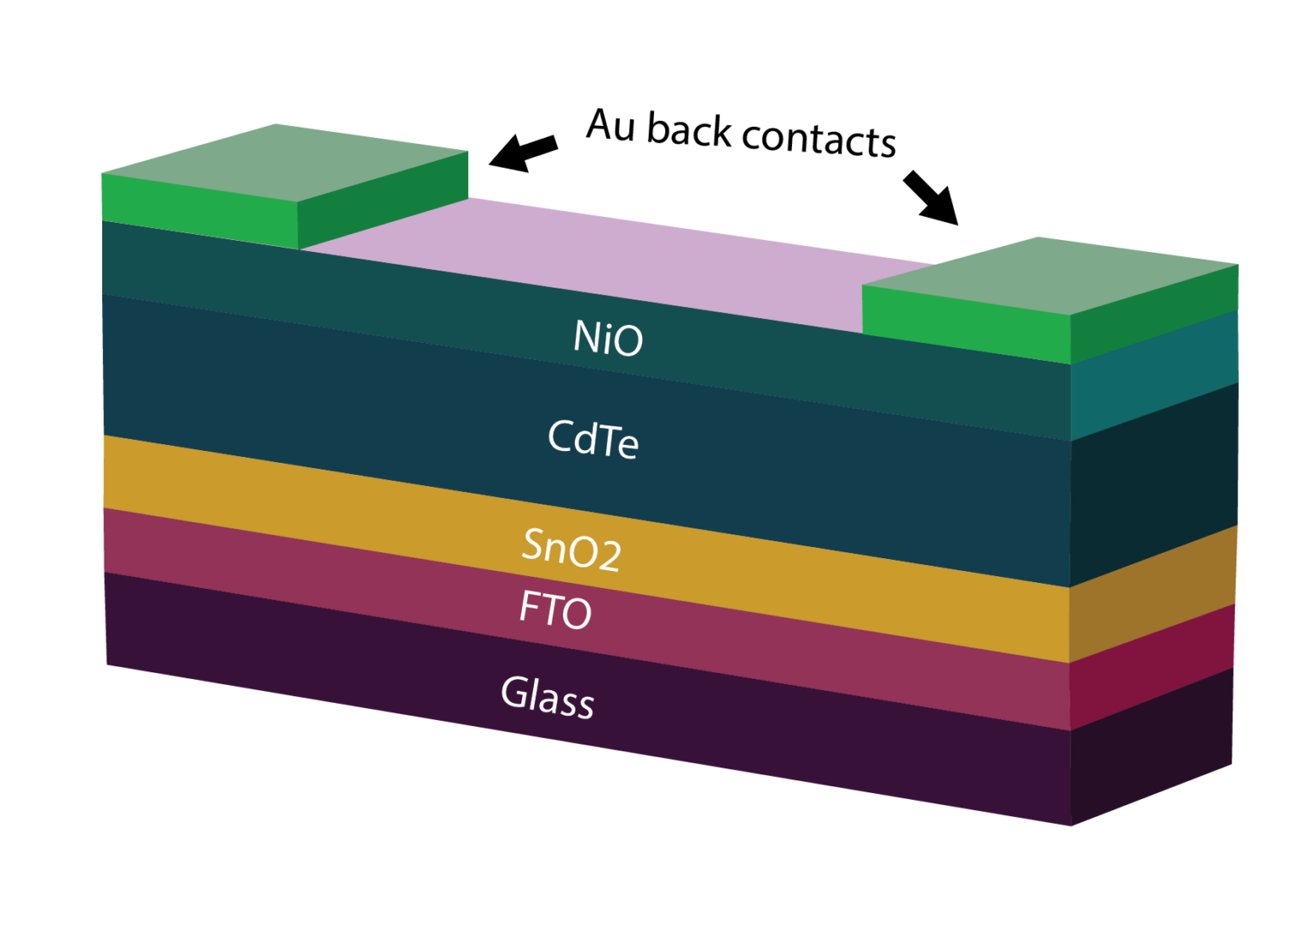

*Hunwick, N., Liu, X., Togay, M. et al. (2024) The effect of oxygen on NiO as a back buffer layer in CdTe solar cells, Energy Advances, Volume 3, Issue 7, Pages 1746-1753,* [*https://doi.org/10.1039/d4ya00125g*](https://doi.org/10.1039/d4ya00125g)

Cadmium telluride solar cells are commonly based on non-ohmic back contacts that affect the device open-circuit voltage, as these devices rely on low minority carrier lifetime, low carrier density and non-ohmic back contacts, and one solution to this problem is to add a nickel oxide back buffer layer, which forms an ohmic back contact and increases open-circuit voltage levels. British researchers have designed a cadmium telluride (CdTe) solar cell with a buffer layer made of nickel oxide (NiO) deposited without oxygen, which improves the device's open-circuit voltage. NiO, which is an efficient electron reflector due to the large conduction band offset, can be used as a back buffer layer to form an ohmic back contact. As optical transmission and band gaps are affected by oxygen input, typically reducing in both aspects with increasing oxygen, NiO begins to exhibit structural changes when introducing oxygen, forming nickel vacancies. The SCAPS-1D solar cell capacitance software, developed by the University of Ghent, was used to simulate the CdTe cell configuration, with the 0.25 cm2 device based on a substrate made of glass and fluorine-doped tin oxide (FTO), a tin oxide (SnO2) electron transport layer (ETL), a CdTe absorber, the Nio buffer layer with a thickness of 100 nm, and gold (Au) metal contacts. In the proposed cell architecture, the NiO back buffer layer increases device efficiency by reducing the barrier height at the Au back contact and improving the valence band offset at the CdTe/NiO interface (Hunwick et al., 2024; Bellini, 2024V).

**Copper Indium Gallium Diselenide**

Copper indium diselenide (CuInSe2) thin-film technology has been considered promising for solar cells because of its favorable electronic and optical properties. It was later found that by substituting gallium (Ga) for indium (In), the bandgap can be increased from about 1.04 electron-volts (eV) for copper indium diselenide (CIS) films to about 1.68 eV for copper gallium diselenide (CGS) films. Optimal devices have been fabricated with only a partial substitution of Ga for In, leading to a substantial increase in overall efficiency and more optimal bandgap. These solar cells are commonly known as a copper indium gallium diselenide [Cu(InxGa1-x)Se2], or CIGS, cells. Although laboratory-scale cell efficiencies have exceeded 20%, commercial CIGS modules typically have efficiencies between 12% and 14%.

***Benefits of Copper Indium Gallium Diselenide Cells***

1. High absorption: This direct-bandgap material can absorb a significant portion of the solar spectrum, enabling it to achieve the highest efficiency of any thin-film technology.
2. Tandem design: A tunable bandgap allows the possibility of tandem CIGS devices.
3. Protective buffer layer: The grain boundaries form an inherent buffer layer, preventing surface recombination and allowing for films with grain sizes of less than 1 micrometer to be used in device fabrication.

***Production of Copper Indium Gallium Diselenide Cells***

1. Co-evaporation, in which precursor elements are allowed to sublimate in a high-vacuum environment and then re-deposit on a heated substrate.
2. Precursor Reaction Processes, in which a precursor containing Cu and In/Ga is deposited at a low temperature by any of several processes, such as sputtering or electroplating. This is followed by a reactive annealing step in a Se compound, such as hydrogen selenide (H2Se) or gaseous selenium (Se), to form CIGS films. This is also commonly known as two-stage deposition; a variant of this technique, three-stage deposition, is also commonly used. After the CIGS deposition, the junction is formed by chemical-bath deposition of the n-type CdS layer. To finish the solar cell, a high-resistance zinc oxide (ZnO) layer and a high-conductivity n+-type ZnO layer are deposited by either sputtering or chemical-vapor deposition. Laser-scribing processes at different steps in the production process create the individual solar cells connected in series.
3. Alternative manufacturing techniques have been explored, such as reactive sputtering, magnetron sputtering (Cu, In, and Ga are sputtered while Se is evaporated), and electrodeposition. However, co-evaporation and precursor reaction processes still remain the most popular.

A major increase in device performance was achieved when the ceramic or borosilicate glass substrate was replaced by soda-lime glass. Although soda-lime glass was chosen because it has closer thermal expansion properties to CIGS, it was ultimately determined that the primary advantage of using soda-lime glass results from the diffusion of sodium (Na) ions from the glass into the CIGS absorber layer. Work is currently being done to identify the role of Na in improving CIGS performance and what tolerances CIGS has to the inclusion of Na. Current manufacturing techniques incorporate Na either from soda-lime glass or a separate Na source. Soda-lime glass has an added advantage of being less expensive than previous glass substrates.

All high‐efficiency CIS and CIGS devices use molybdenum (Mo) as the back contact primarily because of its work function and the high reflectivity of the Mo film. These films are typically deposited through direct-current (DC) sputtering. The sputtering deposition process requires precise pressure to control the stress in the film. Because of some inherent problems with the Mo back-contact, such as the possibility of a hole-blocking Schottky diode effect at the interface, other metals have been investigated to replace Mo, but have had limited success.

A copper indium gallium selenide (CIGS) solar cell with ultra-thin glass (UTG) has been developed that uses a cadmium-free buffer layer made of zinc oxide (ZnO)and magnesium oxide (MgO), instead of cadmium sulfide (CdS), by employing an optimized silver alloying strategy at significantly lower substrate temperatures, in the form of a thin Ag precursor layer to enable effective grain growth at the lower temperatures required by the use of UTG and protect the cell from transparent conductive oxide (TCO) potential sputtering damage. Using DC magnetron sputtering, they also applied molybdenum (Mo) back contacts onto the cleaned UTG and silver (Ag) layers and the Mo contacts. In a further step, they deposited a 2.0 µm-thick CIGS absorber onto the UTG substrate through a three-stage co-evaporation process with a multisource evaporator, followed by sodium (Na) and rubidium (Rb) alkali post-deposition treatments (Amare et al., 2025; Bellini, 2025DD).

**Gallium-Arsenide-Nitrogen-Bismuth Solar Cells**

A low bandgap solar cell based on a gallium-arsenide-nitrogen-bismuth (GaAsNBi) absorber has been developed by a Finnish-German research group, which has a 6 × 6 mm low bandgap GaAsNBi solar cell with an active area of 0.25 cm2. These findings will encourage the viability of GaAsNBi PV devices for use in multi-junction solar cells, and was published in *Solar Energy Materials and Solar Cells*. The device has an energy bandgap of 0.86 eV and is reportedly suitable for applications in multi-junction solar cells, and is intended to be used as a bottom device in a multi-junction PV cell. Their attempt to build a GaAsNBi solar cell follows scientists at Osaka University in Japan unveiling a 2.01%-efficient device with a 1.15 eV bandgap in 2021. The performance of the device was assessed through external quantum efficiency (EQE) and light-current-voltage (LIV) measurements under standard solar illumination conditions. EQE is the ratio of the number of energy carriers harvested by the solar cell to the number of photons of a given energy incident on the cell itself (Puustinen et al., 2024; Bellini, 2023A).

***Challenges***

1. Unconventional growth conditions required for Bi and N incorporation, which may lead to a large number of defects. Incorporating Bi in GaAs needs low growth temperatures and carefully controlled V/III flux ratios. To solve this, they grew the GaAs layers using molecular beam epitaxy (MBE), which is an evaporation technique implemented in an ultra-high vacuum for decomposing compounds with extreme regularity of layer thickness and composition.

A new porosification technique was developed in 2023 to build gallium arsenide (GaAs) solar cells that allow the recovery of germanium films, with the new cell achieving an efficiency that is reportedly in line with that of other GaAs PV devices, but can be produced at a lower cost thanks to the reuse of germanium. They grew the cell on detachable germanium (Ge) films, which allows the reuse of Ge in other applications, thus reducing production costs. “By ingeniously creating a weak layer between epitaxial layers and a germanium substrate, we unlock the potential for reusing germanium, leading to a significant reduction in both environmental impact and production costs for optoelectronic devices,” said Sherbrooke Professor, Maxime Darnon, as published in *RR Solar*. To create this weak layer, it used the so-called PEELER technique, a novel electrochemical porosification technique originally used for silicon wafers. Utilizing metal-organic chemical vapor deposition (MOCVD), the researchers fabricated a 1 mm2 front-contacted GaAs PV device based on a Ge substrate, the weak Ge layer, an epitaxial Ge layer, the GaAs absorber, a top contact made of nickel (Ni), Ge, and gold (Au), and a contact layer. The champion device built with this architecture achieved a power conversion efficiency of 23.1%, an open-circuit voltage of 1.012 V, a short-circuit current density of 26.28 mA/cm2, and a fill factor of 81.98% (Daniel et al., 2024; Bellini, 2023F).

**Gallium Arsenide Solar Cell**

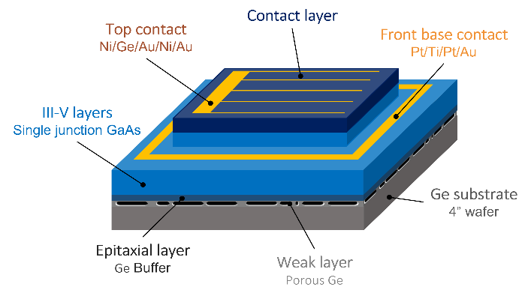

*Image: Université de Sherbrooke,* [*https://www.pv-magazine.com/2023/11/21/gallium-arsenide-solar-cell-achieves-23-1-efficiency-via-electrochemical-porosification/*](https://www.pv-magazine.com/2023/11/21/gallium-arsenide-solar-cell-achieves-23-1-efficiency-via-electrochemical-porosification/)

**Organic Solar Cells**

To fabricate organic solar cells using non-toxic solvents, researchers identified interactions between the acceptor material side chains and the solvent, along with interactions between donor and acceptor materials, as key factors for controlling morphology in organic solar cells. Morphology optimization has been crucial in achieving power conversion efficiencies (PCE) exceeding 20% in organic solar cells. The scientists developed the acceptor material, BTP-TO2, by incorporating an oligo (ethylene glycol) side chain attached to the central nitrogen atom of its benzotriazole unit, as BTP-TO2 leads to similar active layer morphology when processed from a wide range of solvents, both halogenated and non-halogenated (Zhang et al., 2024A; Jowett, 2024D).

Chinese scientists have designed and synthesized a dimerized small molecule donor for ternary organic solar cells. Ternary organic solar cells are the best strategy to achieve high-performance organic cells, but a third component needs to be added to maximize efficiency, with the dimerized small molecule donor, ternary component, DSMD-βV, fabricated by connecting two asymmetric small molecule donors with the vinyl group. DSMD-βV, an oligomeric molecule, is considered a suitable third component in the ternary cell due to its absorption, as it displays a wide absorption range from 350 to 800 nm, and energy level matching when compared with PM6 and BTP-eC9, and DSMD-βV can also improve phase separation of PM6:BTP-eC9 based film morphology. In the experiment, the scientists obtained an asymmetric small donor with bromine substituted end group through a series of synthesis strategies, and the compound was then coupled with vinyl to synthesize the target product DSMD-βV via a Stille-coupling reaction, employing Pd2(dba)3 as the catalyst and P(o-tol)3 as the ligand. To test the dimerized small molecule donor, the scientists fabricated a solar cell consisting of DSMD-βV and a PM6:BTP-eC9 system as the binary matrix, and found that the PM6:DSMD-βV:BTP-eC9 ternary organic cell device recorded a power conversion efficiency of 18.26%, compared to a result of 17.63% in a PM6:BTP-eC9-based binary cell. The ternary device featuring DSMD-βVf achieved more effective exciton dissociation, suppressed trap-assisted recombination, promoted charge transfer, inhibited charge recombination and improved carrier lifetime and extraction time when compared to the reference binary device (Pu et al., 2024; Jowett, 2024E).

Chinese researchers have developed an ultra-thin organic solar cell with a bilayer hole transport layer (HTL) and a power-per-weight ratio of 39 W/g, as the bilayer HTL incorporates a molybdenum trioxide (MoO3) interlayer between PEDOT:PSS, a blend of polymers poly(3,4-ethylenedioxythiophene) and polystyrene sulfonate, and indium tin oxide (ITO), and said the introduction of this interlayer was the key factor allowing the cell to achieve a remarkable power conversion efficiency of 17%, as well as good storage stability and mechanical stability (Zhang et al., 2024B; Jowett, 2024A).

**Kesterite Solar Cells**

Kesterite is currently the most promising emerging fully inorganic thin film photovoltaic technology based on critical raw-material-free and sustainable solutions. Kesterite is one of the most promising light absorber material candidates for potential use in lower-cost thin-film solar cells. Kesterites include common elements such as copper, tin, zinc, and selenium. Unlike CIGS compounds, there are no supply bottlenecks expected in the future. However, kesterite is still less efficient than CIGS in mass production. The world record for such cells is 12.6%, achieved for large-area devices by Japanese thin-film producer Solar Frontier in 2013. The scientists introduced the new cell design in the study “Controlling Selenization Equilibrium Enables High-Quality Kesterite Absorbers for Efficient Solar Cells,” published in *Nature Communications* (Xu et al., 2023; Bellini, 2023D)

The Chinese Academy of Sciences (CAS) has used a new selenization approach that facilitates the direct and rapid formation of the Kesterite phase, thus improving charge transport in the absorber film, to build a kesterite solar cell with better charge transport and power conversion efficiency. They implemented a dual-temperature zone selenization approach to realize a solid-liquid/solid-gas synergistic selenization reaction strategy. “The introduction of a large amount of liquid selenium (Se) has facilitated a solid-liquid reaction pathway, while the high Se chemical potential has promoted the direct and rapid formation of the Kesterite phase,” they explained. “In the subsequent stage, a synergistic regulation of Se condensation and volatilization has led to improved crystal growth and enhanced removal of organic residues.” They also explained that the strategy requires pre-depositing a sufficient amount of liquid selenium onto the precursor film to facilitate liquid-phase-assisted phase evolution and crystal growth. The following synergistic control of selenium volatilization is intended to balance the film crystallization and organics removals. The research team built the cell with an absorber based on Kesterite films with reduced bulk and interface defects, a cadmium sulfide (CdS) buffer layer, a window layer of zinc oxide (i-ZnO), an indium tin oxide (ITO) layer, and anti-reflection coating (ARC) based on magnesium fluoride (MgF2). The device has an aperture area of 0.2627 ${cm}^{2}$  and a designated illuminated area of 1.066 ${cm}^{2}$  (Xu et al., 2023; Bellini, 2023D).

High bandgap kesterite (CZTS) solar cells, a compound of copper, zinc, tin and sulfur, is a high-bandgap thin film, flexible material suitable that offers a promising alternative to the more widely studied perovskite as a tandem top-cell candidate because it is environmentally friendly, cost-effective to manufacture, and is known to maintain its performance over a long period. However, low energy conversion efficiencies have affected kesterite cells, largely attributed to defects created within CZTS during production, though this problem can be addressed with annealing, or heat-treating, the CZTS solar cell device in a hydrogen-containing atmosphere, also known as passivation, which modulates the defects. To create CZTS you take copper, tin, zinc and sulphur and cook them all together at a certain temperature which turns it into a material you can use as a semiconductor, though the defects which are introduced must be controlled (Wang et al., 2025C; Carroll, 2025).

**References**

Amare, A.M., Hwang, I., Jeong, I., et al. (2025) High-efficiency cadmium-free Cu(In,Ga)Se2 flexible thin-film solar cells on ultra-thin glass as an emerging substrate, Journal of Alloys and Compounds, Volume 1024, 180187, <https://doi.org/10.1016/j.jallcom.2025.180187>

Bellini, Emiliano (2023A) PV Magazine. New attempt to build solar cells based on gallium-arsenide-nitrogen-bismuth. Retrieved November 5, 2023. <https://www.pv-magazine.com/2023/11/02/new-attempt-to-build-solar-cells-based-on-gallium-arsenide-nitrogen-bismuth/>

Bellini, Emiliano (2023B) PV Magazine. NREL presents new GaAs solar cell concept with 27% efficiency. Retrieved November 13, 2023. <https://www.pv-magazine.com/2023/11/10/nrel-presents-new-gaas-solar-cell-concept-with-27-efficiency/>

Bellini, Emiliano (2023D) PV Magazine. Kesterite solar cell achieves 12.01% efficiency via selenization approach. Retrieved November 20, 2023. <https://www.pv-magazine.com/2023/11/17/kesterite-solar-cell-achieves-12-01-efficiency-via-new-selenization-approach/>

Bellini, Emiliano (2023F) PV Magazine. Gallium arsenide solar cell achieves 23.1% efficiency via electrochemical porosification. Retrieved November 22, 2023. <https://www.pv-magazine.com/2023/11/21/gallium-arsenide-solar-cell-achieves-23-1-efficiency-via-electrochemical-porosification/>

Bellini, Emiliano (2023G) PV Magazine, Scientists warn of heat-induced failure risks in HJT glass-backsheet PV modules, <https://www.pv-magazine.com/2023/05/09/scientists-warn-of-heat-induced-failure-risks-in-hjt-glass-backsheet-pv-modules/>

Bellini, Emiliano (2024B) PV Magazine, Fraunhofer ISE, AMOLF unveil TOPCon solar cell based on metal nanowire grid front electrodes,

<https://www.pv-magazine.com/2024/12/04/fraunhofer-ise-amolf-unveil-topcon-solar-cell-based-on-metal-nanowire-grid-front-electrodes/?utm_source=Global+%7C+Newsletter&utm_campaign=84fee40efa-dailynl_gl&utm_medium=email&utm_term=0_6916ce32b6-84fee40efa-160603208>

Bellini, Emiliano (2024D) PV Magazine, Nexwafe claims 24.4% efficiency for heterojunction solar cell built with its ultrathin wafers,

<https://www.pv-magazine.com/2024/12/18/nexwafe-claims-24-4-efficiency-for-heterojunction-solar-cell-built-with-its-ultrathin-wafers/?utm_source=Global+%7C+Newsletter&utm_campaign=fe3c6f8aee-dailynl_gl&utm_medium=email&utm_term=0_6916ce32b6-fe3c6f8aee-160603208>

Bellini, Emiliano (2024E) PV Magazine, Improving solar cell performance with dye concentrators,

<https://www.pv-magazine.com/2024/08/07/improving-solar-cell-performance-with-dye-concentrators/?utm_source=Global+%7C+Newsletter&utm_campaign=2a71bf6845-dailynl_gl&utm_medium=email&utm_term=0_6916ce32b6-2a71bf6845-160603208>

Bellini, Emiliano (2024Q) PV Magazine, Ultrathin perovskite solar cell based on Gires-Tournois resonator,

<https://www.pv-magazine.com/2024/11/25/ultrathin-perovskite-solar-cell-based-on-gires-tournois-resonator/?utm_source=Global+%7C+Newsletter&utm_campaign=7e380cd323-dailynl_gl&utm_medium=email&utm_term=0_6916ce32b6-7e380cd323-160603208>

Bellini, Emiliano (2025A) PV Magazine, New research sheds light on impact of sodium-induced degradation in heterojunction solar cells,

<https://www.pv-magazine.com/2025/01/03/new-research-sheds-light-on-impact-of-sodium-induced-degradation-in-heterojunction-solar-cells/?utm_source=Global+%7C+Newsletter&utm_campaign=15eb45e3e4-dailynl_gl&utm_medium=email&utm_term=0_6916ce32b6-15eb45e3e4-160603208>

Bellini, Emiliano (2025C) PV Magazine, Reducing silver use in heterojunction solar cells via low-cost copper wires,

<https://www.pv-magazine.com/2025/01/21/reducing-silver-use-in-heterojunction-solar-cells-via-low-cost-copper-wires/?utm_source=Global+%7C+Newsletter&utm_campaign=34a15409ba-dailynl_gl&utm_medium=email&utm_term=0_6916ce32b6-34a15409ba-160603208>

Bellini, Emiliano (2025F) PV Magazine, TU Delft research outlines optimization path for two-terminal perovskite-silicon tandem solar modules,

<https://www.pv-magazine.com/2025/01/31/tu-delft-research-outlines-optimization-path-for-two-terminal-perovskite-silicon-tandem-solar-modules/?utm_source=Global+%7C+Newsletter&utm_campaign=eac8dda627-dailynl_gl&utm_medium=email&utm_term=0_6916ce32b6-eac8dda627-160603208>

Bellini, Emiliano (2025M) PV Magazine, Study shows sensitivity of heterojunction solar cells to soldering flux,

<https://www.pv-magazine.com/2025/02/12/study-shows-sensitivity-of-heterojunction-solar-cells-to-soldering-flux/?utm_source=Global+%7C+Newsletter&utm_campaign=4de09b618e-dailynl_gl&utm_medium=email&utm_term=0_6916ce32b6-4de09b618e-160603208>

Bellini, Emilano (2025N) PV Magazine, Reducing TOPCon solar cell degradation via copper plating,

<https://www.pv-magazine.com/2025/01/27/reducing-topcon-solar-cell-degradation-via-copper-plating/?utm_source=Global+%7C+Newsletter&utm_campaign=45ea69cbdd-dailynl_gl&utm_medium=email&utm_term=0_6916ce32b6-45ea69cbdd-160603208>

Bellini, Emiliano (2025O) PV Magazine, The impact of impurity concentrations in gallium-doped p-type silicon ingots,

<https://www.pv-magazine.com/2025/02/13/the-impact-of-impurity-concentrations-in-gallium-doped-p-type-silicon-ingots/?utm_source=Global+%7C+Newsletter&utm_campaign=6b78b84db3-dailynl_gl&utm_medium=email&utm_term=0_6916ce32b6-6b78b84db3-160603208>

Bellini, Emiliano (2025P) PV Magazine, New method to predict potential induced degradation in glass-glass TOPCon solar modules,

<https://www.pv-magazine.com/2025/02/25/new-method-to-predict-potential-induced-degradation-in-glass-glass-topcon-solar-modules/?utm_source=Global+%7C+Newsletter&utm_campaign=58bab1825d-dailynl_gl&utm_medium=email&utm_term=0_6916ce32b6-58bab1825d-160603208>

Bellini, Emiliano (2025Q) PV Magazine, TU Delft research suggests back contact tech may push crystalline silicon PV over 28% threshold,

<https://www.pv-magazine.com/2025/02/24/tu-delft-research-suggests-back-contact-tech-may-push-crystalline-silicon-pv-over-28-threshold/?utm_source=Global+%7C+Newsletter&utm_campaign=f53bfce766-dailynl_gl&utm_medium=email&utm_term=0_6916ce32b6-f53bfce766-160603208>

Bellini, Emiliano (2025U) PV Magazine, New research shows degradation mechanisms in rear side of TOPCon solar cells,

<https://www.pv-magazine.com/2025/03/13/new-research-shows-degradation-mechanisms-in-rear-side-of-topcon-solar-cells/?utm_source=Global+%7C+Newsletter&utm_campaign=29f04be287-dailynl_gl&utm_medium=email&utm_term=0_6916ce32b6-29f04be287-160603208>

Bellini, Emiliano (2025V) PV Magazine, TOPCon solar cell based on aluminum contacts achieves slightly lower efficiency than silver-based counterpart,

<https://www.pv-magazine.com/2025/03/28/topcon-solar-cell-based-on-aluminum-contacts-achieves-slightly-lower-efficiency-than-silver-based-counterpart/?utm_source=Global+%7C+Newsletter&utm_campaign=4d92d2f84f-dailynl_gl&utm_medium=email&utm_term=0_6916ce32b6-4d92d2f84f-160603208>

Bellini, Emiliano (2025W) PV Magazine, Indoor transition metal dichalcogenide solar cells may reach 36.5% efficiency,

<https://www.pv-magazine.com/2025/03/19/indoor-transition-metal-dichalcogenide-solar-cells-may-reach-36-5-efficiency/?utm_source=Global+%7C+Newsletter&utm_campaign=2b2339fc7f-dailynl_gl&utm_medium=email&utm_term=0_6916ce32b6-2b2339fc7f-160603208>

Bellini, Emiliano (2025BB) PV Magazine, TU Delft researchers build 23.4%-efficient heterojunction solar cell with localized front contacts,

<https://www.pv-magazine.com/2025/04/23/tu-delft-researchers-build-23-4-efficient-heterojunction-solar-cell-with-localized-front-contacts/?utm_source=Global+%7C+Newsletter&utm_campaign=5cfdbc2860-dailynl_gl&utm_medium=email&utm_term=0_6916ce32b6-5cfdbc2860-160603208>

Bellini, Emiliano (2025DD) PV Magazine, CIGS cell with ultra-thin glass substrate hits record efficiency of 17.81%,

<https://www.pv-magazine.com/2025/04/18/cigs-solar-cell-based-on-ultrathin-glass-substrate-achieves-record-efficiency-of-17-81/?utm_source=Global+%7C+Newsletter&utm_campaign=00c8ab257a-dailynl_gl&utm_medium=email&utm_term=0_6916ce32b6-00c8ab257a-160603208>

Bellini, Emiliano (2025HH) PV Magazine, Silver-lean screen-printing can reduce silver use in TOPCon solar cells by 40%,

<https://www.pv-magazine-australia.com/2025/05/09/silver-lean-screen-printing-can-reduce-silver-use-in-topcon-solar-cells-by-40/?utm_source=Global+%7C+Newsletter&utm_campaign=1520f30184-dailynl_gl&utm_medium=email&utm_term=0_6916ce32b6-1520f30184-160603208>

Bellini, Emiliano (2024V) PV Magazine, Increasing voltage in cadmium telluride solar cells through nickel oxide back buffer layer,

<https://www.pv-magazine.com/2024/08/05/increasing-voltage-in-cadmium-telluride-solar-cells-through-nickel-oxide-back-buffer-layer/?utm_source=Global+%7C+Newsletter&utm_campaign=441c448a28-dailynl_gl&utm_medium=email&utm_term=0_6916ce32b6-441c448a28-160603208>

Bleiji, Y., Müller, R., Micali, M. et al. (2025) Enhanced near infrared light trapping in Si solar cells with metal nanowire grid front electrodes, Solar Energy Materials and Solar Cells, Volume 281, 113289, <https://doi.org/10.1016/j.solmat.2024.113289>

Blom, Y., Vogt, M.R., Isabella, O., and Santbergen, R. (2025) Optimization of the perovskite cell in a bifacial two-terminal perovskite/silicon tandem module, Solar Energy Materials and Solar Cells, Volume 282, 113431, <https://doi.org/10.1016/j.solmat.2025.113431>

Brągoszewska, E., Bogacka, M., and Wajda, A. (2024) Enhancing the efficiency of photovoltaic cells through the usage of dye concentrators, Frontiers in Energy Research, Volume 12, <https://doi.org/10.3389/fenrg.2024.1399020>

Brahambhatt, Rupendra (2025) Interesting Engineering, Breakthrough bifacial solar cells hit 80% efficiency with new transparent electrodes,

<https://interestingengineering.com/energy/transparent-electrodes-for-bifacial-solar-cells>

Carroll, David (2025) PV Magazine, Australian researchers set world record with kesterite solar cell,

<https://www.pv-magazine.com/2025/01/28/unsw-team-achieves-13-2-world-record-efficiency-for-kesterite-solar-cell/?utm_source=Global+%7C+Newsletter&utm_campaign=80e4babb6e-dailynl_gl&utm_medium=email&utm_term=0_6916ce32b6-80e4babb6e-160603208>

Chan, Keng Siew (2019) <https://medium.com/@kengsiewchan/perc-solar-cells-3eb275804ded>

Cheng, Y., Zhang, Y., Xu, Y., et al. (2025) Integration of aluminum contacts in TOPCon solar cells: A pathway to reduce silver usage, Solar Energy Materials and Solar Cells, Volume 285, 113559, <https://doi.org/10.1016/j.solmat.2025.113559>

Cuthbertson, Anthony (2023B) The Independent. Solar panel world record smashed with ‘miracle material’. Retrieved November 13, 2023. <https://www.independent.co.uk/tech/perovskite-solar-panels-uk-b2446225.html>

Daniel, V., Bidaud, T., Chretien, J., et al. (2024), High-Efficiency GaAs Solar Cells Grown on Porous Germanium Substrate with PEELER Technology. Solar RRL, 8: 2300643. <https://doi.org/10.1002/solr.202300643>

de Lafontaine, M., Bidaud, T., Gay, G., et al. (2023) 3D interconnects for III-V semiconductor heterostructures for miniaturized power devices, Cell Reports Physical Science, Volume 4, Issue 12, 101701, <https://doi.org/10.1016/j.xcrp.2023.101701>

Dezfoli, Amir Reza Ansari (2025) Engineering insights into heater design for oxygen reduction in CZ silicon growth, Case Studies in Thermal Engineering, Volume 65, 105596, <https://doi.org/10.1016/j.csite.2024.105596>

Dou, W., Zhang, Z., and Dai, N. (2024) Ultrathin perovskite solar cell based on Gires-Tournois resonator configuration with 27% theoretical efficiency, Solar Energy, Volume 284, 112997, <https://doi.org/10.1016/j.solener.2024.112997>

Foley, EV (2024A) PV Magazine, Trinasolar hits record efficiency high 27.08% for HJT solar cells,

<https://www.pv-magazine-australia.com/2024/12/20/trinasolar-hits-record-efficiency-high-27-08-for-hjt-solar-cells/?utm_source=Global+%7C+Newsletter&utm_campaign=73b4cb8bc3-dailynl_gl&utm_medium=email&utm_term=0_6916ce32b6-73b4cb8bc3-160603208>

Hicks, Wayne (2023) Tech Explore. Design improvements boost efficiency of III-V solar cells. Retrieved November 6, 2023. <https://techxplore.com/news/2023-10-boost-efficiency-iii-v-solar-cells.html>

Hunwick, N., Liu, X., Togay, M. et al. (2024) The effect of oxygen on NiO as a back buffer layer in CdTe solar cells, Energy Advances, Volume 3, Issue 7, Pages 1746-1753, <https://doi.org/10.1039/d4ya00125g>

Jowett, Patrick (2024A) PV Magazine, Organic solar cell with bilayer hole transport layer achieves 17% efficiency,

[https://www.pv-magazine.com/2024/07/04/organic-solar-cell-with-bilayer-hole-transport-layer-achieves-17-efficiency/?utm_source=Global+%7C+Newsletter&utm_campaign=df2cb836f5-dailynl _gl&utm_medium=email&utm_term=0_6916ce32b6-df2cb836f5-160603208](https://www.pv-magazine.com/2024/07/04/organic-solar-cell-with-bilayer-hole-transport-layer-achieves-17-efficiency/?utm_source=Global+%7C+Newsletter&utm_campaign=df2cb836f5-dailynl_gl&utm_medium=email&utm_term=0_6916ce32b6-df2cb836f5-160603208)

Jowett, Patrick (2024D) PV Magazine, Scientists reveal factors for morphology control in organic solar cells,

<https://www.pv-magazine.com/2024/12/06/scientists-reveal-factors-for-morphology-control-in-organic-solar-cells/?utm_source=Global+%7C+Newsletter&utm_campaign=1ca09a0ec5-dailynl_gl&utm_medium=email&utm_term=0_6916ce32b6-1ca09a0ec5-160603208>

Jowett, Patrick (2024E) PV Magazine, Ternary organic solar cell based on dimerized small molecule achieves 18.12% efficiency,

<https://www.pv-magazine.com/2024/08/19/ternary-organic-solar-cell-based-on-dimerized-small-molecule-achieves-18-12-efficiency/?utm_source=Global+%7C+Newsletter&utm_campaign=1a6ba955b3-dailynl_gl&utm_medium=email&utm_term=0_6916ce32b6-1a6ba955b3-160603208>

Kahana, Lior (2024) PV Magazine, Improving solar cell efficiency with upconversion nanoparticles,

<https://www.pv-magazine.com/2024/12/10/improving-solar-cell-efficiency-with-upconversion-nanoparticles/?utm_source=Global+%7C+Newsletter&utm_campaign=0900ac023d-dailynl_gl&utm_medium=email&utm_term=0_6916ce32b6-0900ac023d-160603208>

Kamphues, J., Herguth, A., Miech, J., et al. (2025) The impact of gettering on LeTID in industrial Czochralski grown gallium-doped p-type silicon ingots with melt recharging, Solar Energy Materials and Solar Cells, Volume 282, 113423, <https://doi.org/10.1016/j.solmat.2025.113423>

Li, Z., Yu, K., Wang, L., et al. (2025) Prediction of potential induced degradation for TOPCon PV modules working in field based on accelerated stress testing, Solar Energy, Volume 290, 113340, <https://doi.org/10.1016/j.solener.2025.113340>

Liu, Y., Peters, I.M., Ding, K., et al. (2025A) Silver reduction through direct wire bonding for Silicon Heterojunction solar cells, Solar Energy Materials and Solar Cells, Volume 282, 113412, <https://doi.org/10.1016/j.solmat.2025.113412>

Nitta, F.U., Nazif, K.N., Pop, E. (2025) Transition metal dichalcogenide solar cells for indoor energy harvesting, Device, 100723, <https://doi.org/10.1016/j.device.2025.100723>

Paul, A., Singha, A., Koul, S. et al. (2024) Quantitative Estimation of Albedo and Tilt Angle Variation in Bifacial Perovskite Solar Cells, ACS Applied Materials & Interfaces, Volume 18, Issue 44, <https://doi.org/10.1021/acsami.4c13114>

Peplow, Mark (2023) A new kind of solar cell is coming: is it the future of green energy? Nature, <https://www.nature.com/articles/d41586-023-03714-y>

Procel-Moya, P., Zhao, Y., and Isabella, O. (2025) Unlocking the potential of carrier-selective contacts: Key insights for designing c-Si solar cells with efficiency beyond 28 %, Solar Energy Materials and Solar Cells, Volume 285, 113504, <https://doi.org/10.1016/j.solmat.2025.113504>

Pu, M., Ke, C., Lang, Y. et al. (2024) Dimerized small molecule donor enables efficient ternary organic solar cells, Giant, Volume 19, 100325, <https://doi.org/10.1016/j.giant.2024.100325>

Puustinen, J., Hilska, J., Aho, A. et al. (2024) Low bandgap GaAsNBi solar cells, Solar Energy Materials and Solar Cells, Volume 264, 112598, <https://doi.org/10.1016/j.solmat.2023.112598>

Rani, S., Kumar, A., Chauhan, A.K., and Ghosh, D.S. (2025) Hybrid top transparent electrode for infrared-transparent bifacial perovskite solar cells, Journal of Photonics for Energy, Volume 15, Issue 1, <https://doi.org/10.1117/1.JPE.15.015501>

Rizk, Bernard (2023) Tech Xplore. Researchers manufacture the first back-contact micrometric photovoltaic cells. Retrieved November 29, 2023. <https://techxplore.com/news/2023-11-back-contact-micrometric-photovoltaic-cells.html>

Schulte, K.L., Simon, J., Steiner, M.A., and Ptak, A.J. et al. (2023) Modeling and design of III-V heterojunction solar cells for enhanced performance, Cell Reports Physical Science, Volume 4, Issue 9, 101541, <https://www.cell.com/cell-reports-physical-science/fulltext/S2666-3864(23)00338-7>

Sen, C., Wang, H., Wu, X. et al. (2023) Four failure modes in silicon heterojunction glass-backsheet modules, Solar Energy Materials and Solar Cells, Volume 257, 112358, <https://doi.org/10.1016/j.solmat.2023.112358>

Shaw, Vincent (2025) PV Magazine, Risen claims 30.99% efficiency for perovskite-silicon tandem solar cell,

<https://www.pv-magazine.com/2025/02/20/risen-claims-30-99-efficiency-for-perovskite-silicon-tandem-solar-cell/?utm_source=Global+%7C+Newsletter&utm_campaign=eedd5d12cd-dailynl_gl&utm_medium=email&utm_term=0_6916ce32b6-eedd5d12cd-160603208>

Smits, S., Zhao, Y., Procel Moya, P., Mazzarella, L. and Isabella, O. (2025) Silicon Heterojunction Solar Cells Featuring Localized Front Contacts, Sol. RRL, 9, 2400898, <https://doi.org/10.1002/solr.202400898>

Thompson, Valerie (2024K) PV Magazine, New tech to reduce oxygen defects in Czochralski wafers,

<https://www.pv-magazine.com/2024/12/30/new-tech-to-reduce-oxygen-defects-in-czochralski-wafers/?utm_source=Global+%7C+Newsletter&utm_campaign=e8c7177124-dailynl_gl&utm_medium=email&utm_term=0_6916ce32b6-e8c7177124-160603208>

Tong, H., Wu, X., Wang, X., et al. (2025) Mitigating contaminant-induced surface degradation in TOPCon solar cells: Mechanisms, impacts, and mitigation, Solar Energy Materials and Solar Cells, Volume 286, 113558, <https://doi.org/10.1016/j.solmat.2025.113558>

Wang, Y., Xu, W., Liu, H. et al. (2024B) A multiband NIR upconversion core-shell design for enhanced light harvesting of silicon solar cells. Light: Science and Applications 13, 312 (2024). <https://doi.org/10.1038/s41377-024-01661-5>

Wang, X., Sen, C., Wu, X., et al. (2025A) Alleviating contaminant-induced degradation of TOPCon solar cells with copper plating, Solar Energy Materials and Solar Cells, Volume 282, 113444, <https://doi.org/10.1016/j.solmat.2025.113444>

Wang, H., Sen, C., Fu, J., Khan, M., Song, H., Lv, R., Conibeer, G. and Hoex, B. (2025B), The Influence of Soldering Flux on Stability of Heterojunction and TOPCon Solar Cells, Progress in Photovoltaics: Research and Applications, <https://doi.org/10.1002/pip.3896>

Wang, A., Cong, J., Zhou, S. et al. (2025C) Hydrogen-enhanced carrier collection enabling wide-bandgap Cd-free Cu2ZnSnS4 solar cells with 11.4% certified efficiency, Nature Energy, <https://doi.org/10.1038/s41560-024-01694-5>

Wu, X., Wang, X., Lv, R. et al. (2025A) Unveiling the degradation mechanisms in silicon heterojunction solar cells under accelerated damp-heat testing, Solar Energy Materials and Solar Cells, Volume 282, 113325, <https://doi.org/10.1016/j.solmat.2024.113325>

Xu, X., Zhou, J., Yin, K. et al. (2023) Controlling Selenization Equilibrium Enables High-Quality Kesterite Absorbers for Efficient Solar Cells. Nature Communications 14, 6650, <https://doi.org/10.1038/s41467-023-42460-7>

Zhang, R., Chen, H., Wang, T. et al. (2024A) Equally high efficiencies of organic solar cells processed from different solvents reveal key factors for morphology control. Nature Energy, <https://doi.org/10.1038/s41560-024-01678-5>

Zhang, D., Ji, Y., Cheng, Y. et al. (2024B) High-efficiency ultrathin flexible organic solar cells with a bilayer hole transport layer, Journal of Materials Chemistry A, 12, 15099-15105, <https://doi.org/10.1039/D4TA01679C>

Zhang, Y., Wang, S., Wang, L., et al. (2025A) Silver-lean screen-printing metallisation for industrial TOPCon solar cells: Enabling an 80 % reduction in silver consumption, Solar Energy Materials and Solar Cells, Volume 288, 113654, <https://doi.org/10.1016/j.solmat.2025.113654>